A comparative analysis of men and women's perceptions of True Crime

Criminology and Policing
Independent Project
Madeleine Jones (student number – 2006541)
Word Count: 8754

Declaration
This work has not previously been accepted in substance for any degree and is not being concurrently submitted in candidature for any degree.
STATEMENT 1
This dissertation is being submitted in partial fulfilment of the requirements for the degree of BA/BSc.
STATEMENT 2
This dissertation is the result of my own independent work/investigation, except where otherwise stated.
Other sources are acknowledged in the Reference Section.
STATEMENT 3
I hereby give consent for my dissertation, if accepted, to be available for photocopying and for interlibrary loan, and for the title and summary to be made available to outside organisations.
STATEMENT 4
I hereby give consent for my dissertation, if accepted, to be available on the university’s IT system to those who have consent to use the system.
Student’s Name: Madeleine Jones
Signed: M A Jones
Date: 28th April 2023

Acknowledgments
I would like to thank my dissertation supervisor, Laura Knight, for the support she has given me through writing my dissertation and all my lecturers throughout my time at UWTSD (University of Wales Trinity St Davids). I would also like to thank my friends and family for the constant support through my academic studies and always having faith in me.

List of abbreviations
TC – True Crime
UWTSD - University of Wales Trinity St Davids
PTSD – Post Traumatic Stress Disorder
ONS – Office for National Statistics

Abstract
The purpose of this research is to compare and analyse the perception of the true crime genre and the differences the genders may have. Different topics such as the gender differences, real-world victimisation and the medias' role in glamourising the true crime genre will all be investigated. True crime is rapidly expanding in both negative and positive ways, and the media coverage is at its peak. This research will be conducted through secondary research using a literature review and primary research in the form of a questionnaire. The data from all research will be analysed and a concluding statement will be made to fully understand male and females' perception on the genre of true crime.

Chapter One: Introduction 1
1.1 Background and Rationale 1
1.2 Aims and Objectives 1
1.2.1 Aim 1
1.2.2 Objectives 1
1.3 Method and Timescales 1
Chapter 2 - Literature Review 1
2.1 Introduction 1
2.2 Compare differences in opinions between men and women in relation to TC 1
2.3 Explore the portrayal of gender roles in TC and how they correlate to real-world victimisation 1
2.4 Investigate the media's role in glamorising TC 1
2.5 Conclusion 1
Chapter 3 - Methodology 1
3.1 Introduction 1
3.2 Philosophy 1
3.3 Approach 1
3.4 Research strategy and Methods 1
3.6 Time Horizons 1
3.7 Data Collection 1
3.8 Limitations, Reliability and Validity 1
3.9 Ethical Considerations 1
3.10 Conclusion 1
Chapter 4 - Data Analysis 1
4.1 Introduction 1
4.2 Gender and age 1
4.3 Research data analysis 1
4.4 Questionnaire feedback: Compare differences in opinions between men and women in relation to TC 1
4.5 Questionnaire Feedback: Explore the portrayal of gender roles in TC and how they correlate to real-world victimisation 1
4.6 Questionnaire Feedback: Investigate the media's role in glamorising TC 1
4.7 Conclusion 1
Chapter 5: Conclusion 1
5.1 Introduction 1
5.2 Research Objectives: Summary of findings and conclusions 1
5.2.1 Research Objective One: Compare differences in opinions between men and women in relation to TC 1
5.2.2 Research Objective Two: Explore the portrayal of gender roles in TC and how they correlate to real-world victimisation 1
5.2.3 Research Objective Three: Investigate the media's role in glamorising TC 1
5.3 Limitations and Recommendations 1
References 1
Appendices 1
Appendix One 1
Appendix Two – Female questionnaire answers 1
1
1
Appendix Three – Male questionnaire answers 1

Chapter One: Introduction

1.1 Background and Rationale
People have been interested in the genre of True Crime (TC) for centuries, evolving and changing with the evolution of technology. Even though it has been around for over 400 years, the growing choice of where to watch and listen have come with a new and wider audience. However, there has been speculation there may be a difference in the consumption of TC between male and females. TC can be a harmless watch, but there may be countless reasons behind the obsession (Roberts, 2019).
TC is a genre that explores real-life crimes, including serial killings and murders. People can engage the genre of TC in many ways. This could be through a book, show or any other means of storytelling, explaining a real-life incident into crimes involving real people and real scenarios (Seltzer, 2007).
It has become apparent, younger generations are becoming obsessed with this choice of genre. There is also some research to state women are more likely to be drawn to the stories of serial killers and criminals. Whether the reasons are to learn life skills in case they are ever in a similar situation, they can relate, or whether there are psychological reasons (Vicary, 2010). Whilst, for many, being interested in TC stays a harmless hobby, it is important to note some viewers who watch TC may experience negative effects and outcomes which may be the start of something more sinister (Miller, 2021). Long term effects of having a morbid curiosity into the minds of killers and criminals may influence them negatively and this could be a connection between a rise in actual crime (Surette, 2017).
According to Michallon (2022), TC has relevance within today's society. Apart from the entertainment and the thrill of listening to podcasts, it helped to raise questions that were worth asking, it confronted listeners and showed the harrowing truth behind the wrongful convictions.
Looking at statistics and reviews on platforms, it would be interesting to look at any spikes within TC documentaries throughout the recent Covid-19 pandemic. This may be down to people not wanting to watch happy films in a time of devastation, or whether it was out of boredom (Demopoulos, 2020).
Exploring the demographics of these shows, this report will investigate whether there are any areas where they are more popular, any ages and to what gender. Many recent studies have shown that this genre of shows have been more popular to women. The reasons why women are so fascinated by this topic may include social and psychological perspectives, including having a higher empathy than men and more curiosity into the minds and background of criminals (Browder, 2006). It has also been shown that ‘female rage’ may have had an impact (Gordon, 2021).
There is a problem within the issues regarding TC today and it is surrounding the people who have been victims, together with secondary victims, and how the effects of making a TV show about the incidents, could be triggering for them. Also, some of the most popular TC TV shows have not got permission or even offer a warning to the families and victims about the possible distress it may cause. The outcomes that are often experienced because of this, including triggers of Post Traumatic Stress Disorder (PTSD) (Flynn, 2022).
With the rise of TC TV shows within the past recent years, there has been quite an uproar from people thinking TC is glamorised. This is worth looking into in more depth to explore people’s opinions, including those of fans and those who are not. When making these programmes and films about TC, it is known the actors playing these parts are often attractive and some even sexualised (Cooper, 2019).
Within the research of literature reviews, this research project will go deeper into the issues regarding these topics and if the sensationalism of such crimes could cause copycat crimes or give the offenders of these crimes an unhealthy amount of fame or prosperity. It has been widely reported that when these people who commit these atrocious crimes go to prison, they often attract fans. In some situations, comic books get made and people send in fan mail, love-letters along with money or pictures (Smith, 2022).
1.2 Aims and Objectives

1.2.1 Aim
“A comparative analysis of men and women's perceptions of TC”

1.2.2 Objectives
- Compare differences in opinions between men and women in relation to TC
- Explore the portrayal of gender roles in TC and how they correlate to real-world victimisation
- Investigate the media's role in glamorising TC
1.3 Method and Timescales
To support this research, there will be a questionnaire consisting of approximately fifteen questions relating to the TC genre. The questionnaire will cover gender and age brackets, together with a focus on discovering people's perception on TC while also linking to the objectives posed within this research. The research will look at a mixed method approach and will be shared via the snowball method (Geddes et al, 2019). Another area of research that would be helpful towards conclusion is to look at reviews of TC podcasts/shows through Spotify or Amazon for example to further back up or argue against the conclusive point.
The aim is for the questionnaire to be finished by the 31st of January 2023 and be available for participants to fill out. This will be done via a snowball sampling method (Geddes et al, 2019) and is aimed to be open for four weeks via a link to access online and to be closed on the 21st of February 2023. This will allow the right number of participants to take part in the questionnaire. This will ensure enough time for the snowball sampling to work without rushing the participants, while giving them time to take part at their convenience. This is important as rushed answers may not be reliable (Patten, 2016).

Chapter 2 - Literature Review
“A comparative analysis of men and women's perceptions of TC.”

2.1 Introduction
The purpose of this literature review is to compare and analyse the perceptions of TC in men and women. This will be done by looking in depth in three areas. Firstly, consideration will be had as to who is most likely to watch TC and the reasons for this. It will also show the gap in literature regarding men’s opinions on TC. The correlation between women's perception of TC and real-world victimisation and the impact of the media in glamorising TC will also be considered.

2.2 Compare differences in opinions between men and women in relation to TC
When looking into demographics, both men and women are interested in the genre of TC. TC can be a way for both genders to be in a safe environment such as their home and has been likened to being a fan of horror movies. The TC stories people are watching can be a way to overcome fears by triggering the ‘flight or fight’ response and provides a structure for the violence that can become a reality for some (Johnson, 2020).
The University of Derby shows it is women who engage in TC more. This was done by showing 70% of TC reviews on Amazon were reviewed by women (University of Derby, 2020). This is further backed up by Kerestly (2021) in her research where a survey was conducted, and it was shown women consumed more TC than men (see Appendix One).
Monroe (2019) has shared some opinions on why she thinks women are the more likely audience for TC. She goes on to say how one reason may be that this genre, whether it be a podcast, television show or movie, can allow women to converse and explore individually the topic of vulnerability. This could allow females to read the stories of TC, in particular violence against women to process and understand their own anxieties (Conroy, 2019). It could also be an outlet for female rage and to help express the violence that can be portrayed onto women (Gill et al, 2019).
This is backed up by the personal opinions showed by Lira (2020) who says when she first found her love of TC, a contributing factor was being able to openly talk about personal anxieties. An example of this is locking doors and making sure no one was hiding in her car when she entered, and it was refreshing to hear comparable stories of women on TC fandom pages.
It is also shown how females have a higher empathy level than men (Angantyr et al, 2011) and how this could be a contributing factor towards women indulging in the genre of TC. This is because women may be able to have more compassion and empathy for the victims while they are watching and want to see how things end, while hoping for a happy ending (University of Derby, 2020).
It is shown through Coplan et al (2011) that empathy is a life trait that most people have, benefitting us by helping us to be moral. However, women are seen to be more empathic and nurturing due to social constructs. Singer et al (2006) showed this by his own research. This involved men and women observing criminals receiving an electric shock. The brain activity of both genders was examined, and the findings showed a higher empathy level among women. This shows women are more empathetic, even towards people who do wrong. This could lead to women wanting to watch more TC as they may feel sympathy for all who get hurt (Schulenberg, 2021).
Vulnerability can happen to anyone, men or women, and within the pandemic everyone felt more vulnerable. It has been said, with Covid rising everyone's vulnerability, TC was an escape to get more of an order and understanding of how the minds of criminal's work. When looking at this point in relation to the perceptions of TC people have, it can give them a good sense of how the world works, however, too much may make them overly cautious of the world they live in (Rutledge, 2021).
However, there has been some research to say that this could be biased as Murley (2008) explains this genre usually picks cases where it involved white females. This could be a reason it appeals more to women. This could explain the biased nature of this and show how the idea of TC is not basing their shows on the crimes against men as the market preference is more towards women. Office for National Statistics from ONS (2021) go on to prove this point as they explain that in the year ending March 2020, 40% of violent crime victims were female and 60% were male, however the TC genre does not reflect this.
When looking at men's perceptions and opinions of TC, it is evident that there are gaps within the literature. There are some sources suggesting men do make up some of the demographics of the TC genre through The University of Derby (2020). This states that women make up 70% of reviews of TC books on Amazon, suggesting 30% are males. There is little to no sources that explain why men may like this genre, their opinions and the reasons behind why they may watch it. As stated above, women may enjoy this genre for numerous reasons such as life skills (Lira, 2020) or empathy (Schulenberg, 2021), there is no similar reason or research completed for men's opinions.

2.3 Explore the portrayal of gender roles in TC and how they correlate to real-world victimisation
There are many ways in which TC is presented to its viewers, for example television shows, podcasts, forum posts and books. This use of visual technology has been found to have a significant impact on victims of crime. Some viewers may find the idea of TC to exploit the victims’ suffering, as when these shows are made, they do not have a say in the media coverage (Horeck, 2019). The Depp v Heard trial that was aired for everyone to see has since been very quickly made into a movie to please all who were engrossed. This can be seen as quite insensitive as it sheds light to all viewers surrounding addiction struggles and trauma (Heritage, 2022). This may influence women's perceptions of TC in many ways. Firstly, as previously said surrounding females being perceived as more empathetic and nurturing (Löffler 2021), this could lead to female viewers more likely to want to watch the outcome and feel compassion towards the victims and those involved, along with following people they may look up to as actors and people.
George Gerbner proposed the Cultivation Theory in the 1960s. The idea of which was people's realities of the world being shaped by the television they choose to watch and how, when an individual sees different values and opinions repeatedly, they could be easily incorporated into their life, including violent behaviour (Vicary et al, 2017). Television shows and movies that are shown on any streaming devices are open to anyone who can access this, therefore reaching a wider audience, including age, gender and where people live (Morgan et al, 2015).
Bleakley (2018) has shown that repeated exposure to violent media such as TC or video games can have psychological effects and increased aggression. Numerous hypotheses have been put to the test to show these effects. A model that is commonly used to help show how media increased violent behaviour is the bio-social-cognitive model, the general aggression model. This model is a broad and centralising framework to help understand aggression. It will look at and consider biological factors as well as personality, social, cognitive and development factors (Anderson et al, 2018).
The media is fuelling the stories and portraying women as vulnerable from TC stories to any other forms of entertainment. Women are rightly angered by this as it desensitises this violence against women while also dehumanising women, and this can shape young minds into thinking it is the norm. Not only this however; the idea of crime is also now being shown in pornography where violence against women is also being used (Vera-Gray, 2021).
There are some contrasting arguments shown against this portrayal that violent behaviour is made by the media's portrayal of violence. The National Library of Medicine (2009) suggests that even with research explaining TC and similar media may contribute to aggressive behaviour, it cannot be the main cause. In 2022, the National Library of Medicine further explained that there are multiple reasons it may be happening including biological, i.e., genetics. This shows an argument against how watching TC can affect people and victimisation in the real world (National Library of Medicine, 2022).
Loukaitou-Sideris (2014) has showed that when looking at perceptions of victimization, it is women who are more fearful of becoming a victim. However, the ONS (2021) has shown that it is men who are more likely to become the victim of a violent crime. This is further shown by Callanan (2015) who also explains that this is the case; however, females are more likely than men to be the victims of a sexual assault.
This can be linked to the “shadow hypothesis” by Warr (1984) which explains this fear of crime may be down to the fear of being sexually victimised. This would explain the idea that women like to watch TC to deal with emotions and anxieties of what could happen to them and a way to deal with feeling vulnerable (Conroy, 2019). Due to the media's coverage of females within TC media Murley (2008) could explain why women are more fearful to be victimised in real life as it is being repeatedly shown on a popular genre watched mostly by women in a wide audience.

2.4 Investigate the media's role in glamorising TC
TC has a wide audience, however, some of the fans may cross over to have more of a morbid curiosity and unhealthy obsession with TC. This could manifest in a way of wanting to personally connect with the criminals who have been convicted and get to know them through fan mail (Smith, 2022).
Another way the media portrays TC in an unethical way, is making the criminals look more appealing - taking away from the awful crimes they have committed. This is shown by Broll (2018) in his research where he confirms this is what is happening by using the Ted Bundy case. The Netflix show “Extremely Wicked, Shockingly Evil and Vile” demonstrates this. The writers of this show had not portrayed Bundy as “vile” - as they have left out horrific life details such as necrophilia - while using a well-known, good-looking man to play the part, giving the character a familiar, pleasant face.
This would make these shows more appealing to women as they will know the face and then make connections between the actor and murderer. This is further shown by Dubey (2022) who has a similar argument, stating that these shows and films can draw in females by casting actors such as Evan Peters, well known for playing roles where fans had developed an infatuation due to his previous roles, and has now been casted for playing Jeffery Dahmer.
Even with these statements saying it is wrong to draw the viewers in using these actors, there is a reason behind this. For example, Ted Bundy being portrayed by Zac Efron. This caused commotion, due to the risk of people romanticising the killers. However, Bundy was a charismatic man who was educated and liked among fellow acquaintances. This shows the link between TC media and real life, even when it is not a favoured idea (McMahon, 2019). Ted Bundy, while on death row, received extensive fan mail and even numerous women visiting him while he was incarcerated due to having an attraction to him, despite the things he had done (Isenburg, 2021).
Some similar arguments were shown by Williams (2021), saying how an attractive man was again used to play a rapist who was violent and killed women. This caused uproar; however, some people were defending this as within this TV show, it does show viewers the horrid crimes.
In some cases, a morbid curiosity with TC may extend to people wanting to seek further contact with the convicted criminals. This could be due to the media’s portrayal of these criminals which makes them more appealing to want to talk to. These correspondents can vary from initial communication to detailed love letters, in an attempt to form a relationship. This was the case with Doreen Lioy who sent love letters to serial killer Richard Ramirez, and later they both got married (Kenady, 2022).

2.5 Conclusion
In conclusion, the research found women are seen as more of a fan of TC due to their more empathetic and nurturing nature (Coplan et al, 2011), which has even been scientifically proven (Singer et al, 2006). However, there is an obvious gap within literature surrounding men's opinions on TC. It is shown that men do watch or read TC. However, there is an excessive number of personal opinions on why women like to read it, whether this be to show their own anxieties or get any life tips on how to stay away from the violence of women that is so heavily portrayed within the media (Johnson, 2020). Through the rest of this research there will be questionnaires to fill this gap within the literature surrounding men's opinions on TC and why they may be a fan, or not.

Chapter 3 - Methodology

3.1 Introduction
The objective of this study is to compare and analyse the perceptions of TC between genders. It will compare differences in opinions and explore the portrayal of gender roles in this genre and how they correlate to real-world victimisation. It will investigate the media’s role in glamorising TC and discuss the ethical issues surrounding this.
The objectives of this research are split into three topics. This is to compare differences in opinions between men and women in relation to TC, to explore the portrayal of gender roles in TC and how they correlate to real-world victimisation and to investigate the medias' role in glamorising TC.

3.2 Philosophy
Tamminen (2020), explains that research philosophy must be the starting point of a study, and means that the research that is being undertaken is carried out with a set of beliefs or assumptions about the chosen topic.
The main approach that will be used is interpretivist approach. This type of research is developed on the meanings and interpretations people give to certain areas. This could be how people have different opinions on TC and their different perceptions of the genre (Burdine et al, 2020).
The advantages to using this approach is that it allows researchers to focus on the different individuals and their own experiences and give an insight to each individual and allows them to be studied at a greater level of depth. Through questionnaires, this allows people to say what they think, and cannot be scientifically studied and gives a unique understanding, which gives it a higher level of validity (Thorne, 2020).
However, there are some limitations that arise with this type of approach. For example, this type of approach through the means of a questionnaire may become biased as the questions may be leaded or highly influenced, resulting in a lack of validity. It also may have a much smaller scale and due to this interpretivist studies may not be able to be generalised to the wider population, whether this be gender, age or area (Williams, 2016).

3.3 Approach
The approach that would be used is an inductive approach. With this type of approach, it starts with a set criteria and hypotheses and then this will help to enable the different patterns and themes from the data (Daellenbach, 2018).
This approach is beneficial to this study as it will allow the research to be as flexible as possible as there is no set or pre-determined conclusion, and this will also allow for change and new theories to come about as time goes on. Despite that, there are some critics about this approach, where if observations or questionnaires are not filled out truthfully or not completed in time then the conclusion will be incorrect or biased (Kiger, 2020).

3.4 Research strategy and Methods
The questionnaire will have a mixed method approach as it would allow me to use both qualitative and quantitative data as then I would have a range of information to help conclude the main aim. It is important to use a mixed method approach so that even though researchers would not get a full understanding with just quantitative data, they have the qualitative data to fully understand people's opinions (Slutsky, 2014).
Qualitative data would mean there would be open questions with detailed information, which could also help to fill the gap of men's opinions. This could be in the form of a text box where the information from this could be analysed to show any other outcomes or reasons for why men watch TC, and how different or similar this is to women's perceptions. This will help to add context to the answers. It gives a unique answer that shows personal opinions on the chosen topic, which could give answers that may not have been thought of (O’Cathain et al, 2004). Nevertheless, this strategy does have its limitations, including lack of clarity for the answers that have been given. The researcher may not fully understand what the participant’s point was, which could lead to some inconsistencies within the final analysis of data. As qualitative data can be used in forms of open questions this may also be time consuming due to the detailed answers given and would not allow to analyse statically (Flick, 2014).
From the data collected there will also be quantitative data as this will help to make statistics and put them in the form of graphs and closed questions. This is beneficial as it helps to visualise the data collected and helps to present the data concisely. This will also help with the facts when looking at the participants age and gender. These questions would be quick to answer and mostly easily understood. It can also be helpful during the analysis of data, as it can improve the consistency of answers. However, it is important to understand that if the specific question is in the form of a multiple choice, it may not have an answer the participant wants to choose and may also be quite leading (Nayak, 2019).

3.6 Time Horizons
This research is a cross sectional study which will mean that it will collect data from numerous individuals at the same time (Thomas, 2022). The purpose of this type of study is that it will enable lots of data at one point and is time and cost efficient. It also allows to answer multiple questions and can help analyse each person's answers and help to disprove or prove the posing questions (Setia, 2016). A suitable time horizon is necessary so that the research is completed before the deadline. However, there are some disadvantages of this type of study. As the timing of this study is limited it may cause not enough information if it was done over a longer period (Rivers, 2021).

3.7 Data Collection
There will be questionnaires that will be shared with the public of South Wales. These questionnaires will be formed with a multitude of questions regarding the main research question. This will be shared via a social media platform and will be open to around 100 participants, 50 male and 50 female. It will have 50 male participants as this will help to fill the gap in literature and 50 females will help to answer the main aim of comparing men and women's perceptions of TC. This would help to get statistics and analyse the data. This is good as there will be a range of data to analyse to fully conclude the main aims, also help to conclude the objectives through the primary research by asking related questions and will help to fill the gap within the literature.
The questionnaires will be sampled with the snowball sampling technique and will be done by recruiting people to take part within the study and then the link will be shared socially. This will allow the questionnaire to reach a wider audience in comparison to being shared on a social media platform where not everyone may have access. It will be time and cost friendly and allow time for all research to be completed in the specific time horizons (Geddes et al, 2019).
When all data is collected, it will be stored and analysed using Survey Planet using the pie charts and graphs made. This way the information is all stored on one online website. This is good as no information will be lost. It is also a secure option as even though there will be an option to remain anonymous, if any personal data is there, the web page will be password protected. This is useful way to store and look at data as it will be less time consuming and easy to learn (Clarke, 2022). This is beneficial in this study as there is a short time horizon. All data will be showed within the appendix, showing the different answers between men and women.

3.8 Limitations, Reliability and Validity
Limitations that may arise when planning the research. Firstly, it is imperative that there is enough data collected when it is time to analyse and move on the next step. To combat any of these problems, it is necessary to make sure that the questionnaires are done in time and are available to a wide audience. If this is not done, then there may be more females answering than men or vice versa, causing the research to become less accurate. By closely monitoring the questionnaires it can be made sure that there is the same number of answers from both genders. The access to the questionnaires can also be shared via a link, the participants can also share this with people they think are suitable to answer the questions.
When looking at the research strategy there may be things that could go wrong. As this will be accessed via the internet it may not be as reliable as not everyone will have the means to access. This could be tackled, if this problem does arise, the questionnaire could be printed out and passed around.

3.9 Ethical Considerations
Ethical considerations need to be considered in any study. This refers to how appropriate it is to keep in mind the rights of individuals who become a part of this study (Resnik, 2020).
As proposed by UWTSD, any academic research must also adhere to this organisation's ethical standards and guidelines (University of Wales Trinity St Davids, 2022). This research has been approved by the Research Supervisor as to have met the ethical standards and polices. At the start of the questionnaire there will also be a declaration stating the nature of the questions and if anyone does not want to participate, they can leave it. It will explain how it will be speaking about TC and the sensitive topics that may arise with this. This will protect everyone that may be triggered so it keeps everyone safe. To further make this research more ethical, there will only be adults allowed to participate and end with a thank you message also stating that there are resources available if anyone has been affected by any sort of crime through victim support (Victim Support, 2023).

3.10 Conclusion
In summary, the research will be carried out via a questionnaire on an internet platform which will be available to get an even ratio of men and women over the age of 18. The questions will help to fill gaps within the literature and to answer the main aim and objectives. When moving on to the next chapter, Data Analysis, these answers will be analysed to help critically evaluate and find the answers posed. There may be problems or limitations that may arise that have been addressed within this chapter and different approaches to tackle these will be done.

Chapter 4 - Data Analysis

4.1 Introduction
This chapter will investigate the findings from the primary research carried out to provide the public's perception of TC. This will enable it to reach each objective of this research and be able to compare differences in opinions between men and women in relation to TC, explore the portrayal of gender roles in TC and how they correlate to real-world victimisation and investigate the media’s role in glamorising TC. When this data has been analysed, it will also consider the points made within the literature review to prove or disprove statements and expand points.

4.2 Gender and age
Gender is a key factor to consider due to the overall aim of this research. There were 63 participants in total, this has given sufficient feedback to analyse even though the original aim of 100 participants was not met. The gender ratio was a split of 41.3% male and 58.7% female. The fact that there have been slightly fewer male participants may give an understanding of why there is a gap within the literature, as this may suggest men are less likely to want to undertake a questionnaire in something they are not fully invested in.
Another demographic factor was added to this questionnaire to show the range of ages. 28.6% of participants were within the age bracket 18-24, 19% within 25-34, 20.6% within 35-44, 14.3% within 45-54 and 17.5% were 55+.

4.3 Research data analysis
This data will be reviewed on Survey Planet which provides clear and precise data in the form of pie charts for the quantitative data together with the qualitative data.

4.4 Questionnaire feedback: Compare differences in opinions between men and women in relation to TC
The questions numbered 4, 5, 6, 7 and 8 will be analysed first to correlate with objective number 1. Primarily, there was a question to determine if everyone knew what the TC genre was. 100% of the participants answered ‘yes’. This is important to ensure the credibility and accuracy of the answers provided.
Q4
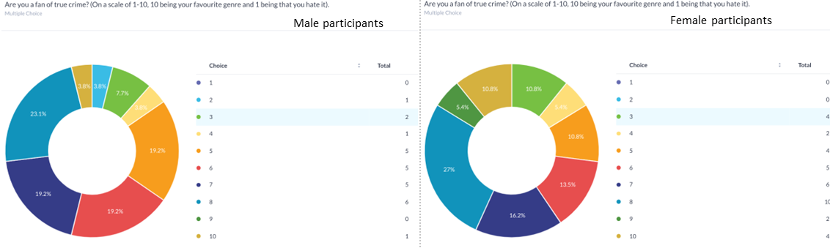
Question 4 was asking whether the participants are a fan of the TC genre. It was posed as a multiple-choice question on a scale of 1 to 10, 1 being that they hate this genre and 10 being that it is their favourite. When analysing the data, it was shown that an overall 34.5% of males answered a 5 or below, as opposed to only 27% of females. This shows TC is more favourable to females.
This further backs up points made by The University of Derby (2020) as it shows both genders enjoy and engage within this genre, however, it shows that females favour this genre more than males. It is important to note from the primary research that the data did not show a big gap in the percentage - therefore, if more males were to take part in this questionnaire, the data may change. Even so, this could indicate that men were less likely to want to partake as the topic of TC genre was not of interest to them.
Q5
Question 5 was to gauge how often the participants view this genre per month. It has been shown through the questionnaire 80.8% of males and 83.7% of females watched TC less than 6 hours. This difference is small but shows that even with females favouring the TC genre more, they seem to watch it less. This proves the statements made by The University of Derby (2020) as it was shown both male and females like to engage in the viewing of TC.

Q6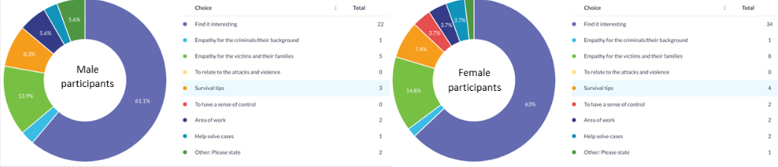
Question 6 posed the question ‘Why do you watch, listen or read to TC?’. There were multiple choices to choose from which can be found in Appendix 2.
The main answer overall was that the main reason for watching, listening and reading this genre is that they find it interesting. In terms of gender specific feedback, 3.7% of females were the only participants who selected the ‘To have a sense of control’ option. This could link in with the research which found that the consumption of TC can ease a women's anxieties (Conroy, 2019), explore their own vulnerabilities, and have control (Monroe, 2019).
According to Antantyr et al (2011) and University of Derby (2020), women may enjoy this genre to a greater extent due to being more empathetic and to get survival tips in case they are ever presented with a similar situation. However, the findings from the questionnaire suggest little differences in terms of empathy. This is shown as 23% of males and 24.3% of women had picked an option of empathy. This could show the gap within literature regarding men's opinions on TC is the same as women.
Q7
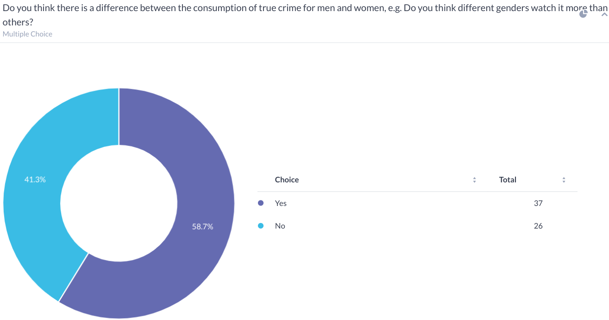
Question 7 asked the participants whether they thought the consumption of TC was different between males and female and if they thought a specific gender are more inclined to watch. The split was even with 58.7% of all participants answering ‘yes’ and 41.3% no.
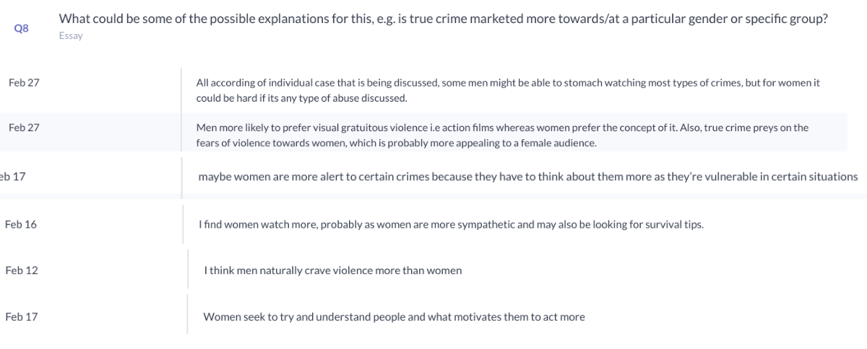Question 8 was to show the participants’ reasoning behind their answer to the question 7. The majority thought that the TC genre is targeted more towards women than men. The reasons given focused on the empathy of women, trying to understand why perpetrators do what they do and for awareness for themselves and for an escape and excitement. It also states how TC may impact women more than men due to their perceived vulnerabilities. However, there were also a few points towards the glamourising of TC and how women may watch it due to the casting of attractive actors. These answers resonate with the findings from Singer et al (2006) due to the thought of women being more empathetic and wanting to understand why people commit these crimes. It is also similar to the thought of women being seen as more vulnerable.
Participants who thought it was aimed at males, said it was down to the biological factors - that men are more aggressive and crave that more than women - and this may be down to men watching it more. Similarly, a further answer showed they thought men may be able to “stomach it more” than females. Those who answered no to question 7, either did not have an explanation or they thought it was directed to both genders.

4.5 Questionnaire Feedback: Explore the portrayal of gender roles in TC and how they correlate to real-world victimisation
The questions 12 and 13 are to help bring a conclusion to the second objective, which looks at gender portrayal within TC and real-world victimisation.
Q12
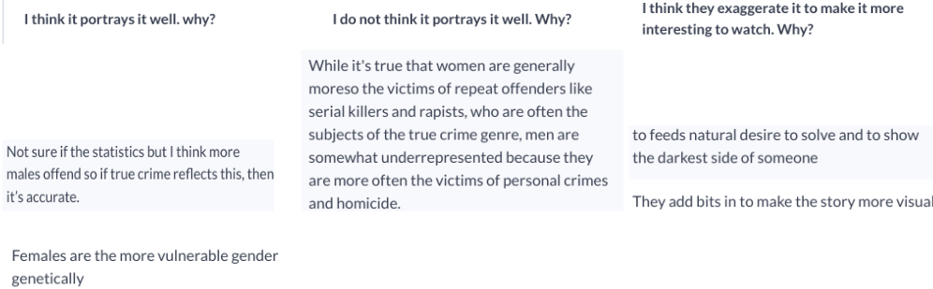Question 12 asked if the TC genre provides a true reflection and accurate gender portrayal as it happens in real life. There were three choices which were: I think it portrays it well; I do not; and I think it‘s exaggerated. Out of all participants, 20 answered that it portrays it well, 11 answered it did not and 38 submitted an answer explaining why they thought it was exaggerated. Some participants did answer two questions rather than just one, which shows the difference in the total number of answers from the total number of participants.
A common theme shown is how TC genre focuses on females as the victims. This could be due to the media’s focus on this making false perceptions (Murley, 2008), even though this is not the case as previously stated. Some participants who answered that they do not think this have stated as shown above.
Q13
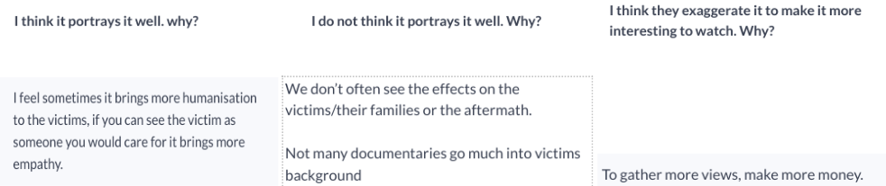Question 13 asked ‘Do you think the ‘TC genre’ portrays real world victimisation accurately as it happens in real life and why?’ Overall, there were 15 people who thought the gender was portrayed well, 20 thought it was not and the majority, 29, thought it to be exaggerated in order to promote interest to viewers.
When looking at the answers, one participant explained how real-world victimisation is portrayed well, and this is beneficial as shown above. However, this contradicts the secondary research found as Vera-Grey (2021) stated how the media fuels the idea that women are vulnerable and how women are dehumanised. From the participants who thought it does not portray it well, it demonstrated that this may be due to the fact the victims are not usually a main focus. This has also been stated within the literature review where Horeck (2019) stated this may be the case. Lastly, the majority vote had a common theme. This was to expand the viewers and make it more engaging for them. This could be shown as stated previously regarding the Depp v Heard trial and the movie made quickly after, not thinking about the consequences it may have (Heritage, 2022).
Some participants have talked about how this genre is based on ‘facts’ whereas some have explained it is dramatized. This could be a point to consider due to some participants thinking about different shows they may have watched, which could have influenced their answer.

4.6 Questionnaire Feedback: Investigate the media's role in glamorising TC
The questions 9, 10, 11, 14, 15, 16 and 17 relate to objective three which investigates the glamourising of TC.
Q9 & Q10
Question 9 asks if the focus on offenders generates empathy for these offenders. Only 14.3% answered Yes, 23.8% No and 61.9% answered Sometimes. To follow on from this, question 10 asked for their opinions on why they thought this. A common theme within this question was those who answered ’Yes’ explained how empathy is something everyone has, and if presented with the explanations of a tragedy, such as a criminal's background, it is bound to have a sympathetic reaction. Coplan et al (2011) also states how all genders have the ability to show empathy, the participants note how this does not mean that they ‘condone’ this behaviour.
Those who answered, ‘Sometimes’ also had similar views to those who answered ‘Yes.’ As shown below, the participants had a common theme of talking about the child version of the offender and how the focus on this and their ‘internal monologue’ generates the empathy in certain cases. This is something that was not mentioned within the literature review.
Q11
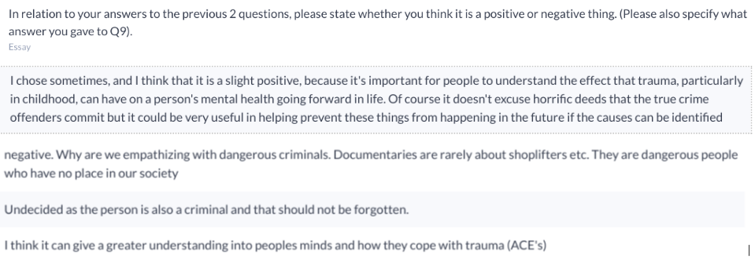Question 11 asks whether the participants thought empathy for offenders a negative or positive thing. The split seems even, with most of the people who answered negative stating that those criminals who commit serious offences should not be gaining sympathy. Williams (2021) shows how in some TC TV shows, it shows the horrendous crimes for what they are, which does not gain sympathy for those who are committing them.
Those who thought it to be a positive thing showed compassion for the child version of the criminal and says it can give an understanding into the minds of the offender and their overlooked trauma. Wolff et al (2012) show that trauma in someone's childhood could impact their criminal behaviour later in life.
Q14
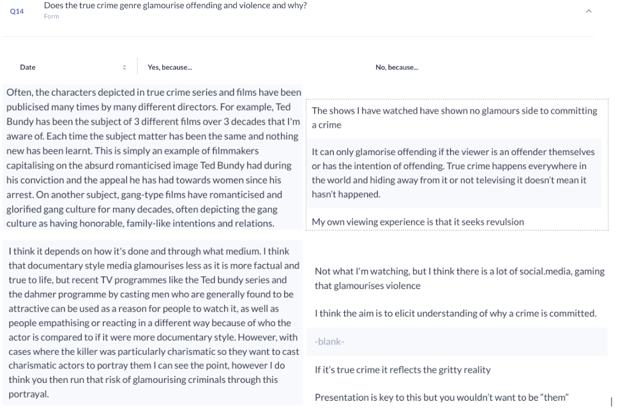
Question 14 asks whether TC glamourises offending and violence. 18 men and 23 women answered ‘Yes’, and 9 men and 16 women answered No. This backs up the literature previously talked about because most of the participants thinks TC is glamourised. Those who answered Yes explains how those casted are conventionally attractive and how this could be a factor to those who glamourise this. This is also shown by Dubey (2022) who explains how it glamorises offenders by casting attractive actors which draws females to watch.
Those who answered ‘No’ thought this as it shows the awful crimes and details of what happened. Even though this is the case, it has also been talked about within the answers that this could have the opposite effect of those who see a different side. This has been shown previously by Kenady (2022) who stated this infatuation with these offenders can lead to some people wanting to reach out and - the case of Doreen Lioy - getting married to serial killer Richard Ramirez. It was also mentioned how apart from the TC genre social media and gaming are also responsible for the glamourisation. As talked about previously, the cultivation theory says how people’s realities are being shaped by what they decide to watch and can be incorporated into their life (Vicary et al, 2017).
Q15
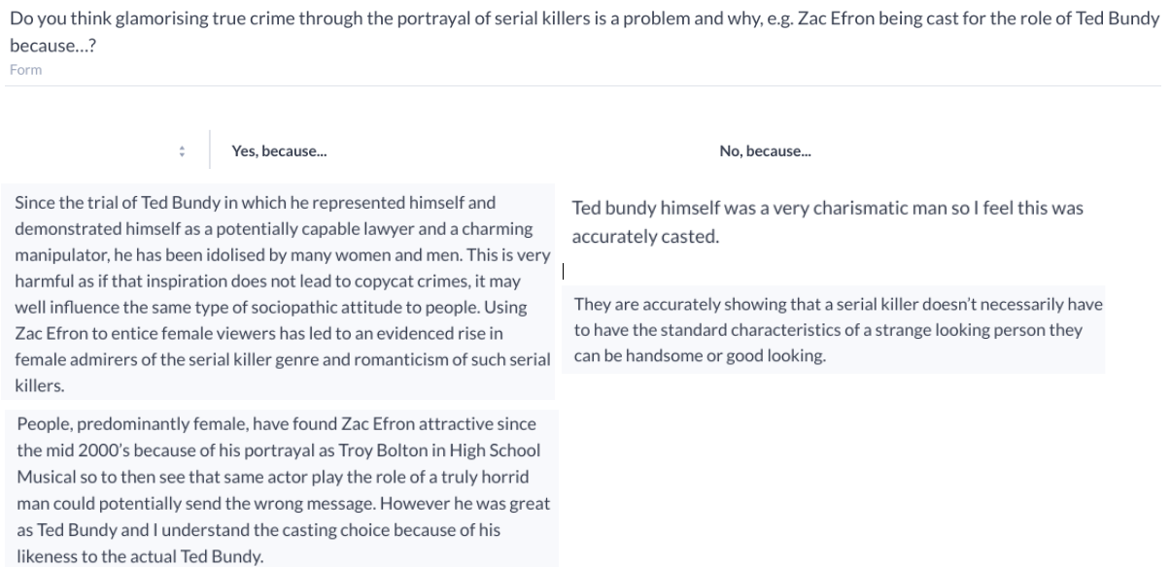
Question 15 asks participants if they think glamorising true crime through the portrayal of serial killers is a problem and why. The majority, 36 people, answered yes and the remaining thought it was not a problem. The reasoning given as to why it is a problem correlated to a lot of information found within the secondary literature. Those who said yes correlates with the research by Dubey (2022) who talked about the well-liked actors playing serial killers. Participants also said how people may become ‘obsessed’ and as above, influence people negatively and even attempt to ‘copycat’ their crimes. This was also shown by Smith (2022) earlier who said viewers may aspire to be like the criminals shown. However, those who answered ‘No’, argued the fact in the instance of Zac Efron being casted for Ted Bundy, it was casted well, which was also shown through McMahon (2019). Another argument made was that this genre helps to show what really happened which does not glamourise true crime. However, as shown by Broll (2018), these shows do leave out some horrific details.
Q16
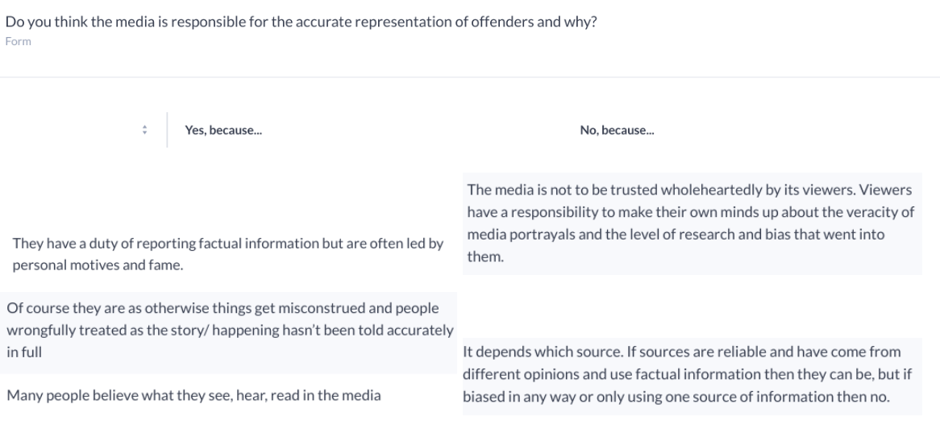
Question 16 asks ‘Do you think the media is responsible for the accurate representation of offenders and why?’. 35 people had a reasoning for why they thought the media was responsible and 29 thought not. Some common themes were that the media have a duty of care, and it would be wrongful and hurtful to victims if they did not get it right. On the other hand, some participants disagreed due to the belief that it is the public’s responsibility to understand and make their own minds up as to whether to believe the media and have an understanding there are reliable sources and unreliable sources. This was touched upon within the literature review where Vera-Grey (2021) states how the media fuelling stories portraying women as vulnerable made women angry as this may not be the case.
Q17
The last question asked if they thought the media was responsible for the accurate representation of victims. 31 participants answered ’Yes’ and 33 answered ’No’. Most answers were similar to question 16. However, what differs here is on both answers the participants state the fact that the media are responsible in some ways regarding the impact it has on victims and their families. This was also shown within the literature review where it expressed how media coverage can have a significant impact on victims and their families and how they may not even get a say in what gets portrayed (Horeck, 2019). This could be a huge set back and backs up the points made by participants who say the media has a duty of care.

4.7 Conclusion
To conclude, chapter four has analysed the public’s opinions and differences surrounding the topic of true crime and has enabled the carrying out of research regarding the three research objectives as follows.
- Compare differences in opinions between men and women in relation to TC
- Explore the portrayal of gender roles in TC and how they correlate to real-world victimisation
- Investigate the media's role in glamorising TC

Chapter 5: Conclusion

5.1 Introduction
The overall aim of this research was to investigate a comparative analysis of men and women's perceptions of TC. The specific research objectives were:
- Compare differences in opinions between men and women in relation to TC;
- Explore the portrayal of gender roles in TC and how they correlate to real-world victimisation;
- Investigate the media's role in glamorising TC.
This chapter will look at the summary of findings and the concluding thought of each of the three research objectives. After this, any limitations that arose will be discussed and any recommendations and lessons learned throughout.

5.2 Research Objectives: Summary of findings and conclusions

5.2.1 Research Objective One: Compare differences in opinions between men and women in relation to TC
Throughout the literature review and primary research, it has been shown that both genders show an interest in the TC genre, and it can be a good way to overcome fears (Johnson, 2020). However, the University of Derby (2020) states that women engage in this genre more than men through their study of the Amazon TC books and TV shows, where women make up 70% of the demographics. Similarly, Kersley (2021) shares the same thoughts through her primary research. Nonetheless, there was a gap within the literature regarding men's opinions. Throughout this primary research, the gap in males' opinion was addressed and often men and women shared similar views in relation to TC.
The reasoning behind the perceived perception that women are more in favour of this genre is: that they are more empathetic (Angantyr et al, 2011); that TC helps women to explore the topic of vulnerability (Monroe, 2019); and to process violence against women and understand their own anxieties (Conroy, 2019). Lira (2020) agrees with these statements as she has found that this is the case personally. She finds comfort in the TC fandom, where women can express their feelings and compare stories and how they feel the need to check their car when they get in and lock their doors. However, Coplan et al (2011) contradicts these statements by saying empathy is a life trait that most people have, regardless of gender but social constructs state otherwise.
When comparing this to the questionnaire feedback, it showed little difference in empathy between both genders. There was a comparatively small gap in those who answered that they watch TC for empathetic reasons, and a relatively even split in the consumption of true crime.
In conclusion, the questionnaire feedback was able to fill the gap within the literature and shows that the split in genders engaging with TC is not that different, along with contradicting the initial hypothesis that women are more empathetic than men. It has also shown that even with the first thought that women may like TC more than men, this is not the case and is not distinguished by gender, but more down to the personal opinions of an individual.

5.2.2 Research Objective Two: Explore the portrayal of gender roles in TC and how they correlate to real-world victimisation
Objective 2 was met through literature review and primary research and investigates the portrayal of gender roles and real-world victimisation and the negative effects around this. Horeck (2019) explains how the TC genre can exploit people who have been affected by crime as they have no say in the media coverage. Heritage (2022) explains the Depp v Heard trial is an example of this, using personal suffering for entertainment purposes. The questionnaire feedback results also show that most people thought that the TC genre was exaggerated or made to be entertaining to people while exploiting victims and their families.
The media is fuelling stories about women being vulnerable, through pornography and violence against women (Vera-Grey, 2021) which could explain why women are more fearful of being a victim. As women are more likely to be shown as victims through this genre. ONS (ONS) (2021) show that men are more likely to become a victim of a violent attack. Subsequently, women are more likely to become a victim of a sexual assault (Callanan, 2015). The public’s opinions through the questionnaire feedback also explained how that the gender roles and how the media portrays this, is not reflected well with real life as not all victims are female, and not all offenders are male. The main concluding thought is that the TC genre does not portray gender roles and world victimisation accurately.

5.2.3 Research Objective Three: Investigate the media's role in glamorising TC
Having looked at the glamourisation of true crime, it was shown that there could be a morbid curiosity for some fans of TC to personally connect with these criminals (Smith, 2022). This could also be shown through Kenady (2022). It was shown the glamourisation of the genre could be to blame for this with the casting of actors such as Zac Efron as Ted Bundy (Broll, 2018) and Evan Peters as Jefferey Dahmer, this could appeal to women more (Dubey, 2022). The media can glamourise offending and TC to the extent that people can become besotted with offenders. However, it also showed the opinion that some were casted well. Both the literature review, shown by McMahon (2019) and primary data show that, on occasion, actors selected accurately represented the offenders in question.
Despite accurate casting, public opinion was that these shows should not be creating empathy, and this could be a factor in women wanted to watch (Loffler, 2021). This was also shown throughout the questionnaire feedback as the public's opinions were that these shows should not be creating empathy as these offenders do not deserve this.
In conclusion, it seems TC does glamourise offenders and violent behaviour, whether this is against women or not. It can have a detrimental effect on victims, their families and influence how the public’s opinion is shaped towards these criminals. However, it seems this is done for the entertainment of others, regardless of the backlash, and can show the morbid side of why some people are interested in the TC genre.

5.3 Limitations and Recommendations
Numerous limitations that could be identified from this research will now be discussed. Restricted word count did not allow for full exploration of the points discussed within the literature review. With this, other points that were shown through questionnaire feedback could have been made. This could have widened the literature and given further understanding of the main aim and objectives. Secondly, although the split of male and female was fairly even, if the split were 50/50 it could have given a better understanding into the differences and given a bigger focus on male's perception of TC.
One issue that was found when carrying out the research was that after the data had been collected, it was shown as ‘all participants,’ rather than separate male and female answers. After some research into this, a way around it was to use a filter option to separate the genders.
Moving forward, it is evident from this research, a recommendation that expanding male opinions and perceptions of TC would be beneficial and help to further and excel this research.

References
- Angantyr, M., Eklund, J. and Hansen, E.M., (2011) A comparison of empathy for humans and empathy for animals. Anthrozoös. Available at: https://doi.org/10.2752/175303711X13159027359764 (Accessed: 10 November 2022)
- Arif, H. Gupta, V. Soreff, S & Wadhwa, R (2022), Aggression. Available at: https://www.ncbi.nlm.nih.gov/books/NBK448073/#:~:text=Biological%2C%20psychological%2C%20and%20socioeconomic%20influences,substances%20of%20abuse%2C%20and%20medications. (Accessed: 20 November 2022)
- Browder, L (2006). Dystopian Romance: TC and the Female Reader. Journal of Popular Culture 39(6), 928–953. https://doi.org/10.1111/j.1540-5931.2006.00328.x
- Burdine, J. Thorne, S. Sandhu, G (2020), Interpretive description: A flexible qualitative methodology for medical education research Available at: https://doi.org/10.1111/medu.14380 (Accessed: 8 February 2023)
- Clarke, V (2022) Thematic analysis: a practical guide London: Sage Publications
- Cooper, K (2019), Is our growing obsession with TC a problem? Available at: https://www.bbc.co.uk/news/world-us-canada-47474996 (Accessed: 10 October 2022)
- Coplan, A & Goldie, P (2011), Empathy: Philosophical and Psychological Perspectives. Newyork: Oxford University Press
- Daellenbach, U & Woiceshyn, J (2018), Evaluating inductive vs deductive research in management studies: Implications for authors, editors, and reviewers, available at: https://www.emerald.com/insight/content/doi/10.1108/QROM-06-2017-1538/full/html (Accessed: 5 February 2023)
- Demopoulos, A (2020), Why True-Crime TV Has Become So Popular During the Coronavirus Pandemic, available at: https://www.thedailybeast.com/as-coronavirus-rages-true-crime-tv-shows-provide-a-strange-and-popular-comfort (Accessed: 5 October 2022)
- Dr. Miller, J K (2021), Miller: TC enthusiasm… dark obsession or hobby? Available at: https://eu.columbiatribune.com/story/opinion/columns/2021/06/04/true-crime-enthusiasm-dark-obsession-hobby-miller-column/7513828002/ (Accessed: 30 November 2022)
- Dubey S (2022), Netflix's 'Dahmer' backlash highlights ethical issues in the platform's obsession with TC. Available at: https://mashable.com/article/jeffrey-dahmer-netflix-true-crime-ethics (Accessed: 24 November 2022)
- E McColl 1, A Jacoby, L Thomas, J Soutter, C Bamford, N Steen, R Thomas, E Harvey, A Garratt, J Bond (2001), Design and use of questionnaires: a review of best practice applicable to surveys of health service staff and patients, Available at: https://pubmed.ncbi.nlm.nih.gov/11809125/ DOI: 10.3310/hta5310 (Accessed: 6 February 2023)
- Flick, U (2014). The sage handbook of qualitative data analysis London: SAGE.
- Flynn, S (2022), TC is America’s guilty pleasure. Victims, families, and even killers have some words of warning. Available at: https://www.independent.co.uk/news/world/americas/true-crime-serial-killer-podcast-documentary-b2138182.html (Accessed: 01 December 2022)
- Geddes, A. Scott, S. Parker, C (2019), Snowball Sampling, available at: https://eprints.glos.ac.uk/6781/ (Accessed: 8 February 2023)
- Gibbs G (1988). Learning by Doing: A guide to teaching and learning methods. Oxford: Oxford Polytechnic.
- Gill, R & Orgad S (2019), Safety valves for mediated female rage in the #MeToo era. Available at: https://doi.org/10.1080/14680777.2019.1609198 (Accessed: 28 April 2023)
- Gordon, (2021), Research Reveals Why Women Love TC, Available at: https://www.magellantv.com/articles/research-reveals-why-women-love-true-crime (Accessed: 5 October 2022)
- Grose, J (2013). Why are women so obsessed with true--crime stories? Available at: https://www.proquest.com/docview/1321578881?OpenUrlRefId=info:xri/sid:primo&accountid=130472 (Accessed: 19 November 2022)
- Heritage, S (2022) Finally, the Depp v Heard trial movie that no one wanted is here. Available at: https://www.theguardian.com/film/2022/sep/30/depp-heard-trial-movie-hot-take (Accessed: 15 November 2022).
- Huesmann, L (2009), The Impact of Electronic Media Violence: Scientific Theory and Research. Available at: https://www.ncbi.nlm.nih.gov/pmc/articles/PMC2704015/ (Accessed: 19 November 2022)
- Isenburg, S (2021), Women who love men that kill. USA: Simon & Schuster
- Johnson, N (2020) How horror movies can help people overcome real-world trauma’, National Geographic. Available at: https://www.nationalgeographic.com/science/article/how-horror-movies-can-help-overcome-trauma-and-relieve-stress (Accessed: 15 November 2022).
- Kennady, S (2022), Extremely Insensitive, Shockingly Misleading and Dangerous: Exploring the Implications of Romanticizing Serial Killers in Film. Available at: https://digital.library.txstate.edu/handle/10877/15969 (Accessed: 24 November 2022)
- Kiger, M. Varpio, L (2020), Thematic analysis of qualitative data: AMEE Guide No. 131 Available at: https://www.tandfonline.com/doi/abs/10.1080/0142159X.2020.1755030 (Accessed: 8 February 2023)
- Lamont, C (2021), Research methods in international relations 2nd Edn London: Sage Publications Ltd
- Lira (2020), My Mental Health Got Better After I Gave Up TC. Available at: https://greatist.com/health/is-true-crime-unhealthy (Accessed: 10 November 2022)
- Löffler, C & Greitemeyer, T (2021) Are women the more empathetic gender? The effects of gender role expectations. Available at: https://link.springer.com/article/10.1007/s12144-020-01260-8 (Accessed: 30 November 2022)
- Loukaitou-Sideris, A. (2014). Fear and safety in transit environments from the women. Available at: https://link.springer.com/article/10.1057/sj.2014.9 (Accessed: 15 November 2022)
- McMahon, A (2019), People finding serial killer Ted Bundy attractive is nothing new. He had fans even on death row. Available at: https://www.abc.net.au/news/2019-02-01/ted-bundy-why-the-serial-killer-attracted-female-fans/10763676 (Accessed: 24 November 2022)
- Michallon, C (2022), Serial: How one podcast changed the face of TC and cast doubt on Adnan Syed’s murder conviction. Available at: https://www.independent.co.uk/news/world/americas/serial-podcast-adnan-syed-sarah-koenig-b2200372.html (Accessed: 5 October 2022)
- Monroe, R., (2019) Savage Appetites: True Stories of Women, Crime, and Obsession. Scribner book company: England
- Morgan, M., Shanahan, J., & Signorielli, N. (2015). Yesterday's new cultivation, tomorrow. Available at: https://doi.org/10.1080/15205436.2015.1072725 (Accessed: 10 November 2022)
- Murley, J (2008), The rise of TC: 20th-Century Murder and American Popular Culture. London: Westport
- Nayak, M. & Narayan, K.A. (2019). Strengths and weaknesses of online surveys. Available at: https://www.researchgate.net/profile/Mudavath-Nayak/publication/333207786_Strengths_and_Weakness_of_Online_Surveys/links/61176e5a0c2bfa282a42253b/Strengths-and-Weakness-of-Online-Surveys.pdf (Accessed: 8 February 2023)
- O'Cathain, A & Thomas, K (2004), "Any other comments?" Open questions on questionnaires - a bane or a bonus to research? England: BioMed Central Ltd
- Office for National Statistics (2021), The nature of violent crimes in England and Wales: Year ending March 2020. Available at: https://www.ons.gov.uk/peoplepopulationandcommunity/crimeandjustice/articles/thenatureofviolentcrimeinenglandandwales/yearendingmarch2020#:~:text=The%20CSEW%20estimated%20that%2060,than%20male%20victims%20(44%25). (Accessed: 15 November 2022)
- Patten, M (2016) Questionnaire research: A practical guide. New York: Routledge
- Resnik, D (2020), Researchers’ Perceptions of Ethical Authorship Distribution in Collaborative Research Teams Available at: https://link.springer.com/article/10.1007/s11948-019-00113-3 (Accessed: 23 January 2023)
- Rivers, J (2021), Cross-Sectional Study: Definition, Advantages, Disadvantages & Example Available at: https://study.com/academy/lesson/cross-sectional-study-definition-advantages-disadvantages-example.html (Accessed: 27 January 2023)
- Roberts, S (2019), TC and the Trash Balance, available at: https://longreads.com/2019/01/18/true-crime-and-the-trash-balance/ (Accessed: 15 October 2022)
- Rutledge, P (2021), Psychologist Explains Our Lockdown Obsession with TC TV. Available at: https://www.psychreg.org/explain-lockdown-obsession-true-crime-tv/ (Accessed: 24 November 2022)
- Ryan Broll (2020) Dark Fandoms: An Introduction and Case Study, Deviant Behaviour, Available at: https://doi.org/10.1080/01639625.2019.1596453 (Accessed: 24 November 2022)
- Schulenberg, K (2021), “You're in a Cult, Call Your Dad”: An Investigation into the TC Podcast My Favorite Murder and Its Online Fan Communities. Available at: https://www.proquest.com/openview/93d81f14cdf1c989a45670d3132dc9d3/1?pq-origsite=gscholar&cbl=18750&diss=y (Accessed: 01 December 2022)
- Seltzer, M (2008), TC: Observations on Violence and Modernity. Routledge: New York
- Setia, M (2016) Methodology series module 3: Cross-sectional studies. Indian journal of dermatology Available at: https://www.ncbi.nlm.nih.gov/pmc/articles/PMC4885177/ (Accessed: 26 January 2023)
- Slutsky, D (2014), The Effective Use of Graphs, Available at: https://www.thieme-connect.de/products/ejournals/abstract/10.1055/s-0034-1375704 (Accessed: 12 January 2023)
- Smith, K (2022), Theorizing a Continuum of Serial Killer Fandom and Fascination in our Society, Kentucky: Eastern Kentucky University
- Smith, K (2022) Theorizing a Continuum of Serial Killer Fandom and Fascination in our society. Available at: https://encompass.eku.edu/cgi/viewcontent.cgi?article=1917&context=honors_theses (Accessed: 10 November 2022)
- Surette, R (2017), Copycat Crime. Available at: https://doi.org/10.1093/acrefore/9780190264079.013.33 (Accessed: 30 November 2022)
- Tamminen, K. Poucher, Z (2020), Research Philosophies, The Routledge International Encyclopedia of Sport and Exercise Psychology 1st Edn London: Routledge
- Thomas, L (2022) Cross-Sectional Study | Definitions, Uses & Examples, Available at: https://www.scribbr.co.uk/research-methods/cross-sectional-design/#:~:text=A%20cross%2Dsectional%20study%20is,observe%20variables%20without%20influencing%20them. (Accessed: 26 January 2023)
- Thorne, S (2020), Applied Interpretive approaches. Available at: https://doi.org/10.1093/oxfordhb/9780190847388.013.14 (Accessed: 8 February 2023)
- University of Derby (2020), Why are we so obsessed with TC? Available at: https://www.derby.ac.uk/magazine/issue-11/why-are-we-so-obsessed-with-true-crime/#:~:text=%E2%80%9CAs%20humans%2C%20we%20are%20always,in%20a%20relatively%20safe%20environment.%E2%80%9D (Accessed: 10 November 2020)
- University of Wales Trinity St Davids (2022), Research Ethics & Integrity: Code of practice. Available at: https://www.uwtsd.ac.uk/media/uwtsd-website/content-assets/documents/research/REICoP-July-2022.pdf (Accessed: 8 February 2023)
- Vera-Gray, F (2021), From porn to TC stories, we must end the portrayal of violence against women. Available at: https://www.theguardian.com/commentisfree/2021/mar/16/porn-true-crime-violence-against-women (Accessed: 18 November 2022)
- Vicary, A.M., and Fraley, R.C., (2010) Captured by TC: Why are women drawn to tales of rape, murder, and serial killers? Available at: https://doi.org/10.1177/1948550609355486 (Accessed: 5 October 2022)
- Vicary, A & Zaikman, Y (2017), The CSI effect: An investigation into the relationship between watching crime shows and forensic knowledge Available at: https://www.researchgate.net/profile/Yuliana-Zaikman/publication/313744303_The_CSI_Effect_An_Investigation_into_the_Relationship_between_Watching_Crime_Shows_and_Forensic_Knowledge/links/58a477864585150402bfbbc8/The-CSI-Effect-An-Investigation-into-the-Relationship-between-Watching-Crime-Shows-and-Forensic-Knowledge.pdf (Accessed: 18 November 2022).
- Victim Support (2023), Need help after a crime? Available at: https://www.victimsupport.org.uk/ (Accessed: 8 February 2023)
- Warr, M (1984), Fear of Victimization: Why Are Women and the Elderly More Afraid? Available at: https://www.proquest.com/openview/2a187a230664693fe2db8505670d05c2/1?pq-origsite=gscholar&cbl=1816420 (Accessed: 18 November 2022)
- Williams, M (2016), Interpretivism and Generalisation Vol 34 available at: https://doi-org.ezproxy.uwtsd.ac.uk/10.1177/S0038038500000 (Accessed: 8 February 2023)
- Williams, Z (2021) From Line of Duty to The Fall: why can't TV shows stop killing women? Available at: https://www.theguardian.com/tv-and-radio/2021/mar/18/from-line-of-duty-to-the-fall-why-cant-tv-shows-stop-killing-women (Accessed: 24 November 2022)
- Wolff, N & Shi, J (2012), Childhood and Adult Trauma Experiences of Incarcerated Persons and Their Relationship to Adult Behavioural Health Problems and Treatment. Available at: doi:10.3390/ijerph9051908 (Accessed: 14 March 2023)

Appendices

Appendix One
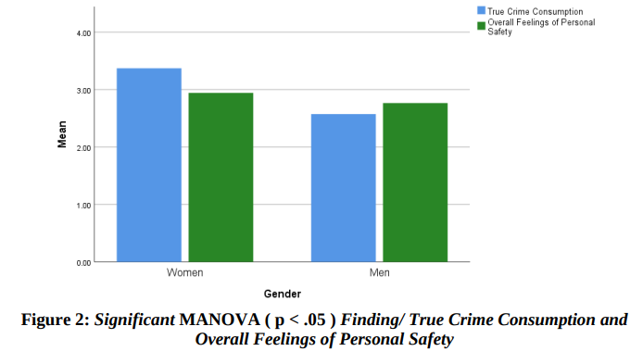

Appendix Two – Female questionnaire answers
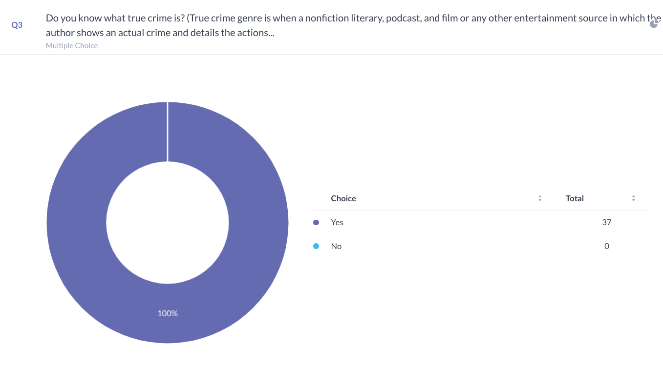
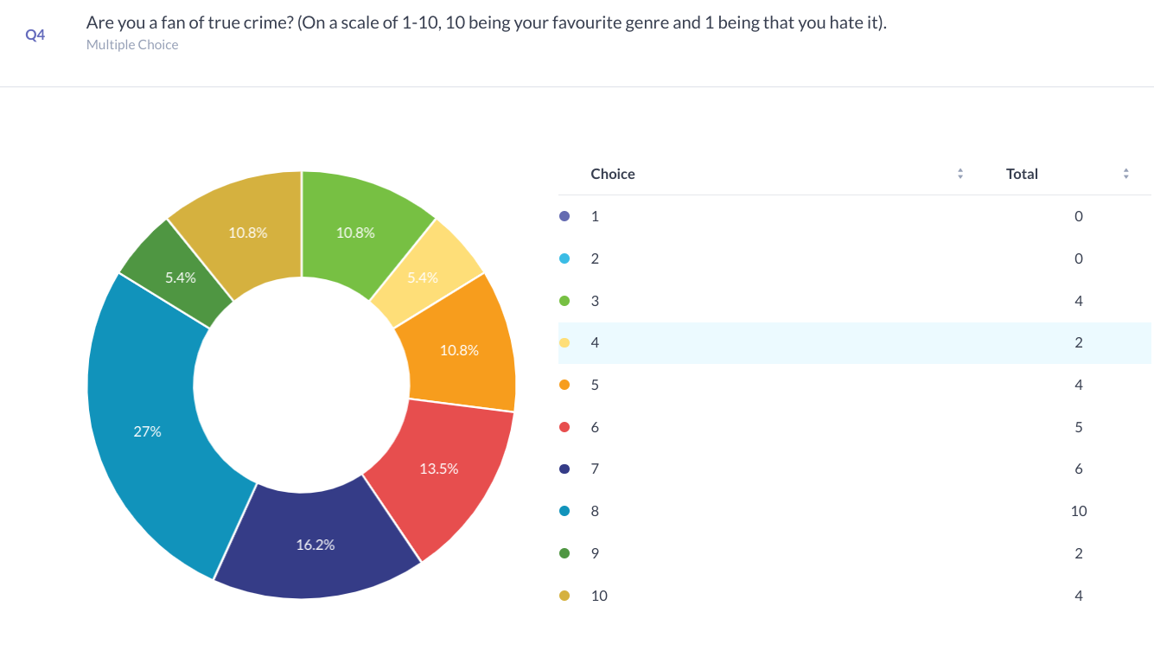

Appendix Three – Male questionnaire answers


