Skills for Self EMPOYMENT

Pathway Project_2

Table of Contents
Introduction 3
Description of the event 4
Application of my personal set of skills 7
Evaluation and analysis 7
Learning 8
Conclusion 10
References 11

Introduction
Self-managed learning and lifelong learning are two important concepts in today’s fast changing world (Michaelsen et al., 2014). The pathway project two helped me to introduce with self-managed and lifelong learning. I was required to create business plan on Travel Plus for the successful completion of this module. In order to do this, I have applied a set of skills and competencies. The project helped to improve my employability skills as I have learnt numerous aspects of creating a business plan.
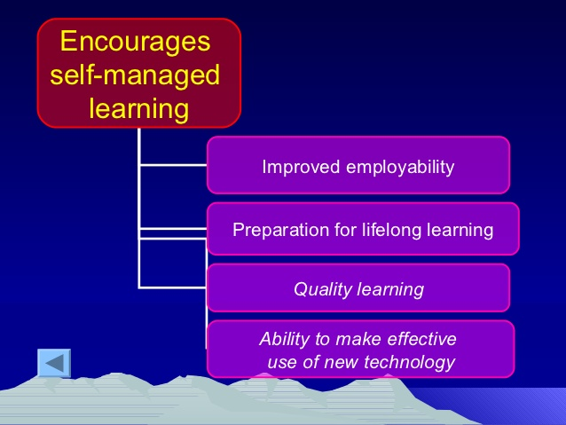
Figure 1 Self-managed learning (Source: Onose et al., 2016)
Therefore, the reflective paper will describe the learning event initially. It will turn next to introduce the application of my personal set of skills. Then, it will evaluate and analyze my contribution to create a business plan. It will end with reflecting upon my learning from the project.

Description of the event
It was mandatory to prepare a business plan for me. This was the core part of the pathway project two. Ultimately, I had no chance to ignore this. Therefore, I attempted to known about the requirements of creating a business plan. According to the guidelines of the assignment based on pathway project two, I was required to be enlisted myself in a group. Therefore, I tried to know the benefits of working in a group. This is the reflection of personality. From my childhood, I am used to get the answer of the question why and how I will learn a particular topic. I searched on the internet to know the actual benefits of group working. I found that group working skill is prerequisite to get a good job (Brandler & Roman, 2015).

Figure 2 Business plan on Travel Plus (Source: Author, 2017)
Therefore, I approached to coming a close connection with some of my classmates. Then, I formed a group. In this case, I adopted a method namely Belbin Team model. The model is widely used by professionals to conduct group activities (Mathieu et al., 2015). The model basically helps professionals to delegate the group activities in relation the ability and competency of group members. It was on 16th November 2017 when I enlisted in a group. The holistic purpose of creating the group is to complete all required activities for creating a business plan on Travel Plus.
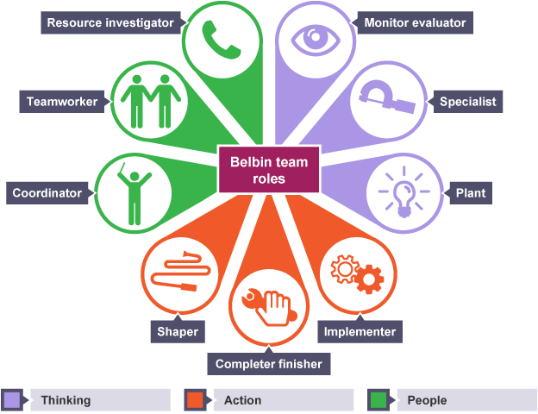
Figure 3 Belbin Team role (Source: Mathieu et, 2015)
However, I shared my opinion to my group members. I told them to us an appropriate methodology to complete the project. As I had previous knowledge to work on a project. Besides, I had theoretical knowledge on project management (Eubanks et al., 2016).
The project management theory tells that a project comprises of five important phases including initiation, planning, execution or implementation, controlling or monitoring, and closing out the project (Synder, 2014). Therefore, I suggested my group members to follow the phases of project management. My co-members accepted my proposal. Even they agreed to meet our tutor to discuss about the business plan. After discussing with our tutor, we decided to create a business plan on travel agency.
As per to the project management phases, we started to complete the initiation phase of the project. In order to complete the initiation part of the project, we were required to determine the objectives, aim, purpose and legal status of the project. Although we completed all activities for creating business plan based on collaborative work. We distributed separate project activities to our individual group members. For example, I was responsible for creating the marketing strategy for our business. We decided to set up our project activities in relation to the five phases of project management (Leach, 2014).
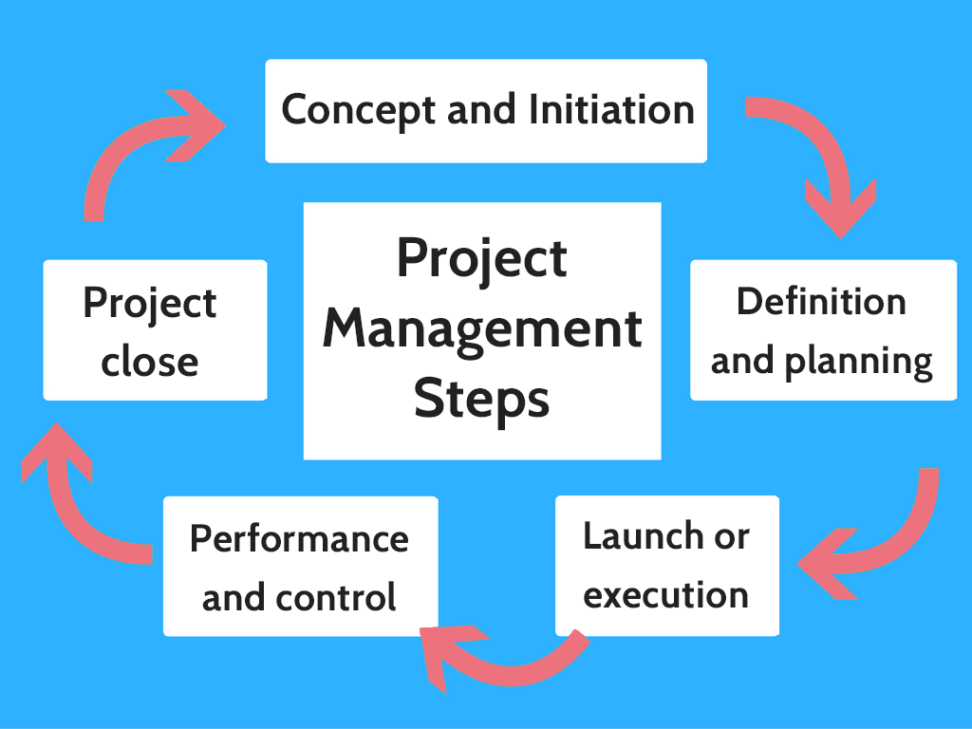
Figure 4 Project management phases (Source: Gido et al., 2014)
We created Gantt chart and project schedule which were the part of planning phase. At execution stage, we started to complete the assigned project activities. After completing individual project activities, we integrated every single part of our business plan (Gido et al., 2014). We put down all relevant information in PowerPoint Slide. We merged the slides of every group members. Then we prepared our whole presentation to present before the tutor and the class. While presenting our business plan, our teacher told that we unfortunately did wrong business plan. We fixed it as per to the tutor’s requirement. Finally we completed the project activities.

Application of my personal set of skills
I was mainly responsible for developing the product, price, place and promotion strategy for our business ‘Travel Plus’. In order to perform my assigned activities, I have applied my own set of skills and competencies. In order to collect information, I applied my research skills. This mean that I collected and analyzed secondary information as per to the requirement of our project task which was creating marketing strategy. I collected information from journal of marketing, academic books, and author’s publication. After collecting and analyzing information, I noted down the findings of my secondary research (Litschfield et al., 2016). This reflects my writing skills. But I found difficulties while communicating with my group members. It is needed to mention that my group working skill was not well-established.
I found hesitate to communicate with my group members. This also reflects upon my poor interpersonal communication skills. However, I communicated with every group members while finishing my project activities. My co-members were very supportive guys. They assisted me to trace our problems incurred in creating the marketing strategy (Arnolds & Boggs, 2015). Then I rectified the problems to finalize my presentation slide. Before delivering the presentation, I practiced more and more. This mean that I sorted out important points for delivering presentation. Then I memorized the important points and information. Ultimately, my presentation was good.

Evaluation and analysis
From the initiation to close out the project “Business Plan on Travel Plus”, I have applied different set of skills. I applied my research skills to collect and analyze required information. Dubrin (2015) stated that research skill is a set of competencies and skills applied by researcher to collect information (e.g. secondary or primary), analyze information (data analysis method), and resolve the problem. In this case, I can conclude that my research skill is not either good or bad. This indicate that I have a scope to develop my research skills.
I have applied my group working skill to work in a group. In this context, my contribution was good. I assisted my group members beyond my assigned roles and activates. According to social exchange theory, people contribute in a group to get some benefits. Therefore, I contributed to the group activities so that we would create an excellent business plan. I helped my co-members to perform each and every activities of group properly. For example, I contributed to create the aim, objective, purpose and legal status of the business. I assisted to create financial strategy. But I was mainly responsible for creating marketing strategy. But I noticed that I have some scope to enhance my group working skills.
Block (2016) argued that group working skill is a set of skills and competencies required to accomplish the objectives of a team. In this case, I am required to improve my leadership and management practice. Although I was good at organizing the project activities, I have poor skills to motivate and influence others. In this context, Levi (2015) argued that effective leader motivates and influences people to accomplish the objectives of a team. Therefore, I needed to improve my leadership skill.
I applied my project management skill to carry out the project activities. In this case, Leach (2014) described that excellent project management skills allowed project manager to increase the efficiency of project by minimizing the potential risks associated with the project. A project manager must have excellent technical skills and soft skills. Therefore, I am required to improve my project management skills. I was poor at creating strong communication with group members. Therefore, I needed to improve my interpersonal and communication skills

Learning
The pathway project two allowed me to improve my self-managed and lifelong learning. I have learned different aspects of creating a successful business plan and implementing a project. While starting to create a business plan, I realized that previous work experience is essential to create a successful business plan. In this context, Drucker (2014) pointed out that successful entrepreneurs have previous experience on management and industry.
As I had no previous work experience on travel agency, I found it difficult to create an excellent marketing strategy. But I had theoretical knowledge on marketing. This helped me to overcome this problem. I have also learned important aspects of implementing successful project. Gido et al., (2014) argued that project manager is required to apply project management methodology to work on a project. In this case, I applied five phases of a project to create business plan. Besides, applied marketing mix strategy to create product, price, place, and promotion strategy. This provided me opportunity to apply the theoretical knowledge into practical context. In addition to this, I have realized the significance of group working which is prerequisite to get a good job. The project helped me to improve my group working skill. Now I am confident that I will successfully manage any group activities. The most important thing is that it has improved my time management skill.
Maxwell et al., (2015) stated that time management skill is a set of competencies and skills required to manage time effectively and properly. According to task prioritization method, an individual is required to prioritize his task based on urgent and important. Therefore, I implemented the time management strategy to complete the project activities. Finally, we submitted our project within deadline. Moreover the project enabled me to think on being an entrepreneur. We made a decision that we will start our new venture on Travel Plus. Therefore, I intend to gather work experience on travel agency. After completing my current educational program, we apply to get a job of travel agency. Then, I will apply my work experience on creating our new venture on Travel Plus.

Conclusion
I was very interested to create a business plan on travel agency. But my poor group working and presentation skill were scared me. This is due to the fact that I thought that I would not be able to complete the project activities within deadline. However, I found it interesting while initiating to conduct the project activities. My previous theoretical knowledge helped me to overcome numerous problem. The supportive and cooperative group members helped me to overcome my weaknesses. I learned different aspects of creating a business plan and implementing a project plan after completing the pathway project two. The event has improved my project management skill, group working skill, presentation skill, interpersonal communication skill, technical skill, time management skill, networking skill, delegation skill and so on. However, I have still some areas to improve. Therefore, I would like to implement a set of activities such as reading book, attending seminar and conference to overcome my current weaknesses.

References
Arnold, E. C., & Boggs, K. U. (2015). Interpersonal Relationships-E-Book: Professional Communication Skills for Nurses. Elsevier Health Sciences.
Block, P. (2016). The empowered manager: Positive political skills at work. John Wiley & Sons.
Brandler, S., & Roman, C. P. (2015). Group work: Skills and strategies for effective interventions. Routledge.
Drucker, P. (2014). Innovation and entrepreneurship. Routledge.
DuBrin, A. J. (2015). Leadership: Research findings, practice, and skills. Nelson Education.
Eubanks, D. L., Palanski, M., Olabisi, J., Joinson, A., & Dove, J. (2016). Team dynamics in virtual, partially distributed teams: Optimal role fulfillment. Computers in Human Behavior, 61, 556-568.
Gido, J., Clements, J., & Clements, J. (2014). Successful project management. Nelson Education.
Leach, L. P. (2014). Critical chain project management. Artech House.
Levi, D. (2015). Group dynamics for teams. Sage Publications.
Litchfield, K., Javernick‐Will, A., & Maul, A. (2016). Technical and professional skills of engineers involved and not involved in engineering service. Journal of Engineering Education, 105(1), 70-92.
Mathieu, J. E., Tannenbaum, S. I., Kukenberger, M. R., Donsbach, J. S., & Alliger, G. M. (2015). Team role experience and orientation: A measure and tests of construct validity. Group & Organization Management, 40(1), 6-34.
Maxwell, S. M., Hazen, E. L., Lewison, R. L., Dunn, D. C., Bailey, H., Bograd, S. J., ... & Benson, S. (2015). Dynamic ocean management: Defining and conceptualizing real-time management of the ocean. Marine Policy, 58, 42-50.
Michaelsen, L. K., Davidson, N., & Major, C. H. (2014). Team-Based Learning Practices and Principles in Comparison With Cooperative Learning and Problem-Based Learning. Journal on Excellence in College Teaching, 25.
Onose, T., Ohnaka, K., Suzuki, K., Anzai, M., Sato, N., Kimura, M., & Shimokurosawa, A. (2016). Effect of self-managed training of the paretic upper limb in stroke patients in the convalescent phase: application of the Transfer Package, an element of CI therapy. Japanese Journal of Comprehensive Rehabilitation Science, 7, 45-50.
Snyder, C. S. (2014). A Guide to the Project Management Body of Knowledge: PMBOK (®) Guide. Project Management Institute.

