
Skills for the Workplace
Module Assignment Submission
Student Name: | Uzma Hussain
Student Number: | 1714319
Module No: | BMSK4006_LON
Module Title: | Managing Enterprise in the 21st Century
Lecturer: | DR Isaiah Oino

Statement of Confirmation of Authenticity
By the act of making this submission, the student declares that this is the work of the student named above. The work has not, in whole or in part, been knowingly presented elsewhere for assessment, or where assessment has been built on a previous assessment, this has been identified. Where materials have been used from other sources it has been properly acknowledged. If this statement is untrue, the student acknowledges that an assessment offence has been committed.
Attention is drawn to the plagiarism and unfair practice policies of both the University and of ILM.

Table of Contents
Introduction 3
Description 5
Feelings 6
Evaluating 8
Analysis 9
Action Plan 10
Conclusion 11
References 13

Introduction

This report will focus on a reflection on a presentation done previously on a business
plan., In addition how we formed a team, and how the process went during the planning
and preparing of the presentation. Challenges in formation of teams, I will highlight the process we took in building up a team as demonstrated by Belbin (1981) as shown in figure 1 below.

Team roles diagram to help with future development, (Kolb’s learning cycle, 1984) is shown in figure 2 below, initially a discussion on how well the presentation went will take place. It will aim to identify some of the successes and where it went well and also highlight some areas that were not so successful and that could be improved. The report will further explore what needs to be done in order to implement these improvements if it was to arise again in the future. Bruce Tuckman stages of team development diagram will be shown in Figure 3 below in the action plan.
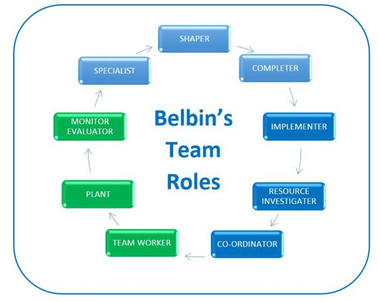
(Belbin, 1981).

The purpose of a reflection is to explore gaps in our knowledge and can be an important tool when assessing the leadership and time management skills of the team. Reflecting on a past project or activity is an essential part of the learning process. ‘It increases self-awareness, insight and can facilitate personal and professional growth. It ensures that any errors are identified, and improvements can be made.’
(Morgan, 2017).
The feelings and emotions that were experienced by the team will be discussed and an analysis of how these may have affected the team morale, allocation of tasks and overall performance.

Description
We had to form a group for the presentation, and then come up with a business plan. We formed a group of four members, how we formed the group was basically two members who sat on the desk in front of us and then myself and the girl who sat next to me, the two members who sat in front asked us if we wanted to be part of their group to which we both agreed, and that is how we formed a group. After forming the group, we chose a group leader to which the chosen member agreed. The reason why that particular member of the group was chosen as a group leader was due to her confidence that we had observed in that short time, she was more vocal and not so shy.

Morgan (2017) states that a good leader should put energy into achieving goals. We felt she would be the best person for that role because she seemed to display this type of energy. The lecturer took all the names of the leaders after the groups were formed and leaders chosen.

We met in university for the first time, so we were unaware of each member of the team’s individual experiences and skillset. We then started to work on the topic for our business plan after several ideas and opinions were put forward, I still felt that no one knew what was being done, neither did I have the experience or knowledge in those businesses and did not feel comfortable with the ideas. I felt no member of the group was comfortable on any plan being discussed, I suggested a plan right at the beginning to which the members thought at the time did not believe it was a good idea.

Feelings
A conclusion had not been reached, I then stepped in to help and suggested my initial plan which was to open a driving school, as I was concerned that we would fall behind schedule and would not be able to meet the deadline to pass our module, I also felt saddened by the fact that our lecturer had put so much effort in to helping the class and we were letting him down my concern wasn’t just about us it was about our lecturer and the rest of the team.

Around week 3 we decided to have a business plan on a driving school as I had some sort of knowledge and experience in it, the group leader wasn’t helpful at all rather then researching and allocating tasks took the back seat and left it all on me, I believe it was due to some knowledge I had on the chosen business plan.

None of us knew who was taking ownership of the tasks although they had been allocated. At week 5 or 6 we asked our lecturer to help allocate the tasks to which our lecturer numbered the sections on the sheet given for the business plan, after the numbering I chose a task and gave the rest of the tasks to other members to choose their pick as the leader wasn’t doing anything at all to help towards the planning or researching and by this time it had started to become extremely stressed

I then started the presentation slides on my laptop and I asked the leader if that was ok to which she agreed. Every week I came in early and I was requesting the members to come in early to so they can use the laptop to do their slides but that never happened. Every lecture I did the slides and added the information for the other 2 members as the fourth member was hardly present.
In week 7 I stepped up as a leader not that I ever told our lecturer that I decided to become the leader but having put my 90% in it I felt like there was no other choice, when I had done most of the work from planning to researching to completing.
No Gantt was used to help plan the steps towards the presentation, if in future I had to do a presentation I will use a Gantt chart to make it an easy process if it was to arise again.

I requested that the presentation should be completed by week 8, so we can practise our timings on the speech on week 9, therefore, if something didn’t seem right or needed amending we would then have the time to correct it ready for week 10. At week 10 I was still waiting for some work for the slides to come in and all references from the other two members as the third one never turned up. Within an hour of the presentation starting our lecturer approached us and informed us that it was just our presentation that he had not received and was outstanding, I informed our lecturer that I was still waiting the other two members to complete their slides and references and I shall email it at my earliest convenience. Presentation was due to be emailed to the lecturer 3 days before the day presentation day.

We were prepared that the fourth member might not turn up for presentation, so we decided that the member who was working on cash flow can do the speaking on swot and pestle to which I said I will prepare the slides as usual.

On the presentation day, when the swot and pestle came up the member who was suppose to speak on the slides decided to turn it back on me and said “my colleague Uzma will speak on this” and not having had a look at the notes I was totally astonished to have been put on the spot, I immediately apologised for the absent member and looked at the slides and briefly explained what they were again not having much knowledge in the swot and pestle made me extremely nervous.

Evaluating
Overall our presentation was good, we didn’t get questioned as much as other groups did, we were questioned on one slide to which all members were silent and looked at me, once again it was due to not having any knowledge in the area, if they had familiarised themselves with the slides they would have known what was said in the presentation and why, I explained it and it was not questioned again, I felt very nervous and anxious at the point of questioning, what I did learn from the questioning was that what we have in our presentation we should have thorough knowledge in it as not being able to explain will look very unprofessional and awkward for us.

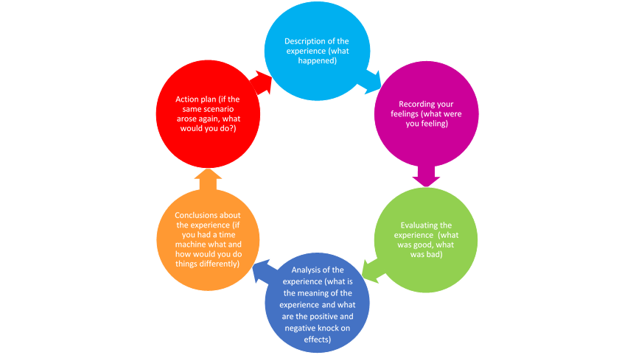Kolb’s learning cycle, (1984)

Analysis
Meaning of the experience is to reflect on what went well and what could be developed in the future, we learnt a lot of skills such as teamwork, communication skills, time management skills, and presentation skills. These skills as mentioned above didn’t all go very well, but this is where the reflection comes, and we now work on these areas to develop them to have a successful team and to have that we must have acknowledge the benefits of team working. Morale and motivation: individuals feel a greater sense of job satisfaction (results in improved efficiency and productivity.

Action Plan
Stages of team development are to be taken in consideration for a successful task or project to achieve the targets in a timely manner.

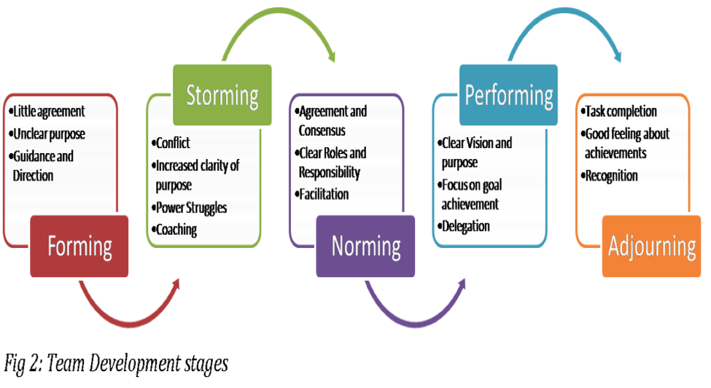
Bruce Tuckman, (1965)
‘Stages of development are explained in figure 2 above, these are to help the leaders understand the changes to manage expectations’ Stages of development were first introduced by Bruce Tuckman in (1965). Following these stages, it will facilitate the effective management of relationships and effective communication through the teams, which will result in the project or task to complete successfully. It is never easy to work as part of a team, but when you value each member for their individual skill and talents and it is all the put together that is where the team strength comes.
Maund. A, Schriek. M and Tinkler P.K. (2017)

Conclusion
In reflection a conversation could have taken place to ensure that everyone knew what their roles were and remained accountable for their tasks and should have completed them within the given timescales. If a dead line was missed a separate discussion should have taken place to establish why and people should be held accountable. If the work wasn’t going to be done it could have been re assigned. I felt like I had taken on the responsibility as a leader, I was expected to do all the work by the team members.
What I have learnt through this process is that knowing the group members better would have been helpful and knowing their strengths and weakness to allocate a task to best meet their ability.

Having the knowledge and sharing that with other group members builds trust and a good relationship within the team. According to Morgan, (2017), If there is synergy between two or more individuals they are more successful.
Sandler.com, 2018 expresses, “Two heads are better than one” shared skills increase creativity. In addition, more ideas are likely to be generated.

https://www.sandler.com/blog/6-benefits-of-teamwork-in-the-workplace

Successful team development is essential, benefits are to avoid repeating what has been done and learn for better if it was to arise again. Gantt is to be used for project planning also to ensure the running of the process is smooth and not only one or some group members taking the responsibility, it is to ensure deadlines are met and tasks allocated accordingly, and time managed effectively.
Stages of team development are to be taken in consideration for a successful task or project to achieve the targets in a timely manner.
Bruce Tuckman, (1965)

References
Belbin: Belbin and Tuckman: Supporting your team at every stage [Online] Available from: https://www.belbin.com/resources/blogs/belbin-and-tuckman/ (Accessed 12 December 2018)

Eba: Belbin team roles: Building effective and balanced teams for success: Available from: [Online]: https://www.educational-business-articles.com/belbin-team-roles/ (Accessed 7 December 2018)

Learning from mistakes: Reflective learning in social work: [Online] Available from:https://theknowledgeexchangeblog.com/2017/05/22/learning-from-our-mistakes-reflective-learning-in-social-work/ (Accessed 7 December 2018)

Maund, A, Schriek, M & Tinkler, P.K (2017). Certificate in higher in education: skills for the workplace student yearbook. (First ed.). London: Sage. Pp 5-13.
Maund, A, Schriek, M & Tinkler, P.K (2017). Certificate in higher in education: skills for the workplace student yearbook. (First ed.). London: Sage. Pp 11-13

Morgan, P, (2017). The business students guide to study and employability. 1st Ed.
London: Sage. Pp 109.

Sandler Training: Benefits of Teamwork in the workplace: [Online] Available from:https://www.sandler.com/blog/6-benefits-of-teamwork-in-the-workplace (Accessed 11 December 2018)

Tuckman, Bruce W. And Jenson, M.A.C. (1977) ’Stages of Small-Group Development Revisited,’ Group Organization Management, Volume 2, Number 4, December 1977.

