
Student name: Vitalina Kraievska
Student ID: 2411153
Module name: Protecting and Supporting Families in Health and Care
Module code: BMHP5021
Lecturer name: Amanda Jones

Assessment (REPORT): An examination and analysis of how the ‘Early Help’ system is signposted to UK families by their local authority website.

Table of Contents
1. Introduction: 2
2. Main body: 2
-Early Help System: 2
- Multi-agency working: 3
Interdisciplinary working: 4
Importance of Interdisciplinary Working: 4
Evaluation of three local authorities’ websites: 5
Comparative evaluation and Strengths and weaknesses: 9
3. Conclusion: 10
4. Recommendations 10
5. References: 11

1. Introduction:
The “Early Help System” in England is a coordinated approach to identifying children, families, and young people in need and supporting them at an early stage to prevent further escalation of challenges and difficulties. As per the “Early Help System Guide (HM Government), early help is not just a particular service activity but rather a multi-layered framework of supporting the delivery of different age-related agencies. At its core, Early Help aims to prevent the worsening of needs, promote positive outcomes, and address risks at their initial stage (Department for Education, 2022).
The “Early Help system” is regarded as an integral component of a wider strategic safeguarding framework, as depicted in “Working Together to Safeguard Children 2023” (UK Govt., 2023). It should be noted that “Early help” falls within the low-to-medium-level tier, which primarily addresses emerging needs. The report would discuss the Early Help System, which is communicated to families via 3 UK local authority websites: “Staffordshire County Council”, “Southwark Council”, and “Norfolk County Council”. The report would discuss the concept of Early Help, explain its role within a broader safeguarding framework, and evaluate the websites in terms of how clear, accessible, and effective the information is.

2. Main body:

-Early Help System:
The Early Help System is a preventive, multidimensional approach designed to support people in need, such as children, young people, and families, during the initial stages of challenges. The key aim behind this is to prevent these difficulties from growing into bigger problems and becoming a statutory safeguarding concern (Department for Education, 2022). It ensures that people in need receive appropriate care at the right time, thereby minimising the risk of severe crises and statutory involvement. The various important features of the Early Help System are discussed in brief:
- The system focuses on addressing the varied needs of different people and hence, takes into consideration the well-being of the child, parent, and the entire family, and hence ensures socio-economic balance, environmental aspects and health outcomes (Department for Education, 2022)
- Participation in early help is entirely based on the individual’s consent. In other words, the families get involved voluntarily, not only fostering trust but also strengthening collaboration among them (Berger, 2023).
- These programs can be utterly complementary, and altogether, they tend to form a powerful local support system for families, led collectively by the “Department for Education”, “Department for Levelling Up, Housing and Communities” and “Department for Health and Social Care”.
- The early help system tends to work within a large-scale safeguarding continuum, entailing “Universal Services” such as schools and healthcare, early help for emerging needs and difficulties, and statutory intervention for high-risk cases (Department for Education, 2022). This positioning of the system indicates that it supports families through a preventive and transitional approach.

- Multi-agency working:
Multi-agency working is a collaborative approach in which various organisations, agencies, and professionals work together towards a shared goal: promoting the health, well-being, and sustainability of children and families. In “Working Together to Safeguard Children 2023”, multi-agency working includes local authorities, the police, health services, educational providers, and voluntary organisations (UK Govt., 2023). This group of organisations further coordinate efforts across the whole system of protecting, helping and supporting people.
Furthermore, “Working Together to Safeguard Children 2023” states that multi-agency working entails shared responsibilities and requires all practitioners to contribute to identifying needs, conducting risk assessments, and providing appropriate support (UK Govt., 2023). Multi-agency working operates through various structured arrangements, such as a “safeguarding partnership program” in which the “local agencies”, “political authorities”, “Integrated Care Boards” and the “Police forces” join together to oversee safeguarding practices for children and families in need.
The Multi-agency working principles are outlined below:
- The multi-agency partners need to share accurate data and information to make informed decisions and take appropriate initiatives to protect children and families in need.
- Agencies need to conduct effective assessment and planning by collaborating with professionals to analyse needs and develop structured support plans.
- Clarity of roles and responsibilities is also important, and each agency must have an effective understanding of its roles and responsibilities within “safeguarding arrangements” (Isham et al., 2025; Becker et al., 2023).
- Their actions and initiatives are child-centred, and all the actions tend to prioritise the welfare and voices of the children.
It should be noted that strong multi-agency working tends to ensure that safeguarding responses are well-coordinated, prompt and effective, especially when the children and families face difficulties and challenges.

Interdisciplinary working:
Interdisciplinary work refers to initiatives by professionals from various fields, such as social work, education, and healthcare. They tend to consolidate their knowledge, skills, and expertise to address the holistic needs of vulnerable people (Xilogianni et al., 2022). Interdisciplinary practices are closely related to multi-agency working but differ in focus, as they concern how different professionals collaborate in real time, rather than solely organisational cooperation.

Importance of Interdisciplinary Working:
- A holistic understanding of the needs of children and families is ensured by the interdisciplinary working teams. They help address the overlapping challenges faced by the children, such as health issues, educational challenges, safeguarding risks, and so on, by conducting comprehensive assessments and ensuring all needs are met (Becker et al., 2023).
- They also enable early identification and intervention by various professionals as they observe vulnerable children across varied contexts. For example, teachers might identify different behavioural concerns, whilst health professionals might identify various developmental and mental health issues, and these data might be shared to support earlier intervention, which is vital to safeguarding policies (Isham et al., 2025).
- Their intervention ensures effective outcomes for the families as well as the children, as the document “Working together to Safeguard Children 2023” depicts that efficient “multi-agency collaboration ensures more effective and positive outcomes, and the services are well-coordinated (UK Govt., 2023).
- It should be noted that interdisciplinary working tends to minimise duplication of effort and ensures that families receive streamlined, consistent support rather than having to navigate several discrete services (Berger, 2023).
- The 2023 guidance document further indicates that interdisciplinary systems tend to function as integrated networks in which agencies challenge and support one another. They also tend to share responsibilities and constantly improve their actions and initiatives (UK Govt., 2023).

Evaluation of three local authorities’ websites:
The critical evaluation of the 3 local authorities’ websites, that is, Staffordshire County Council, Southwark Council, and Norfolk County Council, depicts that the different approaches in terms of the way Early Help and family support are conveyed, especially in terms of accessibility, compliance and coordination with safeguarding principles.
- Staffordshire County Council: This website tends to present early help as part of a large-scale “service delivery framework” that appears relevant to a “Multi-agency ethos”. As a matter of fact, the council's communication approach may focus on the entire system rather than on individual users. The content they use for communication includes details about service structures and various organisational functions, rather than the families' practical experiences (Staffordshire.gov.uk, 2026). Therefore, this is abstract in nature, and users might face difficulty understanding and interpreting the system's exact application to their own circumstances. In addition, the navigation pathways lack an intuitive, coherent flow; as a result, users often need to switch between sections to gain a coherent understanding of the context. So, it can be said that though the website entails procedural depth, it lacks an effective accessibility principle as outlined in the safeguarding policy (Xilogianni et al., 2022).
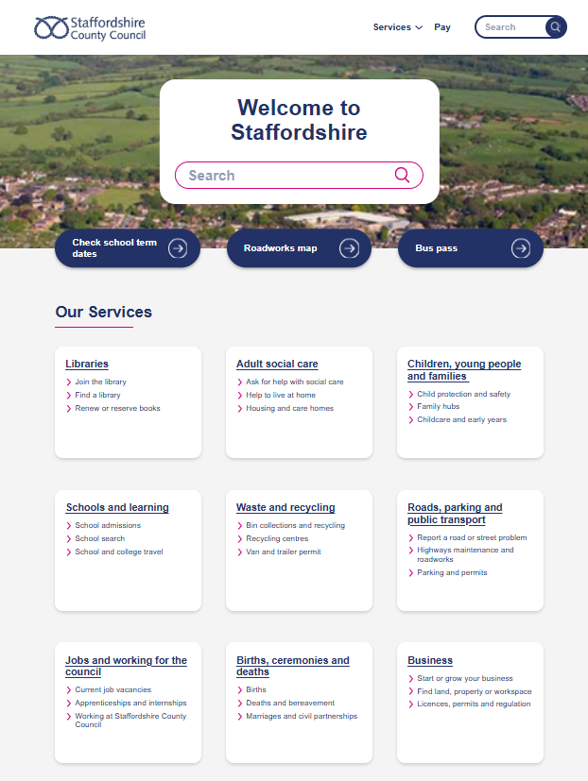
Figure 1: Opening page of Staffordshire County Council website
(Source: Staffordshire.gov.uk, 2026)
- Southwark Council: This council tends to adopt an effective communication style focused on citizens. As a matter of fact, their website places “Early Help” at the periphery of day-to-day family challenges. The language is inclusive and kept simple and readable. Thus, the content is more approachable and engaging. This further aligns with the “preventive ethos” of Early Help, which emphasises that early help relies heavily on understanding and awareness (Southwark.gov.uk, 2026). It should also be noted that this accessibility might come at the cost of transparency regarding the processes and concepts used. However, there is a lack of explicit articulation of the system's key mechanism; hence, the user’s understanding of how decisions are made may be limited (Bastos, 2023). There is also information fragmentation across several pages, which can disrupt the user's journey and undermine clarity (Xilogianni et al., 2022).
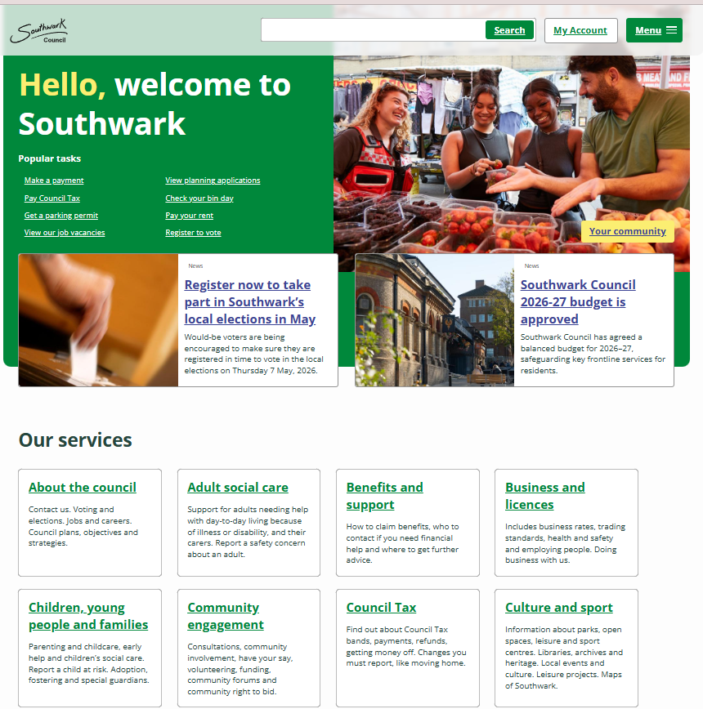
Figure 2: Opening page of the Southwark Council website
(Source: Southwark.gov.uk, 2026)
- Norfolk County Council: The Norfolk County Council’s approach tends to reflect a more integrated and well-balanced communication strategy, with clarity and effective accessibility. This website efficiently positions Early Help within the “Safeguarding Continuum”. It provides potential practical guidelines on service accessibility. This focus tends to improve user experience by providing a transparent and comprehensive understanding of the content (Norfolk.gov.uk, 2026). Thus, from this website, the families tend to understand the types of support services available and how the system operates. The content is organised with a logical flow and hence complies with the principles outlined in “Working Together to Safeguard Children 2023”. However, the website consists of a bulk of data that might sometimes tend to create cognitive overload and hence a streamlined flow of content could have been more effective (Thwairan, 2024; Leggiero et al., 2024).

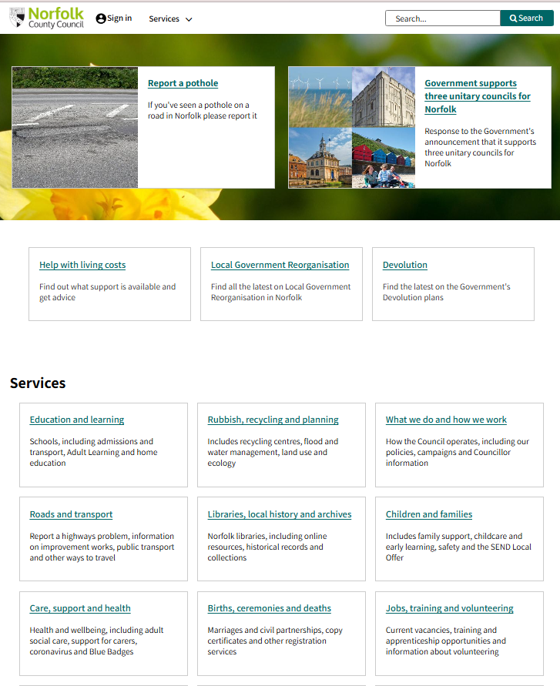
Figure 3: Opening page of Norfolk County Council
(Source: Norfolk.gov.uk, 2026)

Comparative evaluation and Strengths and weaknesses:
Staffordshire |  | Southwark |  | Norfolk
Strengths | Weaknesses | Strengths | Weaknesses | Strengths | Weaknesses
Comprehensive list of services | Very descriptive content | Simple and clear language | Multiple information pages reduce readability | Clear explanation of Early Help services | Text-heavy content
Clear communication support services | Complex navigation | Practical guidance on help-seeking procedures | Inadequately explained formal procedures | Simple language and focus on readability | Simple and monotonous website design
Entails additional resources for further exploration | Limited visual hinders accessibility for laymen. | Emphasises real-life issues | Lack of strategic understanding of the system. | Integration of the family hub model | Less interactive or visual content
Table 1: Strengths and Weaknesses of the Three Websites
(Source: Created by Author)
It should be noted that the “Early Help Section” of Staffordshire offers a service-oriented approach and lacks user-friendly, easily navigable communication. Hence, the information is somewhat inaccessible to non-professionals (Staffordshire.gov.uk, 2026). Though Staffordshire provides comprehensive information on Early Help, it lacks accessibility. Again, Southwark Council adopts a more family-oriented communication style and has high user engagement (Southwark.gov.uk, 2026). However, it lacks clarity in explaining the structure of the Early Help System. The Northfork County Council, on the other hand, provides well-balanced, structured communication about Early Help, along with in-depth, practical insights into accessing services (Norfolk.gov.uk, 2026).

3. Conclusion:
The report entails a brief descriptive and critical study of how the Early Help System is communicated to families via the websites of Staffordshire County Council, Southwark Council, and Norfolk County Council. The report briefly explained the Early Help System as a preventive, multi-agency framework, including multi-agency working and interdisciplinary working, in line with the guidance outlined in “Working Together to Safeguard Children 2023”.
It carried out a comparative analysis of the three websites and outlined the differences, despite providing procedurally aligned information. Southwark Council’s communication approach is more navigable and user-friendly, however lacks a clear focus on structural processes. Norfolk County Council provides a comprehensive overview of Early Help Services and practical guidance on how to access them. It can be said that the most effective communication is demonstrated by “Norfolk County Council” due to easily navigable and accessible information and a clear focus on the structure and usability of the services.

4. Recommendations
The following recommendations can be considered for further enhancement of the effectiveness of Early Help communication:
- The website should consider a more user-oriented design and communication approach, and should reflect on real-life family journeys to enhance user engagement (Thwairan, 2024).
- Use simple language, more visuals and interactive features would keep the users hooked (Leggiero et al., 2024; Xilogianni et al., 2022).
- Transparency and coherence of the system should be improved via a clear explanation of key processes, entailing a logical, structured and centralised flow (Bastos, 2023).
- Website should be inclusive and support diverse intellectual levels, and hence, inclusion of flow-charts, infographics, and short videos would enhance accessibility.

5. References:
Bastos, B.C., 2023. Impact of website navigation on user experience (Master's thesis, Universidade NOVA de Lisboa (Portugal)).
Becker, I., Rigaud, V.M. and Epstein, A., 2023. Getting to know young children: Alternative assessments in early childhood education. Early Childhood Education Journal, 51(5), pp.911-923.
Berger, E., O’Donohue, K., La, C., Quinones, G. and Barnes, M., 2023. Early childhood professionals’ perspectives on dealing with the trauma of children. School Mental Health, 15(1), pp.300-311.
Department for Education, 2022. “Early Help System Guide | A toolkit to assist local strategic partnerships responsible for their Early Help System” | Available at: https://assets.publishing.service.gov.uk/media/628de13be90e071f5f7e1bd2/Early_Help_System_Guide.pdf [Accessed on: 16-04-2026]
Isham, L., Scott, J. and Taylor, J., 2025. Feasibility and acceptability of the “Never Events” method in the context of multi-agency child protection: findings from an exploratory study. Journal of Interprofessional Care, 39(6), pp.1101-1105.
Leggiero, I., Polleri, E. and Rocca, F., 2024, August. Enhance Human Diversity to Improve User Experience: Usability Test for a Public Administration Website. In Congress of the International Ergonomics Association (pp. 71-78). Singapore: Springer Nature Singapore.
Norfolk.gov.uk, 2026. “Norfolk County Council” | Available at: https://www.norfolk.gov.uk/ [Accessed on: 16-04-2026]
Southwark.gov.uk, 2026. “Southwalk Council” | Available at: https://www.southwark.gov.uk/ [Accessed on: 16-04-2026]
Staffordshire.gov.uk, 2026. “Stayfordshire County Council” | Available at: https://www.staffordshire.gov.uk/ [Accessed on: 16-04-2026]
Thwairan, N.S.D., 2024. Analysing the impact of visual elements in website design on user experience and interaction. International journal of religion, 5(10), pp.1608-1619.
UK Govt., 2023. “Working Together to Safeguard Children 2023” | Available at: https://assets.publishing.service.gov.uk/media/69c2c4ce380a2a73a7cf9df4/Working_together_to_safeguard_children_2026.pdf [Accessed on: 16-04-2026]
Xilogianni, C., Doukas, F.R., Drivas, I.C. and Kouis, D., 2022. Speed matters: What to prioritise in optimisation for faster websites. Analytics, 1(2), pp.175-192.

