Understanding and Engaging in the Customer Experience: The Case of Primark and HSBC Bank
Requested by: Marketing Weekly

Name: Saniya Karim (1704776)
UWTSD BA Leadership and Management Skills for the Workplace
Date: 25th March 2019

Executive Summary
Customer relationship management significantly influences the performance of an organisation. Ethics and quality of a product or services are aimed at promoting the sustainability of an organisation. Ethics, sustainability, and quality play a fundamental role in the achievement of corporate objectives. Today, there is little knowledge on how ethics and quality contribute to the organisation sustainability and ultimately the customer experiences. Thus, the report explores how these aspects interact as part of customer relationship management in an organisation. The report found that as the quality and adherence to the ethics and social responsibility augmented in an organisation, the more sustainable an organisation along with its customer relationship management system. It also found that most organisations tend to focus more on the financial aspects, hence failing to meet the ethical and quality prerequisites for achieving sustainability and improving customer experiences. The report concludes that given that the customers take a central point in an organisation, managers seek to understand how they can establish a robust relationship with external stakeholders by portraying a positive self-image. Ultimately, the development of CRM is a matter of ensuring that the stakeholder feels the presence of an organisation through its ethical and quality practices or processes. Therefore, this report recommends that managers in an organisation must consider integrating ethical behaviours and quality in every business process if sustainability is to be achieved.

Contents
1.0 Terms of Reference 4
2.0 Procedures 4
2.1 Sources of information 5
3.0 Findings 6
3.1 Ethics 6
3.2 Sustainability 7
3.3 Quality 8
3.4 Impact on CRM System 9
3.5 Organization CRM systems 12
3.6 Gaps in the CRM system 13
4.0 Conclusion 16
5.0 Recommendation 17
6.0 Appendix 20
7.0 Acknowledgements 30
8.0 Reference List 31

Terms of Reference
The CEO of Weekly Marketing requested this report on 6th March 2019. The purpose of this report is to examine the influence of ethical and sustainable policies and its possible impact on the quality of customer relationship. The report was compiled by Saniya Karim.
Ethics, sustainability, and quality play a fundamental role in the achievement of corporate objectives. For the most part, these aspects of the business are reflected in the customer relationship system in the organisations. Given that the customers take a central point in an organisation, managers seek to understand how they can establish a robust relationship with external stakeholders by portraying a positive self-image. Also, this involves developing policies that give the interests of the customers an upper hand. Unfortunately, as yet, there is a little knowledge of the interactions between ethics, sustainability and quality and their effects on organisation and customer experience. As such, this report provides quality model and theories that may assist in the improvement of CRM in the chosen organisation, along with the conclusion on the impact of ethics, and sustainability of the quality of CRM in organisations. The report was submitted on 25th March 2019.

Procedures

2.1 Sources of information
The research methodology by the researcher has been subject to several procedures to guarantee the quality as well as the reliability of the information provided in this report. Information used in this report was limited to secondary sources that are books, journals, and some few selected websites. Ethics and sustainability report publication for the chosen organisation was also used to obtain specific details as much as possible. Although the report is not a comprehensive review of the existing literature, it offers a broad overview of ideas and facts in question. The research started by identifying the information needed to complete this report. An online search through the databases to collect the most relevant and contextual information. The information gathered was then analysed and synthesised, and put down into writing. The researcher conducted rigorous check and editing to guarantee the accuracy as well as the consistency of this report.

3.0 Findings

3.1 Ethics
According to Upstill-Goddard et al. (2016), ethics is a “philosophical aspect, which involves thinking holistically about morals as well as behaviour along with the making of moral decisions on what is right or wrong”. Holland and Albrecht (2013) suggests that ethics may be influenced by the individual characteristics of the one making decisions, organizational ethos, the social and cultural environment, the unique context and micro or macro environment. In order to make an ethical decision in an organisation, Xia and Li-Ping Tang (2011) suggests that there is a sequential process come up with the most ethical output (Figure 1).
Various theoretical approaches exist that clarifying ethical behaviours in business. Kant's theory holds that ethics is acting morally by performing one's duty and that is to obey the natural moral laws (Kant, 1996). In this theory, according to Zink (2007), ethics must be consistent and preserve respect, and autonomy of the individuals. Ethics are inclined to emphasise the development of character as the foundation for favourable moral judgment as well as action (Schulz and Flanigan, 2016). It appraises voluntary human conduct insofar as the judgment on the right or wrong about the determinative principles. As depicted in the model, ethics seek to promote autonomy, rationality, equality, as well as sensibility in the organisation (Figure 2)
Xia and Li-Ping Tang (2011) formed the normative ethical decision-making models suggesting that the personal characteristic of ethical decision making, work, and professional environment, personal and social orientations, or the prevailing legal framework all influences ethics in business. Ahi and Searcy (2015) found those ethics are significantly influenced by the organisational culture even if individual or groups decide on an organisation. The choices to act ethically is based on morals: one must decide on what they believe to be the right course of action. Moreover, this may involve rejecting the route that would result in the most substantial short-term profit (Macdonald, Kleinaltenkamp, and Wilson, 2016). Ethics in business can attract customer, make employees want to stay in an organisation, attract investors and keep the share price high, among others. According to the utilitarian theory of ethics, the focus in the organisation should be on the ability to predict the consequences of a given action. In this view, a choice that generates the most significant benefit to a majority is ethically correct (Mitra, 2016). Ethics in this theory is much concerned about the maximisation of good, and this may not always reflect justice, beneficence or autonomy of the individuals. Concerning the stakeholder model of ethics, ethical behaviours can be manifested in an organisation through normative, descriptive or instrumental policies (Figure 3).

3.2 Sustainability
Zwetsloot and Van Marrewijk (2014) define sustainability as realising success today without having to compromise the future. It is the organisational ability to meet the present needs of the customers while considering the needs of the future generation. Sustainable growth, according to Lo and Sheu (2017), involves the creation of value that alights with the long-term preservation as well as improvements of the monetary, environment as well as social capital. Sternberg (2010) found that organisations are seeking to develop sustainable policies, but observe that these policies aim to establish an underlying culture of sustainability in the form of policies that accentuates the significance of financial, environmental, and social performance. For this reason, the policies aimed at developing a culture of sustainability by the articulation of the values as well as the beliefs that are underlying the goals of the organisation. Understanding sustainability, according to Tsalikis and Fritzsche (2018), implies the establishment of meaningful values that drives strategic decision-making as well as build a culture for the reinforcement of desirable behaviour. The stakeholder theory holds that realisation of sustainability depends on the ability of an organisation to meet the needs of the stakeholders including customers, suppliers, employees, communities, among others and not just the interest of shareholders (DesJardins, 2009) (Figure 4).
By just focusing on the financial values of the shareholders, often short-term, it may significantly hurt other stakeholders and organisational sustainability. Pope, Annandale and Morrison-Saunders (2014) confirm that many organisations report publicly on their sustainability performance as it relates to the concept of a triple bottom line that is, the economic, social and environmental aspects of the business. He cites explicitly Unilever company, which seek to help over a billion people to take actions that help them improve their health and well-being (Boons, and Mendoza, 2010) (Figure 5).

3.3 Quality
ISO 8402-1986 standards define quality as the general features and attribute of a given product or services that bears its capacity to satisfy the needs of the consumers. According to McAdam and Leonard (2003), quality denotes a culture that continually acts on the belief that real choices befit with the satisfaction of the needs of customers in the most ethical manners and it takes recognition of the projected chances for advantages. As such, Carroll and Buchholtz (2014) believes that it remains the task of managers as well as their responsibilities to develop a value proposition or competitive edge concerning quality and ethics. Therefore, he argues that the organization must match the needs of the customers with the business capabilities, and this necessitates the functional activities such as the Deming Cycle as well as a code of conduct with the aim of supporting the overall brand strategy or business as a guarantee for sustainability (Smith, and Fischlein, 2010) (Figure 6).
Quality, according to Bartelmus (2010) is based on five primary attributes that are technological, psychological, time-orientation, contractual correctness, and ultimately ethics and virtue. In a similar view to Deming, Navimipour and Soltani (2016) state that most of the problems with quality are a result of management failure and not the employee. Geissdoerfer et al. (2017) argue that when taking into account quality management, the tweaking to the overall environment is managed by measurable control as well as a continuous regeneration of the internal processes of an organisation in an ethical way. Today, Hallstedt (2017) found that social network platforms offer organisation with a glorious opportunity where branding strategy can be communicated while enabling the customers to express themselves, exchange ideas and improve the awareness on the brand. With that, the success of an organisation depends on the engagement level, transparency and trustworthiness and an understanding that quality and ethics drive the business trust. Soltani and Navimipour (2016) support the view that quality seeks to satisfy the stakeholders and that ethical propagation of business activities via the EFQM (European Foundation for Quality Management). (Figure 7).
The six sigma provides a discipline-based approach to the management of quality in the organisation as shown in Figure 8

3.4 Impact on CRM System
With the rapid technological advancement, Najafizada, Labonté and Bourgeault (2017) observe that globalisation is accelerating is at a higher rate. As such, visible changes are operating their economic, social, as well as environmental process. For an organisation to survive these changes, they tend to focus on policies to see their sustenance of their business. Various indicators have been designed globally for measuring as well as reporting, primarily highlighting environmental issues and sustainable development. Customer relationship tends to focus more on the corporate activities that promote their wellbeing as espoused by the stakeholder's theory. Miles (2017) urges that instead of the company focusing on economic goals, customers prefer to associate with organisations that emphasise ethics, and quality, which in turn guarantees its sustainability.
DPOBE model (Direction, Posture, Organization, Behavior, Organization and Evaluation ) of sustainability can better explain why organisation integrates ethics, quality, and sustainability in their customer relationship management systems. In a study by Moore and Julie, most companies admit that their sustainability and ethical reporting is conducted because of the external drivers; pressure by the customers. Sustainability involves the development of economic growth and innovation to realise a competitive edge while maintaining a positive reputation and customer relationships, as well as services quality (Soltani, and Navimipour, 2016). Ethical customer relationship management is how organisations handle their operation to generate a positive impact on the community, building a sharp image, as well as gaining trust from the customers. These pillars demonstrate how the strategic, operational, and management plays a fundamental role in the integration of ethics, quality, and sustainability in the improvement of customer experiences (Navimipour and Soltani, 2016) see figure 9
- Direction
This is the first pillar in DPOBE model, which holds that the organisation's sustainability, as well as long-run prosperity, are primarily connected to the welfare of different stakeholders, including the employees, suppliers and most notably the customers. To attain sustainability through ethical customer management, it begins from its mission and vision, quality, among others. According to Gerry (2017), some organisations in the UK retail industry, for example, Primark is committed to social contract obligations as well as upholding ethical values towards the customers with sustainable practices. The integration of ethics in CRM system helps in handling their operation to have a positive impact, and establishing a positive image as well as earning trust from the customers.
- Posture
These aspects provide the measure for the customer services engagement, comprehension on the process, their roles, or obligations. As part of the customer services management system, the agent’s quality control measure by promoting accuracy, an efficient customer with the customers. Also, this includes offering services through the call centres, help desk portals, as well as emails. Fundamentally, these aspect helps in the measure of the ethical principles to promote safe handling of sensitive information and avoid violation of regulations. According to Soltani, and Navimipour (2016), an active customer relationship system management is achieved through the integration of ethical principles that supports the accountability as well as reliability, and subsequently, the customer enjoys the autonomy of their privacy.
- Organisation
Trust and brand image are one of the aspects of building a robust CRM system. The corporate brand that promotes ethical and integrity is an active and influential organisation competitive edge of realising its sustainability. The intellectual property and customer data are one of the valuable aspects in an organisation, and thus integration of quality and ethical principles in CRM permits coordination as well as the integration of crucial data from diverse channels, and thus improve customer experiences (Yip, and Bocken, 2018). An organisation with a strong integration of ethics, quality, and sustainability can appreciate customer relationship and the ethics code of conduct.
- Behaviours
Sustainability is primarily related to the organisation quality control in the industry value chain concerning the customer primary and secondary activities. Total quality management, according to Soltani, and Navimipour (2016), is primarily connected to the organization the customer satisfaction customers need to be protected by the firm's ability to deliver high-quality products or services, and this encourages the customers to have confidence, conscious that the organization will always act ethically towards the financial performance. Ethical behaviours in an organisation; integrity, accountability, and honesty permit the firm to manage their images and establish a healthy and customer positive relationship system grounded on trust and loyalty, which subsequently improve the sustainability of every changing world.
- Evaluation
Corporate social responsibility implies how business activities are conducted continually concerning a social value that is ethics, responsibilities, and transparency. According to Grat (2016), one of the primary reasons for CSR reporting is to demonstrate the organisational capability to the customers and in turn, sustain its development in the long-term. Integrate the ethics, quality, and sustainability in the CRM system helps in the creation of the awareness of the social values for the improvement of organisation image and reputation.

3.5 Organization CRM systems

Primark is one of the leading retail company in the UK industry. Although the company is not fully active, it has integrated ethical and quality policies in the CRM system to improve its sustainability and customer experience (Figure 1).

According to Rahimi, and Kozak (2017), the primary is a member of the sustainable apparel and have quite some initiatives that aim at offsetting their environmental effects. Since 2002, it has been using paper bags in place of the plastic bag and has introduced an action for the reduction of waste and packaging. As part of the customer relationship management system, European Primark store has provided their clothing as well as buying samples to charity Newlife, which gives support for to the terminally ill and individuals with disabilities. According to Wang and Kim (2017), Primark has committed to lessening the number of chemicals perceive hazardous by the Zero Discharge of Hazardous Chemical Group (SDHC). The company now does the reporting by looking at the effect by measuring as well as reporting on the emission of the greenhouse gases originating from their operations or the supply chain (Yip, and Bocken, 2018).

Nevertheless, they have minimal publications, showing the initiatives aimed at reducing greenhouse gas emission and which goes beyond the energy efficiency in stores and currently lacking a reduction target. The company's effort is commendable and is obviously in the right path, but the ethical policy is not adequate (Figure 11)
Primark has adopted some positive with the aim of improving their moral inclinations when it comes to their workforce, but there is still room for enhancements. Of course, the more the Primark considers the interest of the employees, the more they appreciate the customer relation management system (Rutter, Armstrong, and Cano, 2017). The company is one of the signatories to the Bangladesh Accord on Fire and Safety as well as the Cotton Pledge, committing to boycott Uzbekistan Cotton. According to Upstill-Goddard et al. (2017), Primark is a member of the ethical trading initiatives and have integrated a Code of Conduct to support the customer experiences in the services. Nevertheless, this code does not provide a guarantee payment of a living wage. Concerning the company's website, Primark affirms that before the approval of the factory, it is vetted a globally-recognised set of standards as stipulated in the Code of Conduct.
Nonetheless, even if the factories at the final phases of production are audited every year for monitoring their adherence to the Code of Conducts, it is inexplicit if the company follows the same approach in the first and second phases of production. Although the company has taken desirable steps, they have little control of the supply chain because of the absence of factories as well as outsources manufacturing to the supplier. Also, Primark, under the Leather Working Group, does promote sustainability in the leather industry avoid the use of fir, angora, or animal skin in their products (Thomas, 2017). To a more considerable extent, this is a significant issue because it is hard to guarantee the wellbeing of the workforce.
According to Clarke and Boersma (2016), Primark is committed to reducing the impact on the environment, and this is evident through the environmental sustainability performance report. The company has some positive progress in some areas across the business and supply chain from the material they use to their logistic networks, among other areas. The company sustainable cotton program has expanded and has increased over 5000 female farmers in India.
HBSC
HSBC Holdings is a banking and financial service and one of the leading organisations in the world in this sector. For this company, its diversity reaches far beyond the compliance with legislation as well as equal opportunities initiative, which improves the levels of the customer relationship. The company adheres to the MBA Code of Banking practice (Pesendorfer, and Lehner, 2016). The company has developed initiatives with the aim of protecting customers as well as customers information. In particular, this initiative is directed by the Financial System Vulnerabilities Committee, which provides reports on financial crime and information of the customers and any cases of system abuse. The utilitarian theory holds that an action is ethical if it yields the highest good, and in this case, the company is committed to doing its part as well as address issues that relate to human trafficking including sharing of information to security services. Through the Anti-Bribery and Corruption Policy, the company promote ethical practices by stating categorically to the employee and customers that it does not condone any bribery or facilitation compensations.
By having clear whistleblowing policy, the company can maintain ethical practices among the employees to improve the customer relationship and ultimately the sustainability. Concerning the UK's Modern Slavery Act, HSBC provides a transparent reporting of the activities it has taken to combat slavery and human trafficking. Moreover, this is guided by the Bill of Human Rights and the UN universal declaration of the rights as well as principles relating to the rights of workers (Navimipour and Soltani, 2016). In 2016, the company revised its Ethical and Environmental Code of Conduct with the aim of improving the stakeholder's experience and guaranteeing its long-term sustainability. According to Pesendorfer, and Lehner, 2016, the company recognise that customers are getting increasingly concerned about environmental pollution and particularly emission of carbon dioxide. As such, they have been addressing the issue for more than a decade. Most notably, HSBC has supported the transition to the low-emission of carbon through their operations and by assisting the customer in lessening their emission. By working closely with the workers, employees, and customers, and the supply chains, the company can portray a positive reputation and realise sustainable development.

3.6 Gaps in the CRM system
Quality

A clear analysis of the CRM system of the Primark and HSBC reveals that there is a gap in the policies that promote quality delivery of services. Customer relationship management system, at its best, involves clarification of the policies that explains how individuals’ employees relate with the customers (Geissdoerfer et al., 2017). So this may include the control of the interactions through the phones, emails, and other forms of communication.
Ethics
Promotion of gender equality in the workplace, either as an employee or other stakeholders, plays a fundamental role in the organisations. (Navimipour and Soltani, 2016). Unfortunately, the chosen organisation do not appear to consider the ethics of gender discrimination as an aspect of improving customer relationship and sustainable development. Also, there is a deficiency in the ethics of social inclusion of people with disabilities, which is a central component of the customer relationship management systems.

Conclusion

In conclusion, it is clear that the role of ethics, quality and sustainability in customer relationship management is a dispensable one. In order to realise sustainable development, an organisation must seek to establish strong ethic and quality policies that ensure continuous satisfaction of the customers. Ethics in business can attract customer, make employees want to stay in an organisation, attract investors and keep the share price high, among others. Sustainable growth involves the creation of value that alights with the long-term preservation as well as improvements of the monetary, environment as well as social capital. In a broader sense, the success of an organisation depends on the engagement level, transparency and trustworthiness and an understanding that quality and ethics drive the business. In an organisation, the strategic, operational, and management plays a fundamental role in the integration of ethics, quality, and sustainability in the improvement of customer experiences. Development of the CRM is a matter of ensuring that the stakeholder feels the presence of an organisation through its ethical and quality practices or processes (Geissdoerfer et al., 2017).

5.0 Recommendation
- It is recommended that the organisations enhance their score in their ethics by promoting transparency concerning their supplies as well as auditing practices and paying their employees a living wage, coupled with the improvement in the health and safety in the factories.
- The organisations should provide a social media platform such as Facebook, Twitter and Linkedin to express the ethical, quality and sustainability approaches to the customers.
- The ethical and quality approaches should be integrated into every business process.
- The companies should integrate an explicit ethical and quality policy on the corporate website.
- Ethics and Quality should be reflected in the organisation mission, values, and core values.
- The employee and the customers should be trained regularly on ethical and quality approaches to support sustainability and improve customer relationship: A program promoting the inclusion of the customers in the sustainability decision-making process (Geissdoerfer et al., 2017).
- Development of a robust policy on gender mainstreaming, people with disability, social inclusion and diversity issue.
- The company should apply the IDIC (Identify, Differentiate, Interact and Customise) model to improve quality and sustainability and the overall CRM system. The model includes the following elements
Identifying-this implies that the company must seek to establish a deep understanding of the customers.
Differentiating. The company needs to different customers based on their respective needs and value. This permits the organisation to devise as well as implement customer specific strategies structure to achieve the satisfaction of the individual customer needs. What is ethical to one customer may not be ethical to the other, hence the need to understand them.
Interacting- The organisations should focus on interacting with the customer expectations as well as their relationship with other brands. Quality and effective interaction with the customer offers profound insight into the needs of the customers.
Customizing-this is the last approach in this model and involves offering communications to make sure that the needs of the customers are met based on their respective needs (Noe et al., 2017).
- In order to improve the quality, the organisation needs to focus on the CRM value chain as shown in figure 19

6.0 Appendix
Figure 1: Ethical decision-making process
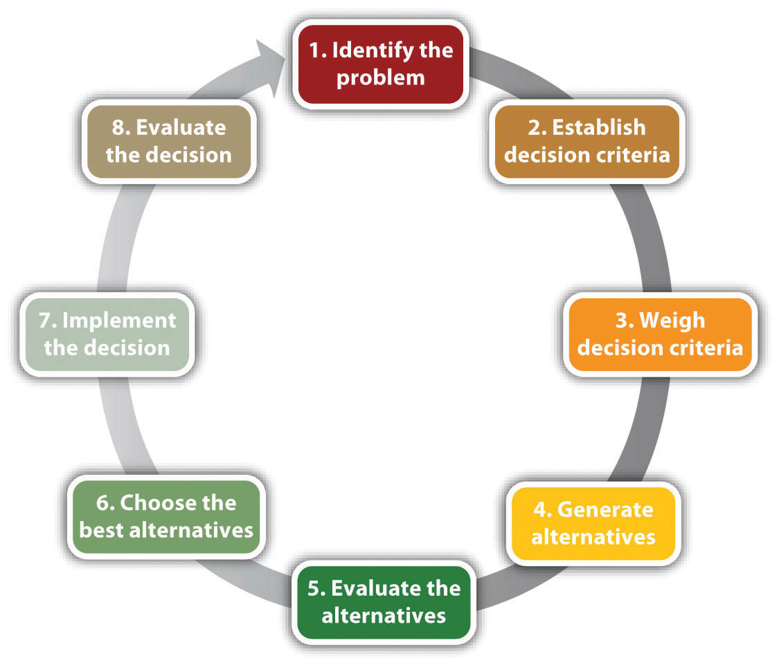
Source: Adapted from (Xia and Li-Ping Tang, 2011).
Figure 2: Ethics model
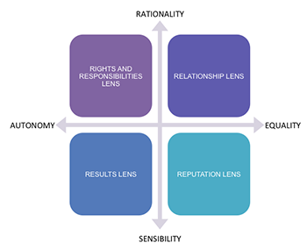
Source: Adapted from (Garad, 2016).

Figure 3: stakeholder-based decision-making model
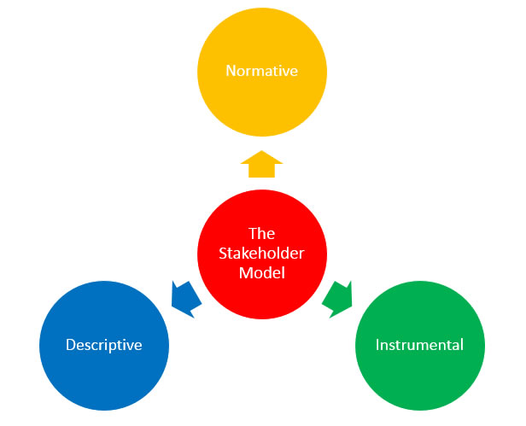
Source: Adapted from (Jones, Wicks, and Freeman, 2017).

Figure 4: Stakeholder theory
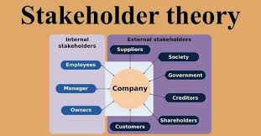
Source: Adapted from (Whipple and Swords, 2012).

Figure 5: triple bottom line model
. 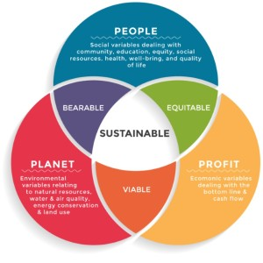
Source: Adapted from (Mitchell, Ladouceur, and Coffman, 2016).

Figure 6: Act, Plan and Do, and Check model
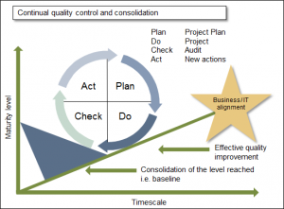
Source: Adapted from (Mitra, 2016).

Figure 7: EFQM model
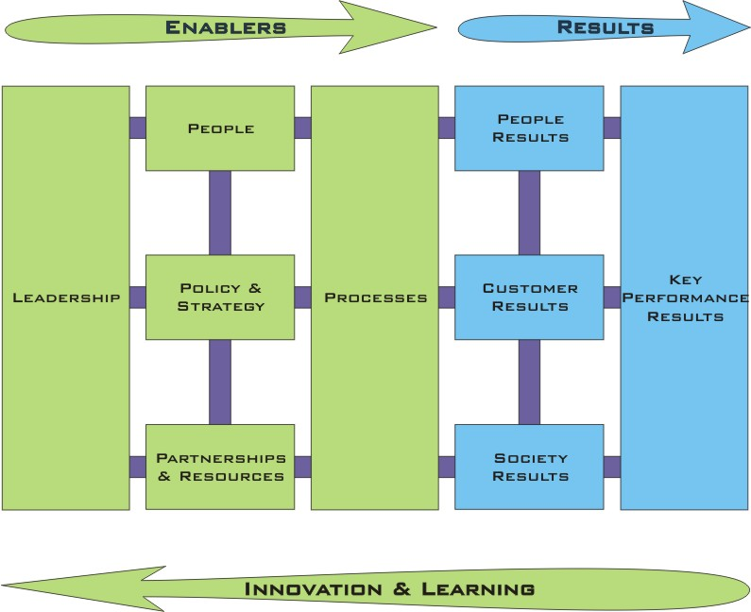
Source: Adapted from (Fleurbaey, 2015).

Figure 8: Six Sigma
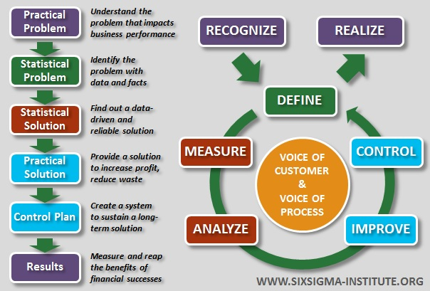
Source: Adapted from (Noe et al., 2017).
Figure 9: Organisational sustainability
. 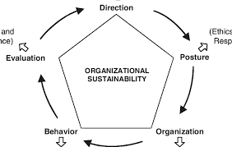
Source: Adapted from (Navimipour and Soltani, 2016).

Figure 10: Corporate Image

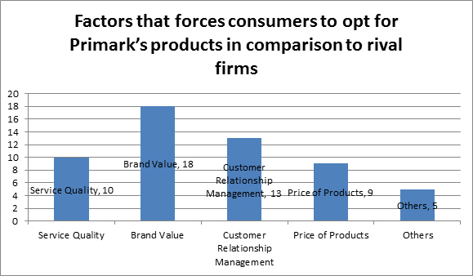
Source: Adapted from (Rahimi, and Kozak, 2017).

Figure 11: Ethical trend model

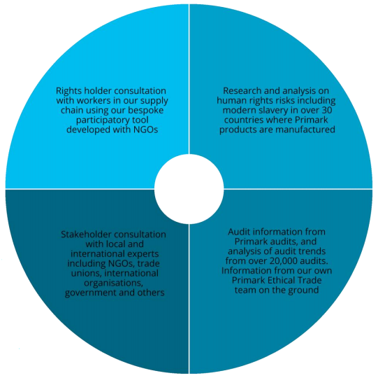
Source: adapted from (Rutter, Armstrong, and Cano, 2017).

Figure 12: Primark Retail
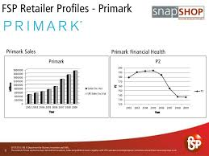

Figure 13: Rate of CSR
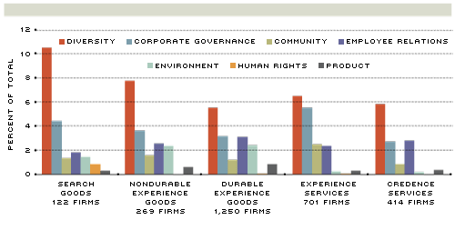
Figure 14: CSR expenditure of HCBS Bank
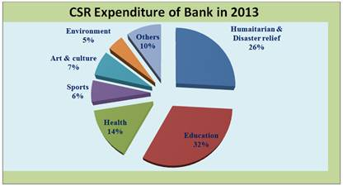
Figure 15: Rate of Social Responsibility

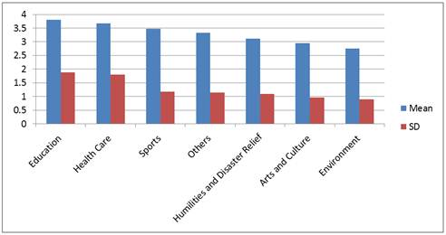

Figure 16
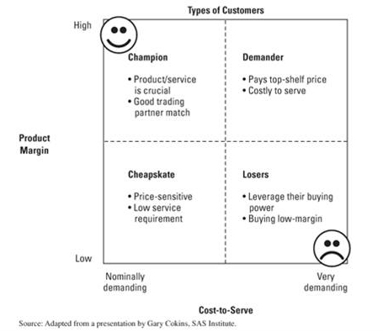
Figure 17
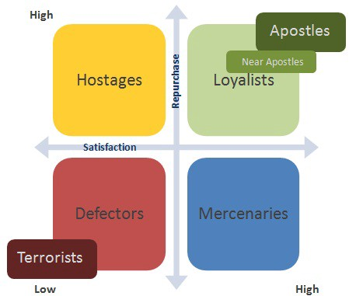
Figure 18: The IDIC Model

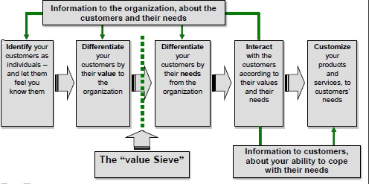

Figure 19: CRM Value Chain
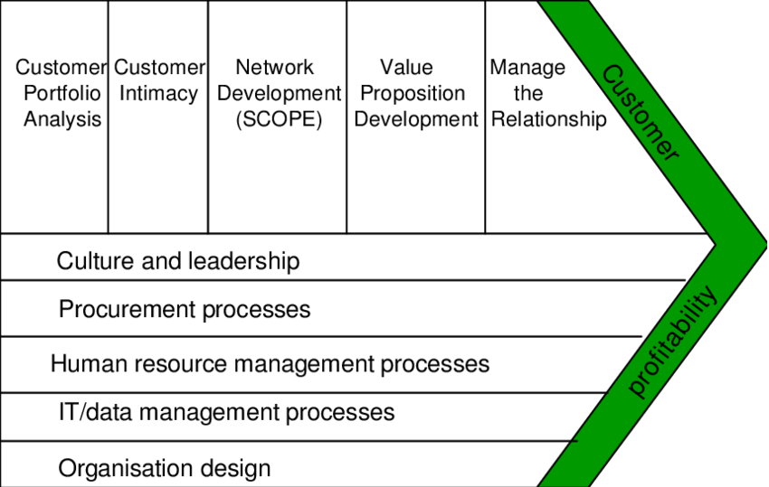

7.0 Acknowledgements
I take this opportunity to thank the University Librarians for guiding me in the selection of the most relevant materials. Without their assistance, it would not have been possible to extract information from the secondary data sources. Above all, I am grateful to God for giving me good health and peace of mind when preparing and completing this report.

8.0 Reference List
Ahi, P. and Searcy, C., 2015. Assessing sustainability in the supply chain: A triple bottom line approach. Applied Mathematical Modelling, 39(10-11), pp.2882-2896.
Bartelmus, P., 2010. Use and usefulness of sustainability economics. Ecological Economics, 69(11), pp.2053-2055.
Boons, F. and Mendoza, A., 2010. Constructing sustainable palm oil: how actors define sustainability. Journal of Cleaner Production, 18(16-17), pp.1686-1695.
Carroll, A. and Buchholtz, A., 2014. Business and Society: Ethics, sustainability, and stakeholder management. Nelson Education.
Clarke, T. and Boersma, M., 2016. Sustainable finance? A critical analysis of the regulation, policies, strategies, implementation and reporting on sustainability in international finance. UNEP-Inquiry: Design of a Sustainable Financial System.
DesJardins, J.R., 2009. An introduction to business ethics. New York: McGraw-Hill Higher Education.
Fleurbaey, M., 2015. On sustainability and social welfare. Journal of Environmental Economics and Management, 71, pp.34-53.
Geissdoerfer, M., Savage, P., Bocken, N.M. and Hultink, E.J., 2017. The Circular Economy–A new sustainability paradigm?. Journal of cleaner production, 143, pp.757-768.
Hallstedt, S.I., 2017. Sustainability criteria and sustainability compliance index for decision support in product development. Journal of Cleaner Production, 140, pp.251-266.
Holland, D. and Albrecht, C., 2013. The worldwide academic field of business ethics: Scholars’ perceptions of the most important issues. Journal of Business Ethics, 117(4), pp.777-788.
Jones, T.M., Wicks, A.C. and Freeman, R.E., 2017. Stakeholder theory: The state of the art. The Blackwell guide to business ethics, pp.17-37.
Kant, I. (1996). The metaphysics of morals.
Kolk, A., 2018. Sustainability, accountability and corporate governance: exploring multinationals' reporting practices. Business strategy and the environment, 17(1), pp.1-15.
Lo, S.F. and Sheu, H.J., 2017. Is corporate sustainability a value‐increasing strategy for business?. Corporate Governance: An International Review, 15(2), pp.345-358.
Macdonald, E.K., Kleinaltenkamp, M. and Wilson, H.N., 2016. How business customers judge solutions: Solution quality and value in use. Journal of Marketing, 80(3), pp.96-120.
McAdam, R. and Leonard, D., 2003. Corporate social responsibility in a total quality management context: opportunities for sustainable growth. Corporate Governance: The international journal of business in society, 3(4), pp.36-45.
Miles, S., 2017. Stakeholder theory classification: A theoretical and empirical evaluation of definitions. Journal of Business Ethics, 142(3), pp.437-459.
Mitchell, K., Ladouceur, A.J., Liu, R. and Coffman, R., 2016. Triple Bottom Line Cost-benefit Analysis of Green Infrastructure in Norman, Oklahoma. International Journal of the Constructed Environment, 7(4).
Mitra, A., 2016. Fundamentals of quality control and improvement. John Wiley & Sons.
Najafizada, S.A.M., Labonté, R. and Bourgeault, I.L., 2017. Stakeholder’s perspective: Sustainability of a community health worker program in Afghanistan. Evaluation and program planning, 60, pp.123-129.
Navimipour, N.J. and Soltani, Z., 2016. The impact of cost, technology acceptance and employees' satisfaction on the effectiveness of the electronic customer relationship management systems. Computers in Human Behavior, 55, pp.1052-1066.
Noe, R.A., Hollenbeck, J.R., Gerhart, B. and Wright, P.M., 2017. Human resource management: Gaining a competitive advantage. New York, NY: McGraw-Hill Education.
Pesendorfer, J. and Lehner, O.M., 2016. Islamic Banking and finance as an Ethical Alternative: a systematic literature Review.
Pope, J., Annandale, D. and Morrison-Saunders, A., 2014. Conceptualising sustainability assessment. Environmental impact assessment review, 24(6), pp.595-616.
Rahimi, R. and Kozak, M., 2017. Impact of customer relationship management on customer satisfaction: The case of a budget hotel chain. Journal of Travel & Tourism Marketing, 34(1), pp.40-51.
Rutter, C., Armstrong, K. and Cano, M.B., 2017. The epiphanic sustainable fast fashion epoch. In Sustainability in Fashion (pp. 11-30). Palgrave Macmillan, Cham.
Schulz, S.A. and Flanigan, R.L., 2016. Developing competitive advantage using the triple bottom line: A conceptual framework. Journal of Business & Industrial Marketing, 31(4), pp.449-458.
Smith, T.M. and Fischlein, M., 2010. Rival private governance networks: Competing to define the rules of sustainability performance. Global Environmental Change, 20(3), pp.511-522.
Soltani, Z. and Navimipour, N.J., 2016. Customer relationship management mechanisms: A systematic review of the state of the art literature and recommendations for future research. Computers in Human Behavior, 61, pp.667-688.
Sternberg, E., 2010. Just business: Business ethics in action.
Thomas, S., 2017. Fashion Ethics. Routledge.
Tsalikis, J. and Fritzsche, D.J., 2018. Business ethics: A literature review with a focus on marketing ethics. Journal of Business Ethics, 8(9), pp.695-743.
Upstill-Goddard, J., Glass, J., Dainty, A. and Nicholson, I., 2016. Implementing sustainability in small and medium-sized construction firms: the role of absorptive capacity. Engineering, Construction and Architectural Management, 23(4), pp.407-427.
Wang, Z. and Kim, H.G., 2017. Can social media marketing improve customer relationship capabilities and firm performance? Dynamic capability perspective. Journal of Interactive Marketing, 39, pp.15-26.
Whipple, T.W. and Swords, D.F., 2012. Business ethics judgments: A cross-cultural comparison. Journal of Business Ethics, 11(9), pp.671-678.
Xia, Y. and Li-Ping Tang, T., 2011. Sustainability in supply chain management: suggestions for the auto industry. Management Decision, 49(4), pp.495-512.
Yip, A.W. and Bocken, N.M., 2018. Sustainable business model archetypes for the banking industry. Journal of cleaner production, 174, pp.150-169.
Zink, K.J., 2007. From total quality management to corporate sustainability based on a stakeholder management. Journal of management history, 13(4), pp.394-401.
Zwetsloot, G.I.M. and Van Marrewijk, M.N., 2014. From quality to sustainability. Journal of Business Ethics, 55(2), pp.79-82.

9.0 Bibliography
Asongu, J.J., 2007. The history of corporate social responsibility. Journal of Business and Public Policy, 1(2), pp.1-18.
Fredericks, S.E., 2013. Measuring and evaluating sustainability: Ethics in sustainability indexes. Routledge.
Kula, E., 1997. History of environmental economic thought. Routledge.

