Student name:Emanuela Ioana Muntean
Student ID number:2018070
Module code:BMIH5006
Lecturer :Huw Thomas
Assignment title:Report

Executive Summary
The environmental sustainability practices in the UK hospitality and tourism sector are significantly increasing to improve customer support and satisfaction. This report shows the sustainability practices, a hospitality organisation needs to implement to improve its brand image and help it meet its corporate social responsibilities.

Table of Contents
Introduction 4
Main Body 4
Conclusion 10
References 11

Introduction
Environmental sustainability refers to the responsibility of an organisation towards conserving natural resources and protecting the global ecosystem. The principles of environmental sustainability include ecological integrity, economic efficiency, social equity and intergenerational equity (Watsonwolfe, 2023). The hospitality and tourism management of the UK is based on this ecological , socio-cultural and economic pillar. This report will assess the sustainability practices of the UK hospitality and tourism industry maintained in daily operations. This will also focus on the benefits and challenges associated with integrating sustainability in their daily operations through which the future of the hotels and hospitality industries in the UK will be identified.

Main Body
“Consider what hotels need to implement and to comply with in order to be granted sustainable accreditation”
The UK Tourism and hospitality management is significantly towards sustainability practices to meet the changing demands of customers who have become more conscious about environmental sustainability. These operational changes are mainly dependent on eco-conscious housekeeping, digital in-room directories, avoidance of use of single-use plastics, and using eco-friendly team uniforms (Frasers Hospitality, 2023). According to Inkson and Minnaert (2018), 21st-century tourism is mainly dependent on some key factors like sustainability, globalisation, the climate crisis, community, technology, the environment and the sharing economy. In recent times, UK tourism has faced several sustainability issues which include increased pollution and waste of natural resources which are putting pressure on wildlife and endangering species. In 2019, before the COVID-19 pandemic, the UK had generated around 23.9 million tonnes of waste from tourism sectors which was around 4% of total waste generated in the UK (Waste Managed, 2019). In this year around 5.3 million tonnes of CO2 was generated from the UK tourism sector (Waste Managed, 2019). The situation has not changed significantly even in 2023 after the pandemic as a report revealed that more than 9.5 million tonnes of food are wasted from the UK hospitality and tourism industry (Capcon, 2023). From these, it is clear that the UK hospitality and tourism organisations are needed to implement. Green tourism is based on green consumption activities which help an organisation meet their corporate social responsibilities (CSRs) effectively.
Eco-conscious housekeeping: This helps minimise waste by increasing the use of reusable cleaning supplies like microfiber cloths and sponges (Seasandstraws, 2023). For example, Marriott guest rooms are a “Green Seal-certified” cleaning solution and here guests are provided with the option to reuse linens, LED Bulbs as well as recycle bins (Marriott, 2024a).
Digital in-room directories: According to Cooper (2021), artificial intelligence, digital marketing and robotics are influencing customer engagement in tourism. As customers have significantly moved towards touchless services in tourism, the implication of robotics is necessary to enhance guest satisfaction in this industry. For example, Marriotts has Implemented AI chatbots named “Marriott Moments” which helps them improve guest satisfaction and engagement (Linkedin, 2023). Apart from these, the organisation has online booking services that reduce guests’ efforts to book services.
Avoidance of the use of single-use plastics: the UK government has put a ban on use of single-use plastics (Food Digital, 2023); which has reduced the use of plastics in UK tourism. For example, the “Banff National Park” has started working on phase 2 from January 2024 to reduce the use of single-use plastics in tourism of this park (Banfflakelouise, 2024).
Using eco-friendly team uniforms: eco-friendly team uniforms are biodegradable which has less impact on the environment. These can improve the green practices of the UK hospitality and tourism organisations. For example, Marriott Hotels implemented eco-friendly uniforms for all its employees to help them improve environmental sustainability in its entire operational structure (Marriott, 2024b).
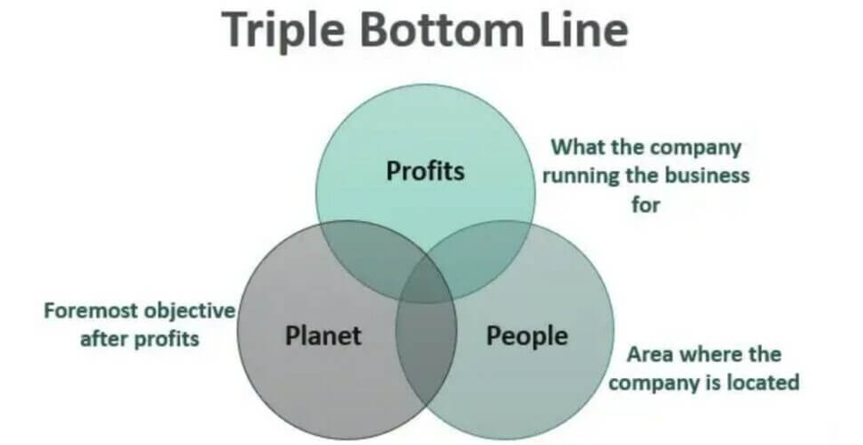
Figure 1: Triple Botton Line Theory
(Source: Wallstreetmojo, 2024)
According to Lock, and Araujo (2020), the “Tripple Bottom Line” theory expands the conventional success of an organisation through social well-being, environmental health and an economy characterised by three bottom lines: People, Planet and Profit. In order to acquire long-term and sustainable growth to the tourism and hospitality businesses, the UK organisations need to expand its focus on social well-being and environmental sustainability which can help them meet corporate social responsibilities which improve financial support. In this recent era of globalisation when customers are moving towards using technologies to improve sustainable practices, a hospitality and tourism organisation is needed to improve the use of eco-friendly products to reduce waste and enhance green operations effectively.
“What are the benefits and challenges associated with integrating sustainability into their daily operations?”

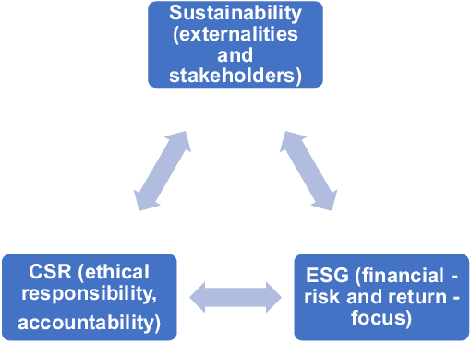
Figure 2: ESG theory
(Source: MacNeil and Esser, 2022, p.11)
It can be stated that implementing and executing green practices in hotels presents and offers various types of advantages as well as benefits including ‘boosts profits, cost savings, competitive advantage, and high customer retention’. However, ‘challenges may include upfront costs, resource limitations, and the requirement for ongoing awareness and training’. It can also be stated that integrating sustainability into hospitality and tourism operations offers and delivers a range of advantages such as cost reduction, enhanced brand image and reputation. In addition to this, sustainable practices such as utilising energy-efficient appliances, decreasing water usage, and reducing waste which can lead to essential as well as important cost savings in the long run.
Environmental, social and governance (ESG) is a framework utilised to assess a business practice and performance of an organisation on different types of sustainability and ethical problems which also provides a pathway to measure business risks and opportunities in those areas. It can be stated that eco-conscious customers are a growing demographic. In addition to this, businesses can attract these customers and build a positive brand image by executing and implementing sustainable practices. Many regions have environmental regulations that hospitality businesses have followed and sustainable practices can help assure compliance and avoid fines.
Sustainability often includes resources and optimising procedures which can lead to a more streamlined process and better overall efficiency. Tourism in the United Kingdom is faced with various types of sustainability issues such as increased pollution, Initial investment and waste of natural resources which are putting pressure on wildlife and endangering species. Some sustainable practices such as installing solar panels require upfront costs which is disrupt their sustainability programmes in the organisation. In addition to these businesses are required to weigh these costs against the long-term advantages as well as benefits.
The objectives of an ESG theory are to demonstrate the ‘environmental, social, and governance factors’ that their organisation believes to be intrinsically essential to consider within their current and upcoming business process (Ajayi, 2024). It has been observed that encouraging guests to participate in sustainable practices such as reutilising their products or turning off lights when not in utilises may need education and clear communication among employees in the organisations. There are various types of sustainability instability available and that can be confusing for both business enhancement and customers’ expectations and satisfaction. It can be stated that finding the right standard and mitigating the instability procedures is challenging for establishing market sustainability. In addition to this ensuring sustainable practices disrupts the supply chain and affects food sourcing, offering various types of facilities from an organisation to laundry services and it can be complex. Overall it can be stated that integrating sustainability into hospitality and tourism management offers and delivers significant advantages although it has some challenges. Businesses can reap the rewards of more sustainable techniques by sincerely considering the challenges and planning for execution and implementation.
The increasing cost of products is significantly affecting customer retention in the UK hospitality and tourism sectors. In 2023, the cost of tourism in the UK increased by around 17.8% due to the current inflation rate not only in the UK but all around the world (Statista, 2024a). This has caused resource limitations for many organisations affecting guests' satisfaction significantly. More specifically, the UK hospitality sector is facing a significant workforce shortage as currently, the UK hospitality sector has around 132,000 vacancies which are 48% above pre-pandemic levels (UK Hospitality, 2024). In this context, the Brexit is also responsible significantly.

What does the future look like within the hotel & hospitality industry?
As per the National and international trends of changing operational structure of the hotel and hospitality industry in the UK, it can be stated that the future of the hospitality industry is bright in the context of sustainability through digital transformation. The COVID-19 pandemic has significantly impacted the UK hospitality industry which led them towards using technologies like Augmented reality and virtual reality (Revfine, 2024). In 2023, the market size of the UK hospitality industry was 24.7 billion GBP which is p by 16.42 billion GBP from the previous year (Statista, 2024b). This indicates the bright future of UK hospitality through implementing sustainability practices and digital technologies which also can minimise the need of human resources significantly.
It can be stated that integration of this sustainability practice has various types of benefits as these ‘boost profits, save costs’, and it helps an organisation acquire high customer retention (Fatima and Elbanna, 2020). However, it has challenges including upfront costs, resource limitations, and the need for ongoing awareness and training. It has been observed that driven by interlinked factors including technical progress for business enhancement, becoming customers’ preferences and a more serious focus on sustainability, hospitality businesses can capitalise on emerging possibilities and opportunities to increase customers' experiences and position themselves for long-term success. Expect even greater technology usage to streamline procedures and personalise the customer experience and mobile check-in or out, smart room management or smart room control, and AI-powered chatbots are just a few examples. Eco-friendly practices are going to become even more important and also as well as hotels are going to concentrate on energy and waste reduction, water conservation, and utilising sustainable materials. It can be stated that travellers are seeking out special and authentic experiences and hotels may offer themed stays, local associations connections, or concentrate them on wellness and special interests. Hotels are going to cater to travellers who work remotely as well as deliver and offer employees spaces and extras that help productivity. It can also be stated that the lines between business and leisure travel continue to blur. The industry is anticipated or predicted to rebound strongly post-pandemic which is driven by pent-up demand for travel and also accommodation choices will resume to diversify with a rise in vacation rentals and boutique hotels alongside chains tradition. It can also be stated that safety and health will remain a priority for travellers or customers, with hotels possibly to support and maintain hygiene protocols. Overall, the hospitality future looks bright and creative or innovative. Hotels can cater to the evolving requirements of travellers and provide their ongoing success by embracing, sustainability, technology, and special and unique experiences. The biggest trends coming for the hospitality industry are ‘sustainability, global perspective, finding balance’ with new lodging opportunities, and increasing demand. Guests are changing too, and desire a more personalised and unique experience. In meeting these requirements, hotels can keep costs and enable to promote and foster a better guest journey, therefore attracting repeat bookings and suggestions or recommendations. It can be considered that hotels have more implement and comply with in order to be granted sustainable accreditation, which is to enhance business engagement and enhance and maintain their sustainability process. Environmental, social and governance (ESG) is a framework that will be used to assess a business practice and performance of an organisation on diverse types of sustainability and ethical problems which also will provide a path to measure business risks and create reding techniques and opportunities in those areas.

Conclusion
In conclusion, it can be stated that, the UK hotel and hospitality industry is undergoing significant changes in customer demands which is leading them to improve sustainability practices in each level of their operations. UK hospitality organisations have to implement eco-conscious housekeeping, digital in-room directories, avoidance of the use of single-use plastics, and using eco-friendly team uniforms to improve their sustainability. Integration of this sustainability practice has several benefits as these boost profits, save costs, and help an organisation acquire high customer retention. However, it has challenges including upfront costs, resource limitations, and the requirement for ongoing awareness and training. Overall, with these benefits and challenges the UK hospitality businesses are growing significantly.

References
Ajayi, O.A., (2024). Implementing Environmental, Social, and Governance (ESG) Principles in Organizations: The Role of Leadership and Impacts on Corporate Financial Performance (Doctoral dissertation, Case Western Reserve University).
Banfflakelouise, (2024). 2024 Brings New Rules for Single-Use Items Reduction Bylaw. Available at: https://www.banfflakelouise.com/members/news/single-use-items-reduction-bylaw (Accessed: 25 May 2024)
Capcon, (2023). Food Waste Management In UK Hospitality Industry. Available at: https://www.capcon.co.uk/food-waste-management-in-uk-hospitality-industry/ (Accessed: 27 May 2024)
Cooper, C. (2021) Essentials of tourism. Third edition. London: Sage.
Fatima, T. and Elbanna, S., 2020. Balanced scorecard in the hospitality and tourism industry: Past, present and future. International journal of hospitality management, 91, p.102656.
Food Digital, (2023). UKHospitality speaks out on the new single-use plastic ban. Available at: https://fooddigital.com/hotels-and-hospitality/ukhospitality-speaks-out-on-the-single-use-plastic-ban#:~:text=The%20UK%20Government%20has%20confirmed,food%20containers%20under%20the%20ban. (Accessed: 25 May 2024)
Frasers Hospitality, (2023). Experience Sustainable Living: Stay in our Eco-Friendly Serviced Apartments. Available at: https://www.frasershospitality.com/en/united-kingdom/sustainability/#:~:text=Going%20Green%20in%20the%20UK%3A&text=These%20include%20eco%2Dconscious%20housekeeping,of%20eco%2Dfriendly%20team%20uniforms. (Accessed: 27 May 2024)
Inkson, C. and Minnaert, L., (2018). Tourism management: an introduction. Sage.
Linkedin, (2023). How the Hotel Industry is Using AI and Custom Chatbots. Available at: https://www.linkedin.com/pulse/how-hotel-industry-using-ai-custom-chatbots-zu-ortenburg-msc-sloan#:~:text=To%20assist%20guests%20in%20making,increase%20guest%20engagement%20and%20satisfaction. (Accessed: 25 May 2024)
Lock, I. and Araujo, T., (2020). ‘Visualizing the triple bottom line: A large‐scale automated visual content analysis of European corporations' website and social media images’. Corporate Social Responsibility and Environmental Management, 27(6), pp.2631-2641.
MacNeil, I. and Esser, I.M., (2022). From a financial to an entity model of ESG. European Business Organization Law Review, 23(1), pp.9-45.
Marriott, (2024a). Sustainability Happens Here. Available at: https://www.marriott.com/marriottassets/marriott/PHXGP/PDF/PHXGP_SHER_Grand_Phoenix_Downtown_Sustainability_Flyer.pdf (Accessed: 25 May 2024)
Marriott, (2024b). Going Green: 5 Hotels Leading the Way in Sustainable Travel. Available at: https://traveler.marriott.com/tips-and-trends/sustainable-hotels-europe-middle-east/
Revfine, (2024). Technology Trends in the Hospitality Industry. Available at: https://www.revfine.com/technology-trends-hospitality-industry/#:~:text=AR%20and%20VR%20Technologies%3A%20Virtual,%2C%20cleaning%2C%20and%20other%20tasks. (Accessed: 25 May 2024)
Seasandstraws, (2023). 5 ECO-FRIENDLY HOUSEKEEPING HACKS FOR HOTELS READY TO GO GREEN. Available at: https://www.seasandstraws.com/5-eco-friendly-housekeeping-hacks.html#:~:text=In%20addition%2C%20minimize%20waste%20by,waste%2C%20and%20composting%20food%20waste. (Accessed: 25 May 2024)
Statista, (2024a). Consumer price index (CPI) inflation rate of travel and tourism services in the United Kingdom (UK) from May to December 2023. Available at: https://www.statista.com/statistics/1319309/cpi-inflation-rate-travel-tourism-services-united-kingdom/#:~:text=In%20December%202023%2C%20the%20consumer,in%20the%20UK%20that%20month. (Accessed: 25 May 2024)
Statista, (2024b). Market size of the hotel industry in the United Kingdom from 2013 to 2023, with a forecast for 2024. Available at: https://www.statista.com/statistics/1364712/hotel-industry-market-size-uk/#:~:text=In%202023%2C%20the%20market%20size,around%20400%20million%20British%20pounds. (Accessed: 25 May 2024)
UK Hospitality, (2024). Campaigning for action to solve worker shortages. Available at: https://www.ukhospitality.org.uk/campaign/workforce/ (Accessed: 25 May 2024)
Wallstreetmojo, (2024). What is a Triple Bottom Line?. Available at: https://www.wallstreetmojo.com/triple-bottom-line/ (Accessed: 25 May 2024)
Waste Managed, (2019). UK Tourism Waste & Litter Statistics. Available at: https://www.wastemanaged.co.uk/our-news/summer/tourism-waste-uk/#:~:text=Tourism%20waste%20poses%20significant%20environmental,wildlife%20through%20ingestion%20or%20entanglement. (Accessed: 27 May 2024)
Watsonwolfe, (2023). A comprehensive overview of the ethical pillars of sustainability.. Available at: https://www.watsonwolfe.com/2023/09/09/the-four-principles-of-sustainability/ (Accessed: 27 May 2024)

