Tendering documents – Best Practice
MC to SC
Procuring a package – say Drylining
I’m your commercial manager and I want you to tell me the best way to procure that package – from ground zero to placing the order
Then we are going to discuss each section in detail….

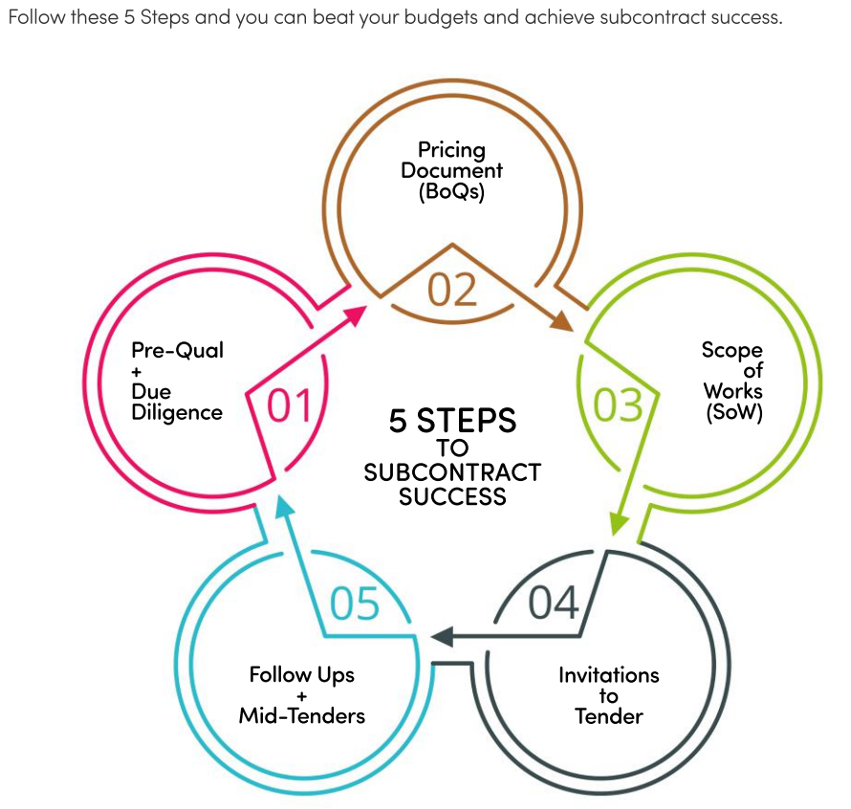

- Look into spec first for ‘equal or approved’ opportunity to make money form estimating stage by value engineering the spec. if its ‘client spec’ed’ then forget it e.g. kitchen.
- Drawings are key, think about all drawings that could have an impact on the package
- Scope of works (what can I pass down to the SC)
- Best is a fully detailed BoQ (seldom are they done, why?) time and resources
- Next best is ‘spec and drawings’ and leave the SC to take off quantities
- Any provisional sums for possible misc. items e.g. access hatches
- Or schedule of rates! (‘contract sum analysis!’)
- BoQ helps the tender analysis, when they come back from the SCs.
- Call them all before we send the tender out, saying what it is for, important return date and any queries etc. to me
- Meet them on site in 1 weeks’ time. Check attendance list what are we going to supply and what are they going to supply!
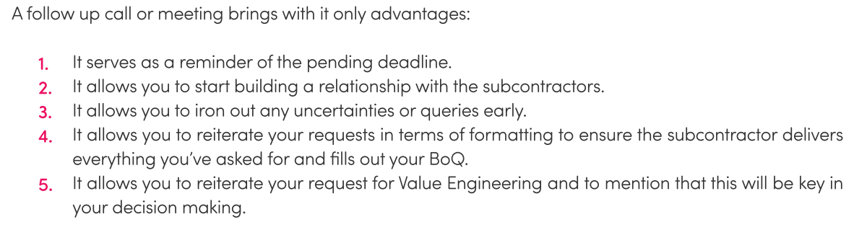
- Email the tender out!!!! Invitation to Tender:
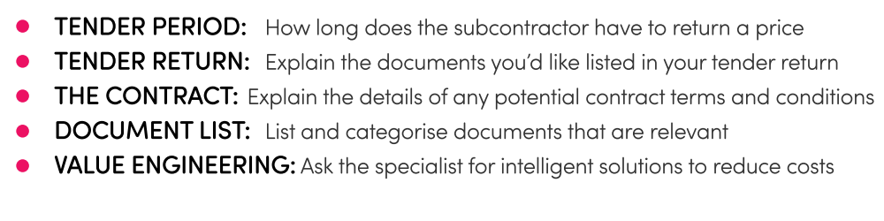

- What happens if just before return date arch gives you REV2? – tender addendum
- What about mid tender meeting? – needed for complex, high value packages following all SC site visit. Take minutes and include in the order.
- How many you going out to tender too?
- Tender return periods! Got to give SC time (4 weeks is go to, 6 for M&E) quicker if have BoQ
- What about digital procurement (not word or excel). Using a central hub, good for communicating changes
- Where do you get your scopes from? Give them an AI example.

- I think the way you have done this is a really good job, of procuring your package!

1.
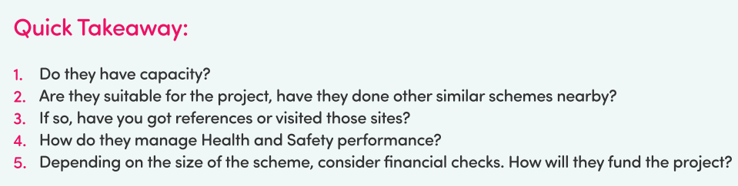
2.
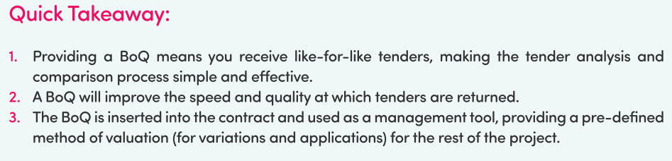
3.
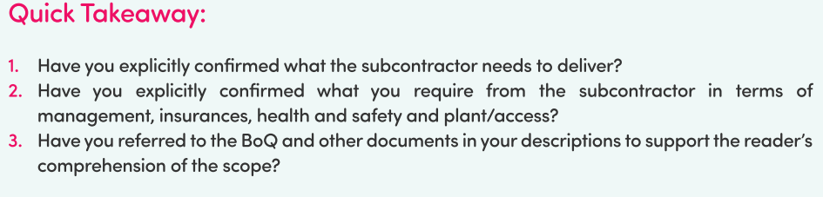
Example SoW
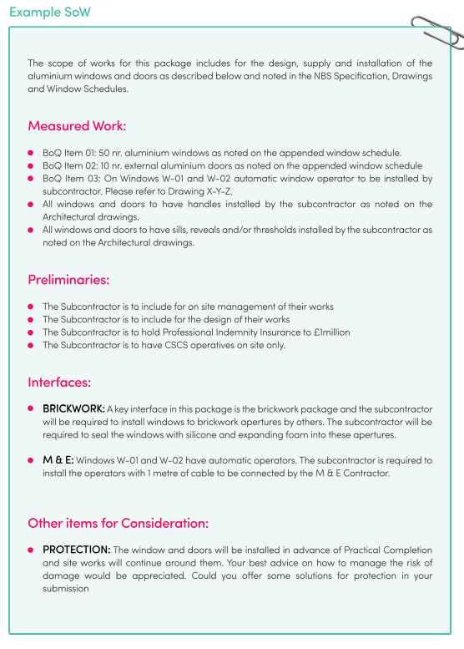
4.
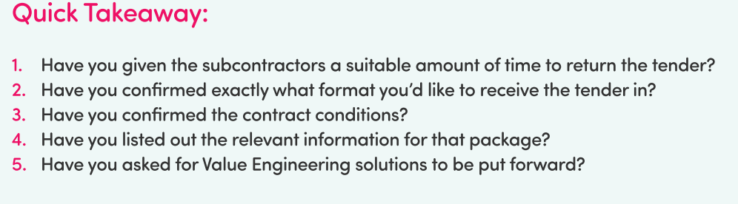

5.


