PSYCHOLOGY
(BMHP 4003_LON)

(THEME: ADULT HEALTH CARE)

DATE: 04/05/2020
LECTURE NAME: Gulnar Aly
STUDENT NAME: Wylma Ceita-1818225
Table of Contents
Introduction 2
Lifespan psychological theories 2
Application of lifespan psychological theories on adult health and social care 5
Discussion of human cognition, emotions and behavioural patterns in adulthood 6
Conclusion 8
Reference List 9

Introduction
Gaining an enhanced understanding of lifespan development is a crucial part of health and social care as it leads to an improvement in identifying and providing care for those in need. It provides an elaborated understanding of the psychological, physical and emotional changes individuals go through during their lifespan and its impact on their overall wellbeing. As individuals age, changes within their behaviour, cognition and emotions are required to be observed prior to providing care measures for them. This study is to illustrate psychological lifespan theories and their role in the provision of health as well as social care to adults.

Lifespan psychological theories
Erikson’s Psychosocial Theory of Development
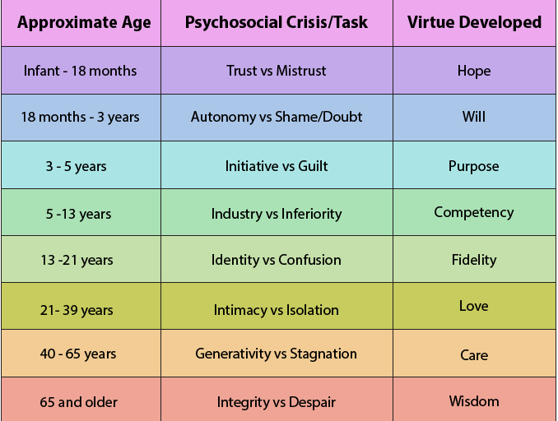
Figure 1: Erikson’s Psychosocial Theory of Development
(Source: Influenced by Çelik and Ergün, 2016)
The primary focus of “Erikson's Psychosocial Development Theory” is on the social nature of development instead of a person’s sexual nature. Çelik and Ergün (2016) observed that Erickson proposed that the development of social skills takes place throughout one’s lifespan. This directly affects the emotional, psychological and social wellbeing of individuals through different development stages in their life ranging from infancy to late adulthood. According to this developmental theory, each stage of a person’s lifespan involves conflicts that are required to be resolved. The successful completion of each task associated with development leads to incorporating a sense of competence along with a healthy personality. For instance, in the infancy stage, it is essential for resolving the conflict between “Trust vs. Mistrust”.
Lack of conflict resolution leads to the development of fear and anxiety among infants. On the other hand, in later life span stages such as in early adulthood, individuals are concerned with developing intimacy and love in their life. Cross and Cross (2017) noted that early adulthood focuses on developing a strong sense of self and finding one’s personal identity. The conflict of “Love vs. Isolation'' gains prominence as people aim to settle down. Individuals who fail to develop a positive self-concept are affected in this developmental stage due to emotional isolation and experiences of loneliness.
Focus shifts towards the conflict of “Integrity vs. Despair” in the late adulthood stage where people reflect on their life and its experiences. Individuals who have succeeded in developing a sense of integrity and accomplished their goals have lesser despair and regret than those who did not. Provision of care for people belonging to the stages of adulthood (early, middle and late) differ on the basis of their psychosocial development. In the late adulthood stage, individuals who live with regret develop a sense of bitterness, despair and depression. It becomes crucial for care providers to empathise with such care seekers and ensure that they are provided with care in an effective manner. It can thereby be ascertained that each lifespan developmental stage is interconnected for a person's social and emotional growth in “Erikson's Psychosocial Development Theory''.

Continuity versus discontinuity theory
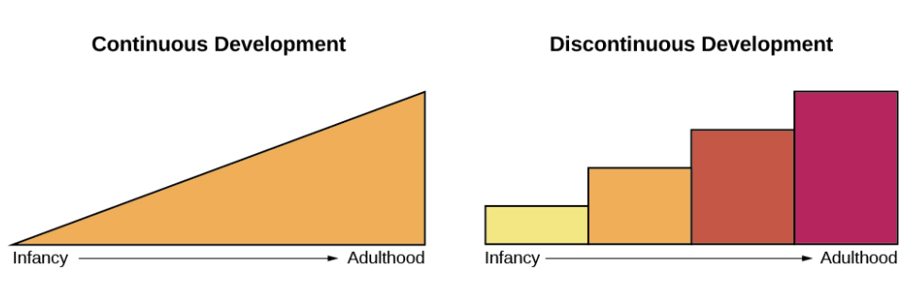
Figure 2: Continuity versus discontinuity theory
(Source: Influenced by Zhang and Zhao, 2017)
The lifespan psychological theory of “Continuity versus discontinuity” focuses on classifying stages of development as a normative continuous process. Zhang and Zhao (2017) observed that discontinuity theorists view development as an abrupt change while continuity theorist view it as a gradual change. Each stage of morality deals with the development of logical reasoning and ideas of moral conventions. For instance, biological changes are considered to be an example of discontinuous or abrupt changes. However, Jia and Krettenauer (2017) noted that psychologist believe that individuals undergo the same stages of lifespan development in the same order. However, the rate at which biological, emotional and psychological development takes place differs drastically.
On the other hand, conventional continuous developmental theorists hold the opinion that distinct transitions take place within humans. However, the transition is considerably smoother and indistinguishable. According to Carmichael et al. (2019), continuous development is facilitated by an improvement in existing skills through gradual developmental changes. The lifespan theory focusing on continuous and discontinuous development indicates the universal nature of development and stages undergone by all individuals. () observed that all children undergo the same initial stage of babbling prior to developing speech skills. Similarly, all children distinctly transition from infancy to adulthood market b key developmental milestones such as development of fine and gross motor skills, ability to distinguish between right and wrong and developing a sense of morality. The drastic changes in physical, social, emotional and cognitive abilities as a person ages and enters adulthood is required to be managed in an efficient manner and acknowledged while developing health care interventions.

Application of lifespan psychological theories on adult health and social care
The application of lifespan theories for adult health and social care determine the processes that can be used for promoting healthy ageing. According to Horn et al. (2020), lifespan psychological theories lead to an understanding of the processes that are available for preventing or delaying the onset of health issues. These act as starting points for developing healthcare interventions in order to support the adaptation of changes related to health.
Adulthood brings its own set of challenges with respect to cognitive, emotional and behavioural changes. As per the views of Fothergill et al. (2016), later stages of adulthood increases the prevalence of health complications and issues due to unhealthy lifestyle choices. Application of “Erikson’s Psychosocial Theory of Development” in managing health-related issues of late adulthood lead to understanding the psychosocial changes faced by adults. This includes their psychosocial development through the stages of early, middle and well as late adulthood. Based on the development stage in which adults are, health and social care providers develop effective care plans for communicating their intervention methods.
Care seekers who belong to middle or late adulthood ranging from 40 and above years require the feeling of comfort and care. These individuals seek to overcome their internal conflicts of stagnation and look back on their achievements in life. It is essential for health and social care providers to ensure that individuals belonging to the late adulthood stage are treated with dignity, care and respect. Knight (2017) observed that eldercare requires empathy and an understanding of their situation as they are often neglected by their children and develop a sense of remorse due to the same. It thereby becomes essential to communicate with them in an empathetic manner and treat them with dignity while taking care of their health and social care needs.
The application of “Continuity versus discontinuity theory” for the development of care intervention methods for adults leads to the ascertainment of key needs of adults and the moral reasoning stage they are at. Damon et al. (2018) stated that the application of “Continuity versus discontinuity theory” leads to the development of prognosis care measures. It provides care providers with an understanding of underlying emotional, and psychosocial distress leading to the onset of symptoms of health issues. Gaining a comprehensive understanding of the same further leads to initiation of better treatment plans which are well-informed and meet the physical, emotional and psychosocial needs of patients. This theory enables care providers to ascertain the moral reasoning that would be beneficial for providing treatment and care initiatives for adults. Apart from this, it further enlightens care providers about the transitions in physical and mental wellbeing among adults leading to improved measures. For instance, it is evident that as an individual grows older, they lose mobility. Healthcare professionals would be required to be well-prepared for dealing with such an issue by determining the physical changes that a person in late adulthood is going through.
Henderson et al. (2018) observed that ascertainment of the transition or development stage an individual is in leads to identification of their key healthcare needs. These individuals would be motivated by their personal desire to improve themselves. However, individuals belonging to the conventional stage of morality would be easier to persuade as they would be comparatively more rational and work towards the benefit of their family’s psychological wellbeing. Post conventional adults would be the easiest to persuade for following care intervention plans developed by healthcare professionals as they are self-aware and comply with the predominant social contract.

Discussion of human cognition, emotions and behavioural patterns in adulthood
Ascertainment of the relationship between cognitive and emotional changes within adults is a crucial aspect of improving psychological along with psychological healthcare needs of people. Anacker and Hen (2017) stated that cognitive and emotional biases since childhood have a direct impact on the development of depression and anxiety among adults. This is further affected by the psychological development of individuals through the lifespan. Assessing the integration of changes within an adult's cognition, behavioural patterns and emotional stages leads to developing functional interventions in adult health and social care.
Cognition
Adult cognitive development spans for a period of over 60 years beginning from early adulthood at 20 years of age. Malinowski et al. (2017) noted that the development of cognitive abilities in the adult range is complex and dynamic. This is deeply affected by an individual's socio-economic, genetic as well as psychosocial developmental skills. The complexity of adulthood cognitions ranges from patterns of regression performances due to excessive stress and improper lifestyle. This leads to low development of cognitive skills. On the other hand, Klindt et al. (2017) contradicted that adult cognition shows a simple forward progression pattern until middle adulthood. Cognitive abilities begin diminishing at the onset of late adulthood as individuals begin to lose functionality of psychomotor skills. The onset of forgetfulness, attention deficit, loss of control and flexibility are among the key issues of cognitive functioning faced by individuals in the stage of late adulthood.
Emotions
As individuals enter later stages of adulthood, their dependency on others begins to increase. This leads to an emotional conflict of guilt, shame and helplessness in late adulthood. Rakoczy et al. (2018) noted that adults are deeply affected by the realisation of death and seeing their loved ones pass away. This has a direct impact on their overall health and well-being. In accordance with Erickson’s theory, it has been observed that late adulthood is marked with the conflict associated with “integrity vs. despair”. Individuals belonging to the stage who have not met their expectations develop a feeling of despair leading to neglect of their personal well-being. It becomes difficult to persuade such individuals to focus on their physical and psychological health leading to the development of a personalised care intervention plan to meet their needs.
Behavioural Patterns
Pre-existing societal norms and standards have a significant impact on the behavioural patterns developed by individuals in adulthood. As per the views of Daugherty et al. (2016), countries where elders are viewed as a burden to one’s household develop a sense of regret and remorse. This directly affects their self-esteem as they grow older leading to increased difficulty in acceptance of old age. Self-perception among people belonging to the stage of late adulthood is greatly formed due to stereotypes of being non-contributing members of society. Lüdtke et al. (2019) observed that people who hold “ageist attitudes” have a higher susceptibility to depression and anxiety with old age. This leads to a development of neglect towards one’s well-being deeming it useful or unnecessary.
It can thereby be ascertained that there is a growing requirement for healthcare interventions in eldercare for the purpose of mitigating the society’s “ageist attitude” towards elders. Enhancing the quality of life and living conditions of individuals is required to be established regardless of their age. This is an integral aspect of developing appropriate health care interventions for adults while according to their social, psychological and emotional care needs. Through the incorporation of a collaborative approach by health social care professionals, governments, families and societies, provision of care in old age can be improved significantly and a positive change in pre-existing behavioural patterns associated with growing old can be incorporated.

Conclusion
The study thereby concludes that it is essential to treat individuals with dignity and care as they grow older. This is due to the changes in their emotional, cognitive and behavioural patterns which led to an increase in their feeling of guilt and helplessness. Through the application of lifespan psychology theories, the provision of health and social care to adults can be met. This would invest treating individuals belonging to the stage of late adulthood with care, empathy and communicating in a positive manner with them. Thus, through the determination of appropriate psychosocial and moral developmental issues in adults, proper care plans can be developed for promoting the holistic wellbeing of adults.

Reference List
Anacker, C. and Hen, R., (2017). Adult hippocampal neurogenesis and cognitive flexibility—linking memory and mood. Nature Reviews Neuroscience, 18(6), p.335.
Carmichael, C.L., Schwartz, A.M., Coyle, M.A. and Goldberg, M.H., (2019). A Classroom Activity for Teaching Continuity versus discontinuity theory. Teaching of Psychology, 46(1), pp.80-86.
Çelik, B. and Ergün, E., 2016. An integrated approach of Erikson’s psychosocial theory and adlerian counseling. The International Journal of Human and Behavioral Science, 2(1), pp.20-26.
Cross, T.L. and Cross, J.R., (2017). Maximizing potential: A school-based conception of psychosocial development. High Ability Studies, 28(1), pp.43-58.
Damon, W., Colby, A. and King, P.E., (2018). They do care: An interview with William Damon and Anne Colby on moral development. Journal of Moral Education, 47(4), pp.383-396.
Daugherty, A.M., Bender, A.R., Raz, N. and Ofen, N., (2016). Age differences in hippocampal subfield volumes from childhood to late adulthood. Hippocampus, 26(2), pp.220-228.
Fothergill, K., Ensminger, M.E., Doherty, E.E., Juon, H.S. and Green, K.M., (2016). Pathways from early childhood adversity to later adult drug use and psychological distress: A prospective study of a cohort of African Americans. Journal of health and social behavior, 57(2), pp.223-239.
Henderson, S., Horne, M., Hills, R. and Kendall, E., (2018). Cultural competence in healthcare in the community: a concept analysis. Health & social care in the community, 26(4), pp.590-603.
Horn, S.R., Fisher, P.A., Pfeifer, J.H., Allen, N.B. and Berkman, E.T., (2020). Levers and barriers to success in the use of translational neuroscience for the prevention and treatment of mental health and promotion of well-being across the lifespan. Journal of Abnormal Psychology, 129(1), p.38.
Jia, F. and Krettenauer, T., (2017). Recognizing moral identity as a cultural construct. Frontiers in psychology, 8, p.412.
Klindt, D., Devaine, M. and Daunizeau, J., (2017). Does the way we read others' mind change over the lifespan? Insights from a massive web poll of cognitive skills from childhood to late adulthood. Cortex, 86, pp.205-215.
Knight, Z.G., (2017). A proposed model of psychodynamic psychotherapy linked to Erik Erikson's eight stages of psychosocial development. Clinical psychology & psychotherapy, 24(5), pp.1047-1058.
Lüdtke, J., Froehlich, E., Jacobs, A.M. and Hutzler, F., 2019. The SLS-Berlin: Validation of a German computer-based screening test to measure reading proficiency in early and late adulthood. Frontiers in psychology, 10, p.1682.
Malinowski, P., Moore, A.W., Mead, B.R. and Gruber, T., (2017). Mindful aging: the effects of regular brief mindfulness practice on electrophysiological markers of cognitive and affective processing in older adults. Mindfulness, 8(1), pp.78-94.
Rakoczy, H., Wandt, R., Thomas, S., Nowak, J. and Kunzmann, U., (2018). Theory of mind and wisdom: The development of different forms of perspective‐taking in late adulthood. British Journal of Psychology, 109(1), pp.6-24.
Zhang, Q. and Zhao, H., (2017). An analytical overview of Continuity versus discontinuity theory in college moral education in mainland China. Open Journal of Social Sciences, 5(8), pp.151-160.

