Internet Technology and Security

27th December 2019

A report submitted in fulfilment of the requirements for Course ACCA4018, Department of Computing, University of Trinity Saint Davids.

Contents Page

Section 1 - Introduction

Section 2 - Requirements

Section 3 - Implementation

Section 4 - Evaluation
Section 5 - References

1 - Introduction

In this report I will demonstrate my understanding of the standards, concepts, principles and practices required in the implementation of websites as you will see from the information below. My website will be about Tesla and I will be talking about their products; their Cyber truck, Model S, 3, X, Y and the Roadster. I will also be giving a brief overview of SpaceX and their Energy, finally finishing off with an about section talking about Tesla as a company.

2 - Requirements

The front page of my website is mainly for show. This will have the Tesla logo across the top of the page, a navigation bar leading to more information about their products, SpaceX, Energy and an About section. Underneath that will have a picture of Elon Musk with an inspirational quote and some information on him.
The first option on my navigation bar are Tesla’s products. A picture of said vehicle and then followed by a short paragraph describing the car and some of its features and statistics. I will lay it out by having the first picture on the left followed by the description on the right. Then for the next vehicle I will have the description on the left and the picture on the right. I'm doing this because I think this design is the easiest to follow and you don't just have a big wall of text on your screen.
The second option will be about Tesla’s Energy. I will break down what they are doing, how it can affect you as a customer and some of the benefits and drawbacks of using Tesla Energy.
For my third selection I will analyze Tesla’s “SpaceX” Research Division. Similarly to the section on Energy I will be explaining what they do, some of the services that they could offer you in time to come and some of their achievements that they have accomplished so far. I will also be changing the Tesla logo to the SpaceX logo at the header.
Finally I will have a section titled “About”. Here I will talk about Tesla, how it was founded and some of their achievements.

I’m making this website to educate people who want to know more about SpaceX, Tesla’s Energy, the vehicles they make and Elon Musk himself. I want to do this because I believe that promoting the use of sustainable energy is becoming more of an obvious option as trying to take a gamble with climate change is a silly idea and there is no good outcome to carry on using them apart from putting more money in the multi-trillion dollar oil companies. With the progression of technology and sustainable energy soon it will surpass non-renewable energy sources in every aspect from production to performance and it will be vastly more ethical, environmentally friendly and most importantly to the corporations more financially stable. The target audience for my website will be people looking for information on the previously discussed topics all in one site that is easily maneuverable.

3 - Implementation

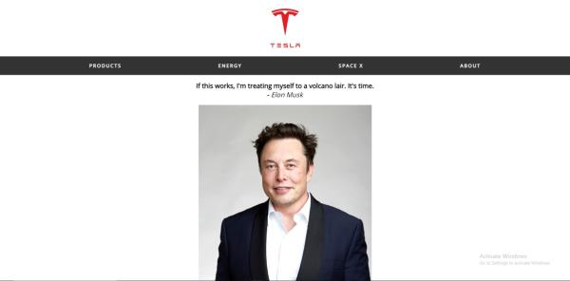
As you can see from my home page I have included a header containing Tesla’s logo, underneath that a navigation bar can take you to the 4 different sections of my website. The main body of the front page contains a lovely picture of Elon Musk, a quote I find rather inspiring and some information on him as a person.

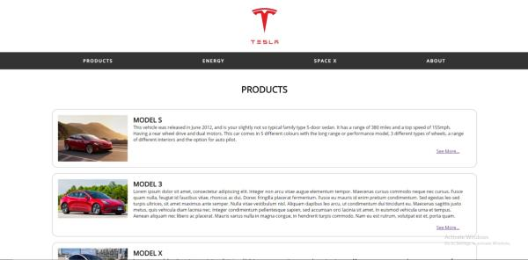
My next page is on the vehicles that Tesla make. I’ve put a picture of the car on the left followed by a title and a brief description of the car. I have also included a link that takes you to a page entirely dedicated to the car. As you can see from the screenshot below.
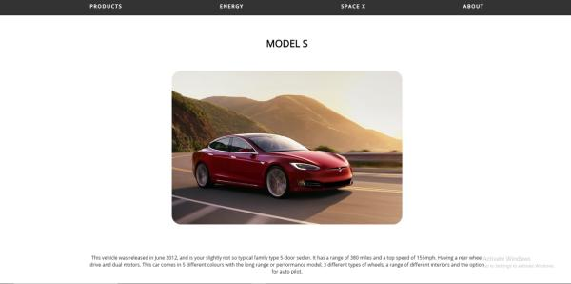

On this page I have given a brief explanation about the Energy side of Tesla and what they have to offer and a video of Elon Musk introducing Tesla.

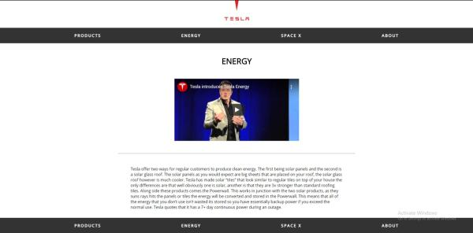

The second to last page is on SpaceX which again has a brief description of who they are, their achievements and a cool video about the Dragon. I have also changed the header to a SpaceX logo.

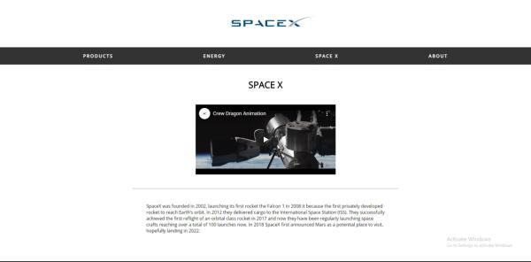

Finally, my last page is an About section giving a brief description of Tesla, their achievements and a copyright claim at the bottom.

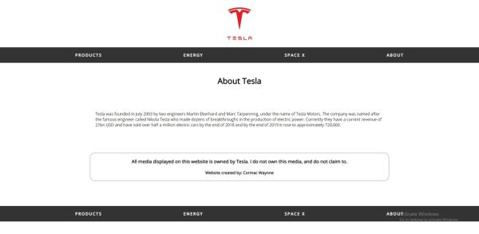

4 - Evaluation

Web Usability is how effective, efficient and satisfied a user can be with his or her goals on a website. [1]. Website accessibility is ensuring your website can be accessed by everyone regardless of barriers such as different sized monitors or going from a laptop to a mobile view. [2]. Search Engine Optimisation (SEO) is where you increase the quantity and quality of traffic to your website through “organic” search engine results. [3].

I believe my website serves its purpose rather well. The aim of it was to inform people on a range of topics surrounding Tesla and I feel like I did a good job at covering the basics of general information on vehicles, brief descriptions and pictures/videos to go along side. My website is quite easy to use, there is a navigation bar for easy use which takes you to the 4 different sections of my website. Some of the future improvements I would like to make is that I would like a drop down menu on the products with a small image and title of the car. Each section would take you to the individual car website which is in my opinion slightly cleaner.

5 - References

[1] - https://webwisewording.com/usability-definition/
[2] - https://www.nomensa.com/blog/2018/what-web-accessibility
[3] - https://moz.com/learn/seo/what-is-seo

marking criteria and Student FEEDBACK

This section details the extent to which the assessment criteria are demonstrated by you, which in turn determines your mark. The marks available for each category of skill are shown. Lecturers will use the space provided to comment on the achievement of the task(s), including those areas in which you have performed well and areas that would benefit from development/improvement.

Common Assessment Criteria Applied (Assignment 1) | Marks available | Marks  awarded
1. Engagement with Literature Skills

Unfortunately the submitted work does not really address the research elements of the assignment brief and generally, demonstrates poor engagement with essential reading and little evidence of wider reading of literature sources. Expand the scope of references to further improve your research work. (Grade mark: 12.00%) | 25 | 3
2. Knowledge and Understanding Skills

As you have not completed the research exercise properly, this has had an impact on your ability to properly evaluate the website against the requirements of the assignment brief. A very basic evaluation has been provided and the validation section is missing. (Grade mark: 15.00%) | 20 | 3
3. Cognitive and Intellectual Skills

4. Practical Application Skills

A good attempt featuring a simple website with well-thought-out content. There is, however, room for improvement. Aim to improve your use of the CSS grid system to achieve page layouts that are also responsive. You have also used internal styles on your pages. Please note that this is not good practice and it creates layout consistency issues and also makes it difficult to maintain your CSS styles. Note that your logo changes on some pages. Also you should highlight the link of the menu item for the currently active page and specify alternative text descriptions for images using the alt attribute. Your alt attributes have all been left blank. (Grade mark: 64.00%) | 50 | 32
5. Transferable Skills for Life and Professional Practice

The report is satisfactory, but is missing required elements. See your report for other suggested improvements. (Grade mark: 40.00%) | 5 | 2

Assignment Mark (Assessment marks are subject to ratification at the Exam Board. These comments and marks are to give feedback on module work and are for guidance only until they are confirmed. ) | Late Submission Penalties (tick if appropriate) |  | 40%
 | Up to 1 week late (40% Max) |  | 40%
 | Over 1 week late (0%) |  | 40%

