Quantitative Study: The Glass Ceiling
Name: Jordan John Coller
Student Number: 1706820

Programme of Study: BA Business and Management
Module: Business Inquiry and Research

Tutor: Dr Alex Bell
Date: 08/05/2019

Table of Contents
1.1 Introduction 3
2.1 Procedure 4
3.1 Data Presentation and Findings 7
4.1 Conclusion 12
References 14

1.1 Introduction
Within this paper, research is conveyed that regards the metaphor known as ‘The Glass Ceiling’. The Glass Ceiling is defined as the barriers and limitations in which females may face based upon organisational and attitudinal bias, thus preventing the female individual’s ability to further develop themselves within the business setting; reflecting ‘discrimination’ (Grout, Park & Sonderegger, 2009). This paper will delve into the reasons as to why this phenomenon of discrimination may possibly exist within The United Kingdom’s (UK) working culture. The rationale for researching this topic concerns the lack of empirical business-related research and literature relating to this subject.
The Glass Ceiling can be perceived as a highly controversial concept as it is thought to influence the employment and personal development of a female. While many choose to argue the fact that discrimination does not exist within the business setting, Bertrand (2017) counter-argues that females are under-represented in comparison to men, emphasising statistics that convey justifiable evidence pointing towards the existence of discrimination towards women. However, Bertrand’s fortification of such research is based in Norway’s working culture, which may not be specifically applicable to the UK’s working cultural environment.
Through adopting the quantitative research approach, a more localised reflection of Bertrand’s work can be achieved to harvest information regarding The Glass Ceiling within the current day working culture. To achieve the number of respondents needed to perform such research, a survey was created and then circulated using social media. The request for female candidacy was requested due to the nature of the research, as I feel this would provide a greater contrast to the results of this research. This paper will present methodology concerning the collection of data though the process of cross-tabulation within the statistical computer software known as ‘Statistical Package for the Social Sciences’ (SPSS). This method of cross-tabulation can be utilised to emphasise casual relationships between variables within the research’s data, to provide meaningful data that is then presented as simplified visual measurements such as, charts and graphs (Golafshani, 2003).

2.1 Procedure
For the purpose of this paper, quantitative research methodologies will be carried out. Walliman (2011) states that the practice of quantitative research deals with statistical data, this statistical data is then analysed within the chosen program; for the purposes of this assignment ‘SPSS’ was chosen. The collected data can be translated into measurements within the chosen program, an example of such measurements may regard, nominal, ordinal, interval and ratio.
Choosing the correct method for the selected topic is significantly fundamental for the result’s success. Quantitative research is commonly known to uphold an unbiased and impersonal approach when harvesting statistical data; this is to ensure an accurate result, as opposed to the qualitative approach, in which data can be misinterpreted. Not only this, the quantitative research method allows extracting data from larger sample sizes with moderate ease, minor preparation and within a timely fashion. However, the quantitative research methodology is not without its limitations; although allowing the ability for researchers to identify and investigate the impacts of the selected variables, its counter-part known as ‘qualitative research’ allows the interviewer to delve deeper into complex subjects that may influence a phenomenon, a trait which quantitative research method may not typically achieve (Quinlan et al., 2019).
During the assignment, the task of adopting the quantitative methodology required the researcher to harvest raw data from ten dependent variables, in order to achieve the desired result. However, due to the complexity, controversy and broad population surrounding the topic, extensive research will be required to ensure that the research’s credibility can be achieved. This means a greater number of dependent and independent variables will be needed to achieve to decrease the margin for error within the result, as well as to achieve a more significant confidence level (Gilliland & Melfi, 2010).
The preparation of organising a series of four dependent variables, which can be perceived as the potential respondent’s input variables, and then the six independent variables, which can be perceived as the questions that can be used to manipulate measurements of the outcome were crucial to the success of the research’s findings. The respondent’s demographics were tailored to the requirements of the research’s purpose, these preferable demographical attributes of the respondents consisted of those who may fit within the female gender.

During the assignment, the task of compiling a series of ten dichotomous questions were required to aid in the findings of this paper’s research, these questions should be carefully structured and simplified to ensure the respondent does not become confused when answering them. Furthermore, when structuring questions, ethicality and convenience to the respondent must be considered to avoid any threatening questions or loss of interest during the questionnaire (Marczyk, DeMatteo & Festinger, 2005).
Once the chosen questions were strategically structured and completed within ‘Survey Monkey’, a free website which enables one to create a survey for the purposes of quantitative research, the next process would regard using a medium channel for my respondents to gain access to the survey. The chosen channel which was used for the purposes of this research was social media – specifically Facebook. Once gaining data from all ten required respondents, it was then manually imported into SPSS, translating each dichotomous answer into numerical data. For example, Variable 1 – Gender would comprise of a dichotomous answer; with ‘1’ representing ‘Female’ and ‘2’ representing ‘Male’. This data will be used within the SSPS cross-tabulation process, so that it can be analysed to create a greater insight towards the research’s findings.
A notable occurrence during the research may regard the fundamentality of deleting the link within social media once the required number of respondent’s answers were obtained. This is to ensure the consensus of the answer’s percentages are not modified further. In my own experience with this method, I had failed to do this, however, this was corrected by choosing the first and original ten answers as the data that would be analysed.

3.1 Data Presentation and Findings
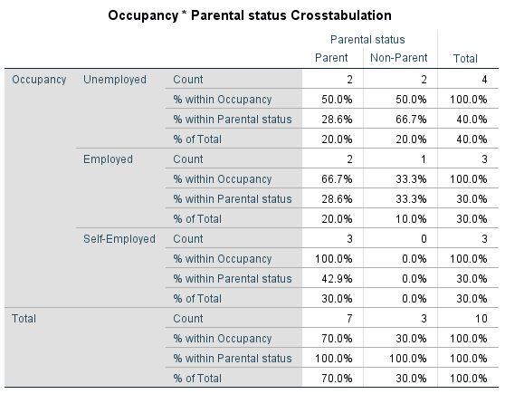
Firstly, the two variables chosen to be cross-tabulated are: Occupancy and Parental status. During this cross-tabulation, it was expected little to no relationship between the two variables. However, it is identified that those who hold parental status were more likely to be employed or hold self-employment status. In comparison to the respondents without a parental status, this information may indicate that those with dependents to provide for, may be more motivated to achieve a better position within the business culture.

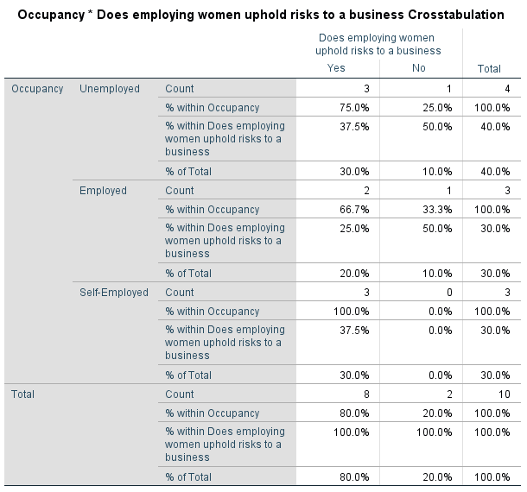
In reflection to the risks to business when employing women, these risks may involve, maternity leave and pregnancy, with 80% of total respondents recognising these risks; this cross-tabulation allows us to identify said implication within the working culture. Additionally, the self-employed respondents uphold significant relevance to this relationship, allowing us to recognise this issue from an employer’s point of view.
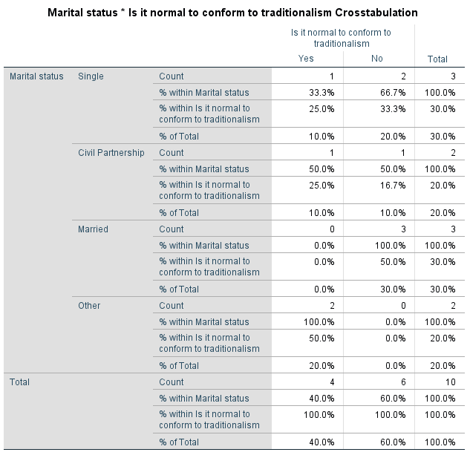

Within this cross tabulation, traditionalism signifies the traditional way in which women stayed at home while men worked. As conveyed in the Total results section, there was seen to be a significant comparison between the respondents’ perceptions of traditionalism; with 40% stating that they do agree and 60% stating that they do not. This indicates that within today’s working culture, women are more independent.

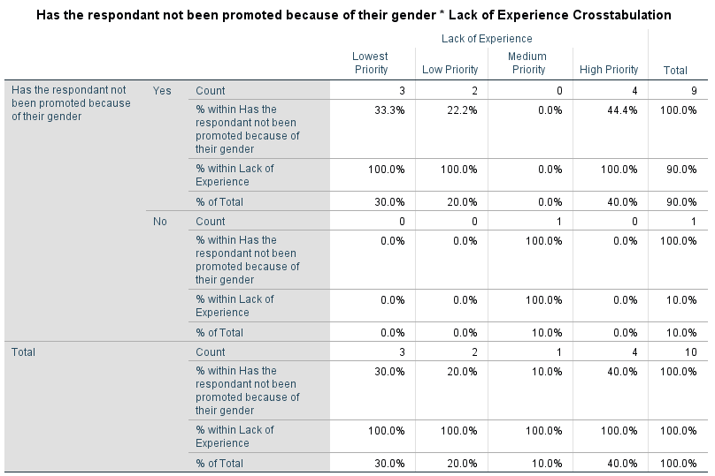
This cross-tabulation demonstrates the relationship between those who have been discriminated against when regarding their personal development within the workplace, and those who consider ‘Lack of Experience’ to be a high priority barrier when pursuing self-employment. Here it is seen that such discrimination to the female gender contributes towards the lack of experience and knowledge gained through hierarchal promotion. This discrimination may be seen as an incentive for why women may want to start their own businesses. However, this may also be a barrier to the skills and experience needed to become self-employed.

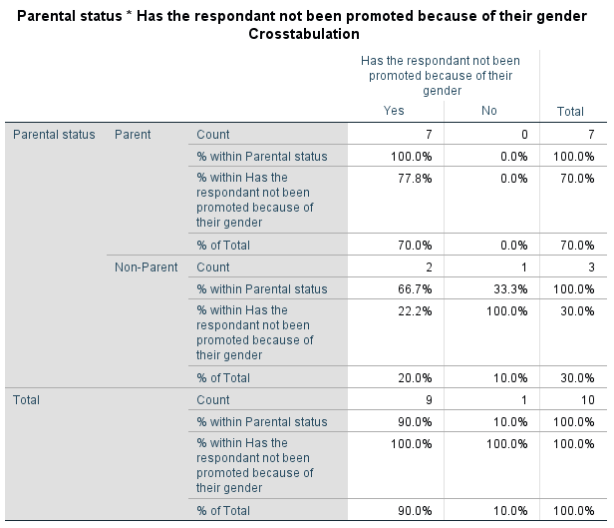
These finding emphasise the key relationship between parents and non-parents alike, and whether parenthood has created barriers when pursuing organisational promotion. Within the table, it is identified that parenthood is a significant barrier when climbing the corporate ladder; with 100% parent respondent’s stating that becoming a parent had hindered their ability to become promoted in some way or another.

4.1 Conclusion
The original purpose of this paper was to build upon Bertrand’s research regarding ‘The Glass Ceiling’, due to the lack of business-related literature surrounding the topic. However, Bertrand’s research was seen as localised to the Norwegian working culture, as opposed to the localised environment of the researcher within the UK.
The collected data was cross-tabulated through experimentation within SPSS through which key relationships were found, all of which were seen to impact the working culture and personal development concerning women.
The most unexpected cross-tabulation indicated the relationship between parenthood and occupancy, conveying that those with dependents possibly uphold a higher motivation to become employed or self-employed. Although this interpretation of statistical findings may potentially be true, it lacks little to no empirical consistency, due to the unbalanced demographics concerning the respondents; seven being those with child dependents and three without.
In reflection to the research, it is apparent that the quantitive research approach is indeed beneficial when collecting empirical evidence in the form of statistics. However, to provide a greater personal insight regarding this experiential and complex subject, the recommendation of extensively researching through the use of a more qualitative research approach could be needed. Although, if one was to continue with the use of quantitative research methods, the need for a greater number of female respondents and variables would be required; this is to enable a more credible response by eliminating the margin for error and bias within the results. Through data collection, ten female respondent’s answers were analysed. However, although this small number of respondents may limit the ability to critically analyse the collected data. The study also did not consider male respondents and a replication of this study could be carried-out with the male gender to see if this would change the findings.
In conclusion and reflection to the findings within this study, discrimination is still a significant existential threat to females within what is considered the UK’s ‘progressive’ working culture.

References
Bertrand, M., Black, S., Jensen, S., & Lleras-Muney, A. (2017). ‘Breaking the Glass Ceiling?’ The Effect of Board Quotas on Female Labor Market Outcomes in Norway. SSRN Electronic Journal. doi: 10.2139/ssrn.2488955
Gilliland, D., & Melfi, V. (2010). ‘A Note on Confidence Interval Estimation and Margin of Error’. Journal of Statistics Education, 18(1). doi: 10.1080/10691898.2010.11889474
Golafshani, N. (2003). ‘Understanding Reliability and Validity in Qualitative Research. The Qualitative Report, (6)’. Retrieved from https://nsuworks.nova.edu/cgi/viewcontent.cgi?referer=http://scholar.google.co.uk/&httpsredir=1&article=1870&context=tqr/
Grout, P., Park, I., & Sonderegger, S. (2009). ‘An Economic Theory of Glass Ceiling’. SSRN Electronic Journal. doi: 10.2139/ssrn.1392776
Marczyk, G., DeMatteo, D., & Festinger, D. (2005). Essentials of research design and methodology (Essentials of behavioral science series). Hoboken, N.J.: John Wiley & Sons.
Quinlan, C., Babin, B., Carr, J., Griffin, M. (2019) Business Research Methods. 2nd Ed. Andover, UK: South Western Cengage
Walliman, N. (2011). Research Methods: The Basics. London & New York: Routledge.

