
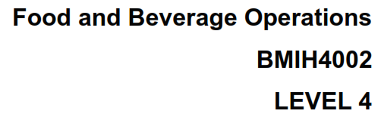
Assessment 2
Assignment Title: Assessment of Practical Tasks (Menu Engineering)

Student Name: Valeria Nistor
Student ID: 2206486

Slide-1
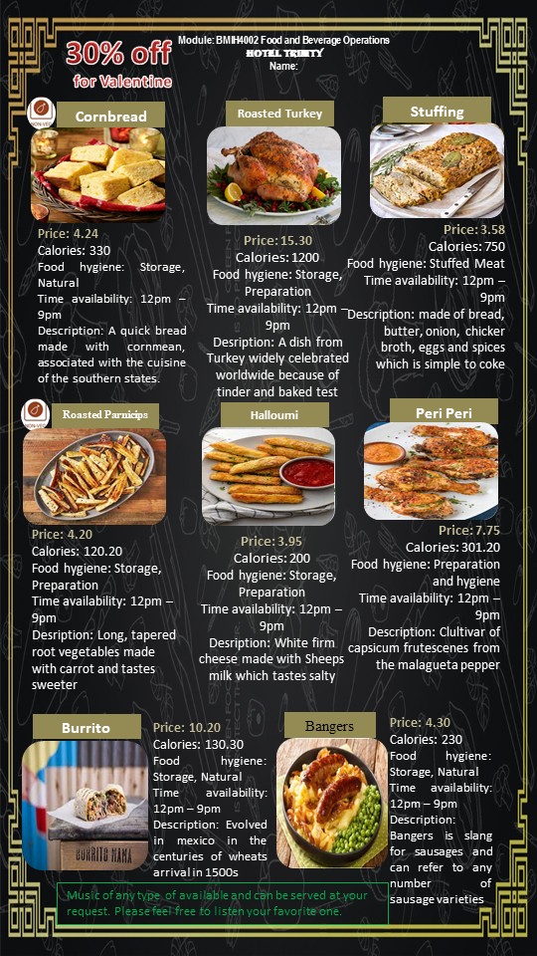

Hotel Trinity
London
Cornbread
- Price: 4.24
- Calories: 330
- Food hygiene: Storage, Natural
- Time availability: 12pm – 9pm
- Description: A quick bread made with Cornmean, associated with the cuisine of the southern states.
Roasted Turkey
- Price: 15.30
- Calories: 1200
- Food hygiene: Storage, Preparation
- Time availability: 12pm – 9pm
- Description: A dish from Turkey widely celebrated worldwide because of tinder and baked test
Stuffing
- Price: 3.58
- Calories: 750
- Food hygiene: Stuffed Meat
- Time availability: 12pm – 9pm
- Description: made of bread, butter, onion, chicker broth, eggs and spices which is simple to coke
Roasted Parnicips
- Price: 4.20
- Calories: 120.20
- Food hygiene: Storage, Preparation
- Time availability: 12pm – 9pm
- Description: Long, tapered root vegetables made with carrot and tastes sweeter
Halloumi
- Price: 3.95
- Calories: 200
- Food hygiene: Storage, Preparation
- Time availability: 12pm – 9pm
- Description: White firm cheese made with Sheeps milk which tastes salty
Peri Peri
- Price: 7.75
- Calories: 301.20
- Food hygiene: Preparation and hygiene
- Time availability: 12pm – 9pm
- Description: Clultivar of capsicum frutescenes from the malagueta pepper
Burrito
- Price: 10.20
- Calories: 130.30
- Food hygiene: Storage, Natural
- Time availability: 12pm – 9pm
- Description: Evolved in Mexico in the centuries of wheats arrival in 1500s
Bangers
- Price: 4.30
- Calories: 230
- Food hygiene: Storage, Natural
- Time availability: 12pm – 9pm
- Description: Bangers is slang for sausages and can refer to any number of sausage varieties
Music of any type of available and can be served at your request. Please feel free to listen your favorite one.

Slide-2
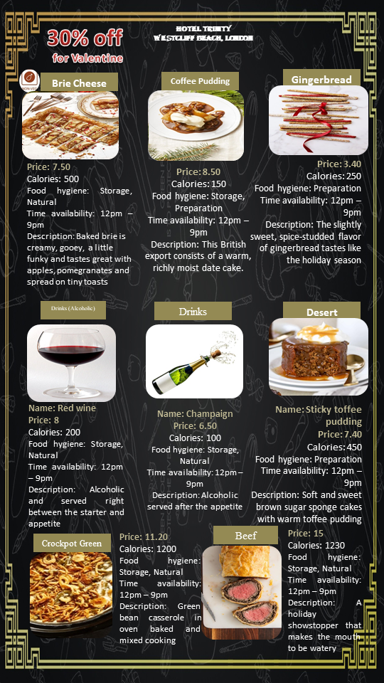
Hotel Trinity
London
Brie Cheese
- Price: 7.50
- Calories: 500
- Food hygiene: Storage, Natural
- Time availability: 12pm – 9pm
- Description: Baked brie is creamy, gooey, a little funky and tastes great with apples, pomegranates and spread on tiny toasts
Coffee Pudding
- Price: 8.50
- Calories: 150
- Food hygiene: Storage, Preparation
- Time availability: 12pm – 9pm
- Description: This British export consists of a warm, richly moist date cake.
Gingerbread
- Price: 3.40
- Calories: 250
- Food hygiene: Preparation
- Time availability: 12pm – 9pm
- Description: The slightly sweet, spice-studded flavor of gingerbread tastes like the holiday season
Name: Red wine
- Price: 8
- Calories: 200
- Food hygiene: Storage, Natural
- Time availability: 12pm – 9pm
- Description: Alcoholic and served right between the starter and appetite.
Name: Champaign
- Price: 6.50
- Calories: 100
- Food hygiene: Storage, Natural
- Time availability: 12pm – 9pm
- Description: Alcoholic served after the appetite
Name: Sticky toffee pudding
- Price: 7.40
- Calories: 450
- Food hygiene: Preparation
- Time availability: 12pm – 9pm
- Description: Soft and sweet brown sugar sponge cakes with warm toffee pudding
Name: Crockpot Green
- Price: 11.20
- Calories: 1200
- Food hygiene: Storage, Natural
- Time availability: 12pm – 9pm
- Description: Green bean casserole in oven baked and mixed cooking
Name: Beef
- Price: 15
- Calories: 1230
- Food hygiene: Storage, Natural
- Time availability: 12pm – 9pm
- Description: A holiday showstopper that makes the mouth to be watery

Slide-3
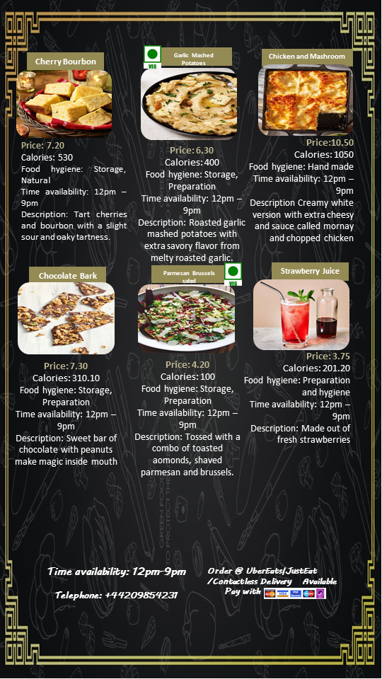
Hotel Trinity
London
Cherry Bourbon
- Price: 7.20
- Calories: 530
- Food hygiene: Storage, Natural
- Time availability: 12pm – 9pm
- Description: Tart cherries and bourbon with a slight sour and oaky tartness.
Garlic Mashed Potatoes
- Price: 6.30
- Calories: 400
- Food hygiene: Storage, Preparation
- Time availability: 12pm – 9pm
- Description: Roasted garlic mashed potatoes with extra savory flavor from melty roasted garlic.
Chicken and Mashroom
- Price: 10.50
- Calories: 1050
- Food hygiene: Hand made
- Time availability: 12pm – 9pm
- Description Creamy white version with extra cheesy and sauce called mornay and chopped chicken
Chocolate Bark
- Price: 7.30
- Calories: 310.10
- Food hygiene: Storage, Preparation
- Time availability: 12pm – 9pm
- Description: Sweet bar of chocolate with peanuts make magic inside mouth
Parmesan Brussels Salad
- Price: 4.20
- Calories: 100
- Food hygiene: Storage, Preparation
- Time availability: 12pm – 9pm
- Description: Tossed with a combo of toasted almonds, shaved parmesan and brussels.
Strawberry Juice
- Price: 3.75
- Calories: 201.20
- Food hygiene: Preparation and hygiene
- Time availability: 12pm – 9pm
- Description: Made out of fresh strawberries

Slide-4
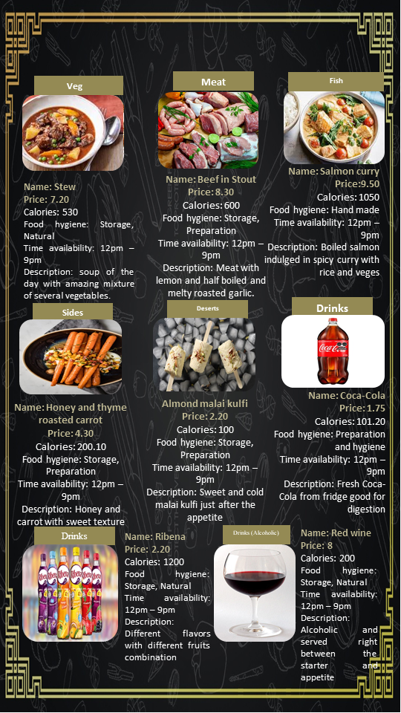
Hotel Trinity
London
- Name: Stew
- Price: 7.20
- Calories: 530
- Food hygiene: Storage, Natural
- Time availability: 12pm – 9pm
- Description: soup of the day with amazing mixture of several vegetables.
- Name: Beef in Stout
- Price: 8.30
- Calories: 600
- Food hygiene: Storage, Preparation
- Time availability: 12pm – 9pm
- Description: Meat with lemon and half boiled and melty roasted garlic.
- Name: Salmon curry
- Price: 9.50
- Calories: 1050
- Food hygiene: Hand made.
- Time availability: 12pm – 9pm
- Description: Boiled salmon indulged in spicy curry with rice and veges
- Name: Honey and thyme roasted carrot
- Price: 4.30
- Calories: 200
- Food hygiene: Storage, Preparation
- Time availability: 12pm – 9pm
- Description: Honey and carrot with sweet texture
- Almond malai kulfi
- Price: 2.20
- Calories: 100
- Food hygiene: Storage, Preparation
- Time availability: 12pm – 9pm
- Description: Sweet and cold malai kulfi just after the appetite
- Name: Coca-Cola
- Price: 1.75
- Calories: 110
- Food hygiene: Preparation and hygiene
- Time availability: 12pm – 9pm
- Description: Fresh Coca-Cola from fridge good for digestion
- Name: Ribena
- Price: 2.20
- Calories: 1200
- Food hygiene: Storage, Natural
- Time availability: 12pm – 9pm
- Description: Different flavors with different fruits combination
- Name: Red wine
- Price: 8
- Calories: 200
- Food hygiene: Storage, Natural
- Time availability: 12pm – 9pm
- Description: Alcoholic and served right between the starter and appetite

Slide-5
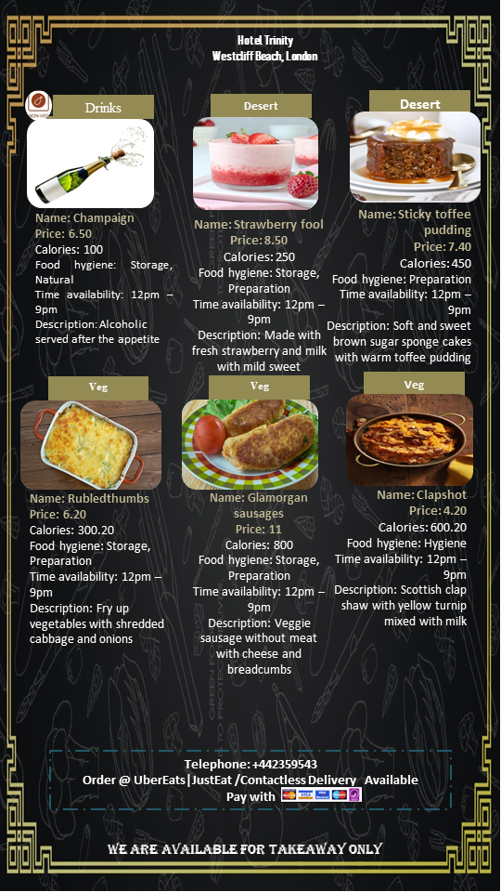
- Name: Champaign
- Price: 6.50
- Calories: 100
- Food hygiene: Storage, Natural
- Time availability: 12pm – 9pm
- Description: Alcoholic served after the appetite
- Name: Strawberry fool
- Price: 8.50
- Calories: 250
- Food hygiene: Storage, Preparation
- Time availability: 12pm – 9pm
- Description: Made with fresh strawberry and milk with mild sweet
- Name: Sticky toffee pudding
- Price: 7.40
- Calories: 450
- Food hygiene: Preparation
- Time availability: 12pm – 9pm
- Description: Soft and sweet brown sugar sponge cakes with warm toffee pudding
- Name: Rubledthumbs
- Price: 6.20
- Calories: 300.20
- Food hygiene: Storage, Preparation
- Time availability: 12pm – 9pm
- Description: Fry up vegetables with shredded cabbage and onions
- Name: Glamorgan sausages
- Price: 11
- Calories: 800
- Food hygiene: Storage, Preparation
- Time availability: 12pm – 9pm
- Description: Veggie sausage without meat with cheese and breadcumbs
- Name: Clapshot
- Price: 4.20
- Calories: 600.20
- Food hygiene: Hygiene
- Time availability: 12pm – 9pm
- Description: Scottish clap shaw with yellow turnip mixed with milk

Slide-6
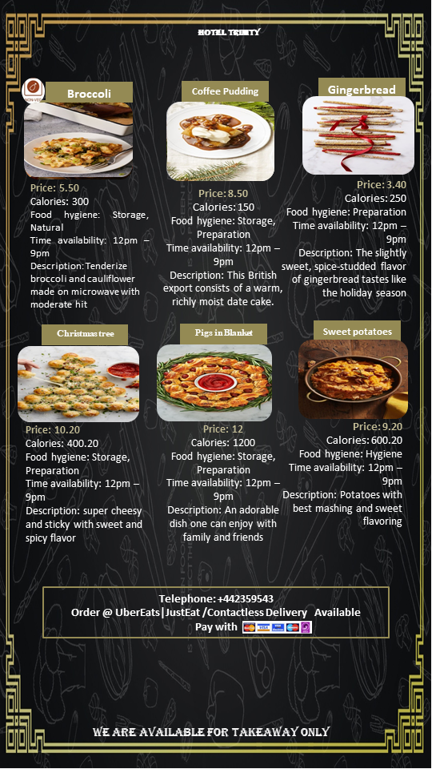
Broccoli
- Price: 5.50
- Calories: 300
- Food hygiene: Storage, Natural
- Time availability: 12pm – 9pm
- Description: Tenderize broccoli and cauliflower made on microwave with moderate hit
Coffee Pudding
- Price: 8.50
- Calories: 150
- Food hygiene: Storage, Preparation
- Time availability: 12pm – 9pm
- Description: This British export consists of a warm, richly moist date cake
Gingerbread
- Price: 3.40
- Calories: 250
- Food hygiene: Preparation
- Time availability: 12pm – 9pm
- Description: The slightly sweet, spice-studded flavor of gingerbread tastes like the holiday season
Christmas tree
- Price: 10.20
- Calories: 400.20
- Food hygiene: Storage, Preparation
- Time availability: 12pm – 9pm
- Description: super cheesy and sticky with sweet and spicy flavor
Pigs in Blanket
- Price: 12
- Calories: 1200
- Food hygiene: Storage, Preparation
- Time availability: 12pm – 9pm
- Description: An adorable dish one can enjoy with family and friends
Sweet potatoes
- Price: 9.20
- Calories: 600.20
- Food hygiene: Hygiene
- Time availability: 12pm – 9pm
- Description: Potatoes with best mashing and sweet flavoring

References
Graham, P.L., Crilley, E., Stretesky, P.B., Long, M.A., Palmer, K.J., Steinbock, E. and Defeyter, M.A. (2016). School Holiday Food Provision in the UK: A Qualitative Investigation of Needs, Benefits, and Potential for Development. Frontiers in Public Health, 4. doi:10.3389/fpubh.2016.00172.
Prideaux, B. and Glover, P. (2015). ‘Santa Claus is Coming to Town’ – Christmas Holidays in a Tropical Destination. Asia Pacific Journal of Tourism Research, 20(9), pp.955–970. doi:10.1080/10941665.2015.951061.

