

Workplace Culture and its impact on Organisation Effeciency
  - Jahanara uddin
  - 1704989
  - bmsk5005 SWAN

Executive Summary

This report is on Workplace Culture and how the environment effects the organizations. The report has an insight of Marks and Spencer’s PESTLE analysis to address issues around environmental impact on the organization. The report also has two theories and model, the cultural web and Deal and Kennedys to analyses the competitiveness in their market sector. The writer also stated past and present position and how and why charges were made to their strategy. The writer also provides Netflix structure and culture.
Increasing importance of ethics, sustainability of organizations means management need to implement and develop strategies to be able to survive in their market sector, because of the public interest. The management of organization are trying the best to take responsibility of the environment and looking for ways to invest to have the competitive advantage. Ethical and sustainable organization are more successful and have a good reputation.
The culture of marks and spencer’s is very collaborative and the company has four main values to help make sure all staff do their best to make sure marks and spencer’s is a great place to work, the company is moving towards digital first culture, and making sure all staff focus on driving the business to a more digital mind-set in all aspects. There’s also a great deal of empowerment at M&S, Steve Rowe the CEO is encouraging staff to make decisions and choices that will benefit customers and colleagues. The company experienced change customers by 21st century when customers of M&S stated shopping online with other competitors instead of their stores. The company though hard and long about how to rectify the situation. M&S introduced change in corporative culture and stretching existing systems and processes.
Netflix was founded as a result a blockbuster late fee and still has DVD subscribers
. Netflix CEO Reed Hastings came up with the idea. Netflix was originally called Kibble.
Netflix is a video and steaming company that’s provides more than 100 million users. The company began as a mail order movie, TV show delivering service in 1997, the company has come a long way, effectively killing its biggest competition blockbuster.Netflix has a flat organisational structure, the employees are given more freedom and responsivities
Acknowledgements
The writer would like the opportunity to thank the librarians for helping to find resources to carryout research in order to complete the report. The writer also has benefited from having a IT technician in the library to help with any IT issues.

Contents
Task 1 4
PESTLE 4
Political 5
Economic 6
Social 6
Technology 7
Environment 7
Law/legal 8
Summary 8
Task 2 9
Paradigm 10
Control systems 10
Stories 10
Symbols 10
Power structure 10
Control systems 10
Structure of organization 12
Task 3 15
Sustainability 15
Ethic 15
Ethical stance of M&S 15
(CSR) Corporative social responsibility 16
Individuals and M&S 17
Task 5 18
Comparing the organisation’s 19
Conclusion 21
Recommendation 23
Action Plan 24
Reference 25

Task 1

PESTLE
“According to Worthington and Britton refer to the complexity of external environment”(p77)
All business and organizations will not have a problem making decision within their organization, however internal and external issues affect the organization. The organization will know who their customers, suppliers, and competitors are, and analyzing the general environment is more complicated because it has varies categories with in the PESTLE framework. According to Briner and Conway (2001). “It can be defined as the perception of the two parties of the mutual obligation towards each other”. And according to Guest and Conway (2002).”By its nature the psychological contract is dependent on trust between the employer and employees.” cited in Business Environment p235.
The frame work covers Political, Economic, and Social –culture, Technological, and Legal. Any change in those sector will influence decision making in the organisations. PESTLE analysis can be used strategic planning, new business idea, new product or services, marketing, innovation, expending stores or researching information about the organization or competitors. There are other from works like The SWOT analysis and the potters 5 forces.
Organisations large or small can benefit from PESTLE, scanning and identifying the environment will help the effectives and pinpoint issues they need to solve or implement. Organisation like Marks and Spencer is a well-established and major British retail merchant, operating in different countries. The headquarters in Westminster London. It was founded 1884 by Michael Marks and Thomas Spencer in Leeds. Carrying out PESTLE analysis helps Marks and Spencer’s innovations and update laws and regulations.

Political
Political factors are all about how and to what degree a government intervenes in the economy or the different se4ctor of the market. This is very important because it has a direct effect on the organization because government policy, tax, foreign trade, law and more legislation on political stability etc. All of those factors need to be taken in to account when making decision. Business and organisations need to keep up to date with existing new laws and policies been implemented for example The Data Protection ACT 2018 is the UK’s General Data Protection Regulation (GDPR). Every business and organization are responsible for using personal data, carefully, lawfully and transparently. (Online) Data Protection-GOV.UK. There are other examples according to online Independent new laws changing from motoring to employment.
In order for Marks and Spencer’s to succeed in changing environment the organization needs adapt to the changes in all categories of PESTLE and consider its corporate culture and stakeholders management strategies. Keeping in line with all the categories of PESTLE. With give Marks and Spencer’s a competitive advantage. According to online financial times Bruit is effecting the Trading agreements of M&S. This has caused M&S uncertainty in varies products to be important and exported. For example sandwiches which are transported through the channel tunnel every day. This is affecting M&S reputation because it can’t meet the demand of customers and will fact the revenues. The EU has rejected the proposal of keeping the broader between the UK and

Economic
economy, for example minimum wage rates, economic growth/decline, unemployment cost of living and interest and exchange rates.
According to (online) The Guardian accessed on 25.03.19. Marks and Spencer’s boss Marc Boland had a target profit for the next three years, however because of uncertainty of Bruit, consumers spending is on the decrease. The boss needed to re set targets and reduced it by 30% less then he originally targeted. This has effected employee’s bonuses. This year. Marks and Spencer’s Plan A to sustainability should help increase their potation in the economy. The organization has set commitments and targets for the coming five years. Some of the commitments are sending zero waste to the land field from their operations and construction activities in the UK and Republic of Ireland. M&S is also reducing the usage of packaging. According to (Online) Marks and Spencer’s. Annual report. accessed on 22.03.19.

Social
According to Henry E ( 2011) p53. social issues, this is because activities like culture norms, attitudes of individual can make a large difference in society. Business and organisations need to know trends in the market in order to operate and meet consumer needs. The organisations need to be aware of population growth, age distribution, emphasis on safety and global warming.
Marks and Spencer has been effected by recent change in social issues. Mark and Spencer’s needed to introduce lower price products and cater and design clothes for younger generations. Changes in consumer buying habits and the increase of choice to shop elsewhere and on line has effected the revenues. M&S have launched new-eco shopping bag that helps prevent waste and reduce poverty among people living in Haiti and the Philippines. According to (Online) The Guardian accessed 22.03.19. . Marks and Spencer’s also decided to sell their fruits and vegetables loose with without using packaging to reduce waste.
“Launching in stores on 6th November the re-useable bag is made from 75% social plastic. Which is a plastic waste that has been collected and recycled by plastic bank, social enterprise seeking to stop ocean plastic pollution.” According to Marks and Spencer social impact.

Technology
Cited on ethical performance Journal (2017).” The government new digital strategy announced to aim to help underpin innovation across the whole British economy with a plan that sets policy for the next five years.” According to Sanpete Waldron.
Innovation of technology and keeping up to date is very important to all business and organization because it has a large impact on way things are done internally and externally. Marks and Spencer is always trying to provide the best quality and innovated products to its customers. M&S has planned technology transformation programmer as part of its Plan for the next five years. This will allow M&S to be digital first business and deliver an improved service on line shopping and deliveries direct from the warehouse.

Environment
Factors from the come from natural environment effecting business and organization from pollution and packaging like plastic. Business and organization need to think about their responsibility in internal and external operation. This effects individuals and animals, therefore it is very important to think of ways to protect the environment. Individuals are more aware of environmental issues and the importance due to wide range information available on social media arability. According to
Marks and Spencer is one of the first organization to be fully carbon neutral. According to (online) The Guardian. Accessed 23.03.19

Law/legal
There are many rules and laws governing the products, distribution, protection of employees and packaging employee safety. Marks and Spencers have a host of laws they need to implement and follow, the recent legal and ethical policies the organization has up dated their website terms and conditions. According to Marks and Spencer online report accessed on 23.03.19.

Summary
Marks and Spence’s PESTLE analysis tool helps identify internal external issues. The analysis shows what Marks and Spencer’s as an organization are implementing to be able to meet customer needs and keep up to date with laws, However Social, economic and technology factors has affected M&S because of the clothing trends, and online shopping as well the uncertainty of Brexit. Marks and Spencer’s is a great place to work, the company is moving towards digital first culture, and making sure all staff focus on driving the business to a more digital mind-set in all aspects Marks and spencer’s main strategy has been redefined to focus

      - customer service
      - Quality.
      - Reputation

Task 2
Cultural web is used to understand the culture of the organization. Johnson et al, presents a cultural web.(cited in Mullin (2016) P543.

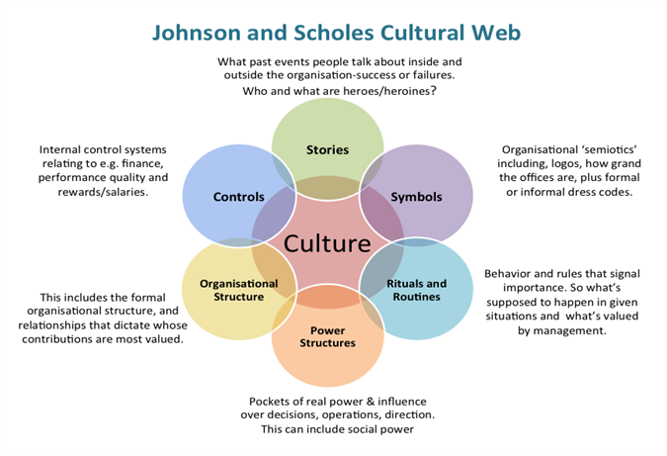

Paradigm
- The core competency
- High quality “British” Products at reasonable price
- Value for money

Control systems
- Top- down management
- Bureaucratic culture
- Became structure to decrease bureaucracy & make employees more skilled by encouraging them to make decisions until late 1990s were family /all life employees in M&S but in 2000 for the first time. M&S appointed someone from outside to position of chairman

Stories
- Michel marks set up 1st “Penney stalls” in the 1880s.
- Tom spencer, a cashier of M&S supplier became a partner and M&S grew since then.
- Reputation for the quality

Symbols
- Brand & St Michael logo as a sign of quality, status and prestige

Power structure
- Head office has power of stores, training staff, goods, logistics and quality standard, finance

Control systems
- Top-down management system. Reward system by prompting life employees to become managers & executives. Few of top management positions.

The cultural web identifies six interrelated elements that helps to make up what Johnson and Schole. Some of the elements need to developed and changed in order to be effective. Workplace culture need to change due to the change in social and comic change in customer buying habits. And due economic uncertainty customers are looking for similar products in other shops and online. Other organization like Gap, Next are able to offer cheaper price because they use suppliers from abroad.
There are many theories and models for organizational culture like the Deal and Kennedy (1982). This theories are used by many organisations it is based on two dimensions. The business environment in the way its operated its called, Corporate culture which they asserted embodied what was required to succeed in the environment, and the feedback strategies Both dimensions are effected by the business activities.

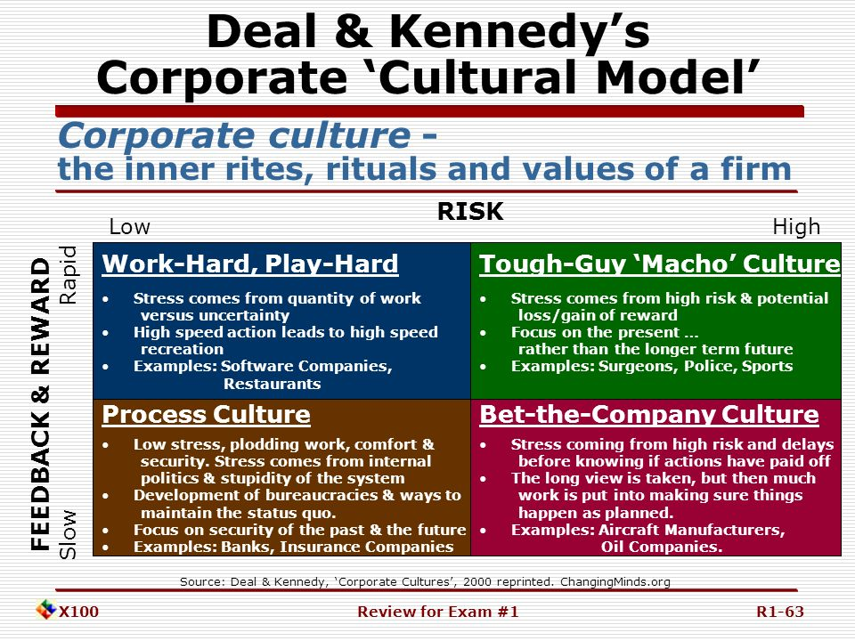
http://slideplayer.com/slide/6329673/21/images/63/Deal+&+Kennedy%E2%80%99

Deal & Kennedy | Low Risk  M&S has low risk | High Risk
Fast Feedback | Work Hard Play Hard Culture | Tough Guy Macho Culture
Slow Feedback  Organisation like M&S have slow feed back | Process Culture  Individuals working at M&S can’t determine the results of risks because the feedback is low, therefore they focus on process. | Bet-your company Culture
Marks and spencer’s have a process and control culture, where they do things with technical excellence and focus on what worked well in the pas

Structure of organization
According to (BUSINESS Case Studies, 2014) Due to the competition Marks and spencer’s hierarchical structure and chosen cultural web is effecting the performance of the organisation. To be able to compete, the organisation changed their culture and structure to match their new objectives. Marks and spencer’s main strategy has been redefined to focus on innovation, and customer service quality.
Marks and spencer’ follows a flatter structure joined with role culture. “Role culture are found in large bureaucracies and work by logic and rationality. This is called the role culture because the position in the organisation are more important than the individuals who fill them” cited in Organisations, structures and processes.
Figure 1 shows a tall hierarchy and flat hierarchy

Figure 1
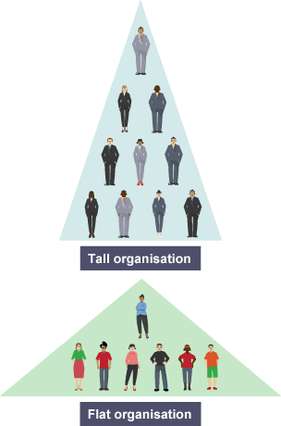
https://www.bing.com/images

According to (BUSINESS Case Studies, 2014) Due to the competition Marks and spencer’s hierarchical structure and chosen cultural web is effecting the performance of the organisation. To be able to compete, the organisation changed their culture and structure to match their new objectives. Marks and spencer’s main strategy has been redefined to focus on innovation, and customer service quality.
Marks and spencer’ follows a flatter structure joined with role culture. “Role culture are found in large bureaucracies and work by logic and rationality. This is called the role culture because the position in the organisation are more important than the individuals who fill them” cited in Organisations, structures and processes.
organisation and management. From the 1920 it became clear in order to improve performance and to be effective as an organisation, the management need to recognize the social dimension of work and employee wellbeing. This is kwon as the Hawthorn studies. (Cited In Jim Stewart, Patricia Rogers)

Task 3

Sustainability
“An approach to economic growth and development which takes account of social and environmental consequences.” (Worthington & Britton 2006) p215
Marks and Spencer are committed to delivering a sustainable value to its shareholders and want to enhance lives everyday through their high quality products, own brands using organic raw materials.

Ethic
(Acceding to Armstrong G 2012) Cited in ArmstronMichael2006. Strategic Human Resource Management. Accessed on 23.03.19. Marks and Spencer have launched a Plan A which has over 180 specific commitments to tackle social and environment issues. Marks and Spencer hade a code that applies to everyone who works for them no matter where they are located and what position they hold. On top of all the responsibility they have trust and respect for each other and hold the values when dealing with colleagues, customers and suppliers.

Ethical stance of M&S
There are many ethical stans in M&S, one of them is they use a wide range of different animal derived materials such as leather and feather in M&S. In general merchandise products, they say they never sold products with animal fur. They work with their suppliers and the RSPCA. M&S also say they never use animal to test their beauty or house hold products. The organization also has a Fair trade commitment and using organic and sustainable cotton. One of the resent commitment to the environment is the M&S has cut back on food carrier bag use by 80% and pledge to stop sending operational and construction waste to the landfill. According to online the Guardian. Accessed 29.03.19 and Perrerr, M.(2016). Marks & Spencer wins award for environmental impact. (Online).

(CSR) Corporative social responsibility is refers to the citizens that organisations have responsibility to society as well as the expectations and responsibilities from their stockholders or investors. All organisations large or small needs to implement CSR, however this has a positive outcome to because it can give u a competitive advantage.
More and more businesses are more concerned about CSR, Many organization believe they have a responsivity to ‘give back’ to society. It starts with been environmentally friendly products and services and try to enhance people’s lives around the world. This is done by organization investing time, money and want to make a difference by duty of pride.
- According to (online www. Marks and Spencer’s/responsibility) accessed on 09.03.2019). This organization Macmillan is a charity that is close to marks and spencer’s and they support and care about communities by running programmers
M&S is an ethical and a sustainable organization providing our citizens with fair trade coffee, with this they have created C.A.F.E. The organization has a set of guidelines to achieve product quality, economic accountability, social responsibility, and environmental leadership.

Task 4

` `M&S released they need to change their strategy in order to meet requirements and become competitive. The organization has expended and invested in new strategy like introduced new clothing brand per Una in order to fit in and be fashionable and trendy and attract younger generation to increase sales. And also are using other strategies like E commerce to Promoting by using story telling strategies to sell their food and clothing products.

According to Lynch R (2015) p 500. “Strategic change is the proactive management of change in organization to achieve clarity identified strategic objectives”
“Competitive advantage may usually be thought of as which allows organization to meet customer needs better than the rivals”. Its not just the products and services, its also the culture and nologigic know how and the process in which the organization operates. According Henderson (1989) p4 “astutely points out, ‘you most dangerous competitors are those that are most like your organization, the use of strategy in decision making is the primary way in which managers take account of constantly changing environment.

Individuals and M&S
All individuals have a responsibility to read and undersatns the code and policies to be able to protect the reputation, by behaving in the right manner is everything they do and say.
To work in any sector of the market individuals need good communication skills and need to be up skillerd with using digital technology. Those qualities will employees to be effective anf productive. This has a positive effect on a workplace. Those are a basic experience to work in M&s because dealing with customers face to face and also delegating tasks to other colleagues.

Task 5

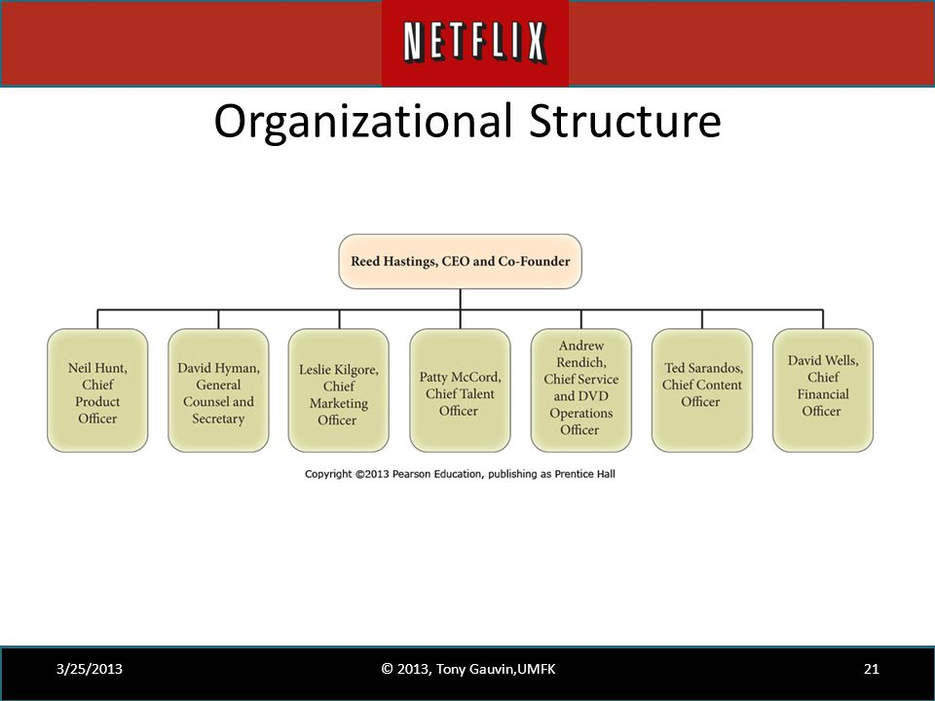
https://www.bing.com/images/search
Netflix avoids top down decision making and seeking management approval for all problems and situations.

Comparing the organisation’s

Marks and spencer’s have changed from a tall hierarchy to a flat structure, and also changed from a bur acritical to more collaborative this help to communicate and work more effectively because it take less time to delegate tasks. Netflix already has a flat srtructur. The management of M&S encourages employees to make decisions and choices that will benefit customers and colleagues.
Netflix has a flat organisational structure, the employees are given more freedom and responsivities
Netflix is more concerned about having only the high performance employees and about innovation to compete with their competitors. In the recent years the organization has relished the importance of responsibility of the environment, and are concentrating in using renewable energy and training and prodding ways to the employees to ne more green minded to help the environment. The organization as a whole is only worried about keeping up to date with technology and how to get the best out of their employees. In the recent years Netflix has planned to be more environmentally friendly where M&S as a company has is involved in lots of projects to help the environment and communities.
Marks and spencer’s employees are one of the most important asset as they can be the reason to increase the footfall and retiring of customers. Marks and spencers are improving the standard of customer service by increasing employees in stores. Netflix as an organization is only worried about the growth and their thinking is only to recruit and keep the best employees by carrying out a keepers test. .The management of M&S are focusing more on training employees and listening to them to be able to give the best service. The organisation has a very approachable management, where employees can ask and lean from their mistakes. According to Marks & Spencer online website. Accessed 27.03.19. Netflix doesn’t have any one to one appraisal for employees, they ask pears about their views on a colleague performance, and the feedback and the keepers test are carried out to keep the best performers in the organization. Netflix only employs creative and critical thinkers who can make decision, choice and take responsibility for the tasks and actions. This sort of culture isn’t for everyone, whereas M&S recruits and training and appraisals to keep their employees productive.

Netflix has a flat organisational structure, the employees are given more freedom and responsivities
Netflix is more concerned about having only the high performance employees and about innovation to compete with their competitors. In the recent years the organization has relished the importance of responsibility of the environment, and are concentrating in using renewable energy and training and prodding ways to the employees to ne more green minded to help the environment. The organization as a whole is only worried about keeping up to date with technology and how to get the best out of their employees.

The organisation uses traditional bureaucratic approaches.
Netflix core vales
Netflix has ten company values that the company prides itself.
- Judgement
- Communication
- Impact
- Curiosity
- Innovation
- Inclusion
- Courage
- Passion
- Integrity
- Selflessness
The culture is about people over process.

Conclusion
Marks and Spence’s is one of the most established organization afferent quality products and services to customers. The organization always trying to give the customer service and value customers. Facing strong competition from clothing, food and service sector M&S are forced to adopt and develop their strategies in order to be competitive and survive in the market. Marks and Spencer having a strong relationship with supplier and efficient distribution systems help to meet customer demands. M&S are trying to implement new products and suppliers to have the competitive advantage. For example the new clothing range and sourcing organic products to be more sustainable. The organization also Macmillian, is a charity that is close to marks and spencer’s and they support and care about communities by running programmers to make awareness of cancer. Mark and spencer’s mainly sell fair trade products. The organisation wants to make a positive change.
According to ITV News M&S has decided to join online Ocado , after Waitrose partnership with them came to an end. Online grocer Ocado and high street retailer M&S announced to work together.

Recommendation
The current strategy M&S is not very competitive because of the changing environment and the innovation, choice available. M&S can benefit if they implement changes to look to capture back the lost market share and customers.
Come up with new products for food, clothing and new ideas of financial services to get customer satisfaction.
Carry out market research in the operating countries to see trends and implement in Per Una range.
M&S will benefit from having a suggestion box and a shopping experience questionnaire for customers. This will show they are instructed in customer choice and feedback.
M&S will benefit if the compare with other organisation like Netflix, the system in which they recruit, because from the application form before the interviewing process they already know who they will invite for interviews, they only want creative and critical thinkers.
M&S can also benefit from Netflix because they give a lot of freedom and responsibility to their employees.
Having the right individuals and training programmers improves workplace culture. Having a positive workplace culture will increase the effectiveness and efficiency of productivity.

Action Plan

Who | What | When | How | Cost
Department manager | Recruit critical and creative individuals | 15.13.2019 | Caring out critical thinking role plays | Management time
Supervisor | Need to make decision and take responsibility | Ever week | Need to work in different departments will increase the level of skill, therefore employees will be able to make decisions and take responsivity. | Supervisor time.

Reference

Armstrong, M (2006) . Strategic Human Resource Management.3rd ed. GB. London. Pearson. GB
Available at : http://corporate –marks and spencer.com/media/press-releases/2018/m/s-launches-eco-bag-with-social-impact. Accessed 22.03.19
Available at: http://marksand specer.com/c/faqs/legal-ethical-policies/what –are-the-websites-terms-and-conditions. Accessed on 23.03.19
Available at: http://www.gov.uk.data protection. Accessed 29.03.19
Available at: http://www.independent.news.co.uk.accessed 30.03.19
Available at: http://www.theguardian.com/fashion/2019/jan/23/marksandspencer-. Accessed 22.03.19
Available at: http://www/thelocal financial times. Marks -spencer-sandwiches-in accessed 1.04.2019
Available at: http://wwwcoporate marks and spencer.com/annual report. Accessed 22.03.19
Available at: http://wwwtheguardian.com/business2012/marks-and spencer-week-economy-sales-target. Accessed 25.03.19
Available at: https://www.cipd.co.uk/knowledge/strategy/organisatuin-development/pestle-analysis-factsheet
Available at:http://www.itv.com/news/2019/02/27the-ocado-venter-mark-and-spencer. Accessed 2.03.19
Available at:http://www.ffodmanufacture.uk/article/2016/05/20marks-spencer-win-award-for-environmental-impact.
BoddY, D. (2004). Management : An Introduction. Sixth ed. GB. Pearson.GB
Deal, K, and Kennedy, A. (1999). The New Corporate Cultures: Revitalizing the Workplace after Downsizing, Mergers, and Reengineering. Cambridge, P164
Henry, A .(2011). Understanding Strategic Management. 2nd ed. Oxford: Oxford UP, 2011. P4 & 53
Howell J (2017). Ethical performance. Journal. Premier print. UK
http://www.theguardian.com/environment/2012jun/marksandspencer-carbon-neutral-sustanability. Accessed 23.03.19
Kew, S, Stredwick, J,(2015). Chartered Institute of Personnel Development. Business Environment : Managing in a Strategic Context. 2nd ed. London: Chartered Institute of Personnel and Development, 2008. Print.
M&S. (2014). Putting service in the spotlight. [Online]
Available at: https://corporate.marksandspencer.com/blog/putting-service-in-the-spotlight
[Accessed 05 02 2019].
Mullins, J, and Gill C.(2016) Management & OrganiSational Behaviour. Eleventh ed. GB. Pearson, GB. P557 & 543
Otter, D, and Paul W. (2013). The Business Environment : Themes and Issues. UK, British Library p235
Qamar, A. (2018). The 2018 Retail Crisis Catches Up With Marks and Spencer. [Online]
Available at: https://blog.bham.ac.uk/cityredi/the-2018-retail-crisis-catches-up-with-marks-and-spencer/
[Accessed 24 02 2019].

Slack, B-J. Johnston, B-J, Alistair, and Johnston, Robert.(2013). Operations Management. Seventh Edition / Nigel Slack, Alistair Brandon-Jones, Robert Johnston. ed. Harlow, England: Pearson,
Thompson, J L., and Frank M. Strategic Management. (2010) Awareness & Change. 6th Ed. /Western Cengage Learning, GB. British Library 662
Worthington, I, and Chris. B. (2009). The Business Environment. 6th ed. GB. Pearson. UK. 215

