

LCMB7000
Assessment 1: Human Resource Management

MBA – Master of Business Administration
Student Name:- Sapnaben Jayesh Desai
Student ID:- 2244134
Subject Name:- Human Resources Management
Subject Code:-LCMB7000
Tutor Name:- Mohamed Asim
Submission Date:-23/08/2023

Abstract
This research aims to investigate the current state of the labour market in the UK and evaluate the emerging changes in the HR strategies in response to the post-Covid and post-Brexit external environment. The pandemic has induced economic uncertainties due to job losses and the introduction of remote working while presenting serious health concerns. Brexit introduced changes in the immigration policy along with import-export regulations impacting the availability of international talent that have influenced changes in the HR strategies for adapting to the new circumstances. It has been more found with the findings determine the labour market trends in the UK after the post-COVID and post-Brexit. However, it has been found that the market faced challenges due to labour shortages. It has been found through the discussion that HR strategies have evolved their strategies to continue the development of business to reach global expansion. Moreover, the leader needs to effectively monitor the entire business by providing more support towards reaching the benefits of workers. Businesses in the UK are recommended to invest in technology to promote flexible working and virtual work for responding to the pandemic.

Table of Contents
Introduction 4
Research Background 4
Research Aim 4
Research Objectives 4
Related literature and gaps 5
Methodology 5
Results and Findings 6
Present trends in the labor market of the UK 6
The impact of the Covid-19 pandemic and Brexit on the UK's labor market 8
Impact of the post-Covid and post-Brexit environment on the changes in HR strategies 9
Implications of the changes for businesses and workers 9
Discussions 10
Labor market situation in the UK after Brexit and Covid 10
HR strategies adopted by UK businesses after Brexit and Covid 11
Conclusion and Recommendations 11
Conclusion 11
Recommendations 12
References 13

Introduction

Research Background
There have been significant transformations in the labour market of the UK in recent years due to the combined implications of Brexit resembling the withdrawal of the UK from the European Union and the Covid-19 pandemic (Lyons, 2020). The pandemic contributed to significant job losses in the UK due to nationwide lockdowns and travel bans creating uncertainty for the services and hospitality sectors. Also, the Brexit of the UK from the EU jeopardized the labour market by reducing the availability of non-skilled workers by 1% with a net loss of 330,000 workers (Ukandeu, 2023). Brexit and Covid-19 have contributed to some permanent changes in the human resourcing strategies and practices in the UK due to heavily impacting the economic and business environment (Mayhew and Anand, 2020). The topic of the report is based on the evaluation of the present state of the labour market in the UK and the investigation of the emerging changes in the HR strategies in the post-Covid and post-Brexit external environment.
The labour market is highly critical for the economy of the UK as it supports the location of human resources for the functioning of businesses and shapes the social economic landscape of the country (Portes and Springford, 2023). The UK has a diverse workforce that uses both its domestic and international talent which has been subjected to disruptions due to the pandemic and Brexit that reshaped the dynamics of the labour market (Theodoropoulou, 2018). The pandemic has induced economic uncertainties due to job losses and the introduction of remote working while presenting serious health concerns (Walsh et al., 2022). On the contrary, Brexit introduced changes in the immigration policy along with import-export regulations impacting the availability of international talent that have influenced changes in the HR strategies for adapting to the new circumstances.

Research Aim
This research aims to investigate the current state of the labour market in the UK and evaluate the emerging changes in the HR strategies in response to the post-Covid and post-Brexit external environment.

Research Objectives
The research objectives for achieving the aim are:
- To analyse the present trends in the labour market of the UK.
- To evaluate the impact of the Covid-19 pandemic and Brexit on the UK's labour market.
- To analyze the influence of the post-Covid and post-Brexit external environment on the changes in Human resourcing strategies and their implications for businesses and workers.

Related literature and gaps
The existing literature shows the relevance of geopolitical changes like Brexit and social economic events like the pandemic with the changes in the labour market (Walsh et al., 2022). There have been passed investigations regarding the implications of the crisis on changes in the labour market and employment patterns forcing alterations in HR strategies and flexibility (Paton, 2022). Despite unemployment in the UK reaching its peak during 2020 compared to the last few decades, the unemployment rate has since declined presenting more job vacancies than unemployed people. This is also attributed to the decision of Brexit that has limited the availability of international workers from other EU countries (Paterson et al., 2023). This has resulted in increasing difficulties for businesses to hire the required workers as they are forced to pay higher wages and more benefits to the workers from within the UK. The pandemic has forced businesses to look for candidates with digital skills and resilience to work flexibly (Portes and Springford, 2023). Despite this, there is a gap in research regarding the combined effects of the pandemic and Brexit on the changing HR strategies within the UK (Lyons, 2020). This study aims to fill the gap in knowledge by providing the current analysis of the situation reflecting the changes in the HR strategies due to responding to the unique market and business challenges by the events.

Methodology
The research methodology section represents the methodological considerations while selecting the type of data to be used in the research along with the methods for data collection and evaluation (Rajasekar and Verma, 2013). The investigation in the research report included both the positivism and interpretivism philosophies due to focusing on numerical aspects and the generation of a detailed understanding of the topic. The choice of philosophy has been considered for shaping the data collection methods in the research to include both qualitative and quantitative data. The research strategy included the incorporation of both qualitative and quantitative data to present highly reliable and generalizable findings regarding the present status of the labour market in the UK and the changes brought in the HR strategies for responding to the pandemic and Brexit.
The research was conducted with a library search for collecting data by considering secondary data sources like journal articles, books, academic reports, news websites, industry publications, etc. after 2018. The keywords mainly used in this investigation are the labour market of the UK, liver market, Covid-19 impact on the labour market, HR strategies during Covid and Brexit, Brexit impact on the labour market, immigration policy changes after Brexit, workforce adaptation due to pandemic, etc. The information search strategy included searching for academic articles and books in the university library and using the help of the internet to identify relevant graphs and charts. The data analysis has been conducted with the approach of secondary data evaluation techniques for representing the quantitative and qualitative findings and establishing comparisons (Johnston, 2014).

Results and Findings
The present research has been done by analyzing the trends of the labour market in the UK both secondary quantitative and qualitative data have been used to conduct the research. However, the study mainly aims to identify the results and findings of strategies and emerging changes to impact the UK market after post covid and Brexit external environment. Moreover, the findings have been

Present trends in the labour market of the UK
It has been identified that the employment rate of the UK has been estimated at 76.0% after the post-COVID covid. Thus, it is higher than pre-covid by 0.0 per cent. However, the majority of the population increased their employment recorded as high in the latest quarter with a higher number of self-employed labourers. Based on the industrial report and library, the severe growth of average total pay was 6.5%, and growth in regular pay was estimated as 7.2% in between labour (Commons Library, 2023). This has been done through an increase in the job opportunities recorded by more than 39000 which is 36.8 million.
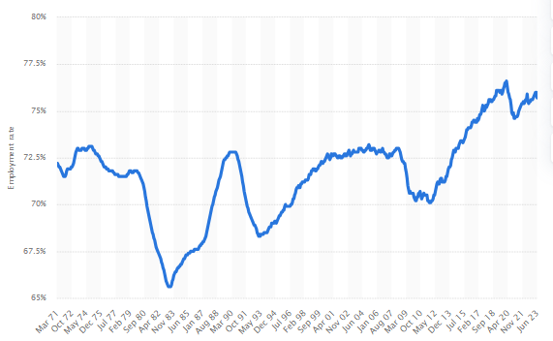

Figure 1: Employment rate in the UK
(Source: Statista.com, 2023)
The above figure depicts the UK labour market trend that rebounded after COVID-19, as it spiked at 5.1% in pre covid pandemic. It fell throughout most of 2022 to just 3.5%, as it has been identified that the majority of job opportunities in the UK were quite high (Statista.com, 2023). Thus, strong labour puts employees in a strong position, and uncertainty is encouraged due to the high number of job resignations. The high rate of infliction has also been quite strong and cancelled the gains on the ongoing living crisis.

The impact of the Covid-19 pandemic and Brexit on the UK's labour market
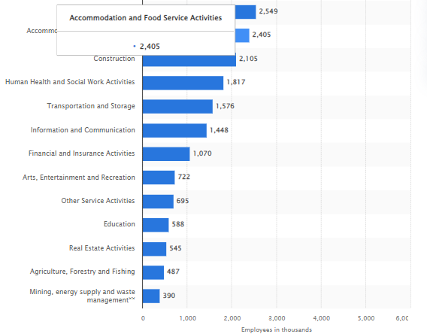
Figure 2: Labor in the private sector
(Source: Statista.com, 2023)
The pandemic generated a huge impact on the UK with millions of job retentions and schemes. Hence, the UK government determined a huge policy in response to the COVID-19 pandemic, as it is a clear sign of trouble in the labour market. However, at the end of 2021, over 11.7 million jobs. The wholesale and retail trade sectors employed just under 5 million labour workforces within the UK in addition to the huge support service activities the largest sector employer has been estimated as 2.99 million (Statista.com, 2023). Moreover, Brexit is also a serious disruption of the UK supply chain and freedom of movement. Thus, the European Union citizens no longer had an automatic right to live and work in the UK market. This is because Brexit introduced a trade barrier and customs regulations that impacted the movement of products and services in the UK. However, an external environment affects the industrial reliant on a just-in-time supply chain potentially to market changes and the needs of workforces. The end and shortages of the EU have led to a huge concern and potential skill shortages within these sectors, as it needs to attract workers from multiple sources (De Lyon). However, the uncertainty could have influenced hiring a decision and workforce planning. Conversely, Brexit introduced huge changes possibly to the availability of workers based on disrupting the trade relations. Therefore, it influences the market situation in the UK, to enhance employment patterns and job security or workforce planning.

Impact of the post-Covid and post-Brexit environment on the changes in HR strategies
Considering the post covid and post-Brexit environment, it brought huge changes based on significant changes in HR strategies to organize or adapt to new challenges.
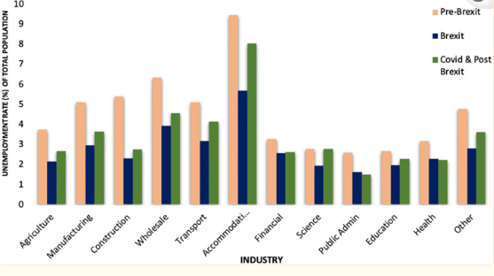
Figure 3: Average Unemployment Rate
(Source: Commons Library, 2023.)
Considering the figure and statistical data, the average percentage changes in wages across industries in the UK. Throughout the pre-Brexit, Brexit, COVID-19 and post-Brexit periods. Hence, it has been identified during the Brexit COVID-19 average income across industries has significantly changed with the greatest admiration, the public and health industries to raise their profits. Conversely, the income for the business such as accommodations was comparatively lower (Dhingra, 2021). Hence, Brexit influences a talent pool and encourages HR teams to reassess their sourcing strategies. The HR strategies to attract retained skilled workers by offering intense market competition and profit. The strategies of HR underscored the significance of employee well-being and mental health to identify the prioritized initiatives based on motivating employees.

Implications of the changes for businesses and workers
Considering the implications, COVID and Brexit have brought huge changes in employment law and regulation. The strategies of HR are being updated to ensure compliance with new requirements. This is because HR teams are working closely with legal and regulatory experts to navigate the changes. However, it is important to identify remote and employee engagement based on digital tools and platforms to utilize virtual training and team-building activities (Brooks et al., 2021). Moreover, the change brought flexibility and an agile approach to organizations that need to enhance business flexibility and agility in the workforce. This is because data-driven insights mainly help to identify trends and assess the effectiveness of strategies that optimize the process. However, in the post covid and post-Brexit landscape, HR strategies are evolving to align the new realities consisting of remote work, changing talent dynamics, and regulatory shifts (Paterson et al., 2023). Moreover, organizations are focusing on a credit-resilient and diverse workforce to ensure compliance effectively in managing the labour market and team complex environment.

Discussions

Labour market situation in the UK after Brexit and Covid
It has been identified through the above-mentioned finding, that the current trend of the UK labour market provides clear insights based on trends to emerging the current situation evolved since the pre-covid market. Hence, the situation and present trends have been mainly analyzed through remote work and hybrid models, thus the post-COVID-19 pandemic accelerated the growth and adoption of remote workers in the UK and globally. While the other workers have returned to their physical workplaces, many organizations have adopted their hybrid work models to allow an employee to work remotely. It has been discussed that many industrial sectors faced a challenge based on talent shortages even before the pandemic. Industrial sectors such as technology, healthcare, and engineering were mainly affected (Petrie, 2020). This is because the Brexit combination and the pandemic could potentially exacerbate these shortages due to changes in the availability of foreign talent disruption and education training. Based on technology, the continuous impact of artificial intelligence and automation enhances the labour opportunity it emphasizes diversity, equity, and workplace inclusion. This includes the efforts to create a more diverse workforce and address pay gaps to ensure equal opportunities for all employees. Through, the implication labour and staff of an industry identify diversity, inclusion, and equity to place stronger emphasis within the workplace. Hence, the pandemic has led to huge changes in the hiring and onboarding process with many interviews and activities to move online. Based on research, the implications and changes are significant especially for remote workers by consulting huge government support and initiatives (Dayan et al., 2020). This has been done through industrial analysis and news articles to get the most accurate and current insights into the trends that help shape the UK labour market.

HR strategies adopted by UK businesses after Brexit and Covid
The impact of post covid and post-Brexit environment might impact the HR strategies in the UK. Hence, the discussion has been made through using the models as Hybrid work models to impact the strategies evolved with various considerations and market trends based on the current market of the UK (Heald, 2020). Based on the model, the experience determined the widespread of remote work during the pandemic has highlighted the feasibility of flexible work environments and arrangements. In the COVID and post-Brexit world, HR continues to evaluate its strategies by segregating Autocratic leadership to make decisions independently regarding the employees and directives without inputs. Hence, leadership is a top-down approach where the business leaders hold the most effective decision-making power to identify the harsh market situation (Elsayed, 2021). The secondary sources have been properly used to analyze the UK market condition and the effects of COVID and Brexit external environment. It has been identified that leaders need to seek input and ideas from the team to make decisions as well as an approach to foster collaboration and innovations before making decisions. Therefore, Brexit provides more illusions in employment regulations, consisting of the immigration of labour laws. Thus, the HR department might need to closely monitor and adapt new rules and regulations to ensure the business's contents and market operations. Additionally, Data analytics has played an important role in HR significantly to make an informed decision. It involves huge adaptation in changing the business circumstances including the shifts in market demand and regulatory complaints.

Conclusion and Recommendations

Conclusion
The report aims to represent the present condition of the labour market in the UK and evaluate the changes in the HR strategies for adapting to the pandemic and Brexit across the organizations. The report concludes the requirement for businesses to adapt their HR strategies to remain competitive in the changing external environment. The strategies need to be changed to attract the best talent and ensure worker retention by offering higher wages and flexible working conditions. It has been concluded that the research identifies the current changes and patterns in the labour market in the UK. However, Brexit and post covid determine its impacts in the implication of changes in work responsibilities through creating opportunities among labour. This is because of the competitive edge and advantages in the UK marketplace. Therefore, the employees and labour need to adopt the flexibility approach to identifying income benefits. However, the UK market faced challenges of labour shortages due to Brexit complexities. Additionally, the leaders also need to focus more on implementing technology such as automation and Artificial intelligence techniques.

Recommendations
Businesses in the UK are recommended to invest in technology to promote flexible working and virtual work to respond to the pandemic. There is a need to invest in skill development for the workers to mitigate any shot ages and integrate diversity and inclusion efforts for increasing recruitment from within the UK. The business needs to provide the required training and collaborate with institutions to recruit low-skill workers to fill the vacancies for promoting employment and contributing to the national economy of the UK.

References
Brooks, C. et al. (2021) ‘A review of food fraud and food authenticity across the food supply chain, with an examination of the impact of the COVID-19 pandemic and Brexit on the food industry’, Food Control, 130, p.108171.
Commons Library (2023) ‘Labor market’, Available at: https://commonslibrary.parliament.uk/research-briefings/cbp-9366/#:~:text=Key%20figures,137%2C000%20over%20the%20last%20year. [Accessed on: 18-8-2023]
Dayan, M. et al. (2020) ‘Understanding the impact of Brexit on health in the UK’, Nuffield Trust, pp.2020-2012.
De Lyon, J. and Dhingra, S. (2021) ‘The impacts of Covid-19 and Brexit on the UK economy: early evidence in 2021’, London: Centre for Economic Performance, London School of Economics and Political Science.
Elsayed, A. and Abdelrhim, M. (2021) ‘The Impact of Brexit on the United Kingdom Stock Market Sectors in Under of the COVID-19 Crisis’, Available at SSRN 3825230.
Heald, D. and Hodges, R. (2020) ‘The accounting, budgeting, and fiscal impact of COVID-19 on the United Kingdom’, Journal of Public Budgeting, Accounting & Financial Management, 32(5), pp.785-795.
Johnston, M.P. (2014) ‘Secondary data analysis: A method by which the time has come’, Qualitative and quantitative methods in libraries, 3(3), pp.619-626.
Lyons, K. (2020) ‘Book review: EU migrant workers, Brexit and precarity: Polish women’s perspectives from inside the UK’, European Journal of Social Work, 23(4), pp.724-725.
Mayhew, K. and Anand, P. (2020) ‘COVID-19 and the UK labour market’, Oxford Review of Economic Policy, 36(Supplement_1), pp.S215-S224.
Paterson, A. et al. (2023) ‘The Impact of Government Policy Responses to the COVID‐19 Pandemic and Brexit on the UK Financial Market: A Behavioural Perspective’, British Journal of Management.
Paton, C. (2022) ‘Toxic cocktail: a hangover from austerity, the pandemic, Brexit and barely sorted social care’, In NHS Reform and Health Politics in the UK: Revolution, Counter-Revolution and Covid Crisis (pp. 175-186). Cham: Springer International Publishing.
Petrie, K. and Norman, A. (2020) ‘Assessing the economic implications of coronavirus and Brexit’, London: Social Market Foundation.
Portes, J. and Springford, J. (2023) ‘The impact of the post-Brexit migration system on the UK labour market’, Contemporary Social Science, 18(2), pp.132-149.
Rajasekar, D. and Verma, R. (2013) ‘Research methodology’, Archers & Elevators Publishing House.
Statista.com (2023) ‘Brexit issues’, Available at: https://www.statista.com/study/36274/brexit-and-the-uk-economy/ [Accessed on: 18-8-2023]
Statista.com (2023) ‘Employment rate’, Available at: https://www.statista.com/statistics/281992/employment-rate-in-the-united-kingdom/#:~:text=Although%20unemployment%20in%20the%20UK,1.3%20million%20by%20May%202022. [Accessed on: 18-8-2023]
Theodoropoulou, S. ed. (2018) ‘Labour market policies in the era of pervasive austerity: A European perspective’, Policy Press.
Ukandeu (2023) ‘The impact of Brexit on the UK labour market: an early assessment’, Available at: https://ukandeu.ac.uk/the-impact-of-brexit-on-the-uk-labour-market-an-early-assessment/#:~:text=The%20net%20loss%20of%20workers,but%20at%20a%20sectoral%20level. [Accessed 18 August 2023].
Walsh, D. et al. (2022) ‘Increased Risks of Labor Exploitation in the UK following Brexit and the Covid-19 Pandemic: Perspectives of the Agri-food and Construction Sectors’, Journal of Human Trafficking, pp.1-16.

