Yanick Mukanda Gracia (2210554)

(PDP) Personal Development
Yanick Mukanda Gracia
Contents
Task 1 Self Evaluation 1
(PDP)My Personal Development Plan Screenshot 2
Link 2
My Progress Engagement 3
Task 3 Unit 4 Summary 3
Task 4 PDP Video screenshot 4
Final Testing 4

Learning in Digital Era

Task 1 Self Evaluation

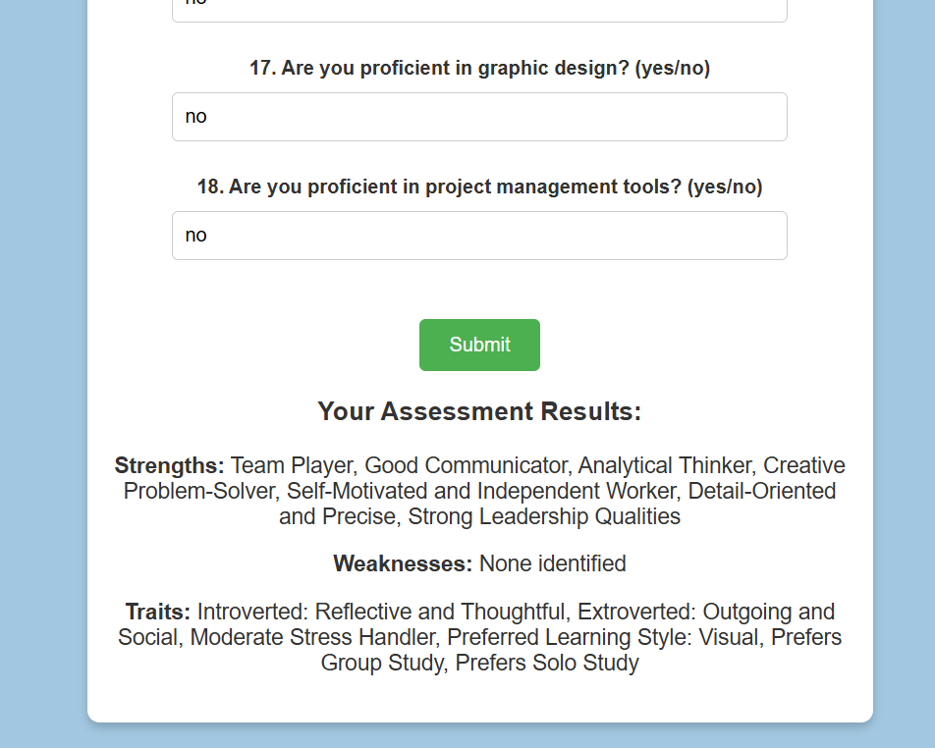

This is a screenshot of my self-evaluation assessment result and the result states I am a:

- Team player
- Good Communicator
- Analytical thinker
- Creative
- Problem solver
- Self-Motivated

Task 2 (PDP) Screenshot

(PDP)My Personal Development Plan Screenshot
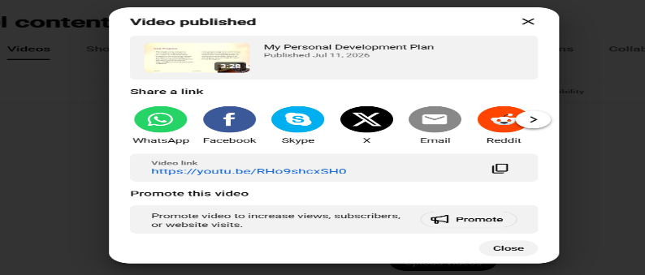
I have attached my screenshot for my personal development plan which I’ve uploaded via YouTube

Please see attached link below its working

Link
https://youtu.be/RHo9shcxSH0
this is the link attached link below for the personal development plan
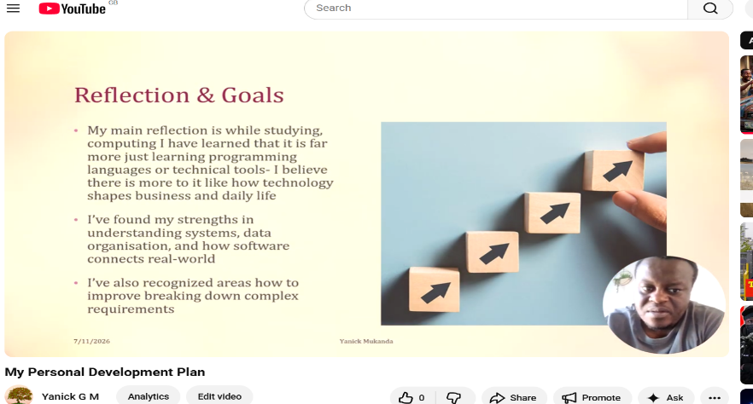

My Progress Engagement

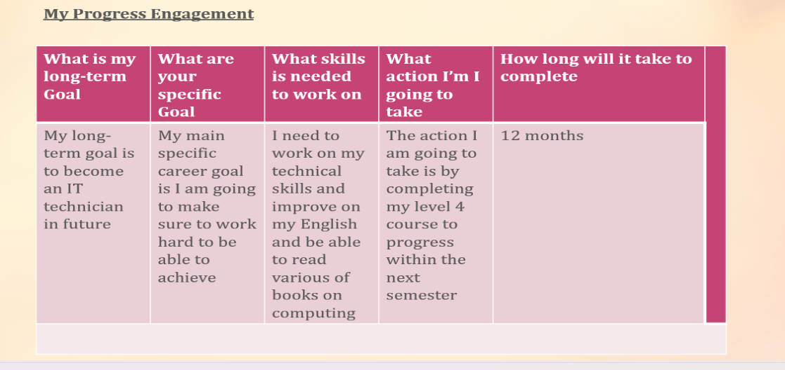

Here is a screenshot of my progress engagement which shows how long it will take me to reach my achievements

Task 3 Unit 4 Summary



This is a screenshot of my unit 4 summary answers

Task 4 PDP Video screenshot

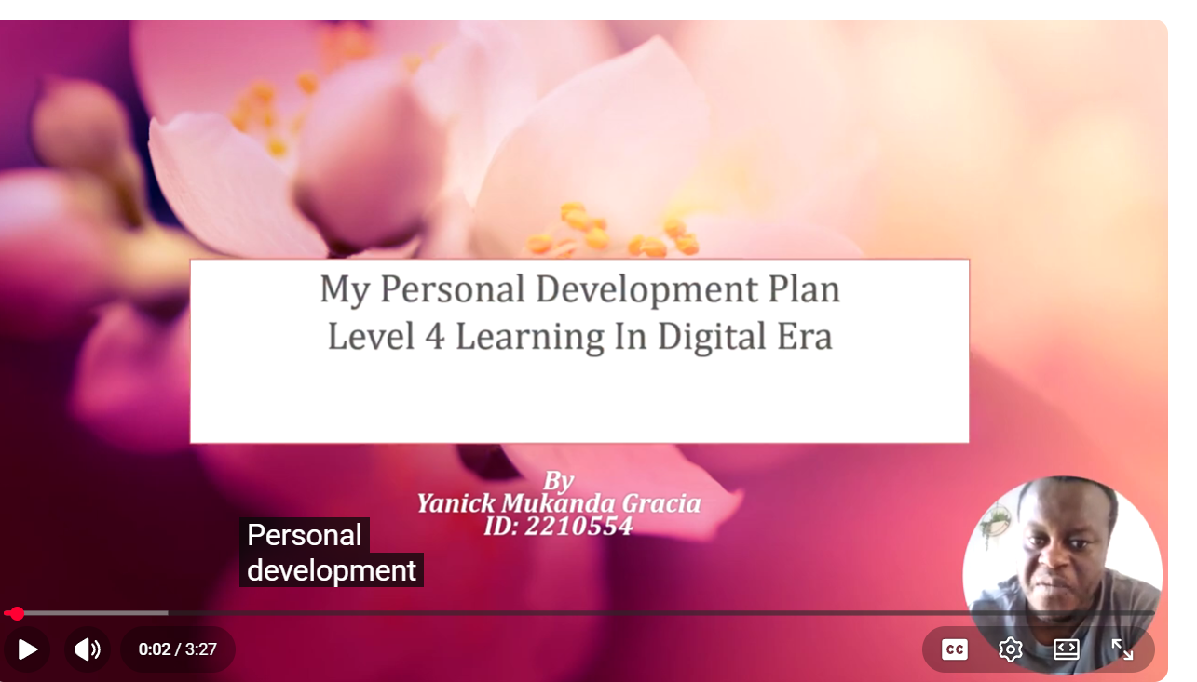
Here is a screenshot of my video which lasted approximately 3:27min

Final Testing
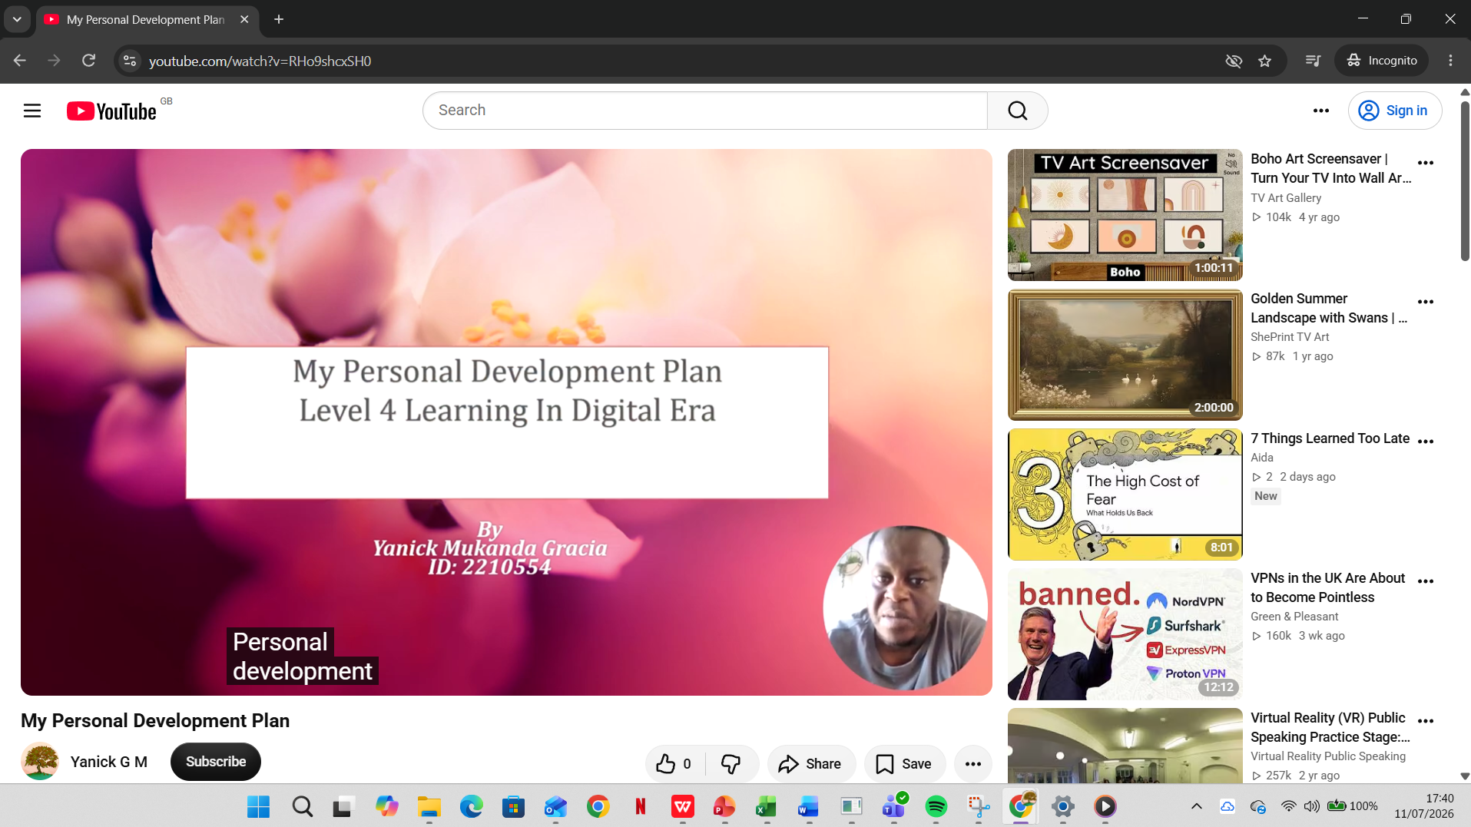
I have tested the video via incognito chrome and it is still operating fine

