

BA (Hons) Leadership and Management Skills for the Workplace

Module: Leading and Implementing Change (LCLM6003)
Assignment Title:
A Strategic Change Plan
Student Name: Alexandru Tanasa
Student ID:2231915

Executive summary

This report has assessed the strategic change requirements of Amazon in the UK during the era of fast-paced technological disruption, regulatory challenges, and labour issues. External factors such as CMA probes into AWS, the Digital Markets Act, and the post-pandemic e-commerce landscape have combined with internal challenges such as a fragmented culture, skill deficiencies, and morale issues due to restructuring. Although Amazon has been strong in AI, data, and logistics, these core competencies have been increasingly hampered by compliance requirements and labour issues.
This report has recommended a comprehensive transformation strategy focusing on responsible AI adoption, data governance, and workforce development by integrating the McKinsey 7S and Kotter models. A stakeholder-centric strategy has underlined the importance of open communication, aligning UK and US leadership, and ADKAR-modelled upskilling to minimise resistance. The report has concluded that Amazon needs to address its challenges in regulatory preparedness, workforce trust, and responsible AI use to maintain its long-term competitiveness in the UK market.

Table of Contents
Executive summary 2
1. Introduction to the Organisation 5
2. Environmental and Organisational Analysis 7
2.1 External Environment Analysis 7
2.2 Internal Environment Analysis 8
2.3 Analysis 9
2.4 Triggers for Change 10
3. Review and Evaluation of Change Management Models 11
I. Lewin’s Three-Step Model 11
II. Kotter’s 8-Step Process 11
III. ADKAR Model 12
IV. McKinsey 7S Model 12
V. Justification for the chosen model 13
4. Leadership and Organisational Culture in Change 13
1.1 Leadership Styles and Their Impact on Change 13
I. Transformational leadership 13
II. Transactional leadership 14
III. Situational leadership 14
1.2 Organisational Culture and Its Influence on Change 15
I. Schein’s Levels of Culture 15
II. Hofstede's cultural dimensions 15
III. Handy’s Cultural Typology 16
1.3 Integrated Impact 16
5. Proposed Strategic Change Management Plan 17
I. Change Vision and Objectives 17
II. Stakeholder Analysis 18
III. Implementation Framework 19
IV. Communication Plan 19
V. Financial and Resource Plan 20
VI. Risk Assessment and Mitigation 21
VII. Evaluation and KPIs 22
6. Discussion and Critical Reflection 23
7. Conclusion 24
Reference List 25
Appendices 31
Appendix 1: 31
Appendix 2 32

1. Introduction to the Organisation
Amazon is one of the most dominant technology-driven multinational corporations in the world, which operates across cloud computing, E-Commerce, digital media, and artificial intelligence. The brand is globally recognised for its mission to be the most customer-centric company on earth with a strategic vision based on operational excellence, innovation, and seamless customer experience (Amazon, 2026a). It also operates in a highly competitive digital, retail, and cloud services industry in the UK and has doubled AI investment with the pledge of £1.8 billion in cloud computing (Gooding, 2022). The rationale for selecting Amazon lies in the strategic complexity, the pace of technological transformation, and the debates on organisational agility and digital disruption.
The author has worked at Amazon since 2024 and has gained practical insight into its leadership expectations, operational procedures, and communication practices in times of organisational change. The professional engagement provides a concept for analysing the ways change initiatives are implemented, understood, and experienced at the professional level, which improves the relevance and authenticity of the study.
A major focus of this report is the recent and ongoing transformation programme at Amazon. The digital transformation strategy of Amazon includes a significance in AI automation Network and communication (GlobalData, 2023). UK online sales during COVID increased by 33.9% as a share of retail spending (ONS, 2021). This led Amazon to hire 15000 British workers to meet the demands of home delivery and employ automated digital services during the pandemic (Thomas, 2022). Furthermore, the brand had to expand the fulfilment centre capacities while increasing health and safety operations. Remote work structures were also deployed across corporate and customer service teams as well. This created significant issues after the demand normalised, which forced Amazon to restructure its workforce. It cut 16000 corporate jobs to reduce management layers and replaced them with artificial intelligence to address operating costs (Singh, 2026).
Industry pressures further established the requirement for strategic change. Digital retail competition is intense, while rapid advances in logistics and AI challenge the capacity of Amazon to sustain differentiation. Regulatory pressures, namely UK data governance requirements, also increased complexity for the brand. Furthermore, labour rights movements and concerns regarding automation-related job displacement also exposed the internal cultural vulnerability that should be managed by the company.
The report will critically analyse internal and external drivers that influence the change landscape of Amazon while evaluating leadership responses and organisational capabilities. It will develop a strategic change plan aligned with the mission and vision in the long-term. The study aims to provide a comprehensive analytical evaluation of the ways Amazon can navigate the transformation to have a competitive edge in the industry.

2. Environmental and Organisational Analysis

2.1 External Environment Analysis

Pestle Analysis
Factor | Impact
Political | There is strict ongoing regulatory scrutiny in the UK, with the Competition and Markets Authority (CMA) cloud competition probe targeting AWS dominance (Hale, 2025). The government's industrial strategy supports investment, which should be conducted by Amazon to create thousands of jobs.
Economic | After Brexit, there was an 11% increase in import prices, with spending per UK household increasing by 0.6% due to trade policy uncertainty (Graziano, Handley, and Limao, 2023). This increases consumer spending volatility, and inflation affects demand, yet Amazon can invest and hire individuals to mitigate this.
Social | Around 51% of young adults in the UK worry about artificial intelligence and technology replacing their jobs (Partridge, 2025). This can be a concern for Amazon, so it needs to bring parity between the robot and human workforce in its warehouses.
Technological | The UK is the third largest AI and technology market, valued at $89 billion with a growing rate of 10% per year, and harbours AWS and Microsoft (ITA, 2026). Expansion of AWS and AI infrastructure aligns with UK technology growth, robotics drives efficiency, but risks workforce friction.
Legal | The UK Digital Markets, Competition and Consumers Act 2024 enables strict DMU oversight, imposing conduct rules and heavy penalties on dominant cloud providers (Legislation.gov.uk, 2026). This regulation could impose stricter oversight on AWS.
Environmental | There is a growing UK focus on sustainable logistics and emissions due to the commitment to reach net zero (Parliament.uk, 2025). Amazon faces pressure to decarbonise transport and data centres.

Porters Five forces
Force | Implication | Explanation
Threat of New Entrants | Low | Due to capital intensity (logistics, data centres), brand scale, and Prime ecosystem lock-in, which deters new competitors.
Bargaining Power of Suppliers | Low–Moderate | Diverse product suppliers globally, but AWS’s own supplier ecosystems show moderate leverage.
Bargaining Power of Buyers | High | UK consumers have extensive alternatives (eBay, Tesco online, local retailers). Price transparency strengthens consumer leverage.
Threat of Substitutes | Moderate | Brick-and-mortar and multi-channel retail offer alternatives; digital cloud alternatives influence AWS.
Competitive Rivalry | High | Intense competition from eBay, Tesco, and ASOS in retail. Regulatory pressure in the cloud (CMA scrutiny of AWS) reinforces rivalry.

2.2 Internal Environment Analysis

SWOT
Strengths | Weaknesses
- Strong logistics network, Prime ecosystem, and dominant cloud division, Amazon Web Services (Amazon, 2026).  - High automation capability and scale efficiencies. | - High operating costs  - Fulfilment Centre injuries reported in UK media (Sherman, 2024)  - Workforce dissatisfaction during restructuring.
Opportunities | Threats
- UK £40bn investment plan enabling AI expansion and robotics adoption (Amazon UK, 2026).  - Scope to strengthen sustainability leadership. | - Labour-union pressure  - Rising automation anxiety  - Intense scrutiny under the DMCC 2024 Act  All these factors can affect cloud dominance.

Resource-Based View
Resource and Capability | VRIO Assessment | Implication
Brand reputation and customer loyalty | Valuable, rare | Supports competitive positioning and reliability perception.
AWS cloud infrastructure | Valuable, rare, hard to imitate | Sustainable advantage but vulnerable to UK regulatory intervention.
Robotics and AI capability | Valuable, partly imitable | Enhances efficiency but requires continuous reinvestment.
Data analytics capacity | Valuable, rare | Enables personalised services and operational optimisation.
Workforce performance culture | Valuable but imitable | Drives productivity yet risks burnout and labour relations issues.

2.3 Analysis
The external pressures at Amazon reveal several strategic threats that interact directly with the capability gaps present inside the organisation. The most critical issue is regulatory scrutiny in the UK, where CMA investigations and the Digital Markets Act can place a structural constraint on AWS. This is an internal strength that simultaneously becomes a vulnerability due to existing compliance gaps and limited capacity in AI governance. Another major pressure is AI expansion, which aligns with the VRIO advantages of Amazon in data analytics and robotics while exposing skill shortages, workforce dissatisfaction, and cultural resistance. This reveals a lack of alignment between human capability and technological ambition. Changing customer expectations and competitive rivalry are identified as moderate risks, yet can increase depending on efficiency, thereby intensifying sensitivity to labour relations issues, as evidenced in the SWOT. Regulatory and workforce tensions can rise as the highest priority by weighing the pressures according to likelihood and scale, which requires strong strategic attention. However, technological opportunities depend on the ability of Amazon to reduce cultural gaps and increase internal capabilities.

2.4 Triggers for Change
There are several triggers that promote strategic change at Amazon. The most significant aspect is the acceleration of AI-driven business models and digital disruption. The rise of the generative AI market is projected to reach a value of $91.57 billion in 2026 with an annual growth rate of 34.3% (Statista, 2026). This intensifies the competitive pressure on the retail and cloud operations of Amazon. Major competitors of the brand include Tesco, ASOS, and quick commerce firms that have adopted algorithmic pricing and AI forecasting (Mordor Intelligence, 2026). The factors push Amazon to escalate its efficiency by using AI and robotics. This explains the recent £40 billion UK investment plan of Amazon focused on advanced logistics and AI infrastructure (Browne, 2025).
There is also a major change in online shopping behaviours where online revenues of e-commerce in the UK observed a decline of 3.5% after normalisation following the pandemic (Fibre2Fashion, 2024). This implies Amazon should innovate beyond them to maintain demand in the market. Additionally, the UK Data Protection and Digital Information Bill introduced strict implications regarding algorithmic transparency, data handling, and accountability for Digital platforms (Parliament.uk, 2023). The retail logistics and AWS systems of Amazon depend on extensive data processing, and this bill can increase compliance pressures while necessitating restructuring regarding privacy governors and AI decision-making.
Labour tensions and increasing operational costs, highlighted by warehouse issues in the UK and concerns about automation replacing roles, are major internal issues. These expose vulnerability in the capability of Amazon to maintain a resilient culture in its workforce. Automation has significantly increased in Amazon as the organisation deploys around 75000 robots around the world (Amazon, 2023). This marks balancing employee well-being with efficiency as a strategic imperative. These issues demand transformation and change, which requires Amazon to reconfigure its capabilities, technological strategy, and leadership approaches to maintain competitiveness in a volatile industry.

3. Review and Evaluation of Change Management Models

Lewin’s Three-Step Model
Lewin's change management model consists of three major stages, namely unfreeze, change, and refreeze, guiding transformation at an organisation (Santos et al., 2023). However, it is criticised as static and linear for the volatile digital environment of the present times. Unfreezing can support the requirement of Amazon to challenge the existing norms in leadership routine and human centres, especially regarding data governance and automation acceptance. Still, the refreezing stage contradicts the Day 1 philosophy of Amazon, as it is built on readiness for disruption and continuous innovation. However, Vasel (2025) argues that this raises a deeper question about whether any traditional model premised on stability can meaningfully operate in a digital ecosystem where disruption is continuous. Thus, this model can be helpful for initial destabilisation and culture; however, it cannot guide the continuous transformation at Amazon.

Kotter’s 8-Step Process
Kotter's 8-step model emphasises leadership urgency, creation, and building of a coalition (Carreño, 2024). This can address the major challenges for Amazon during its investment in the UK regarding AI and robotics. Establishing urgency aligns with the competitive pressures from Tesco, ASOS, and Microsoft Azure while generating short-term wins and empowering employees to strengthen morale in times of job restructuring. However, Kotter's approach has been criticised for being rigid and for its assumption of top-down and sequential change (Carreño, 2024). This further gives rise to an issue of whether a linear model can deliver change in an organisation built on decentralised authority, rapid experimentation, and continuous learning. The decentralised decision-making and rapid experimentation at Amazon required continuous feedback and adaptive loops, which may not align with fixed progression. It fails to identify political behaviour and resistance dynamics, which can be critical issues in the automation-driven environment at Amazon.

ADKAR Model
ADKAR emphasises Awareness, Desire, Knowledge, Ability, and Reinforcement, with a clear approach to individual behavioural change (Ali et al., 2021). This is very helpful for Amazon’s big and varied workforce that needs to adapt to new robotics technology, new data handling rules as part of the UK Digital Information Bill, and new performance measures. The strength of the model is its applicability, which tackles resistance, capabilities, and skills transition at the employee level. A major weakness of ADKAR is that it does not emphasise organisational structures and alignment (Al-Alawi et al., 2019). The model presumes that individual change occurs independently of the system, which becomes a challenge for Amazon’s change that also involves restructuring warehouses, new algorithms, and a shift in cloud priorities. This identifies a theoretical assumption that individual change precedes organisational change, which can be problematic in a mechanised environment like Amazon.

McKinsey 7S Model
The McKinsey 7S framework combines strategy, structure, systems, staff, skills, style, and shared values (Chmielewska et al., 2022). It is a comprehensive framework that makes it extremely applicable to Amazon, where technology, culture, and strategy are connected deeply. Using this framework, managers can analyse the interdependence between the rise in automation (systems) and the anxiety of employees (style/values), training (skills), and organizational culture. Moreover, the framework is applicable to Amazon’s complex global structure, where AWS, fulfillment centres, and corporate groups must work in a coordinated manner. Nevertheless, the 7S framework is a diagnostic tool and lacks prescriptive capability because it points out inconsistencies but does not provide any suggestions on how to effect changes (Ishii, Takemura, and Kitamura, 2025). Moreover, the framework overlooks external forces, which are important in Amazon’s case, considering the changing UK regulations. Its internal focus assumes stability in external conditions, which can be unrealistic for Amazon’s regulatory and technological volatility.

Justification for the chosen model
Depending on the speed, scale, and complexity of transformation in Amazon, a combination of McKinsey 7s framework and Kotter's 8-step model can be useful. It can offer strategic coherence and operational discipline to the brand in times of regulatory technology and workforce disruption. The McKinsey 7s Framework offers a comprehensive diagnostic approach to Amazon to evaluate online retail competition, AI automation, and cloud regulation, and their interaction with structural capabilities, systems, and leadership styles. It can reveal gaps like warehouse skills or weak AI governance. Kotter's 8 step model also complements this by driving urgency, communication alignment, and short-term wins to manage behavioural resistance during regulatory and automation changes. Lewin's model was not chosen due to its linear stages, which contradict the continuous day one culture at Amazon. Additionally, ADKAR focuses narrowly on individual change, which lacks the strategic and structural alignment required for large-scale transformation at Amazon.

4. Leadership and Organisational Culture in Change

Leadership Styles and Their Impact on Change

Transformational leadership
Transformational leadership is strongly aligned with an environment driven by innovation (Alqatan et al., 2025). This can be useful at Amazon as leaders such as senior AWS executives shape an aspirational vision built around day one thinking, which encourages ownership and strategic focus in the long term. This can be effective during robotics deployment, AI adoption, and strategic restructuring to bring transformation and organisation by motivating employees through continuous improvement. However transformational leadership style can present a risk of developing a demanding performance expectation from the team. As per research by Sanchez-Segura et al. (2023), transformational climates can increase burnout among the workforce, especially during change environments. This can increase warehouse pressures and resistance during redesigns driven by automation at Amazon. However, Amazon’s performance-driven culture may also unintentionally amplify transactional behaviours beneath the surface, meaning transformational rhetoric does not always translate into daily practice.

Transactional leadership
Transactional leadership supports efficiency and reliability for organisations in times of change (Mekonnen and Bayissa, 2023). This can be incorporated in the operational culture at Amazon, especially at fulfillment centres driven by productivity metrics and KPIs, driving automation and redesign in workflows. Transactional leadership is highly beneficial for routine operations, yet it can undermine adaptability. It can promote a culture of compliance in place of commitment, which can be problematic if an organisation is adopting new systems (Wang, Toseef, and Gong, 2021). This can be difficult for Amazon while adjusting to UK data governance reforms and AI systems that require procedural and behavioural changes. Transactional systems can increase tension between management and frontline employees in times of restructuring. This suggests a deeper cultural pattern where transactional expectations are reinforced by structural pressures, creating misalignment with Amazon’s innovation-oriented values.

Situational leadership
Situational leadership supports adaptation of leadership behaviour to contextual demands (Del Pino-Marchito, Galán-García, and Plaza-Mejía, 2025). This is necessary for the hybrid and automation-driven environment at Amazon. For instance, automation rollout demands supportive leadership that provides coaching, while regulatory compliance in AWS can require directive styles. The situational approach, however, can be inconsistently applied due to the different hierarchy and scale of Amazon's operations. Leaders may default to transactional behaviours in times of high pressure, which reduces the flexibility required for change during complex transformations. This inconsistency demonstrates how leadership style is constrained by cultural expectations and operational systems rather than individual choice alone.

Organisational Culture and Its Influence on Change

Schein’s Levels of Culture
Schein’s model can identify the ways the culture of Amazon can shape the change dynamics. Artefacts include productivity dashboards, automated workflows, and high-tech warehouses, which establish a culture of efficiency and speed. Espoused values are operational excellence, customer obsession, and innovation that drive transformation. Underlying assumptions reflect Amazon’s move-fast ethos, which influences expectations of constant adaptation. The culture supports innovation while generating tension during employee transition (Naylor, 2025). Assumptions that employees continuously adapt can conflict with well-being and increase resistance during restructuring or AI adoption. The differences between aspirational values and lived pressures strengthen the dominance of transactional norms during change.

Hofstede's cultural dimensions
Hofstede scores demonstrate the ways Amazon is navigating a culturally similar yet operationally divergent situation. A low power distance (US 40; UK 35) and high individualism (US 60; UK 76) encourage autonomy and decentralized decisions across teams (Appendix 1). High motivation for achievement (US 62; UK 66) and low uncertainty avoidance (US 46; UK 35) support innovation, yet cultural variation between UK fulfilment teams and US corporate systems can affect alignment.

Handy’s Cultural Typology
Amazon constitutes a task culture at AWS and corporate teams with dominating project-based innovation (Colvin, 2022). It offers a role culture in logistics which is driven by rules and standardisation. Finally, there is a power culture at executive levels where strategic direction is centrally determined. This cultural fragmentation can complicate transformation for the brand. Task cultures innovate quickly, but role cultures can struggle with the agility required for AI integration or changes in regulatory governance. Differences between power and the role cultures can result in low moral misalignment and perceived unfairness in times of organisational change. This fragmentation reinforces the mixed leadership tendencies across the organisation, impacting coherent change execution.

Integrated Impact
Leadership in culture determines the change capacity at Amazon. Situational and transformational leadership can promote AI adoption and regulate transitions related to compliance and operational restructuring. However, overly transactional leadership systems and inconsistent cultural patterns can develop barriers to adaptability and employee engagement. These cultural complexities collectively demonstrate that Amazon’s structures often reinforce transactional systems even when transformational leadership is desired. Amazon needs to improve cultural expectations and communication and adapt supportive and adaptive leadership to sustain a competitive advantage in the UK while driving transformation through automation. Hence, integrating leadership and culture shows that effective change depends on leadership intent as well as on the alignment between structural systems, cultural expectations, and the daily behavioural norms that shape employee experience.

5. Proposed Strategic Change Management Plan

Change Vision and Objectives
The strategic change vision at Amazon is to transform into an ethically governed AI-enabled business with a workforce-centred system, maintaining competitiveness in the UK. The vision responds to pressures, including rapid AI diffusion, fluctuating E-Commerce performance, and increased scrutiny of cloud dominance. It also involves internal challenges created by restructuring with uneven capability development across global operations. The organisation aims to improve AI-driven efficiency, stabilise labour relations, and prepare UK operations for cloud competition and data governance rules without creating organisational fragmentation. The vision prioritises rebuilding capability in the workforce through leadership development and targeted upskilling while enhancing coherence between UK subsidiaries and the United States headquarters to reduce implementation gaps and communication issues. Thus, the vision can balance technological ambition with regulatory readiness, cultural stability, and organisational resilience in the long term.

Stakeholder Analysis
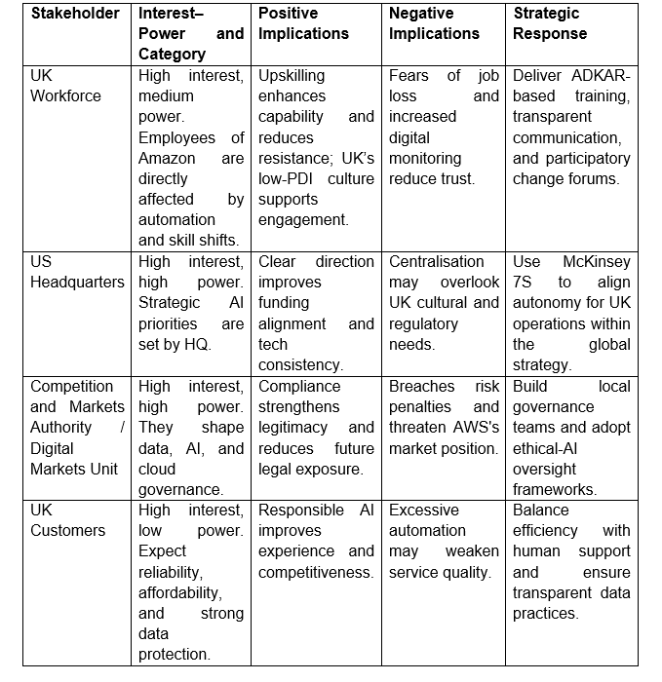

Implementation Framework
The strategic change programme will be delivered through an integrated Kotter-McKinsey 7S framework to align the AI-enabled transformation at Amazon with skills, systems, and culture. Kotter's early stages involve creating urgency around UK regulatory scrutiny from the CMA and addressing labour tensions while mobilising UK-US leadership and building commitment. The 7S model will diagnose misalignments like capability gaps in the fulfilment centres in the UK or weak AI governance structures, thereby guiding structural and skills re-design. Communicating a unified vision can reduce uncertainties in the workforce, while pilot AI deployments can create wins for the short term. However, Kotter can risk rigidity, while 7S offers limited implementation guidance. Still, their combination can provide the structural coherence and momentum necessary for responsible AI adoption.

Communication Plan
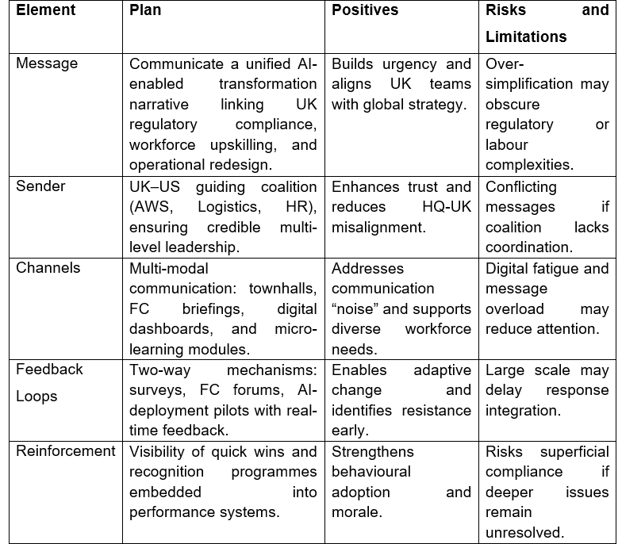

Financial and Resource Plan
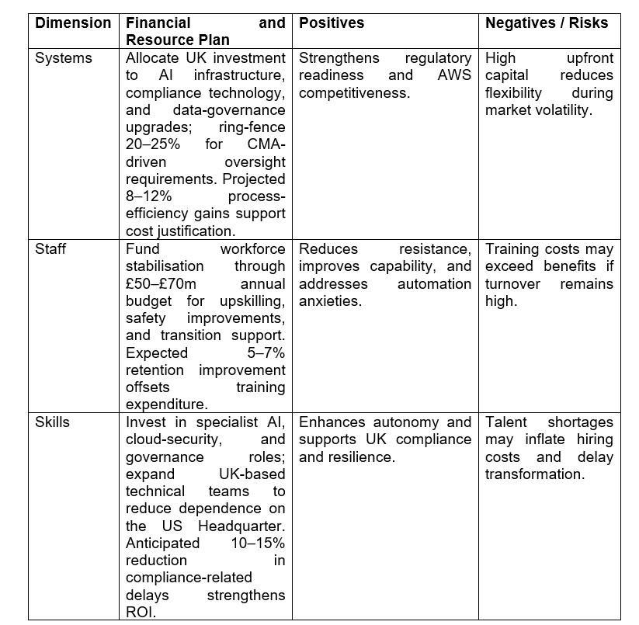

Risk Assessment and Mitigation
Risk understanding will be developed through the diagnostic reviews by McKinsey 7s framework, which identifies misalignments in systems, structures, skills, and culture. Kotter's feedback and urgency loops can reveal political and behavioural resistance early (Sistare, 2022). Regulatory risks driven by increased scrutiny from the CMA will be understood through continuous compliance audits and stakeholder mapping. A probability–impact matrix will categorise these risks to prioritise high-severity compliance threats. It can be mitigated through the rough early coalition engagement and redesigning of governance systems, thereby strengthening legitimacy while reducing strategic flexibility. Workforce resistance due to automation anxiety and restructuring will be evaluated through a pilot feedback service and capability audits. High-probability cultural fatigue will be flagged as a priority risk. Communication and targeted upskilling can reduce anxiety despite the presence of cultural fatigue. Furthermore, operational disruption during AI deployment can be understood through process mapping and scenario testing and can be mitigated through phased pilots. However, this may slow the realisation of efficiency gains for the company, which must be considered.

Evaluation and KPIs
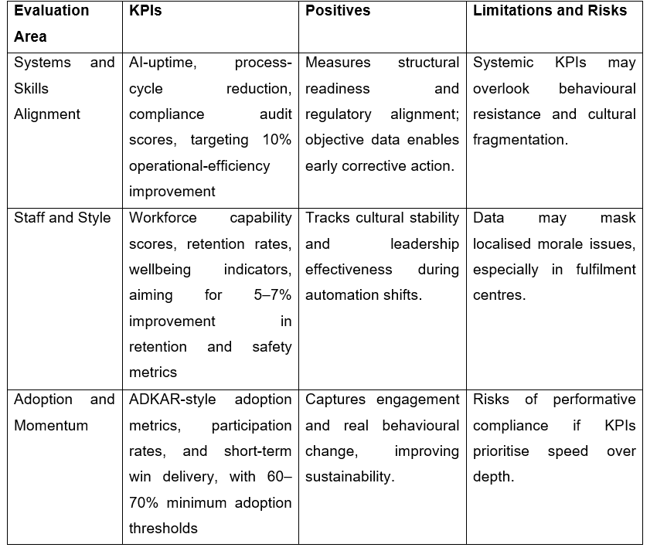

6. Discussion and Critical Reflection
The change plan is strategically strong, yet its viability depends on the navigation of cultural, ethical, and other sustainability issues. Integrating Kotter with McKinsey 7s model is a major strength as it balances structural alignment with behavioural mobilisation. This is essential for a complex and global organisation like Amazon due to its different levels of operations. The dual framework approach will support regulatory compliance under the CMA of the UK while enhancing capability in AI governance and providing clarity in transitions in the workforce. Previously, I viewed change frameworks as sequential tools, but applying both models revealed how misalignment between systems, leadership behaviour, and values can quietly undermine strategy. This has influenced how I now interpret restructuring and communication practices within Amazon.
The emphasis of the plan on building capacity, ethical AI, and transparent communication will place Amazon as a socially responsible employer. It will address increasing labour tensions and automation anxiety in the country. Through this analysis, I also recognised that leadership inconsistencies are often shaped by structural and cultural constraints. This insight will shape how I respond to change communication in my own role. Upskilling for workforce budgets may not mitigate any perceived inequities if automation results in job displacement (Patil, 2024). Ethically, the intense use of algorithmic systems and monitoring technologies can challenge privacy expectations, which requires strong safeguarding systems to maintain trust. Sustainability can be improved through investment in data governance systems and low-carbon logistics (Ojadi et al., 2021). However, the expansion of AI infrastructure can increase energy consumption. Reflecting on these issues, I now view the automation–trust relationship not only as a risk but as an enduring strategic dilemma that requires continuous balancing rather than one-time solutions. The plan is strategically robust yet should remain flexible, culturally sensitive, and ethically grounded to ensure viability in the long term.

7. Conclusion
In summary, the current operating model of Amazon requires targeted transformation to remain compliant, competitive, and culturally cohesive in the UK environment. The analysis demonstrated that inconsistent leadership practices, fragmented organisational culture, and emerging regulatory issues can be major constraints on resilience and performance in the long term. Application of the McKinsey 7S framework and Kotter's model highlights the requirement for strategic alignment with improved workforce capability and strong data governance, especially during the extension of AI-driven automation processes.
The board is advised to prioritise three strategic actions to ensure better outcomes. At the onset, incorporating a unified culture through shared values, transparent communication, and a psychologically safe learning environment is essential to reduce resistance. Secondly, investment in compliance and AI governance infrastructure is crucial to mitigate regulatory risks. Thirdly, improving leadership capability and the training of employees is required to support sustainable transformation. These recommendations will help Amazon to improve operational effectiveness, build workforce trust, and maintain innovation leadership in the dynamic UK market.

Reference List
Al-Alawi, A.I., Abdulmohsen, M., Al-Malki, F.M. and Mehrotra, A. (2019) Investigating the barriers to change management in public sector educational institutions. International Journal of Educational Management, 33(1), pp.112-148. https://www.emerald.com/ijem/article-pdf/33/1/112/789094/ijem-03-2018-0115.pdf
Ali, M.A., Zafar, U., Mahmood, A. and Nazim, M. (2021) The power of ADKAR change model in innovative technology acceptance under the moderating effect of culture and open innovation. LogForum, 17(4). https://yadda.icm.edu.pl/baztech/element/bwmeta1.element.baztech-41cf6e03-fd95-45ed-a13f-73ae9c4b979f
Alqatan, A., Simmou, W., Shehadeh, M., AlReshaid, F., Elmarzouky, M. and Shohaieb, D. (2025) Strategic pathways to corporate sustainability: The roles of transformational leadership, knowledge sharing, and innovation. Sustainability, 17(12), p.5547. https://www.mdpi.com/2071-1050/17/12/5547
Amazon (2023). How Amazon deploys collaborative robots in its operations to benefit employees and customers. Available at: https://www.aboutamazon.com/news/operations/how-amazon-deploys-robots-in-its-operations-facilities (Accessed: 25 February 2026).
Amazon (2026). What We Do. Available at: https://www.aboutamazon.com/what-we-do (Accessed: 25 February 2026).
Amazon (2026a). Amazon Connect Customers. Available at: https://aws.amazon.com/connect/customers/ (Accessed: 25 February 2026).
Amazon UK (2026). Amazon announces plans to invest £40 billion in the UK. Available at: https://www.aboutamazon.co.uk/news/job-creation-and-investment/amazon-40-billion-uk-investment (Accessed: 25 February 2026).
Browne, R. (2025). Amazon to invest £40 billion in the UK over next three years. Available at: https://www.cnbc.com/2025/06/24/amazon-to-invest-40-billion-in-the-uk-over-next-three-years.html (Accessed: 25 February 2026).
Carreño, A.M. (2024) An analytical review of John Kotter's change leadership framework: A modern approach to sustainable organizational transformation. Available at SSRN 5044428. https://papers.ssrn.com/sol3/Delivery.cfm?abstractid=5044428
Chmielewska, M., Stokwiszewski, J., Markowska, J. and Hermanowski, T. (2022) Evaluating organizational performance of public hospitals using the McKinsey 7-S framework. BMC health services research, 22(1), p.7. https://link.springer.com/article/10.1186/s12913-021-07402-3
Colvin, G. (2026). How Amazon grew an awkward side project into AWS, a behemoth that’s now 4 times bigger than its original shopping business. Available at: https://fortune.com/longform/amazon-web-services-ceo-adam-selipsky-cloud-computing/ (Accessed: 26 February 2026).
Del Pino-Marchito, A., Galán-García, A. and Plaza-Mejía, M.D.L.Á. (2025) The Hersey and Blanchard’s Situational Leadership Model Revisited: Its Role in Sustainable Organizational Development. World, 6(2), p.63. https://www.mdpi.com/2673-4060/6/2/63
Fibre2Fashion (2024). UK's e-commerce sales see 7% YoY decline in January 2024: IMRG. Available at: https://www.fibre2fashion.com/news/e-commerce-industry/uk-s-e-commerce-sales-see-7-yoy-decline-in-january-2024-imrg-293058-newsdetails.htm (Accessed: 25 February 2026).
GlobalData. (2023). Amazon.com – Digital Transformation Strategies. Available at: https://www.globaldata.com/store/report/amazon-com-enterprise-tech-analysis/ (Accessed: 25 February 2026).
Gooding, M. (2022). AWS to double UK investment with £1.8bn pledge. Available at: https://www.techmonitor.ai/hardware/cloud/aws-in-the-uk-cloud-azure-google-cloud (Accessed: 25 February 2026).
Graziano, A., Handley, K., and Limao, N. (2023). Brexit inflation: The role of trade policy uncertainty in increasing UK import prices. Available at: https://cepr.org/voxeu/columns/brexit-inflation-role-trade-policy-uncertainty-increasing-uk-import-prices (Accessed: 25 February 2026).
Hale, C. (2025). UK looks to stop "harmful" cloud domination by AWS, Microsoft - but the tech giants are hitting back. Available at: https://www.techradar.com/pro/uk-looks-to-stop-harmful-cloud-domination-by-aws-microsoft-but-the-tech-giants-are-hitting-back (Accessed: 25 February 2026).
Ishii, K., Takemura, Y. and Kitamura, A. (2025) Organizational transformation elements for evidence-based practice by hospital nursing staff: a qualitative study using 7-S framework. BMC nursing, 24(1), p.625.
ITA (2026). United Kingdom Country Commercial Guide. Available at: https://www.trade.gov/country-commercial-guides/united-kingdom-information-and-communication-technology (Accessed: 25 February 2026).
Legislation.gov.uk (2026). Digital Markets, Competition and Consumers Act 2024. Available at: https://www.legislation.gov.uk/ukpga/2024/13/contents (Accessed: 25 February 2026).
Mekonnen, M. and Bayissa, Z. (2023) The effect of transformational and transactional leadership styles on organizational readiness for change among health professionals. SAGE open nursing, 9, p.23779608231185923. https://journals.sagepub.com/doi/abs/10.1177/23779608231185923
Mordor Intelligence. (2026). United Kingdom E-Commerce Market Size & Share Analysis - Growth Trends and Forecast (2026 - 2031). Available at: https://www.mordorintelligence.com/industry-reports/united-kingdom-ecommerce-market (Accessed: 26 February 2026).
Naylor, R. (2025) Enacting transition pedagogy at a school level: An action research analysis of institutional change using Schein's model of organisational culture. Student Success, 16(3), pp.93-104. https://search.informit.org/doi/abs/10.3316/informit.T2025112700006601787259929
Ojadi, J.O., Odionu, C., Onukwulu, E. and Owulade, O.A. (2024) Big data analytics and AI for optimizing supply chain sustainability and reducing greenhouse gas emissions in logistics and transportation. International Journal of Multidisciplinary Research and Growth Evaluation, 5(1), pp.1536-1548. https://www.allmultidisciplinaryjournal.com/uploads/archives/20250325155124_MGE-2025-2-119.1.pdf
ONS (2021). Impact of the coronavirus (COVID-19) pandemic on retail sales in 2020. Available at: https://www.ons.gov.uk/economy/grossdomesticproductgdp/articles/impactofthecoronaviruscovid19pandemiconretailsalesin2020/2021-01-28 (Accessed: 25 February 2026).
Parliament.uk (2023). The UK’s plans and progress to reach net zero by 2050. Available at: https://commonslibrary.parliament.uk/research-briefings/cbp-9746/ (Accessed: 25 February 2026).
Parliament.uk (2025). The UK’s plans and progress to reach net zero by 2050. Available at: https://commonslibrary.parliament.uk/research-briefings/cbp-9888/ (Accessed: 25 February 2026).
Partridge, J. (2025). Half of UK adults worry that AI will take or alter their job, poll finds. Available at: https://www.theguardian.com/technology/2025/aug/27/half-of-uk-adults-worry-that-ai-will-take-or-alter-their-job-poll-finds (Accessed: 25 February 2026).
Patil, D. (2024) Impact of artificial intelligence on employment and workforce development: Risks, opportunities, and socioeconomic implications. Opportunities, And Socioeconomic Implications (November 12, 2024). https://papers.ssrn.com/sol3/papers.cfm?abstract_id=5057396
Sanchez-Segura, M.I., Dugarte-Peña, G.L., Medina-Dominguez, F., Amescua Seco, A. and Menchen Viso, R. (2023) Digital transformation in organizational health and safety to mitigate Burnout Syndrome. Frontiers in Public Health, 11, p.1080620. https://www.frontiersin.org/journals/public-health/articles/10.3389/fpubh.2023.1080620/full
Santos, E., Queiroz, M., Borini, F.M., Carvalho, D. and Dutra, J.S. (2023) The journey of business transformation: unfreeze, change and refreeze–a multiple case study. Journal of Organizational Change Management, 36(1), pp.47-63. https://www.emerald.com/jocm/article/36/1/47/248659
Sherman, N. (2024). Amazon aware of warehouse injury risk, report finds. Available at: https://www.bbc.com/news/articles/clyjm507462o (Accessed: 25 February 2026).
Singh, A. (2025). Amazon plans to cut 16,000 jobs globally amid AI-driven restructuring. Available at: https://www.business-standard.com/companies/news/amazon-plans-16-000-job-cuts-as-ai-competition-reshapes-operations-126012801063_1.html (Accessed: 25 February 2026).
Sistare, S.C. (2022) Overcoming resistance through organizational change models and leadership strategies. Charleston Southern University. https://search.proquest.com/openview/19cb2bc547c3152fc87df5dfb9a012ec/1?pq-origsite=gscholar&cbl=18750&diss=y
Statista (2026). Generative AI - Worldwide. Available at: https://www.statista.com/outlook/tmo/artificial-intelligence/generative-ai/worldwide?srsltid=AfmBOoqy5etI9l80NftlmZ1eyyCqrPfDlpgqXFE-FfD4gl9zQdDk895s#market-size (Accessed: 25 February 2026).
The Culture Factor (2026). Country Comparison tool. Available at: https://www.theculturefactor.com/country-comparison-tool?countries=united+kingdom%2Cunited+states (Accessed: 26 February 2026).
Thomas, D. (2022). Amazon adds 25,000 workers in UK to handle Covid sales boom. Available at: https://www.ft.com/content/354328ff-e8a1-48b0-8594-0633de1e149d (Accessed: 25 February 2026).
Vasel, H. (2025) Factors shaping the implementation of educational organizational change: An analysis of Lewin's model in the context of teaching innovations. Social Sciences & Humanities Open, 11, p.101599. https://www.sciencedirect.com/science/article/pii/S2590291125003274
Wang, Y., Toseef, M. and Gong, Y. (2021) It process alignment in business strategy: Examining the role of transactional leadership and organization culture. Information, 12(6), p.237. https://www.mdpi.com/2078-2489/12/6/237

Appendices

Appendix 1:
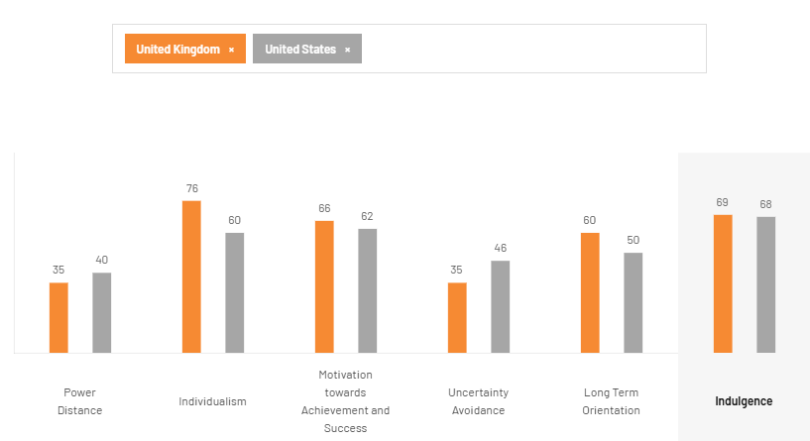
Figure 1: Hofstede Analysis of USA and UK
(Source: The Culture factor, 2026)

Appendix 2
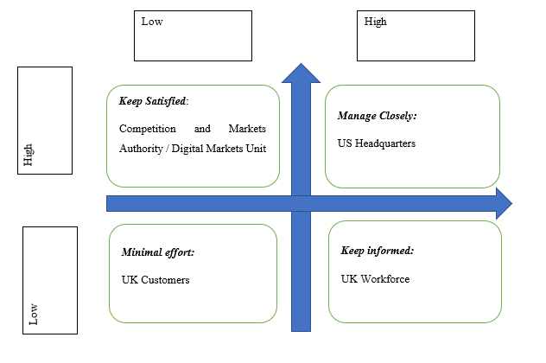
Figure 2: Stakeholder Mapping through Mendelow’s Matrix for Amazon
(Source: Created by the learner)

