Module: Coexistent perspectives, ADAA7000
Student name: Isobel Bridgland
Student number: 2005215
Course: MA Illustration

Word count: 4,203
Submission date: 14/12/23

Viewing Women: The Surveillance of Female Subjects in Art Through the Voyeuristic Male Gaze

De/Constructing the Human: Self Identity and Other

Abstract

Viewing Women: The Surveillance of Female Subjects in Art Through the Voyeuristic Male Gaze questions the way in which women in art are viewed, this applies for both women artists and women who the subject in a piece of art. It uses Freud’s psychosexual theories, more specifically the Madonna whore dichotomy as a reference as well as Laura Mulvey’s writings on the male gaze theory to examine the ways in which the male psyche has affected how women are viewed. It will contextualise the possible reasons that men enjoy watching women through an exploration of voyeurism and scopophilia.

These theories will be applied to two pieces of work, both of which are from different eras and therefore have different cultural implications. Included are Gustav Klimt’s Danaë and Jennifer Ringley’s JenniCam. Both of these pieces include a woman who is portrayed in an intimate light and are therefore subject to the male gaze and misogyny, despite the 90-year difference in their publications. Using both Danaë and JenniCam as references, this essay will hypothesise on the possible future of men viewing women through the context of the rise of technology and social media.

Introduction

Psychology and psychosocial theories are an essential tool in understanding how humans behave, they can help to illustrate the ways in which someone may perceive the world around them, and thus can be used to explain the way in which an audience reads a piece of art. The ideas and theories of various seminal psychologists, philosophers and thinkers are able to illustrate the psychology behind how a person may have deeply rooted prejudices or preconceptions of the people around them. Within a society that operates under a patriarchal system, the ideas and opinions of men are heard the loudest, misogyny and sexism are able to run rampant. This can be seen in the way a misogynistic man will interact with women. Their acts of sexism are not limited to the living, breathing women that the man will interact with, as the male psyche can be projected onto any depiction of women, wether they are real, imaginary, or being viewed from afar. Every woman is susceptible to becoming a blank canvas for a man to project his own ideas onto, this has an impact on the way in which female subjects of art are viewed. The male psyche’s biases, perceptions, and prejudices have influenced the way in which audiences read an image, for example, the naked female body signifies sex and arousal. Nudity of women is seen as erotic and sexual, whereas male nudity is not as big of a socially recognised sexual symbol.

Through the patriarchy and the systemic oppression of women, these ideas have become the mainstream opinion. In a male dominated society women seldom hear a neutral opinion of how they should look or behave, a man will always have an opinion on her, she becomes the focus of the voyeuristic male gaze. This essay will examine how the male psyche affects the way that women are viewed using the psychoanalysis of Sigmund Freud’s psychosexual theories, with the Madonna/ Whore dichotomy being the primary emphasis. Laura Mulvey’s text Visual Pleasure and Narrative Film will also provide crucial contextual theology through its inclusion of the male gaze theory.

The two pieces of work that are included, Gustav Klimt’s Danaë and Jennifer Ringley’s JenniCam experiment, provide evidence of the attitudes of men and how they can make a female centred piece of work phallocentric. This essay will compare the two pieces, using the Madonna/ Whore dichotomy and the male gaze as the prominent theories. It will also dissect the voyeuristic gaze that is cast upon women through the sexual desire to look at erotic content, also known as scopophilia, and its relation to misogyny.

Part 1- The Male Gaze and the Madonna/Whore
Sigmund Freud remains one of the quintessential psychologists of the 19th and 20th century. He introduced many theories to do with the human psyche and was the founder of psychoanalysis. His ideas are sometimes considered to be controversial and rooted in misogyny, yet some still remain notable and highly referenced today.

As a commentary on the male idiosyncrasies of the time, Freud developed the Madonna/ Whore Complex, otherwise known as the Virgin/ Whore complex, a dichotomy of how men view the desirability of women. He wrote that “Where such men love they have no desire and where they desire they cannot love” (Freud, 1912, p.g 40-50). They are seen as either being “virtues or vices” (Hertler, et al, 2023, p.g 373) without being afforded the perceived complexity of being able to fit in neither or both of these categories.

Madonna derives from the Italian word for ‘my lady’. It is used in Christianity and Catholicism in reference to the Virgin Mary, or the mother of Christ. In religious contexts, the Madonna is a visual representation of the “immaculate conception, or perpetual freedom from original sin” (Britannica, 2019). She bares a child while remaining pure and not tainted by her sexuality. Freud uses the term to display how these standards were further assigned to women of the time. In a Freudian context, the Madonna is the idealised version of a women through a male gaze. She is not inherently sexual, in fact her sexual desires are considered a negative factor that is ignored. She is a nurturer and an ideal child bearer and mother. She is marriage material and expected to be asexual in nature, much like the Virgin Mary. Arnaiz, Puget and Siquier are quoted by Welldon saying “A mother who before anything else is a breast, therefore centred in the nurturing bond and pregnancy. The woman, then, is understood from a mammalian ecological viewpoint” (Welldon, 2018, p.g 33). To reduce women down to their biological function also cements the idea of the Madonna. The comparison of a woman as an animal allows a man to dehumanise her and reduce her down to her expected path in life. This discounts the fact that she may not want to bare children, or that she might not be attracted to men.

It may seem as though it would be less damaging to be perceived as the Madonna rather than the Whore, as it means you are viewed with a more positive light. This is in fact nothing to do with the woman herself and instead all to do with the way the man perceived her, and to assume that a man viewing a woman as a Madonna means he will respect her is incorrect, as to expect a woman to be subservient, virginal and pure is to rid her of any depth and real feelings. No woman will ever reach this standard. It is an idealised version of a woman, not one based on how women actually behave.

The whore in Freud’s Madonna/ Whore dichotomy is seen as inherently immoral. She is sexual and impure; she is portrayed as a temptress who is not a viable option when choosing a partner. This archetype can be used for women who engage in sex work, women who enjoy sex, or even just women who aren’t virgins. This does not mean that men do not want to engage in sexual activity with her, quite the opposite. Even though she is seen as a whore she still insights sexual attraction from men. The way that men do not seem to integrate their romantic and sexual desires means that the sexual degradation of women, mainly sex workers will prevail. Sex is not always seen as a transactional act between two partners that respect each other. Men will have sex with the women they see as whores as a way to satisfy themselves, not because they see them as anything other than their bodies.

To categorise women into either of the two concepts is a way to dehumanise and devalue them. Men are only interested in how the women can serve them, either through sex or as a nurturer. It is as if there is an attraction to women, yet no desire to look behind the attributes they have projected onto them. Instead, it seems easier to look at a woman from afar, rather than having to acknowledge her complexities. From a phallocentric perspective, a woman who you can view, rather than engage with allows for more liberties to be taken when imagining what she may behave like.

To be able to narrowly classify women into either Madonna or Whore, means a man does not involve himself too much into her personality and inner workings. This creates a voyeuristic dynamic where a man views a woman but doesn’t understand her. This links to another of Freud’s psychosexual theories called scopophilia, which can be described as the attraction of seeing something erotic. This can be applied to those who enjoy pornography and sexual material, or those who are aroused by nudity or specific fetishes.

In her essay Visual Pleasure and Narrative Cinema, feminist film theorist Laura Mulvey used the psychoanalytic theories of Freud and expanded them into a feminist context. She wrote of scopophilia, “in their traditional exhibitionist role women are simultaneously looked at and displayed, with their appearance coded for strong visual and erotic impact so that they can be said to connote to-be-looked-at-ness.” (Mulvey, 1975, pg. 809) Through a feminist lens, scopophilia illustrates how women are the scrutinised subject. They are expected to perform for the men around them and yet shunned for being looked at. This a more female-centric telling of the Madonna/ Whore. It is within Visual Pleasure and Narrative Cinema that Mulvey developed the concept of the Male Gaze. The concept of the gaze existed in the writings of other thinkers besides Mulvey, notably, Michael Foucault’s ideas of how the gaze effects sociopolitical dynamics, or John Berger’s Ways of Seeing. Berger and Mulvey have both been credited for the introduction to the concept of the male gaze respectively. Ways of Seeing analysed the way in which women in paintings are perceived using the semiotic surveyor/surveyed framework, while Mulvey referred to the male gaze in film. She states that “the image of women as (passive)” creates “raw material for the (active) gaze of a man”. (Mulvey, 1975, p.g 815), meaning that to create a female character that is not complex allows men to see her through his own idealised view. In a Freudian context this could either be as the innocent Madonna or the immoral Whore.

Part 2- Gustav Klimt’s Danaë
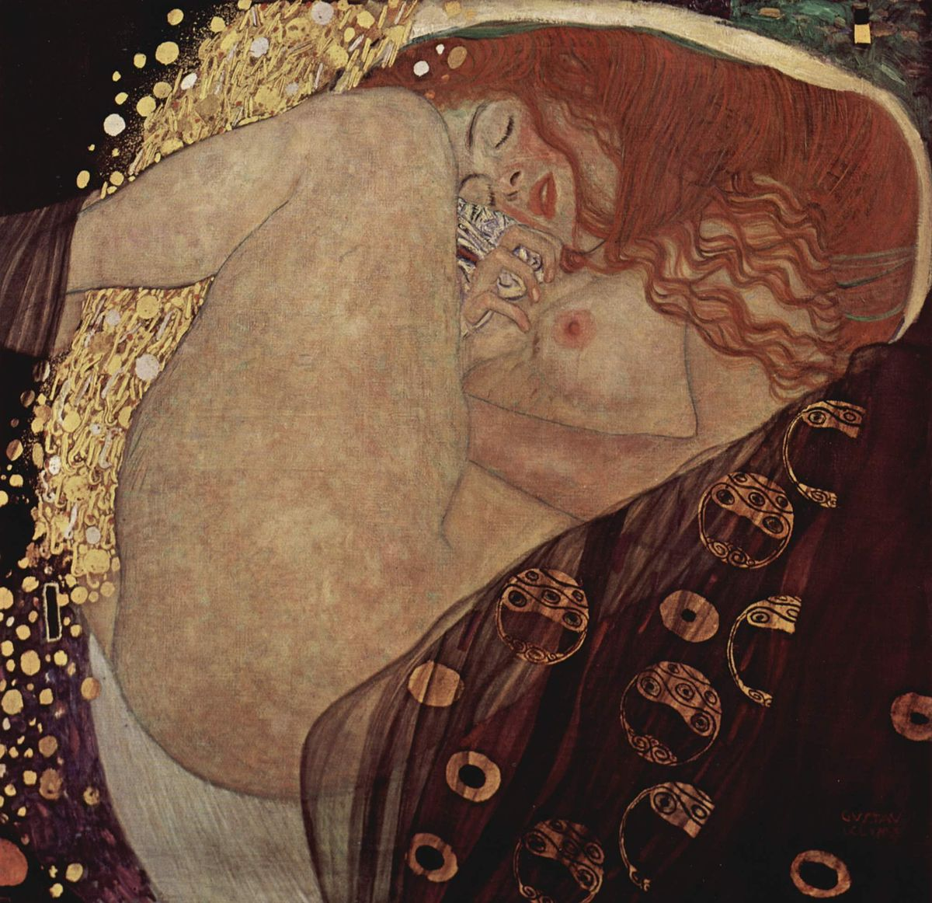
Danaë, Gustav Klimt, 1907

Klimt’s Danae portrays the female subject in laying on her side, nude. Her legs and lips are both slightly parted, in an effort from the artist to invite the viewer to view her sexually. Her thighs, breast and buttock are being highlighted by the light, attracting the eye, and further allowing the voyeuristic gaze on her form. Her cheeks are rouged, and her hair is red signifying desire and passion. The way in which her body is slightly contorting, and her hand is slightly clenched could be interpreted as her masturbating. The piece was made decades prior to the sexual liberation and feminist movements that encouraged women to enjoy sex and pleasure, at the time female pleasure was taboo. From a feminist liberation point of view, it may seem as if Klimt is allowing the viewer to become comfortable with seeing a woman experiencing pleasure, however Freudian theory and the idea of the male gaze would suggest otherwise. The subject is reduced to her body, her eyes being tightly shut means there is no sense of life or humanity in her. The Madonna/ Whore complex explains how men view sexual women as nothing more than a body to desire.

Danaë allows the audience to view the subject with a voyeuristic eye. Her eyes being shut, and her face being turned away from the camera allow for a feeling of intrusion on somebody who doesn’t know they are being watched. While the model would have agreed to this portrait being painted, the way in which she is positioned gives a feeling of viewing her in a vulnerable position without her consent. A man viewing and painting a woman engaged in self-pleasure takes away her autonomy and thus makes the act phallocentric. This would align with Freud’s theory of men seeing sexual women as something to lust over rather than show respect towards.

The way in which women in art are perceived by a male audience is an essential part of Berger’s gaze theory. Within the book, he analyses pieces of art that include female subjects and describes how they are perceived by a male audience. When discussing a nude portrait of a woman, he said that “this nakedness is not, however, an expression of her own feelings; it is a sign of her submission to the owner’s feeling or demands. (The owner of both woman and Painting)” (Berger, 1972, p.g 52). This illustrates that from a male gaze perspective a woman subject can be as easily possessed as a painting would be. This allegory further examines the male gaze and the concept of looking. A painting is created to be looked at; the highly notable ones are hung on gallery walls to be marvelled at by people on mass. Being looked at is an element of womanhood, however it seems to be done with a much more scrutinised gaze. Berger’s suggestion that a painting and a woman are both things that a man thinks he can own shows how objectified women are, especially when considering the way in which paintings are sold to the highest bidder and bragged about owning.

The relationship between men’s misogyny and their desire is firmly embedded in their psyche that even a two-dimensional depiction of a woman is susceptible. Author Gottfried Fliedl was quoted saying that “Danaë is an ‘icon of female narcissism’- created by male wishful fantasy, and so self-referential that her own body excludes any object of love” (Hammer-Tugendhat, et al, 2012, pg 372). The recognition that Klimt’s potential sexual desires may have been what made him want to paint such an image does not negate the fact that Danaë, the fictional woman, is facing the most disapproval. Fliedl’s words further show how the Madonna/ Whore way of thinking was applicable to how men viewed the piece at the time, the fact that Danaë was masturbating made her self centred and devoid of feeling.
The misogynistic gaze was not only cast onto the subject of Danaë, but also to the women who did not deem the piece to be scandalous. Ayres cites Hugo Ganz’s writings of how women were expected to react to Klimt’s pieces by saying “the ‘decent’ woman, who would be unable to look at Klimt’s erotic drawings without blushing, was equated, through the display of such images, with the prostitute” (Ayres, 2014, p.g 241). This not only illustrates how deeply rooted the misogyny of the time was, but also shows how the judgment of the male gaze was applicable to women who merely looked at Danaë with anything other than disgust or neutrality.

The male gaze afforded to men of the 1900’s and their misogynistic, voyeuristic view of sexualised women has only been exasperated with the rise of technology and pornography. You can now view women through a screen, allowing for total animosity. The woman may have allowed herself to be filmed or photographed but the lack of face-to-face interaction makes for a tantalising feeling of viewing something that wasn’t meant for your eyes. In an annual summary of pornography website Pornhub’s analytics, it was found that the top porn category was Reality, “The Reality category grew by +169% to become one of the Top 20 categories” (pornhub.com, 2022). It is often filmed in a Cinèma Vérite style that gives the viewer the impression of watching a real couple engaging in authentic sex. There are also millions of videos on the website that fall under the category of Voyeurism, in which the plot revolves around the subject being unknowingly surveilled by hidden cameras or people filming from a secret location.

The sexual attraction that is experienced when engaging with voyeuristic content seems to come from the notion of not being recognised by the subject. Typically, it would be assumed that people who view pornography are finding arousal from imagining themselves as one of the people who are engaged in the intercourse, but through the rise in popularity of voyeuristic reality pornography suggests that for some the attraction comes from the idea of not actually having sex with the women they are watching. This aligns with the idea of the Madonna and the Whore. Men find the women in these videos are sexually attractive, however they are posting themselves in promiscuous situations, which therefore makes them unappealing and undesirable, negating any obligation to go and meet them.

Part 3- JenniCam

Screenshot from JenniCam.org, Jennifer Ringley, 1998

Jennifer Ringley was a 19-year-old college student who decided to embark on an experiment after buying a webcam on the 14th of April 1996. Ringley created the website Jennicam.org, in which photos would be taken on the webcam and uploaded every 15 minutes. She wouldn’t know exactly when these photos were being taken. The placement of the camera was in her bedroom which allowed viewers to see Ringley in a number of intimate positions, including getting changed, masturbating, having sex and sleeping. The photos captured the mundanity of her life, often she wouldn’t be in the room for hours on end and yet her website gained thousands of visitors. One fan complained of having to wait to see Ringley appear on the camera, writing on his blog joshuawaller.tripod.com that “she is kinda cute, although it does get kinda boring waiting!” (Waller, 1999).

In one instance Ringley’s partner made his first appearance on the website where the two shared a kiss, causing the number of viewers to skyrocket by thousands. By uploading images of herself in these situations, Ringley is allowing herself to be viewed through a voyeuristic perspective, however it is important to note that being under constant surveillance may have made her more accustomed to being watched. The innovation of the JenniCam website meant that in a pre-social media time, nobody could rationalise why someone might choose to document their lives for so many to see. In their publication on the exposure of private lives via webcams Knight noted that “This mode of communication creates a new kind of social space, in which the private is performed for the public, and interaction is initiated by the one who is being watched.” (Knight, 2000, pg 22). While it is true that the situation is being initiated by Ringley, it’s the taboo of watching someone without them knowing that gave people the attraction to JenniCam. By allowing an audience to view her, she created a space where the privacy of life as a woman could be taken over by thousands of men.

One’s bedroom is a sacred place; it is where we are our most vulnerable. To add surveillance juxtaposes the room’s private nature. Ringley opened the metaphorical curtains and allowed herself to be the exhibitionist. When considering the idea that “in the instance of Jennicam, there is a voyeuristic pleasure derived from the study and analysis of the body and life of a female subject, the othered body” (Adam and Green, 2000, pg. 294) it poses the question, was Jennicam so popular for any reason other than men finding a way to cast their gaze on a woman whenever they pleased. Ringley was a normal woman who became the “othered body” through the male desire to watch women.

Looking back at the Pornhub statistics that stated ‘reality porn’ was the top category for 2022 through a contemporary technological lens it can be suggested that Jennicam was an early example of the fetishisation of voyeuristic content. Ringley said that she was not posting her photos to be provocative or sexual, and that sex was just something that happens in real life, but that does not stop her from being viewed by the male gaze. Harroway states that “a woman is not simply alienated from her product but in a deep sense does not exist as a subject, or even potential subject, since she owes her existence as a woman to sexual appropriation” (Harroway, 2016, pg 24). Applied to JenniCam this could mean that her sexuality is what was giving her the notoriety, but also caging her.

Using the texts of Nell Tenhaaf in relation to JenniCam, Knight states that “the body becomes either idealised, and therefore a commodity, or fragmented in the form of the automaton and the cyborg, half metal/ half flesh” (Knight, 2000, p.g 22). Considering this, it is possible that the combination of the cyborg and the human allows for a mental detachment of humanity when viewing Ringley. She becomes a spectacle, almost like a character in a film. Watching her for 24 hours a day creates an intimacy that is also completely void of human connection. The male gaze could be implemented upon Ringley easily, she was a silent figure whose thoughts and feelings could be disregarded and forgotten about. Using Freud’s theory of the Madonna and the Whore, Jennicam can be perceived from both ideations. The Whore’s typical narrative could describe Ringley. She is posting sexual images online for an audience; however, the contemporary surveillance dimension adds more nuance. From a male gaze perspective, the man may feel like he actually holds the power in the situation, not Ringley. She is seen doing other things that are non-sexual and ordinary, making the man feel as if he has caught her doing something private when she is nude. She never feels as if she is performing for the camera, which made Ringley a target for the male opinions.

The downfall of JenniCam came in 2003 when Ringley was caught on webcam having sex with a man who was known to already be in relationship. This caused the men who had been watching Ringley to become disgusted in her actions. To see someone they had formed a one-sided connection with behave in a way that they didn’t agree with gave the viewers a feeling of betrayal. Before, through the male gaze Ringley could be presented as whomever the viewer wanted her to be, she could have sex or masturbate on camera but the man watching her felt like he had the power. She could be seen like a contemporary version of Freud’s Madonna. The desire and enjoyment of sex is recognised for the most part as a normal aspect of the contemporary woman, in the 1900’s this would have defined her as the whore. Today, men will align the whore trope to sex workers, women who enjoy casual sex, and adulterous women. To see Ringley make a choice and partake in adultery did not fit the narrative of the Madonna she was perceived as. She faced online abuse, and her websites view count started to dwindle, this can be attributed to the fact that she went against the male gaze’s image of a good woman.

The misogyny Ringley faced by being a woman portraying herself in a certain way online showed implications of what was to come in the foreseeable rise of technology and social media. Men employing the voyeuristic male gaze will only increase with how easily accessible woman are online. The line between the woman and cyborg will certainly grow due to men being able to interact with women online rather than in real life. Both the women portrayed on the internet and in their real lives will face their male gaze and psychosexual thoughts such as the Madonna and the Whore.
Conclusion
Both Klimt’s Danaë and Ringley’s JenniCam portray a woman who is in an intimate situation. The fact that Danaë was painted by a man and Ringley was self-published through JenniCam means it could be argued that Ringley was less susceptible to the male gaze. Being the owner and producer of her own content, she may have had an extra level of consent due to the fact that she could see the analytics of the numbers of people who visited her site, however she was not sheltered from the patriarchy, as no woman is.

The male gaze is cast into every single woman who has lived, and any woman who ever will live. The feminist movement has progressed greatly over time, especially from the time of Danaë’s conception to the digital era of JenniCam. Women in western countries of the late 1990’s and early 2000’s were liberated in their professional and personal lives following the Sex Discrimination Act and the Equal Pay Act of 1975 and the Sexual Liberation Movement of the 60’s and 70’s. While such strides were made in the liberation of women, it does not mean that misogyny went away, in fact it is still rampant in society today.

When considering the role of women in society in 1907, the year Danaë was created, and how it was during a pivotal time in the Women’s movement it deepens the context of how the piece would have been considered. The suffragettes had been active for several years and were still advocating for Women’s rights. Despite the 1900’s being such an important time in female history, it was teeming with violent misogyny. Women were expected to be wives and nothing else, their success was gained through being a good mother while their husband was able to work and be the man of the house, any other path a woman could make was seen as unworthy of respect. The men around them would indorse that they should not show any sexual desire, so as to not behave like whores.

Despite the 90-year difference between the two pieces, the attitudes of men still shared similarities. Although the male gaze and Madonna/ Whore dichotomy have developed since the 1900’s as women have gained more rights, JenniCam is an example of how misogyny through the voyeuristic male gaze and the Madonna / Whore Dichotomy is still widely committed.

The woman portrayed in Danaë and Jennifer Ringley were surveilled by the male gaze in their most intimate states. Both of them ignited a feeling of lust that lived simultaneously with feelings of disgust and slut shaming. Neither woman was able to break free from the misogynistic gaze. Instead of being remembered for their respective cultural impacts, they will be remembered as taboo pieces of work. The detachment of women from their complexities will only continue through the patriarchy.
Bibliography
Adam, A. and Green, E. (2001) Virtual Gender: Technology, Consumption and Identity Matters, 1st Edition, London, Routledge

Ayres, S. (2014) Staging the Female Look: A Viennese Context of Display for Klimt’s “Danaë”, Oxford art journal, 37(3), pp. 227–244

Berger, J. (1972). Ways of Seeing: Based on the BBC Television Series. United Kingdom: Penguin Publishing Group.

Britannica, T. Editors of Encyclopaedia (2019, August 29). Madonna. Encyclopedia Britannica. https://www.britannica.com/topic/Madonna-religious-art

Freud, S. (1912). Über die allgemeinste Erniedrigung des Liebeslebens

Hammer-Tugendhat, D. and Zanchi, M. (2012) Art, Sexuality, and Gender Constructions in Western Culture, Art in translation, 4(3), pp. 361–382

Haraway, D. J. (2016) A Cyborg Mainfesto, Science, Technology and Socialist-Feminism in the Late Twentieth Century, University of Minnesota Press, ProQuest Ebook Central

Hertler, S., Perñaherrera-Aguirre, M. and Figueredo, A.J. (2023) An Evolutionary Explanation of the Madonna-Whore Complex, Evolutionary psychological science

Knight, B.A. (2000) Watch Me! Webcams and the Public Exposure of Private Lives, Art journal (New York. 1960), 59(4), pp. 21–25

Ibid

Mulvey, L. (1975) Visual Pleasure and Narrative Cinema, Screen, Volume 16, Issue 3,

Ibid

Welldon, E. V. (2018). Mother, Madonna, Whore: The Idealization and Denigration of Motherhood. Ukraine: Taylor & Francis.

Online Sources
https://joshuawaller.tripod.com/attt/jen.htm

https://www.pornhub.com/insights/2022-year-in-review

