Title: Understanding the Impact of Toyota Scandal to Customers and Brand Reputation

Student Name: Dhaamin Ahmed
ID:2312240

Executive Summary
The dissertation investigated the impact of Toyota certification and safety scandal on customer trust as well as brand reputation by identifying organisational factors which contributed to workplace incident along with practical strategies for recovery. A mixed method research approach was adopted, that combined quantitative data from a survey of 60 Toyota users of the United Kingdom with qualitative evidences from the semi structured interviews that involves two Toyota managerial executives and the three automotive experts. The approach enabled both perception of customers and organisational perspectives allowed to be examined comprehensively.
The findings also reveal that the scandal significantly weaken the reputation of Toyota for quality, reliability and safety. Most of the survey respondents believed the incident impacting the reputation of the company and reducing the trust of customers, which resulted in lower purchasing intention and also reducing the willingness to recommend Toyota vehicles to others. Although, most of the respondents acknowledge that Tata have taken corrective actions, concerning regards to transparency, quality assurance and governance which were very evident. The interview findings for that identified the performance pressure, hierarchical decision-making, limited the voice of employee and weaknesses in independent verification and boarding the oversight as major organisational causes.
The study concludes the Toyota can rebuild stakeholder confidence by stronger governance, independent safety testing, transparent communication, improving the management accountability as well as a culture which encourages ethical behaviour and employee participation. The recommendations also provided practical guidance by restoring the trust of customer and prevention of similar certification failures, as well as contributing valuable insights towards crisis management and corporate reputation within the global automotive industry.

Contents
Executive Summary 2
CHAPTER 1: INTRODUCTION 6
1.0. Introduction to the chapter: 6
1.1 Background of the Study: 6
1.2. Problem Statement: 7
1.3. Research Aim: 7
1.4. Research Objectives: 7
1.5. Research Questions: 8
1.6. Significance of the Study: 8
1.7. Structure and Summary: 8
CHAPTER 2: LITERATURE REVIEW 10
2.0. Introduction to the chapter: 10
2.1. The Toyota Way and Kaizen: 10
2.2 Organisational Hierarchy and Decision-Making at Toyota: 11
2.3 Crisis Management and Brand Reputation in the Automotive Industry: 12
2.4 Competitive Environment: Application of Porter’s Five Forces: 12
2.5 Customer Trust and Brand Reputation: 13
2.6 Research Gaps: 14
2.7 Summary of the Literature Review: 15
CHAPTER 3: METHODOLOGY 16
3.1 Chapter Introduction: 16
3.2 Research Design: 16
3.3 Research philosophy and approach: 16
3.4 Sampling size and sapling technique: 16
3.5 Data collection tools and techniques: 17
3.6 Data analysis procedure: 17
3.7 Limitations of the research: 18
3.8 Ethical Considerations: 18
3.9 Chapter Summary: 18
CHAPTER 4: RESULTS AND DISCUSSION 20
4.1 Introduction 20
4.2 Survey Results and Findings 20
4.3 Interview Findings 27
4.4 Secondary Data Findings 29
4.5 Analysis and Discussion 31
4.6 Chapter Summary 33
Chapter 5: Recommendations, Research Limitations and Conclusion 34
5.1 Chapter Introduction 34
5.2 Summary of the Main Research Findings 34
5.3 Achievement of the Research Aim and Objectives 34
5.4 Recommendations for Toyota 35
5.4.1 Strengthen Independent Safety Testing and Certification 35
5.4.2 Improve Transparency and Customer Communication 35
5.4.3 Reform Governance and Management Accountability 35
5.4.4 Strengthen Employee Voice and Ethical Culture 36
5.4.5 Monitor Customer Trust and Recovery 36
5.5 Limitations of the Research 36
5.6 Recommendations for Future Research 37
5.7 Overall Conclusion 37
References: 38
Appendix A: SURVEY AND INTERVIEW QUESTIONNAIRE 41
APPENDIX: B: INTERVIEW TRANSCRIPTS 43
APPENDIX C: SURVEY RESULTS 47

CHAPTER 1: INTRODUCTION

1.0. Introduction to the chapter:
The scandal of certification and health-and-safety that took place in Toyota had taken shape over the years 2023 to 2025, raising some intense questions regarding their internal control systems, the process of decision-making, and the strong reputation that Toyota had maintained in the global automobile market over the years. The research done in this dissertation attempts to gather in-depth insights about the major impacts exerted by the scandal on overall trust factor of the consumers, and the brand's long-standing reputation for pristine quality of their automobiles. The study entails strategic recommendations that Toyota may follow to redeem their brand image and refrain from any such massive cases in near future.

1.1 Background of the Study:
The company, Toyota Motor Corporation has its origin in Japan and was founded by Kiichiro Toyoda in 1937. Operating on a multinational level, as a renowned automobile manufacturer, Toyota has built its reputation over the global automobile industry brick by brick based upon reliability, efficiency, and its ability to integrate continuous improvement leveraging the Japanese philosophy of Kaizen (Liker, 2017). The vehicles Toyota manufactured were validated by a diverse section of consumers and were heavily used across different countries positioning Toyota as one of the most dominant and influential brands in the automotive sector.
Even with its long successful term, the company Toyota had experienced substantial challenges during recent years. The time from 2023 to 2025, were most damaging, during this period Toyota and its subsidiary company Daihatsu faced the serious accusation of systematic fraud of certification and they were also held accountable for falsifying their health and safety data. The reports established that test vehicles used different mechanical parts to rig the results and pass safety requirements (Mukunde, 2021). This provoked the shutting down of Daihatsu manufacturing factories and derailed 64 different car models from Toyota.
The scandal jeopardised product safety, corporate governance and overall integrity of Toyota as an automobile brand raising alarming concerns (Ohno, 2019). There were also tensions around excessive straining of Kaizen (continuous improvement) and rigour of the compliance standards for health and safety (Liker, 2017).

1.2. Problem Statement:
Even with its long - standing association with supreme standards in terms of quality and safety, the recent certification and health-and-safety scandal had been damaging to Toyota, especially it eroded the stakeholder trust. The customers, regulators and the public have deemed the brand's management systems and decision-making processes under the hierarchy highly questionable. The allegations were around the brand's inclination towards their own production and sales target over the prioritisation of customer safety and public health. The incident had marked origins of severe uncertainties around ability of the company to maintain the brand reputation and keep the loyalty of its customers intact amidst the highly competitive landscape of the automotive market, especially after the market is being disrupted by rivals with electric vehicles (example, Tesla, or BYD, etc.).

1.3. Research Aim:
The research that is being done for the dissertation has a set aim primarily dedicated to investigating what are the major impacts that resulted on the brand's reputation from Toyota's failure in compliance certification and their falsification of health-and-safety data. Additionally, the research extends focus on ways the scandal eroded consumer trust. The research findings establish a consolidated plan of action that can be followed by Toyota to recover from this situation and avoid such mishaps from happening in the future.

1.4. Research Objectives:
The research objectives help in consolidating the fundamental approach for the research work, it helps in narrowing down the specifics that are covered in the data collection and analysis process with an ode to the findings that are to be attained after thorough analysis of the collected data. The following are the main objectives laid out for the present research.
- To conduct thorough analysis of the performance, and decision-making processes that are presently used by the management system of Toyota, (during the timeframe from 2024 to 2026), especially after the scandal's news broke out and the market reacted.
- To understand the nature and extent to which impacts were exerted on Toyota's brand image due to the certification misconduct and identify the specific factors that escalated the damage.
- To find the overall scandal impact upon the brand's reputation and the perception of the brand that customers had before.
- To examine strategic approaches that Toyota could undertake to address the issue at hand and eventually rebuild customer trust.
To conduct a thorough assessment on ways Toyota can improve its processes and prevent any such scandal or mishap from occurring once again in the future.

1.5. Research Questions:
The research questions are framed so that it can give the overall research a strong direction. The research's sole purpose is to build evidence-based answers to these research questions. The study includes the following main research questions.
- How can Toyota reconcile from this scandal that occurred to prevent it from happening again?
- Will there be any changes in the company?
- What can the customers expect in the future from the brand?
- Who was in charge of the go-ahead of the operation of the scandal?
- What will be done differently, and can Toyota maintain trust and reputation within the company?

1.6. Significance of the Study:
The research significance lies in few specific areas, owing to its intuitive nature and investigative stance. First, the findings from the research will extend active contributions towards building an academic understanding of ways global corporations handle crises related to safety and regulatory certification failures. Secondly, the analysis and findings together provide robust practical insights that can help Toyota or other automobile companies to deal with similar ordeals and actively work towards rebuilding trust of consumers and adding strength to their internal control systems post any such crises. Finally, the research findings will yield value to the regulatory works, build consumer perceptions and enlighten industry stakeholders, worried about the safety standard compliance and corporate accountability.

1.7. Structure and Summary:
The chapter introduces the background of the research along with a brief idea about Toyota's profile as an automotive brand. The idea is clearly communicated wherein it is established that the recent certification and safety compliance scandal at Toyota is the key area of focus. The chapter discusses the aim, objectives, and presents the research questions that are to be answered at the end of the research. The dissertation overall will include five chapters. The first chapter is complete, the following chapter will include the literature review, this will include discussion about Kaizen, hierarchical structures, and use tools for crises management and discuss frameworks like the Porter's five forces. The third will cover discussion of research methodology. After these, the results and analysis will be done along with the discussion of findings. The fifth and the final chapter will offer recommendations for Toyota, along with the conclusion of the findings and study limitations with a hint about the future scope of research in this field.

CHAPTER 2: LITERATURE REVIEW

2.0. Introduction to the chapter:
The chapter here conducts thorough critical reviews of existing academic literature that are retrieved using secondary research methods. The literature is sorted based on their relevance with the case of Toyota's scandal related to certification fraud and health-and-safety compliance issues. The chapter has the sole purpose of establishing a strong theoretical and conceptual foundation underpinning the fundamentals of the present research. The chapter is arranged according to specific themes including Toyota way and principles of Kaizen, along with it are the literature associated with organisational hierarchy and decision-making processes, crisis management and brand reputation.
There is also the Porter's five forces framework supplying theoretical foundation along with concepts like customer trust and brand reputation in context of automobile industry. The chapter expresses the findings from secondary research and analysis by synthesising ideas from contemporary and previous research. In due course, the chapter identifies the important research gaps demonstrating ways in which present investigation can be built upon such a case. The chapter is targeted towards building a robust theoretical justification of topic of the research along with research questions and objectives outlined in the previous chapter.

2.1. The Toyota Way and Kaizen:
The production system at Toyota is also associated with a broader philosophy often referred to as the "Toyota Way", this had been often widely recognised as a robust model that can assist achievement of operational excellence (Ohno, 2019). The core of this philosophy is built around the Japanese concept of 'Kaizen'. 'Kaizen' translates to continuous improvement, (Liker, 2017; Liker, et. al., 2008). Kaizen readily stresses upon a more inclusive strategic approach wherein employees are often involved in organisational processes for identification and implementation of small incremental improvements in areas of quality and efficiency. Liker (2017) further argued that the continuous improvement has been an integral part of the fundamental culture at Toyota and has been of great use for its success and building the company reputation on grounds of reliability.
However, some recent studies have taken a critical turn pointing out potential tension related to the Kaizen and its practices in practical setting. The studies establish that while on one side continuous improvement drives innovation and efficiency, on other hand, it is done in excesses a strong pressure may unfold on performance delivery that may lead to prioritisation of speed over quality. Hence it can lead to compliance failure or leniency in terms of safety standards (Liker, et. al., 2008). There are some studies that even claim that over-stressing production target deliveries can give rise to a strict and suffocating work environment wherein hierarchical communication structures are not at all open causing severe problems and underlying inefficiencies (Ohno, 2019).
These concerning factors of the 'Kaizen' or continuous improvement method is directly related to the 2023-2025 scandal at Toyota. There can be a plausible cause wherein maintenance of continuous improvement and meeting deadlines for certification together may had added intensive pressure on the workforce that urged them to falsify the test data (Mendez, and Vila-Alanso, 2018). Hence, even though Kaizen is a strong and powerful tool assisting performance and service delivery, yet there is a possible chance that if not carefully balanced using ethical oversight, excessive stress can lead to issues regarding compliance failure or deter the safety culture of an organisation.

2.2 Organisational Hierarchy and Decision-Making at Toyota:
Toyota had been renowned name in the global automotive or automobile sector and had gotten solid recognition owing to its integral hierarchical structure as an organisation that is set to foster efficiency, standardised practices, and consistency in implementing dedicated production systems (Liker, 2017; Liker, et. al., 2008). The nature of the organisational hierarchy at Toyota had been in line of a top-down structure that allows the senior management section of the company to have authority in setting the strategic direction all while keeping operational discipline intact. According to Ohno, (2019), the company's use of such as hierarchical model has historically helped it to preserve higher levels of quality and ascertain decent productivity through standardising procedures and integrating principles like continuous improvement.
However, there are studies that reveal possible rigidness and limitations of hierarchical systems. The research findings from some studies reveal that for hierarchical systems the complete authority of decision-making is often concentrated only at the top levels, the employees, who are the actual workforce at mid and lower levels have much lesser or no autonomy. This makes the staff and working force reluctant towards openly speaking out the issues, especially when it comes to the aspects of safety or quality (Matriano, 2024). According to Noyes, (2022), communication openness is constrained in case of hierarchy structures that acts as a root cause of delay in identification and resolution of problems. Especially when under substantial pressure, this type of structure can lead towards a feeling of being rushed among the staff affecting the entire decision-making, as it reduces adequate consultation, hence there is heightened risk of failure in compliance.

2.3 Crisis Management and Brand Reputation in the Automotive Industry:
Organisational crises associated with certification failure and product safety can be significantly damaging towards the brand's reputation and erode stakeholder trust massively. Crises’ management studies stresses on the idea that it is the company's response to a specific crisis that often lays the groundwork for long-term outcomes on its brand-name and reputation more than the crises (Thakur, and Hale, 2022). Effective responses often commonly consist of timely identification and acknowledgement, alongside of transparency in communication and immediateness of corrective action deployment, and finally, the visible accountability of leadership.
Scandals associated with safety had been significantly damaging across the automobile sector on accord of the customer trust. Falsification of safety data or any tampering with tests, along with failure in certification directly leads to deterioration of customer confidence, causing penalties and financial losses for the company (Mukunde, 2021). Brand reputation in the sector directly is linked with perceptions of safety, reliability, and ethical strategy of automobile companies. As there are doubts around such attributes there is a plausible chance for customer loyalty to shift and look for other alternatives. Hence transparency of communication and implementation of visible corrective strategies are paramount to recover from any such harm.

2.4 Competitive Environment: Application of Porter’s Five Forces:
The framework of porter's five forces helps by providing a strategic and structured tool to analyse the recent scandal regarding the impacts it exerted upon the competitive position Toyota held in the market (Frăsineanu, 2008; Dälken, 2014). The porter's five forces helped in examination of the competitive rivalry among Toyota and other competitors, along with it the framework fosters analysis of the bargaining power of buyers and suppliers, it also accounts for the threat of substitutes and the threat from new entrants in the market.
Firstly, the automotive industry presently has intense competitive rivalry. This is majorly fuelled by the rapid adaption of electric vehicles owing to the sustainability awareness growth among conscious consumers, and emergence of new brands like Tesla and BYD. The scandal has heightened the risk wherein Toyota consumers can be turnover to its competitors further escalating rivalry among the market giants (Dälken, 2014).
The buyer power of bargaining has also substantially increased due to the scandal at Toyota. This implies that presently customers have greater freedom and motivation for turning to alternative brands as their confidence in quality and safety standards of Toyota had taken a significant hit. This pivot of buyer power puts Toyota under additional pressure, which should be taken care of by the company strategists right away.
The supplier power is relatively less impacted despite the scandal. The private-sector competitors may gain some advantage for shorter time span, as the scandal news disrupted Toyota's production for some time. The threat of new entrants is from moderate to low as automobile industry work on trust of consumers and customers would rather go to existing alternatives rather than switching to complete new brands. Lastly, the threat of substitutes has risen significantly as due to sustainability awareness consumers are turning to public transports, shared vehicles, or even elective vehicles instead of fuel automobiles.

2.5 Customer Trust and Brand Reputation:
In automotive or any other industry, it can be said that customer trust and brand's reputation are substantially important intangible assets (Afzal, et. al., 2010). Trust among customers is something that is built over time with consistency, safety practices, strong reliability, and maintaining transparency in communication (Stravinskienė, et. al., 2021). Any violation of such standardised expectations of customers, especially from the areas like safety or quality may create significant damage upon the brand's reputation that can be severe and even last for longer times in the future.
Present studies establish that regarding any failure of product safety; customers often immediately turn to other brands or reduce purchasing from company under question. The common practice includes switching over to competitor brands or even expressing dissatisfaction vehemently across public forums, (Mukunde, 2021), creating a snowballing impact on the brand's image and reputation.
Safety is one non-negotiable aspect that imparts influence upon customers' intention of selecting automotive brand. Hence if the manufacture's image is compromised on grounds of safety standards customer loyalty can erode immediately.
Furthermore, perceived integrity and ethical behaviour are some practices that are closely linked with a brand's reputation (Mohammed, et. al., 2026). Therefore, when reports came out of Toyota falsified safety test data, there were not only questions around specific products but on the brand overall and there were ill-talks about its corporate culture, and organisational values. Thus, the present circumstances demand rebuilding of customer trust with more priority. To regain consumer trust mere technical corrections won't suffice, there is need of deeper corrective strategy building starting from instilling transparency in communication, visible changes in accountability and the brand should continue showing improved practices over time.

2.6 Research Gaps:
There has been an extensive review of literature done so far on the Toyota's production system, considering concepts of Kaizen (continuous improvement), hierarchical structures, and crisis management. However, some gaps are found to surface that remain concerning, speaking strictly in research terms. First, there are limited number of extensive studies framed specifically on the Toyota and Daihatsu case from 2023-2025 related to the health-and-safety failure. Majorly, the contemporary and past studies focus on earlier timeframes and generalised principles that can be hold relevant to the case of crisis at Toyota.
Secondly, the benefits of Kaizen are researched upon in-depth and documented accordingly in a formidable manner, but there are fewer studies that lay extended focus or explore the underlying tension of pressure due to continuous need of improvement and the stringent guidelines of safety compliance. The chances are plausible that succumbing to the intense pressure of performance targets safety standards are compromised by burned out workforces. This also happens because of the organisation's hierarchical structure that restrains open communication from staff back to the management level.
Finally, there is lack of empirical research focusing on the post-scandal recovery strategies that companies can deploy to restore the customers' trust and re-establish the brand's reputation in the market after image takes such as massive hit. In most cases, the crisis management studies focus on western cases leaving behind a substantial gap related to in-depth understanding of culture specific response strategies implemented by organisation in-response to crises.
These gaps led towards building motivation and laying the foreground for the present study and dissertation that is targeted towards thoroughly examining the impact of such a scandal on Toyota's brand reputation and trust of its loyal customers. Additionally, there will also be practical measures provided as recommendations that company can follow to recover its image and prevent such incidents in future.

2.7 Summary of the Literature Review:
The chapter critically examines relevant studies and research on Kaizen, hierarchical organisational structures, and approaches for crisis management. There is theoretical lens from porter's five forces that helps in understanding the aspects of competitiveness in the automotive industry and the role of customer trust within the same. The reviews helped understanding that Toyota's intense pressure on continuous improvement and its rigid hierarchical system may have contributed towards the issues with safety compliance. Studies reviewed strong stress upon transparency maintenance and cultural reforms for restoring brand image and reputation. The ending of the review marked with a discussion of research gaps and the way the present study will attempt to bridge the same. The chapter hence builds a strong theoretical insight based on solid foundation of secondary research wherein the research questions are built from. The next chapter discusses the methodology followed by the chapters for results and analysis.

CHAPTER 3: METHODOLOGY

3.1 Chapter Introduction:
In this chapter, detailed explanation of the research methods selected to evaluate the implication of Toyota certification scandal affecting customer trust and brand reputation are provided. The chapter also explains the tools and techniques used to collect and analyse information systematically and with proper justification.

3.2 Research Design:
To meet the objectives of the research, consideration of a mixed-method research design technique has been done. As a part of the process, both qualitative and quantitative methods are regarded to gain deeper understanding of the research problem. As a part of quantitative data collection online questionnaire are distributed to the consumers of UK that helps to understand the impact of the scandal of on brand reputation, customer trust and purchasing intention of customers (Haq and Yasin, 2025). Moreover, qualitative data will be accumulated by conducting a semi-structured interview upon Toyota managers and automotive experts, helping to gain in-depth evidences on the primary causes behind the scandal and the recovery strategies developed by the firm.

3.3 Research philosophy and approach:
The research is streamlined by selection of positivism philosophy, as focus is given on obtaining measurable data and organization specific information to understand the implication of Toyota certification scandal on brand reputation and customer trust. Positivism philosophy is ideal as structured survey questionnaire is used to evaluate customer perceptions and observe patterns based on existing facts (Tomaszewski et al., 2020). In alignment with the selected philosophy of research a deductive research approach is further used, through which evaluation of the survey and interview data carried out with existing theories based on brand reputation, crisis management and customer trust. The interview findings are assistive to provide additional support for the quantitative results.

3.4 Sampling size and sapling technique:
The overall sample size of the research involves 65 participants. In the first place 60 UK-based consumers have been regarded to carry out the survey. Existing Toyota customers who are familiar with the vehicles and can comment on the certification scandal are considered as a part of survey sample population (Nyimbili and Nyimbili, 2024). The aid of convenient sampling technique is looked upon to select the survey population as these individuals can be reached out easily through different online platforms within the allocated timeframe. Moreover, for the semi-structured interview program, consideration 2 managerial executives and 3 automotive experts from UK are regarded who will provide valuable information on importance on quality control, vehicle safety and customer relations (Nyimbili and Nyimbili, 2024). The aid of purposive sampling technique is regarded to select the interview population as they have proper knowledge and experience.

3.5 Data collection tools and techniques:
Obligation to primary data collection is done through online survey and semi structured interview. In the first place, the survey is conducted based on a closed-ended questionnaire, comprising of twelve questions, involving demographic questions and questions on customer perception of the Toyota scandal. The questionnaire will be incorporated with options which can be selected by the involved survey participants and the desired opinions can be provided. The survey questions are formulated based on crucial factors like vehicle safety, brand reputation, customer trust purchase intention and recommended actions that should be regarded by Toyota (Hays and McKibben, 2021). The survey will be carried out with the help of the Google form tool and will be shared electrically electronically with the consumers of Toyota across UK.
Apart from this, five semi-structured interview questionnaires are developed to accumulate in-depth evidences from Toyota managers as well as automotive experts in UK. These questions are developed in the form of open-ended question and are related to the scandal, weakness of the management, customer reactions and strategies (Ruslin et al, 2022). As a form of data triangulation, information from secondary source data like industry reports, company information or published sources are regarded (Noble and Smith, 2025).

3.6 Data analysis procedure:
The accumulated quantitative information gathered through the survey is stored in the Google form. The survey data and the opinions of the respondents are analysed with the help of trend analysis technique and the results are illustrated graphically through pie-charts, helping in identification of the patterns of customer trust, brand reputation and purchasing intention (Tomaszewski et al., 2020).
Apart from this, to systematically evaluate the quantitative interview data, thematic analysis technique is used. The responses provided by the managerial executives and the automobile experts are systematically evaluated and categorised into relevant themes like customer trust, management accountability, transparency and strategies for reputation recovery (Proudfoot, 2023). Apart from this a content analysis technique will also be regarded to evaluate the secondary data sources and a comprehensive understanding of the certification scandal of Toyota and its business implication are understood in the process.

3.7 Limitations of the research:
Several limitations have been acknowledged in course of carrying out the research. It is noted that, for the survey, a convenient sampling technique is used that might not be effective to represent the viewpoints of every Toyota customers based in UK. Accessibility to the managerial executives of Toyota and employees are on a limited scale due to confidentiality associated with the certification scandal of the firm. The research also provides attention on the UK market, so it is believed that the findings might not portray the overall customer perceptions of Toyota across other countries (Hays and McKibben, 2021). Apart from this, the research is carried out within a limited time frame, which limits the opportunity to accumulate long-term evidence and observe changes in customer trust over the time.

3.8 Ethical Considerations:
Standardised ethical principles are followed throughout the research. As a part of the process, inform consent from all the involved participants has been accumulated prior to the data collection. The purposes of the research are also well documented that further encourages the participants in getting involved (Laryeafio and Ogbewe, 2023). The overall participation is made voluntary and responses are also providing the scope to withdraw from the research without any justification. All the personal and sensitive information of the participants are kept confidential and anonymity will be maintained to protect their identities (Laryeafio and Ogbewe, 2023). The research data will be protected as per UK GDPR regulations and strictly will stored in password protected devices and solely used for academic purposes.

3.9 Chapter Summary:
The methodologies chapter thoroughly explains the tools and techniques regarded to develop the framework of the research and involve critical steps like research design, sampling strategy data, collection and analysis procedure. The research limitations observed and ethical considerations regarded to streamline the data collection are also described. By means of selecting relevant methods, reliable evidences are accumulated, helping to meet the desired objectives of the research effectively.

CHAPTER 4: RESULTS AND DISCUSSION

4.1 Introduction
The current chapter has represented and interpreted the primary and secondary findings of the study with regard to the certification and safety scandal of Toyota. The chapter has specifically integrated semi-structured interviews, survey results, and literature evidence prior to doing comparison among the data sets and assessing how the combined findings can address the research questions.

4.2 Survey Results and Findings
1. 60 existing Toyota users have taken part in the survey data collection, out of which 60% have been male and 40% have been female consumers of Toyota. The survey sample population and have represents different consumer groups that has been assistive to enhance the reliability of the findings.
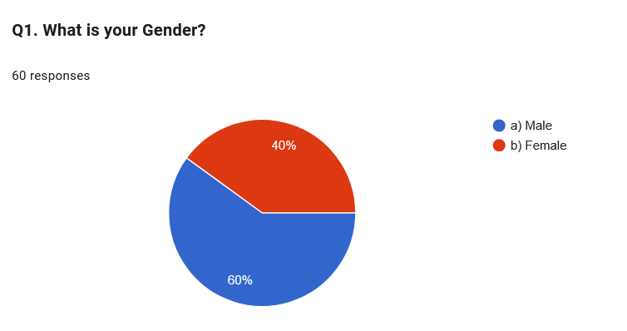
2. Major section of the respondents have been from the age group 26-30 years as represented by 36.7% of the survey population and 31-35 years representing 31.7% of the survey population. This outlines that the survey mainly demonstrates opinions of young and middle aged consumers of Toyota who are active vehicle buyers and are associated with automotive developments news.

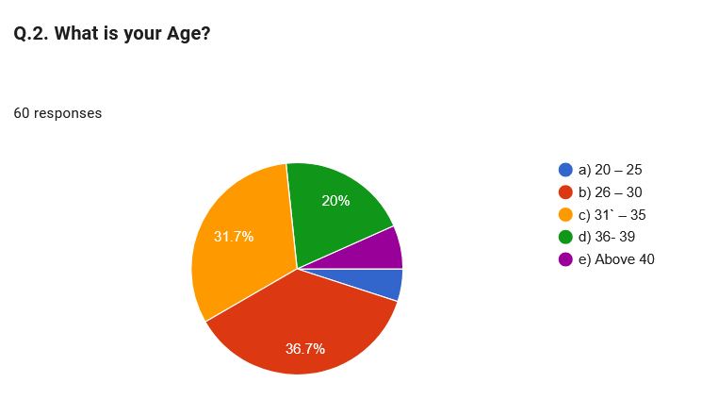
3. Most of of the respondents as represented by 38.3% of the survey population have indicated that they have been using Toyota vehicle for a time frame of 4-6 years, followed by 33.3% of survey population who have been Toyota vehicle users for a time frame 1- 3 years. This finding outlines that most of the users have proper experience of Toyota vehicle usage.
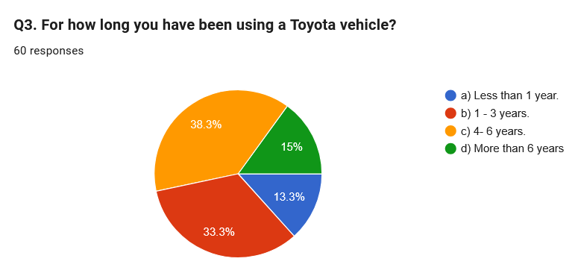
4. Amost all the survey participants have been aware of the certification scandal of Toyota. 33.3% of the survey participants were slightly familiar, while 21.7% were moderately familiar and 15% of the survey population were extremely familiar. Only 11.7% of the respondents were not familiar with the issue. This outlines that most of the participants are aware of the scandal and can provide meaningful opinions regarding the implication of the event.
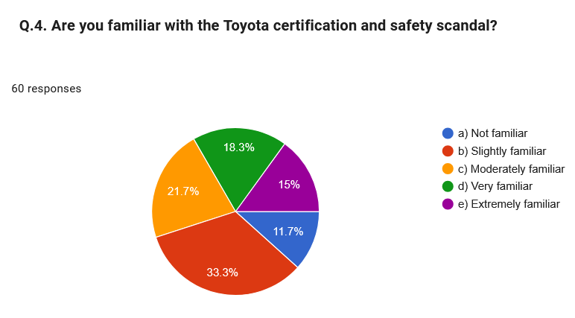
5. 83.3% of the survey participants aware of the opinion that the certification scandal had negatively affected the overall reputation of Toyota. From the findings of the survey it is observed that the scandal damaged overall public perception of the company and thus it is essential to rebuild brand reputation within the UK market.
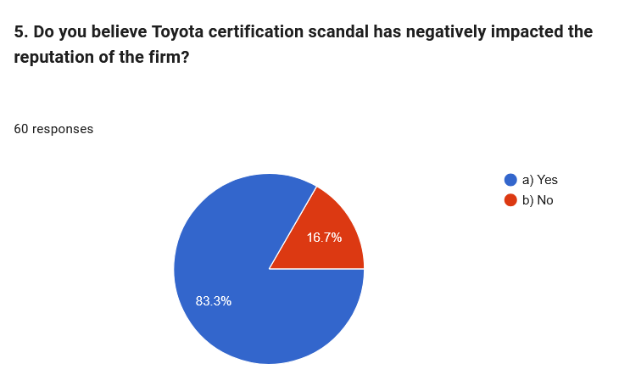
6. Participants involved in the data collection have agreed to the fact that the scandal has reduced their trust in Toyota vehicles. Collectively 85% of the involved participants have agreed that due to the scandal their overall trust towards Toyota vehicles has reduced to a significant level. As a result, it is believed that Toyota requires long-term improvement to rebuild consumer trust an improve customer confidence.
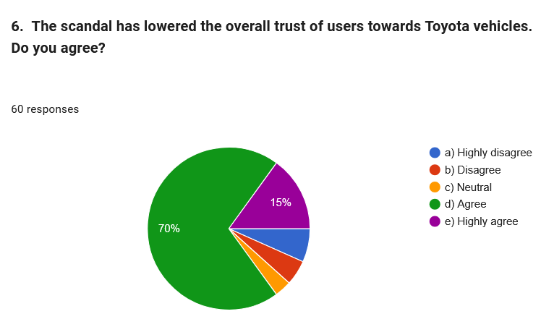
7. 58.3% of the involved survey population have agreed and 25% of the involved participants have highly agreed to the fact that Toyota has appropriately taken actions to tackle the scandal. This indicates that customers have properly acknowledged the overall efforts of the organization to address the issue and align their cuurent practices.

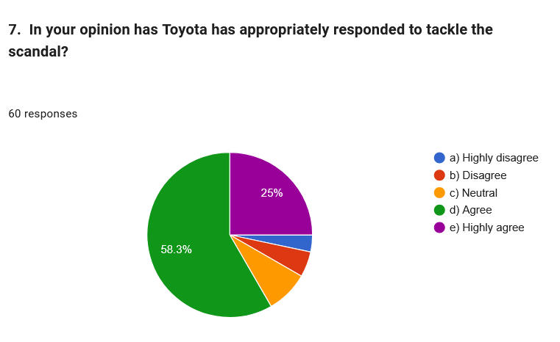
8. Survey data reveals most of the respondents have been concerned on the safety of Toyota vehicles as 35% of the sample population were very concerned while 11.7% were extremely concerned. Moreover, 25% of the population were slightly concerned, indicating that the safety is a crucial part of the issue, which influences the overall confidence and perception of Toyota customers.

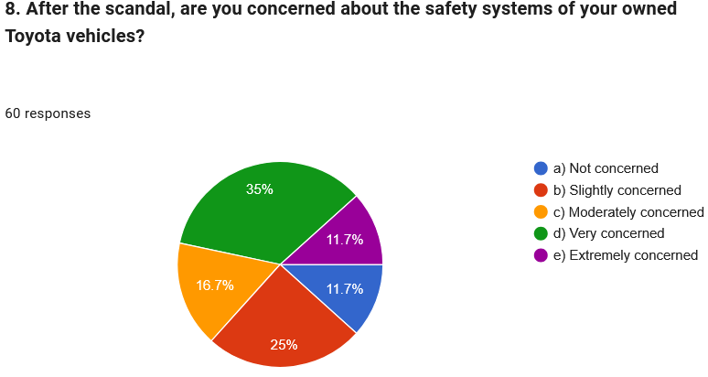
9. 53.3% of the survey population are unlikely to purchase a Toyota manufactured vehicle in the future, while 10% of the participants are very unlikely. This outlines that due to the scandal, the customer future buying intention have been reduced. However, a collective 36.7% have demonstrated their willingness an association with Toyota manufactured vehicles likely to be continued in the near future.

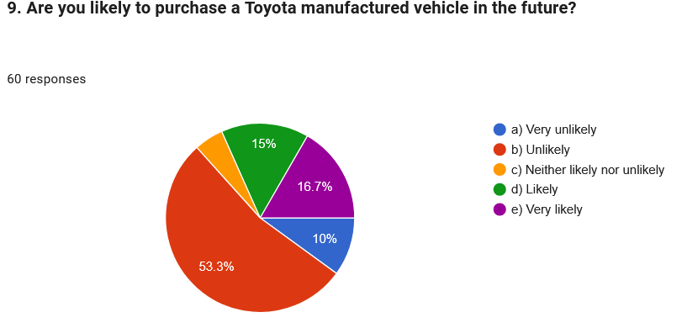
10. Major section of the survey population as represented by collectively 80% of the participants believes there should be greater emphasis by Toyota to enhance their transparency and communication. The findings demonstrate that customer expect Toyota to be open about safety, quality and comply with essential corrective actions to gain customer confidence.

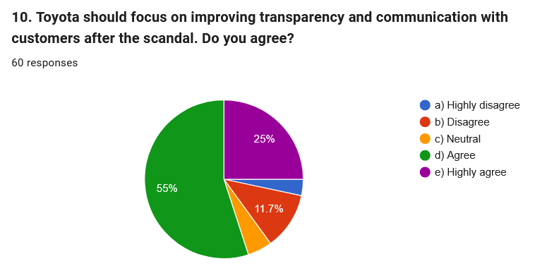
11. Observations reveal that the participants have developed a sense of hesitancy to recommend Toyota after the scandal. Major sections of the participants, as represented by 43.3% of the survey population are unlikely to recommend Toyota vehicle to their friends and families while 25% of the participants were very likely to recommend. This finding outlines that despite brand loyalty still exists, the scandal has lowered positive word of mouth recommendation

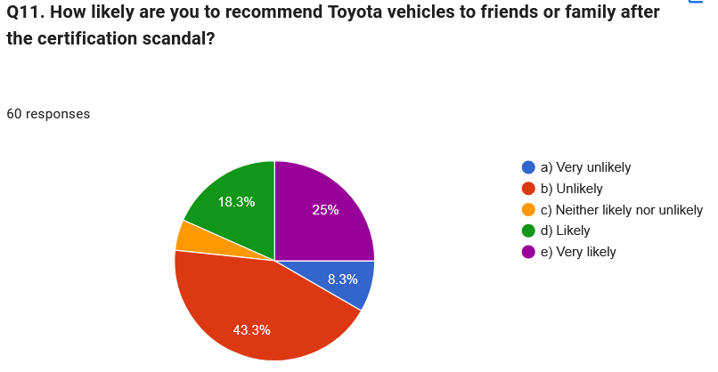
12. Prioritising customer trust rebuilding has been deemed to be most important aspect by most of the respondents. 25% of the involved participants believe enhancement of transparency with customers is essential while other 25% believes that improving of vehicle safety testing should be prioritized by Toyota as a form of their best possible action to rebuild customer trust. Part from this, strengthening of managing accountability and introduction of these safety inspections were also deemed to be highly essential. Overall customers want Toyota to improve organizational accountability and improve safety inspection mechanism.

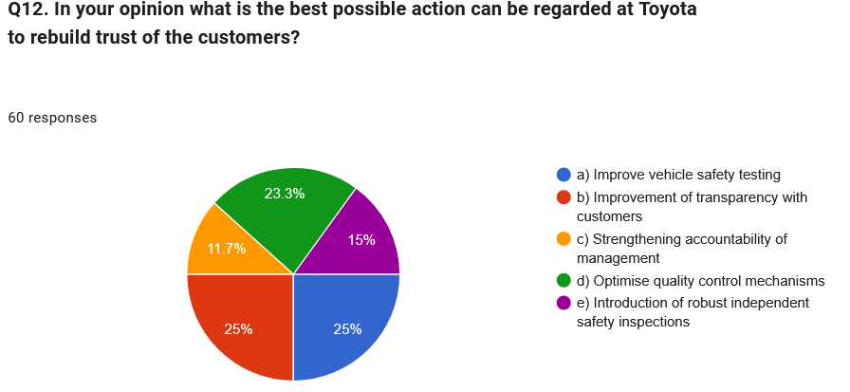

Discussion of the Survey Findings:
The analysis of the survey findings reveals that the certification safety scandal of Toyota significantly affected the brand reputation and lowered customer trust. Most of the respondents were familiar with the scandal, outlining that the issue grab public attention. Major section of the involved participants was of the opinion that the scandal contributed towards lowering customer trust and also reduced brand reputation of Toyota. These findings indicate that safety and honesty are of paramount importance to influence customer decision making while selection of a vehicle.
The survey results also demonstrate that a collective 46.7 % of the respondents remained highly concerned on the safety standards incorporated within Toyota vehicles. More than half of the involved participants were unlikely to purchase Toyota manufactured vehicle in the future signifying that the scandal negatively lowered purchasing intention. Additionally, major section of the involved participants outlined they would be reluctant to recommend Toyota vehicles to family members or friends, indicating that the reputation of the firm has been weakened drastically.
Despite negative opinions presented, 83.3% respondents have outlined that Toyota has initiated positive action to respond to the scandal. However, strong belief are showcased by the customers, and they are of the opinion that Toyota should focus on improving transparency, boost communication practices with customers and optimise their quality control processes. The importance of incorporating robust vehicle safety standard testing and management accountability and deemed to be priority action elements that can help Toyota in rebuilding public confidence. Overall, from the survey findings it is noted that Toyota needs continuous improvement, commitment to safety and should comply with open communication to regain lost consumer trust and improve brand reputation.

4.3 Interview Findings
A thematic analysis of the interviews conducted with two Toyota managerial executives (TM1 and TM2), along with three UK automotive experts (AE1, AE2, AE3), has been provided in this section, including further explanation of the scandal and its outcomes.
Quality Control and Governance Weakness
Each of the participants have recognised weaknesses in evaluating documentation, governance oversight, and verification. For example, according to the observation of AE1, independence has been appeared as limited at the time a single department is going to prepare for a vehicle, conducting its reports and assessments, and preparing the results, along with informing them properly. On the other hand, TM1 has also did criticism on excessive dependence on internal reporting, whereas AE2 have denoted insufficiency in comprehensive level visibility of poor authority and certification risks regarding the compliance group. Thus, participants have shown their support towards independent audits, retesting, digital audit, trials, along with ensuring protection to the whistleblowing arrangements. Apart from this, their responses have also reflected the ineffectiveness of a written quality process, unless the liabilities have been segregated, employees receive the access of reporting concerns safely, and records remaining traceable.
Performance Pressure and Organisational Culture
The interview findings reflected a connection from the responses of the participants between certification scandal to addressing production demand and approval-related deadlines. According to the explanation of TM1, employees might overlook the increase in complexities at the time management tries to demonstrate delay to be a failure. Quite similar to this, TM2 has also recognised significant challenge in the hierarchical structure, whereas AE2 has argued that commercial preferences have been failed in maintaining balance sufficiently with the regulatory liabilities. In addition to this, the response of AE3 added that the reputation of Toyota regarding operational excellence might have influenced complacency. Such kind of findings recommend that the misconduct has not been happened entirely by an individual; rather, it occurred in a culture in which accomplishing goals might be considered as a priority more than ethical judgment, reporting, and procedural adherence.
Brand Reputational Damage and Minimised Customer Trust
All the interview participants have agreed that as a result of the scandal, the conventional association of Toyota with safety, quality, and reliability has been undermined. According to the response of TM2, consumers looked for clarification, whereas potential buyers might decide to postpone their purchases. Furthermore, the argument of AE3 also reflected that the negative media coverage might be highly impactful for the Toyota brand even when customers were confused about which models had been affected. On the other hand, the response of AE2 regarded manipulated certification to be more impactful in comparison to the accidental error, as it directly raises questions towards the corporate integrity. Nevertheless, the interview participants have the trust that the long-standing brand reputation of Toyota can offer a foundation for recovery, independent verification, impactful and credible corrective measures, and sustainability over time. For the recent certification and health-and-safety scandal of Toyota, it can be said that the hierarchical structure and pressure of performance delivery may have acted as active triggers to delay timely identification of issues. However, successful recovery is imperative for restoring the brand's image, and this does not merely depend upon technical reforms but that can only be achieved by thorough restructuring the internal psychological safety to showcase dedicated commitment towards maintaining transparency of processes within the company.
Trust Recovery and Future Prevention
The majority of the interview participants have focused on the fact that Toyota is required to emphasise on combining consumer-based communication with technical reform. In that case, TM2 has recommended a transparent apology, convenient investigations and model based guidance. Moreover, AE1 has called for publication of methods and results, and independent re-evaluation, whereas AE3 has suggested a searchable consumer information platform, along with updating development and progress on a regular basis. Considering long term prevention, AE2 has suggested to make connection between the executive rewards with ethics, safety, and adherence. Apart from this, all the participants have also denoted their support towards cultural audits, verification on three stages, and evaluating consumer trust, along with warranty complaints and safety data. Overall, it can be mentioned that the recovery needs accountability, transparency, and independent oversight, along with an organisational culture which would treat the delayed certification for safety to be a liable performance.

4.4 Secondary Data Findings
A comprehensive content analysis of the reviewed secondary data and literature has recognised four associated findings with concern to the certification scandal of Toyota, the organisational reasons behind it, and the overall market outcomes.
Hierarchy, Communication and Governance Weaknesses
The secondary data findings have indicated that hierarchical structure of Toyota has supported the operational discipline and consistency from long before. However, there is a risk that the centralised authority might create a restriction towards upward communication. In that case, it can also be possible that employees from the lower levels might feel hesitation to challenge the decisions, and express their safety concerns at the time of dealing with excessive management pressure. Furthermore, many research on the organisational hierarchy concept have denoted that inequality in the power relationships might create obstacles towards open communication and thus, a significant delay can be caused in identifying specific problems (Noyes, 2022; Matriano, 2024). In context to application of Toyota, it has suggested that irregularities within the certification have been occurred due to insufficient employee voice, inadequate independent verification, and lack of escalation. Hence, only the formal processes might be failed in assuring adherence, where challenges have been discouraged by the organisational culture. Regarding the certification fraud and health-and-safety scandal at the Toyota, these ideas and dynamics of hierarchical structure is relevant and appear strongly significant. Reports also point out that pressure from higher management authorities are constant burdens stressing upon the production and certification benchmarks that eventually forces the staff to falsify data or resort to unethical measures (Mukunde, 2021). Toyota's case also falls under this category wherein top-down pressure along with restricted or reluctant feedback from downlines undermined safety culture raising chances of serious failure in compliance.
Toyota Way, Kaizen and Performance Pressure
According to the literature review, it has represented the Toyota Way and Kaizen to be crucial foundations of the operational success of Toyota. Moreover, enhancement on continual basis has also motivated standardisation, employee participation, incremental quality improvement, and efficiency (Liker, 2017). Nevertheless, according to the evidence, it has also been identified that there is a tension existing between high performance pressure and enhancement. At the time deadlines, production, speed, as well as certification goals dominate, priority can be given by the employees towards measurable output rather than accuracy of process and safety. Moreover, the findings of Mendez and Vila-Alonso (2018) have indicated that Kaizen needs a proper balanced sustainability instead of uncontrolled productivity requirements. Thus, the scandal is not the evidence of the fact that Kaizen itself is with fault rather it represents that its incorporation have been appeared as disconnected from employee well-being, ethical oversight, and adherence controls.
Consumer Trust and Reputational Outcome
A consistent recognition of reliability, safety, and ethical behaviour has been recognised in the literature to be the primary elements of brand reputation for an automotive company. Furthermore, researchers have also recognised that corporate reputation helps in empowering customer trust at the time a specific brand reflects predictability, competence and integrity (Stravinskienė et al., 2021). However, manipulation in certification becomes the reason of violating such expectations as consumers are not able of verifying the technical safety claims independently. As an outcome of this, there can be increased perceived risk, poor purchasing intention from the customer side, and negative word of mouth might be spread in the market. Apart from the impacted models, it further generates comprehensive brand reputational damage, and also becomes the reason of increasing willingness of customers to switch to the competitors. For the case of Toyota, the scandal had led towards building a strong pressure upon the long-standing reputation of the company regarding its quality and reliability. The reviews of literature done are shows that recovery strongly relies on ways the company can maintain open communication with customers while strengthening its internal work culture for prioritising safety, and they would also need to prove through continued action that any such incident will never occur in future. There should effective strategies in place to repair the trust and rebuild customer loyalty over time.
Recovery and Competitive Implications
According to different crisis management literature it has been suggested that the recovery of Toyota is relied on the quality of its response specifically clear communication acknowledgement on time visible leadership accountability and corrective measures (Thakur and Hale, 2022). Apart from this, Porter’s Five forces analysis also has denoted that the excessive competition and hire consumer choice have increased the commercial expense of the impacted trust hence it is necessary for Toyota to pay increasing attention on independent assessment protected reporting channels Robust compliance oversight along with sustained disclosure finally the secondary data have also denoted the necessity of technical correction to be accompanied by both governance and cultural reform for the purpose of re-establishing credibility in a sustainable way over time and prevent from reoccurrence. Overall, the scandal has wielded significant damage to the competitive position of Toyota along some major areas like consumer trust, and stakeholder confidence. Restoration of the brand's reputation and rebuilding customer confidence is henceforth extremely essential for the company to re-establish itself amidst the intensely competitive market, with evolving challenges.

4.5 Analysis and Discussion
Comparing and Contrasting the Research Findings
Overall triangulation has denoted the comprehensive agreement throughout the interview, survey, and secondary data findings. However, each data set has given a distinct point of view. For example, the quantitative survey findings have reflected the perspectives of consumers, the qualitative interview findings have demonstrated the causes of the organisation behind the scandal and possible strategies, whereas the secondary literature review findings have supplied both industry and theoretical contexts. Furthermore, based on the causation, the interview findings have connected the scandal to the pressure of performance, hierarchical communication, certification deadlines, and insufficient independent supervision. On the other hand, these findings have been supported by the secondary literature evidence through representing that centralised authority might create restriction to the voice of employees, and high target pressure might create separation between ethical control and Kaizen. It is also notable that the survey findings have failed in directly verifying the internal reasons; however, the demand of the consumers towards robust accountability represents that they have also understood the failure of governance and management.
Apart from the above, all the sources have also agreed that the scandal created damage to the reputation of Toyota regarding reliability, quality, and safety. Moreover, the quantitative survey findings have given the most transparent numerical evidence, which involve 83.3% of the perceived reputational impact, and nearly 85% reporting about minimised trust. Quite similar to this, interviews have denoted that certification manipulation appeared as impactful in comparison to the accidental damage, as it raised questions towards the integrity of Toyota. Apart from this, literature findings have also demonstrated this response by representing that consumers rely highly on the manufacturers in terms of offering appropriate technical information. Nevertheless, the results cannot be considered as entirely negative. Although it has been found that 63.3% were very unlikely or unlikely to consider repurchasing decision for Toyota, there were also 36.7% participants who remained likely to do it again. Furthermore, 83.3% of the participants possessed strong belief to the fact that Toyota had taken suitable actions. Such kind of contrasting scenario among the responses represents that consumers identified the response of Toyota; however, this recognition yet not been able of restoring confidence of the customers. Nevertheless, throughout all the data sets, independent testing, transparency, transparent communication, and robust oversight appeared as necessary however the interview findings have denoted higher focus on the internal reformation like audit trails and whistleblowing. Hence, such kind of differences among the findings have demonstrated the reason behind the successful combination of qualitative, quantitative and secondary evidence leading towards empowered analysis of results.
How the Findings Addressed the Research Questions
The combination of the qualitative, quantitative, and secondary data findings has addressed the research questions with the use of complementary evidence. Moreover, the question regarding the reasons behind the scandal has been answered through recognising pressure of performance, poor verification, restriction to the upward communication, and governance shortcomings. Nevertheless, evidence has supported systemic liability, and might not conclusively recognise an individual person who can authorise the irregular activities.
Moreover, the question related to the impact on trust and organisational reputation has been answered directly by the minimisation in trust, intention to repurchase, and eagerness to recommend Toyota by the survey responses, which has also been re-amplified by the literature and interview evidence regarding corporate integrity and perceived risk. Furthermore, the findings have addressed essential organisational changes, and recognised distinction of the board-level adherence oversight, testing liabilities, protected reporting channels, external audits, along with traceable certification records.
Finally, the question regarding trust recovery has been answered with the continual support for independent reassessment, accessible investigation, model-based information, visible managerial accountability, along with public progress reporting. Overall, the recommendations regarding the prevention involved cultural audits, verification on three stage, continual supervision of complaints, safety based executive appraisals, and consumer trust and warranties. On a final note, it can be mentioned that the triangulation has answered the research questions sufficiently; however, long term recovery has been appeared as uncertain, as the cross sectional evidence might be failed in demonstrating whether reform should be incorporated on a continual basis or whether the confidence of the consumers would enhance over time.

4.6 Chapter Summary
The chapter has recognised governance weakness, performance pressure, and restricted communication to be the primary reasons behind the scandal of Toyota. Moreover, the triangulated evidence has described substantial impact to the trust of consumers, along with highlighting independent evaluation, transparency, cultural reform, and robust accountability to be pivotal foundations of recovery in a sustainable way.

Chapter 5: Recommendations, Research Limitations and Conclusion

5.1 Chapter Introduction
The chapter summarises principal findings of the research and evaluates how they help in addressing the research objectives aims and questions. It also presents practical recommendations that Toyota implements in strengthening the trust of customer, improves governance as well as prevents similar incidents in future. The chapter also discusses limitations of research, identifies opportunities for future studies as well as concludes dissertation by highlighting the overall significance of the res primary contributions.

5.2 Summary of the Main Research Findings
The findings demonstrate the certification of Toyota and safety scandal that significantly weaken the reputation for quality, vehicle safety and reliability. Survey evidences showed 83.3% of the respondents believing in the scandal negatively impacting the reputation of Toyota, whereas a combined 85% of agreed that the trust in Toyota vehicles have declined. The concerns influenced behaviour of consumer, since 63.3% have stated that they were unlikely or very likely to purchase a Toyota vehicle in the near future. Respondents were also much more hesitant in recommending the brand to friends and relatives, which indicates weaker positive word of mouth. However, 83.3% of believe Toyota taking appropriate action would have suggested that reputational recovery remains achievable. The interview findings have provided deeper explanations regarding the scandal in identification of performance pressure, the hierarchical decision making, insufficient voice of employee, weaker independent verification along with limited board level oversight as the primary organisational causes. Across datasets, independent safety testing, transparency, stronger accountability of management and clearer customer communication have emerged as essential recovery measures. Overall, the survey have also confirmed declining the trust and purchasing intention while interviews have explained cultural, governance and quality control weaknesses which contributed towards the problem and could also obstruct the long-term competitive position of Toyota.

5.3 Achievement of the Research Aim and Objectives
The result successfully achieved the aim of investigating the impact of Toyota certification misconduct upon the trust of customer and brand reputation as well as identifying suitable recovery with prevention strategies. The survey findings have provided quantitative evidences of customer perceptions, that demonstrated reduced trust, weakened the reputation of brand, lowered purchasing intention as well as decreasing the willingness to recommend Toyota vehicles. The semi structured interviews also provided qualitative insights towards management systems, organisational culture with quality control weaknesses which contributed towards the scandal. Together, the findings have addressed the research objectives by evaluation of managerial processes, which examines reputational damages, understanding the responses of customer as well as identifying practical measures for restoring confidence. The mixed method research approach enabled in a comprehensive understanding of both the outcomes of customer as well as organisational causes to provide evidence-based recommendations for strengthening the governance, improving transparency as well as reducing the likelihood of similar incidents that might occur in the future.

5.4 Recommendations for Toyota

5.4.1 Strengthen Independent Safety Testing and Certification
Toyota must Commission accredited organisations for retesting the affected models as well as published verified outcomes. Vehicle development, testing with final certification approval must also be separated in order to reduce the conflicts of interest. A three stage verification system must also involve operational teams, internal compliance specialists as well as external reviewers. Securing the digital audit trails must also record who completed each of the tests, components reduced and any data changes. Unannounced external audits should also be introduced (Mukunde, 2021).

5.4.2 Improve Transparency and Customer Communication
Toyota must publish model specific information that explains which vehicles were affected and what corrective action is needed. A searchable customer information portal must also provide testing methods, results and progress updates in accessible languages. The customers must receive convenient inspections, direct support and repairs. Toyota must issue an apology acknowledgement the seriousness of the misconduct. The response of 80% of respondents requested greater transparency and communication (Liker, 2017).

5.4.3 Reform Governance and Management Accountability
Toyota must also establish an independent safety and certification committee reporting directly to the board. Clearer responsibility must be assigned for every certification decision, which is supported by measurable compliance indicators. Executive appraisal with reward systems must also include safety, regulatory compliance along with ethical conduct, rather than prioritising the production speed and sales target. Senior leaders should also review the certification risks, warranty information, complaints along with safety data. Public reporting must also demonstrate progress as well as strengthen the accountability of customers, regulators and the investors.

5.4.4 Strengthen Employee Voice and Ethical Culture
Toyota must introduce protected anonymous whistleblowing channels and make sure of employees can stop in testing or certification when the evidence is incomplete or inaccurate. Staffs reporting concerns must also be protected from retaliation (Ruslin et al., 2022). Managers must also recognise delaying the approval for safety reasons that represents responsible performances. Cultural and psychological safety audits should also assess whether employees feel able to challenge the decisions. Stronger communication of upward between technical teams and senior leaders would help in reduction of the hierarchical pressure as well as hidden risks.

5.4.5 Monitor Customer Trust and Recovery
Toyota must conduct UK customer trust surveys and track purchasing intention, safety concerns, recommendation levels and complaints. The results must also be combined with warranty claims, feedback of leadership and regulatory findings. Recovery KPIs must include improving the trust scores, fewer amounts of safety-related complaints, stronger recommendation rates along with increasing the purchase consideration full progress must also be reported publicly over an extended. Sustaining monitoring would provide credible evidences in improving and avoiding relying on temporary advertising and public relation campaign (Noble and Smith, 2025).

5.5 Limitations of the Research
The research has limitations affecting the interpretation of findings. Survey included only 60 respondents and cannot represent every Toyota customer in UK. Convenience sampling might have introduced selection bias and participants were recruited as per the accessibility. UK focus could also limit the generalisation of international markets. Only five interview participants were included, by limited amount of access towards executives, certification employees, regulators reduce the first hand evidences. Some responses reflected professional opinion rather than direct involvement. Survey answers were also self-reported and potentially influenced by recall buyers, media exposure and social disability. Cross-sectional design also limited the resources that prevented long-term analysis of customer trust (Haq and Yasin, 2025).

5.6 Recommendations for Future Research
Future research must also use larger, more representative customer sample in comparison to the perceptions across several countries. Longitudinal studies must measure whether the reputation of Toyota and trust can recover over time. Researchers should interview regulators, the dealership managers, certification engineers and affected the employees. Comparative studies could examine the Toyota alongside any other automotive scandals. Further researchers could also distinguish loyal owners from prospective buyers as well as test whether governance reforms, independent audits and transparency measures improves the purchasing intention (Thakur and Hale, 2022).

5.7 Overall Conclusion
The certification of Toyota and safety scandal damages the trust of customer, brand reputation as well as future purchasing intention. Findings show problem reflected weaknesses in organisational culture, employee voice, governance along with quality control oversight rather than isolated misconduct. However the established reputation of Toyota provided a foundation for recovery. Rebuilding confidence needs independent safety verification, transparent communication, accountability of management and protected employee voice. Trust must therefore be restored through consistent, sustained and measurable corrective action over time.

References:
Afzal, H., Khan, M. A., ur Rehman, K., Ali, I., and Wajahat, S. (2010). Consumer's trust in the brand: Can it be built through brand reputation, brand competence and brand predictability. International business research, 3(1), 43.
Dälken, F., (2014), July. Are porter's five competitive forces still applicable? a critical examination concerning the relevance for today's business. In 3rd IBA Bachelor Thesis Conference (Pp. 1-9).
Frăsineanu, P.L., (2008). THE PORTER'S THEORY OF COMPETITIVE ADVANTAGE. Annals of the University of Craiova, Economic Sciences Series, 7(36).
Haq, M., and Yasin, N. (2025). Qualitative, quantitative, and mixed methodology paradigms. Journal of Practical Studies in Education, 6(6), pp.1-15. https://jpse.gta.org.uk/index.php/home/article/download/144/219.
Hays, D., and McKibben, W. (2021). Promoting rigorous research: Generalizability and qualitative research. . Journal of Counseling & Development, 99(2), pp.178-188.https://www.researchgate.net/profile/Danica-Hays/publication/349921097_Promoting_Rigorous_Research_Generalizability_and_Qualitative_Research/links/676afb9f117f340ec3d5ebab/Promoting-Rigorous-Research-.
Kisselburgh, L., and Beever, J. (2022). The ethics of privacy in research and design: Principles, practices, and potential. In Modern socio-technical perspectives on privacy (pp. 395-426). Cham: Springer International Publishing. https://library.oapen.org/bitstream/handle/20.500.12657/52825/1/978-3-030-82786-1.pdf#page=392.
Laryeafio, M., and Ogbewe, O. (2023). Ethical consideration dilemma: systematic review of ethics in qualitative data collection through interviews. . Journal of Ethics in Entrepreneurship and Technology, 3(2), pp.94-110 https://www.emerald.com/insight/content/doi/10.1108/jeet-09-2022-0014/full/pdf.
Liker, J.K. (2017) The Toyota Way. New York: McGraw-Hill.
Liker, J.K., Hoseus, M. and Center for Quality People and Organizations (2008) Toyota Culture. New York: McGraw-Hill.
Matriano, M. T. (2024). Organizational Structure, Its Drawbacks and Shortcomings and Overall Impact to Organizational Behavior. Gsj, 12, 1873-1882. ISSN 2320-9186.
Mendez, J., and Vila-Alonso, M. (2018). Three-dimensional sustainability of Kaizen. The TQM Journal, 30(4), 391-408. https://doi.org/10.1108/TQM-12-2017-0179.
Mohammed, A., Al-Swidi, A. K., Al-Hakimi, M. A., & Ferraris, A. (2026). From greenwashing to brand avoidance: the roles of perceived risk, trust and negative word-of-mouth. International Journal of Bank Marketing, 44(5), 970-996. https://doi.org/10.1108/IJBM-09-2024-0535.
Mukunde, D. (2021) ‘Analysis of Toyota Motor Corporation’s Strategic Partnerships and Impact on Stakeholders’. Available at: SSRN 4749778.
Noble, H., and Smith, J. (2025). Ensuring validity and reliability in qualitative research. Evidence-Based Nursing, 28(4), 206-208. https://ebn.bmj.com/content/ebnurs/28/4/206.full.pdf.
Noyes, A. L. (2022). Navigating the hierarchy: communicating power relationships in collaborative health care groups. Management Communication Quarterly, 36(1), 62-91. https://doi.org/10.1177/0893318921102573.
Nyimbili, F., and Nyimbili, L. (2024). Types of purposive sampling techniques with their examples and application in qualitative research studies. British Journal of Multidisciplinary and Advanced Studies, 5(1), pp.90-99 https://bjmas.org/index.php/bjmas/article/download/808/1429.
Ohno, T. (2019) Toyota Production System: Beyond Large-Scale Production. Productivity Press.
Poucher, Z. A., Tamminen, K. A., Caron, J. G., and Sweet, S. N. (2020). Thinking through and designing qualitative research studies: A focused mapping review of 30 years of qualitative research in sport psychology. International Review of Sport and Exercise Psychology, 13(1), 163-186. https://www.tandfonline.com/doi/pdf/10.1080/1750984X.2019.1656276.
Proudfoot, K. (2023). Inductive/deductive hybrid thematic analysis in mixed methods research. . Journal of Mixed Methods Research, 17(3), 308-326.https://journals.sagepub.com/doi/pdf/10.1177/15586898221126816.
Ruslin, R., Mashuri, S., Rasak, M. S., and Alhabsyi, F. (2022). Semi-structured Interview: A methodological reflection on the development of a qualitative research instrument in educational studies. IOSR Journal of Research & Method in Education (IOSR-JRME), 12(1), 22-29. http://repository.iainpalu.ac.id/id/eprint/1247/1/Saepudin%20Mashuri.%20Artkel%20inter..pdf.
Stravinskienė, J., Matulevičienė, M., & Hopenienė, R. (2021). Impact of corporate reputation dimensions on consumer trust. Engineering Economics, 32(2), 177-192. https://doi.org/10.5755/j01.ee.32.2.27548.
Thakur, R., and Hale, D. (2022). Strategic crisis response: managerial implications and direction for recovery and survival. Journal of Business & Industrial Marketing, 37(10), 1959-1973. https://doi.org/10.1108/JBIM-01-2021-0029.
Tomaszewski, L. E., Zarestky, J., and Gonzalez, E. (2020). Planning Qualitative Research: Design and Decision Making for New Researchers. International Journal of Qualitative Methods https://journals.sagepub.com/doi/full/10.1177/1609406920967174.

Appendix A: SURVEY AND INTERVIEW QUESTIONNAIRE
Section A: Demographic profile of the participants
Q1. What is your Gender?
- Male
- Female

Q.2. What is your Age?
- 20 – 25
- 26 – 30
- 31` – 35
- 36- 39
- Above 40

Q.3. For how long you have been using a Toyota vehicle?
- Less than 1 year.
- 1 - 3 years.
- 4- 6 years.
- More than 6 years
Q.4. Are you familiar with the Toyota certification and safety scandal?
- Not familiar
- Slightly familiar
- Moderately familiar
- Very familiar
- Extremely familiar

Section B: Customer Perception of the Toyota Scandal
5. Do you believe Toyota certification scandal has negatively impacted the reputation of the firm?
- Yes
- No
6. The scandal has lowered the overall trust of users towards Toyota vehicles. Do you agree?
- Highly disagree
- Disagree
- Neutral
- Agree
- Highly agree
7. In your opinion has Toyota has appropriately responded to tackle the scandal?
- Highly disagree
- Disagree
- Neutral
- Agree
- Highly agree
8. After the scandal, are you concerned about the safety systems of your owned Toyota vehicles?
- Not concerned
- Slightly concerned
- Moderately concerned
- Very concerned
- Extremely concerned
9. Are you likely to purchase a Toyota manufactured vehicle in the future?
- Very unlikely
- Unlikely
- Neither likely nor unlikely
- Likely
- Very likely
10. Toyota should focus on improving transparency and communication with customers after the scandal. Do you agree?
- Highly disagree
- Disagree
- Neutral
- Agree
- Highly agree

Q11. How likely are you to recommend Toyota vehicles to friends or family after the certification scandal?
- Very unlikely
- Unlikely
- Neither likely nor unlikely
- Likely
- Very likely

Q12. In your opinion what is the best possible action can be regarded at Toyota to rebuild trust of the customers?
- Improve vehicle safety testing
- Improvement of transparency with customers
- Strengthening accountability of management
- Optimise quality control mechanisms
- Introduction of robust independent safety inspections
Interview questions managers of Toyota and automobile experts in UK
- In your opinion, what were the primary reasons that led towards formation of Toyota's certification and safety scandal?
- How has this scandal impacted the overall brand reputation and customer trust of Toyota?
- Have there been any weaknesses in quality control system or management of Toyota that contributed to the incident?
- What are the measures has Toyota taken, or should take, to regain customer trust and improve user confidence?
- Based on your professional experience, what recommendations would you suggest to Toyota, helping them to eliminate similar issues from occurring in the future?

APPENDIX: B: INTERVIEW TRANSCRIPTS
Participant 1: Toyota Quality-Control Manager (TM1)
Interviewer: In your opinion, what were the primary reasons that led to Toyota’s certification and safety scandal?
TM1: The incident appears to have resulted from intense pressure to meet development and certification deadlines. Communication between technical teams and senior management may not always have been sufficiently open. When employees believe that delays will be viewed as failure, they may attempt to solve problems without properly escalating them.
Interviewer: How has the scandal affected Toyota’s brand reputation and customer trust?
TM1: Toyota has traditionally been associated with quality, reliability and continuous improvement. Therefore, certification irregularities created a contradiction between the company’s public values and reported practices. Some customers understandably questioned whether they could trust the testing process, although Toyota’s long-standing reputation may support recovery if corrective actions remain visible.
Interviewer: Were there weaknesses in Toyota’s quality-control system or management?
TM1: The technical standards themselves were extensive, but weaknesses may have existed in their implementation and independent verification. Too much dependence on internal reporting can allow problems to remain hidden. Management also needed clearer escalation routes through which employees could report compliance concerns without fearing negative consequences.
Interviewer: What measures has Toyota taken, or should it take, to restore trust?
TM1: Toyota should independently retest affected vehicles, publish understandable results and strengthen certification governance. Customers should receive prompt information about whether their vehicles are affected. The company should also separate final compliance approval from teams responsible for achieving production targets.
Interviewer: What would prevent similar incidents?
TM1: Toyota should conduct regular external audits, introduce protected whistleblowing arrangements and assess managers partly through safety and compliance performance. Employees must be empowered to stop a certification process whenever evidence is incomplete or inaccurate.

Participant 2: Toyota Customer-Relations Manager (TM2)
Interviewer: What were the main reasons behind the scandal?
TM2: From a customer-relations perspective, the underlying causes may include performance pressure, insufficient challenge of internal decisions and delayed communication of problems. A strong organisational hierarchy can sometimes make employees reluctant to question senior colleagues or disclose information that might delay product approval.
Interviewer: How has it affected Toyota’s reputation and customer trust?
TM2: Customers were concerned because certification is closely connected with vehicle safety. Existing customers contacted support teams seeking clarification, while prospective buyers may have delayed purchasing decisions. The reputational effect is wider than the affected models because customers evaluate the integrity of the Toyota brand as a whole.
Interviewer: What quality-control or management weaknesses contributed?
TM2: One weakness was the possible gap between Toyota’s stated commitment to quality and employees’ daily experience of operational targets. Management may also have relied too heavily on established procedures without checking whether staff followed them correctly. Customer communication initially needed to be faster and simpler.
Interviewer: What should Toyota do to rebuild customer confidence?
TM2: Toyota should communicate openly, apologise without minimising the issue and provide model-specific information. Customers whose vehicles require inspection should receive convenient appointments and appropriate support. Progress reports from independent reviewers would demonstrate that Toyota’s promises are supported by evidence.
Interviewer: What are your recommendations?
TM2: The company should create a customer-trust recovery programme combining transparent reporting, independent testing and continuous communication. Senior leaders should regularly review complaints and safety concerns because customer feedback can provide an early warning of wider quality problems.

Participant 3: Independent Automotive Engineer (AE1)
Interviewer: What factors led to Toyota’s certification and safety scandal?
AE1: In my view, the problem was not simply the behaviour of individual employees. Certification misconduct generally becomes possible when deadlines, technical complexity and weak oversight interact. If the same department prepares a vehicle, performs the test and reports the outcome, there may be insufficient independence.
Interviewer: How has the scandal affected the brand?
AE1: Toyota’s reputation was damaged because safety certification is expected to provide objective evidence that a vehicle meets legal requirements. Customers may reasonably ask whether other tests were completed correctly. Nevertheless, reputational recovery is possible if Toyota provides verifiable evidence instead of relying only on corporate statements.
Interviewer: Were there weaknesses in quality control?
AE1: Yes. The reported irregularities suggest weaknesses in test governance, documentation and verification. Digital records should provide a complete audit trail showing who conducted each test, what components were used and whether any data were changed. Unannounced independent inspections could also have identified inconsistencies earlier.
Interviewer: What measures should Toyota take?
AE1: All potentially affected models should be retested by competent independent bodies. Toyota should publish the scope, methodology and outcome of the reviews while explaining any actual safety implications. Certification staff also need updated training on regulatory requirements and professional accountability.
Interviewer: What would you recommend for the future?
AE1: Toyota should introduce a three-stage verification system involving the testing team, an internal compliance unit and an independent external reviewer. Certification data should be protected against unauthorised alteration, and any test variation should automatically trigger investigation.

Participant 4: UK Automotive Governance Consultant (AE2)
Interviewer: Why do you believe the scandal occurred?
AE2: The scandal appears to reflect a governance failure in which commercial or production priorities were not sufficiently balanced against compliance obligations. Organisational success can create overconfidence, causing established companies to assume that existing systems remain effective without testing their underlying culture.
Interviewer: What impact has it had on reputation and trust?
AE2: The incident weakened perceptions of corporate integrity. Customers may forgive an accidental technical defect more readily than deliberate manipulation because manipulation suggests an ethical and governance problem. Regulators, dealerships, investors and business partners may also demand stronger evidence of compliance.
Interviewer: What management weaknesses may have contributed?
AE2: Possible weaknesses include centralised decision-making, limited board-level visibility of certification risks and insufficient protection for employees who challenge inappropriate practices. A compliance function cannot be effective if it lacks authority or reports to managers whose performance depends mainly on product-launch speed.
Interviewer: How can Toyota rebuild confidence?
AE2: Toyota needs clear accountability at board and senior-management levels. It should disclose investigation outcomes, corrective actions and measurable progress indicators. An independent safety and certification committee could review high-risk decisions and report directly to the board.
Interviewer: What further recommendations would you make?
AE2: Executive incentives should incorporate safety, ethical conduct and regulatory compliance rather than focusing mainly on production and financial performance. Toyota should also commission periodic cultural audits to determine whether employees feel psychologically safe to report problems.

Participant 5: UK Automotive Consumer and Brand Analyst (AE3)
Interviewer: What were the primary causes of the scandal?
AE3: I believe pressure to achieve business targets was combined with insufficient transparency and challenge. Toyota’s reputation for operational excellence may also have created complacency. Employees and managers may have assumed that internal processes were reliable without examining whether actual workplace behaviour matched official policies.
Interviewer: How has it affected brand reputation and customer trust?
AE3: The scandal introduced doubt into Toyota’s central brand promise of dependable quality. Highly loyal customers may wait for evidence before changing brands, but less committed buyers can easily compare Toyota with competitors. Negative media coverage may also influence customers who know little about which models were involved.
Interviewer: Were there quality-control or management weaknesses?
AE3: The central weakness was the apparent inability of internal controls to identify or prevent irregular testing. There may also have been a communication failure because customers require timely, accessible explanations. Technical statements alone are unlikely to restore confidence among ordinary vehicle owners.
Interviewer: What should Toyota do to regain trust?
AE3: Toyota should combine technical correction with customer-focused communication. It should provide a dedicated information platform, searchable vehicle identification details, regular progress updates and clear contact routes. Independent endorsements and transparent test results would be more convincing than advertising claims.
Interviewer: What are your recommendations for preventing recurrence?
AE3: Toyota should track customer trust through regular UK surveys and connect the findings with complaint, warranty and safety data. Leaders should communicate that delaying a product for safety reasons is responsible behaviour. Long-term consistency will be essential because reputation cannot be restored through one campaign.

APPENDIX C: SURVEY RESULTS

