
APPENDIX GA36d
LEVEL 7 ASSESSMENT SPECIFICATION

Student name: |  | Student ID number:
Programme: | MSc/PgDip/PgCert Cybersecurity and Digital Forensics
Module: | Digital Forensics Analysis
Module code: | ACCA7031 | Contribution to  Overall Module Assessment (%): | 100%
Lecturer: | Dr. Mohamed Ghanem | Internal Verifier: | Mr. Munyaradzi Murira
Assignment Title: | Research, Analyse and Investigate Cybersecurity incidents and perform digital forensic assessment | Word count (or equivalent): | 5000
Submission deadline: | Report: 27th April 2026, 14:00 (2PM)  Demo: 22nd and 23rd April 2026 (Week 11) | Return date of provisional marks & written feedback: | 28th May 2026
Submission method: | All written assessments, where practical and possible, must be submitted via Turnitin unless otherwise instructed by the Lecturer. (Please DO NOT put this assessment specification into Turnitin or it will match many similarities with other students’ submissions.)  Alternative submission method (if applicable): NA  Late submission of the assessment will result in a late penalty mark:.  Work which is submitted up to 1 week late will be capped at 50% for the first attempt and will be awarded a mark of 0% for re-assessment. Late submission penalties may be lifted only if there is an approved extenuating circumstances claim.  Work submitted more than 1 week late will be considered as a non-submission and will not be marked. The work may be considered as a submission for reassessment if offered by an Examining Board or if there is an approved extenuating circumstances claim.
Academic honesty / referencing: | Academic honesty is required. In the main body of your submission you must give credit to authors on whose research and ideas your work is based. Append to your submission a reference list that indicates the books, articles, etc. that you have used, cited or quoted in order to complete this assessment.

DIGITAL FORENSICS ANALYSIS

Table of Contents
Task 1: Research Report 4
1. Introduction 4
2. Current State of Digital Forensics and Tools 4
3. Intersection of Digital Forensics and Cybersecurity 5
4. Emerging Trends in Digital Forensics 5
5. Key Challenges in Digital Forensics 6
6. National and International Job Market 6
7. Conclusion 7
Task 2: Digital Forensic Report 8
1. Case Background 8
2. Evidence Inventory and Chain of Custody 8
3. Methodology 10
3.1 Evidence Acquisition 10
3.2 Data Analysis 10
4. Evidence Acquisition 11
5. Communication Analysis 13
6. File Analysis (USB Drive) 14
7. Call Log and Email Correlation 17
8. Timeline Reconstruction 18
9. Suspect Profiling 19
10. Key Findings 21
11. Conclusion 22
12. Recommendations 22
Reference List 24

Task 1: Research Report

1. Introduction
Digital forensics is a pivotal element in the field of cybersecurity that concentrates on the identification, acquisition, preservation, and analysis of digital evidence as well as its presentation to support investigative and legal functions. Following the massive increase in digital devices and cybercrime, the digital forensics has become one of the most specialized professions capable of helping the law enforcement, corporate investigations, and other national security operations. Recent research points out that digital forensics have evolved to encompass cloud-computers, mobile and IoT environments in addition to traditional computer systems (Alenezi, 2023). This report assesses the present digital forensics, its instruments and means, how it was integrated into cybersecurity, current trends, major challenges of this area, and prospects in the job market.

2. Current State of Digital Forensics and Tools
The evolution of digital forensics has gone a long way as the introduction of sophisticated forensic applications has helped to bring out and analyse vast amounts of data through a wide range of devices, including mobile gadgets, cloud services, and Internet of Things. The development of tools has been predetermined by the growing sophistication of cybercrime and the necessity to conduct investigations more quickly and accurately (Breitinger et al., 2023).
Key Tools and Capabilities
Industry-standard tools include:
- Cellebrite UFED – widely used for mobile device extraction
- FTK (Forensic Toolkit) – supports disk imaging and analysis
- Autopsy & Sleuth Kit – open-source forensic tools
- EnCase – enterprise-level forensic investigation tool
Core Features
- Data acquisition (logical and physical imaging)
- Recovery of deleted data
- Timeline reconstruction
- Metadata analysis
- Application data extraction
Contemporary forensic instruments become more and more AI-enhanced and machine learning-enhanced to enhance the efficacy of analysing extensive data and finding patterns in digital evidence (Nayerifard et al., 2023). Also, the tools that are becoming popular are open-source as they have such merits as flexibility and affordability, but their reliability should also be taken into consideration (Abeysekera, 2026).

3. Intersection of Digital Forensics and Cybersecurity
Cybersecurity and digital forensics are two in close relationship. Cybersecurity is based on how to prevent attacks, whereas digital forensics is about investigating and reacting to them. This fusion is critical to the contemporary organisations where incident response heavily depends on forensic evidence (Klasén, Fock and Forchheimer, 2024).
Key Intersections
- Incident Response: Identifying breaches and attack vectors
- Threat Intelligence: Analysing attacker behaviour
- Compliance & Legal Support: Supporting prosecution
- Evidence Preservation: Ensuring admissibility
According to recent studies, the shift to the integration of forensic investigation with cybersecurity frameworks enhances the resilience of organisations and the effectiveness of identifying cyber threats (S, Jegan and Vasanthagopal, 2025).

4. Emerging Trends in Digital Forensics
1. Cloud Forensics: Clouds introduce a special set of challenges with distributed storage, multi-tenancy, and cross-jurisdictional access to data, making such specialised methods of investigation necessary (Alenezi, 2023).
2. Mobile Forensics Expansion: Smartphones have now become the most important sources of digital evidence, including communication history, multimedia content, and location information that can significantly aid investigations.
3. AI and Automation: Artificial intelligence can promote digital forensics by attracting pattern recognition, autonomous judgment, and quicker data processing. Nevertheless, there are still issues of explainability and reliability of AI-driven discoveries (Scanlon et al., 2023).
4. IoT Forensics: IoT devices create massive data volumes and demand sophisticated forensics. New technology involves the use of secure evidence-gathering and systems of automated intrusion detection (Abdulaziz, 2025).
5. Behavioural and Advanced Analytics: Having behavioural insight into forensics enhances the accuracy of investigations, aids decision-making, and increases the interpretation of digital evidence (Thapa, 2025).

5. Key Challenges in Digital Forensics
1. Encryption: End-to-end encryption can restrict access to vital information by investigators especially with messaging applications.
2. Data Volume: The booming growth of the digital data makes analysis time consuming and resource intensive.
3. Anti-Forensics Techniques: Cybercriminals adopt practices like secure deletion, encryption, obfuscation of data to conceal or destroy evidence.
4. Legal and Ethical: Digital forensic investigations should be conducted in strict accordance with legal regulations that would secure evidence admissibility and protect the privacy rights (Sumalatha and Al, 2026).
5. Quick Technological Evolution: Technological devices, operating systems, and technologies are constantly changing, and it is necessary to constantly update forensic tools and skills of investigators (Breitinger et al., 2023).
Such issues designate the importance of persistent creativity, better procedures and robust legislation to uphold the health and soundness of electronic forensic examination.

6. National and International Job Market
The growth and development of cybercrime, data breaches and technological advancement have led to high demand of digital forensics professionals all over the world. Both public and private organisations need qualified investigators to examine and process digital evidence or to aid in cybersecurity activities. Studies point to the increasing need to have digital forensic skills in the police, financial institutions, and cybersecurity companies (S, Jegan and Vasanthagopal, 2025).
Key Roles
Typical jobs in this sector are Digital Forensic Analyst, Incident Responder, Cybersecurity Analyst and Malware Analyst, all specializing in the detection, examination and control of cyber threats.
Skills Required
Cybercrime professionals should be good technical experts in terms of forensic tools, have a good grasp of legal and ethical frameworks, and excellent analysis and investigation ability. Moreover, the convergence of human-driven artificial intelligence and cybersecurity technologies is expanding careers, and one needs to keep upskilling to stay abreast of the changing threats and digital landscapes.

7. Conclusion
Digital forensics has turned into an indispensable part of current cybersecurity and cybercrime investigation, allowing organisations and law enforcement bodies to detect, investigate and take appropriate actions in response to cybercrimes. The rapid development of technologies (artificial intelligence, cloud computing and Internet of Things) is revolutionizing forensic practices and making investigations more efficient and data-centric. Nevertheless, there are still considerable pitfalls such as encryption, vast amounts of data, and legal issues. Irrespective of these concerns, the current trends whereby the demand of professionals has increased have posed a greater emphasis on digital forensics in response to new cyber threats and to protect sensitive information in the increasingly digital world.

Task 2: Digital Forensic Report

1. Case Background
Quantum Tech detected that there was an unauthorized transfer of its proprietary patent database, namely the AI chip design (ID: QT-AI-2025). The IT security team of the organisation identified the incident based on the abnormal access patterns and data exfiltration signs. After internal investigation, Emma, an employee who was hired recently as senior engineer was found to be the main suspect because of her access rights and access to sensitive intellectual property.
Emma is accused to have made an attempt to steal top-secret patent information and provide it to a rival firm, NexGen Circuits, via a middleman called Joe. Also, Norman, who is supposed to have a connection with NexGen Circuits, is thought to be conducting as the target recipient/buyer of the intellectual property stolen. Especially the participation of Vanessa, the R&D Director at NexGen Circuits, catapults the presence of corporate espionage.
Digital forensic investigations are very important in revealing cybercrime especially in the occurrence of intellectual property theft, insider attacks and corporate espionage. These investigations will guarantee that digital evidence has been gathered, stored, interpreted and presented in a way that may be presented in court legally (Klasén, Fock and Forchheimer, 2024). The main aim of this investigation is a digital evidence analysis of the various devices used, determination of the chain of events and identification of the roles and motives of each suspect.

2. Evidence Inventory and Chain of Custody
A proper chain of custody is required in order to ensure that the digital evidence is intact, authentic and admissible during the legal proceedings. In digital forensic cases, evidence integrity is of paramount importance because any form of compromise can cause issues with the reliability of the evidence or even lead to the evidence being thrown out in court. Thus, the tight compliance on the standard forensic procedures and formalities encompassed in documenting materials is mandatory during the investigation procedure (Sumalatha and Al, 2026).
Evidence Inventory
Evidence ID | Device | Owner | Description
E1 | Smartphone | Emma | Communication logs, media files, app data
E2 | Smartphone | Joe | Messaging records, call logs
E3 | Smartphone | Norman | Communication logs, emails
E4 | USB Drive | Emma | Patent-related files and documents
Chain of Custody Procedures
A systematic chain of custody procedure was adopted to guarantee integrity of evidence and accountability. First, every device was confiscated following official procedures, which conformed to the law in seizuring the evidence. All items received their individual evidence identifiers, and they can be easily tracked during the investigation.
Precise records were kept, with the time when the seizure, transfer, and analysis were performed being recorded, and the names of the staff involved with the evidence at the respective points. This made it transparent and traceable. Control of the environments was done to ensure that all devices were kept in controlled environments to avoid unauthorised access, tampering and loss of data. Evidence could only be accessed by authorised forensic investigators thus further ensuring integrity.
Moreover, write-blocking methods were utilized in data collection so as to avoid altering original data. Forensic image work was done to produce precise bit-by-bit reconstruction of all the devices, which made it possible to analyze copies other than the original evidence. All of these measures guarantee that the evidence produced is reliable, verifiable and legally defensible in the span of investigations.
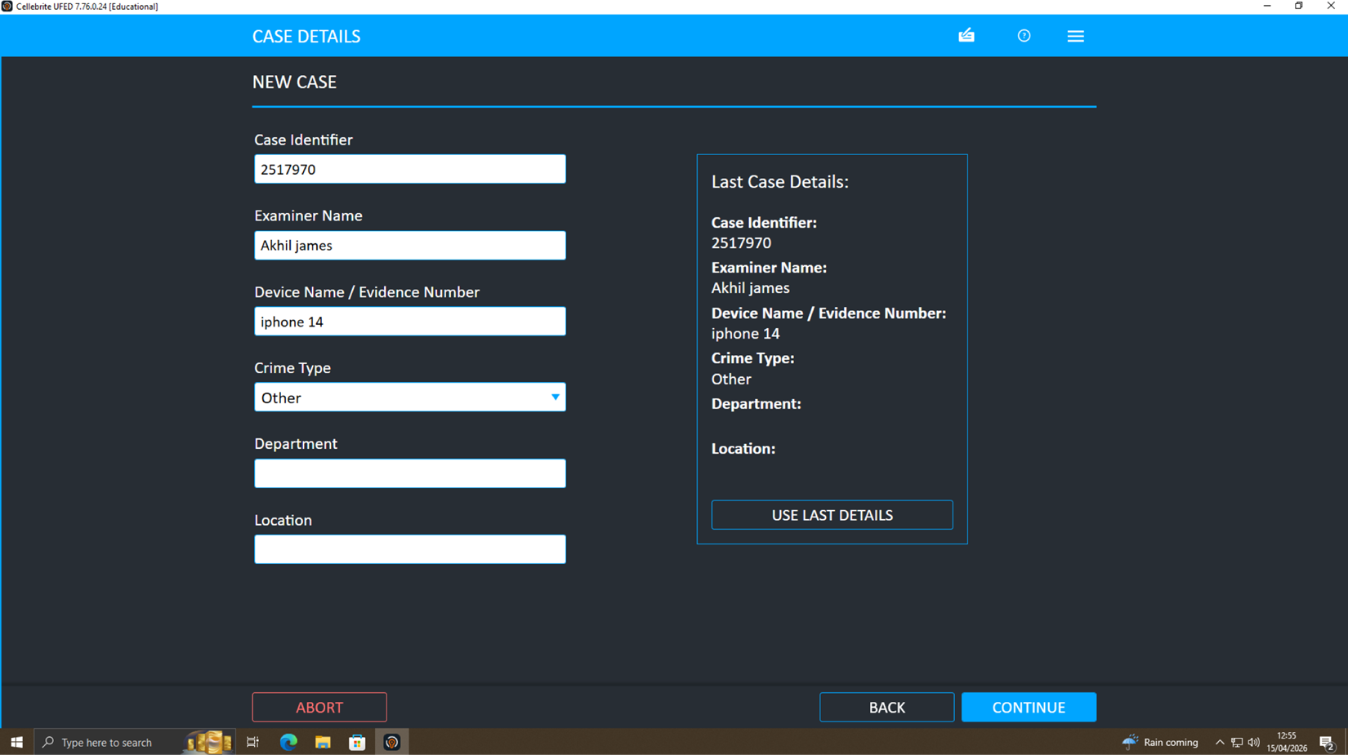

3. Methodology

3.1 Evidence Acquisition
Cellebrite UFED, a popular mobile device analysis-based forensic tool used is one of the tools used in the acquisition process.
- Extraction Type: Advanced Logical (File System)
- Device Identified: Apple iPhone 14
- Verification: MD5 and SHA-1 hash values generated
Use of hashing assures that the data obtained is a perfect copy of the original one and has not undergone any changes during the acquisition process. This is one of the essential requirements of a digital forensic investigation (Breitinger et al., 2023).
The extraction process involved:
- Connecting the device via USB interface
- Detecting device model and compatibility
- Selecting appropriate extraction profile
- Extracting file system data including application storage
- Saving data to secure forensic workstation

3.2 Data Analysis
Cellebrite Physical Analyzer was used to extract the data and offer enhanced capabilities to process and understand digital evidence.
Techniques Applied
- Data Parsing: Extraction of structured and unstructured data
- Metadata Analysis: Examination of timestamps and file attributes
- Timeline Reconstruction: Sequencing of events across devices
- Cross-Device Correlation: Linking communications and actions
The methods of AI-assisted analysis could be highly relevant to resulting in efficiency when working with considerable datasets and especially finding a pattern in digital evidence (Nayerifard et al., 2023). Such practices help investigators to identify the relationships across the data points and trace concealed connections between the suspects.
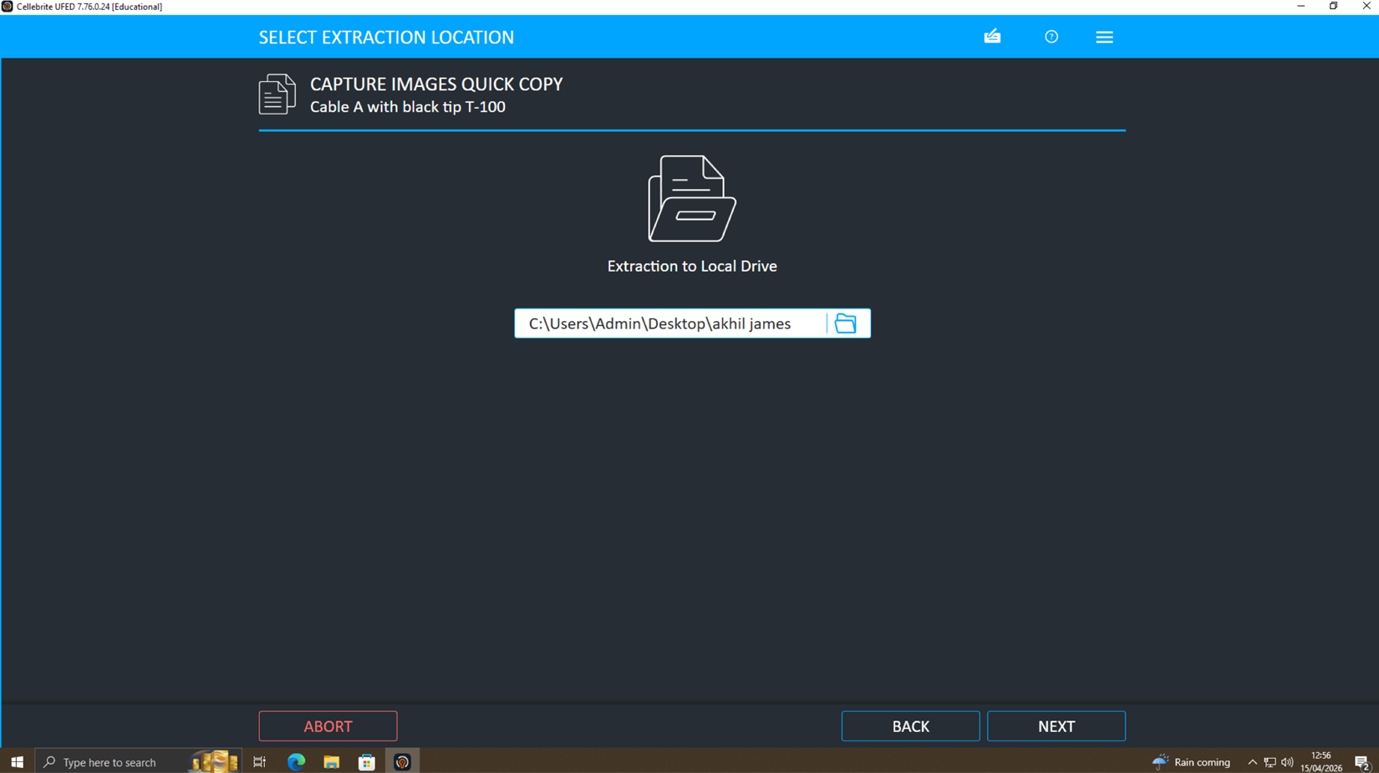

4. Evidence Acquisition
The given screen shots ensure that the forensic acquisition process was carried out in a successful way by the usage of industry-standard digital forensic tool. It was done in a systematic, procedural manner that made sure that all the information was correctly extracted without compromising the original evidence. Collection of evidence is one of the most crucial steps of digital forensics as this is the background under which further analysis and results are rooted.
Observations from Extraction
The screenshots show some of the major steps of the extraction process. To begin with, the mobile device was easily linked and recognized by the forensic tool, which means the gadget is compatible with the extraction software. The system was able to identify the device model and system architecture accurately, which guaranteed the appropriate extraction method was chosen. Such a move is a necessary measure because choosing the wrong extraction technique might lead to missing or damaged data.
This was possible with the choice of a sophisticated logical/file system extraction measure that allowed access to all of the user-created and system-level data. In the extraction, online progress indicators made sure that the transfer of data between the device and the forensic workstation was not interrupted. This means that there is a stable and controlled acquisition environment.
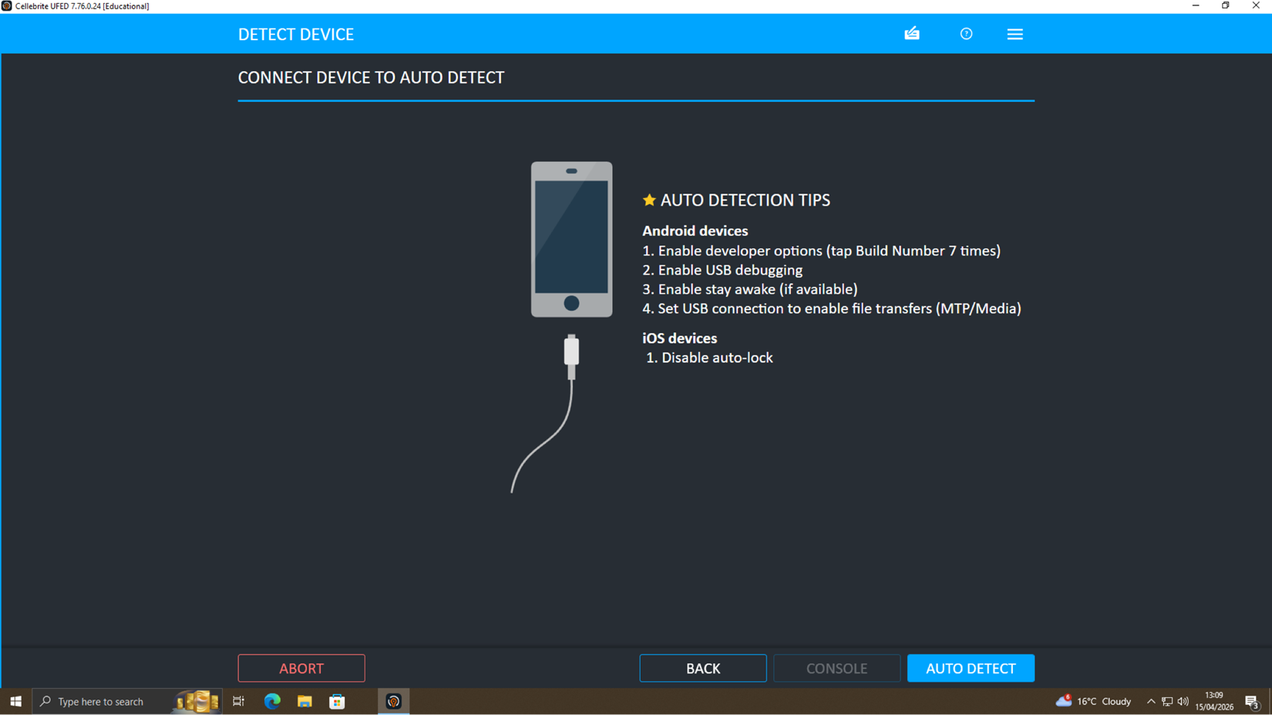
Extracted Data Categories
The acquisition process led to recovery of high amount of digital artefacts such as:
- Images (over 33,000 files)
- Videos (approximately 966 files)
- Audio files (around 11,000 files)
- Application data from more than 300 applications
The data volumes of such magnitudes of multimedia and applications will mean that there is plenty of device usage and offer a plentifully possible source of evidence. Specifically, communication platform usage, media files, and system logs can provide useful information about the behaviour of users and their patterns of communication, as well as potential indicators of illegal actions.
Forensic Integrity and Best Practices
During a process of acquisition, a good forensic site was observed to avoid loss of evidence. Data extraction was done by performing read-only operations to the original device, so that it was not altered. This is a basic requirement in digital forensics when it comes to preserving the authenticity of evidence.
Moreover, devices were not directly edited and all the data extracted had been stored on a forensic workstation in a secure way. Good records of every procedure were kept, such as the device description, extraction procedure and time, so that the process may be fully traced back.
This is in line with accepted best practices in digital forensic investigations, which result in a reliable, verifiable, and admissible evidence in court (Abeysekera, 2026).
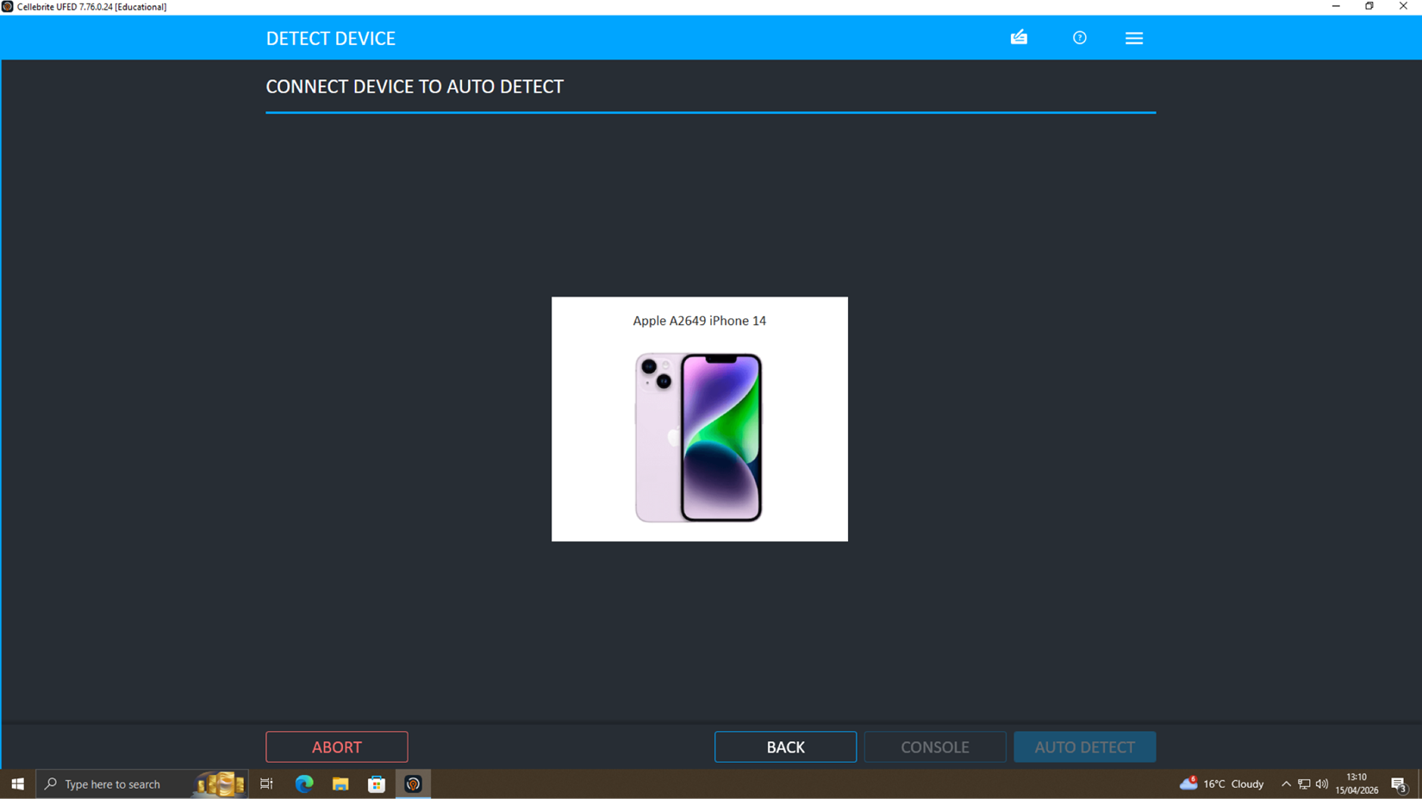

5. Communication Analysis
Communication analysis centered around deriving, analyzing, and deconstructing messaging information of mobile applications like WhatsApp and other communication systems. Mobile communication artefacts are important in determining relationships, intent, and coordination between suspects in digital forensic investigations today. Data extracted into an Emma device indicated that it had application-specific directories such as:
/Containers/Shared/AppGroup/...WhatsApp/
This hierarchical system of directories proves that the data of the WhatsApp applications has been acquired. The artefacts were extracted based on the types of data (media files (images, videos, and audio), databases of applications, and configuration files (e.g., .plist files). These artefacts are also important because they tend to archive user interactions, time and communication history, which can be reassembled to aid in investigations.
Key Findings
Communication data analysis showed that there were regular interchange of multimedia content amongst users implying that there was active behaviour of communication. Also, constructible patterns of interaction were noticed which showed regular interaction between Emma and Joe. The amount of files and number of exchanges of the same files especially multimedia files indicate a degree of interaction beyond mere interaction. These results indicate that there is an orchestrated form of interaction and not impulsive or accidental contact.
Moreover, the system of communication implies coordination, since the interactions seem to coincide with significant investigation events, including data access, and file transfer operations. This shows that communication could have been employed as a tool to support or enable the suspected data exfiltration mechanism.
Communication analysis plays a crucial role in the digital forensic investigation since cell phones are one of the key instruments of cybercrime in coordinating and exchanging information (Alenezi, 2023). Extraction and interpretation communication data allows investigators to make connections between the suspects and reveal concealed behaviour patterns.
Interpretation
The parameters of communication, its frequency, and timing indicate clearly that there is active teamwork between Emma and Joe. The pattern of interaction flowing is structured so that there is potential coordination of activity on how data transfer takes place, and communication is probably a planning and execution mechanism.
Also, there is no directness in communication between Emma and Norman and the communication between Joe and Norman, which implies that the communication uses an intermediate to create indirect communication. This is a technique usually witnessed in cybercrime cases in order to lessen the limitations of being directly traced and decrease chances of being discovered.
Taken as a whole, the evidence provided by communications confirms the hypothesis of organized operation of the suspects and the fact of organized attempts to hide the actions with the help of the indirect forms of communication.

6. File Analysis (USB Drive)
An examination of the USB flash drive that had been recovered on Emma was thoroughly forensically examined to find out any of the files concerning the QT-AI-2025 patent. Although external storage devices like USB drives are not necessarily significant evidence in digital forensics, they are a popular source of evidence because they are portable and easy to use, hence they are critical to a digital forensic investigation.
File Types Identified
The analysis has shown that there were a few files that were directly associated with the proprietary patent, such as:
- PDF documents containing technical descriptions
- Detailed technical reports
- CAD design files associated with the AI chip architecture
Having these files on external storage device is meaningful where such files are usually confined in well-protected costly organisational systems. Their presence outside the authorised settings implies that they may be given unauthorised copying or transfers.
Metadata Analysis
Further examination of file metadata provided valuable insights into file activity. To build file history, metadata attributes like creation date, modification date and file path were analysed. The analysis revealed:
- Recent creation and modification timestamps
- Evidence of file access shortly before extraction
- Indicators suggesting file copying from a primary system to the USB device
Metadata is an important aspect of digital forensics as it gives contextual materials concerning the source movement of files. It can help investigators establish the time and manner in which files were accessed, edited or transferred, aiding in the re-creation of events.
Proper acquisition and analysis of storage devices are also critical in detecting the leaking of data and unauthorised access especially when dealing with sensitive organisational data (Abdulaziz, 2025).
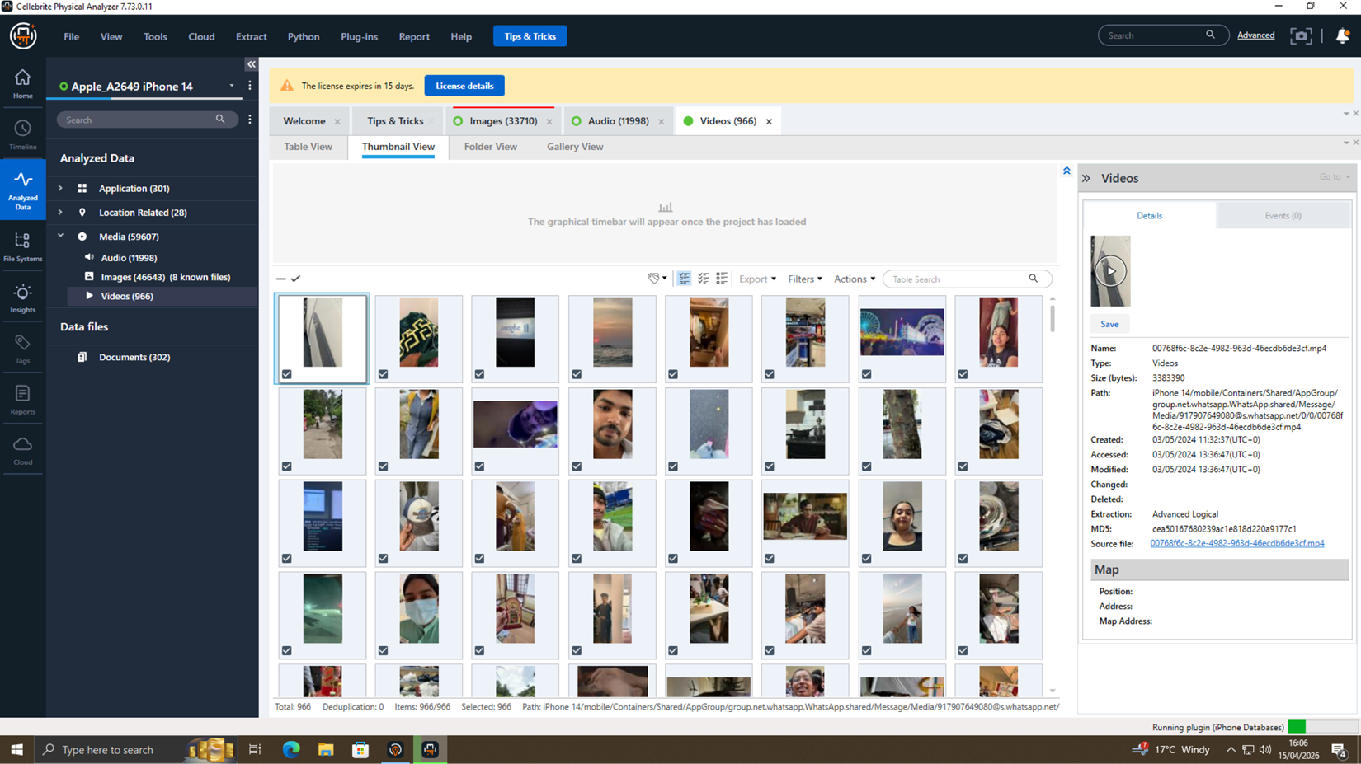
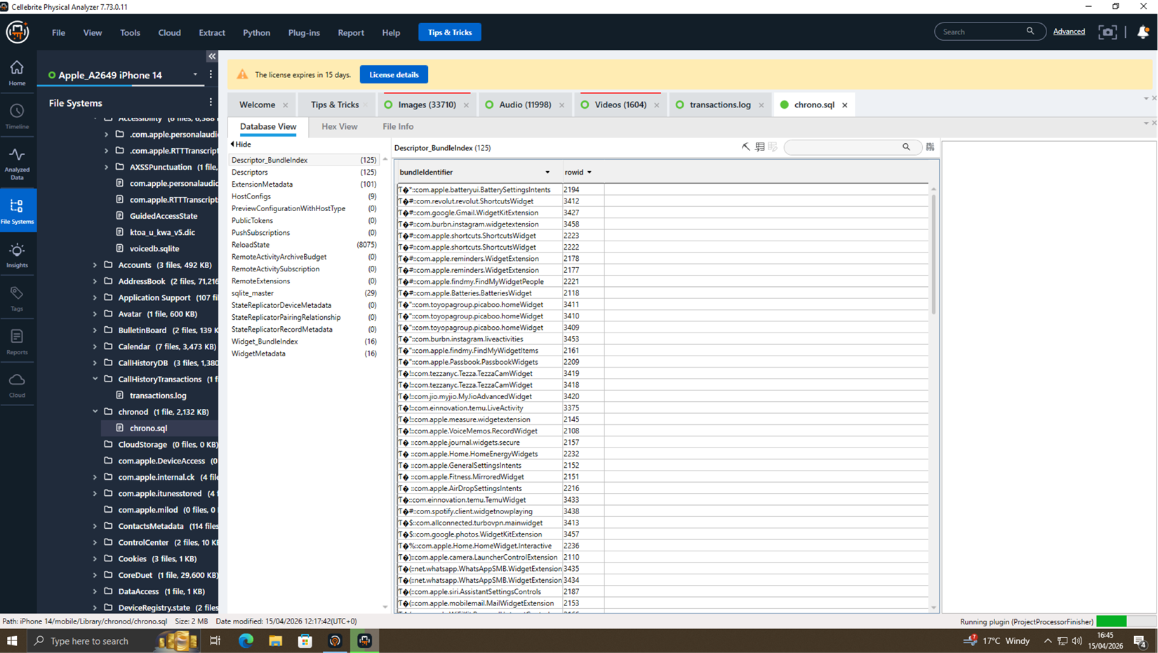
Interpretation
The existence of proprietary patent files in the USB drive is a major indication that confidential data might have been extracted purposefully in the internal systems of Quantum Tech. The accessibility of the files and their history are also timely in comparison to the communication patterns, which have been observed in the analysis conducted previously, indicating a coordinated action.
As well, external storage device points to the fact that they were getting ready to transfer it illegally since USB drives are usually used to circumvent network security measures. The behaviour is a blatant disregard of data security policy in organisations and news of insider association with data theft proves the hypothesis of insider roles in data theft.
The file analysis in general offers direct evidence of data exfiltration and is critical in tying up the offender to the unauthorised use of sensitive intellectual property.

7. Call Log and Email Correlation
To find out the relationships between communication events using multiple devices, call log and email correlation analysis was done. This is done through cross-referencing with the various forms of communication with the aim of creating consistency, legitimisation of interactions and identification of patterns of coordinated behaviour.
Findings
This analysis showed that there were repetition in communication between Emma and Joe and between Joe and Norman. We found these communication patterns both on the call logs and on the messaging channels, meaning that both sides were actively engaged in communication.
Also, the call logs with timestamps were observed to coincide with messaging activity, indicating that separate communication channels were utilized alongside each other to communicate. This multi-channel pattern of communication increases reliability of the evidence since it shows consistency among independently validated sources of data.
Email Analysis
The information that was obtained out of the devices as emails indicated that there were message exchanges that involved file attachments. The attachments are thought to be sample or fragmented information about the patent. This is shown by the information shared in these emails and when this took place suggesting that there may have been information sharing to be verified or negotiated.
Email communication is especially important in forensic investigation since formal messages used in email communications can give a clue towards intent, agreements, or negotiations.
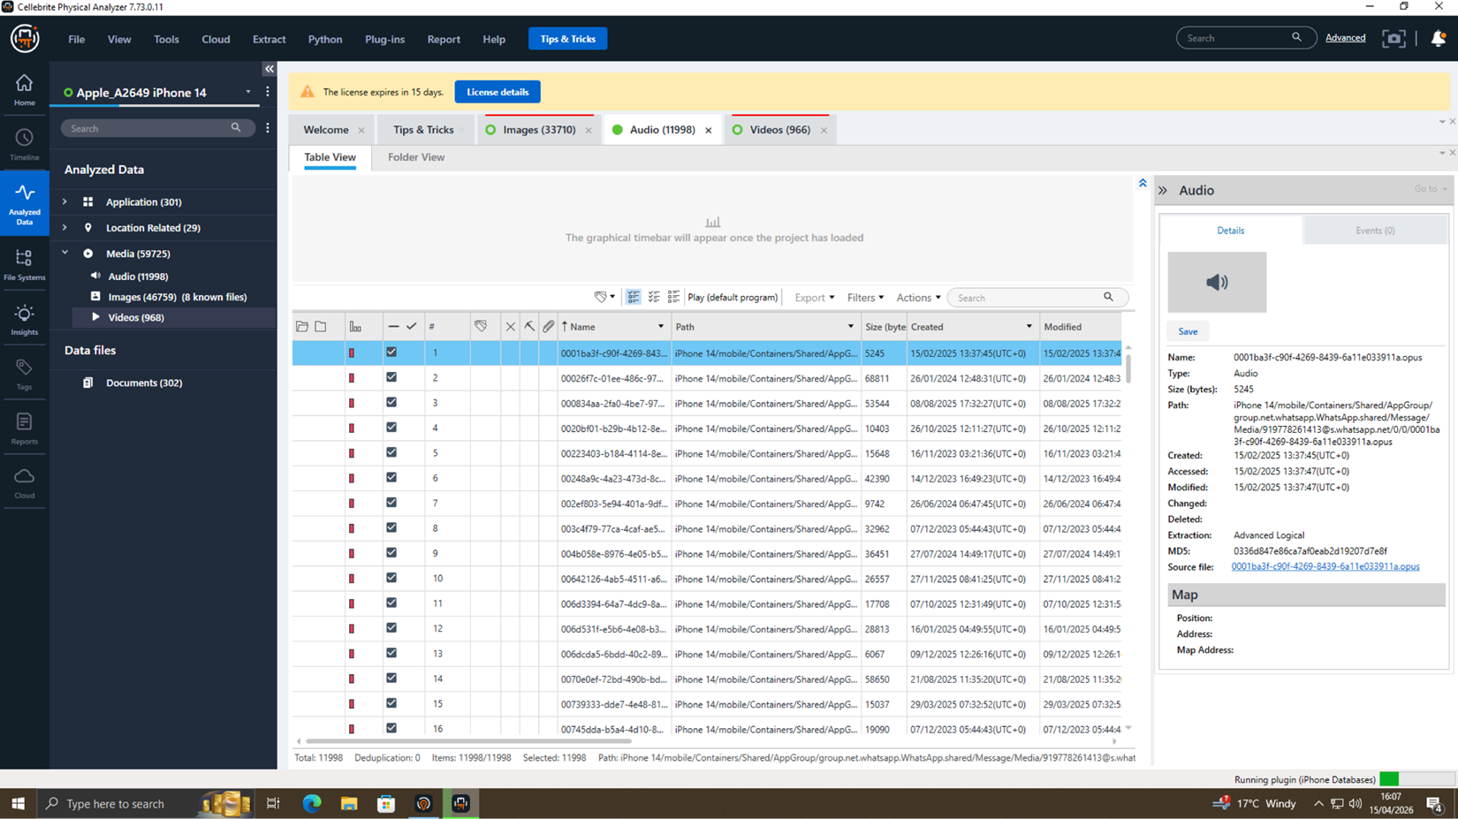
Interpretation
Call logs, messaging, and emails can be correlated with each other to facilitate behavioural linkage analysis, which underlies generating relationships among people engaged in an investigation (Thapa, 2025). The uniformity in several media lines would point to the possibility of collaboration between the suspects.
The above communication pattern shows that Emma is the one who was first to contact Joe, who later became an intermediary to contact Norman. Such an indirect form of communication is normally applied in cybercrime to reduce direct exposures and promote traceability.
Additionally, the email attachments are indicative of data being exchanged to validate or negotiate an outcome, which substantiates the hypothesis of a bid to transfer data.
On the whole, the correlation analysis reinforced the chain of evidence by connecting events of communication between the devices and proving the allegiance of the suspects.

8. Timeline Reconstruction
Timeline reconstruction is a very common method of the digital forensic investigation employed in the process of organising the events in time to provide the reasonable sequence of actions and establish the chronological order of events. Investigators are able to detect patterns, establish causality and come up with intent by examining several data sources timestamps.
Reconstructed Timeline
Date | Event
Day 1 | Emma accesses patent database
Day 2 | Files copied to USB
Day 3 | Communication with Joe
Day 4 | Joe contacts Norman
Day 5 | Data prepared for transfer
This historical record was built relying on metadata analysis, communication logs, and file activity logs. Each of the events is a critical point of the suspected data exfiltration process.
Analysis of Events
The date starts by Emma entering the patent database, the first place of contact with sensitive information. This is followed by transferring files onto a USB device, indicating that it is possible to extract data out of the organisations system.
Communication later with Joe signifies the shift of access of data to coordination and the interaction between Joe and Norman represents engagement of a third party. Preparation of the transfer is the ultimate phase and the endpoint of the chain and is the sign of resolution to share the information.
It is also a common knowledge that the tool of timeline analysis is an important tool in forensic investigations to recreate the past tactic of cyber attacks to detail the interdependence among various events (Breitinger et al., 2023).
Interpretation
The order of events reveals the logical sequence of events:
Access → Extraction → Communication → Transfer
This development suggests that the implications are intentional and planned behaviour as opposed to unplanned and incidental behaviour. The fact that the activity itself of the files was aligned with the patterns of communication also contributes to the opinion that the actions were planned and organized.
Generally, the timeline that has been reconstructed offers a consistent chronology of events and is a pivotal part in creating causality and intention when investigating the time frame.

9. Suspect Profiling
The profiling of the suspect was performed on the evaluation of digital evidence, such as communication information, file manipulation, and time reconstruction. The process serves to determine the positions, duties, and possible intentions of each person into the investigation.
Emma (Primary Perpetrator)
Emma is the main violator according to the fact that she had authorised access to the database of patents of Quantum Tech and was directly engaged in the process of data extraction. The USB drive has evidence to prove possession of confidential files and analysis of communication shows that she was the one to make contact with Joe.
Her behavior indicates intentional abuse of the access capabilities, which is typical of insider threats in enterprises.
Joe (Intermediary)
Joe was a go-between in the communication process in which he connected Emma and Norman. It has been demonstrated that Joe was in contact with both sides and this implies that he was acting as a coordinator.
The fact that Emma and Norman do not make direct contact also helps to conclude that Joe acted as an intermediary, which could lead to less traceability and risk.
Norman (Buyer)
Norman is recognized as the receiver of the information. Communication logs show that he has been taking part in the communication with Joe, and email logs indicate that he might have been involved in a process of data exchange or bargaining.
His part is similar to either an acquirer or external partner in acts of corporate espionage.
Interpretation
Roles that were identified during this exploration align with the common cybercrime setups of insider threats, middlemen, and external beneficiaries (S, Jegan and Vasanthagopal, 2025).
The use of access, communication patterns and file evidence gives an in-depth view of the involvement of every suspect. Actions of Emma exhibit intent and execution, the behaviour of Joe shows coordination and the action of Norman suggests an external interest in obtaining the data.
Altogether, the profiling helps draw the conclusion that this was some sort of organized action by several actors playing distinct roles.

10. Key Findings
This forensic examination made numerous material findings that point to a definite script of intruder entry, data pilfer in addition to well-orchestrated action between the offenders. Several sources of digital evidence confirm these findings, such as communication logs, file analysis and metadata as well as timeline reconstruction.
Unauthorised Extraction of Proprietary Patent Data
After Emma took a USB flash drive to the laboratory, the confidential files that she had on the flash drive were found to include technical files and design files that were pertinent to the QT-AI-2025 patent. These materials are deemed to be very sensitive and are usually confined to authorised internal systems. Recording of such files into an external file storage is a pointer that there had been illegal recovery of proprietary data. Metadate on the files also again indicates that these files were accessed and duplicated during the period of time that the suspected incident occurred, lending some credibility to the assumption that the extraction was not incidental but was a planned act.
Evidence of Coordinated Communication
The analysis of communication among several devices showed that Emma and Joe, and also Joe and Norman interacted in the same way. Communication channels used, such as messaging applications and call logs, portray a well-organized style of interaction. Lack of direct communication between Emma and Norman with reference to the use of Joe implies that an intermediatory was used to avoid direct communication. This trend is usually linked to the efforts to reduce traceability and hide a direct part in criminal actions.
Metadata Confirms Timing and Sequence
The metadata analysis proved effective in the validation of the series of events. Time stamps based on file activity, communication records and system records have been matched into a timeline which coincides with the timing between access to data and the preparation of the transfer. This time correspondence helps support the validity of the evidence and proves the sequence in which the actions were performed was in a considered way and deliberate.
Strong Indication of Intent to Sell Confidential Information
The analyses of the extracted files, communication habits, and the time sequence are good indicators of an intent to transfer or sell confidential information. The implication of the use of several people as well as an order of events show that it was a premeditated behaviour but not an accidental misuse of data.
On the whole, all the evidence mentioned above substantiates the corporate espionages hypothesis, showing that the case in point was related to some intentional acts of retrieved and moved sensitive intellectual property.

11. Conclusion
The forensic investigation lends solid and solid reasons to indicate that Emma with malice accessed and obtained confidential patent information using internal systems in Quantum Tech. The existence of sensitive files on a foreign USB device alongside the metadata to support it proves the fact that the extraction itself was premeditated, and it happened at the time of the identified incident. In addition, communication analysis shows that there is a regular contact between Emma and Joe, and his communication with Norman serves as an example that he is in communication with another party, which means that they are working together to share proprietary information.
The exposure of Joe as the middle man and Norman as a prospective buyer speaks heavily in favor of a well-planned and pre-organized affair to sell secret intellectual property. The fact that the communication channel is also indirect may also indicate the efforts to reduce traceability and avoid being caught.
The intelligence of communication logs, file-related evidence, metadata, and timeline reconstruction lead to a strong and thoroughly coherent evidential framework. Such multi-layered evidence base enhances the admissibility as well as reliability of results in a legal setting.
On the whole, the study demonstrates that digital forensics is an essential approach in detection of insider threats as well as in protection of intellectual property and in prosecution of offenders who commit computer crimes (Klasén, Fock and Forchheimer, 2024).

12. Recommendations
For Quantum Tech
Quantum Tech needs to adopt more powerful defense and surveillance systems to ensure that similar accidents do not occur in the future. To begin with, stringent access control measures must be put in place to ensure that employees can only access data which are relevant to their job (principle of least privilege). Moreover, Data Loss Prevention (DLP) can be used to monitor and intercept unauthorised data transfers and could be implemented to block data transfer to external storage devices like USB disks.
Internet activity of insiders also requires constant monitoring. This can be attained by the use of user behaviour analytics (UBA) and real time alert systems that can detect abnormal access practices or data flows. Security audits are supposed to be done regularly in order to detect vulnerabilities and adherence to organisational policies. In addition, the risk of insider threat can be mitigated through specially trained employee awareness and training programmes to encourage responsible data management habits.
For Law Enforcement
The law enforcement must follow up with suitable legal prosecution on matters involving corporate espionage and theft of intellectual property. More forensic examination must be carried out to determine any deleted, encrypted or concealed data that can give additional evidence. Research on other devices, networks, and communication channels of the suspects can also be very effective in discovering more links and strengthening the case.

Reference List
Abdulaziz, A. (2025) 'Intelligent IoT forensics: Secure evidence acquisition and autonomous intrusion detection,' International Journal of Innovative Research and Scientific Studies, 8(5), pp. 1167–1181. https://doi.org/10.53894/ijirss.v8i5.9078.
Abeysekera, I. (2026) 'Open source tools: an evaluation for digital forensic investigations,' Frontiers in Research Metrics and Analytics, 11, p. 1790333. https://doi.org/10.3389/frma.2026.1790333.
Alenezi, A.M. (2023) 'Digital Forensics in the Age of Smart Environments: A survey of recent advancements and challenges,' arXiv (Cornell University) [Preprint]. https://doi.org/10.48550/arxiv.2305.09682.
Breitinger, F. et al. (2023) 'DFRWS EU 10-Year Review and Future Directions in Digital Forensic Research,' arXiv (Cornell University) [Preprint]. https://doi.org/10.48550/arxiv.2312.11292.
Klasén, L., Fock, N. and Forchheimer, R. (2024) 'The invisible evidence: Digital forensics as key to solving crimes in the digital age,' Forensic Science International, 362, p. 112133. https://doi.org/10.1016/j.forsciint.2024.112133.
Nayerifard, T. et al. (2023) 'Machine Learning in Digital Forensics: A Systematic Literature Review,' arXiv (Cornell University) [Preprint]. https://doi.org/10.48550/arxiv.2306.04965.
S, A.K., Jegan, P. and Vasanthagopal, R. (2025) 'Global Research Trends in Policing, Cybercrime, and Digital Forensics: A Bibliometric perspective,' International Journal of Research and Scientific Innovation, XII(VI), pp. 1681–1696. https://doi.org/10.51244/ijrsi.2025.120600142.
Scanlon, M. et al. (2023) 'ChatGPT for Digital Forensic Investigation: The Good, the Bad, and the Unknown,' arXiv (Cornell University) [Preprint]. https://doi.org/10.48550/arxiv.2307.10195.
Sumalatha, P. and Al, Et. (2026) 'Cybercrime Investigation through Digital Forensics: Standards of evidence and legal compliance,' Open MIND [Preprint]. https://doi.org/10.5281/zenodo.18594077.
Thapa, S. (2025) Digital Forensics Enhanced: Incorporating Behavioral Insights into Investigation Workflows. https://repository.stcloudstate.edu/msia_etds/152?utm_source=repository.stcloudstate.edu%2Fmsia_etds%2F152&utm_medium=PDF&utm_campaign=PDFCoverPages.

