

Determining the perceptions of Gender Parity within the South Wales Police Force by Police Officers within South Wales Police Force.

Name of student: Esther Cole
Student number: 1816485
Degree title: Professional Policing

Acknowledgements
I would like to acknowledge the Police Officers who have completed the surveys and the Officers who participated in the interviews with me. Taking time out of their already very pressured and stressful day to enable me to complete my research.
I thank you.

Declaration
This work has not previously been accepted in substance for any degree and is not being concurrently submitted in candidature for any degree.
Signed: E. Cole
Date: 29/11/2021

STATEMENT 1
This dissertation is being submitted in partial fulfilment of the requirements for the degree of BA.
Signed: E. Cole
Date: 29/11/2021

STATEMENT 2
This dissertation is the result of my own independent work/investigation, except where otherwise stated.
Other sources are acknowledged by footnotes giving explicit references. A bibliography is appended.
Signed: E. Cole
Date: 29/11/2021

STATEMENT 3
I hereby give consent for my dissertation, if accepted, to be available for photocopying and for interlibrary loan, and for the title and summary to be made available to outside organisations.
Signed: E. Cole
Date: 29/11/2021

STATEMENT 4
I hereby give consent for my dissertation, if accepted, to be available on the university’s IT system to those who have consent to use the system.
Signed: E. Cole
Date: 29/11/2021

Abstract

Gender Parity is an important element of Gender Equality and has attracted significant research about it being a reality, its historic formation, the culture that maintains it, the difficulty to break out of it, its impact on women and the moral imperative for change. But there is less research about what women feel and their strength of feeling about Gender Parity particularly in the Police Force.
This mixed method study sought to identify what were the perceptions of Gender Parity within the South Wales Police Force by Officers within the South Wales Police. Four semi structured interviews were conducted with limited stratification of equal numbers of male and female with ranks of below sergeant and sergeant and above.
The email survey conducted by an formal online agent, had a sample of 103 randomly selected participants in two stations in a region of South Wales Police. The only criteria for those surveyed was to be a Police Officer. In the analysis regressional analysis was not conducted as this was primary data. The results demonstrated a significant lack of understanding of the definition of both Gender Parity and Gender Equality, and the status of Gender Parity particularly in the Police Force. There was no little desire for change from both female and male Officers, and if change were to be initiated, there was strong feeling that it should not be at the cost of the role of Officer and through positive discrimination or forced quotas. However, there was strong desire to review support protocols for female Officers and faster responses to unwanted sexist comments and actions.

Table of Contents
Chapter one - Introduction page - 1
Chapter two – Literature Review page - 3
Chapter three – Methodology page - 11
Chapter four - Analysis of results page - 16
Chapter five – Findings page – 22
Chapter six - Conclusion and recommendations page - 27
Bibliography page - 29
Appendix page - 36

Chapter one – Introduction
The issues surrounding sex and GE are often in the press and the issues of gender have become serious political issues within the UK and the EU, having their own departments and attending officials. Those championing the cause of women and GP believe they speak for those negatively affected. This study investigated the perceptions of PO on GP within the SWP.

Drawing on ONS data with other Governmental reports, and academic research, the gap in what the Officers felt, and how strongly they felt about GP, within the force, was measured. Four face to face interviews were held, with both female and male Officers, and lower and higher ranking Officers within the SWP. The semistructured interviews were informed by the literature review. The interviews provided additional insight into the values and strength of feeling so as to inform an electronic questionnaire survey. The survey was anonymised, and covered random chosen stations within an region within the SWP force. The questions covered their current knowledge of GP and their knowledge of the easily available statistics regarding GP within the Police Force, their desire for change, and the desire for GP, and asked what priority should any change or GP be given. The survey also offered possible suggestions as to how GP may be achieved, and sought their views on those suggestions, and also sought original ideas from the participants as to what changes they thought would be needed to achieve GP. The survey investigated their personal experiences when becoming a PO, and their time as a PO within SWP with regard to GP, including the policies and initiatives of SWP and their co-workers.

103 surveys were sent and 40 responded within the timeframe;- 26 males and 14 females which is the same ratio as the males and females within the survey population. The respondents understanding of the meaning of GP and the actual status of GP within the Police Force was not very high, 60% and 50% respectively. Their initial desire generally was for no change, but that, if there were to be increases in GP, it had to be within certain constraints saying, that it should take as long as it takes to ensure the safety of the Officers and public, and that there should be no forced quotas, with no lowering of standards and without positive discrimination. There was a major lack of their own ideas as to how GP maybe achieved, and the interviews also revealed a lack of structure in their understanding as to who was responsible for achieving GP.

The respondents, both male and female, supported some of the suggested ideas for protecting and supporting female staff in order to increase the retention figures. However the majority did not feel affected by any GP policies, from recruitment through to their experience as a PO. The role of rank did not appear to play a significant role in their perceptions, though with a higher rank came a moderately increased understanding of the facts of GP. The data indicates that GP is not an issue of critical importance to male or female Officers in the SWP.

Chapter two - Literature Review
It is important to understand commonly used terms from the whole framework of equality that are employed in this study. Gender Equality (GE) is an overarching term that covers a range of factors regarding gender. The Cambridge Dictionary (2021), defines and explains GE as not meaning that “men and women are the same, but that they have equal value and should be accorded equal treatment”.
The concepts of equal value and equal treatment impact all elements of life. This is seen in the European Union’s Gender Equality Index (GEI). This index has six core areas: work, money, knowledge, time, power and health; and two additional areas: violence against women and intersecting inequalities (European Institute for Gender Equality, 2020).

There are many different indicators used to measure these eight areas in arriving at a GEI score. Gender Parity (GP) is a concept indicator which can be applied to various factors regarding men and women. The European Institute for Gender Equality (2021) explains GP as relative equality in terms of numbers and proportions of women and men, girls and boys, and is often calculated as the ratio of female-to-male for a given indicator.

This is the same understanding used by the United Nations Educational, Scientific and Cultural Organisation (UNESCO, 2021), and is seen as a numerical concept. GP in education would imply the same proportion of boys and girls – relative to their respective age groups – entering the education system and participating in its different cycles.

This study focuses on GP and not GE. Further, it is focused particularly on the GP of men and women who work in the South Wales Police force. But there are other elements that are associated with this index that will also have a significant impact, such as the relationships between rank/promotion and gender, age and gender, disability and gender, ethnicity and gender, length of service and gender, complaints (sexual harassment and gender), work rotations/job allocations and gender, and pay and gender. However, it is not possible to meaningfully research all of these associated elements within this study, therefore the focus is on the numerical indices of GP.

GP by its definition is understood as a 50/50 ratio of men and women. There is evidence showing that the number of women working in the UK has been rising and continues to rise. The data for those employed as of April 2020 was 80.1% for men, this being 0.2% down on the year before and 0.4% down on the previous quarter. Whereas the employment data for women was 72.7%. This was up 0.7% on the year before and up 0.2% on the previous quarter (Office for National Statistics, 2020).

This suggests that employment rates are moving towards parity, and whereas the data for men shows a decrease on the year and a continuing downwards direction in the last quarter, the opposite is shown for women, with an increase on the year and in the last quarter. Whilst the effects of the Covid pandemic present challenges to the data (this being acknowledged by the government in the report), the report also acknowledges that these difficulties would apply to both men and women. This data and continuing trends are good indicators that GP is still a goal that has the commitment of both the government and society. It is also worth noting, to add a global perspective, that women have become the majority of the American workforce for the first time ever, at 50.4% (Time, 2020).

This news may be welcome, however, the British Broadcasting Corporation (BBC) has discussed the Fawcett Society’s (FS) who are a large charity campaigning for women’s rights in the work place, report on the affects of Covid and GE in November 2020. The BBC used quite emotive words: “The pandemic has had devastating impact on GE in the workplace but there are signs of hope” (BBC, 2020).

The FS report also stated that women were experiencing growing discrimination at work, part of which included more redundancies of women compared with men. The FS calls upon the government for action regarding these redundancies. The significance of this report is the FS’s determination for GP, and their requirement that the government produce legislation to make all jobs optional for flexible and part-time working. These requests and demands from the FS have not been implemented and therefore these ‘hopes' have not, as yet, materialised (Fawcett Society, 2020).

And yet the actual data from the Office for National statistics (ONS) records growth in women working and reductions in men working, which is contrary to the findings from the FS. However, the very latest figures suggest that more women were furloughed than men in the pandemic (Office for National Statistics, 2021).

The question is: are the arguments presented for GP within the workforce not actually about GP, but rather are enmeshed with the many other elements of GE, which could be the actual goal, both for the government and agencies like the FS.

The UK Government’s GE report (2019) states that the full-time Gender Pay Gap (GPG) is decreasing, but is still at 8.6%, though it is actually in favour of women at 4.4% for part-time working. However, while the number of women in employment has increased, the government seeks to make that full-time employment rather than part-time employment, as this is a key driver of the GPG and limited wage progression for women. Statistics show that women are three times more likely to work part-time than are men (HM Government, 2019).

However, part-time working is seen as a significant positive effector of change in increasing women in work, including in the Police force (Silvestri, 2014). A part-time working increase has also been called for by the FS’s report in 2018 and it continues to be called for in the FS’s 2020 report in their efforts to obtain GP in the workforce.
Clearly, much has been achieved in getting women into work, and following on from that, into other indices regarding more senior roles and equal pay, but the research appears conflicting. Part-time working is reported as effective for GP (Silvestri, 2014) and at improving career progression, but, at the same time, part-time working is reported as an inhibitor of GP, and to career progression (UK Government’s GE report, 2019). So the evidence remains mixed.

The underlying structure of the organisation, and indeed society, may well have impact on the effectiveness of the implementation of part-time working. Dick (2009) identifies the negative effects of moving from full-time to part-time working within the Police. Her research discusses the importance of the application of part-time working and comments that while it may well be beneficial for retaining women Police Officers in the organisation, it creates other difficulties; for example, it has often led to women Police Officers not working night shifts, and this has negatively affected working relationships with full-time Police Os that have to cover additional night shifts. A difficulty of implementing part-time working can be seen when the organisation desires and the individual desires are not aligned and this has significant consequences on the effectiveness of part-time working.

Having a non-structured approach to the application of part-time working tended to deliver negative affects for both parties. However, developing a structure for the implementation of part-time working is not simple. The idea that both employees’ and employers’ interests can be integrated into one view does not fully grasp the reality of the different needs of employees and employers (Dick, 2009). Clearly the mechanisms and motives for implementation of part-time working will impact on its efficacy and perhaps can help explain some of the contradictions in the research highlighted above.
As noted already, GP in work has made significant improvements but it is claimed to be improving too slowly, and the GEI stated that things were improving at “a snail’s pace” (European Institute for Gender Equality, 2017).

Because of this apparent slow improvement to GP, action has been called for in the form of targets and quotas. This is not favoured by the government, which would prefer the participation of business and public bodies in a voluntary and progressive manner, whilst understanding the benefit of GP on their business (Gender equality at every stage: a roadmap for change, 2019). The government wants GP to be achieved at a pace that any organisation can successfully maintain. The government, in its report Gender equality at every stage: a roadmap for change (2019), does not take the position that it knows how to run every business better than those who actually run it. However, the government sees the need to provide education and research to substantiate its position to business and public bodies in order to facilitate GP within the workforce. The government states they will also provide the structure and incentives and political pressure to overcome any inertia. The position of the government is made plain in the document by the use of words such as “promote” and “support”: the legislative components focus on enabling GP, not enforcing it (HM Government, 2019).

Other research takes a different stance; for example, the FS (2020) report looks not so much at whether these actions by the government would work, but rather at the length of time that it would take to achieve the objectives. The issue is one of patience or moral obligation to women and the right of GP, and they call upon the Government for direct action, that is, to legislate for quotas and targets, claiming there is a strong case for this recourse (Fawcett Society, 2020).

The FS is a large feminist organisation and public champion of women’s rights, but the issue of GP is more complex than the argument presented in their report (2020). Part of their argument claims that women are still experiencing discrimination and harassment simply due to their gender. There are already laws governing and prohibiting such treatment against women but having the law to prohibit or control such discrimination, as reported by their own research, does not necessarily make it so. Making more laws for targets and quotas may not have the desired effect, because laws by themselves do not offer guarantees, as is seen in the continuing discrimination and harassment of women.

It is not just research from the FS that calls for quotas and targets. The Organisation for Economic Co-operation and Development (OECD) supports the use of quotas and discusses the significant progress in GP seen as a result in Belgium. In 1999, 25% of Chamber of Representatives were women; in 2014 this was 41%. In the same year, 50% of the Senate were women (Organisation for Economic Co-operation and Development, 2015).

Germany has been using quotas for women on corporate boards since 2020, and now France has introduced quotas on board executives (Forbes, 2021). Norway has been a leader in the use of quotas to support GP, legislating for 40% of board members in Public firms and bodies to be women (The Conversation, 2015).
Reuters also comments on Norway’s success in its application of quotas in an interview with Olaug Svarva, managing director of Folkertrygdfondet, a state-owned investment management company in Norway (2015).

In certain contexts, quotas have been a success, in that the law was obeyed and the applicable quotas have been achieved. However, that would be an over simplified view of success. Despite these particular success, with other countries following suit, and major companies and banks also engaging in this process, there is data showing it was not such a success in reality. The Federalist (2018) investigated (some ten years after the Nordic legislation) as to whether the profitability of those companies was better, as promised by advocates of GP. Some were better, some worse – the data was inconclusive. The substance and quality of the decisions of those companies did not always improve as promised. In the shortage of qualified women for the positions, less qualified and less experienced women were employed and this did not help corporate performance or governance.

The number of public limited companies (those covered by the legislation) fell from 452 in 2008, to only 257 in 2013. The number of board seats dropped from 2,366 in 2008, to only 1,423 in 2013, and so with fewer public companies with executive boards, there were actually far fewer board seats for women to fill, thanks to the reduction of board seats in total. Further, the promised benefits of women in leadership positions translating into more career opportunities and promotions for women, at lower levels within the organisation, did not materialise. There was no flow of women moving up the ranks in these organisations from the lower levels (The Federalist, 2018).

The Washington Post (2019) also comments on the results that followed the mandatory quotas on public organisations in Norway, as California was considering following suit in 2018. With approximately 14 years of data, they report that the value of the companies dropped as less experienced female directors were added. The quotas led to less experienced boards, increases in leverage and acquisitions and deterioration in operating performance consistent with less capable boards. However, California was still considering the possibility of mandatory quotas, hoping to learn from Norway’s mistakes.

Encouraging those companies, rather than forcing those companies, may well have removed the significant negative repercussions of forcing women quotas onto the boards. The ability to train and prepare those from this underrepresented group for senior executive positions requires time. Allowing and supporting the companies to move slower reduces the companies’ need to dissolve, or to cease being a public organisation, as this results in reducing the positions possible for women to fill. This would improve the performance of the companies, which would significantly and positively influence other organisations, even those not under the legislative requirements to place women on their boards, even for purely fiscal reasons.

Obtaining parity is a complex process, and the support and initiatives that are needed to facilitate GP are also complex and cut across government, business and society. The Police Workforce report (Home Office, 2020) identifies a 1% increase of women overall since the previous report in 2018 in the Police. However, Police forces appear to be making real progress with their initiatives. During the year March 2019 to March 2020, 48% of new POs were female, this fact being somewhat obscured by the 1% overall increase (Home Office, 2020).

Projections of complete GP within the UK are dismal, according to the FS, who predict that with the current trends and efforts it will take generations to achieve (Fawcett Society, 2020).

While “generations” is a vague term, it is considerably longer than Brown and Woolfenden’s aim of GP by 2029 for the Police in England and Wales, with the current recruitment and wastage trends. They predicted 35% by 2020, which was 3% adrift, and this margin of error may continue through to 2029, but it is still considerably more optimistic than “generations” away (Brown and Woolfenden, 2011, p. 356).However, while this data provides insight into the progression of GP and into its complexity, there is a gap in the research data regarding the perceptions and strength of feeling of POs regarding GP within the Police force. There is one article by Cunningham and Ramshaw (2019) with tentative links to actual individual perceptions of GP, in which they reviewed the actual lives and stories of 23 female POs. The focus of the research was on policing practice, but it did try to interpret the POs' experiences as to how they felt about their experiences in relation to GE (p. 34-35).

So, while it has been shown that there have been investigations into GP, there does appear to be an absence of research on a more individual level. What does the individual know about GP, are they aware of what is being implemented, whether they want these interventions, whether they think they are good or bad and how strongly they perceive the issue of GP and the current changes towards it? Without this information, researchers can describe what they believe to be good or unfair practices, campaigners can call for changes, and governments can take action, but they will do so without an in-depth appreciation of how the individuals involved feel, if they see the need for or even want these changes, or how strongly they feel about such situations

Chapter three – Methodology
This chapter describes the design and selection of the mixed-methods research methodology used in this dissertation to determine the perceptions of Gender Parity within the South Wales Police Force by its Police Officers. This will include a discussion of the philosophical rational of the selected research methods. The latter part of the chapter will also describe the data collection strategy and ethical considerations regarding the participants.

Mixed methods
The question has been asked of whether mixed methods – research combining quantitative and qualitative methodology – can be used to investigate subjects who hold simultaneously contrasting, even competing, assumptions about what matters in human action (Greene, 2008). Greene concludes they can, with associated benefits. Other researchers also agree with the premise that mixed methods do not have to be fundamental opposites but can be combined. While acknowledging the clear differences between the two paradigms, the justification for using mixed-methods research stems from its pragmatic philosophical position, which gives a better understanding of social realities by using both qualitative and quantitative methods (Haq, 2014).

Qualitative research method
Women can potentially be a marginalised group. Women’s experiences can be framed around their gender, sexism and the intersection of other gender equality. Qualitative methods provide an opportunity to explore how women perceive their place in their work reality and the intensity of those feelings, whether any support programs offered are beneficial for the participants in this study, and the perceived benefits for the larger population under consideration.

When looking for an explanation of a phenomenon by relying on only the perception of a person’s experience in any situation, a qualitative study is applicable (Stake, 2010). Qualitative research in this dissertation will provide space for the participants to express their perceptions and experiences of gender parity and its impact. While it may be thought that women are the focus for the research, the impact of gender parity on male Officers and their perceptions are also valid and important in understanding the current status and opportunities for the South Wales Police Force in its stated progress towards gender parity.

Method used
The qualitative study method used was grounded theory. Grounded theory is a research approach to gain an understanding of the perspective, or point of view, of those who have experience of the phenomenon being researched. It aims to generate a theory that is grounded in data and shaped by the views of participants, thereby moving beyond description and towards theoretical explanation of a process or phenomenon (Turner and Austin, 2021).

While grounded theory is thought of as supported by the constructivist paradigm, Charmaz (2006) believes that it has both constructivist inclinations and also somewhat challenging positivist inclinations. Charmaz describes the positivist position as concerned with addressing human experience and trying to investigate it with complete objectivity, while understanding a human’s perception is imperfect.The constructivist position values a view that comes from the human experience relative to their paradigm, influenced by society, culture, or other external influences (Charmaz, 2006).

Grounded theory is inductive and will be used in this research as it is suited to face-to-face interviews. It will enable the interviewees to explain what and how, from their experiences, they understand and perceive of gender parity within the South Wales Police. It will also enable their strength of feeling regarding their perceptions to be recorded. This primary data would provide particular insight for appropriate and valid questions in a questionnaire for a larger population sample.

Quantitative research method
Quantitative social research is about collecting numerical data and analysing it, using statistical methods to explain a phenomenon. Quantitative research ultimately assumes that there exists only one single reality about a social phenomenon which is insulated from any researcher effects (Muijs, 2010).

Quantitative research is used to find associations in a descriptive study or causality in experimental study. This data is generalised across groups of people or used to explain a particular phenomenon (LeTourneau University, 2021).

While quantitative methods are primarily concerned with numerical data, often, social phenomena (such as in education or health), do not naturally generate numerical data (Muijs, 2010). Social researchers mitigate these weaknesses by using a number of techniques, instruments or indirect variables, such as scales in questionnaires, that ask to rate a phenomenon from “strongly agree” to “strongly disagree” (Muijs, 2010).

Quantitative research will be used as it is well suited to the use of survey questionnaires that are to be sent out to a larger sample of the Police population. It will facilitate the expression and manipulation of the data from larger group participation and enable the wider collection of data in the short time-frame that is required to complete this study. Further, it can reduce the possible impact of the researcher on the data obtained.

Process
Four interviews will be undertaken by the researcher. Each interview is expected to take thirty to forty-five minutes. The interviews will be held in Police stations in an individual’s office or a pre-allocated interview room.

The participants will all be PO within the South Wales Police Force. Two stratification layers will qualify selection: the first is that two participants must be sergeant (or above), and two must be below the rank of sergeant. The second is that there must be a female and a male in each ranking.

The surveys will consist of a questionnaire of approximately twelve questions, around half of which will use a Likert scale, and there will be some multiple choice questions. The questionnaire should be able to be completed within three minutes to facilitate better response rates. The surveys will be emailed to each individual’s Police email address. The survey will be available online for ten days as this covers a full ‘work set’, inclusive of rest days. This will assist response rates for the survey, despite the highly pressured and busy work environment.

All qualifying staff from two randomly selected stations within a region of the South Wales Police Force will be emailed; this should total approximately 120 questionnaires. The criteria for the email is to be a PO. The length of service, rank, ethnicity or gender will not disqualify any participant. All participants will have given informed consent before participating in an interview, or before returning the questionnaires. There are no rewards offered for participation.

Data collection
The qualitative study will use face to face interviews with the participants. The interviews will be audio recorded electronically, and later transcribed. The interview will be semi-structured, with open-ended questions regarding what they understand about GP, and the differences between GE and GP. More probing questions will follow, with the intent to obtain data on their perceptions of their circumstances and their strength of feeling about the impact of GP on them. The data obtained will be categorised and coded for ideation and themes, and meanings behind the responses will be sought.

The quantitative study will use a structured survey. The questions will be formed from the primary data from the interviews and informed by the literature review. The sampling method will be simple sampling from randomly chosen stations within the South Wales Police. The data will be analysed by a formal online survey proprietor, with cross tabulating and filtering/modelling. Longitudinal analysis will not be possible as this will be primary benchmarking data.

Acknowledged Potential limitations and obstacles
The interviewer is a female PO and this may cause reactivity distortion from the interviewee, both in that she is female and an indirect focus of the study and that she is a PO and may also be seen to reflect the establishment. The interviewer will provide assurances in seeking to resolve any such reactivity.

The interview will be undertaken within the Police station, which may facilitate openness due to familiarity of surroundings, or it may cause inhibitions as to the reason for enquiry from others and the motive for the interview. The data, whilst being stored on Police servers and being exceptionally well protected, may nonetheless cause some apprehension due to the concern it could be viewed from within the organisation. The interviewer will provide assurances to minimise this possible worry.

The interviewer may bring their own paradigm and unconsciously impose this on the interview, therefore introducing researcher bias. The interviewer is very conscious of this possibility and will seek to remain open to the responses, as explained by the interviewee.

There could be participant bias, in that this may be an emotive issue for individuals that may have suffered because of the lack of GP or suffered from the efforts to obtain GP. This may cause overly defensive or aggressive responses. It may even cause barriers, protecting their real thoughts, as they maybe in direct opposition to the policies of the Police force. Their anonymity will be emphasised and the neutrality of the interviewer to attempt to limit this potential bias.

The number of interviewees is small, as is the comparative number of surveys being emailed. While efforts will be made to encourage a high response rate, low rates are normal in such online surveys. This would impact the confidence rates of the survey data. Other limitations will be the limited availability of time, both of the interviewer for undertaking the research, and of the participants of the interviews, which could affect the surveys numbers and participants who can be engaged. The design of the qualitative interviews and the uncomplicated survey is hoped to encourage high response rates.

Chapter four – Analysis of results
The survey questions were designed to investigate the perceptions of Police Officers (PO) regarding gender parity within the Police force, and the strength of feeling of the Officers have towards gender parity in the South Wales Police force (SWP).
This chapter will discuss the quality of the data and analyse it for trends and patterns, comparing the survey responses to the interviews.

Interviews
Only 4 interviews were undertaken due to the significant time constraints. The interviews were set at 40 minutes this may have negatively affected the amount of relevant data that could be obtained, but it was necessary due to the time constraints. The interviews were audio recorded and transcribed manually by the researcher, without the use of transcription software. The analysis of the interviews were also undertaken by the researcher without the aid of analysis software.

Whilst the researcher has significant experience of investigative interviewing, together with supporting skills, these skills can be counter intuitive for interviewing as a researcher. When interviewing to obtain information from a victim, an officer should support, sympathise and empathise. The Officer would be doing a disservice to the victim and the Police force by remaining aloof to the fear and pain of recounting, for instance, a violent and/or sexual assault. However, for a research interview, neutrality is important, otherwise the interview could become biased. As these research interviews were the first means of gathering data and influenced the subsequent survey, bias could weaken the data collected.

Reliability in qualitative interviews can be attained through a number of practical aspects of the process of interviewing, including the wording of the interview questions, establishing rapport with the interviewees, and considering the “power relationship” between the interviewer and the participant (Breakwell, 2000).

These practical elements can be optimally employed through the experience and attitude of the interviewer. The interviewer took great care when asking the questions to elicit the true feelings and knowledge of the participants about the research topic. Care was taken to ensure that the structured element of the interview was the same for each interviewee; however, they all could express their own personal reflections and take different routes when completing the interview.

During the interview there was a good rapport and the interviewees were comfortable and relaxed. Their body language was open and there was good eye contact. They were happy to give their opinions, even if they thought it was not a common view, and if a specific numerical response was required, they were not embarrassed when they did not have the correct answer. It was a discussion and not merely a question and answer session.

Regarding the power relationship between interviewer and interviewee, the interviewer being aware of the impact of this, sought to diminish its effect. Lincoln and Guba (1985) state that what is particularly relevant when discussing qualitative studies is their validity, and the three common threats to validity in qualitative research are researcher bias, re-activity and respondent bias. Researcher bias is the researcher influencing the interview, re-activity is the researcher causing the interviewee to respond in a certain way for example due to gender and respondent bias is the interviewee being untruthful or inaccurate.

Within this power relationship the interviewer was conscious of avoiding researcher bias affecting the interview, instead striving to facilitate the truthful expresion from the interviewee. While reviewing the interviews after they had been recorded, care was taken to check for researcher bias that could have effected the interview. Assessing for re-activity of the interviewees was more difficult as it was not video recorded. And from the answers of the interviewees, respondent bias appeared to be low as frequently their perceptions were different from what the establishment would like.

Thematic analysis and exploration were used. According to Braun and Clarke, thematic analysis is a method used for “identifying, analysing, and reporting patterns” (themes) within the data (2006, p.79).

Interviewees understanding of GP
No interviewee, regardless of rank or sex, had an accurate understanding of GE and all had less of an understanding of GP. One of the male interviewees thought it a matter of terminology but said he understood the concept. None of the interviewees, regardless of rank or sex, knew what initiatives SWP were undertaking to achieve GP. Only one male knew the correct percentage of male and female Police Officers in SWP.

All interviewees, regardless of rank or sex, thought that it was easier, in terms of the requirements, to become a Police officer now than previously, with one female saying that people were entering the Police force who should not, as they are not best suited for the job. And one male officer said that it would be harder for men “like him” (that is white) to get in now.

Opinions/feelings
Despite their lack of understanding of GE and GP, the actual current statistics of GP in the Police force, and what is being done to address GP by SWP, all the participants felt capable of expressing their views and feelings on the subject. Both male and female interviewees thought the situation was unsatisfactory and the female interviewees had stronger feelings, being “appalled by” the situation as they perceived it. The female interviewees also expressed a more despondent view of the future, predicting that it would not change or change quickly enough, with one female officer effectively giving up on believing GP could be achieved and just accepting it at current level. While none felt that they had been directly affected by GP per se, one female expressed negative experiences of treatment from her male colleagues. All the interviewees, regardless of rank or sex, thought that while it is easier to get into the Police force now, but the educational requirement imposed on the recruits is unnecessary and not required for the job.

Survey Analysis
Due to the significant cost, smaller sample numbers and completion rates, no sophisticated computer analyses were carried out. The analysis is percentage based, with some simple cross tabulating and filtering by the formal online survey proprietor (SurveyMonkey). Some calculations were performed manually by the researcher.

Data Quality
Rules
1. Due to the significant time constraints and costs, the survey was left online for ten days - everyone was made aware of this constraint when they were emailed. These ten days allowed a complete set of six days work and four days leave for all those who were emailed. Any survey responses outside of the ten days were not evaluated.

2. Some questions were “If” and “then” questions, and if the criteria for the “If” question was not met, then there would be no requirement to answer the rest of the question. Such unanswered questions were still taken as valid and formed part of the data collection and analysis.

Data quality indicators
There were 103 eligible staff randomly selected from the two stations that were received the survey by email. There were 56 responses. However, only 40 were received within the required time frame, and so only those 40 are analysed. However, even though the 56 responses are not all being analysed, this nonetheless indicates a 54% response rate.

Response rates to email surveys are usually 30-35%, without any follow up (Fincham, 2008).

The 40 that were analysed represent a 39% response rate. This would suggest that there was significant interest in the purpose of the survey topic. The completion rate (where all questions were answered completely) was 32%. The average completion rate for online surveys of 9-14 questions is approximately 56% (Survicate, 2021). This shows a lower than average completion rate for this survey, the potential reasons for which will be discussed later.

However, only 2 questionnaires had specific questions regarding their knowledge or opinions unanswered. The more significant number were the 5 questionnaires in which the individual did not supply their rank. This may have been an oversight as the question asked for their sex and rank and they all responded regarding their sex, or it may indicate a reluctance to supply both data due to fear of being identified. As it was particularly this question, it is less likely to indicate a frustrating or poorly composed survey questionnaire overall. It has, however, a minimal impact on the completion, and therefore the accuracy, of the data. The typical time to complete the survey was 3 minutes and 40 seconds, which would suggest it was a simple questionnaire to complete, which would support more accurate results.

Representative sample
The number of emails that were sent out as a sample population was quite small. There are 3,174 Police Officers within the SWP (House of Commons, 2021). The random sample of the two stations were both in the same region of the SWP, therefore they will be less likely to represent the whole of the 4 regions in the SWP. While the stations were not the smaller stations, the number of staff in those stations was still only 103. Due to the reasons mentioned above, having only 33 totally complete surveys will affect the quality of the data.

The number of male and female Officers in the original 103 surveys sent was 66 male and 37 female; this provides a population of 64% male and 36% female. The number of male and female Officers in the response rate was 26 male and 14 female, this provides a sample of 65% men and 35% women. This ratio between the sample population (the Officers who were emailed) and the respondent population (the Officers who responded) is remarkably consistent, which suggests an equal importance of the survey topic to both men and women.

However, the number of male and female Officers who returned a completed survey were 21 male and 11 female with an 80% completion rate for men and 85% for women. With the small numbers involved, the difference is probably not statistically significant, but may indicate a greater level of interest from the women respondents. Only one question had a free text field, and only three respondents completed it, all of whom were female, indicating a greater level of interest. The implications of these findings and results will be discussed in the next chapter, “Findings and Conclusion”.

Chapter five – Findings
This chapter will analyse the findings from the data collected and draw conclusions to evaluate this study’s research objectives. It will also discuss the limitations of the project, recommendations that should be taken forward, and suggest future areas of research.

The initial interviews provided data that was corroborated by the subsequent survey. In the discussions, there was a lack of understanding of Gender Equality (GE) and Gender Parity (GP), the status of GP within the Police Force, and current GP initiatives within the Force. There was a desire for GP, believing that it is a positive step forward. The generic responses, as to how this may be achieved, were also corroborated. The interviews provided significant, useful guidance to direct the survey.

The interview discussions also provided additional data that was only partly included in the survey, due to limits on the numbers of questions without incurring a personal cost and to keep respondents engaged. Many respondents wished for GP but had never actively sought it, while others had not particularly considered it. They had no substantial ideas of their own, other than the need for improved recruitment and more support for women, and generally had no suggestions and were unclear on who would be responsible for achieving any goals set. Most respondents wanted GP, but strongly advocated for the current requirements for becoming a Police Officer, saying that dropping any of the standards was an absolute “No”, due to safety requirements of Officers and the public. Enforced quotas, being employed just for being female, and other positive discrimination options were all rejected.

A male interviewee responded firstly as a father, and secondly as Police Officer, in desiring GP and its benefits. Fuller investigation of this area is outside the scope of this study but warrants future research.

Basic understanding of the differences and definitions of GE and GP was investigated in questions 2 and 3 respectively. There did not appear to be a precise level of understanding of the difference, with 60% answering correctly. 12.5% were half correct, and 27.5% were completely wrong. Of those answering correctly, 54% were male, and 72% were female. Females had a significantly better idea of GE. Further, the males were more likely to select multiple answers wrong answers.

Their understanding of GP was often inaccurate (50% being correct). Of those answering correctly, 58% were male and 36% were female, a reversal of GE result. 29% of females answered incorrectly, selecting “all of the above”, and only females selected this option. While the percentage selecting, “all of the above” in question 2 was not, at 29%, the largest incorrect option, it is still significant, as in both question sets of 2 and 3, an option was included that was clearly unrelated and wrong. This is a large percentage of men who understand so little in regards to GE and GP. Interestingly, of the 42% of males with the wrong answer, 90% of them felt that it was men who treat women less fairly.

Question 4 provided their first response as to their feelings about GP, without any probing as to their awareness of the facts of their situation, allowing them to provide their gut feeling. 40% were, “satisfied” and 42.5% were, “neither satisfied or dissatisfied”, meaning 85% feel content or ambivalent with the current status of GP. 42% of females and 38% of males were, “satisfied”, and 35% of females and 46% of males were, “neither satisfied nor unsatisfied”. Overall, a greater percentage of the total females were, “satisfied” with GP within the Police than males. Question 5 provided a conformation of their responses to question 4, and provided them with the opportunity to express their opinions and what they wanted to happen. A number of women but still the majority, 56% wanted no change. 62% of males wanted, “no change” and this appears to confirm a significant majority are satisfied with the current status. This shows a small change, where 46% of females wanted, “no change” and in question 5, 50% of females wanted the current levels of GP to increase. It is noteworthy that 8% (approximately an equal ratio of males and females) also wanted to decrease the current level of female GP.

Question 6 probed their knowledge of the current reality of numbers of male and female Officers. Only 35% overall were correct, with 42% of females and 27% of males knowing the right figure. Equal numbers of males and females underestimated and overestimated the number of female Police Officers.

Questions 7, 8 and 9 provided an understanding of the strength of feeling regarding their expressed views of GP. The results from question 7 suggests the respondents did not fully understand the question and assumed that GP was going to happen anyway. The question was asked, “if you believed increasing the current level of GP would be beneficial” but 56% had already requested, “no change”, 82.5% were satisfied or not unsatisfied, and yet 95% answered the question. However, 68%, a significant majority, believed it should take as long as it takes to safely implement GP. Of those selecting this option, females were the most concerned, at 71%.

Question 8 provided a variety of options of assistance, with various degrees of impact on the service, to help gauge the strength of feeling. A free text option was included to capture ideas of anything that they felt needed to be actioned, as an indicator of strength of feeling. As they could select as many or as few as they wanted, direct total percentages do not apply. It is noteworthy that no one wanted to allow those with criminal records into the force, or to reduce the fitness requirements to enable GP. Also, reducing the number of night shifts worked, and removing females from stressful areas, was not thought practical in a job that is stressful by nature, and when criminals operate 24 hours. If these ideas were applied, a significant burden would be placed on the remaining staff to undertake the more unpleasant responsibilities of the job, which would counter the argument of GE.

An argument maybe made that if the above positive discrimination is what is required to promote females/males into an Officer’s post and to retain them, then they are not suitable for the job. 33% opposed forced quotas. The question did not ask about support for quotas, only active opposition to forced quotas, with the exception of promotions. The two largest and strongest responses were for “greater action against sexist behaviour” (48%), and wanting ‘stronger support protocols for women’ (60%). Females chose the whole selection, whereas the males focussed on the top three scoring options and did not select any other option. Of those who selected, “greater action against sexist behaviour”, 50% were males and 42% were female. The free text comments were only from females and generally were linked to the hindrances for female progression and retention.

Question 9 gauged their overall feeling as to how far they would go to achieve GP for themselves as Officers. They felt strongly that their position and achievements as an Officer was not to be based on their sex. 80% ”strongly agreed”, or “agreed”, that being an Officer would mean less to them if it was based on their sex. There was a stronger feeling amongst the females, with 43% “strongly agreeing” and only 36% of males.

Question 10 measured overarching feelings of the impact of GP policies on them as individuals. 80% felt they had not been impacted by the policies, and of that 80%, 88% of males and 64% of females responded as “not being impacted”. Both males and females also selected positive and negative impacts; however only males selected, “very negatively affected”. I would have thought that females may have selected being very negatively affected, not males. Those that selected “very negatively affected” were more aware and had all correct answers to the knowledge sections and did not select any extreme options in the survey, but, nevertheless, had very strong feelings about this section. Their positions were of sergeant and above, and perhaps the impact was not on them as a person, but rather on their responsibilities. 80% felt unaffected by the fact that female Officer numbers are increasing annually, and this could be interpreted as a positive feature for SWP, with GP being achieved without the vast majority having any problems. However, this could also be viewed as a negative, as the increases should be affecting people by making them feel more positive about these demographic changes.

Rank did not generally affect the responses, except all senior ranks scored higher in all the knowledge questions. The largest differences were seen in that 100% of the senior ranks, both male and female, wanted no change to the current status of GP and 50% wanted no forced quotas, both significantly higher than in the other response groups.

Chapter six - Conclusion and Recommendations

Conclusion
This study set out to determine the perceptions and strength of feeling for GP within SWP by gathering and analysing data from interviews and surveys. The data demonstrates a considerable lack of understanding of GE and GP, and the current status of GP within the Police Force. This indicates these issues have a low importance. The researchers and feminist groups, noted in the literature review, are quite critical of GP within the population, demanding change from the government and society. Whilst they may justify their demands and claim to be engaging in their activities for others, this data suggests that they are not speaking for the vast majority of the Police Force, whether female or male. The challenges to the patriarchal society that they seek are not supported by research in this study. The data here shows that females Police Officers are not unsatisfied with the current situation, and they do not want to change their situation either. Further, any changes to an Officer’s appointment based on sex, to achieve GP, would be considered demeaning to the role. This would undermine the achievement of becoming an Officer and was not wanted.

Recommendations
Due to the time and financial constraints, the interview sample was four PO, two male and female with one from each rank. This study needs to be repeated with a larger interview group. There was a lot of significant data in these interviews that the study was unable to peruse. Whilst, specifically not wanting change, there was a nebulous ideation that GP was a good idea, but they did not think about, or take any course of action to enquire or seek it. What was the rational or drive for the male PO thinking, firstly as a father, and secondly, as a PO when discussing the reality of GP? There was no clarity in their thoughts regarding GP. They had this benevolent idea of it, but no cohesive idea as to whose responsibility it was, whether governmental, or organisational, or the individual Officers themselves, or the impact it would have on society and the public. Why had they given this so little thought, was it just someone else’s issue to resolve? Their desire for GP was not strong, and whilst expressing a desire for it, they were more protective of PO standards and the safety of Officers and the public, sometimes contradicting their own ideas of enabling GP. This was the case for both men and women. The origin and strength of these feelings need to be investigated further. The survey data has provided insight to suggest additional avenues to be further investigated.

The survey number was not very large at 103. The survey data would be strengthened with a further survey of increased numbers. The timing constraints need to be reduced to provide greater response times as13% responded too late and could not be included. Additional efforts are needed to encourage an even greater response to provide a 95% confidence limit, adding rigour to the data. A greater effort will be required to ensure various ranks are represented in the survey.

Due to costs and time constraints only ten questions were asked. Additional questions are required to broaden and deepen the data obtained regarding the motivations and feelings of the PO. It is clear from the data that POs knowledge of GP was not good and generally, their understanding of the current status was poor. Why this was the case would need to be investigated, and the result of the actual facts upon their feelings and desires once know.

While there were many elements in the answers where both male and female Officers selected the same answers, those where there was statistically significant differences would need further investigated. A deeper insight as to why the male Officers so strongly supported action to stop sexist behaviour against women PO’s is required to see if that is part of the patriarchal problem or whether it is due to genuine concern, or even guilt from having seen it happen? The fact that both male and female POs did not want their position just because of their sex also deserves further investigation. Is this still because they are trying to prove their worth to the men or because they do not want those who are not suited to do the job in the job? Finally the fact that there is so little impact by the GP policies and protocols in place from SWP needs to investigated to determine whether this is a positive or negative feature.

Bibliography
Braun V. & Clarke V. (2006) ‘Using thematic analysis in psychology’, Qualitative Research in Psychology, 3(2), 77-101.
Available at: https://librarysearch.uwtsd.ac.uk/discovery/fulldisplay?docid=cdi_proquest_journals_223135521&context=PC&vid=44WHELF_UWTSD:44WHELF_UWTSD_VU1&lang=en&search_scope=Search_ELEC&adaptor=Primo%20Central&tab=Everything&query=any,contains,Braun%20V.%20%26%20Clarke%20V.,%202006.%20Using%20thematic%20analysis%20in%20psychology.&offset=0
(Accessed: 28/9/2021).

Breakwell, G. M, Hammond, S. & Fife-Shaw, C (2000) Interviewing Methods in Psychology. 2nd Ed. London: Sage.
(Accessed: 26/8/2021).

British Broadcasting Cooperation (2020) It’s really hard to progress when working part time.
Available at: https://www.bbc.co.uk/news/business-54960456
(Accessed: 14/7/2021).

British Broadcasting Corporation (2020) Covid has 'devastating' impact on gender equality.
Available at: https://www.bbc.co.uk/news/business-55002687
(Accessed: 3/7/2021).

Brown, J. (2011) ‘Policing: A Journal of Policy and Practice’, Implications of the Changing Gender Ratio amongst Warranted Police Officers, 5(4), pp.256-364.
Available at: https://academic.oup.com/policing/articleabstract/5/4/356/1614548?redirectedFrom=fulltext
(Accessed: 26/6/2021).

Cambridge dictionary (2021) Gender equability.
Available at: https://dictionary.cambridge.org/dictionary/english/gender-equality
(Accessed: 9/7/2021).

Charmaz, K. (2006) Constructing grounded theory: A practical guide through qualitative analysis. London, UK: Sage.
Available at: http://www.sxf.uevora.pt/wp-content/uploads/2013/03/Charmaz_2006.pdf
(Accessed: 12/8/2021).

Cunningham, E. Ramshaw P. (2019) ‘International Journal of Police and Science Management’, Twenty-three women Officers’ experiences of policing in England: The same old story or a different story, 22(1), pp. 26-37.
Available at: https://journals.sagepub.com/doi/full/10.1177/1461355719868490
(Accessed: 10/6/2021).

Dick, P (2009) ‘British Journal of Management’, Bending over Backwards? Using a Pluralistic Framework to Explore the Management if Flexible Working in the UK Police Service, 20(1), pp 182-193.
Available at: https://whel-primo.hosted.exlibrisgroup.com/primo-explore/fulldisplay?docid=TN_cdi_crossref_primary_10_1111_j_1467_8551_2008_00636_x&context=PC&vid=44WHELF_UWTSD_VU1&lang=en_US&search_scope=CSCOP_EVERYTHING&adaptor=primo_central_multiple_fe&tab=tab1&query=any,contains,Bending%20over%20Backwards%20using%20a%20pluralistic&offset=0
(Accessed: 17/6/2021).

European Institute for Gender Equality (2017) Gender Equality Index 2017: Progress at a snail’s pace.

Available at: https://eige.europa.eu/news/gender-equality-index-2017-progress-snails-pace

(Accessed: 19/7/2021).

European Institute for Gender Equality (2020) Gender equality index.
Available at: https://eige.europa.eu/gender-equality-index/about
(Accessed: 7/7/2021).

European Institute for Gender Equality (2021) Gender parity.
Available at: https://eige.europa.eu/gender-equality-index/about
(Accessed: 8/7/2021).

Fawcett Equality. It’s about time (2020) The Corona virus crossroads.
Available at: https://www.fawcettsociety.org.uk/Handlers/Download.ashx?IDMF=dbe15227-4c02-4102-bbf2-dce0b415e729
(Accessed: 30/6/2021).

Fawcett Society (2018) Sex and power.
Available at: https://www.fawcettsociety.org.uk/Handlers/Download.ashx?IDMF=ea2cb329-e6e0-4e0f-8a0b-5022f99bc915
(Accessed: 13/7/2021).

Fawcett Society (2020) Sex and Power Index reveals men continue to dominate every sector of UK public life, politics and business.
Available at: https://www.fawcettsociety.org.uk/Handlers/Download.ashx?IDMF=1b492fef-2e79-461c-977f-27aeaf30a7a2
(Accessed: 25/6/2021).

Fawcett Society (2020) Sex and power.
Available at: https://www.fawcettsociety.org.uk/Handlers/Download.ashx?IDMF=bdb30c2d-7b79-4b02-af09-72d0e25545b5
(Accessed: 14/7/2021).

Fincham, J. (2008) ‘Response Rates and Responsiveness for Surveys, Standards, and the Journal’, United States: American Association of Colleges of Pharmacy, 72(2), 43-43.
Available at: https://librarysearch.uwtsd.ac.uk/discovery/fulldisplay?docid=cdi_pubmedcentral_primary_oai_pubmedcentral_nih_gov_2384218&context=PC&vid=44WHELF_UWTSD:44WHELF_UWTSD_VU1&lang=en&search_scope=Search_ELEC&adaptor=Primo%20Central&tab=Everything&query=any,contains,Response%20Rates%20and%20Responsiveness%20for%20Surveys,%20Standards,%20and%20the%20Journal&offset=0
(Accessed: 22/9/21).

Forbes (2021) France unanimously votes gender quotes for executive leadership.
Available at: https://www.forbes.com/sites/avivahwittenbergcox/2021/05/15/france-unanimously-votes-gender-quotas-for-executive-leadership/?sh=620de6ff2b8e
(Accessed: 23/6 2021).

Greene, J. (2008) ’Journal of Mixed Methods Research’, Is Mixed Methods Social Inquiry a Distinctive Methodology, 2(1), p10.
Available at: http://mmr.sagepub.com/cgi/content/abstract/2/1/7
(Accessed: 5/8/2021).

Haq, M. (2014) ‘A Comparative Analysis of Qualitative and Quantitative Research Methods and a Justification for Adopting Mixed Methods in Social Research’, Annual PhD Conference, University of Bradford Business School of Management. University of Huddersfield.
Available at: https://www.researchgate.net/publication/288829287_A_Comparative_Analysis_of_Qualitative_and_Quantitative_Research_Methods_and_a_Justification_for_Adopting_Mixed_Methods_in_Social_Research
(Assessed: 6/8/2021).

Her Majesties Government (2019) Gender Equality at every stage: a roadmap for change.
Available at: https://assets.publishing.service.gov.uk/government/uploads/system/uploads/attachment_data/file/821889/GEO_GEEE_Strategy_Gender_Equality_Roadmap_Rev_1__1_.pdf
(Accessed: 18/7/2021).

Her Majesties Government (2019) Gender Equality monitor.
Available at: https://assets.publishing.service.gov.uk/government/uploads/system/uploads/attachment_data/file/814080/GEO_GEEE_Strategy_Gender_Equality_Monitor_tagged.pdf
(Accessed: 6/7/2021).

Home Office (2020) Police workforce, England and Wales, as at 31 March 2020 second edition.
Available at: https://assets.publishing.service.gov.uk/government/uploads/system/uploads/attachment_data/file/955182/police-workforce-mar20-hosb2020.pdf
(Accessed: 24/7/2021).

House of Commons (2021) Police service strength.
Available at: https://researchbriefings.files.parliament.uk/documents/SN00634/SN00634.pdf (Accessed: 25/9/21).

LeTourneau University (2021) Quantitative Research and Analysis: Quantitative Methods Overview.
Available at: https://lib-guides.letu.edu/quantresearch
(Accessed: 21/8/21).

Lincoln, Y. S. and Guba, E. (1985) Naturalistic Inquiry. Newbury Park, CA: SAGE.

Muijs, D. (2011) Doing quantitative research in education with SPSS. 2nd edn. London, UK: Sage publications.
Available at: https://books.google.co.uk/books?hl=en&lr=&id=apFMQHF768EC&oi=fnd&pg=PR5&dq=Muijs,+D.+(2010)+Doing+quantitative+research+in+education+with+SPSS.+Sage.&ots=WwlgrZg485&sig=7QhOjLaDRlHVVISHkkAXK8lXtfA#v=onepage&q=Muijs%2C%20D.%20(2010)%20Doing%20quantitative%20research%20in%20education%20with%20SPSS.%20Sage.&f=false
(Accessed: 12/8/2021).

Office for National Statistics (2020) Labour market overview UK.
Available at:https://www.ons.gov.uk/employmentandlabourmarket/peopleinwork/employmentandemployeetypes/bulletins/uklabourmarket/june2020#other-pages-in-this-release
(Accessed: 12/7/2021).

Office for National Statistics (2021) Coronavirus (Covid -19) and the different effects on men and women in the UK, March 2020 to February 2021.
Available at: https://www.ons.gov.uk/peoplepopulationandcommunity/healthandsocialcare/conditionsanddiseases/articles/coronaviruscovid19andthedifferenteffectsonmenandwomenintheukmarch2020tofebruary2021/2021-03-10
(Accessed: 12/7/2021).

Organisation for Economic Co-operation and Development (2015) Why quotas work for gender equality.

Available at: https://www.oecd.org/social/quotas-gender-equality.htm

(Accessed: 10/7/2021).

Reuters (2013) Norway's gender quota law has made boards more professional: state fund boss.
Available at: https://www.reuters.com/article/us-nordic-investment-fund-idUSBRE98T0LM20130930
(Accessed: 4/72021).

Silvestri, M. (2018) ‘Feminist Criminology’, Disrupting the “Heroic” Male Within Policing: A Case of Direct Entry. 13(3), pp. 309-328.
Available at: https://journalssagepubcom.ezproxy.uwtsd.ac.uk/doi/full/10.1177/1557085118763737
(Accessed: 17/6/ 2021).

Stake, R. (2010). Qualitative research: Studying how things work. New York, NY: The Guilford Press.

Survicate (2021) How to get survey completion rates of over 80%.
Available at: https://survicate.com/surveys/survey-completion-rate/
(Accessed on: 29/9/21).

The conversation (2015) Lessons from Norway in getting women onto corporate boards.
Available at: https://theconversation.com/lessons-from-norway-in-getting-women-onto-corporate-boards-38338
(Accessed: 3/7/2021).

The Federalist (2018) Evidence from Norway shows Gender quotas don’t work for women.
Available at: https://thefederalist.com/2018/03/13/evidence-from-norway-shows-gender-quotas-dont-work-for-women/
(Accessed: 24/6/2021).

The United Nations Educational, Scientific and Cultural Organisation (No date) Glossary.
Available at: http://uis.unesco.org/en/glossary
(Accessed: 15/7/2021).

Time magazine (2020) Woman are now the majority if the US workforce – but still face serious challenges.
Available at: https://time.com/5766787/women-workforce/
(Accessed: 11/6/2021).

Turner, C and Astin, F. (2021) ‘European Journal of Cardiovascular Nursing’, Grounded theory: what makes a grounded theory study, Vol.20 (3), pp. 285-289.
Available at: https://librarysearch.uwtsd.ac.uk/discovery/fulldisplay?docid=cdi_proquest_miscellaneous_2506276851&context=PC&vid=44WHELF_UWTSD:44WHELF_UWTSD_VU1&lang=en&search_scope=MyInst_and_CI&adaptor=Primo%20Central&tab=Everything&query=any,contains,Grounded%20theory:%20what%20makes%20a%20grounded%20theory%20study
(Accessed: 7/8/2021).

Appendices

Appendix 1

Semi-structured Interview schedule

1. What do you understand Gender equality to mean?

2. What do you understand Gender Parity to mean?
• Ensure they have a correct understanding of both Gender Equality and Gender Parity.

3. Are you aware of the current status of GP within the Police for England and Wales?
• Ensure they have a correct understanding of GP in the Police for England and Wales.
• Explore why they do not know the current status.

4. What do you think about that status of GP in the SWP?
• Explore why they think it is enough or not enough or even if they think it is too much.
• If they think it is not enough, explore what more do they think should be done.
• If they think it is not enough, and more should be done - Explore who they think should be doing it. Identify their allocation of all responsibilities from organisation to individuals
• Explore their thoughts from before enrollment e.g. recruitment through specific female staff policies and additional support for women.

5. Are you aware of the current SWP efforts to achieve GP?
• Ensure they know what is being done. Explore their thoughts on the merit/value/ success of these efforts and their satisfaction with these efforts. Explore their ideas for improvement?
• If they didn’t have any knowledge, explore why they do not know the current efforts for GP.

6. Is it important to you to have GP in the SWP?
• Explore why it is so important.
• Some may think that GP may be detrimental to the Police Force, explore why.
• Explore the question that if there were difficulties achieving GP, should GP be imposed? What do they see as acceptable to achieve GP, should quotas be enforced?
• Explore whether GP is more important than the current standards of the Police Force or even if the current standards are viewed as inadequate or biased.

7. From their experiences, how has GP affected them in their career?
• Explore how difficult it was for them to join - do they think it is easier now?
• Explore were they made welcome - did their work environment want to make them stay or leave, is it better now?
Did they feel that everyone was an equal (in the same rank and work experience)?
• Do they think society plays a part in how they feel/treated, particularly their interactions with them?
• Have they been involved in anything like this research before?
• Carefully explore if they been involved in assisting or challenging the current GP levels or efforts of the SWP

8. Ask is there anything else they wish to raise.

Appendix 2
Consent Form.

This form is part of a research project undertaken by Esther Cole as part of her degree programme with South Wales Police. This form provides information for the participants in the research:-
The purpose of the research is to determine the perceptions of Gender parity within the South Wales Police force by Police Officers within the South Wales Police.
This research is being undertaken to try and understand what are the perceptions of and strength of feeling towards Gender parity within the South Wales Police force by Police Officers within the South Wales Police.

Participation in the research is only to be undertaken voluntarily by Police Officers and involves a face-to-face interview. There will be no reward or detrimental effect for participation in the project. It is undertaken voluntarily.

The interviewee can refuse to answer any questions and can withdraw from the interview at any time without having to give a reason. However, once the paper is submitted it will no longer be possible to remove any data that contributed to the research.

The interview audio will be digitally recorded and transcripts will be also be digitally stored. This data will be encrypted and stored on secure Police servers in accordance with data protection regulations.
Information used from the interview will be anonymised.

The data will be used to support the submission of the research paper for a degree award in Professional Policing. The interview audio file and transcripts will be destroyed six months after the award has been declared.

However, the actual research submission will be the property of the University of Wales Trinity Saint David and may be used by others for future research.
I have read and understood the information above, and voluntarily consent to be a participant in this study:

Date ………………… Signature…………………

Appendix 3

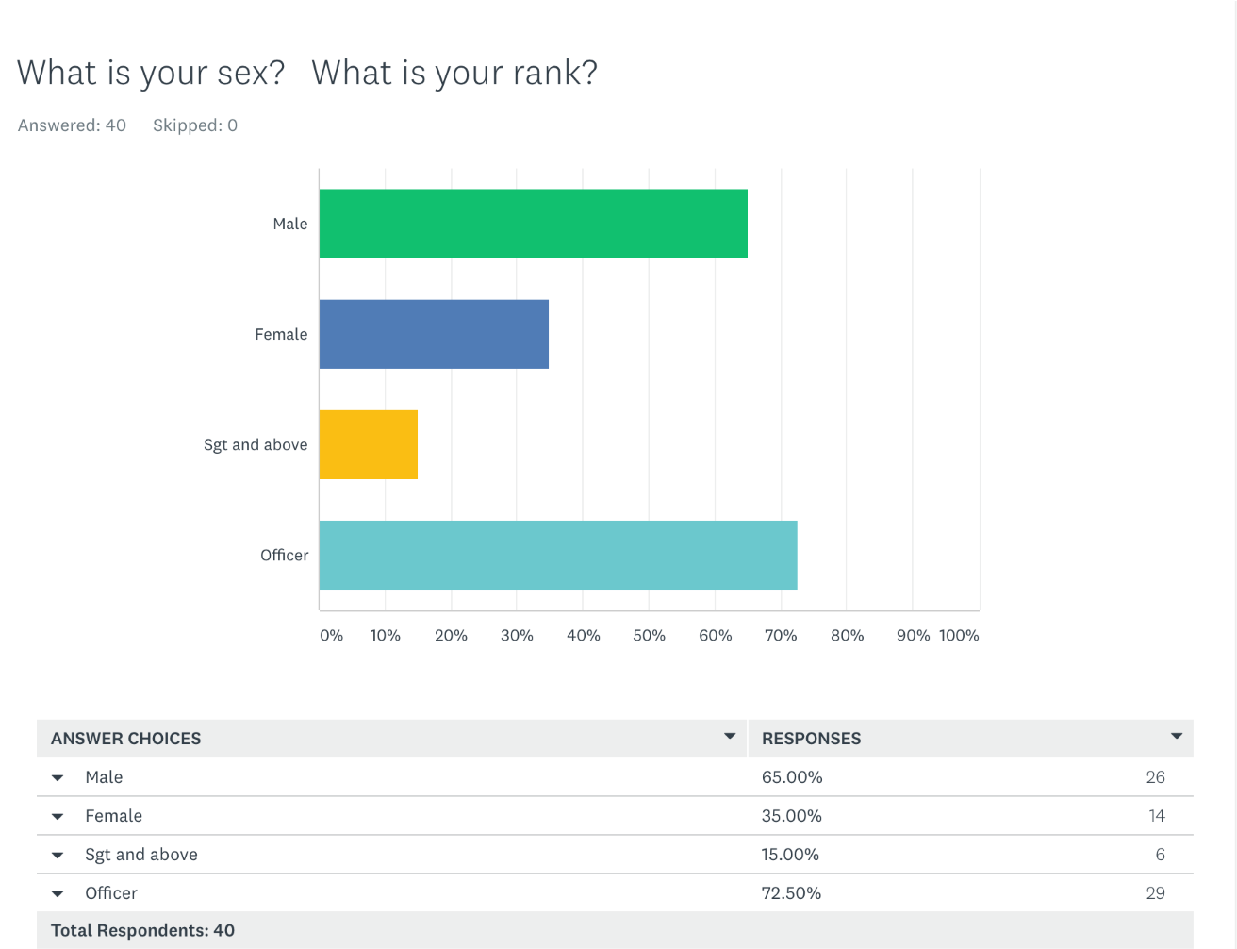
Fig 1
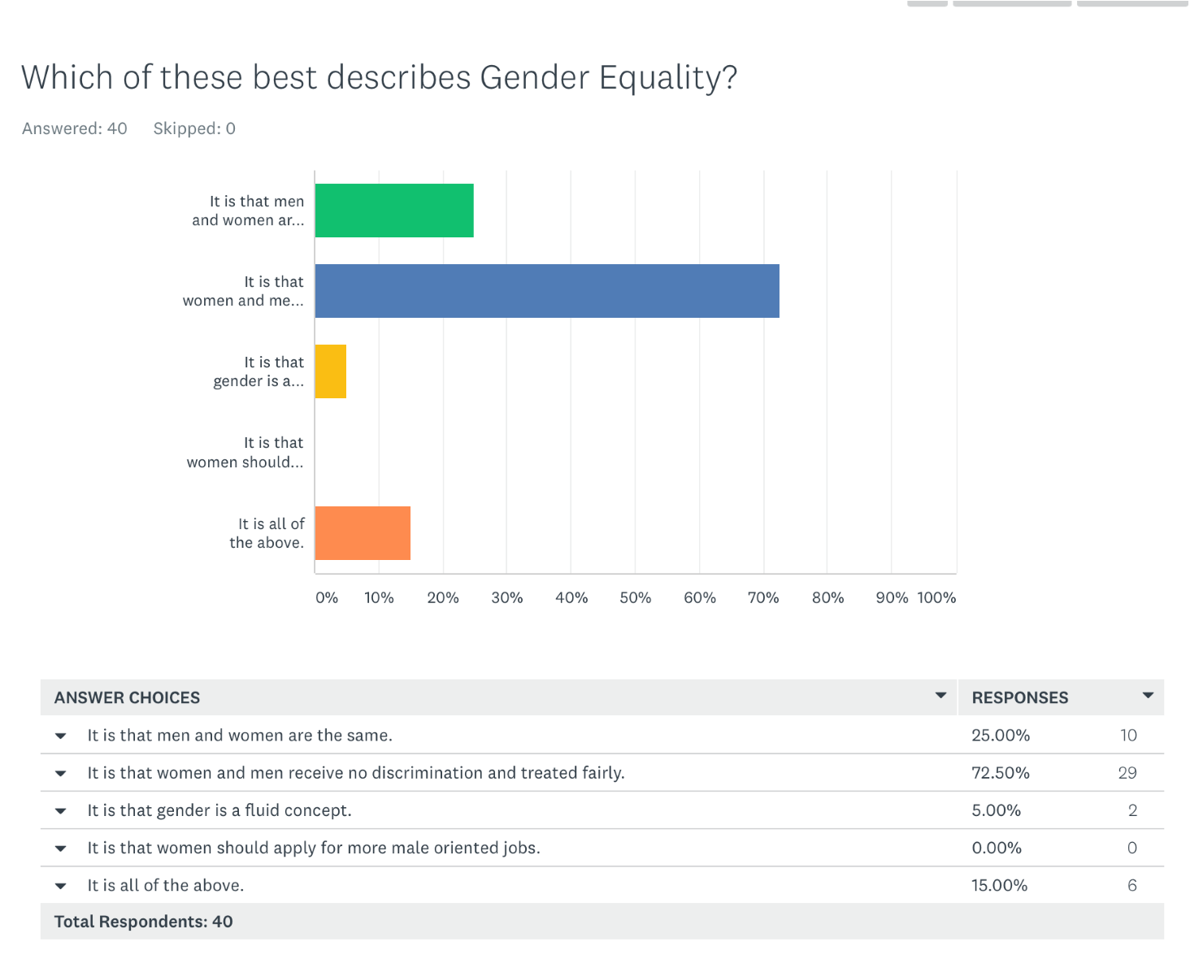
Fig 2

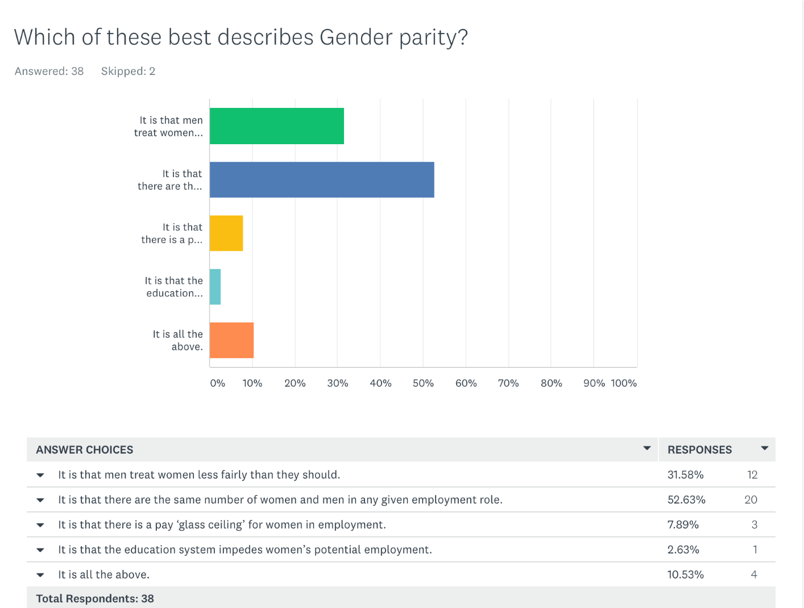
Fig 3
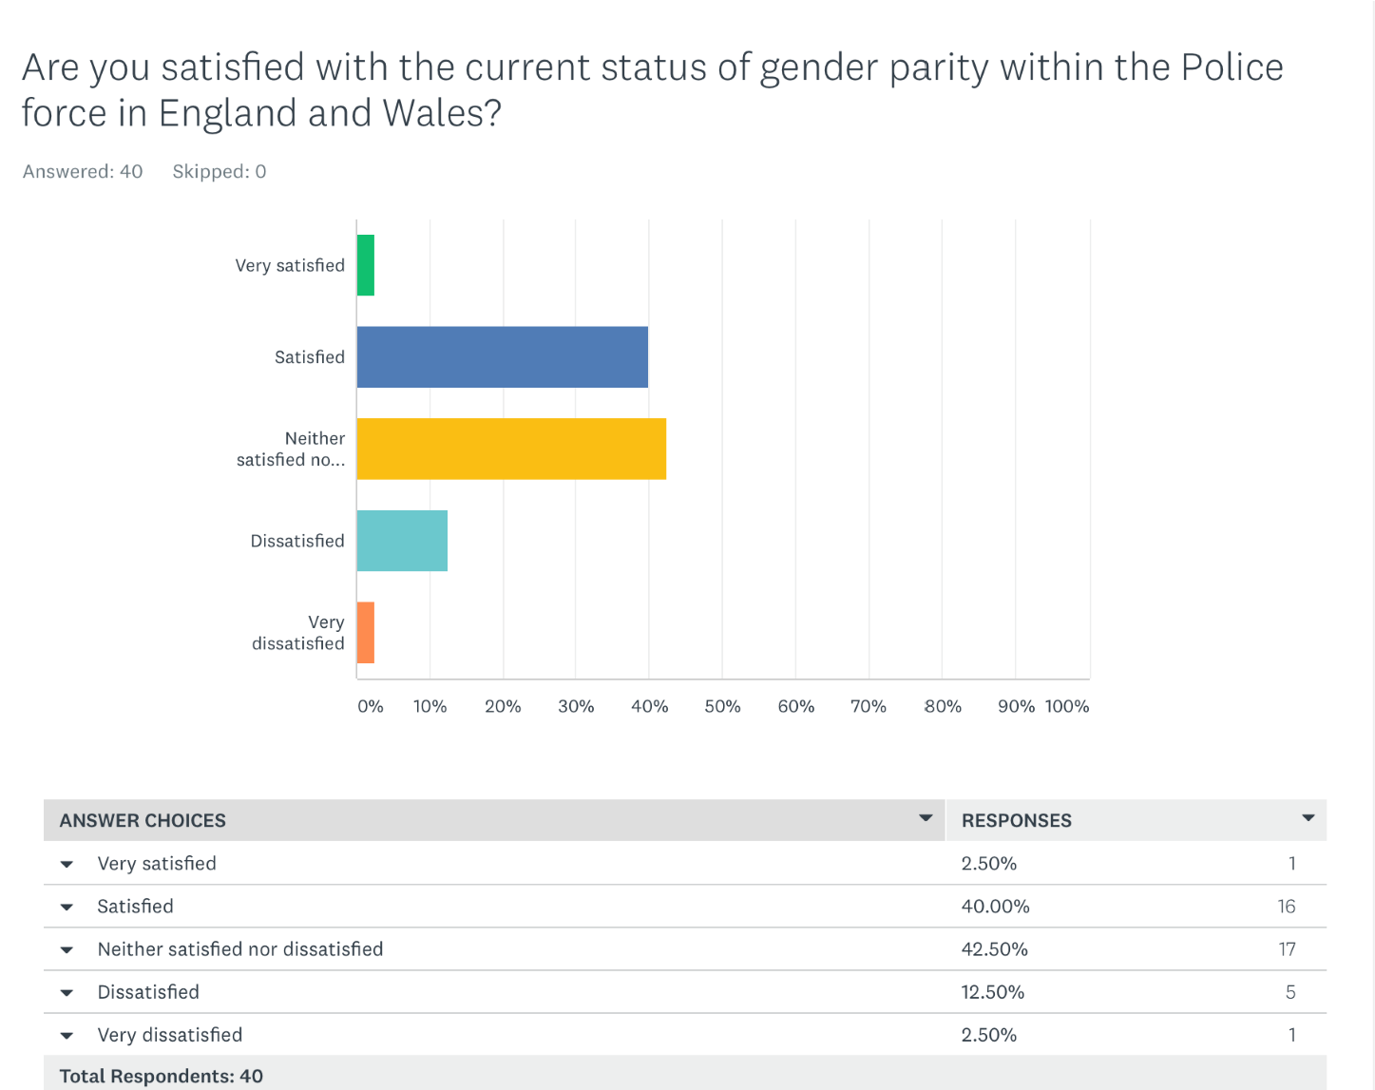
Fig 4

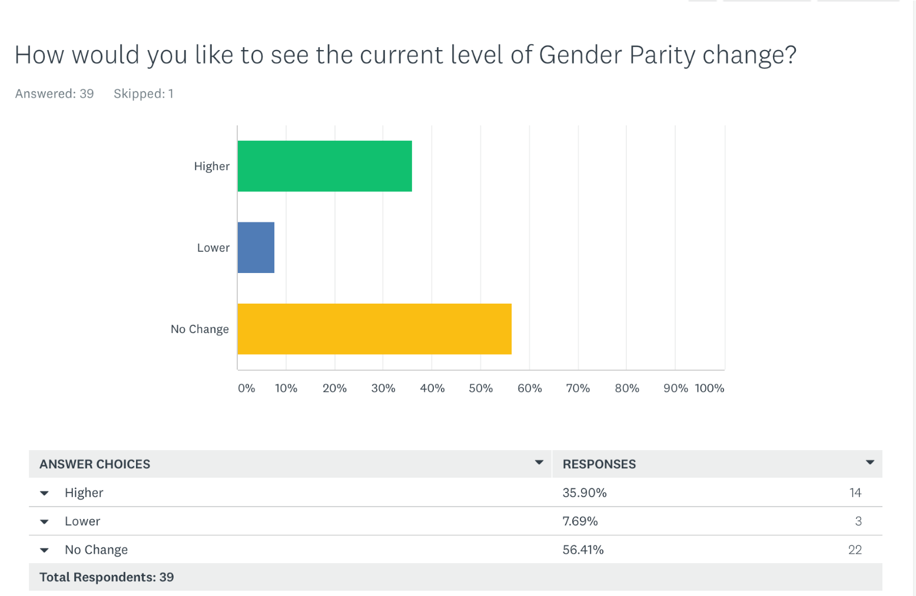
Fig 5
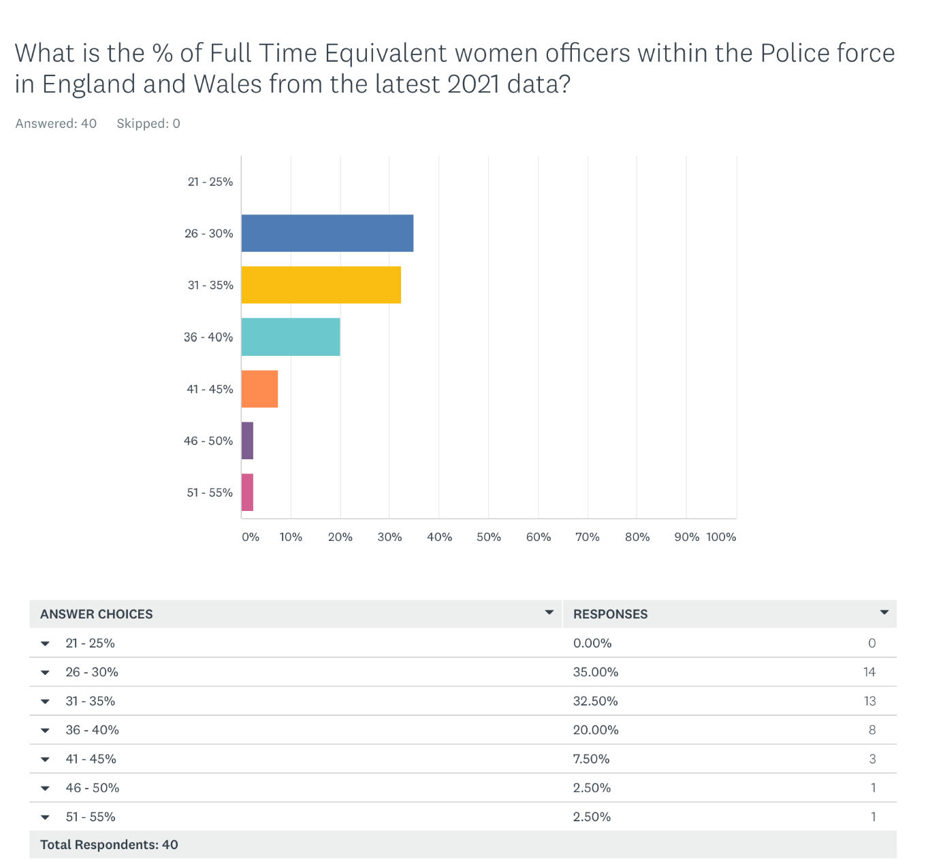
Fig 6

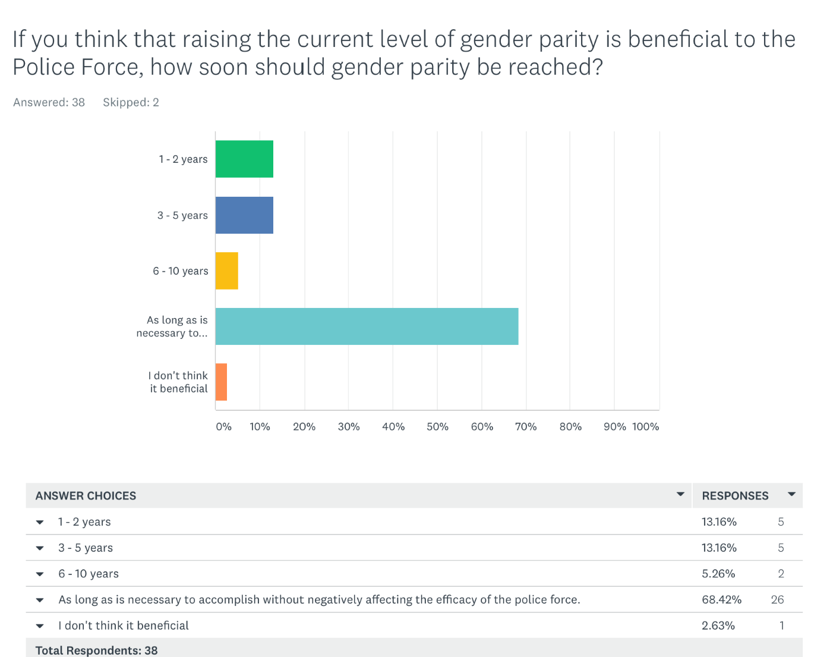
Fig 7

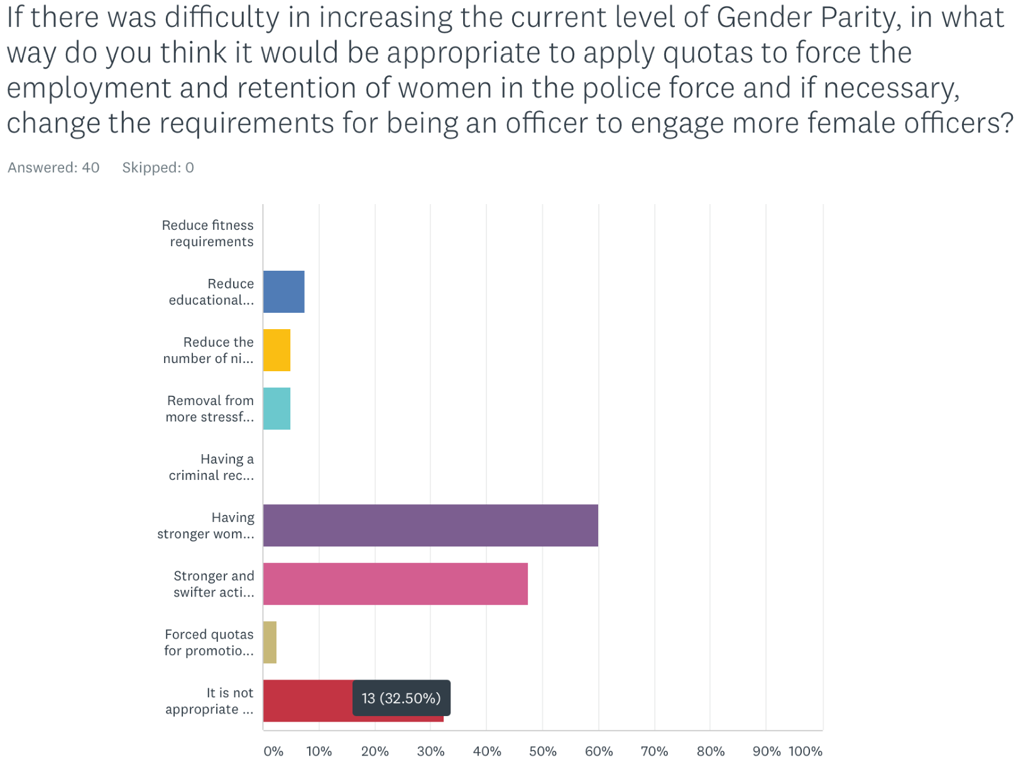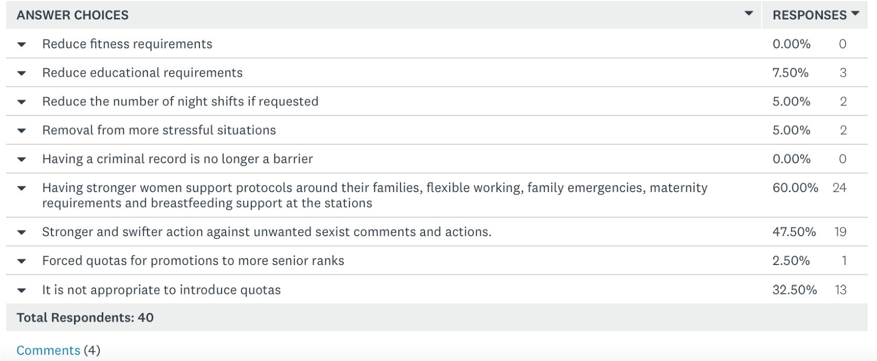
Caption
Fig 8
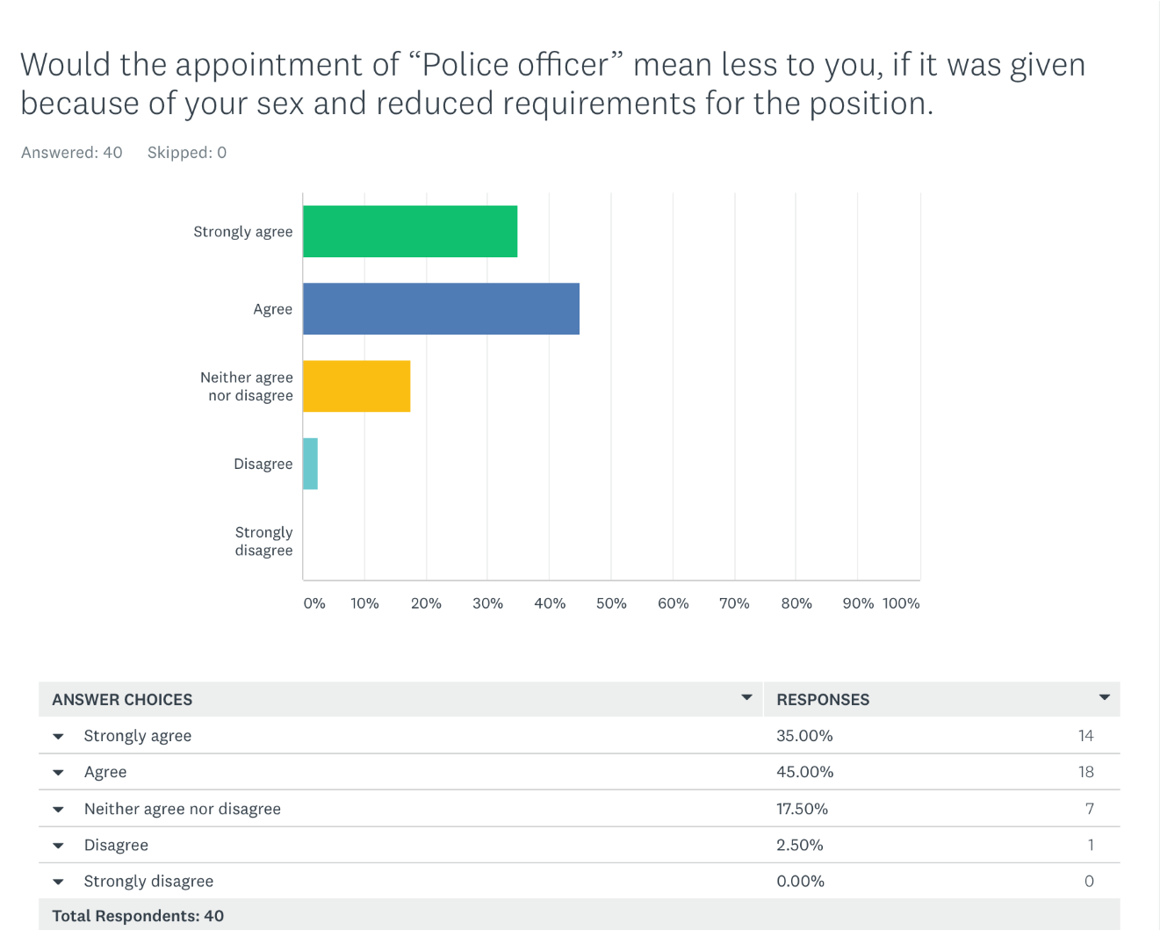
Fig 9
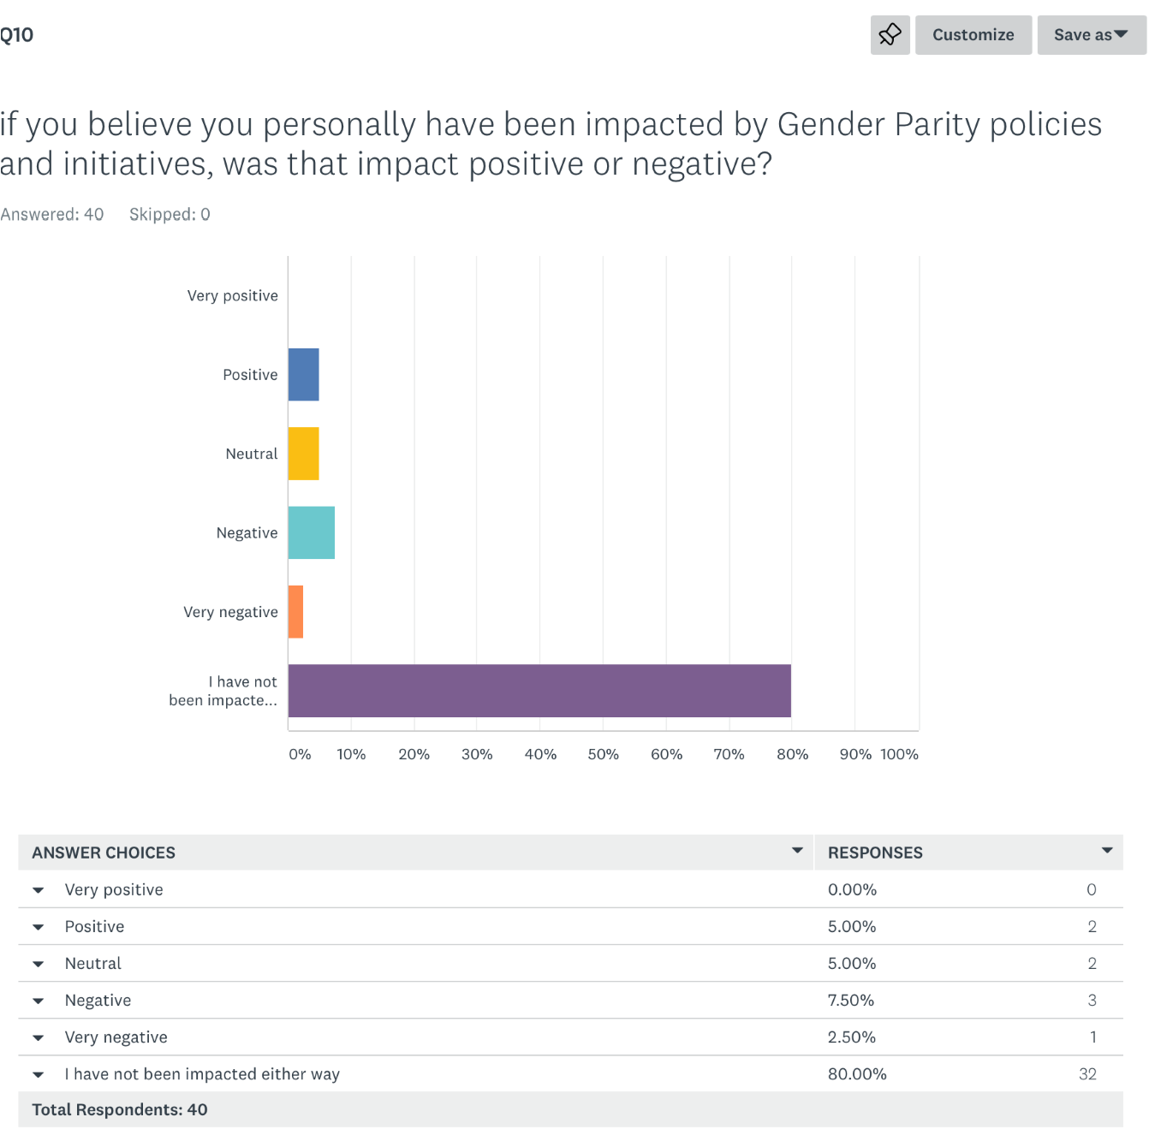
Fig 10
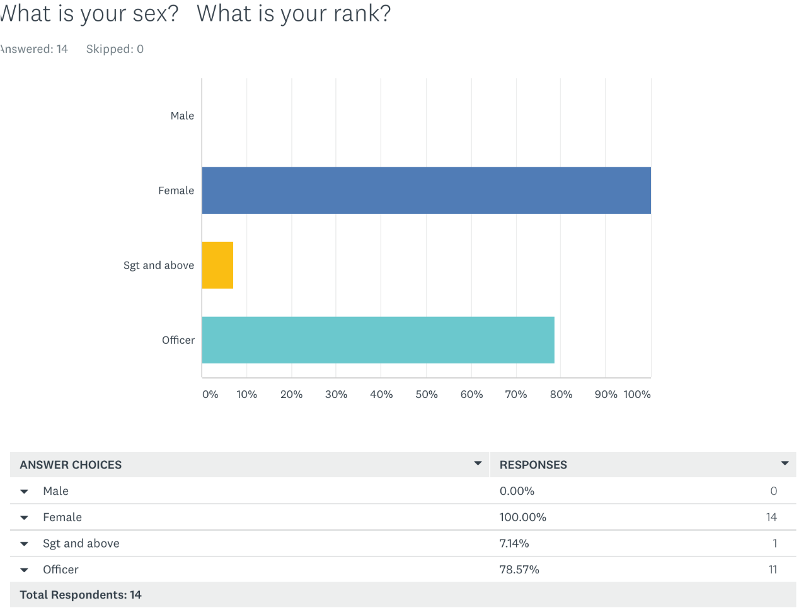
Fig 11
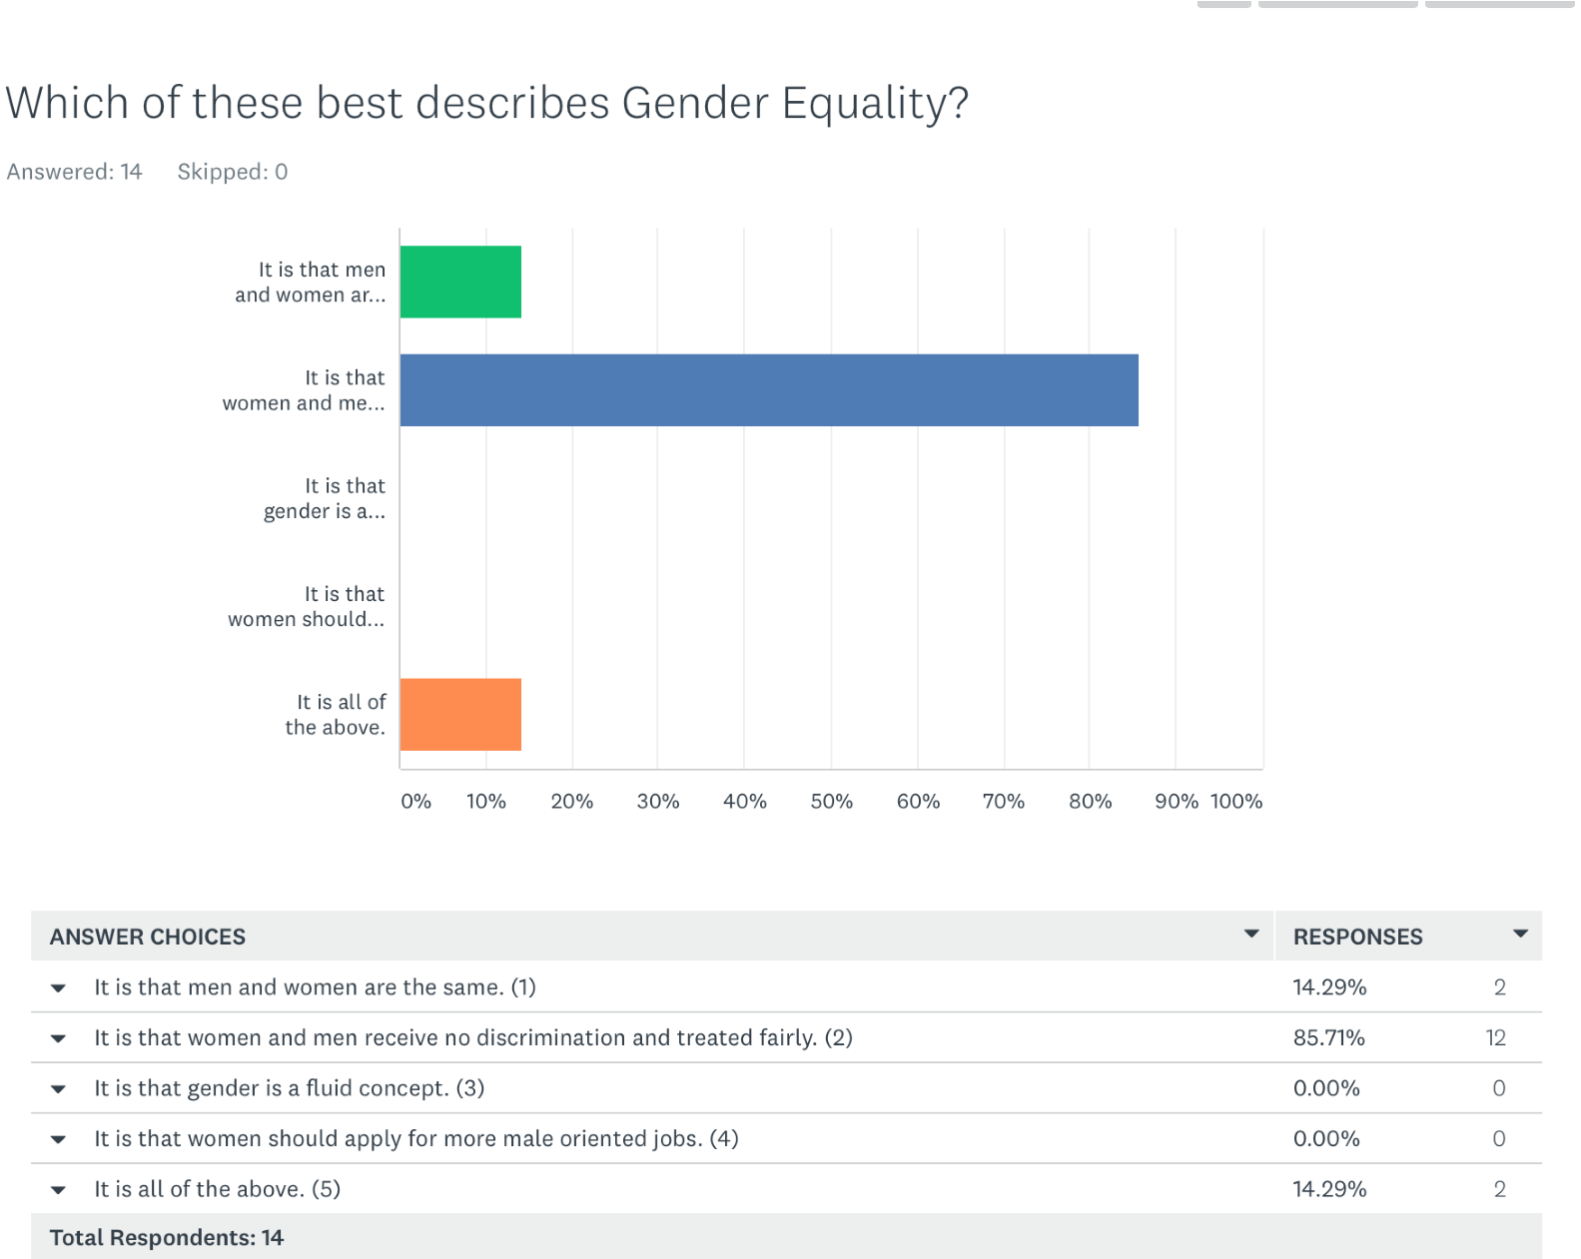
Fig 12
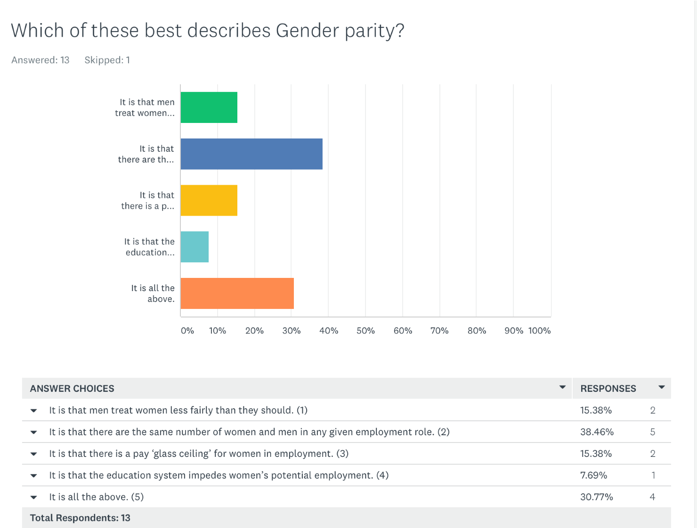
Fig 13
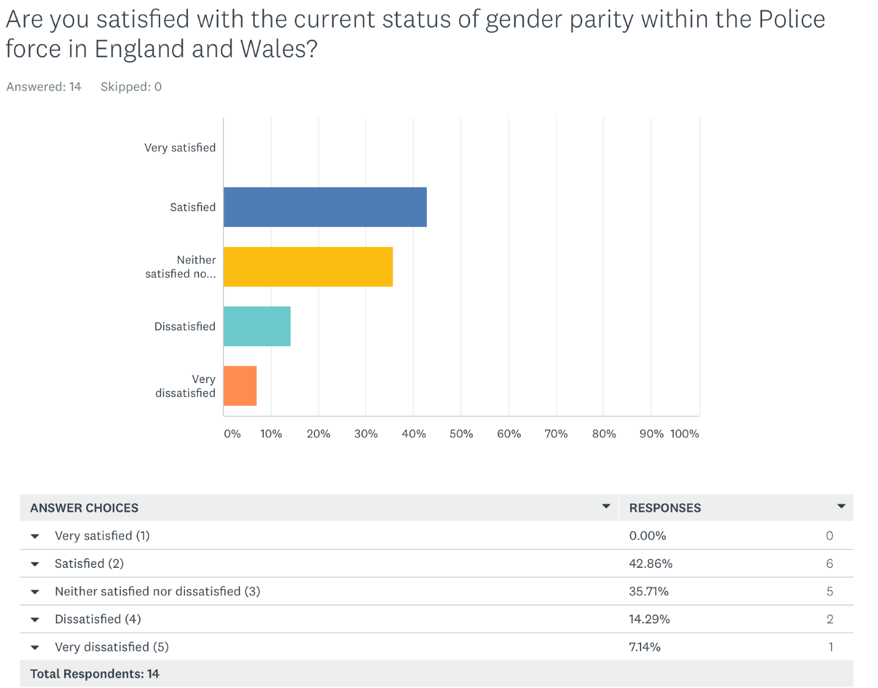
Fig 14

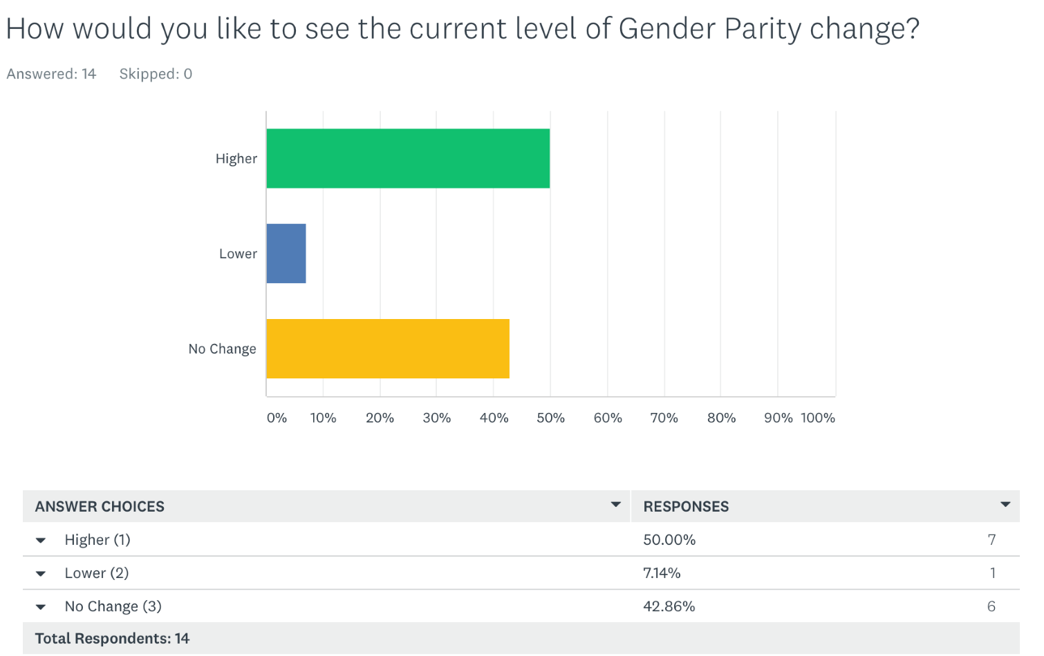
Fig 15
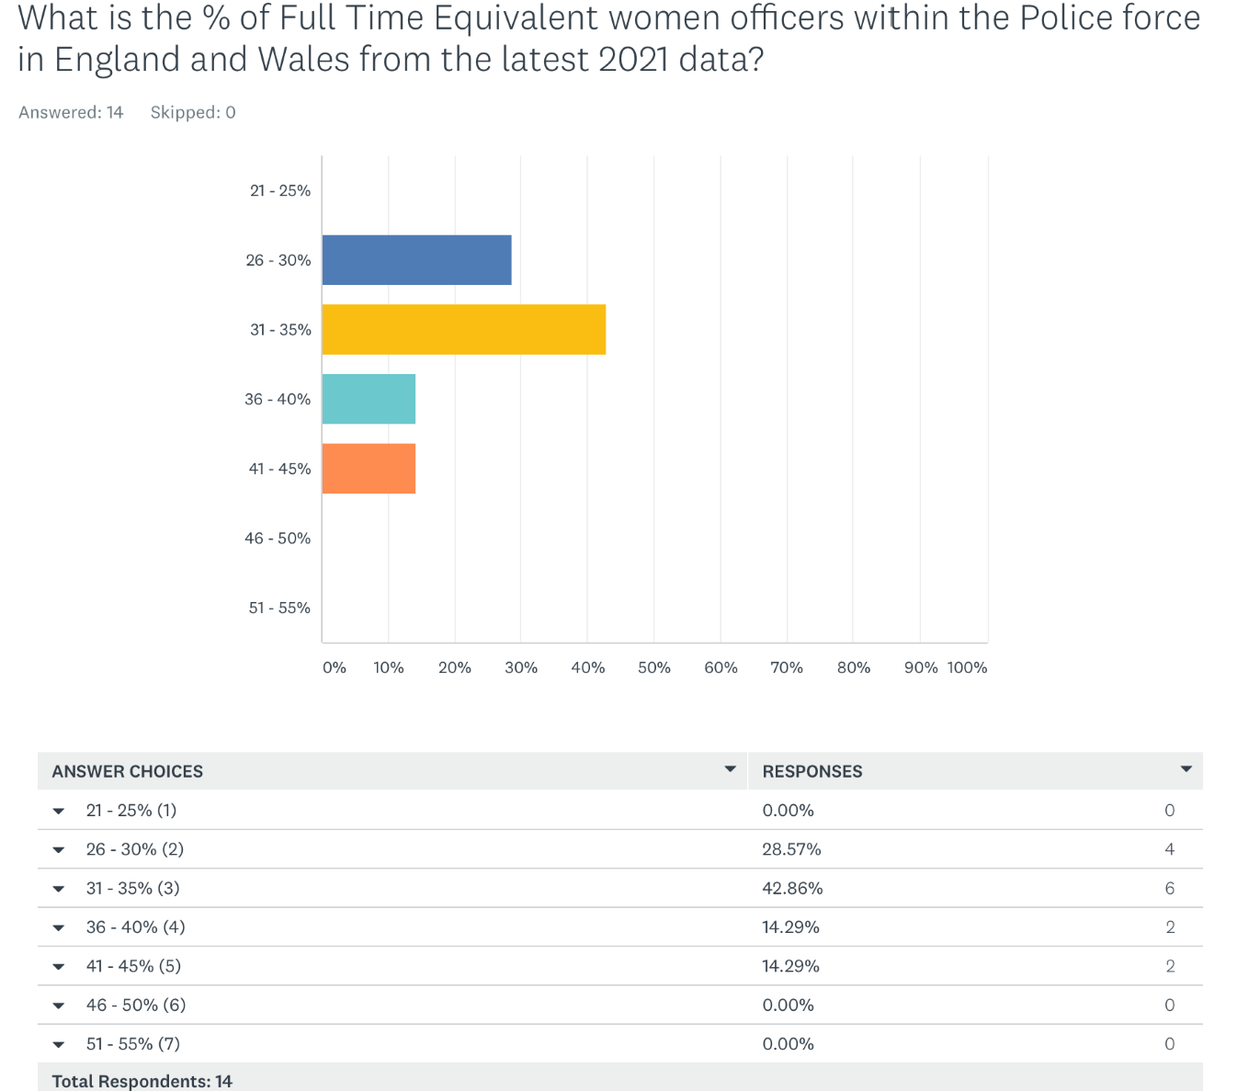
Fig 16
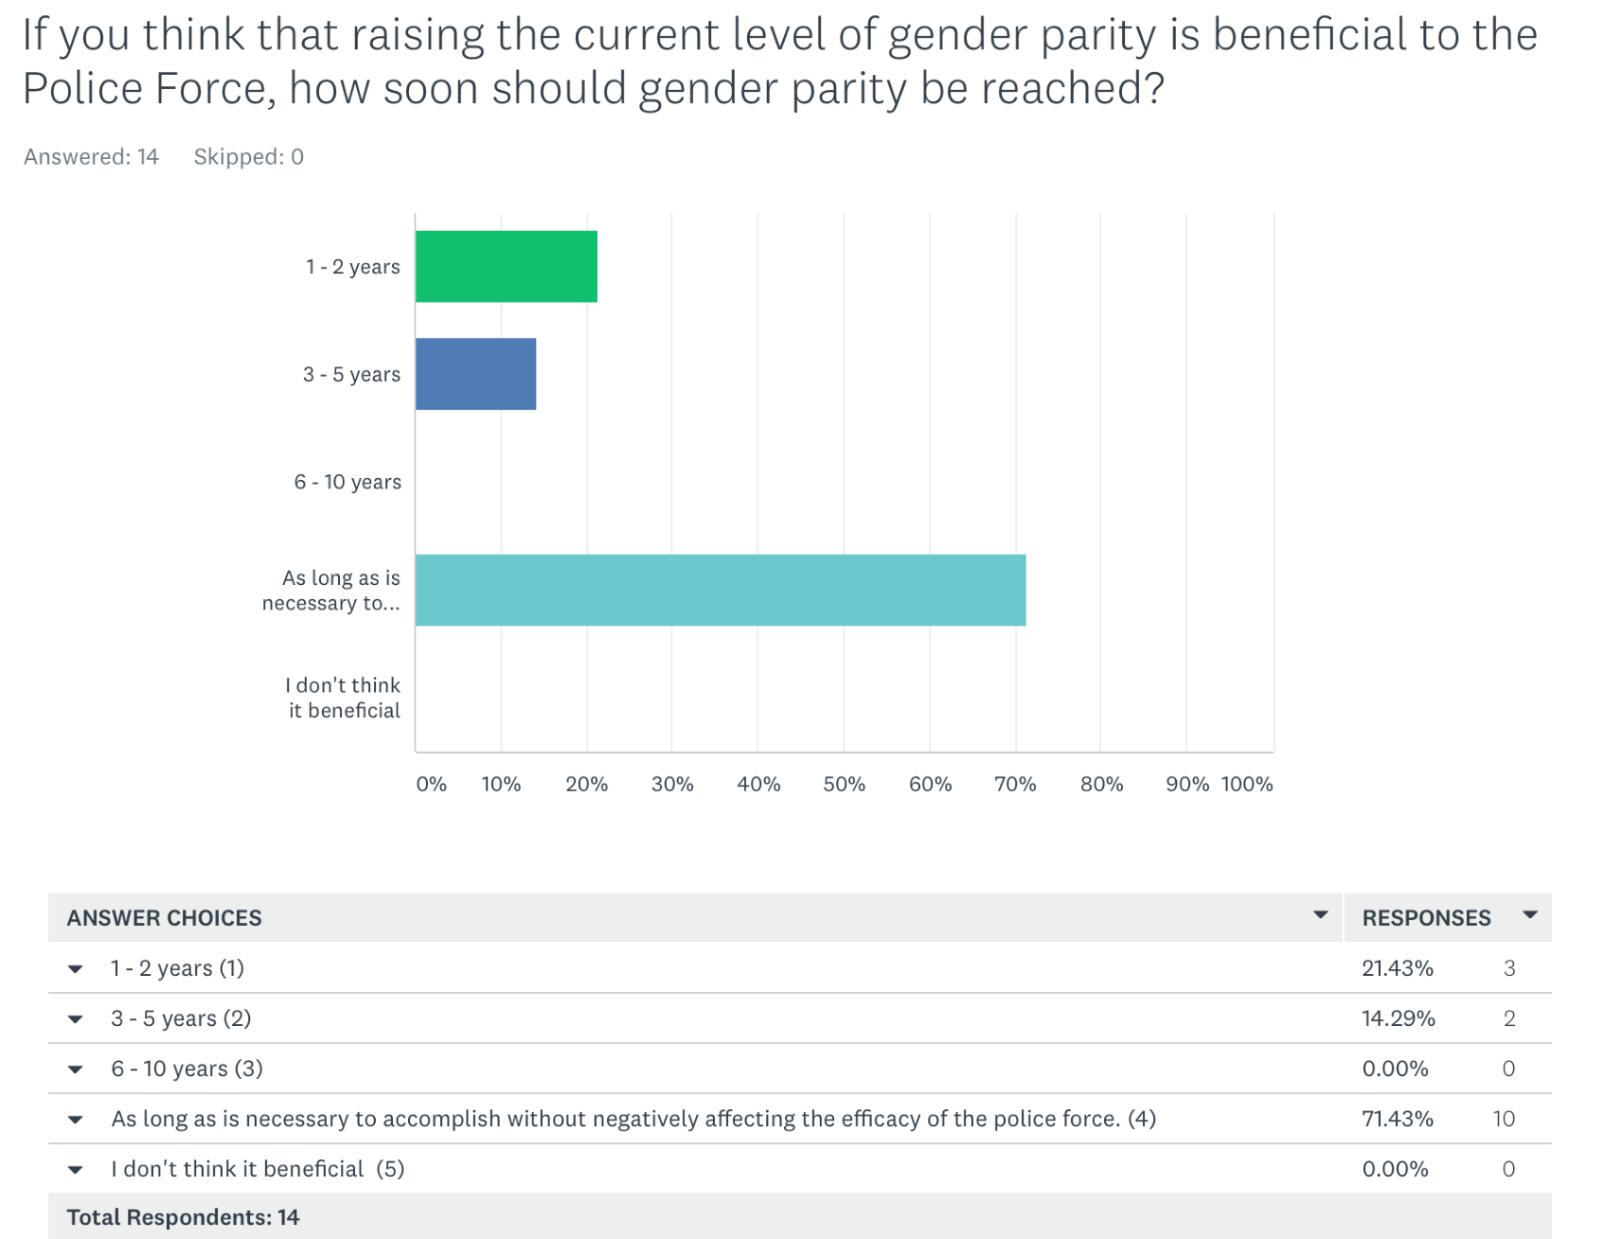
Fig 17
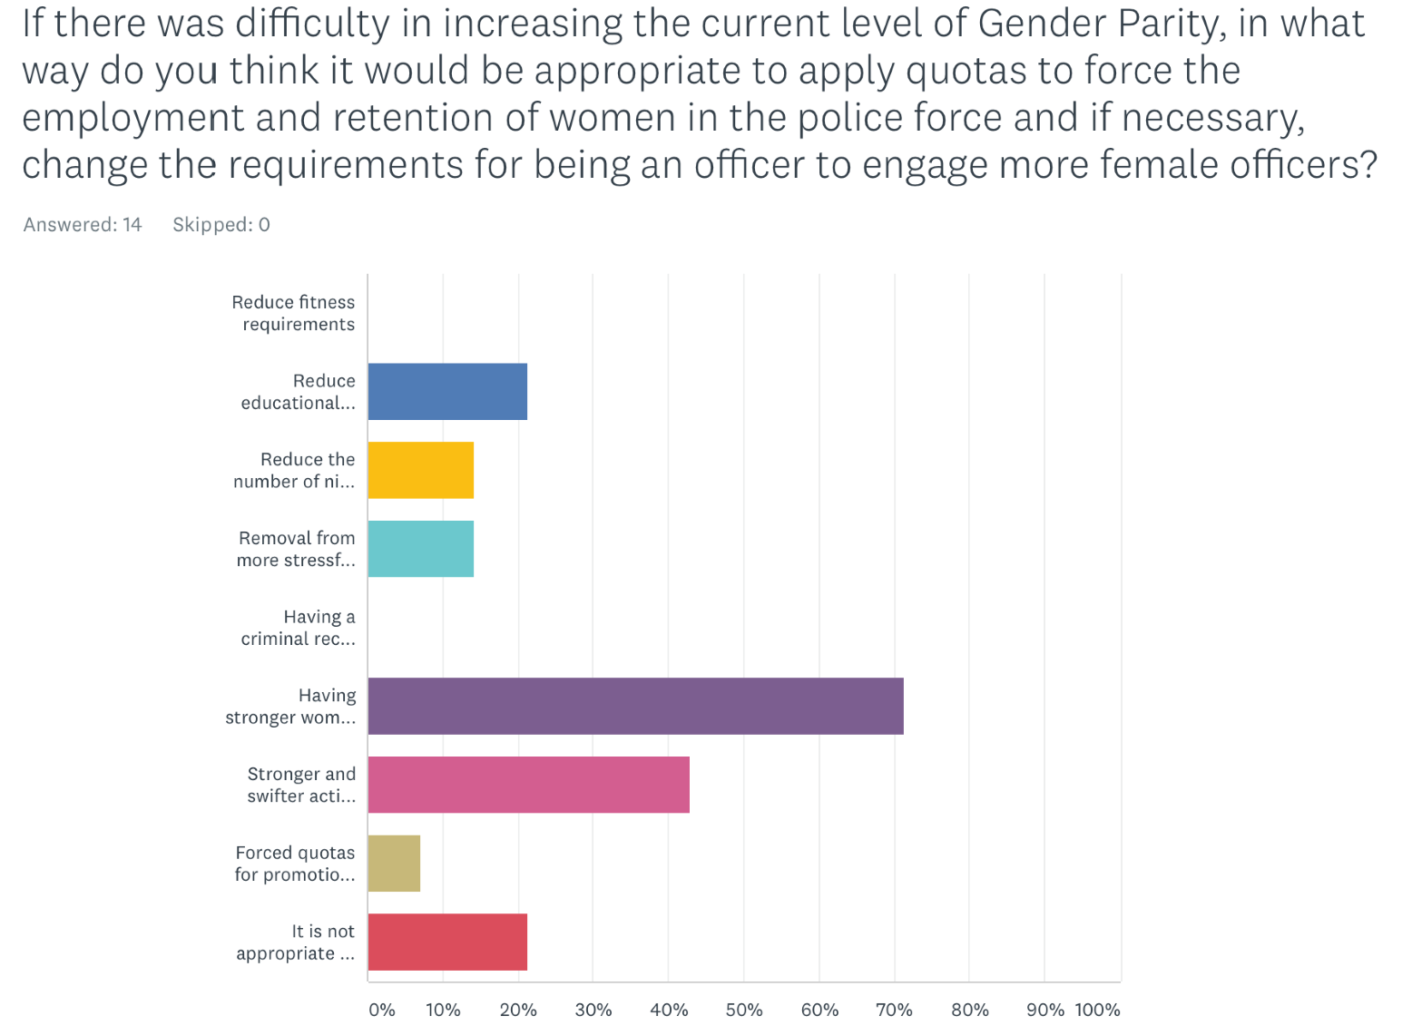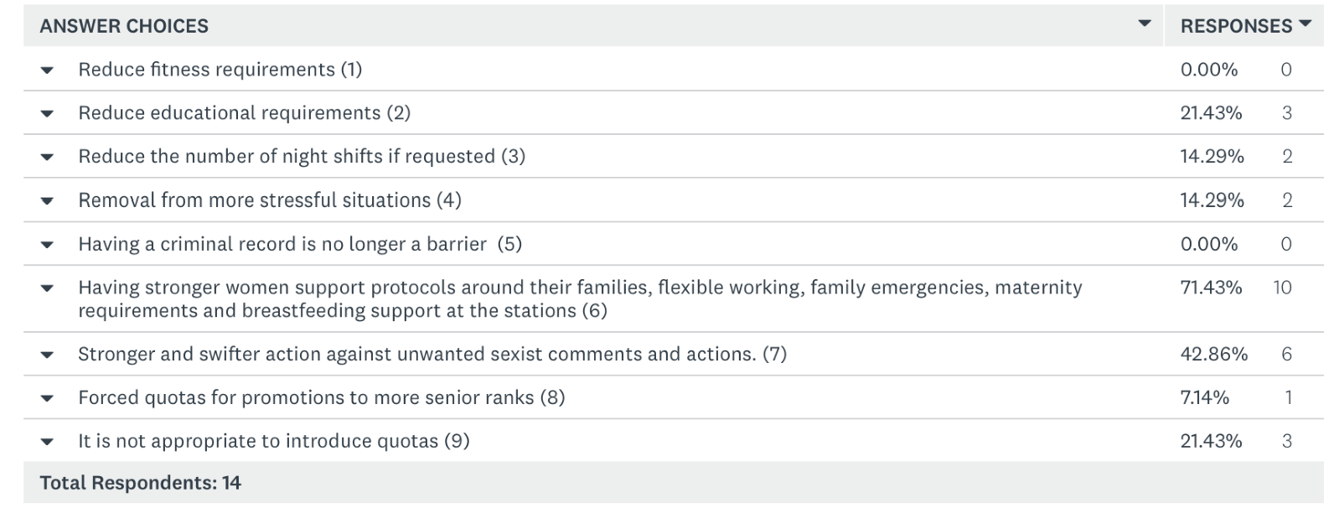
Caption
Fig 18

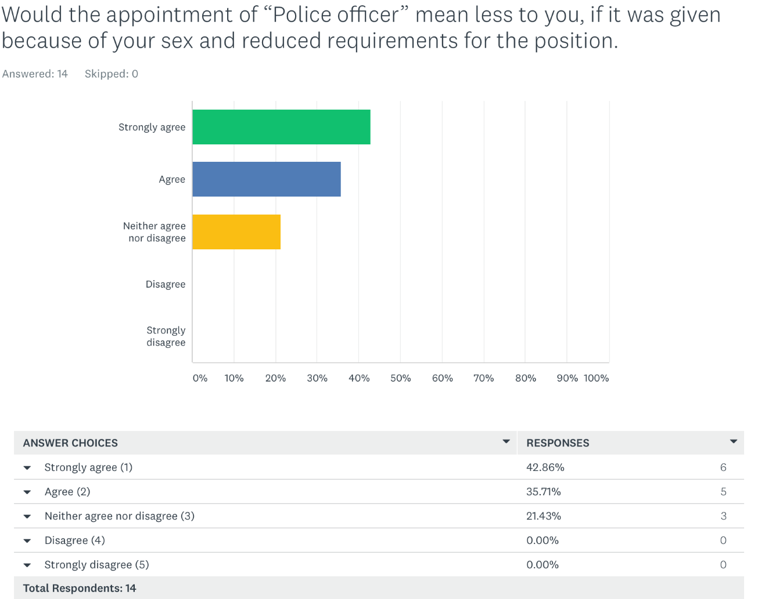
Fig 19
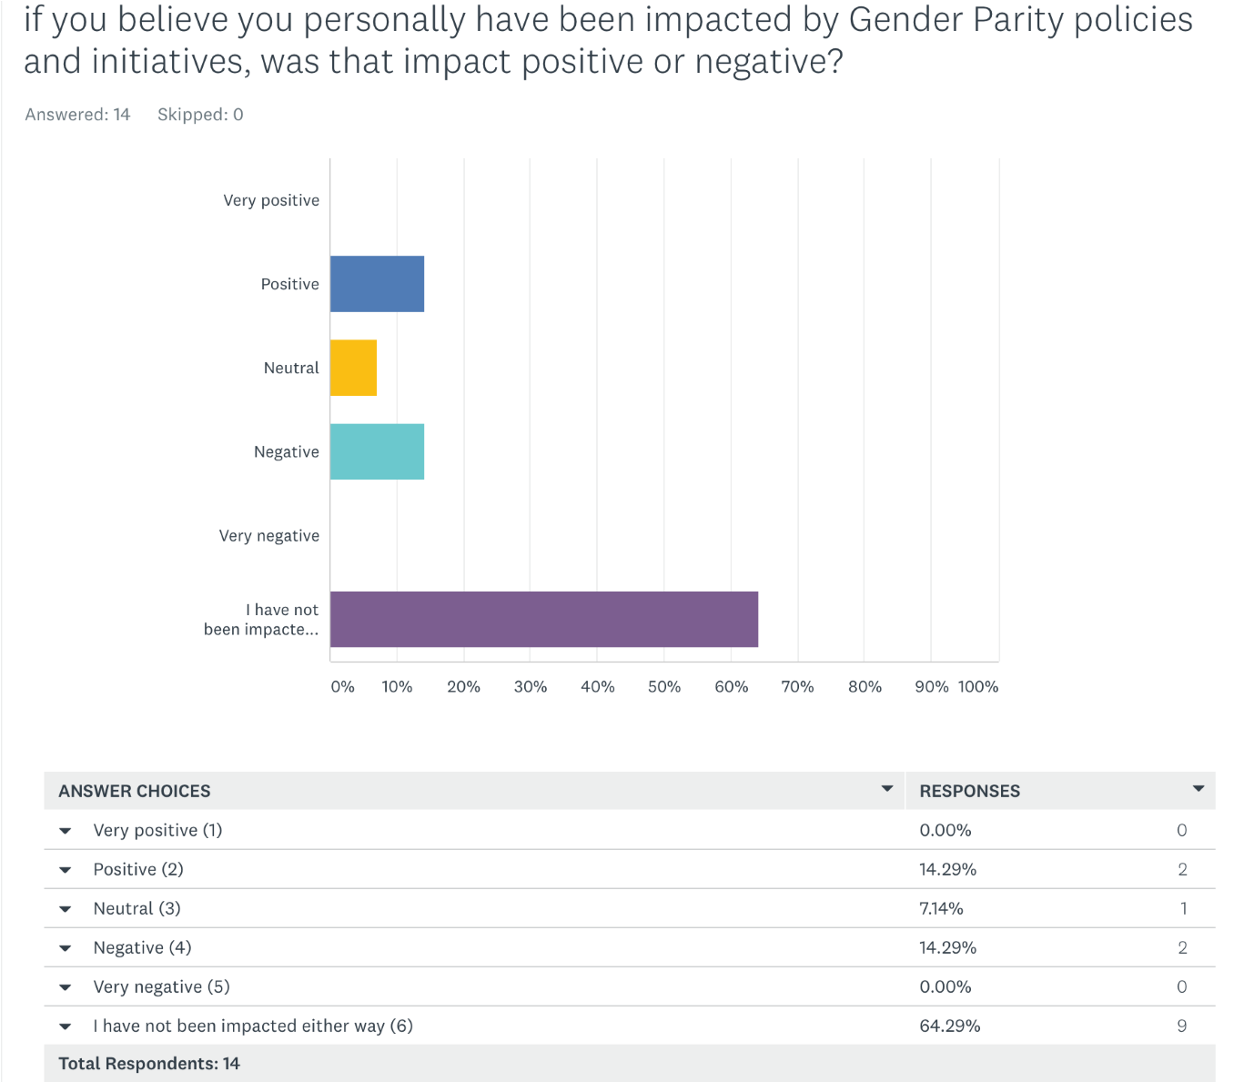
Fig 20

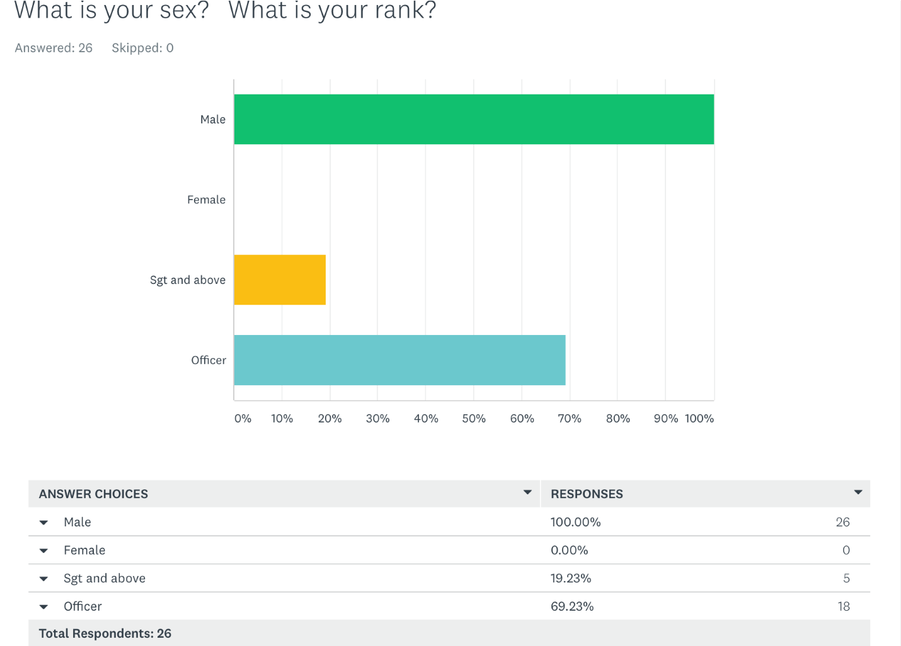
Fig 21
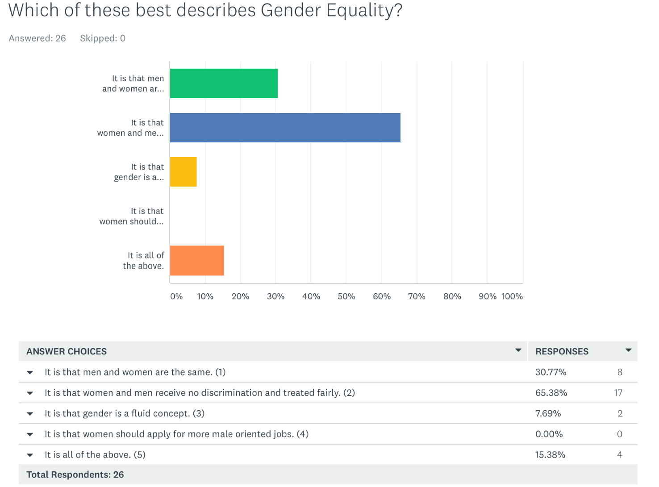
Fig 22

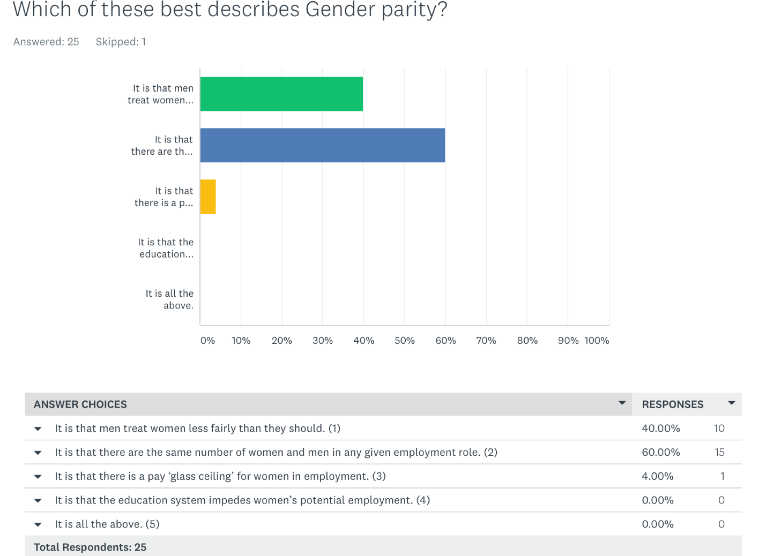
Fig 23
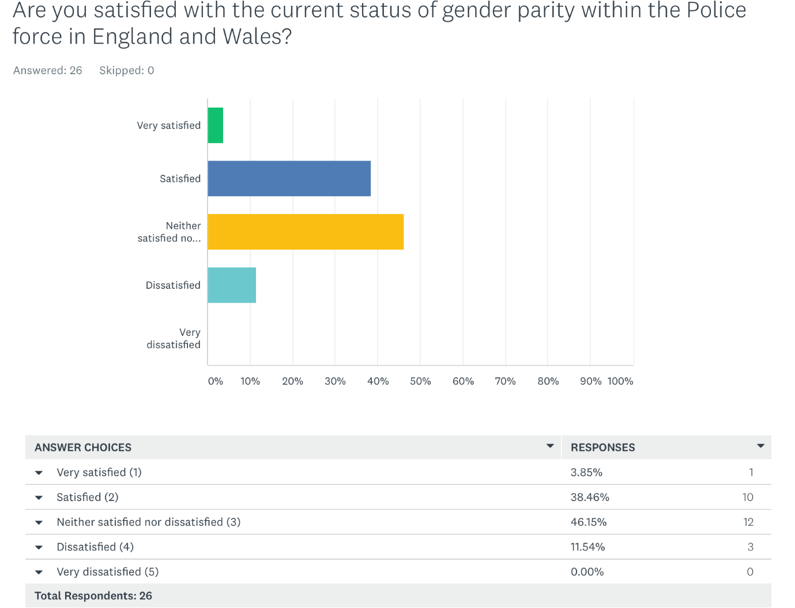
Fig 24

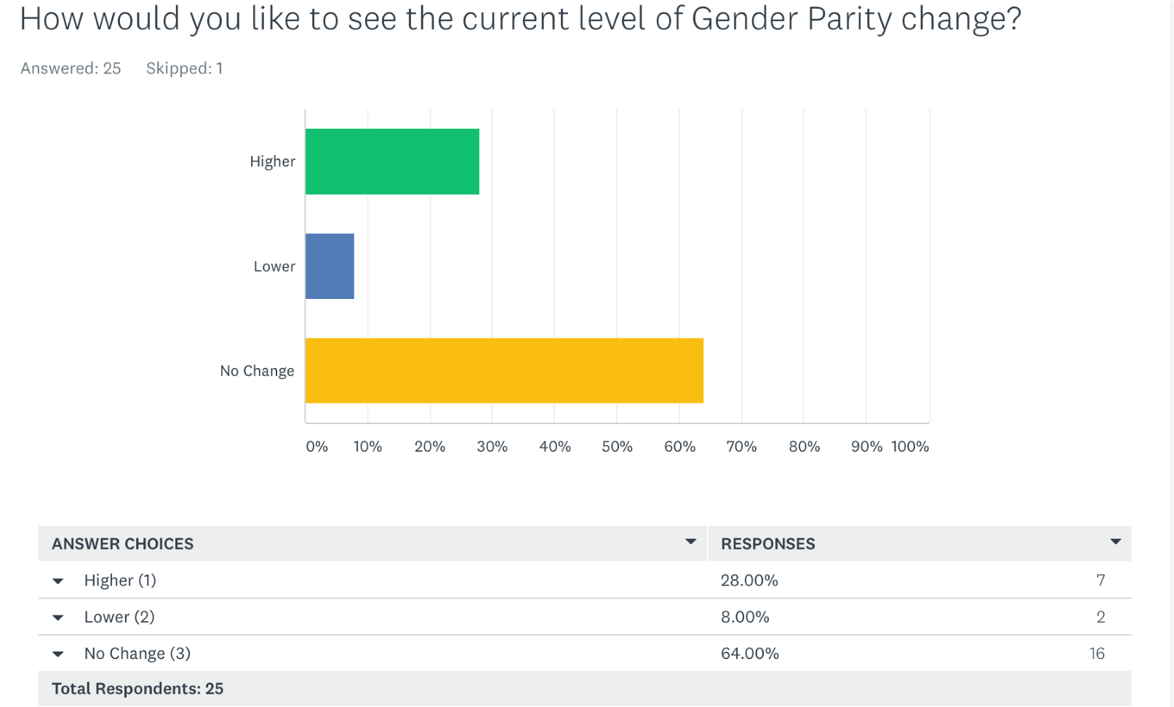
Fig 25
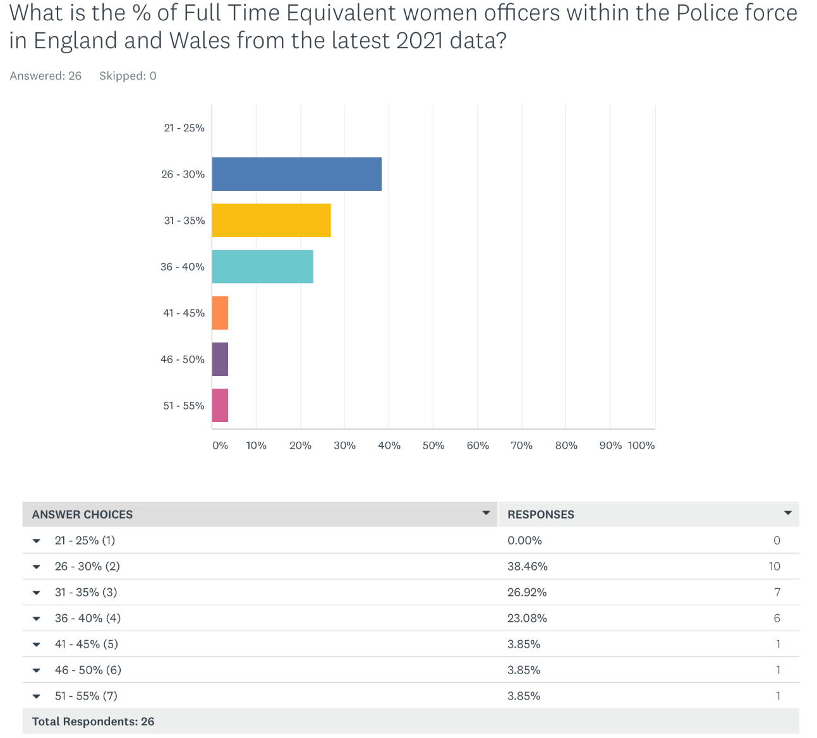
Fig 26

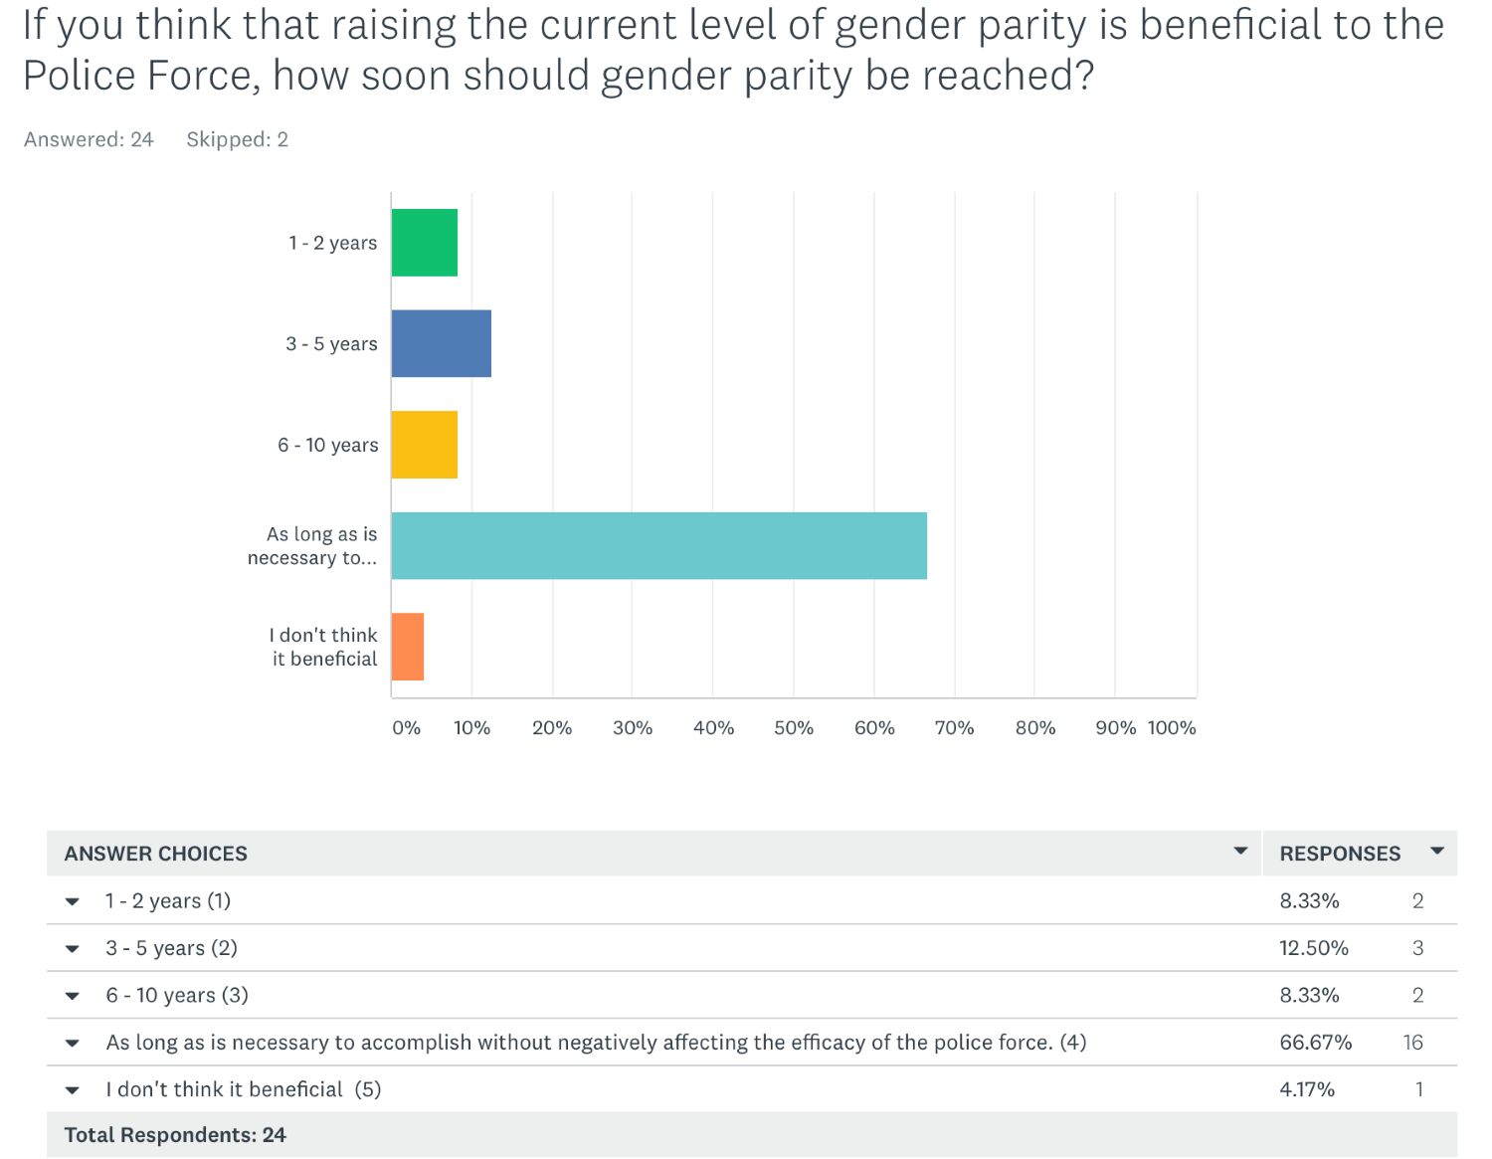
Fig 27
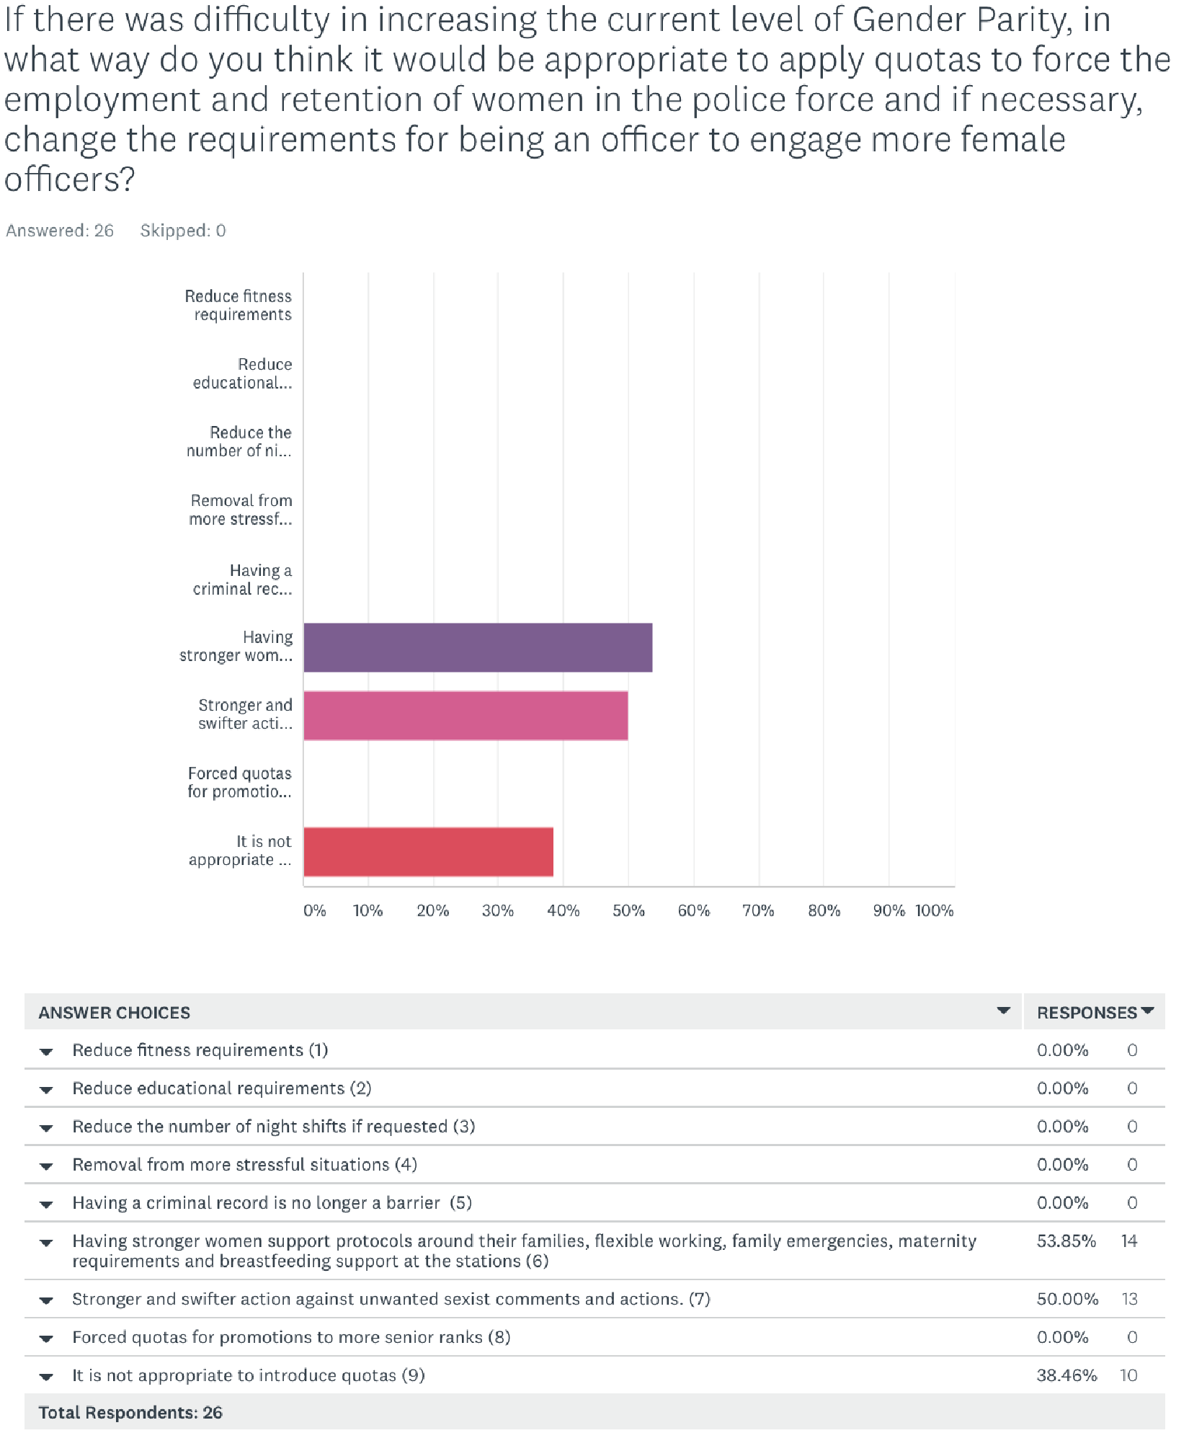
Fig 28

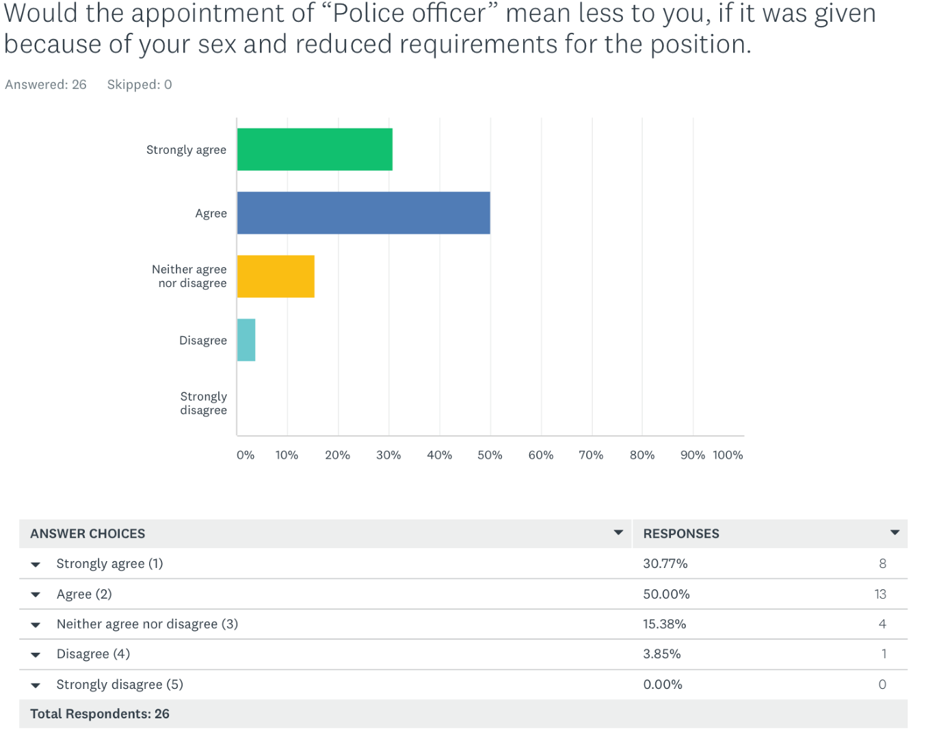
Fig 29
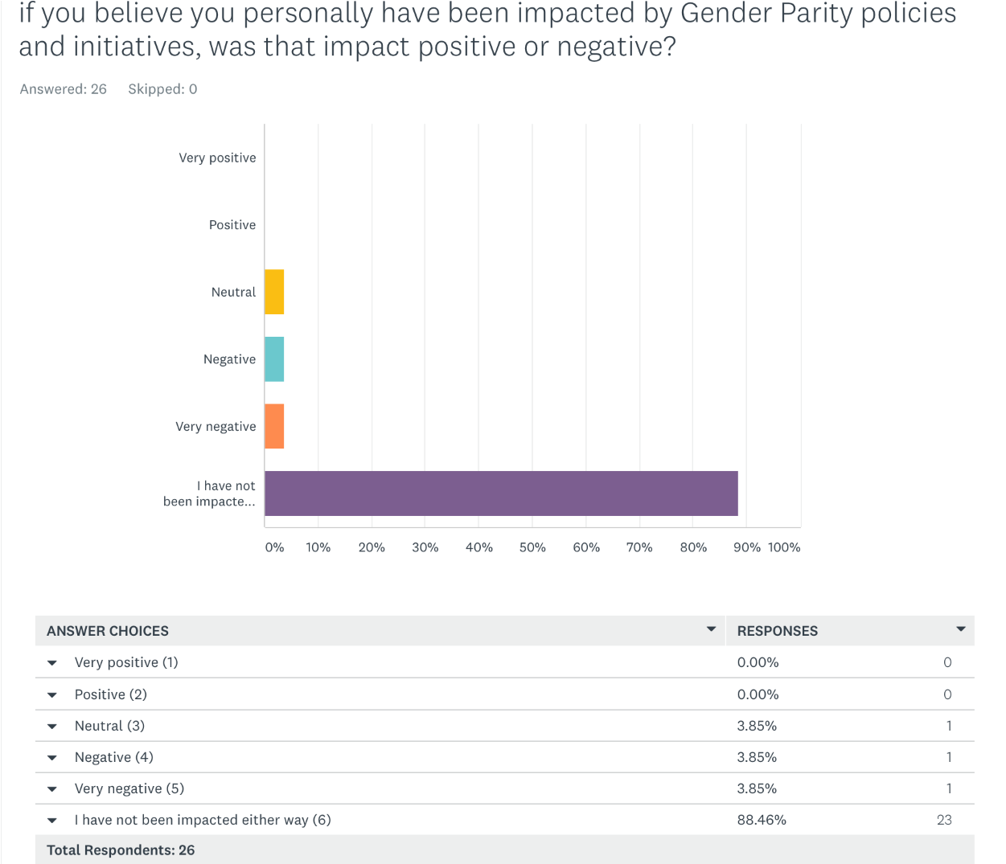
Fig 30

