Liliana Calin

ID Number- 181614

Course Name- Effective Team Working and Communication (BMSW4002-Loan)

Effective Team Work and Communication.

Table of Contents.........
Prologue.................................. 3
The Communication in the work environment ...........................................4
The necessity of Effective communication by Employers in the work place...5
Theory of Fixed Structures......................................................................8
Critical Theory ......................................................................................9
Groupware Theory..............................................................................10
Framework Exemplar to Effective Communication............................13
Shannon and Weaver Model...........................................................13
Berlo’s Model......................................................................................15
Methods of transmission to improve job performance of industrial workers...16
Abstracts....................................................................................................17
References.....................................................................................................18

Prologue:
A consistent theme of this unit is the importance of understanding and how and what the employees had to say, in most of the cases the business and the organizations has a major influence on the challenges and opportunities each organization and faces and many of the decision taken by managers reflect their understanding and interpretation.
In this assignment I will explain how the terms of the communication are important and how can be a major factor in the companies including the jobs.

The Communication in the work environment;
As we know the communication it’s a necessary skill in different circumstances, the importance of the communication in the laboral environment, however this will established a good communication with the customers its essential to create relations for positives and productive works.
Those are some tips of how to have a strong communication between your employees and with the customers;

- Be Respectful ;
The amability and the respectful it’s to construct a good communication in the work. When different points of view are shared, these virtues will make communication effective.

- Learn to listen carefully ;
Communicating successfully requires speaking properly, but also listening carefully to others, therefore, if you want to be heard and, in addition, that your message is transmitted effectively, then you must do the same when another member of the company wants to express himself.
- Be Consistent ;
When you communicate, do it in the way consistent and genuine, including the way of speaking , body language and eye contact, don’t lend yourself to ambiguities, as these can lead to misinterpretation so be as direct and concise as possible.

- Implement group activities;
Working in a team can help improve communication methods within the work environment and, as a consequence have a positive impact on productivity. In addition activates that promote communication can give company employees a moment of fun and relaxation, making them more committed to it.
There are several methods to break the communication barriers existing in employees, some company’s use team building, or trainings or courses with topics related to their areas to improve the work environment and improve and have a work communication of quality.

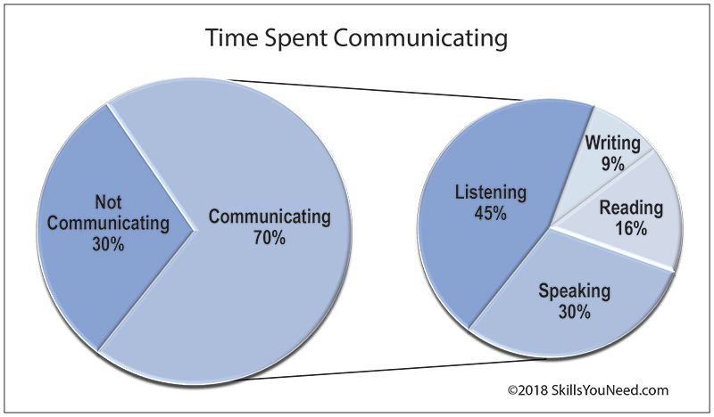

Figure: Skills you need
Source: Adler, R. et al. 2001
the chart bellows, have different significant in terms of communication demonstrating different skills and ways to communicate.
In the chart the highest percentage it’s the communication as its 70% meaning they are communicating between them.8
The necessity of Effective communication by Employers in Workplace:
Communication, this skill it’s a necessary in workplace, schools, universities and in the real life.
In the workplace a person can have interactions with superiors , colleagues etc.
Similarity it receives information, gives or receives instructions and coordinates with work teams.
All these factors and relationships between others requires communication, the importance of having good communication in labour organizations.
Communication is the most important factor of each member, can be developed in the workplace, business , families , friend environment , etc. This skills and factor is the principal attribute required in any situation. Having this we can build a successfully action in the work environment .
Effective communication can bring and make a good relationship between staff and superiors .

- Virtuous actions – These are behaviours that have a positive impact on others-co-workers, customers ( Being helpful , being generous , engaging in feedback to people that emphasize their strengths and contributions)

- Listen with attention and empathy – Although it is not about complying with all complaints or suggestions, it is about following up on them, and therefore, employee’s requests must be taken into account in order for communication to flow.

- Know the staff –Diagnose the problems or improvements in each area , meet your staff, this although many do not believe it is part of learning to communicate, this will help you realize the channels that you must improve in terms of communication.

- Feedback- This can be one of the most important role for the employees via to their managers, to communicate and be able to give their own opinion about the different circumstances or issues they may have.

- Working in teamwork- Having a good communication with your colleagues, will help you to be a good communicator and the most important working in teamwork meaning you will have to communicate with other members of staff to solve the problems.

- Make your point of view clear- Rather than fully listening to what the other person is saying, you are just thinking about how you can step into express your own point of view.

- Frame it as a cooperation- Most discussions revolve around the question of who is right, rather than what is the truth. Reframe the discussion as a mutually beneficial clash of minds that will bring you both closer to the truth.

Concept and principles of effective communication; The theory of Frederick Taylor (1917) developed scientific management theory (often called “Taylors”) at the beginning of this century. His theory had four basic principles: 1) find the one "best way" to perform each task,
2) carefully match each worker to each task,
3) closely supervise workers, and use reward and punishment as motivators, and 4) the task of management is planning and control.
Taylor was successful improving production; his methods involved getting the best equipment and people, and then carefully each component of the production process. By analyzing each task individually, Taylor was able to find the right combinations of factors those large increases in production.
For example - Amazon Alexa skills in the U.S. totaled 25,784 at the beginning of 2018 and sit at 56,750 as 2019 begins. That reflects 120% growth in one year which isn’t quite as impressive at the 266% growth between 2017-2018 but confirms continued developer interest in the platform.

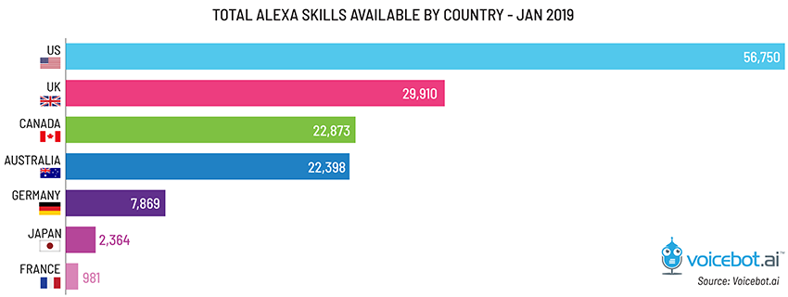

Figure: Statistics Amazon Skill Counts
Source: Bret Kinsella (January 2019)
This chart shows different countries with the Amazon skills counts, we can also notice the highest country with “Alexa skills Amazon” it’s the United States and after follows United Kingdom , Canada , Australia , Germany , Japan and France, those shows the communication level used at their company including in different countries .
Critical Theory:
These theories have an important role of the methods in the business industries as we saw many of the countries has a different “skills” which are quiet high, meaning the highest communication has it America, encouraging the employees .
For example the Yazoo milkshake drink, this company motivated their employees to work harder, including the change in customer taste , they recently faced sales growth in the recent years .

Top Ten Flavoured milkshakes rate.

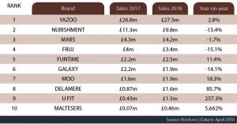

Figure: Growth rate of Milkshakes
Source :( Liz Wells 2018)

This chart shows us how the different milkshakes growth during the years including the different brands, we can also differentiate the highest brand of the milkshakes its YAZOO with the sakes of 2.8% on year which it’s a big percentage for this brand including the famous brand as Mars or Galaxy.
Groupware Theory: This demonstrates how the business industries work including their employees at every brand, for example the image bellow showed us how developed was the organizations.
However if we think the strategy and how the organizations used different methods and different skills to develop their business, in a major part all the merits are because of their employees , because they work hard and they make the industries successfully .
This theory has 3 standards which are;
- Recreation Bonding
- Communication
- Motivation
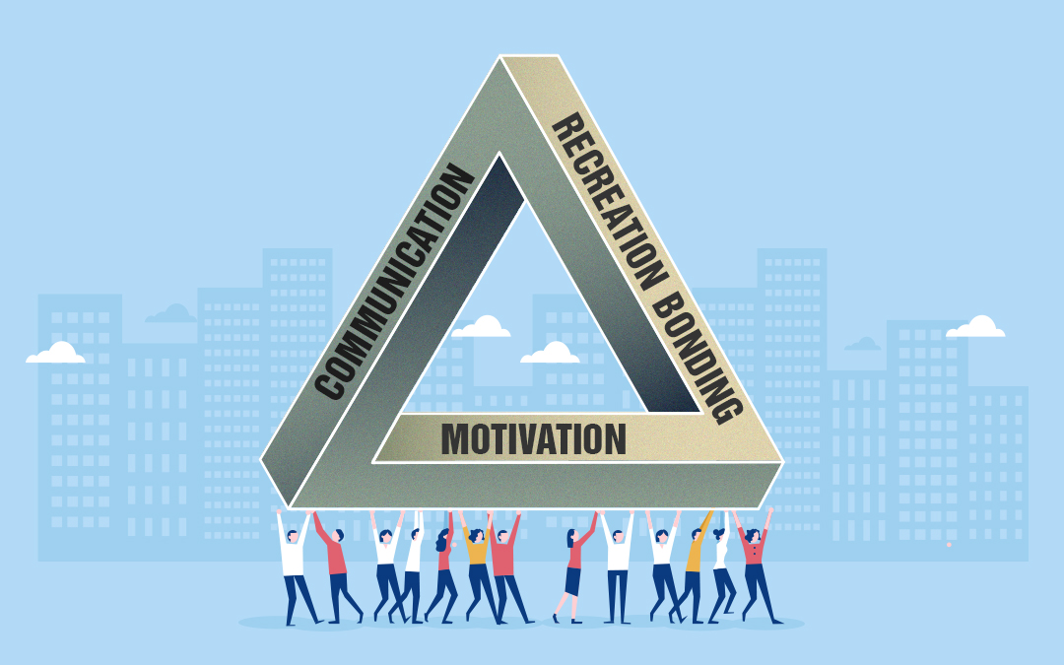

Image; Pillars of Employee Engagement
Source; Prakash Santana (Aug 2, 2018)
Those 3 pillars with many different ones are required in a job especially the employees will have to develop their pillars in a workplace, managing the information has become a challenge for the managers , the methods they can use it’s to allow and connect with any person .
For example Motivation, this pillar demonstrates an understanding a positive speaks of an employees along engaging through the different situations.
The second Pillar I choose it’s the Communication, this bring the employees to share information and remove barriers in the organization, this can a combination both traditional and modern ways of communications.
The third pillar it’s the recreation and bonding, this it’s the principle pillar for an employee because this word brings employees and teams closer.
This meaning engaging activities will build a team, and to be more intriguing in the teams and performance will make a great empathy to the workplace.
What people do on the internet;

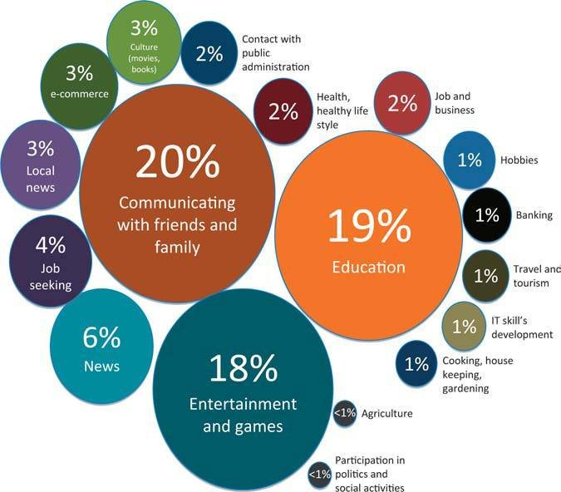

Figure: Use of different internet resources
Source: (Maciej Kochanowicz 2012)

The highest percentage in the image of people using it’s the Communication with friends and family this meaning (WhatsApp, mails, messages and different application to communicate with your family or friends).
Perhaps the communication of family , friends , work coach , universities and many more , are very important because there it’s a highly percentage of us using it as a internet resources no matter what we will use to communicate effectively.

Framework Exemplar to Effective Communication
Claude Elwood Shannon and Warren Weaver: This model was enunciated by Claude Shannon in 1948 and was published with an introduction by Warren Waver. This model provide how the process of the communication it’s elaborated for the facility for analysis and comprehension.
Lasswell, H (1948) said the process of the communication it is formed by means of a series of questions;
- Who says what?
- On what channel?
- To who?
- And with what effect?
Therefore, to each question Lasswell attributes a type of analysis.
- Who: A control analysis
- Says that: A content analysis
- On which channel: A media analysis
For example this had 5 elements-Information Source, Sender, behaves, message, decodes and receiver.

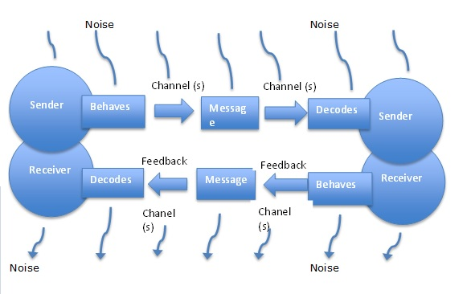
Figure: Effective Communication Model
Source: Tutorials point
This model of effective communication, it is a very productive system as in every industry and in our daily life we follow this system , especially the feedback its received and sent to the sender and once the receiver , receive it , will be modified according to the advice.
Berlo’s SMRC Model of Communication:
In 1960 David Berlo p n 1960, David Berlo postulated Berlo’s Sender-Message-Channel-Receiver (SMCR) model of communication from Shannon Weaver’s Model of Communication (1949). He described factors affecting the individual components in the communication making the communication more efficient.
https://www.businesstopia.net/communication/berlo-model-communication#:~:text=Berlo's%20Model%20has%20mainly%2C%20four,is%20affected%20by%20many%20factors.
The representation of Berlo’s SMC Model, consist in representing different mass communication to improve technical communication in terms of expanded the application to the measurement of human communication. The SMRC Stand for:

S =Source
M= Message
C= Chanel
R= Receiver

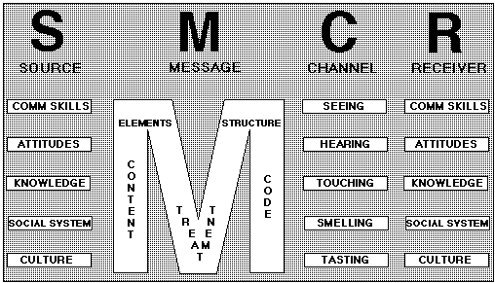

Image: SMRC Model
Source: Berlos model (2012)

Methods of transmission to improve job performance of industrial workers.
For a good work improvement and performance it is very important that the employees can understand what functions and duties they have . The way can be followed, the rules which must be respected and the objectives that they can meet.
A good solution to build the performance of workers is by constantly motivating, and offer support. This can be using different techniques such as delegating greater authority, giving them good responsibilities, rewarding achievements, offering a good work environment.

- The motivation
Motivation on the part of the company, on the part of the worker and the economy. The first and the last would go hand in hand. Money is a factor that motivates workers, and it must also be taken into account if working for objectives.
The adaptation to the work environment;
The adaptation of the worker to the job consists of incorporating in a specific job, the person who has the knowledge, skills and experience sufficient to develop the job with guarantees and who is also motivated and interested in its characteristics.

- To Establish objectives ;
The establishment of objectives is a good technique to motivate employees, since objectives are established that must be developed in a period of time, after which the worker will feel satisfied with having met these objectives and challenges.

- Employee Participation;
For any employee the contribution of planning and practice their tasks
Is very important factor to help and grow the productivity. The participation of members in one business or workplace is the most important key to build successfully a relationship with the environment .

ABSTRACT
The Classic analysis of the work relations starts from the division of functions and the interchanges of material objects. From the perspectives of the theories of human relations , this analysis is approached from the concept of communication as an interchange of messages, according to diverse motivations and using a knowledge elements that both have in common.
References;
Time -Spent Communicating
Adler, R., Rosenfeld, L. and Proctor, R. (2001)
The process of interpersonal communicating (8th edn) https://www.skillsyouneed.com/ips/listening-skills.html

What people do on the Internet;

Maciej Kochanowicz March 2012

SMRC; Berlo’s Model (2012)

http://hyderabad-blues1.blogspot.com/2012/03/hm252083-effective-communication-berlos.html

Effective Communication;
https://www.tutorialspoint.com/effective_communication/effective_communication_models.htm(Models

Pillars of Communication:
Prakash Santhanam (Aug 2018)
https://selfdrvn.com/3-pillars-of-employee-engagement/

Growth Rate of Milkshakes;
Liz Wells (July 2018)
https://www.talkingretail.com/

