BA and Business Environment

LCBB4005 - Dr.Rexon
Radu Claudiu Pintea - 1921951

Table of Contents
Introduction 3
Car Industry in the UK 4
Overview of Land Rover 4
Porter’s Value Chain Model 4
Conclusion 12
References 13

Introduction
This report is mainly based on porter’s value chain model that is divided into two portions and they are primary activities and support activities. In the case of primary activities, it will be tried to represent the collection of raw materials to the distribution of the final products to the customers where Land Rover will be the base of the overall analysis. Then, marketing and sales along with services will be presented considering the case of Land Rover. In the case of support activities, procurement, HRM, R & D, and infrastructure will be analyzed with proper analysis.

Car Industry in the UK
The automotive or car industry in the UK has profound sustainability to conduct its business operations effectively for which the government of the UK has arranged various facilities for a sustainable business environment. Within which, the existing business can grab the market opportunities and needs to envisage economic and political condition of the country that may hinder the path of the businesses to get success and compete with each other but the new business requires lots of money for investing in this sector (Biedenkopf, 2011); that is why it is quite difficult to start a new car business in this sector. Land Rover is such a strong brand name in the automotive or car industry in the UK that has successfully operating its business operations and conducting divergent functions to cope up with the existing market competition.

Overview of Land Rover
This company is very popular in the UK as it has a strong brand image in terms of manufacturing four-wheel vehicles for customers. It is a British-owned car manufacturing company that was introduced in 1948 and related to Jaguar Land; that indicates that Land Rover is owned by Jaguar Land Over where this company is a multination car manufacturing company in the UK (Premium 4x4 Vehicles & Luxury SUVs - Land Rover UK, 2020); before that it was owned by Tata Motors where Land Rovers’ cars are manufactured in different five countries and several models of the cars are assembled under an effective license in divergent locations.

Porter’s Value Chain Model
It is a value chain model that is introduced by Porter to improve an analytic framework that indulges in following divergent independent activities. In this case, this framework considers diversified activities that involve both primary and secondary activities for manufacturing products and services (Al-Shammari and Al-Faqir, 2017). Such as:
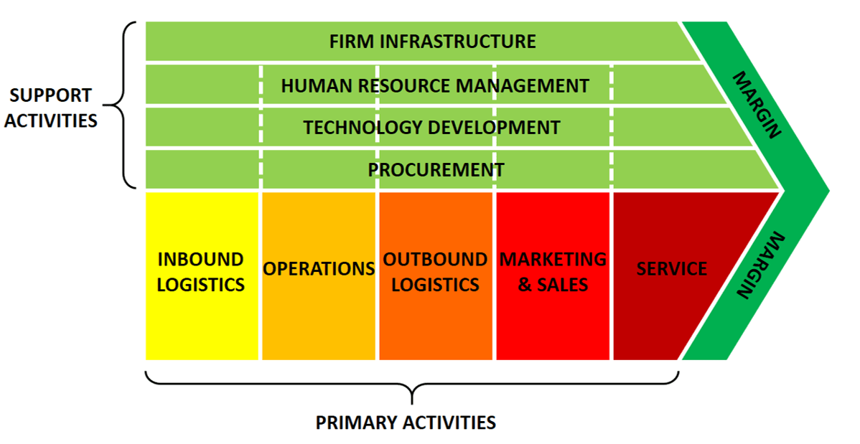
Figure 1: Porter's Value Chain Model
Source: (Al-Shammari and Al-Faqir, 2017)
In this case, it will be tried to present this porter’s value chain considering the case of Land Rover in the UK that is a car manufacturing company. Land Rover remains in the essence of the collection of divergent activities that are utilized for designing, producing products, marketing, delivering products, as well as supporting products or services in terms of reaching those to the customers (Saunders, 2011). The main of using this model will be for manufacturing cars in such a way that will help them acquire greater value or customers compared to the original cost of generating such cars. In this case, such added value will be envisaged as the revenue or profits where this will always be brought under the margin (Madudová, 2017). Moreover, Land Rover can use this model as a systematic way of exploring as well as examining all sorts of internal activities where the company’s management will need to try to make the interaction between such activities and sources of competitive edge in the market (Palewatta and Perrera, 2017). For having a more competitive edge in the car market, Land Rover will have to perform strategically and effectively via cost leadership strategy or differentiation strategy that will put this company ahead than Aston Martin, Bentley, Lotus, and so on. Considering these issues, value
Primary Activities
These activities are considered as the first and foremost activities for any business by considering which they begin manufacturing products and services for the customers. In this case, these primary activities include five major sections and they are logistics of inbound and outbound, operational activities for producing products, promotional activities along with marketing functions that are also related to sales and services (Reimann and Ketchen, 2017). These activities are quite the same for all sorts of industries despite having differences but these need to be conducted efficiently.
Inbound logistic: Kim and Kim (2019) delineated that this type of activity suggests the manufacturing sector of the company where purchase needs to be input, especially it requires the manufacturing department of the company to put their focus on the utilization of raw materials, their proper treatment where these need the importance of the suppliers who will be eligible for supplying raw materials. Land Rover is owned by Jaguar Land Rover where this parent company finds sources from internal and external sources; In the UK, there is a limited number of suppliers that supply automotive components to the local brands. Moreover, China and India also export automotive components to the UK from which companies like Land Rover assembles its sources for manufacturing a brand-new car for the customers. In this case, this company needs to conduct several activities like receiving, storing, as well as disseminating inputs for goods and services (Reimann and Ketchen, 2017). Managers of Land Rover in the inbound logistics functions handle materials for the final product, manage warehousing for storing and reserving assembled raw materials from the effective suppliers, scheduling vehicles, and returning to the suppliers (Thompson, Scott, and Martin, 2017). Car industry must have a lump sum amount for the investment as this inbound cost contains in inbound logistics including transportation costs, storage expenditure, costs for warehousing and delivery of materials to the manufacturing sector where the typical inbound structure looks like:
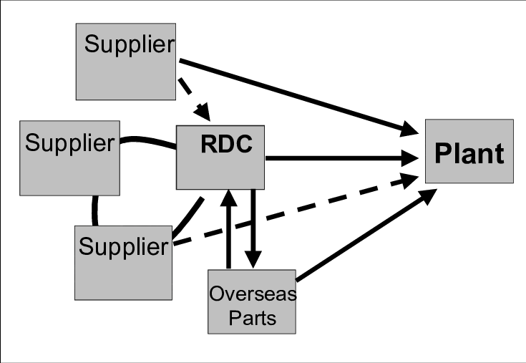
Figure 2: Typical structure of Inbound logistics
Source: (Kim and Kim, 2019)
Operations: After assembling raw materials and delivering them to the manufacturing sector, the company needs to utilize such materials effectively to produce the products (Palewatta and Perrera, 2017). In the case of Land Rover, it is considered as the phase of producing the final products for which the company sends the collected raw materials for producing cars to its factories for manufacturing a final product that can be sold to the customers and the company manufactures its products in different five countries where it aims at produce 1,30,000 cars for the customer per year. Operation managers need to play the role of a leader within the factories who will be responsible for envisaging operational activities for the final products (Smith, 2013). In this case, it is required to machine different equipment appropriately; otherwise, an accident may occur that can be dangerous for the lives of the employees within the factories. Equipment or types of machinery need to be tested and rechecked before using that need proper maintenance. Finally, the final products are packaged along with printing and facility operations for presenting a brand-new car for the customers, and skilled, talented engineers should be appointed for manufacturing world-class cars that can attract the customers easily (Thompson, Scott, and Martin, 2017). In the case of Land Rover that is a subsidiary of Jaguar Land Rover Limited where this parent company produces cars for the subsidiary and for which factories of this company look like:
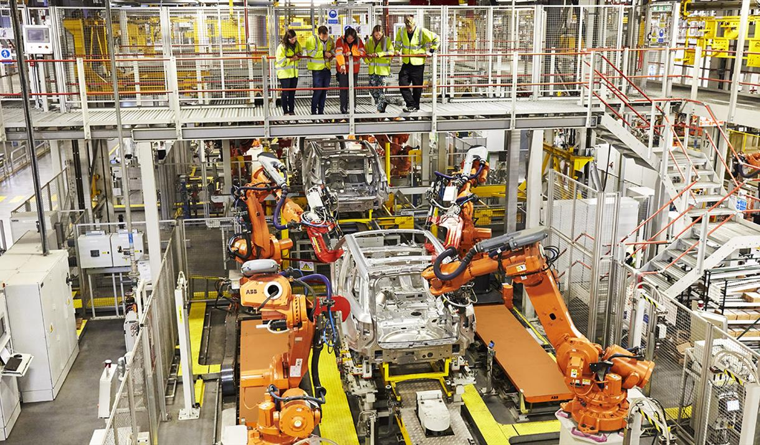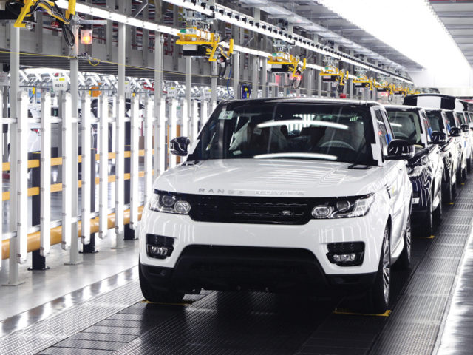
Figure 3: Operational activities in Land Rover in the UK
Source: (Premium 4x4 Vehicles & Luxury SUVs - Land Rover UK, 2020)
Outbound logistic: Bernardi de Souza and Pires (2010) opined that after producing the final product and completing additional features and activities, the company needs to find a way to distributing as well as reaching such final products to the customers where such way is quite dependent on the management how lean the company can be. Besides, the management is also responsible for the shipment of the products and the appropriate storage of such products (Kim and Kim, 2019). The warehouse can be used for the final products also and it is also required to handle materials and deliver vehicle operations where the entire procedure looks like:
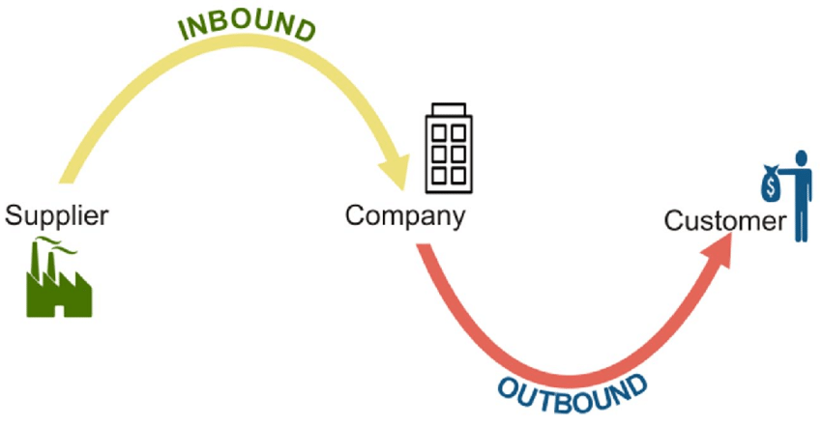
Figure 4: Procedures of outbound logistics
Source: (Kim and Kim, 2019)
In the figure, it has been identified that inbound and outbound logistics are interrelated to each other where business operations remain in between these two activities. After collecting raw materials, such materials are sent to the factories for manufacturing final products, considering the case of Land Rover, or producing a brand-new car that is packaged, and sent to the warehouses for being sold (Reimann and Ketchen, 2017). Land Rover has several logistics centers in five countries around the globe and ships the cars from the warehouses after being manufactured or distribution centers where this company has adopted a lead in terms of utilizing in-vehicle technology (Smith, 2013); as well as connectivity for developing outbound visibility where it looks like:
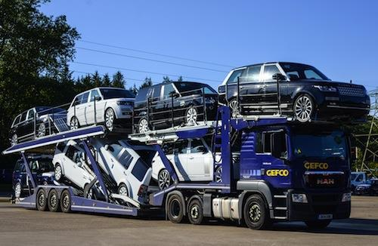
Figure 5: In-vehicle technology and connectivity for outbound logistics of Land Rover
Source: (Smith, 2013)
This company is now exporting its vehicles to around 150 markets around the world that have increased its sales turnover rate by 8-20% (Saunders, 2011).
Marketing and sales: The effectiveness of inbound and outbound logistics solves half of the problems for Land Rover; that is why is the company has successfully maximized its sales turnover. But this will not ensure that the company can keep and sustain this rate for a long period for which the company also needs to ensure effective marketing strategy along with the quality and effectiveness of the cars (Kotler, Armstrong, Harris and He, 2019). This company is recognized as a global brand that brings lots of marketing strategies for increasing sales in terms of sustaining its competitive edge in the market where it uses selecting targeting strategy; that means the company promotes its products to a particular group or section. After its successful 60 years in the automotive industry of the UK, this company has started raising awareness of its all-new cars via using a social media, name ‘YouTube’ and successfully assembled and created intense exposure to over 23 million users in that social media within 24 hours (Saunders, 2011). At the end of the day, it has achieved a 3.65% engagement rate wherein North America, it has budgeted for advertising, promotion, sales, and so on.
Services: Like other car companies, land Rover also tries to manage its customers so that it can fulfill the customers’ complaint within the period. This company considers customers’ complaints consider as the feedback for developing its products’ quality, effectiveness, as well as efficient services to the customers and this aids them in retaining customers and making the customers loyal, especially those who visit the company stores frequently (Thompson, Scott and Martin, 2017). In this car company, it has been identified that customers put complaints about repairments of their cars or suppling parts of the automotive components.
Support Activities
Al-Shammari and Al-Faqir (2017) stated that support activities are mainly used for providing aid to the primary activities; that means these additional but supporting activities are accomplished for ensuring the effectiveness of the primary activities where support activities include procurement, research, and development, HRM, firm’s infrastructure.
Procurement: This is such sort of activities under support activities that include purchasing inputs, that are used in the firm’s value chain system (HITT, 2011). These purchase inputs are mainly used for manufacturing final products that require raw materials, supplies, as well as consumable factors including machinery, equipment used in the laboratory, relative equipment and buildings where manufacturing activities are conducted (Bernardi de Souza and Pires, 2010); In Landrover, it is found that procurement is usually used for assisting value chain activities.
Research and Development: For maintaining the brand image, well-established companies need to consider exceptional engineering and technology for attracting and satisfying the customers’ needs (Biedenkopf, 2011). In this case, the company, like land Rover needs to invest a good amount of money for its research and development sector for ensuring exceptional engineering for the company where its global research and development as well as engineering capability can ensure such effectiveness and quality of the product.
HRM: Land Rover follows the international standard for recruiting and selecting an appropriate candidate for itself, especially the company hire a high-skilled and talented engineer for itself so that they can add value to the research and development of the brand and maximize brand value for the company (Madudová, 2017).
Infrastructure: For having quality products and proper time management, the company has been operating its business functions in divergent countries in different continents around the world including the south and north America, Asia, Australia, and Slovakia. International financing and accounting system can ensure appropriate overhead costs for overall infrastructure; for which it has successfully arranged the brand as an impressive presence in most of the parts of the world where it has generated employment for lots of people around the world (David, 2013). In its product lifecycle management, the company has used a proposed data-sharing standard for the development within the product lifecycle management.

Conclusion
Across this segment, it has been tried to discuss the company, Land Rover, and its primary and support activities. Primary activities included inbound logistics, operations, outbound logistics where the company assembles raw materials from different countries, then sends them to factories located in five different countries where cars are manufactured. After packaging such final products, the company uses in-vehicle technology as well as shipment to distribute such cars to the customers across the globe. It has adopted social media for promoting its products and considered feedback services for improving the services of the customers where the company uses support activities for strengthening its primary activities that include procurement, HRM, research and development, and infrastructure.

References
Al-Shammari, E., and Al-Faqir, T., 2017. Analysis Support Activities Value Chain Model to the Porter and Impact on the Knowledge Department. Iraqi Administrative Sciences Journal, 1(1), pp.60-86.
Bernardi de Souza, F., and Pires, S., 2010. Theory of constraints contributions to outbound logistics. Management Research Review, 33(7), pp.683-700.
Biedenkopf, K., 2011. Mikler, John. 2009. Greening the Car Industry: Varieties of Capitalism and Climate Change. Cheltenham, UK: Edward Elgar. Global Environmental Politics, 11(2), pp.129-131.
David, F., 2013. Strategic Management. Old Tappan: Pearson Education UK.
HITT, M., 2011. RELEVANCE OF STRATEGIC MANAGEMENT THEORY AND RESEARCH FOR SUPPLY CHAIN MANAGEMENT. Journal of Supply Chain Management, 47(1), pp.9-13.
Kim, J., and Kim, S., 2019. Investigating the Effects of Inbound Logistics Models on the Logistics Performance. Journal of the Korean Society of Supply Chain Management, 19(1), pp.57-70.
Kotler, P., Armstrong, G., Harris, L., and He, H., 2019. Principles Of Marketing. Harlow, United Kingdom: Pearson Education Limited.
Landrover.co.uk. 2020. Premium 4X4 Vehicles & Luxury Suvs - Land Rover UK. [online] Available at: <https://www.landrover.co.uk/index.html> [Accessed 22 August 2020].
Madudová, E., 2017. Creative industries value chain: The value chain logic in supply chain relationships. Marketing and Branding Research, 4(3), pp.227-235.
Palewatta, I. and Perrera, H., 2017. Inventory Optimization using ERP to reduce final product lead time, Inventory value an inbound logistics cost for MTO, FMCG Company. International Journal of Multidisciplinary Studies, 3(2), p.53.
Reimann, F., and Ketchen, D., 2017. Power in Supply Chain Management. Journal of Supply Chain Management, 53(2), pp.3-9.
Saunders, D., 2011. Jaguar Land Rover goes for speed. Strategic HR Review, 10(1).
Smith, N., 2013. Classic projects: Land Rover Series 1. Engineering & Technology, 8(5), pp.100-101.
Thompson, J., Scott, J., and Martin, F., 2017. Strategic Management. Andover: Cengage.

