Additional File

- Reflected Cross Site Scripting in Multiple Pages

Proof of vulnerability: -

The attacker can inject JavaScript code sent in URL directly to html code which will be executed.

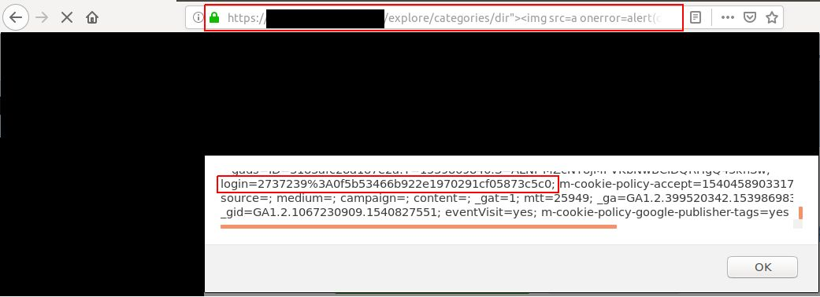

- SMTP Server without authentication

Proof of vulnerability: -

Attacker has connected to the server without authentication and successfully sent email from pentest1@service1.com to pentest2@service1.com.

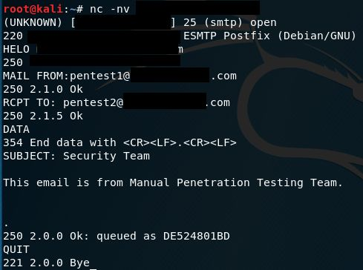

- Password Brute Force Allowed

Proof of vulnerability: -

User is not locked after 65 attempts of password enumeration and successfully logged in after it.

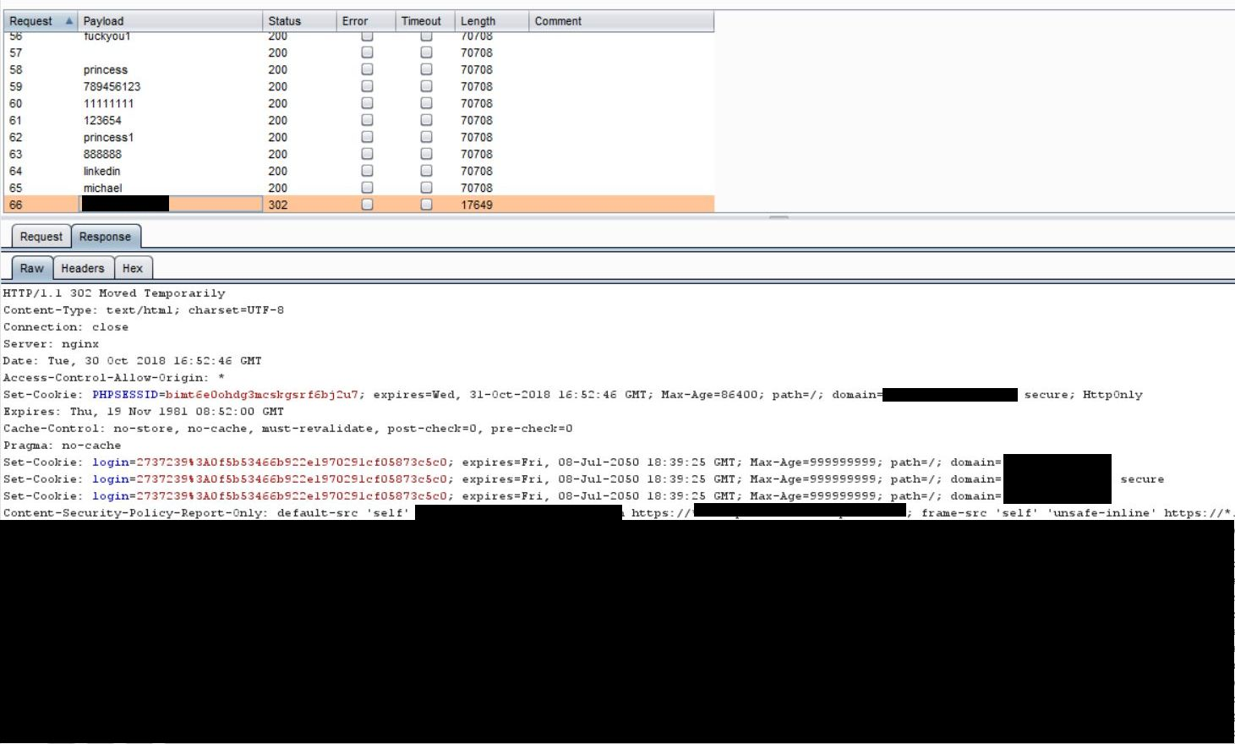

- Session Fixation

Proof of vulnerability: -

Request made after Logout with the same cookie value.

curl -i -s -k -X $'GET' \
-H $'Host: www.client.com' login=2737239%3A0f5b53466b922e1970291cf05873c5c0​; ' -H $'X-Forwarded-For:
spoofed.s6zuzg64yc4wqc6vs0nxrfqjmasci86x.burpcollaborator.net' \
-b $'login=2737239%3A0f5b53466b922e1970291cf05873c5c0' \
$'https://www.client.com/member/account-preferences'

- Weak Account Preferences Update functionality

Proof of vulnerability: -

User can update email and password without any authorization whether user is account owner.


