
Technology-based tools, techniques and methods to manage the performance of remote workers
Essay
Milena Adzhemova (2129045) | 12/21/23 | Managing People

Contents
Technology in appraising the perform in remote workforce 2
Advantages in using technology in appraising the perform in remote workforce 3
Disadvantages in using technology in appraising the perform in remote workforce 3
Four performance measurement methods for remote workforce 4
Measuring Reply Time 5
Time for completing a task 5
Skill and knowledge retention 5
Reaching Goals 6
Four performance appraisal tools for remote workforce 6
Performance appraisal 7
Productivity test 7
360-degree feedback 8
Management by objectives 8
Reference: 10

Technology in appraising the perform in remote workforce

(businesslink.co.za, 2020)

Every business with a structured approach, require functioning appraisal of workers. This became even more essential after the world accept remote work.
Functional appraisal assists for getting realistic estimation of remote work policy accomplishment. Furthermore, it gives clear picture of examining input and output, generating a performance revision, highlight the area for improvement, present new initiatives from remote workforce, and gives a clarity in finding efficient way of growth remotely.
Performance appraisals is connected with the psychologist Walter Scott, and it is appeared in the first twenty years of last century, when he displayed his idea of assessing the capabilities of the workforce. (Chernets, 2022)
According to Sahu (2021) machinery is refine the evaluations. Accurate presentation judgment approach could upgrade worker presentation in the organization. The technology penetrates features of the function of HR, and talent specialists use these upgraded technologies to computerize their tasks. Automation penetrates performance evaluation procedure. Technology replaces the human interposition in starting the procedure and measure it to be done on time. It has a crucial role in heaving performance information, sets performance points, highlights the high-performance culture, compare with the targets, and make classifications. Technologies make the process simpler, as it helps in worker performance reviewing, goal orientation and receiving feedback. Furthermore, the managers can save time because they will see all reports in the system, they will discuss with employee tasks and performances for bigger periods of time and on this way, they will have more time for their daily duties and will achieve better results.
According to The Benefits and Risks of Using Technology for Performance Appraisals (2023) there are several advantages and disadvantages using technology appraising in performance in remote workers:

Advantages in using technology in appraising the perform in remote workforce
- Streamlining the process
Streamlining make the performance estimation more effective, save time, make the procedure simpler and reduce errors in manual processing.
- Real-time feedback
Getting access to digital track record the employees can see their goals and development over the time, that make them more motivated and engaged with their job. Real-time feedback promotes a culture of high-performance and give to workers feedback and adjustments during their work.
- Improve accuracy
Technology guarantee that estimations are created more on objective than subjective criteria. It helps in eliminating the biases and receiving better bonus, promoting, and learning decision, bast on better accuracy.

Disadvantages in using technology in appraising the perform in remote workforce
- User training is required.
The employees need definite ability and understanding to use the tools. It is necessary they to be trained, in other case they will start to feel uncomfortable and confused. This will affect their performing.
Additionally, wrong used tools will cause not accurately assessment.
- Data privacy
Collect and store big data for employees can cause workers to be anxious how their data will be used, and this can disrupt their trust in the company.
Furthermore, the workplace productivity and culture can be affected. To eliminate this risk the company, have to ensure data policy protection on its employees.
- Potential biases
The algorithms can increase any biases, causing from incorrect or defect data. It is necessary the managers to examine the algorithms for mistakes, before to take decisions, based only on systems outcomes.

Four performance measurement methods for remote workforce

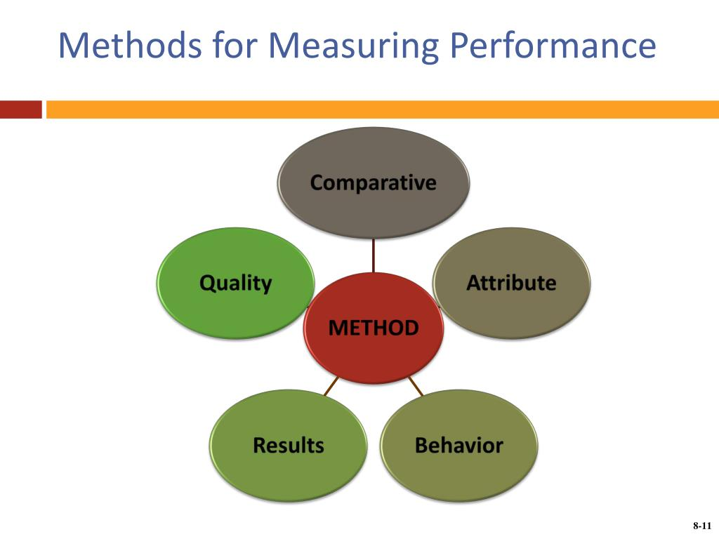
(slideserve.com, no date)
The productivity is not how many hours the workers spend in their workplace, it is how much they produce and how high is their performance. After Covid 19 pandemic frequent practice became to work from home and hybrid-team options. This sets new trial in front of the managers how to measure the employee performance and especially for remote workforce.

According to Duran (2021) the companies alarmed that working from home will impact negatively the operative performance. Because the employee is far away from the office this bring the need from tracking monitoring software for remote workers.
Opposite on the expectations productivity of working remotely is increased.
Instead to look all the time how the members of staff doing their job, nowadays managers use Key Performance Indicators to measure how they achieve company’s goals and improve their self.
But to be effective KPIs have to be well specified and not too many.

Here will be explain four methods /PIs/for improving remote workforce efficiency:

Measuring Reply Time
When the employer work from home he still has to be in touch with
his customers, managers, and colleges. The regular updates are especially important and corresponding with email, video or chat must be respectful, short and clear.
To verify how well the operatives communicate with each other, or with their clients is to measure their reply time, how quick they answer on calls or emails. Could be ask their customers or colleagues. To long reply time can cause less productivity for the company, so this measure will help this problem to be solved.

Time for completing a task
The control and supervising in the office are not priority now for the businesses. The workers and especially these who work from home are more independent and supervise themselves. They have to be able to finish their task on time. This KPI can be measure with target how many tasks every employer will have, for example how many phone calls and emails, have to be answered, how many presentations to be done, etc.
The worker from home can have difficulties with his remote working, good help for him it will be if a big project is separate on smaller pieces, if he uses better app for better productivity, changing work hours and more.

Skill and knowledge retention
The remote workers do not have the same tools at home as in the office, they also do not have opportunity to ask college, next to them for advice or support. Important skill in this case is they to adapt quickly in different environments. To improve their work will be required to learn new technology or to develop new tactic. Even excellent in theory they have be able to keep their knowledge in different environments and this is not easy to be saw by the manager. One technique to be checked this ability is the worker to use new skills, as creative collaboration tools for making a presentation. How confident will be now and after period of time. This could be done with online seminar platform or similar applications. It is great when the manager believes in the knowledge of his employees. To encourage someone is better than to be critical. Very frequently they found alone their mistakes.

Reaching Goals
Setting a goal gives opportunity for feedback and motivation for better accomplishment. It involves the workforce to the company with weekly goals can be tracked worker performances.
Examples of evaluation goals examples are productivity, motivation, education, problem solving, organization, communication, leadership, time management, customer satisfaction, company capabilities and many more.
Placing work goals admits time for reflection in work presentation and set profession goals.
SMART is coming from the first letters of
Specific,
Measurable,
Achievable,
Relevant,
Time-based.
(Herrity,2023)

Four performance appraisal tools for remote workforce
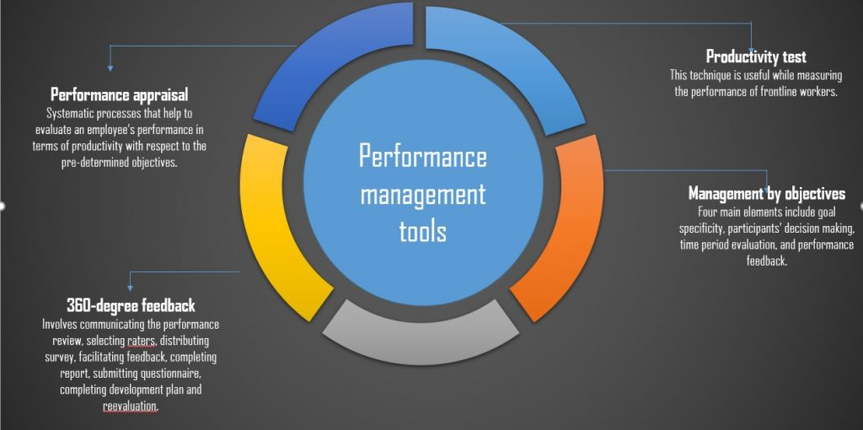
(projectguru.in, 2020)

Performance appraisal
According to Andreev (2023) this is an employee’s job evaluation for a period of time, based on the expectation of the organization. It includes core competencies and specific competences. The performance appraisal will show the workers helpful feedback from the evaluation and give them information for improving their work. In the same time the managers can see the employees potential and their skills
Advantages for the organization
Workforce appraisal will make a change in the performance of a corporation. They visualise how workers are corporate and enable organizations to:
- Show the points, which can be improved from the employers for better quality and performance.
- Find issues in the behaviour before to be affected sector productivity.
- Motivate the workforce to show their skills and talent.
- Strengthen employees to develop their career and skills.
- Develop tactical decision-making.

Advantages for the workers
Performance evaluation deliver a positive result for employees. It is helping in:
- Recognition of the employee’s accomplishments and contributions.
- Recognition of the chance for bonus or promotion.
- Recognition and supporting the demand for employee’s education and training for development.
- Finding out the areas where talents to be improved.
- Motivating workers and advance their development.
- Discus worker’s long-term aims.
Performance appraisal is constructive response, and it is important to be used polite words and behaviour.

Productivity test
Productivity testing is software testing. It takes information from multiple data or from one source.
Matching to Geeks for Geeks, (2023) the aim of this testing is to indicate the quality, software testing progress, overall health, and productivity. It raises the effectiveness of testing process and help to be taken better conclusions in upcoming tests. Test metrics find what kind of improvements are needed to be build software program with high quality and without defects. It inspects the existing procedure or technology for necessary changes and evaluate in every phase of testing how much will cost and evaluate the schedule of the project. Geeks for Geeks, (2023) shows three groups of software metrics:
- Processes metrics – main for SDLC /Software Development Life Cycle/
- Product Metrix – analyse product quality, design, size, and performance.
- Project Metrics – value the overall quality of the project, find out the productivity, cost, and errors.

360-degree feedback
This is feedback, based on customers, vendors, supervisor, colleges from worker department and they can come from outside or inside the organization. This is usually anonymous survey. Businesses, which uses 360-degree feedback receive larger range of response and their decisions are more accurate and valuable. Getting feedback from many resources reduce the chance the survey to be unfair, because of individual bias.
Gathering the information from 360 feedback it is separate in several types: workplace perception, behaviour and competences, soft skills, unresolved issues.
There are some limitations in using this feedback:
- Employees performance objectives
- Basic job requirements
- Technical competences and skill
- Performance metrics (Indeed.com,2022)

Management by objectives
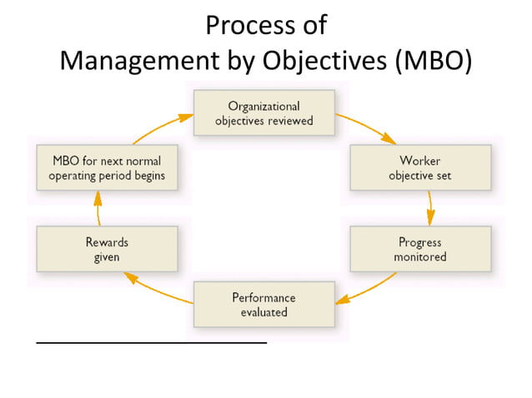
(slideshare.com, no date)

This is a process, where worker and manager accept performance aims and after that they plan to achieve them. It is strategic management model and improves company performance, based on clearly defined objectives. MBO encourage participation and commitment with workers and supporting organisation’s objectives. (Hayes, 2023)
There five steps in MBO:
- Define objectives.
- Share the objectives with workforce.
- Advance workers to participate.
- Monitor the progress.
- Estimate the performance and reward the success.
The critics claim that Management by objectives cause the workers to try to get to the goals, even sometimes for company’s price.
Covid 19 changed the world, for better or worse the life will never be the same as before the pandemic. The people and the companies must adapt to the fast-changing environment. Remotely workforce has enormous capability, but the people who work from home should use the performance appraisal methods and tools to be enough confident in their job.

Reference:
Ayling, J. (2020) '5 Examples of Employee Evaluation Forms for Remote Work,' Performance Review, 24 September. https://www.peoplegoal.com/blog/5-examples-of-employee-evaluation-forms-for-remote-work (Accessed: December 21, 2023).
Chernets, A. (2022) Performance Appraisal: Methods and tips for Evaluating Remote employees. https://blog.tmetric.com/7-tips-for-performance-appraisal-of-remote-workers/#:~:text=For%20a%20higher%20chance%20of%20success%20in%20performance,remote%20communication%20to%20a%20new%20level%20of%20efficiency.
Characteristics of homeworkers, Great Britain: September 2022 to January 2023 (2023). https://www.ons.gov.uk/employmentandlabourmarket/peopleinwork/employmentandemployeetypes/articles/characteristicsofhomeworkersgreatbritain/september2022tojanuary2023 (Accessed: December 21, 2023).
Employee Performance Appraisal (2020). https://www.inc.com/encyclopedia/employee-performance-appraisals.html (Accessed: December 21, 2023).
Measure Performance: Strategies for Remote and Hybrid Teams (2021). https://www.gallup.com/workplace/341894/measure-performance-strategies-remote-hybrid-teams.aspx (Accessed: December 20, 2023).
Sahu, A. (2021) How technology is redefining the future of appraisals. https://hr.economictimes.indiatimes.com/news/workplace-4-0/performance-management/how-technology-is-redefining-the-future-of-appraisals/82080889 (Accessed: December 21, 2023).
The Benefits and Risks of Using Technology for Performance Appraisals (2023). https://www.linkedin.com/pulse/benefits-risks-using-technology-performance (Accessed: December 21, 2023).
Performance appraisals help company and employee - Business Link (no date) businesslink.co.za. https://businesslink.co.za/wp-ontent/uploads/2020/09/performance-appraisal.png.
Duran, V. (no date) 5 KPIs That Measure Remote Employees’ Productivity. https://blog.deliveringhappiness.com/5-kpis-that-measure-remote-employees-productivity (Accessed: December 22, 2023).
Herrity, J. (2023) 45 Work Evaluation Goals Examples. https://www.indeed.com/career-advice/career-development/work-evaluation-goals-examples (Accessed: December 22, 2023).
Methods for measuring performance (no date) slideserve.com. https://image3.slideserve.com/5600167/methods-for-measuring-performance-l.jpg.
Andreev, I. (2023) Performance Appraisal. https://www.valamis.com/hub/performance-appraisal#The%20Purpose%20of%20A%20Performance%20Appraisal (Accessed: December 22, 2023).
What is 360 feedback? (with examples, benefits and FAQs) (2022). https://uk.indeed.com/career-advice/career-development/360-feedback#What%20Information%20Can%20360%20Feedback%20provide? (Accessed: December 22, 2023).
GeeksforGeeks (2023) Software Testing Metrics its Types and Example. https://www.geeksforgeeks.org/software-testing-metrics-its-types-and-example/.
Process of Management by Objectives (MBO) (no date) slideshare.com. https://image.slidesharecdn.com/planningasafunctionofmanagement-170424144315/85/planning-as-a-function-of-management-19-638.jpg?cb=1666109840.
Hayes, A. (2023) Management by Objectives (MBO): Learn its 5 steps, pros and cons. https://www.investopedia.com/terms/m/management-by-objectives.asp#:~:text=Management%20by%20objectives%20%28MBO%29%20is%20a%20process%20in,an%20organization%20and%20boost%20employee%20participation%20and%20commitment.

