Programme: BA SOTAH – International Hotel Management
Module name: Financial Management for the Hotel Industry
Module Code: BMIH5007
Student name: FAHIMA AKTER
Student ID: 2013107

Contents
Introduction 3
Understanding of Traditional Budget and Zero Based Budget 4
Process for Preparing Zero Based Budget and its implementing method 6
Budgeting Control Support Sustainability 8
Conclusion 8
References 9
Appendix 11

Introduction
The act of preparing a budget is referred to as budgeting. The term "budgeting" is used to characterize the process ( (Phaup, 2020)). Numerous businesses have specialized departments that are entirely responsible for the preparation and implementation of their budgets.Corporate budgets are important. Every phase of decision-making, planning, and coordinating involves budgets or plans. It helps management communicate with and lead the team by outlining the company's goals and direction. There are four types of Budgeting (Florida, 2018). They are given below.

Figure one: Types of Budgeting (Florida, 2018)

Understanding of Traditional Budget and Zero Based Budget
Traditional Budget
The budget from the previous year is used as the basis for the traditional method of budget construction, which is known as "traditional budgeting." The budget for the current year is constructed from the budget for the previous year, with necessary adjustments made for things like inflation, consumer demand, market circumstances, and other elements (Wildavsky, 2021). The income and spending of the previous year have had a significant impact on the budget for the current year. Only those parts of the budget that represent an increase from the prior year's allotment need to be justified.
Advantages of Traditional Budgeting
The advantages of Traditional Budgeting are given below:
- Implementation:The procedure is straightforward and easy to carry out. In addition, the budget for the year before may be created in a shorter amount of time since it requires fewer changes than the budget for the current year (Phaup, 2020). As a result of this, managers will enjoy significant benefits in the long term.
- Stability:Numerous businesses stick to this method of budgeting since it's proven effective. Since of this, the operational stability of an organization is improved because all of its financial activities are coordinated and everyone is aware of their respective duties (Wildavsky, 2021).
- Consolidation:When using the traditional method budgeting, a number of separate projects of a smaller scope might be rolled into a single endeavour that covers greater ground. This enhances the performance of those efforts that were doing poorly prior to being integrated with a project that was already in progress (Florida, 2018).
Zero Based Budgeting
According to what the name suggests, zero-based budgeting does not take into consideration any sort of beginning point when establishing a budget. When a new budget is created, each and every expense is taken into consideration and accounted for. In zero-based budgeting, there is no point that serves as the starting point (Ibrahim, 2021). Before a budget can be allotted, each and every expense needs to be carefully examined and analysed in depth.

The advantages of Zero Based Budget are given below.
- Focus on the Process of Making a Decision:The traditional method of budgeting involves taking into consideration the whole amount of money that will be spent. On the other hand, the "why" strategy uses a budgeting approach known as zero-based budgeting. It goes right down to the core of the issue. The accomplishment of the organization's objectives is the objective of the zero-based budgeting method (Ogden, 2020). When using a zero-based approach to budgeting, the outcomes of previous years are completely disregarded.
- Resource Allocation in a more efficient manner: Increasing a company's profitability should be the ultimate objective of every business since this will result in an increase in the wealth of the company's owners (Marpaung, 2020). A budget based on zero based budgeting helps get us closer to achieving this aim. When an organization implements zero-based budgeting, the resources it has are distributed in the most effective and efficient manner possible.
- Improvements for the next term: The procedure for developing a budget using a zero-based starting point always begins with the same presumption: there will be no reference to any previous period (YemaneWolde-Rufael, 2017). Each division of the organization is responsible for performing an annual cost analysis of the company. They make certain that Zero Based Budgeting includes just those charges that are both necessary and advantageous to the organization.

Process for Preparing Zero Based Budget and its implementing method
The Zero-Based Budgeting method has a few amounts of steps and if one wants to prepare a zero-based budget, then he or she has to follow the steps must (Ma, 2019). Here in the below have gone the steps in details:
The Steps for preparing a Zero Based Budget is shown is a chart below with its details:

Figure Two: Process of Zero Based Budget
Identification of Decision Unit: In the process of zero-based budgeting, the first and most important step is to determine the decision unit. A decision unit may consist of a single activity or a series of connected behaviours that may be broken down into their component parts independently. An activity is considered to be autonomous if it can be carried out by its participants independently of any other activities. Because of this, every single one of the decision units will operate independently from one another (Yue, 2020). Within an organization, there may be multiple different decision-making units. Every one of these divisions—marketing, production (which includes human resources), research and development, and so on—is a decision-making unit that contributes to the overall cost of the product. The arguments for the budget are highly dependent on the completion of this stage. The board of directors requires the managers of the decision unit to defend their expenses and the budget allotments they were given (Schmeiser, 2020). The manager's argument should not be able to be supported by either the budget from the previous year or the expenditures made by his decision unit in the previous year. Because zero-based budgeting starts from scratch, the justification for the forthcoming financial obligation must likewise be brand new.
Making Decision Packages: In this stage, the larger decision units is from the previous phase are broken down into several smaller decision packages. These decision packages have to be in line with the objectives set forth by the firm. Every decision package may be viewed as a separate request for funds that also functions as an argument (Gajowniczek, 2020). Each decision package includes a synopsis of the functions, operations, and operations of the proposal, as well as the need for the proposal, the economic and intangible benefits it would provide, and the opportunity that would be missed if funds were not awarded.
A general decision making includes the following information:
- The reason for the decision package's existence.
- The aims and objectives of the larger decision-making unit to which it belongs.
- The decision package's aims and goals.
- Analysis of why it's necessary to complete the work.
- The evaluation of the task's technical and operational feasibility.
- Considering other options for action.
Ranking Decision Making: Third step of zero-based budgeting. Decision packages and units are prioritized at this level. Prioritizing decision packages maximizes limited resources. Decision packages are ranked by cost-benefit from least to most beneficial. During this procedure, all alternatives are assessed to determine the best and most cost-effective. Top management must approve a decision package (Lewan, 2020). Only those decision packages help the organization reach its goals. Management ensures that decision-package costs are accurate and realistic.
Allocating Available Resources:This is the following step, and it continues the process of zero-based budgeting that was started in the stage before this one. The decision packages that were previously rated now each have a certain amount of cash assigned to them. Therefore, decisions pertaining to finances are decided at this period (Ibrahim, 2021). When it comes to assigning financial and human capital resources, decision packages are prioritized according to their level of significance. More money is allocated to decision packages that have a better chance of being implemented successfully. As a direct consequence of this, limited resources are used to their utmost capacity.
Controlling and Monitoring:The planning for the zero-based budgeting process has reached its conclusion. During this phase, the performances of the decision packages as well as the output they produce are monitored and evaluated (Phaup, 2020). Measuring the performance of decision packages enables management to ascertain whether or not the distribution of resources has been done accurately.

Budgeting Control Support Sustainability
Budgeting is a vital tool for achieving and maintaining sustainable growth. In addition to this, budgeting ensures that the money and resources available to the organization are utilized to the best of their abilities.The process of determining the degree to which an organization's actual performance deviates from its budgeted performance is known as budgetary control. This process begins with management establishing a budget (Gajowniczek, 2020). The management team may utilize these budgets to monitor and keep tabs on the numerous expenditures that take place over the course of a certain accounting period. Through Budgeting control, a company can focus on the future goal and also can plan its strategy. Also through the budgeting control a company can maintain its operational control, Cash flow control and cash expenditures (Ibrahim, 2021). Brown and Howard's method of cost management, which they refer to as "Budgetary control," entails developing budgets, coordinating departments, creating roles and tasks, and then comparing actual outcomes to the ones that were planned in order to achieve maximum profitability (Marpaung, 2020).

Conclusion
The management of a company's budget has a significant impact not only on its day-to-day activities but also on its long-term prospects. It is possible for it to help manage expenses and improve efficiency provided that it is positioned in the appropriate place. In addition to it, there are other variables to consider, such as the conventional pricing (Ogden, 2020). Through the budgeting control a company a company can reach to its goal in a fluent way. So Budgeting Control has an important effect on a company’s sustainability and its effectiveness.

References
Florida, R., 2018. The Distribution of budgeting. Public Budgeting &amp; Finance, 3(8), p.847.
Gajowniczek, K., 2020. Interactive Decision Tree Learning and Decision Rule Extraction Based on the ImbTreeEntropy and ImbTreeAUC Packages. Processes, 8(4), p.7.
Ibrahim, M., 2021. Designing zero-based budgeting for public organizations. Problems and Perspectives in Management, 1(5), p.321.
Lewan, T., 2020. Zero based budgeting defines OR goals. AORN Journal, 2(5), p.263.
Ma, J., 2019. Zero-based budgeting in china. Journal of Public Budgeting, Accounting &amp; Financial Management, 1(5), p.471.
Marpaung, A., 2020. Comparative Analysis of Share Price, Company Value, and Company Profitability. Journal of Economics, Finance And Management Studies, 7(5), p.834.
Ogden, D., 2020. Beyond Zero Based Budgeting. Public Administration Review, 3(8), p.435.
Phaup, M., 2020. Budgeting for Mandatory Spending. Public Budgeting &amp; Finance, 3(3), p.2.
Schmeiser, S., 2020. Corporate Board Dynamics: Directors Voting for Directors. SSRN Electronic Journal, 4(7), p.98.
Wildavsky, A., 2021. A Budget for All Seasons? Why the Traditional Budget Lasts. Public Administration Review, 3(6), p.98.
YemaneWolde-Rufael, 2017. Company Goals. The Journal of Developing Areas, 4(2), p.189.
Yue, Z., 2020. Application of the projection method to determine weights of decision makers for group decision making. ScientiaIranica, 1(5), p.87.


Appendix

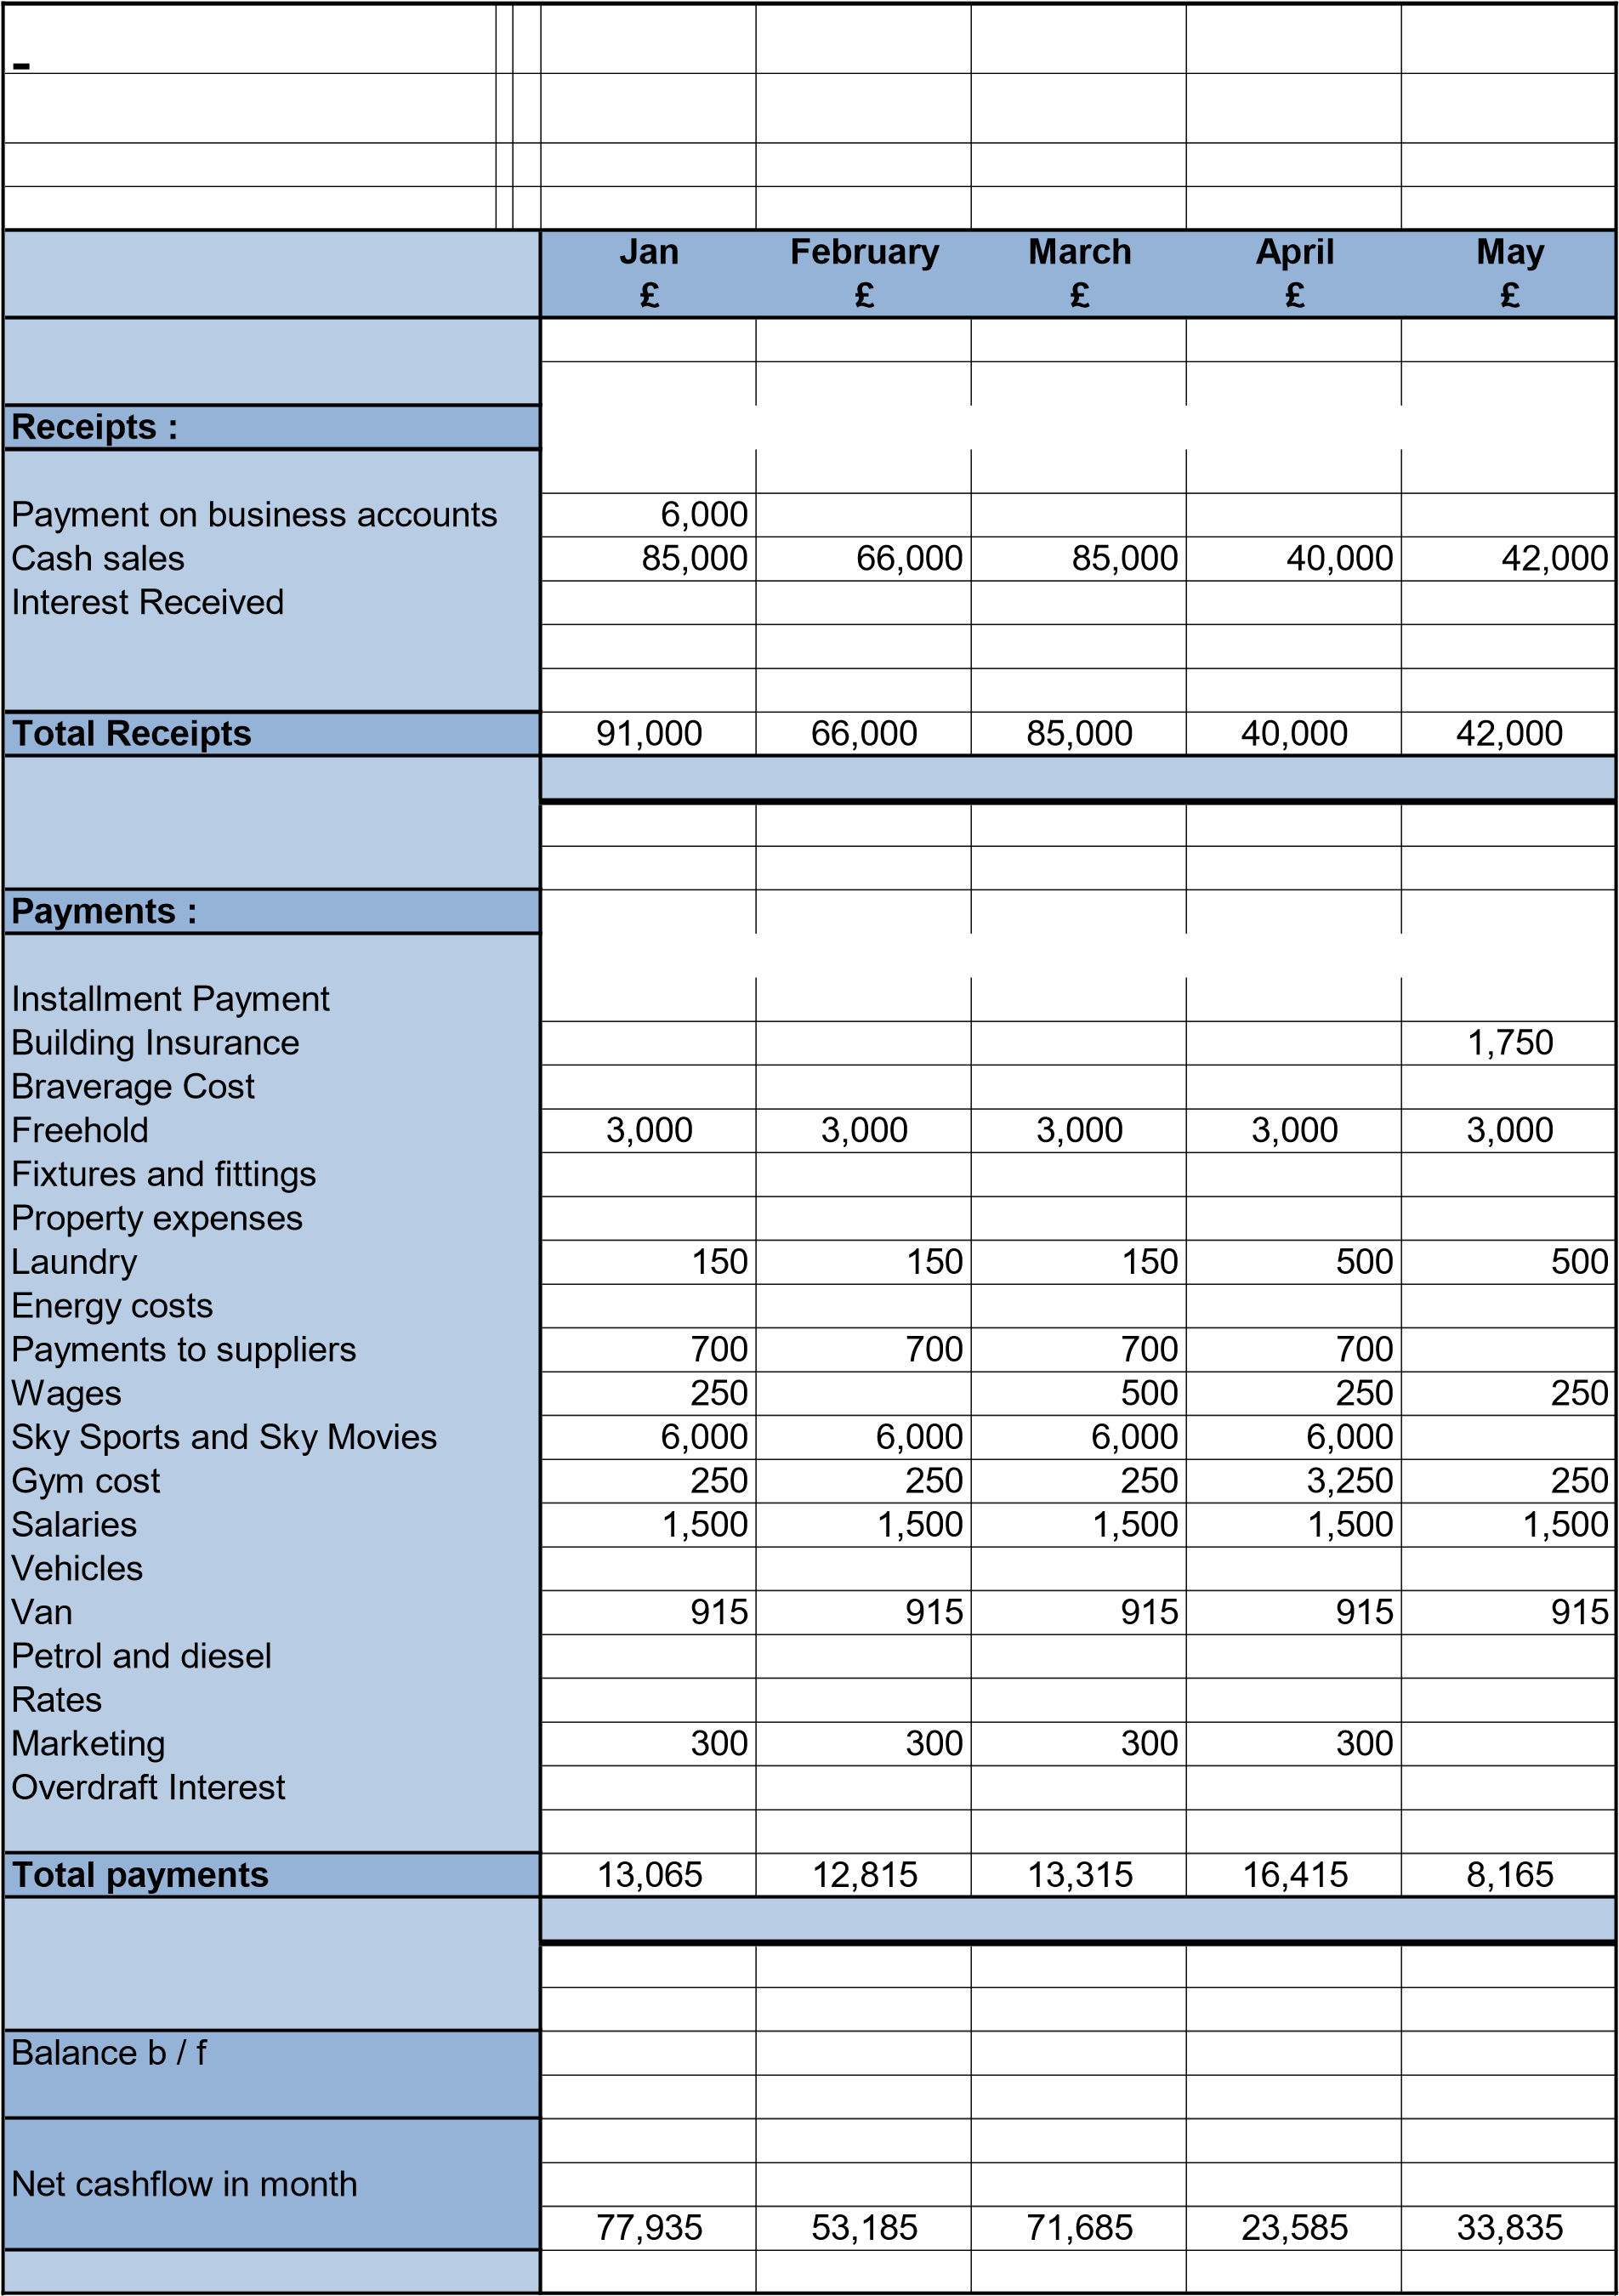

Balance c / f |  |  | 77,935 | 53,185 | 71,685 | 23,585 | 33,835

June July |  | August | Sept | Oct | Nov | Dec Total
£ £ |  | £ | £ | £ | £ | £ £
 |  |  |  |  |  |  | 6,000
49,000 | 56,500 | 66,900 | 74,000 | 49,000 | 50,900 | 50,800 | 664,300
 |  |  |  |  |  |  | 0
 |  |  |  |  |  |  | 0
 |  |  |  |  |  |  | 0
49,000 | 56,500 | 66,900 | 74,000 | 49,000 | 50,900 | 50,800 | 670,300
 |  |  |  |  |  |  | 0
 |  |  |  |  |  |  | 0
 |  |  |  |  |  |  | 0
 |  |  |  |  |  |  | 0
 |  |  |  |  |  |  | 0
 |  |  |  |  |  |  | 0
1,750 | 1,750 | 1,750 |  |  |  |  | 7,000
 |  |  | 2,500 |  |  |  | 2,500
3,000 | 3,000 | 3,000 | 3,000 | 3,000 | 3,000 | 3,000 | 36,000
 |  |  |  |  |  |  | 0
 |  |  |  |  |  |  | 0
150 | 150 | 150 | 150 | 150 | 150 | 150 | 2,350
 |  |  |  |  |  |  | 0
700 | 700 | 700 |  | 700 | 700 | 700 | 6,300
250 | 250 | 250 | 250 | 250 | 250 | 250 | 2,750
6,000 | 6,000 | 6,000 |  | 6,000 | 6,000 | 6,000 | 54,000
250 | 250 | 250 | 250 | 250 | 250 | 250 | 6,000
1,500 | 1,500 | 1,500 | 1,500 | 1,500 | 1,500 | 1,500 | 18,000
 |  |  |  |  |  |  | 0
915 | 915 | 915 | 915 | 915 | 915 | 4,915 | 10,065
 |  |  |  |  |  |  | 0
 |  |  |  |  |  |  | 0
300 | 300 | 300 |  | 300 | 300 | 300 | 2,700
 |  |  |  |  |  |  | 0
 |  |  |  |  |  |  | 0
14,815 | 14,815 | 14,815 | 8,565 | 13,065 | 13,065 | 17,065 | 142,915
 |  |  |  |  |  |  | 0
 |  |  |  |  |  |  | 0
 |  |  |  |  |  |  | 0
 |  |  |  |  |  |  | 0
 |  |  |  |  |  |  | 0
 |  |  |  |  |  |  | 0
 |  |  |  |  |  |  | 0
34,185 | 41,685 | 52,085 | 65,435 | 35,935 | 37,835 | 33,735 | 527,385
 |  |  |  |  |  |  | 0

