
Developing Relationships and Workplace Achievement


December 9, 2019
DANIEL GRASU
1805703

1. Executive summary

The purpose of this report is to highlight the importance of development vehicles inside an organization. In his report the author will explain the benefits and disadvantage of this development vehicles as motivation, training, and personal development plan for the business, employees and their impact on the organization and on the individuals.

2. Contents

1. Executive summary 1
2. Contents 2
3. Introduction 3
4. Findings 4
4.1. Motivation 4
4.2. Training 6
4.3. Personal Development Plan 8
5. Conclusion 12
6. Reference list 13
7. Bibliography 14

3. Introduction

In his report, the author will conduct a research regarding the Motivation, Personal developing plan and Training inside an organization. The author will analyses the impact of those development vehicles on the organization and on the individuals.
In his report, the author will bring example of Motivation, Personal developing plan and Training from inside Amazon and will explain the advantage and disadvantage of those elements.
The author will consult a no. of books, journals, newspapers, websites to support his work and a conclusion will be draw on the end.

4. Findings

In this chapter the author will define and analyses every development vehicle in part and will highlight the issues what can appear.

4.1. Motivation

According to the Business Dictionary, motivation is an internal and external element that stimulates people's desire and energy to be constantly involved and committed to a task, position or subject, or to make an effort to achieve a goal. (BusinessDictionary.com, 2019)
Back in 1943, Maslow had developed a theory regarding human motivation known as Maslow's hierarchy of needs. Differing levels of importance to human life are reflected in a hierarchical structure of needs. In his theory, Maslow explain how “human beings have wants and desires which, when unsatisfied, may influence behavior”. (Maslow, 2016)

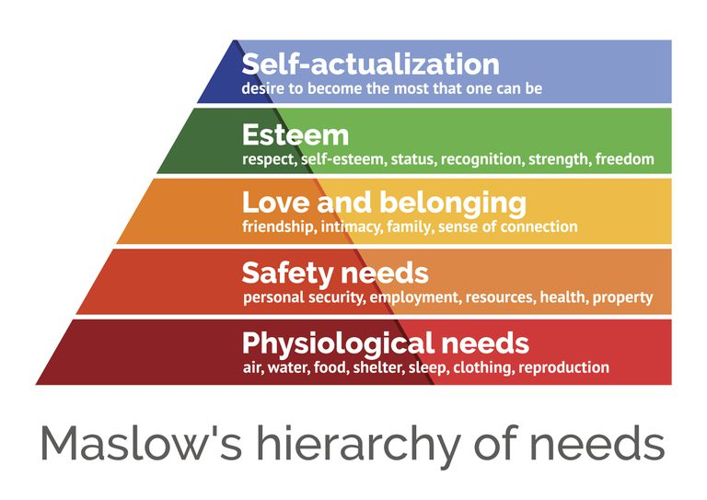
According to Ballone, in these days, most of the employees are attracted by promotions and bonuses. Changing the dynamics of the workforce has become a particular concern for leadership because now, for the first time, there is the probability that four generations will work side by side in the same working climate. (Ballone, 2007).
According to Vroom’s expectancy theory, the employees believes that the effort will result in acceptable performance which will generate desired rewards. (Vroom and Deci, 1992)

Vroom’s expectancy theory
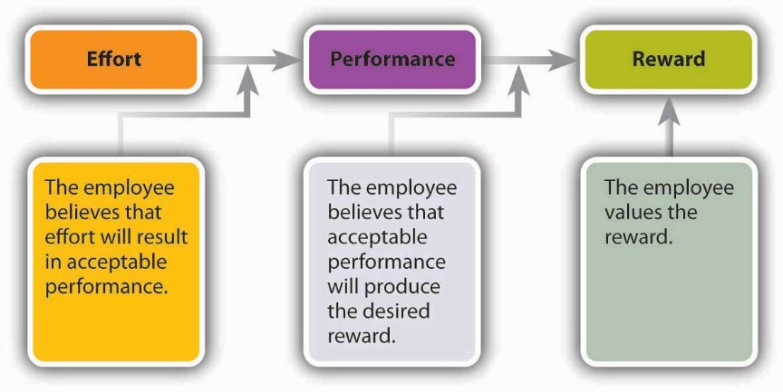
According to Marita M. Heyns, management team is advised to create a motivational environment which typically encourages a quickly and efficiently motivated behavior and will be focus on unique established individual motivational preferences that may exist within groups instead of approaching to a generational segments as homogeneous groups. (Heyns and Kerr, 2018)
According to Blumberg, individual attributes (capacity to perform), organizational support (opportunity to perform) and work effort (willingness to perform) will have a direct impact on the job performance. (Blumberg and Pringle, 1982)
According to Frederick W. Taylor, employees are motivated primarily by money. For the company is important that they will ensure jobs enabled maximisation of earnings. Every job need to be treated individually to ensure that the best worker will fulfil the role in the best way and he will receive a payment according to his results.(Anne and James, 2011)
Motivation includes financial rewards (wages, bonuses), good working conditions (flexi time, holiday entitlements, learning & development opportunities, illness & maternity leave) and additional benefits such as corporate pension, car, private health care, subsidized child care and canteen, gym membership, etc..

Motivation will bring benefits to the organization as:
- Productivity will increase
- Work accident rate will drop off
- Sick leaving rate will drop off
- Employees will be more engaged in the company activities
- A healthy working environment
- Employee will be more innovative and creative

Motivation will bring benefits to the employees as:
- Employees will be more focus
- Employees will be more happy
- Employees will be more approachable
- Employees will be more healthy (mental health)
- Employees will understand company’s goals better
- Employees will handle uncertainty better
- Employees will be a better problem-solvers

As an example of motivation inside the workplace, the author has given some example from his experience with the Amazon. According to the author, inside the Amazon, the management team is motivating their employees with games before start of shift, shares scheme, private pension, private medical insurance, discounts for shopping, salary above the minimum national wage, development programs and trainings. In the same time, the management team is focused to maintain a healthy working environment, to support the employees in their activity and to offer them all the support what they will need.
Another example of motivation inside the workplace the author is mentioning that the Amazon, on the big events as Christmas Eve, New Year Eve are pleased they employees by playing music inside the work place and by offering them an extra day off.
As a pros of motivation the author had identify that the companies how are motivating their employees had a better image regarding their jobs, have more skilled employees and it is more involved in community activities.
As a cons of motivation the author had identify that the organisations are using a group motivation scheme and will not manage to satisfy all theirs employees. No matter how many benefits a company will offer, the employees will be still unhappy and unmotivated to do their job. Not all employees are the same and not all are motivated by the same things. Some prefer monetary rewards, and some appreciate recognition in the form of nice words or touch.

According to Nigel Nicholson in every company will be a “problem maker”. (Nicholson, 2003)
No matter how much the company will offer, always will be an employee unhappy, important is how management team will deal with this kind of persons. In this case the company will lose the investment and they will not reach their objective if they will not take actions against those kinds of persons.

4.2. Training

Training is the process of learning the skills that an employee needs it for a particular job or activity. (Collinsdictionary.com, 2019)
According to Cox Hill, the Training goals are to improv capability, capacity, productivity and performance of an employee in a short period of time. The training program is the bridge between the employee skills gap and company needs. (Hill, 2011)
Based on the author research, Training is defined as being focused on short term objectives and have a limited scope. As an objective, the training process is aiming to improve productivity, accidents prevention, safety process etc. by learning the latest technological developments regarding the products, process, materials etc. in a short period of time. The training process is helping an employee to gain a new skill in a short period of time, creating a safe working environment and help the business to remain competitive on the marker.
The Training process is a cycle process and will start by identifying the learning needs fallowed by training design, training deliver and evaluation. After evaluation the cycle can be close or can be reopen.

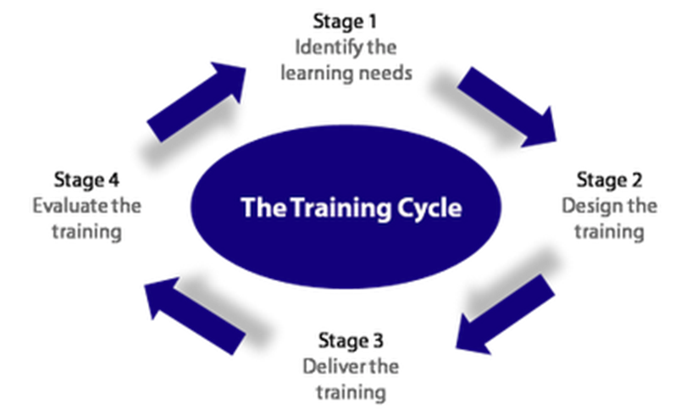

According to Thomas Lorraine (Lorraine, 2004) every time when a training cycle is starting and ending an employee need to remember that:
  - At the beginning, acknowledge the end.
  - At the end, acknowledge the beginning.
  - In the revolutions, focus on the moment.
  - Knowing the rode, it's easier to plan the route.
  - Planning the route, it's easier to stay on course.
  - Maintain the course, it's easier to reach the destination.
  - Reaching on destination will be a new begin.

Employees need the knowledge, skills, attitudes and behaviors that will enable them to do their jobs correctly. Every training process can be done on-the-job and/or off-the-job. (McGuire and Bagher, 2010)

On-the-job training includes the following methods:
- Shadowing - The employee is guided by the person already in job.
- Coaching - Any appointed staff member or manager will help trainees work and inspire them to find solution.
- Mentoring - An experienced member of staff plays the role of an adviser.
- Job rotation - By taking full responsibility on temporary or limited basis, the trainee has the chance to cover the target role

Off-the-job training includes all the training process outside the job. In many times those kinds of training are full paid by the company. Sometimes the employee needs to pay for them if he wants to continue his job. As an example of off-the-job training when the employee will pay for the full training course is the lory driver when he needs to do his 35 hours of periodic training. This training is aiming to keep up to date the driver’s skills with the new driving legislation and will be fully paid by the driver.
Another example of off-the-job training is the first aid training. First aid training is hold by the specialized organization and the companies will send theirs employees to do this course because they need to create a safety work environment and in case of accident to have qualified person how can take actions and can save a live in a critical circumstance.

The outcomes of training can help the organization to:
- Reduce the costs / rase their profits
- Provision of services, customer retention, technical innovation, added value
- Growth of the business and remain competitive on the market
- Increase employee’s loyalty
- Become more flexible and adaptable to the changes
- Coping with critical incidents, problems, opportunities

According to Bhasin Roberta (Roberta, 1998), benefits of the training for the organizations are:
- Increasing profitability
- Better work quality
- Less complains
- Less work accidents
- A better reputation
- A skilled workforce
- Remain competitive on the market

According to Bhasin Roberta (Roberta, 1998), benefits of the training for the employee are:
- Filling the gap skills
- Become more professional into the workplace
- Remain competitive with the job criteria and company needs

According to the author, Amazon are offering on-the-job training and off-the-job training to his employees. Every new starter will have his first week based only on trainings program, no matter is he/she had worked before in Amazon or not. After his first week the employee will enter in a full target period and if will not manage to fulfill it, he/she will be retrained and coached. Every employee will have the opportunity to receive up to 3 retraining programs before Amazon will end their contract. Sometimes this action can become a problem for the company because it’s become costly and time consumer.
As an example of off-the-job training, the Amazon will send theirs managers and team leads to do a specialized development training where they will improve theirs communication skills, problem solving and they will learn how to deal with the bad employees by avoiding conflicts.

As disadvantages of the training programs, the author has identified that:
- The training program can become a time consumer.
- The report between investment and outcome is not equal.
- If the training programs are focused on group of people, not all of them will have the same outcome.
- The training program is focused on a short period of time and can become out of date quickly.

According to Furnham Adrian, there are eight reasons for why training will fail. (Adrian, 1996)
- Lack of training is the wrong diagnosis.
- The training outcome is not specified.
- The training outcome expectations are unrealistic.
- The training is not of the right type.
- The training course is too short.
- Training goals are not related to work goals.
- New skills are not supported by the environment.
- There is no accountability for follow-up or implementation

As pros of the training program, the author had identified that the employees will gain new skills, will fill theirs gaps and will become more engaged in the company activities helping in this way the company to grow the profit and to remain competitive on the marker.
As cons of the training, the author had identified that sometimes this program can become a time consumer and will not have the desired outcome. Being a general development program, the training program will not have the same outcome for all the candidates and the companies can lose money and time.

4.3. Personal Development Plan

Development is the process in which someone or something grow or change and become more advanced. (Dictionary.cambridge.org, 2019)
Development is related to the progress of longer-term organizational and employee goals. Thru the development program an employee can find a better place in organization and can help the organization to grow up, together in the same time.
Personal development plan, known as PDP, is the process of establishing aims and objectives or goals. Is a rout planning regarding what an employee wants to achieve or where he wants to go, in the short, medium or long-term in his career. (Managers.org.uk, 2019)
In the same time, a PDP identifying needs for skills, knowledge or competence,
monitor and evaluate achievements by providing continuous learning, making the most of opportunities which may arise and ensuring employability and survival in an age where very few jobs can be guaranteed to stay the same.
PDP is as a cyclical process, where improvement comes from moving around the circle.

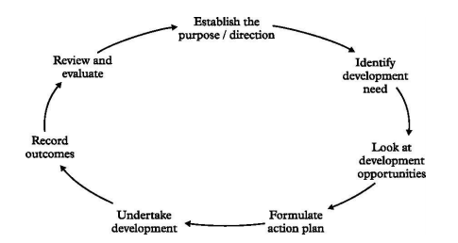

In his article, Simon B. is saying that the PDP assessment is effective for learning, personal or professional development and improving professional practice. (Simon, 2013)
In the same time, Bunker and Leggett in 2004 are not supporting these positive findings. They said that PDPs are often based on small sample sizes and therefore do not lead to generalizable results. (Bunker and Leggett, 2004)
As an effect of using a PDP, an employee had undertaken learning activities in the past, he’s planning further training, and perceiving job competencies. To be accurately, a Personal Development Plan need to have a SMART objective.
Every Personal Development Plan need to be personalized to fill the gaps for an employee and he can’t be created for a group of people.
Thru a Personal Development Plan, an employee can gain adaptive skills, transferable skills and Job-related skills.

Adaptive Skills:
- Ambition
- Patience
- Creativity
- Assertiveness
- Enthusiasm
- Flexibility
- Persistence
- Dependability
- Pride in doing a good job
- Sincerity

Transferable Skills:
- Leadership Skills
- Communication Skills
- People Skills
- Data/Information Skills
- Creative Skills
- Manual & Mechanical Skills
- Intellectual Skills

Job specific skills
- Operate specific equipment
- Use certain software packages
- Trade skills eg Electrical, Plasterer
- Manufacturing skills eg Assembly, soldering
- Warehouse skills eg Stock storage, dispatch

Inside Amazon, the active employees will have the chance to create a Personal Development Plan with their manager. Inside Amazon, a personal development plan it’s an agreement between organization and employee. After the employee will complete his PDP the company is offering them the chance to reach his goal. As an example of PDP, the author had created a chart based on his experience inside Amazon and his skills gaps.

PDP example:

Objectives | Measures | Priority | Support &  Development |  | Review  dates | Other  Comments
Objectives | Measures | Priority | Internal | External | Review  dates | Other  Comments
Become a team lead  for Amazon | Know how to work on the Amazon platform and with the Amazon programs | High  Will help me to raise my wage and open more opportunities | Inside Amazon  Manager  Team lead  SO, Manager |  | After 4 weeks from starting the training. | Enroll in the Team Lead pool program. Be more engaged in team lead activities.
Develop IT skills | Lear how to work on Mc Office / PowerPoint | Medium  Will help me in the job role and with the university assessments |  | IT lessons | After 2  Weeks  from starting the training. | Practice at home by writing the assessments for university. Try to play with the programs (learning by doing)
Improve communication  inside workplace | Learn the terminology used inside Amazon | Medium  Will develop my communication skills inside work. | Inside Amazon  Manager  Team lead  SO, Manager |  | After 2  Weeks from starting date. | Get involve in different activities with the manager / team lead. Ask them to explain the terms for a better understanding.
Pass the interview for the team lead role | Practice the STAR model and try to formulate an answer for the interview questions | High  Will offer me more confidentiality on the interview process. | Inside Amazon  Manager |  | After 2 weeks from receiving the interview questions | Ask the manager to set up a meeting to simulate an interview and to provide a feedback after.
Become a lorry driver | Pass the CPC test | Low  It’s a cover plan just in case off quitting from Amazon |  | Specialized Driving Scholl | After 6 weeks from enrolment | Be active on the legislation lessons and after passing the exam, practice as a second driver on a lorry.
Develop the Problem-solving skills | Lear how to deal in a critical situation and how to choose the right outcome | Medium  Will offer me more opportunities into the workplace | Inside Amazon  Manager  Team lead  SO, Manager |  | After 2  Weeks  from starting the training. | Ask the manager to send me on the problem-solving training and get involved into the problem-solving process.

A personal development plan can be considerate as a long-term investment in employee and in this way the business can remain competitive on the market. (Beausaert et al., 2013)
In the same time, according to Joseph Folkman a PDP is not always successful. Sometimes the employees are seeing the PDP as a paper-passing, bureaucratic practice with little real value. Sometimes the managers don’t see the process as doing much to really develop talent. For them, it’s another check-the-box exercise that siphons valuable time. (Forbes.com, 2019)

According to the author a personal development plan will fail when:
- Employees don’t have time to accomplish their goals.
- Employees don’t follow up process.
- Employees will choose something not value to the organization.
- PDP is not well established with SMART objectives.
- A PDP can fail because is not driven by the individual.
- When a PDP is ignoring the importance of the individual’s personal energy and motivation.

As pros of the personal development plan, the author had identified that an employee will become more engaged into the business activities and will have the same aim as the business helping the organisation to have more skilled people and to cover more easy the jobs gaps.
As cons of the personal development plan, the author had identified that not all the employees who have complete a PDP inside an organisation will have de desired outcome. Sometimes the organisation can’t promote them on the desired role and the employee will become unmotivated and will start to search for another job.

5. Conclusion

In conclusion the author is highlighting the importance of the motivation, training and personal development plan inside an organization. All three together are forming the key to success.
As an organization it’s very important to keep the employees engaged with the job and to offer them the possibility to evolve. As an organization the objectives need to be focused on short term as filling the employees’ skills gap by offering them access to the training and for a long term by creating a pool with skilled employees who can fill a job gap easier. A personal development plan will help an employee to reach his goal and, in the same time, will help the organization to have more competitive and qualified workforce. To have success in training and in PDP the employee need to set up the SMART objectives and to monitories theirs activities all the time.
A training process or a personal development plan will not have success on an unmotivated employee or, sometimes will unmotivated an employee do to outcoming.

6. Reference list

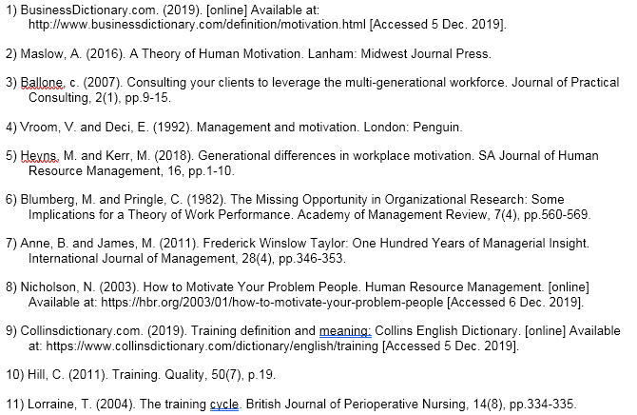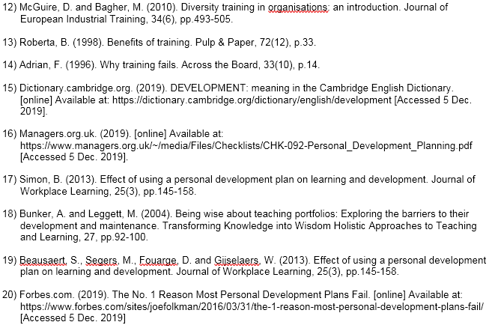

7. Bibliography



