

Professional Career Development
BMSW 4005

Name: Irina Merlan
1818268
Lecturer: Mary March
11.05.2020

My reflections on my career development
Essay/Report
1.Introduction
As you can see on the first page of this report, I am Irina Merlan and this report it is going to be about me and my reflections on my career based on my employability skills and my knowledge.
Why is it important?
This is important because it demonstrates my understanding of the skills that I have and the knowledge that contribute together toward achieving my employment goals and developing a personal development plan. In the first week of this last term we learned about the lifeline exercise. In this website http://www.open.edu/openlearn/ocw/mod/oucontent/view.php?id=28130&section=2.1 which was accessed by me at 12/03/2020.

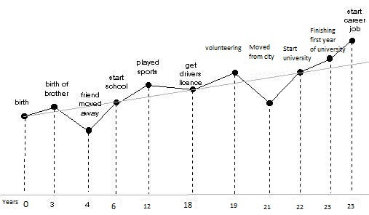
This helped me to analyse what were the influencing factors and which one were positive and negative. The positive influencing factors are: my birth, the birth of my brother when I was 3 years old and since then he is a blessing in my life and a positive impact and the fact that I have started school at age 6 because I consider, as Nelson Mandela said that “education is the most powerful weapon which you can use to change the world”. I started to play sports around age 12 and this was another good influencing factor because beside mental education I have developed my physical education as well. At age 18 I have got my driving license which helped me travelling and has opened my eyes and mind to want to achieve more. Even if I moved from natal town and lost a lot of connection with my friends and family, I have done it to start the university at age 22. Before starting the university I was volunteer at age 19 and I didn’t stop from then. Currently the most influencing and positive factor is the fact that I have started my career by obtaining a job. I had downs and ups during my lifeline exercise but I consider that downs were at age 4 when I lost my connection with my best friend because he moved away in another country. Since then until I started school I was upset and I was missing him and our friendship. As soon as I started school I made a lot of new friends. Another negative influencing factor was the fact that I have moved from the city and I consider that it was really hard for me because I felt lonely and I was a bit scared to make any friends.
2. Reflection
During this personal reflection I found out that Gibbs is one of the best methods which I can use because of the easy steps of the cycle. Gibbs is clear and precise as a model and it is allowing for description, analysis and evaluation of the experience which are helping the reflective practitioner to make sense of experiences and examine their practice.
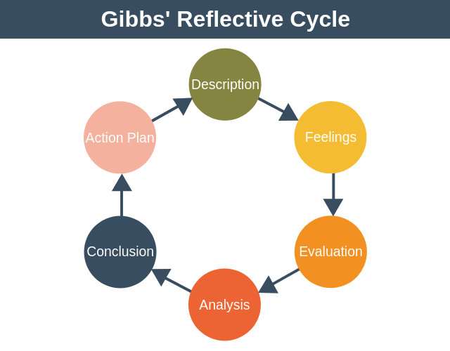
This reflective model comes down to six steps that I have followed to develop my report. These are: description, feelings, evaluation, analysis, conclusion and action plan. These stages can be easely followed by answering the right question for each of the stage.
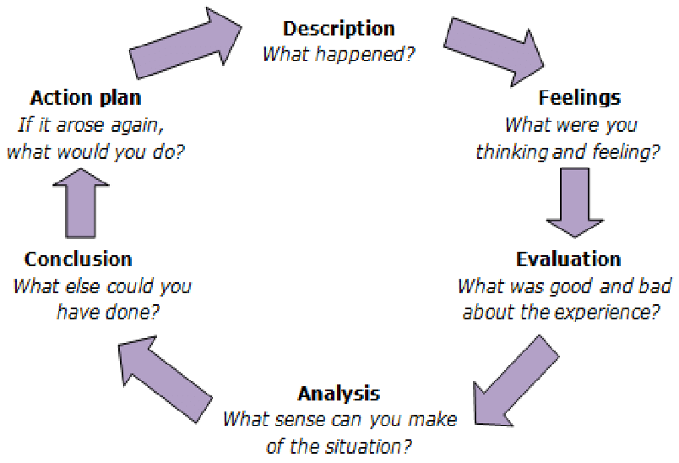

This is why Gibbs’ Reflective Cycle is useful because I can use it to make sanse of situations in my life during different experiences so that I can understand what I have done well so far and what I could do better in the future.
Description - What happened?
Through my college period I was employed yet I needed to change my activity so as to do this I needed to compose my CV. I didn't realize how to compose a decent CV previously but since of the considerable number of aptitudes that I picked up during this two terms now I am positive about my CV composing abilities.
Feelings - What where you thinking and feeling?
I see myself formed as an altogether extraordinary yet better individual on both expert and individual fields on the grounds that from the asking of college I increased numerous aptitudes which helped me to pick up the expertise of composing a decent CV.
Evaluation – What was good and bad about the experience?
I think it was a feeble point for me the way that I didn't thought about the presence of a Personal Statement and I didn't constantly joined a Cover Letter alongside my CV, just if the business mentioned it. The great about this experience of applying at a new position on this term is the way that I learned and practice the composition of a CV with a Personal Statement and what is the configuration of a Cover Letter..
Analysis – What sense can you make of the situation?
In the wake of investigating this circumstance I should concede that I figure out how to make the most precise form of my CV which truly speaks to me and after a short holding on to be called at interviews I prevailing to get utilized on the position that I needed at extraordinary compared to other organization which I have ever applied to.
Conclusion – What else could you have done?
Before this term I didn't realized what is a Personal Statement and that a decent CV has this included yet since I have built up my basic and scientific speculation and with the assistance of the SWOT Analysis which I have made last term about my abilities I am feeling prepared to apply this and to compose a Personal Statement which speaks to me in a short, clear and compelling route and to compose the ideal CV.
Action Plan – If it arose again, what would you do?
I will likely create and to follow my Personal Development Plan to check how to achieve my objectives particularly in my expert life and on the off chance that I will lose my employment I am ready to apply rapidly for another one since I picked up the abilities that I need so as to improve my employability.
3.Career plans
According to Herriot (1992), an organisational career is the sequence of renegotiations of the psychological contract which the individual and the organisation conduct during his/her period of employment.
In order to analyse my ideas for the future career, I need to do a self-reflection because this will lead me to identify what kind of career I want Reflection is the key to success and it helps me to increase performance and productivity. After self-reflection, I need to set my goals. That is why I choose to establish SMART goals. These are specific, measurable, attainable, relevant and time bound and assure my achievement. Also they need to be short, middle and long term goals. The last step is to develop a plan, more exactly a personal development plan. To do that I need to analyse the pros and cons list, to evaluate how each path aligns with my values and which are the future consequences of each path.
4.What employers want
According to Golzen & Garner (1990), “ownership of careers is being transferred from the organisation to the individual. In a career sense we are all self-employed now.”
Employers search in their employees these aptitudes in order to keep them in the business. To be able to present ideas, verbally and in writing. This means that I need to have presentation skills and I reflected on this skill. I have used Kolb’s Learning Cycle is the learning style to reflect and demonstrate that I have this quality.
Concrete experience
During my scholarly experience I needed to do a couple of introductions about various subjects during my classes and I needed to introduce myself during interviews.
Reflective Observation
Presentations weren't my most grounded expertise yet as an understudy and as a specialist in retail industry as a group chief I increased intriguing encounters which helped me to improve my introduction aptitudes. I understood that on the off chance that I am interfacing with my partners and all in all with the individuals that I have to do group working I become progressively certain on myself. I needed to do an introduction about Transferable Skills and it was a gathering introduction but since different people were missing I expected to deal with the circumstance myself and to introduce alone the entire thing.

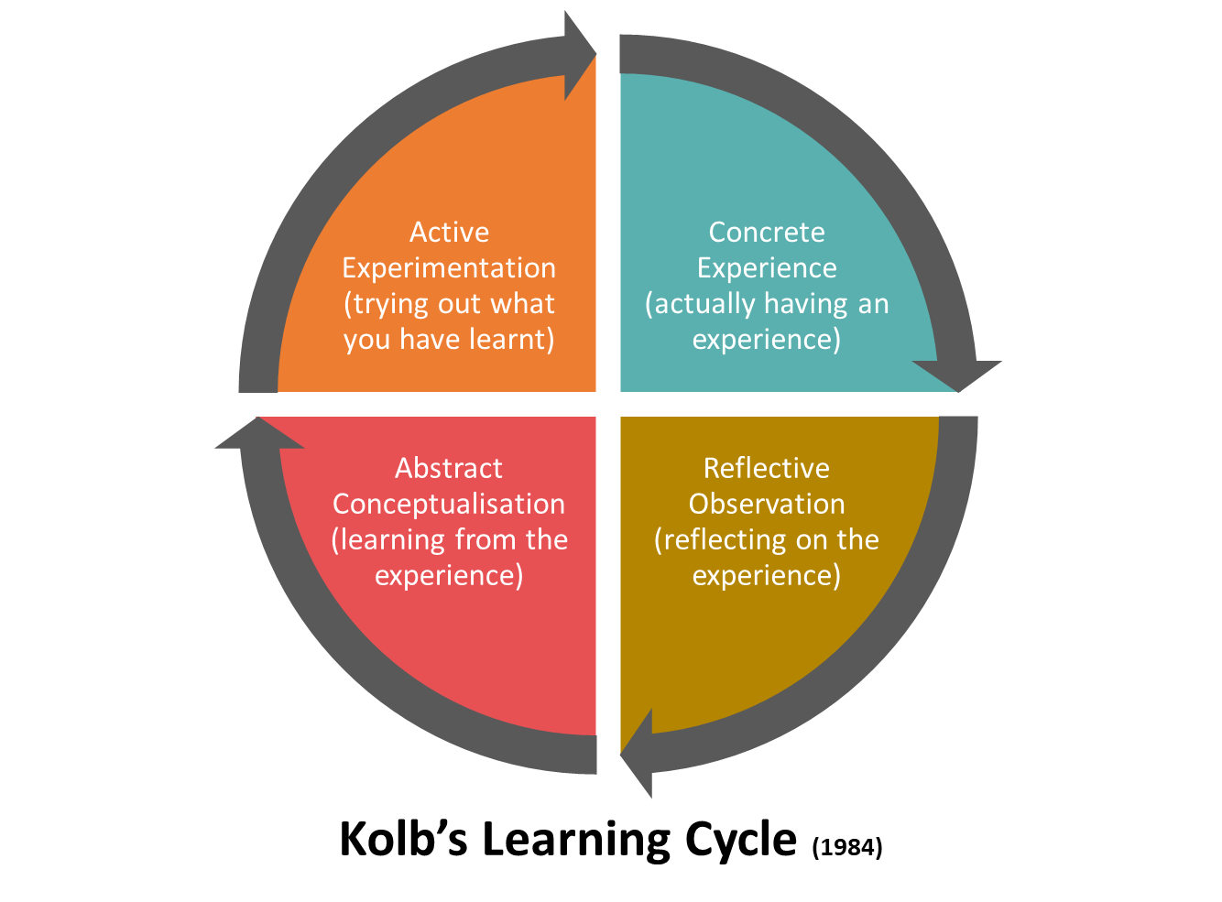
Abstract Conceptualisation
I gained from my encounters as an understudy and as a group chief that on the off chance that I get myself out of my customary range of familiarity and investigate new stuff and attempt to build up my capacities I become ready to introduce myself whenever and anyplace in light of the fact that I am arranged at this point. That is on the quality of this module too on the grounds that I needed to do the in-class introduction which I have it connected in my addendums.
Active Experimentation
The next week after that introduction which fundamentally change my perspective about introductions I needed to do an introduction without anyone else which I prevailing at in light of the fact that I figured out how to apply all the things that I learned and how to improve my presentation abilities dependent on the feedback that I have got.
Demonstrate good time management
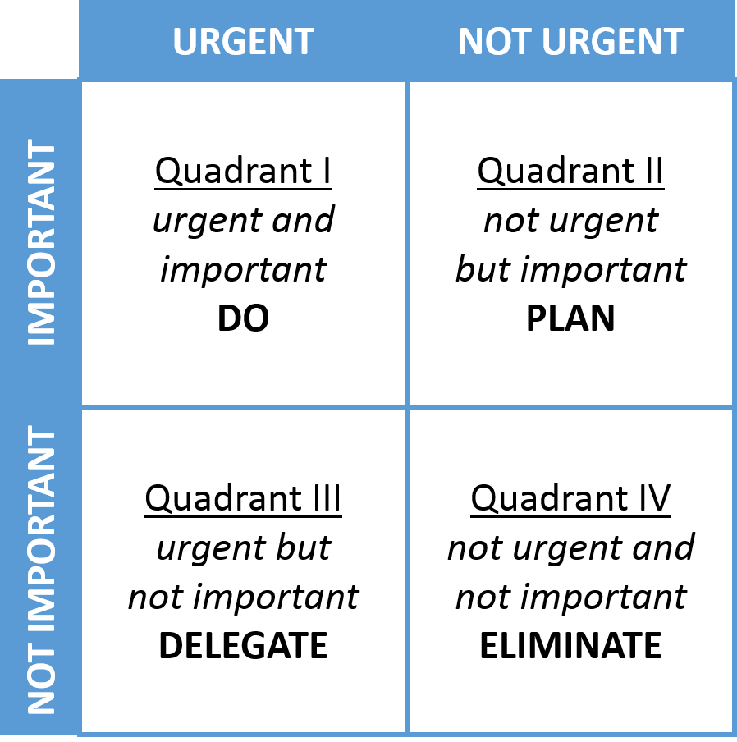
Time management is a crucial skill in everybody’s life. The Eisenhower Method helped me to improve my time management skill. This method helps me to analyse my activities based on which one is urgent and which one is important and I can divide my activities in 4 categories: urgent and important, not urgent but important, urgent but not important and not urgent and not important. In the first category I choose which tasks I need to do now, in the second category I planned when to do the important activities, in the third category I can analyse which activities are urgent and I can delegate another person to help me to complete my activities. In the last one I observed which are the activities that I need to eliminate from my plan because they are not urgent and not important.
Plan and manage their time
Another important skill that employers look for is how their employees plan and manage their time. Another learning style that I have used is Driscoll’s model of reflection to demonstrate if I have this skill.
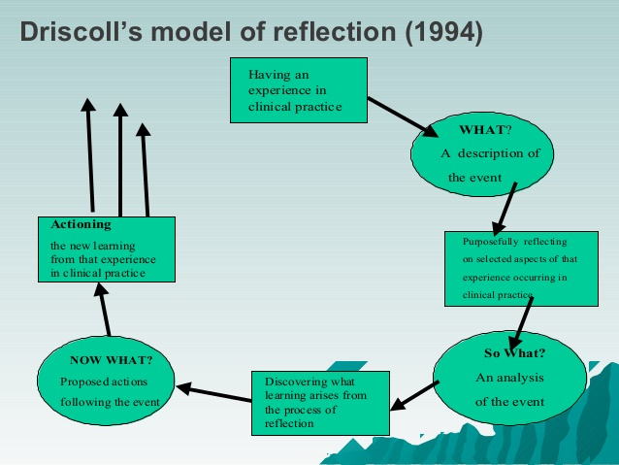

Description of the event: At the start of my scholarly experience I was in every case late for classes, I had a great deal of activities since I was truly occupied however I concentrated myself on unessential and not significant exercises which take my time. Presently with the assistance of Time Management Matrix which I found out about in the primary term I am ready to design my every day assignments and to finish them effectively.
Analysis of the event: I began to make my personal-development plan and I didn't t finish to finish it since I needed to consider diverse timeframe, for example, objectives on a short term, middle term and long term and it was difficult for me to design it for that time.
Proposed actions following the event: Now with the strategy learned I completed my PDP and I can concentrate more on my objectives since I realize the time mentioned for every objective and I am ready to organize things successfully which likewise incorporates the arranging of the outstanding tasks at hand alongside that showing up on time at the working environment and oversee everything on time too (Cathro, O'Kane and Gilbertson, 2017).

5.Self-motivation
I am motivated to achieve what I really want in my life because I don’t like to loose. I want to become the best version of myself and I am trying day by day to proceed that.
As an example, During the lifeline exercise I reflected on what motivated me to go forward to the next step in my life and to succeed even if it was with ups&downs.

Abraham Lincoln said “And in the end, it's not the years in your life that count. It's the life in your years.” According to him, it doesn’t matter how many years you can count in you life as what counts the most is the way you are living your best life everyday. It’s not about how much you lifed, but it is always how you lived because life is all about living in present moment. Life is all about the experiences that you got throughout your living and that’s why this quote inspires me in every moment of my life. I have this desire to be the best, I want to help other people in my way to become a succesful person and I think that the passion that I am using everytime when I am following each goal from my personal development plan is another key to my self-motivation.
I push myself really hard to get my things done. As far as I am young, I don’t care really much about the hours of sleep that I get every night, neither the time that I invest daily but without an immediate result because I know that everything that I am doing continuously pushing myself in the present has an impact either small or big for the future version of myself.
6.Learning Styles
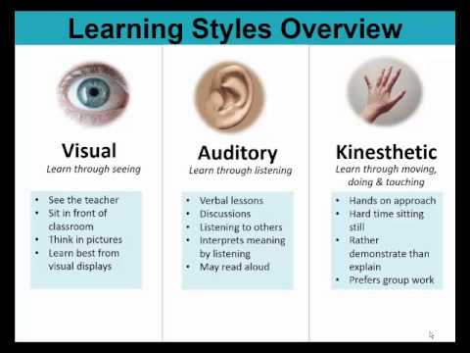
I think that the most common learning styles that we are applying at least durind the classes if not everyday are the visual learning style and the auditory learning style. The kinesthetic learning style works the best during our in-class exercises which were made as a teamwork.
7. Personal Development
SWOT stands for Strengths, Weaknesses, Opportunities, and Threats. The initial two of them are inward investigated which implies my strengths are the abilities that I have and my shortcomings which implies the aptitudes that I have to learn or create. The last two represents outside elements which are my chances to apply my abilities and to build up some of them which I don't have however I need them. Also, dangers allude in this consideration for any hindrances which could prevent or intrude on me from picking up these abilities.

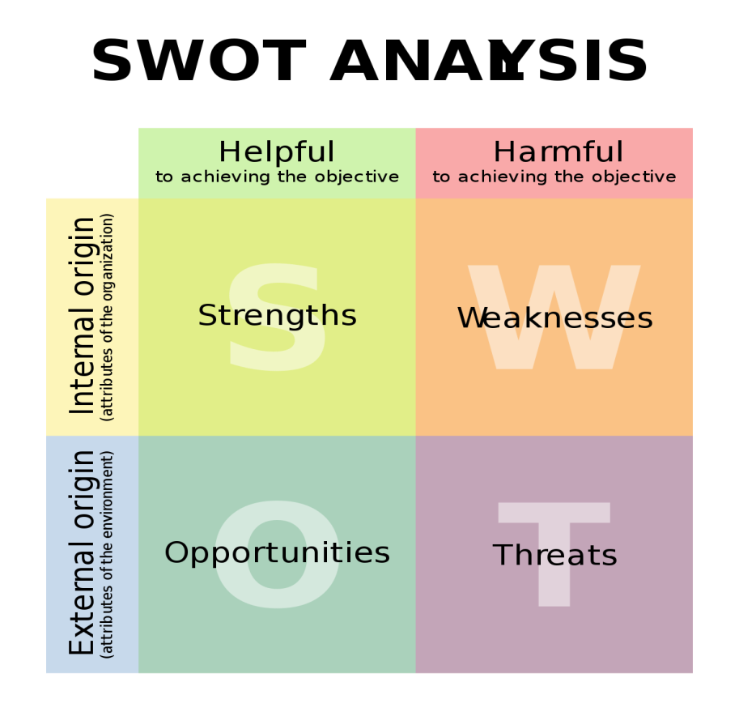
My skills are: Personal Mastery, Problem Solving and Decisions Making, Communication Skills, Time Management, Academic Writing(Language and Grammar), Paraphrasing How to Write a Report, adjustment, knowing unknown dialect, respectability, investigate abilities, speedy learning aptitudes and PC aptitudes picked up toss another module called Digital Skills and Research Methods. The aptitudes that I have to create are: authority and the executives. This are too required at GFK and in the event that I need to accomplish my objective..
My opportunities are: this course which I am student at and it’s called „Certificate of Higher Education in Skills for the Workplace” and before the finish of the main year of studies I ought to be set up to go after the fantasy position. Presently I am working in retail at a bustling store in which I can build up my administration and initiative aptitudes. I am in route to be a group head now so I am finding out about this aptitude and in the event that I will accomplish it, I will create too my overseeing abilities. This is my arrangement about building up the abilities that I need.
My threats would be possibly on the off chance that in the event that I bomb in learning as an understudy at this course named „Certificate of Higher Education in Skills for the Workplace" that I am marked in and on the off chance that I am not advanced at the earliest opportunity for the group chief position.
The course is intended to assist me with developing myself step by step and to set myself up to turn into an individual with advanced education abilities for the working environment so this ought not so much be a danger. Regardless of whether in one day a risk of mine will become reality and I have to confront it, I will change it in an open door since I need to proceed and to complete what I intended to achieve.

Another tool is Johari Window and I have made it in the picture bellow:
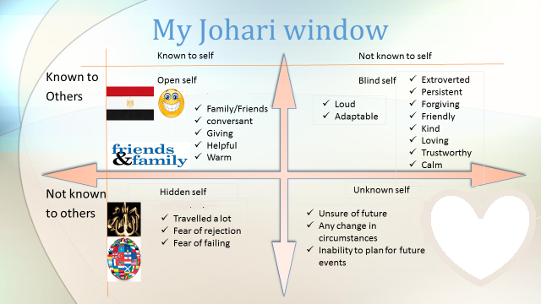
I can say that the most important section for me is Known to Others&Not Known to Self because I am loud when I speak, adaptable to any situation, extroverted, persistent in what I am planning to do, maybe a little too forgiving, kind and loving because I am sensitive, trustworthy because I have honour and I am calm besides any situation or circumstances.
Not known to other and not known to self are the fact that I am unsure about my future, I don’t like when things are changing and they are not predictable and any inability to plan for my future events.
- Employment Goals Explain your plans for the future. You will probably need to carry out some research into specific career paths so that you understand the requirements and entry criteria.
I start setting goals for me to improve myself so I learned about SMART goals.
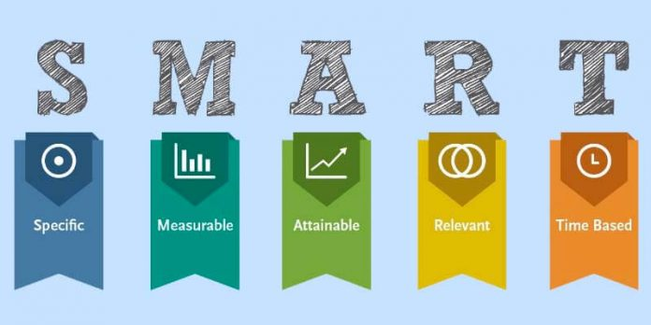
As indicated by Bovend'Eerd (2014) he learned me in his work about „Writing SMART recovery objectives and accomplishing objective fulfillment scaling: a down to earth manage" in Clinical restoration this technique for defining SMART objectives which implies explicit, quantifiable, attainable, reasonable/significant and timed(SMART). Every objective can be developed by utilizing around four sections: the objective action, the help required, evaluation of execution and the timeframe to accomplish the ideal state. I discovered that the accomplishment of objective defining and objective fulfillment scaling relies upon me and how I figure the objectives. The technique depicted here is a valuable instrument since it spares time and disentangles for me the development of objectives that are adequately explicit to be quantifiable.
So I began to set this objective: to function as an analyst in GFK continuously of 2021.
GFK is a global association which demand for a business to have distinctive acquirable abilities like perusing, composing, math, adjustment and science knowing unknown dialect, authority aptitudes, uprightness, inquire about abilities, relational abilities, brisk learning aptitudes, overseeing aptitudes, PC abilities and some more.
Persuade Power: in the working environment I have persuade my customer and clients to guarantee better benefit and result. Then again, I likewise need to persuade my partner, better and labourer than guarantee better workplace and result. I persuade power help me to execute my arrangement successfully and satisfy my objectives (Dr. R. Hemanalini, 2011).
Speaking and Communication Skill: as a worker for GFK I need to speak with numerous clients and partner I need to talk in better and well way. For this situation I am truly adept at talking which help me to persuade my customer and client. Talking ability help me to interface with individuals so I can satisfy them to speak with me which help me to satisfy my objectives and destinations.
Administrative Skill: overseeing aptitude is the one of the most significant ability for the representatives who need to get best result from working environment. In such manner I am extremely skilful at overseeing where I am capable oversee everything in compelling way. In my working environment at GFK I have deal with my representatives who work under me where I need to convey work among them. I additionally viable in dealing with my work and obligation which help me to accomplish my work impeccably and in cooperation my overseeing expertise increment the result of the GFK (Fetzer and Tuzinski, 2011).
Personal development plan (PDP):
A PDP is a Personal Development Plan which speaks to a kept in touch with self-reflection and improvement which needs to act like a nitty gritty activity plan dependent on objectives and used to fulfill on scholastic, individual or vocation plan. I have made this intend to consider a turn of events and I am believing that this works in an effectively route for me by permitting myself to build up which are my points, destinations and objectives and to distinguish my qualities and shortcomings and my requirement for development and how to create myself.
I have submitted my targets in a request dependent on the regions that I might want to see an improvement or to improve something in my life and my PDP comprises in my customized activities made in a request and these activities are helping me to accomplish them in a timeframe depending in the event that it is a momentary objective, center term objective or long haul objective.
In segment 1 I have fixed my objectives for present moment (three to a half year), center term (a half year to two years) and long haul (a few years).
In segment 2 I recognized my aptitudes and information to be educated for each of the three time of terms. So as to finish my objectives and to become familiar with each one of those aptitudes and to pick up the information that I need it is important to consider the subsequent stages that I am going to make and those were deliberately picked in area 3.
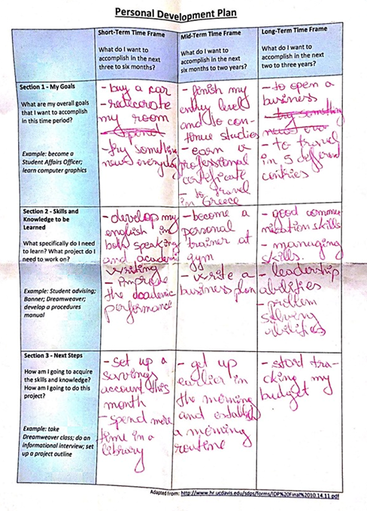
Conclusion
In an association, there exist a few parts of work where each division required explicit talented and information. These essential aptitudes are the necessary for the representatives and managers to bring out best result structure the organization and can get most elevated benefit from business. In the work environment, these talented assistance the two representatives and boss from beneficiary won perspective. Here boss get most noteworthy profit by business and accomplish their objectives and workers show signs of improvement pay and guarantee their security of occupation. So in this report the vital aptitudes for viable working, status for employability, ability that need to encourage improvement and a legitimate activity intend to improve the aptitudes.
Both of my personal and professional development has to do with academic and employability skills and so I started to learn more and more about me and I am already improving myself day by day so this will be a success.

Development plan

NAME: | Irina Merlan | Student NUMBER: | 1818268
COVERING THE PERIOD FROM: | 2019-2022 | TO: | Mary March
This record sheet is for your guidance only – you may present your development plan in any other format.
What do I want/need to learn? | What will I do to achieve this? | What resources or support will I need? | What will my success criteria be? | Target dates for review and completion
How to drive  How to sign  How to cook  Get up earlier in the morning | Pass the driving test  Canto  Training  Setting alarm | Money and Driving hours  Talent, Money, Time  Recipes, ingredients  Rest, Motivation | The speed of which I gather all the info  Prizes  The taste of food  Productivity | 01.06.2020  14.10.2020  24.12.2020  20.07.2020

References:
- Green, W., Hammer, S. and Star, C., 2009. Facing up to the challenge: why is it so hard to develop graduate attributes?. Higher Education Research & Development, 28(1), pp.17-29.
- Cathro, V., O’Kane, P. and Gilbertson, D., 2017. Assessing reflection: Understanding skill development through reflective learning journals. Education+ Training, 59(4), pp.427-442.
- Cottrell, S., (2015). Skills for success: Personal development and employability. Macmillan International Higher Education.
- Hind, D. and Moss, S. (2011) Employability skills. Houghton le Spring: Business Education Publ.
- Robinson, J.P., 2000. What are employability skills. The workplace, 1(3), pp.1-3.
- Pitan, O. (2016). Employability development opportunities (EDOs) as measures of students’ enhanced employability. Higher Education, Skills and Work-Based Learning, 6(3), pp.288-304.
- Brewer, L. (2013). Enhancing youth employability: What? Why? and How? Guide to core work skills. ILO.
- Ghose, A., Majid, N. and Ernst, C., 2008. The Global Employment Challenge. Geneva: International Labour Office.
- Antonio, Н., 2009. Technologies in providing training. Problems of Informatization and Management, 2(24).
- Moran, M., 2012. Building Your I.T. Career.
- International Journal of Science and Research (IJSR), 2017. Skill Development through Higher Education. 6(7), pp.710-713.
- Varlejs, J. and Walton, G., 2009. Strategies For Regenerating The Library And Information Professions. München: Saur.

