The NACCCE (1999) defines creativity as being an ‘Imaginative activity forms outcomes that are both original and of value’.
The EntreComp Framework is a framework devised to aid identification of various competencies that make a person entrepreneurial. The wheel of competencies within the framework means that that the different competences are contrasting yet interconnected. The framework is split into 3 interlinking areas which consist of: ‘Into Action’, ‘Ideas and Opportunities’ and ‘Resources’. From these areas are 15 different Competences. Each of the 15 competences are split into 8 progressive levels. These competences contribute to acquiring and recognising skills which enhance knowledge and skills within teaching and learning which make a person entrepreneurial.
Hudson (1973) recognised the different attributes and skills presented by learners who are convergent and divergent thinkers. It was suggested that learners who were convergent thinkers, excelled only in areas where there was one solution or answer, whereas divergent thinkers are considered to excel in areas of learning such as the arts as they possess the ability to find several possibilities to a problem. However, this idea regards areas of learning such as mathematics and science to be ‘uncreative’.
Craft (2000) argued that a type of thinking that was defined as ‘Possibility thinking’ is the basis of creativity. A learner displays possibility thinking if they use their imagination to find a way around a problem in order to find a solution or solve the problem. Craft suggested that both convergent and divergent thinking both include possibility thinking during the process of learning. Furthermore, Craft (2000) recognised that creativity means that learners can use their original ideas and knowledge to make connections between various unrelated things.
There has been many ways and interpretations of what creativity is and what the characteristics and attributes of it are. Learning which is creative involves relevance, ownership and innovation which are also considered to be attributes of creative teaching, (Jeffrey & Woods, 2003). Rosen (2010) agrees with this and identifies creative learning as including investigation, intention and discovery. It also includes learners cooperating with the learning and being engaged with what they are being taught.
The NACCCE details creativity and creative learning as having 4 main characteristics. Firstly, to be creative a learner should think or behave imaginatively. Second, the creative activity must be imaginative and purposeful and should be focused to achieve an aim or objective. Thirdly, throughout the creative process must generate something original by the learners. And Lastly, the outcome of the creative learning must be of value to the final objective and be valued by the learners themselves, (Ellyatt,2010).
Duffy (2010) recognises that learners need opportunities to develop and practice skills involved with creativity but the environment they do so in needs to be supportive where they can feel valued and their creativity and curiosity can be encouraged. Adults can use positive reinforcements such as encouragement and praise and show interest which will solidify to learners that what they are making or producing is valued, (Woolf and Belloli, 2005)
The effect that play has on expressing children’s creativity is beneficial. Allowing a child to have free choice during play allows for varied and wide opportunities which promote creative learning, (Duffy, 2010)
Woolf and Belloli (2005) recognised the significance that ‘the process’ of creativity learning has for learners during the creative activity rather than the end result. Frequently, parents and often practitioners have expectations of the end product that a child is going to produce, and the expectation is that a general outcome for each child to achieve the same finished product. It is beneficial to the learners if there is a general understanding that children’s creativity is a varied process and no child will produce the same outcome, it is not about ‘pleasing’ adults by conforming to a certain way, rather allowing children to be free on their own journey to the determined outcome.
Estyn (2016) recognised that it is beneficial to good practice if emphasis is placed on using learners’ ideas to create purposeful and engaging tasks and experience for the learners that will engage their curiosity towards learning and improve their skills.
Within Successful Futures, Donaldson highlighted that wider evidence during research suggested that there has been growing trends of emphasis being placed on the need for emphasis on to be placed on development of creativity, entrepreneurship and digital literacy skills to be enhanced.
Creativity and enterprise are beneficial and attractive features to hold in modern life and should be developed and extended across all areas of the curriculum. Learners should experience stimulating teaching and learning where their imaginations can be stimulated to foster creative thinking and generate excitement, (Donaldson,2015).
The Curriculum for Wales 2022 proposes that “creativity and innovation” are an integral part of the wider skills within the curriculum. They can be used to help learners generate ideas about their learning and enlist learners with the confident and courage to explore different ideas, express contrasting opinions and challenge ideas.
Winnicott (1990), a psychologist, suggested that when learners experience the feeling of ‘being alive’ that belongs to creativity. He added, that children need to feel safe physically and emotionally to enable them to take their own learning in new directions, make new connections and look at things with a new insight. Whilst children may be considered to be ‘natural explorers’, they must be provided with the right environment to do so.
Donaldson (2015) identifies that the four curriculum purposes will require a wide range of teaching and learning approaches. Embedment of both the Cross-curriculum Responsibilities and all skills within each Area of Learning and Experience gives clear indications on related teaching approaches. The purpose of this is to liberate the creativity of teachers which will provide rich learning for all learners.
Creativity contributes to achieving one of the 4 purposes; “enterprising, creative contributors”. When learners are developing their creativity, it is done so in various forms of expression. Providing learners with various contexts which are challenging and rich means that they will be able to work collaboratively whilst learning from the journey of their learning experience where they will have opportunity to critically appraise their work.
The most significant competence from the framework for evaluating my own creative and entrepreneurial skill is the ‘Creativity Competence’. This competence is part of the ‘ideas and opportunities’ area and is used to distinguish how to develop purposeful and creative ideas. Using the framework, I have considered the various threads of descriptors that are included in each competence and measured my own performance against each. These descriptors enable practitioners to evaluate what skills and qualities they should hold to be considered to be competent in this competence according to the framework. A benefit of this is that the level of proficiency is on a progression with different outcomes at each level. This allows practitioners to develop their skills on a continuum which motivates them to work towards the next level, in turn improving the learning of the learners by improving the ways they utilise how they teach. Reflecting on my previous professional teaching experiences (PTE) I am pleased with some the levels of creativity that I feel that I have shown, according to the framework. I can effectively ‘define problems’ during lessons and I have placed myself at level 5 for this which is considered to be at an ‘advanced’ level. During PTE, it was recognised that I displayed the ability to identify problems and misconceptions within the lesson and effectively planned for these issues in the next session, See appendix 1.
I frequently use AFL strategies during lessons to ensure that these issues are identified as soon as possible. These strategies include use of a ‘traffic light’ system for learners to self-assess using highlighters. Following a lesson, I also think it is beneficial to the learners if they are able have an opinion on what they think should come next... What do they think will be beneficial to the work they have already completed? This is effective for creativity as it allows the learners to continue on their own journey. In my experience, observation is a very useful tool for assessment for learning. It allows the practitioner to gage how the learners are coping and even though to it is crucial to creativity that learners proceed on their own journey, it is appropriate to filter in ample amount of scaffolding and encouraging environments. Bruce (1991) identified that observation and recording is effective for ensuring and encouraging rich free-flowing experiences and play. Craft (2000) furthers this by adding that observation, particularly in the foundation phase, interlinks intervention. This ensures that real time interventions are made through this form of assessment which means that learners are continuing their learning as according to the planning without hinderance to the learning. Each child has their needs specifically met during the activity which ensures that misconceptions are minimised. However, whilst this method has proved effective for me on many occasions, Wood and Atfield (1996) posed the problem with observation as assessment, highlighting that with the nature of fluidity of learning and the children’s self-initiated activities observations must be made with sensitivity to the patterns that the children choose to lead into.
Another element of the creativity competence that I feel that I perform well in is ‘being innovative’. During PTE I felt that I needed to push the boundaries of what I was teaching within the ‘Victorian’ topic in a year 5 class. I considered ways to enhance the learners’ creative skills which will also better their understanding of the Victorian subject of ‘toys’ that was being explored. I explored and experimented with the best types of material to provide the learners with for the task of making a Victorian toy spinner. It was valuable to the children’s learning that I took the time to research different methods as it allowed them to make their own decisions and consider the rationale for ways, they wished to complete the task and construct the toy. It was observed by my tutor that I from my research I was able to use the Victorian toy to show the learners what it was and the use of a visual aide was beneficial for the lower ability children who found it difficult to visualise abstractly, See Appendix 2. Using an example and then providing different types of materials meant that the task was inclusive for all learners as they were able to independently select how to proceed; the less able children who at times lacked the ability to independently initiate their learning where able to use the example as a scaffold. Craft (2010) recognises the benefit that providing young learners with a range of materials aids them to be able to signify their individual perception of the learning. In addition, providing learners with scaffolding, gives them a structure to work within, which allows them to demonstrate techniques and skills independently and initiate ideas confidently, (Woolf and Belloli, 2005). Using the framework, I have measured my skills against this element, and I believe I am a level 4 which means that I am able to ‘judge if an idea or process is innovative or just new to me’. Reflecting on the teaching I have displayed; I feel that the evidence meets this level sufficiently. The NACCCE, (1999) identified that it is beneficial for learners to be encouraged to innovate, and not just imitate what the teacher is doing. Additionally, there may be occasions where modelling is beneficial to the expansion of learners’ creative abilities. An example of this is the modelling of curiosity. Practitioners can decide when in implement scaffolding and when to solely encourage independent thinking, (Craft,2005). In order to further progress myself in this area I feel that it necessary that in future teaching, I consider using scaffolding more effectively and at times I feel that I could broaden the resources used to show more innovation, which in turn will allow learners more choice, thus benefitting their creativity. Whilst I have previously found modelling and scaffolding to be useful, I recognise that I need to choose the right setting and target group to do so with.
Another thread of the creativity competence is possessing the ability to be ‘design value. I feel that this thread of creativity is not appropriate to assess against for an education setting. This is more suited to a business setting where services and products are frequented. Despite this, elements I have considered through this thread is that I hold the ability to ‘assemble objects that create value for me and others’. Interpreting this into terminology appropriate to teaching, I think that unfortunately I only posses the skills of level 1 and possibly 2. I am able to produce resources such as PowerPoints to aid lessons which is beneficial to the learners, I assess the value that these aids will have on the teaching and learning and it was noted during PTE that I “regularly makes my own PowerPoints for the lessons so that the children's learning is enhanced”.
‘Develop Ideas’ is another thread of the competence which I feel that my skills reflect. I place myself at level 5 for this thread as I feel that I frequently collaborate with other staff within the school to enhance my own learning and understanding. Seeing and hearing ideas and resources from another set of eyes means that my own learning has been scaffolded to then self direct on my own path. I am able to collaborate with other members of staff regarding their roles within the school which allows me to develop an understanding of different roles within the school. This allows me to gain understanding of different areas of the curriculum that other teachers may have more expertise in. During an observation it was noted that I hold the ability to “accept advice from mentors and tutors coupled with a willingness to address my own professional needs in the next appropriate situation”, See appendix 3.
The thread of ‘Be Curious and open’ is a key aspect to promotion and exemplification of creativity. Robinson (2011) recognised that creativity is often associated with learners having ‘free’ expression, which why often people worry about creativity in education as they feel that allowing learners freedom and deviation from the traditional methods is to fearsome. Critics of creative teaching often have the idea that it involves little ‘serious’ work. Although creativity does frequently involve debating different ideas and enjoyment and imagination. Nonetheless, creativity also focuses on contemplating ideas and projects, challenging them to their best forms and making critical decisions to decide what makes the best and the reasons why. Across all areas of learning, creativity is able to obtain skills and knowledge. Curious children have the ability to enthusiastically explore the world around them. They are inquisitive to what they see and are able to predict why a certain outcome has turned out that way. They are able to trial their assumptions and theories and effectively analyse the results of their investigations and share their findings with others, (Thornton and Brunton, 2007).
A factor with creativity is that teachers who are seeking to encourage creativity is the uncertainty of it. Teachers cannot expect to have all the answers but can offer workable structures and processes that allows the learners to personalise and develop in their own ways. Creative teachers focus on knowledge but delve deeper into the skills, attitudes and values associated with the learners, (Craft, Jeffrey and Leibling (2001). Curiosity is a form of fundamental motivation which is essential for fostering ‘active learning’ and exploration which is self-initiated and spontaneous, (Freeman et al., 2014). Novelty and surprise are features that characterize properties that have been shown to enhance memory retention, but it has also been argued that they are fundamentally rewarding, motivating organisms which learners actively search for, (Stahl and Feigenson, 2015)
‘Intrinsic motivation’ is something that has been defined as the participation of an activity for a learner’s individual satisfaction rather than some separable outcome. When a learner is intrinsically motivated, they are motivated to act for the fun or challenge entailed with the activity or learning rather than due to pressures, rewards or outcomes, (Ryan and Deci,2000). I have displayed curiosity and openness during many aspects of my teaching experiences and I have contemplated where in the framework I would place myself for this thread, I think I am at a level 6 which means that I am capable of ‘combining my understanding of different contexts to transfer knowledge, ideas and solutions across different areas’ (Entrecomp Framework,2016). This is the most advanced level of this thread and I feel that this is a very important creative element to have the skills for as it benefits more than one area of the curriculum which allows for a continuum of learning within sessions and activities. During the teaching of a unit of work during PTE I utilised the skills and experiences from a previous theme of work to initiate the learning. During a ‘gruffalo’ theme I used a recipe activity which captivated the learners’ attention and they thrived through having the ability to adapt their recipes to suit their own needs; freedom was key to this activity. Acting on this I adapted this lesson in another theme of ‘Romans’ and the knowledge I had previously acquired allowed me to utilise and pinpoint what the learners will find valuable, See appendix 4.

One of the 15 competences is ‘motivation and perseverance’. There are a number of threads within this competence that I feel I show characteristics of. One being, ‘be resilient’. I have placed myself at level 5 which identifies that I am able to ‘persevere in the face of adversities when trying to achieve my goals’. Frequently I have been placed in situations where I have needed to adjust a lesson and resource to suit the situation, where I have had to adapt the lesson as it did not quite work. This demonstrates that in the face of challenge, I am resilient to continue. An example of doing so is, when teaching a lesson to a year 2 class I had to adapt the lesson on the spot as it did not fit the needs of the learners. Whilst this was a deviation from my planning, I needed to persevere with what I felt the learners needed in that moment. The learners were not engaging with the resources provided within the continuous provisions, each were linked to the topic of ‘Dragons’ which previously all learners showed enthusiasm with. Following observation of lack of engagement, I became aware that I was constricting the learners to much. The outcomes that I had implemented for the learners meant that there was no room for individual exploration, they all had to complete the same resources which would produce the same out outcome. This meant that there was no room for individuality, and learners were getting the impression that it was about conforming to one way of completing a task. For example, I had provided learners with a list of criteria in the literacy area for how to train a dragon, the task was to write a sequence of how to find it, but I noted that an effective trained dragon included the characteristics of the criteria. Following discussions with the class teacher I decided to hold a pupil voice session, it was only a 10-minute session but was very effective in distinguishing what ideas the learners had. Following the session, I consulted the planning for that I had prepared for this block of teaching and re-evaluated what needed to be changed. These changes did not need to be drastic, subtle but effective changes were implemented to suit what the learners wanted but still in line with the theme and curriculum, See appendix 5. The need for openness to change is paramount to creativity and Fritz (1943) talked about the benefits of allowing ideas to ‘germinate’ has a positive effect on creativity.

Another of the competences is part of the area, ‘Into Action’ and is ‘Planning and Management’. I personally pride myself on having the ability to plan short and long-term goals effectively as well as effectively dealing with prioritising actions and adapting to change. I feel that whilst I recognise, I have the ability to react to change I do feel that I need to improve on certain aspects. One of the main features of creative learning is the unknown. Fear of the ‘unknown’ and risk taking is a negative feature of creativity, Gardner (1993) talks about the breaking of convention in regard to risk. In order to fulfil my creative potential, I feel that I need to become accustomed to risk taking and unpredictability that accompanies teaching. Perkins (1991) recognises that creative people have the ability to take risks and regularly push the boundaries of their predicted limits. Furthermore, Creative people have the ability to be open to taking criticism and seeking feedback in a bid to refine their work and products. An example of how I have previously coped with the effects of planning Is during a lesson, a group of children were called for a reading intervention group, this was not in my planning and meant that needed to act in the moment and adapt the lesson to include different grouping, See appendix 6. I consider myself to be a planner so I do at times struggle with the thought of uncertainty and pride myself on ensuring all aspects of my teaching, such as my placement file, to be effectively managed and all possibilities planned for, See appendix 7. In addition, I frequently try to adapt my teaching on the spot to suit the learners, but this is not reflected in planning but can then be planned for in future lessons following the deviation of planning. In order to improve my planning and management I feel that I need to prepare for the possibility of uncertainty and possible change should be anticipated.
I have used the framework to evaluate my creativity and entrepreneurial skills, and it is also important to consider how creative and enterprise skills in primary learners may be developed also. Creativity requires adults to provide children with opportunities to explore materials, resources and environments and play in free- flow environments which are not over- controlled and feature the ideas of the learner. Adults are of great importance to supporting and encouraging creativity, (Bruce, 2011). Practitioners need to provide learners with adequate time and space which gives them opportunities to explore ideas within an environment which enables them. It is appropriate to watch the learning take place which will allow time to adequately notice what the learners are intrigued by, what confuses them and how they are inspired. This allows the teacher to appropriately stage an intervention when they are more aware of how the child displays creativity, (Craft, 2010).
Estyn (2016) identified that there is a need for teachers to deviate from the ‘usual’ ways of teaching and be more creative in the strategies they put in place. However, it was also noted that it was important that teacher’s creativity must also take into consideration that any learning taking place must consider development of learners’ numeracy, literacy and ICT skills. This recommendation can be supported by Donaldson (2015) who detailed that the curriculum 2022 will have three cross-curricular responsibilities to be embedded across all areas of the curriculum; literacy, numeracy and digital competence. It is important to note that whilst teachers can enhance their methods by using their own creativity alongside promoting creativity in children, it can be done within all areas of the curriculum.
Habits of Mind is made up of 16 characteristics of effective problem-solvers which have been produced through studies of effective problem-solvers from all aspects of learning and intellects. (Costa and Kallick, 2009). A Habit of Mind is an outline of intellectual behaviours that effectively leads to beneficial and productive actions.
The Habits of Mind focuses on using ‘cognitively demanding’ tasks. A cognitively demanding task engages learners in a variety of activities. Such activities involve problem solving, creation of new things and investigating the unknown. Moulds (2006) identifies that engaging learners in the learning process and involving learners with solving of problems, provide cognitively demanding tasks. Teachers who frequently use cognitively demanding tasks are seen to effectively provoke creative learning in their learners, (Costa and Kallick, 2009).
To employ the habits of mind as a teaching aid, the teacher needs to unitise the habits within their own teaching, which models good practice for learners.
Using one of the habits of minds, ‘Persisting’ can allow learners to identify characteristics of persistence within themes or areas of learning that they are currently working on. For example, perhaps well-known historical events or allow learners to envision how events may have been different if they were less persistence made in the specific situation. Learners will benefit from understanding what persistence is and how it is usually displayed. This will allow them to possess an awareness of ways they themselves can persevere. Another Habit of mind that is beneficial for encouraging learners to evoke their creativity is ‘Managing Impulsivity’. This can be modelled by educators within the classroom. I will ensure that this is modelled by myself during teaching to encourage good practice with the skills associated with this habit, such as demonstrating appropriate wait times during discussions and use of reflective sentences such as “following review of various solutions”, which demonstrates the ability to consider various outcomes and solutions during the learning process.
Another beneficial habit of mind that I will use to develop creativity in learners is ‘Creating, Imagining and Innovating’. I will provide resources which inspire thought in learners, resources will be implemented into the daily routines of learners. These resources will include discussion points and writing prompts which allow learners to self-direct their own learning independently. In addition, an important habit to develop creativity is ‘taking Responsible Risks’. A key feature of creativity is possessing and utilising the ability to take risks, therefor for learners to take responsible risks they must be have the understanding that failure will be utilised and analysed for future understanding rather than being punished.
Scientists engage in trials, theories and analysation of their investigations which means that a range of skills can develop a great range of skills through scientific explorations. Practitioners can use scientific exploration to effectively encourage children to creatively practise the skills associated with explaining, predicting and questioning. They can also be encouraged to experiment with language associated with scientific, (Thornton and Brunton, 2007).
De Bono has six thinking hats which can be used as a toolkit for supporting creative problem solving. The hats represent a different role and purpose for each. I will develop creativity in scientific exploration using the hats which will be a great help for as they encourage processes that help learners to evoke creativity and be inquisitive towards their learning. In particular I would use the ‘White Hat’ which encourages learners to first look at the information that they have initially and see what they think they can learn from it. I think that this is the starting point as it gets the learners thinking, it is the starting point of the creative process. Another hat that I would use effectively is the ‘Green Hat’ which helps learners to develop creative solutions to a problem; this is open-ended and there is not room for criticism with this hat. Rosen (2010) recognised that learners need to able to respond to experiences that they have in ways that they are not told to do so in and be aware that there is no wrong way to respond either. The Blue hat can be used to by the person managing the creative process. This would be myself in this situation and this hat will encourage all learners to be involved in the process, equally.
Another strategy that I will use to develop creativity in learners is the implementation of the Leonardo effect. Whilst this is usually an approach used on a large scale and typically a whole school approach, I feel that even implementing it as an individual teacher, even one lesson a week will be useful for the learners. Jones and Wyse (2013) highlighted that there is no need for special programmes to improve learners’ creativity, the main feature is that teachers and schools need to commit to the idea that all learners have the right and ability to express themselves creatively in all areas of the curriculum.
ESTYN (2015) recognised the innovation that the Leonardo Effect demonstrates. It was recognised that one of the excellent features of the approach is that it is a creative approache which develops higher-order thinking and promotes problem-solving and oracy skills. An example of how the effect is implemented in lead schools is that during the first term learners are taught to acquire the skills and knowledge about a specific topic or theme. In the next term, they are given the opportunity to manage their own learning about the topic or theme. The third term is then used to develop the learners’ science and creative skills regarding the topic. I will use the Leonardo effect concept to creatively teach mathematic. This is an area of the curriculum which is constricted to right or wrong answers but using the effect will allow learners to have more choice and freedom in the learning process and give them the responsibility and freedom to choose what they want to learn. I feel that using mathematics within a theme or topics will be useful. Both mathematic and scientific enquiry are areas which are frequently considered to be un-creative and areas where convergent thinking excel in. I want to use these strategies to prove that all learners can utilise both convergent and divergent thinking by making these areas creative. De Bono (1985) when talking about divergent thinking, identified ‘parallel thinking’ which involves learners posing questions to explore understanding further, such as, asking ‘what if’ there is more than one way to find a solution. Using maths and numeracy in a creative way means that “It enables people to communicate ideas in a concise, unambiguous and rigorous way, using numbers and symbols”, (Donaldson,2015). Grigg (2015) recognised that literacy and numeracy is not at the opposite end of achieving high standards and that should be utilised by teachers.
After considering the impact that the framework can have on my own pedagogy and the strategies and approaches that can be used to develop creative learning in pupils I feel that I am on the correct path to improving my own creativity and that of my learners.

Reference List:
Bacigalupo, M., Kampylis, P., Punie, Y., Van den Brande, G. (2016). EntreComp: The Entrepreneurship Competence Framework. Luxembourg: Publication Office of the European Union.
Bruce, T. (1991), Time to Play in Early Childhood Education, London: Hodder and Stoughton Educational.
Bruce, T., 2011. Cultivating creativity: for babies, toddlers and young children. Hodder Education.
Brunton, P. and Thornton, L., 2007. Designing from scratch. Early Years Educator, Publisher Unknown.
Costa, A., Kallick, B. (2008) Learning and Leading with Habits of Mind, Virginia: ASCD.
Craft, A. (2000) Creativity across the primary curriculum: Framing and developing practice, London: Routledge.
Craft, A. (2010) Creativity Across the Primary Curriculum, Abingdon: Routledge.
Craft, A., 2005. Creativity in schools: Tensions and dilemmas. London: Routledge.
DeBono, E. (1985) Six Thinking Hats: An Essential Approach to Business Management, New York: Little, Brown and Company.
Deci, E.L. and Ryan, R.M., 2010. Self‐determination. The Corsini encyclopedia of psychology.
Duffy, B., 2006. Supporting creativity and imagination in the early years. McGraw-Hill Education.
Donaldson, G. (2015) Successful Futures. Cardiff. WAG. Available at:
http://gov.wales/docs/dcells/publications/150317-successful-futures-en.pdf

Ellyatt, W., 2010. A science of learning: New approaches to thinking about creativity. Born Creative.
Estyn (2016) A collaborative approach to developing creative activities. Cardiff. Crown
Freeman, S., Eddy, S.L., McDonough, M., Smith, M.K., Okoroafor, N., Jordt, H. and Wenderoth, M.P., 2014. Active learning increases student performance in science, engineering, and mathematics. Proceedings of the National Academy of Sciences.
Fritz, R., (1943), The path of Least Resistance, Salem, MA: Stillpoint.
Fulton, D. (2012) The Leonardo effect: Motivating children to achieve through Interdisciplinary learning. Edited by Ivor / Hickey and Deirdre Robson. London: Taylor & Francis.
Gardner, H. (2006) Changing Minds: The Art and Science of Changing Our Own and Other People’s Minds, Boston: Harvard Business School.
Grigg, R. (2010) Becoming an Outstanding Primary School Teacher, Harlow: Pearson, 2010.
Hudson, L. (1973), Originality, London: Oxford University Press.
Jeffrey, B. and Craft, A., 2004. Teaching creatively and teaching for creativity: distinctions and relationships. Educational studies, Routledge.
Jeffrey, B. and Woods, P. (2003) The creative school: A framework for success, quality and effectiveness, London: Routledge/Falmer.
N.A.C.C.C.E. (1999) All our futures: creativity, culture and education, London: DfEE.
Robinson, K., 2011. Out of our minds. Tantor Media, Incorporated.
Rosen, M. (2010) Foreword to Born Creative. Available at:
www.demos.co.uk/publications/born-creative

Stahl, A.E. and Feigenson, L., 2015. Observing the unexpected enhances infants’ learning and exploration. Science.
Winnicott, D.W., 1990. Creativity and its origins. Essential papers on the psychology of women, Publisher unknown.
Wood, E. and Atfield, J. (1996), Play, Learning and the Early Childhood Curriculum, London: PCP
Woolf, F. and Belloli, J., 2005. Reflect and review: The arts and creativity in early years. Arts Council England.
Estyn (2015) Innovative approach to supporting more able and talented pupils .Cardiff. Crown

APPENDICIES:
Appendix 1
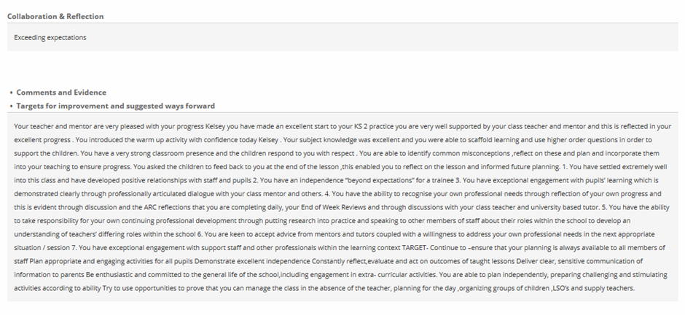
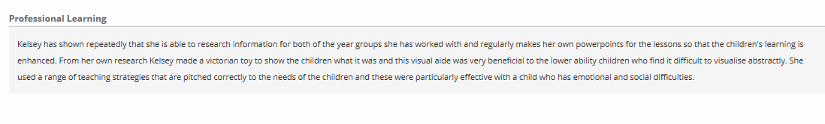
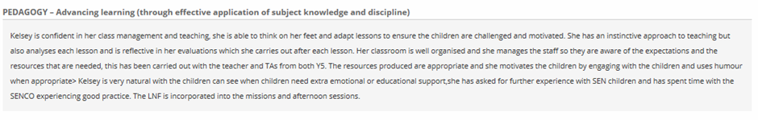
Appendix 2:
Appendix 3:
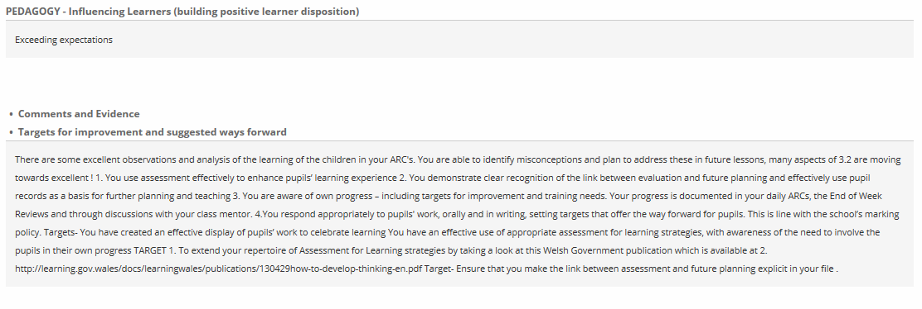

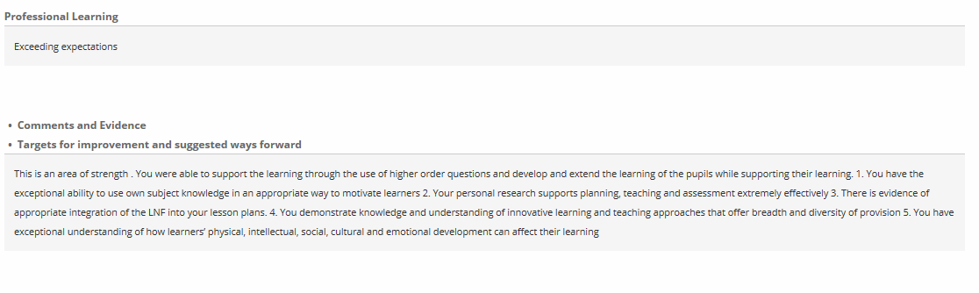
Appendix 4:
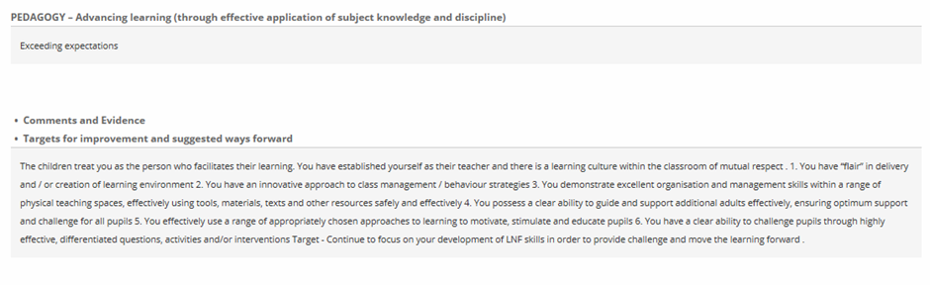
Appendix 5:
Appendix 6:
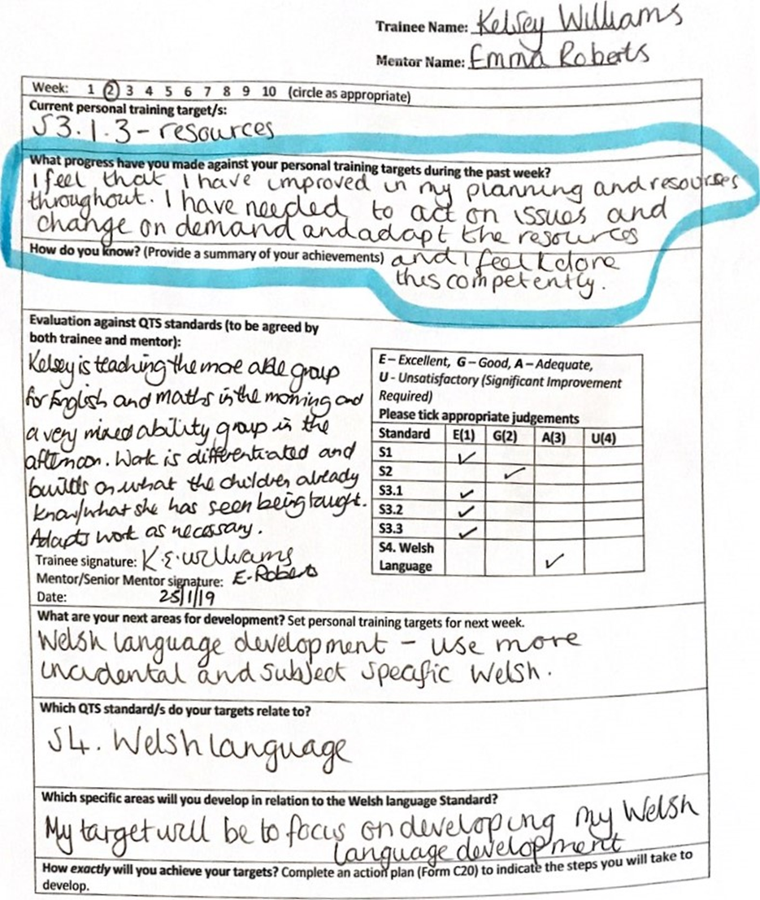
Appendix 7:

