

Module: Project Management
Module Code: LCLM5003
Assignment title: A Project Portfolio

Student name : George Burlui
Student ID : 1907641
Table of Contents
Part A: Poster 2
Part B: Reflection 3
Part C: Project Management Plan 5
1. Introduction 5
2. Project description 5
3. Scope 6
4. Work breakdown structure 6
5. Quad Chart 7
6. Gantt Chart 8
7. Stakeholders' involvement 10
8. Allocation of resources 12
9. Risk Analysis 13
10. Conclusion 16
References 17

Part A: Poster
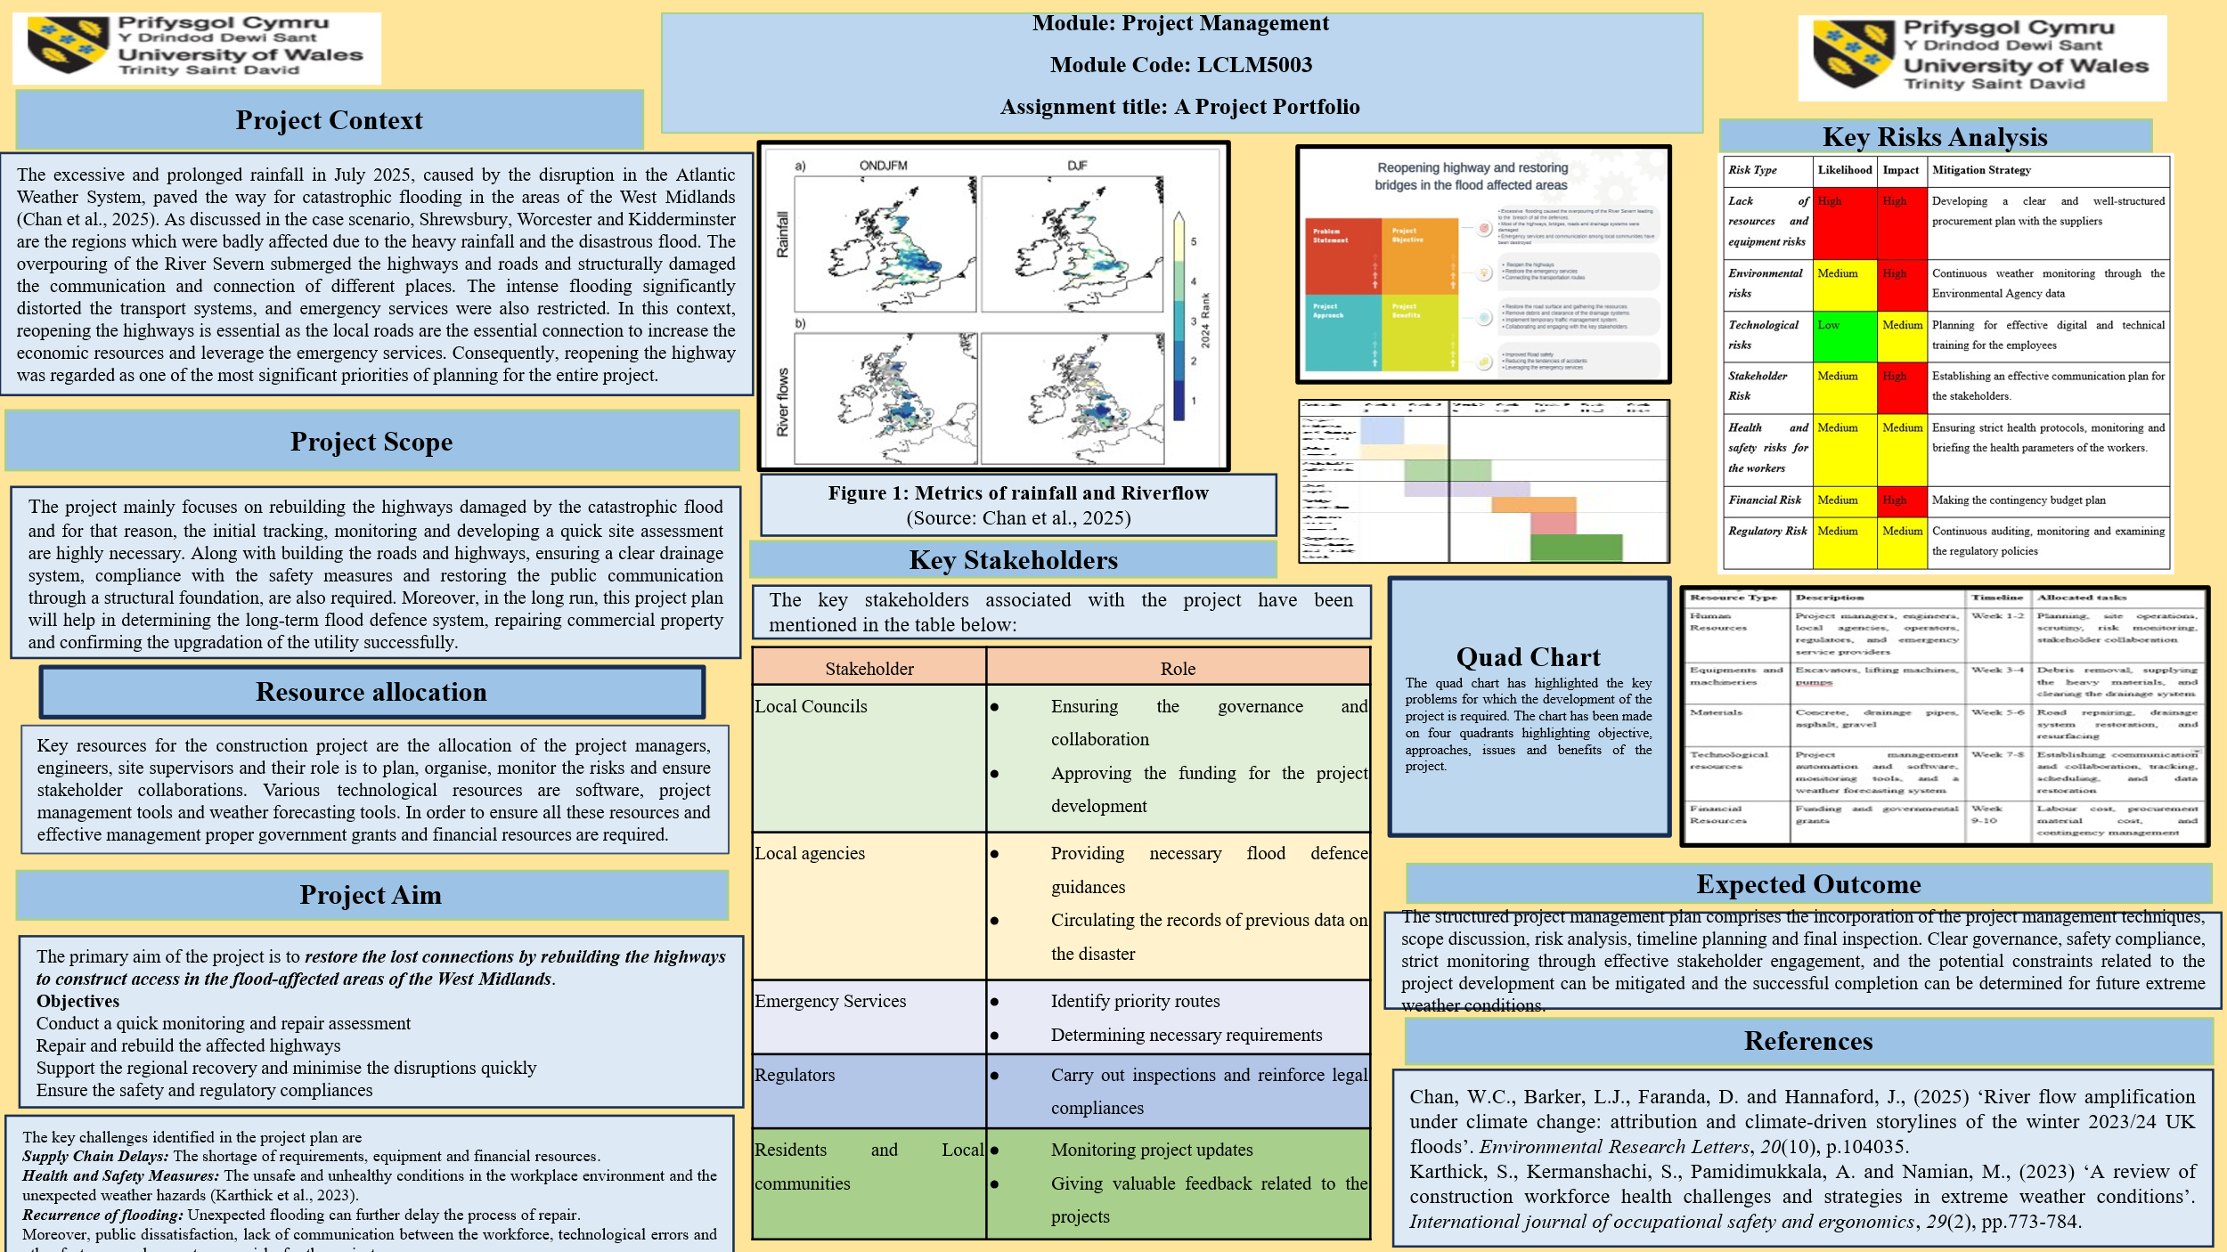

Part B: Reflection
Based on the project proposal poster, I received feedback from my tutor and peers, and the constructive feedback helped me shape my vision regarding the current context and some mitigation strategies. Valuable feedback helps to recognise all the strengths of the project management plan and identify the areas of further improvement (Tonni et al., 2023). The entire feedback guided me to understand the concepts accurately, developed my skill to communicate with all the project managers and stakeholders, and to evaluate how the project management plan can be strengthened after the final inspection, for the final submission.
The tutors and the peers have praised my choice of reopening the highways as a major mitigation policy for the restoration of the connection and communication of the flood-affected regions. The primary aim of this project is justified as it will reinforce the communication and provide emergency services to the flood-affected regions. The objectives developed for this project are clear, valuable and realistic in nature. The feedback also highlighted the relevance of conducting a quick assessment and monitoring, and based on that, developing the necessary timeline for the project plan. Within the project management plan, key activities sum up the project management plan, sequencing the tasks, which are highly necessary to execute the project completion.
One of the most positive pieces of feedback was to identify the legitimate stakeholders to complete the project. The advocacy of the local councils, local contractors, communities, supervisors and residents in the project development plan helped in the successful completion of the project delivery. Peers have suggested to me that to conduct the project plan, effective resource allocation is highly required. Designs, specifications, durability checking, and other activities are necessary while developing a highway project plan (Deep et al., 2022). The tutor and peers, through their feedback, suggested that I focus more on the risk analysis programme. After identifying the risks, the tutor suggested conducting the final project plan with the detailed mitigation strategies. The project activities must be linked with the risks and the future outcomes. In the future, while developing the project, I planned to develop a detailed risk register by monitoring and tracking the risks and the implications of these risks within the project plan. Along with the risk analysis, I have to focus in a detailed manner on the resume allocation process. Prioritising the environmental needs and ethical standards, sustainable and valuable resources are required to be gathered and used within the project.
As per the opinion of the peers, the project will develop a value and critical explanation of more critical and effective visual charts, diagrams and graphs used in the programmes. I have planned to develop a more detailed assessment of the resource allocation and exciting methods to reinforce the quality, sustainability and durability of the project. Analysing every segment of the project proposal, the feedback of the tutors and peers highlighted the relevance of the project management plan, ensuring clarity and depth. Mitigating the suggested areas of improvement, through proper risk management, resource allocation, completion and presentation, a more comprehensive and sustainable final project management plan will be delivered.

Part C: Project Management Plan

1. Introduction
Unprecedented rainfall, overpouring of the waterbodies due to the change in the Atlantic Weather System, led to a devastating flood in the regions of the West Midlands, such as Shrewsbury, Worcester and others. The flood has been caused due to the breach in the River Severn, submerging multiple regions, including the highways, destroying the infrastructure and causing widespread damage among the communities and local agencies. The transport links and communication of the emergency services were completely hampering the economic stability and sustainable development of the region.
In this situation, the primary aim of the Project Management Plan (PMP) is to outline a structured approach to reopening and rebuilding the highways in the flood-affected regions. As opined by Li et al. (2023), a project management plan is a structured and equity-centred framework, including various stages of damage identification, risk analysis, resource allocation and final inspection. The main aim of the project management plan is to restore the reliable and sustainable access and connection between various transport routes to leverage stakeholder collaboration, public safety and long-term resilience.

2. Project description
Project Aim
The development of the project plan is focused on the restoration of the emergency services, reopening of the highways, rehabilitation of the flood-damaged highways and transport routes within the flood-affected areas of the West Midlands.
Project Objectives
The main objective of the project is to ensure emergency services, restore communication and reinforce recovery systems within the flood-affected regions. Along with these primary objectives, the secondary objectives are ensuring safety and regulatory compliance, reducing the disruptions caused by the flood and restoring public communication by building an effective transport infrastructure. In a concrete form, the objectives of this project planning are:
- Tracking, monitoring and repair assessment
- Repair the highways and restore the long-lost connections, mitigating the risks of emergency services.
- Removing the debris and minimising the disruptions
- Determine the safety and regulatory compliances
The project further follows a project lifecycle model including initiations, planning, execution, monitoring, control and closure, offering a structured framework necessary for the complex infrastructure of the project (Wang and Chen, 2023). It is the role of the project managers to navigate the challenges and build a strong relationship with the regulators, investors, local agencies and supervisors.

3. Scope
The scope of this project pivots around the emergency of restoring and reopening the bridge and highways of the flood-affected regions of the West Midlands, which are now in high demand. The vulnerable regions like Shrewsbury, Worcester and other regions highly require emergency services as the communication and transportation system has been disrupted due to the overflowing of the River Severn (Chan et al., 2025). These disruptions and hazards have destroyed the functionality of the social and welfare services of the West Midlands region. It is identified that planning is a prerequisite in developing an engineering project of road infrastructure, including a highway project connecting several regions of a country; a well-structured plan is highly required (Castañeda et al., 2022). Highways in flood-prone regions work as a critical lifeline, helping in conducting all the emergency services and establishing strong communication among the residents and local communities.
The restructuring and restoration of the highway development plan focuses on determining the establishment of the reopened safety connection among the residents, ensuring bridge safety, compliance with legal and regulatory frameworks and others. The project plan further covers temporary waste management by removing the debris, conducting a damage assessment, regular monitoring and reopening the public communication. In the long run, it can further ensure a strong and effective flood defence system within the region, minimising unnecessary delays and optimising the transport delivery.

4. Work breakdown structure
Within a project management plan, a work breakdown structure is considered to be a tool that divides all the essential activities into small components for the sustainable and successful execution of the project tasks. The work breakdown structure of the current project is illustrated below:
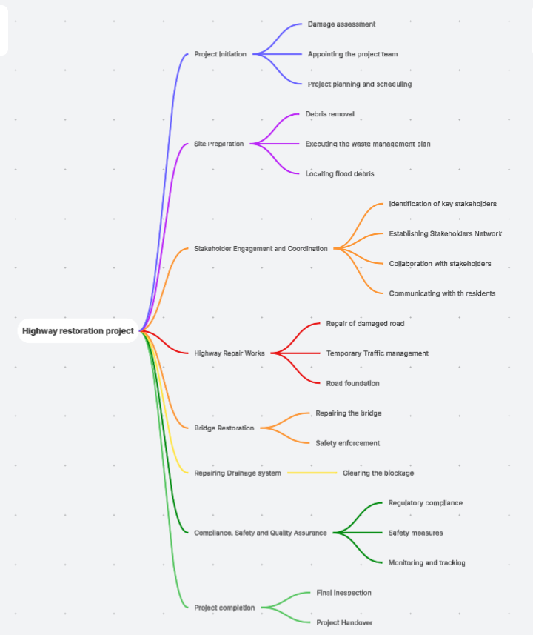
Figure 1: WBS
The WBS of the project management illustrates the deliverables clearly to ensure the cost management, environmental compliance, scheduling and effective project planning.

5. Quad Chart
The quad chart developed for this project, based on the four quadrants, has been illustrated underneath:
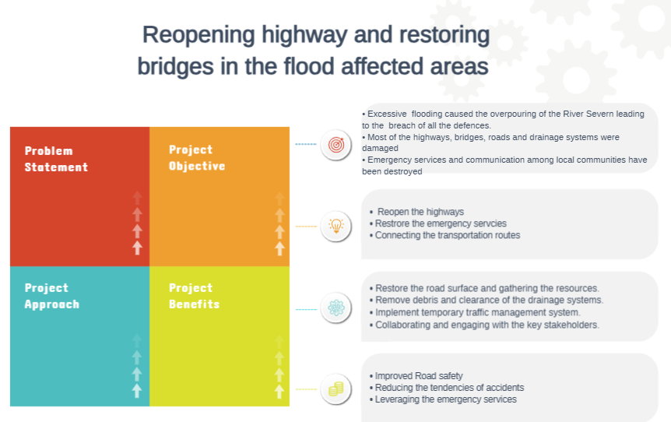
Figure 2: Quad Chart
The quad chart is a concise project management tool that highlights all the essential variables of a project plan within a single page format, highlighting four quadrants. The problem statement highlights the essential problems in the project management plan. In this project, the problem is caused by the heavy rainfall leading to a devastating flood. The flood submerged and damaged the roads, highways and bridges, disrupting the communication and emergency services. The main objective of the project is to develop an effective plan to restore the bridges and reopen the damaged highways. It further helps in increasing the accessibility of the emergency services by enforcing the regulatory laws and legal frameworks. Thirdly, the main approach of the project is to build up the road surface by collecting the materials and resources. Also, removing the debris and clearing the drainage system are also necessary. In this regard, the engineers and project avengers are needed to communicate and collaborate with each other. Lastly, to demonstrate the benefits of the project, it has been identified that improving the road foundation and ensuring the safety of the strong communication network can be established. Further to leverage emergency connections in the affected regions, the reinforcement of this project plan is necessary.

6. Gantt Chart

Stages | Activities | Week 1-2 | Week 3-4 | Week 5-6 | Week 7-8 | Week 9-10 | Week 11-12 | Week 13-14
Project Initiation | Project initiation and damage assessment
Site preparation | Debris removal
Site preparation | Stakeholder collaboration
Reformation | Road repairs
Reformation | Bridge restoration
Reformation | Drainage system renewal
Legal Compliances | Regulatory Compliance and Safety Check
Project monitoring and Completions | Final inspection and project handover
Table 3: Gantt chart
The project manager is required to frame the timeline for the project activities and thus can determine the time management process. The stages of the project development have been divided into some necessary activities. First stage project initiation, a total time frame of two weeks, includes damage assessment and project initiation. The next activity of site preparation took a total of 4 weeks, including activities like debris removal and collaborating with stakeholders. The reformation stage was the longest stage that took almost 9 weeks, including the reformation of roads, bridges, clearance of drainage and other activities. Lastly, in 2-3 weeks, the legal compliance and monitoring stage will be completed, making the project ready to hand over.

7. Stakeholders' involvement
Project stakeholders are the individuals, including the local communities and organisations, who are involved in the project, and it is the responsibility of the PM managers to prioritise their interests in the process of project execution (Mariani et al., 2023). As opined by Carlander and Thollander (2023), a regular stakeholder involvement plan includes transparency, communication, collaboration and completion of all the tasks within the project. The involvement and role of the stakeholders within the project can be analysed by using the aspects of the stakeholder management theory. Stakeholder management theory evaluates the role and responsibilities of various constituencies of a project, analysing their role and moral values (Mahajan et al., 2023). The internal stakeholders of this project are the local council, the finance team, the procurement team, the project managers and highly efficient engineers. The external stakeholders of this project are emergency service providers, constructors, transport operators, local residents and others. The power and interest of the stakeholders engaged in this project can be analysed based on Mendelow's matrix chart.
High Power, High Interest  Local councils, project managers, emergency services, transport operators | Low interest, High power  Environment Agency, constructors, regulators, Government
Low Power, High Interest  Local businesses, residents, and users of the road | Low Interest, Low power  Media
Table 4: Mendelow’s Matrix
Roles of the stakeholders
Stakeholders | Roles
Local council | The local council examines the process of planning, coordination and execution.
Finance team | Allocating the funding necessary for resource allocation, gathering the equipment and conducting all the activities.
Procurement team | Managing contracts and suppliers' payments
Project managers | Gathering the resources, overseeing the timeline and communicating with the stakeholders.
Engineers | Conduct the inspection and develop the entire design.
Emergency Service providers | Identify the demands and offers necessary for quick services
Contractors | Executing the repair and reconstruction of the project works.
Local residents | Offering feedback about the end projects and road closures.
Table 5: Role of the stakeholders

8. Allocation of resources
Resources of this project plan refer to the valuable attributes highly required to conduct and complete this project plan. The role and relevance of each of the resources aligned with the project plan can be analysed by evaluating the aspects of the Resource-Based View theory. The theory analyses that organisations determine success and ensure growth by collecting valuable, rare, organised resources (Ozdemir et al., 2023). In the restoration of the highway projects, the management is required to gather a highly skilled workforce, structured equipment, essential funding, and effective machinery to quickly deliver the project. Experienced engineers, local agencies, contractors, regulators, transport operators and emergency service providers are valuable resources who are irreplaceable. On the other hand, to reinforce the organised coordination, monitoring the risks, site assessment and making an overall project timeline are very essential.
Resource Type | Description | Timeline | Allocated tasks
Human Resources | Project managers, engineers, local agencies, operators, regulators, and emergency service providers | Week 1-2 | Planning, site operations, scrutiny, risk monitoring, stakeholder collaboration
Equipments and machineries | Excavators, lifting machines, pumps | Week 3-4 | Debris removal, supplying the heavy materials, and clearing the drainage system
Materials | Concrete, drainage pipes, asphalt, gravel | Week 5-6 | Road repairing, drainage system restoration, and resurfacing
Technological resources | Project management automation and software, monitoring tools, and a weather forecasting system | Week 7-8 | Establishing communication and collaboration, tracking, scheduling, and data restoration
Financial Resources | Funding and governmental grants | Week 9-10 | Labour cost, procurement material cost, and contingency management
Table 6: Resource allocation
The well-structured and integrated resource allocation plan, including the collection of sustainable materials, financial resources, technological equipment and skilled human resource management, ensures the safe and successful delivery of the highway project.

9. Risk Analysis
Risk management is an essential and crucial factor of developing an effective project management plan. An effective risk management plan for a project ensures that project activities cannot be damaged due to unexpected hazardous reasons (Salzano et al., 2024). Project risk management is an effective tool that helps experts and project managers identify the potential risks associated with a project. In the context of developing a construction project, establishing a clear and vision-oriented risk management plan is essential. A well-developed risk register table registers and updates all the potential risks associated with the project development plan, and it also highlights the implications and mitigation strategies (Khodabakhshian et al., 2023). The risk register table for this project management plan of the highway project is illustrated below:
Risk Type | Description | Likelihood | Impact | Mitigation Strategy
Lack of resources and equipment risks | Shortage of skilled labour  Unavailability of sustainable resources  Lack of specialised machinery and equipment can delay the completion of the project. | High | High | Developing a clear and well-structured procurement plan with the suppliers  Navigating alternative resource allocation sources  Communicating with alternative suppliers
Environmental risks | Unexpected heavy rainfall leading to a flood can delay the construction project activities. | Medium | High | Continuous weather monitoring through the Environmental Agency data helps in protecting the natural environment (Gov, 2026)
Technological risks | Failure to install the project management software due to a lack of knowledge and coordination. | Low | Medium | Planning for the effective digital and technical training for the employees (Ngereja and Hussein, 2022)  Using reliable and effective software management platforms is also necessary.
Stakeholder Risk | Lack of communication and coordination among the stakeholders, Poor stakeholder management, dissatisfaction of the local communities and residents | Medium | High | Establishing an effective communication plan for the stakeholders.  Planning for effective collaboration and communication training.  As opined by Vuong and Nguyen (2022), establishing monitoring for the feedback sessions for the employees within the project is necessary.
Health and safety risks for the workers | Heavy machinery operations, contaminated flood water, and a lack of proper waste management can cause some serious health hazards for the workers. | Medium | Medium | Ensuring strict health protocols, monitoring and briefing the health parameters of the workers.  The Health and Safety Act (1974) ensure occupational health and safety in the workplace (Gov, 2026).
Financial Risk | Lack of financial resources and unforeseen financial budget costs can create some barriers to the project execution.  Increased cost of the construction materials and equipment, such as BMI and digital tools, can also create a financial burden for the project plan (Sepasgozar et al., 2022). | Medium | High | Making the contingency budget plan and estimating the budget plan for the project can help in managing the funding-related risks.
Regulatory Risk | Failure to meet environmental sustainability or safety transportation plans can cause some legal and regulatory hazards within the development of the project. | Medium | Medium | Continuous auditing, monitoring and examining the regulatory policies can ensure the regulatory safety and legal compliance within the project.
Table 7: Risk analysis table
The risk management table, along with the mitigation strategies, highlights the structural approaches of identifying, assessing, monitoring and completing the project to reopen the highway. Identifying the potential risks, analysing the impact and likelihood, developing the mitigation strategies and developing the highway within the flood-affected areas can be determined successfully.

10. Conclusion
From the overall analysis, it has been identified that the project management plan presents a structured and well-reformed approach, including the methods of reopening the roads, restoring the highways, collecting the resources, removing the debris and ensuring legal compliance in the West Midlands' flood-affected regions. The project management principles include clear identification of the problem statement, collaborating with key stakeholders, resource allocation, risk analysis and following the necessary mitigation strategies for the determination of the project's success. In order to reopen the emergency services, ensuring continuous access and enhancing community mobility, the development of project management is highly essential.
From the overall evaluation, it can be recommended that some effective strategies need to be implemented, including the clear development of a stakeholder engagement plan. Establishing effective communication and collaboration with all the key stakeholders can help in identifying the issues and, based on that, can develop an effective mitigation plan through digital tools and automation (Zwikael et al., 2023). Further strong communication with the residents can leverage the community trust and loyalty, helping to maintain transparency and loyalty. The insights developed from the overall project management plan and its execution can further help in the future process of infrastructure planning, analysing the resilience system, strengthening the process of preparedness and determining long-term sustainability within a constructive project.

References
Part A
Chan, W.C., Barker, L.J., Faranda, D. and Hannaford, J., (2025) ‘River flow amplification under climate change: attribution and climate-driven storylines of the winter 2023/24 UK floods’. Environmental Research Letters, 20(10), p.104035.
Karthick, S., Kermanshachi, S., Pamidimukkala, A. and Namian, M., (2023) ‘A review of construction workforce health challenges and strategies in extreme weather conditions’. International journal of occupational safety and ergonomics, 29(2), pp.773-784.
Part B
Deep, S., Banerjee, S., Dixit, S. and Vatin, N.I., (2022) ‘Critical factors influencing the performance of highway projects: an empirical evaluation’. Buildings, 12(6), p.849.
Tonni, I., Fine, P., Leung, A., Louca, C. and Paganelli, C., (2023) ‘Students' perceptions of tutor feedback: a pilot study’. Minerva Dental and Oral Science, 72(2), pp.61-68.
Part C
Carlander, J. and Thollander, P., (2023) ‘Barriers to implementation of energy-efficient technologies in building construction projects—Results from a Swedish case study’. Resources, Environment and Sustainability, 11, p.100097.
Castañeda, K., Sánchez, O., Herrera, R.F. and Mejía, G. (2022) ‘Highway planning trends: a bibliometric analysis’. Sustainability, 14(9), p.5544.
Gov (2026) Environment Data Available at:https://environment.data.gov.uk/ (Accessed: 4 February 2026)
Gov (2026) Health and Safety at Work 1974 Available at:https://www.hse.gov.uk/legislation/hswa.htm (Accessed: 4 February 2026)
Khodabakhshian, A., Puolitaival, T. and Kestle, L., (2023) ‘Deterministic and probabilistic risk management approaches in construction projects: A systematic literature review and comparative analysis’. Buildings, 13(5), p.1312.
Li, Y., Zhang, F. and Ji, W., (2023) ‘Integrated data-driven and equity-centred framework for highway restoration following flood inundation’. Journal of Management in Engineering, 39(3), p.04023012.
Mahajan, R., Lim, W.M., Sareen, M., Kumar, S. and Panwar, R. (2023) ‘Stakeholder theory’. Journal of Business Research, 166, p.114104.
Mariani, C., Navrotska, Y. and Mancini, M., (2023) ‘Unsupervised machine learning for project stakeholder classification: Benefits and limitations’. Project Leadership and Society, 4, p.100093.
Ngereja, B.J. and Hussein, B., (2022) ‘Employee learning in the digitalisation context: An evaluation from team members’ and project managers’ perspectives’. Procedia Computer Science, 196, pp.902-909.
Ozdemir, S., de Arroyabe, J.C.F., Sena, V. and Gupta, S. (2023) ‘Stakeholder diversity and collaborative innovation: Integrating the resource-based view with stakeholder theory’. Journal of Business Research, 164, p.113955.
Salzano, A., Cascone, S., Zitiello, E.P. and Nicolella, M. (2024) ‘Construction Safety and Efficiency: Integrating Building Information Modelling into Risk Management and Project Execution’. Sustainability, 16(10), p.4094.
Sepasgozar, S.M., Costin, A.M., Karimi, R., Shirowzhan, S., Abbasian, E. and Li, J., (2022) ‘BIM and digital tools for state-of-the-art construction cost management’. Buildings, 12(4), p.396.
Vuong, T.D.N. and Nguyen, L.T., (2022) ‘The key strategies for measuring employee performance in companies: a systematic review’. Sustainability, 14(21), p.14017.
Wang, T. and Chen, H.M., 2023. Integration of building information modelling and project management in the construction project life cycle. Automation in Construction, 150, p.104832.
Zwikael, O., Salmona, M., Meredith, J. and Zarghami, S.A., (2023) ‘Enhancing project stakeholder communication under insufficient knowledge of project management concepts’. Engineering, Construction and Architectural Management, 30(10), pp.5007-5029.

