

Postgraduate/Distance Learning
Assignment coversheet & feedback form

THIS SHEET MUST BE THE FIRST PAGE OF THE ASSIGNMENT YOU ARE SUBMITTING (DO NOT SEND AS A SEPARATE FILE)

For completion by the student:
Student Name: Amanda Page

Student University Email: 2218536@student.uwtsd.ac.uk
Module code: HPCA7014  Module title: Sacred Geography | Student ID number:  2218536 |  |  | Educational support needs:  Yes/
Assignment title: Is sacred space a human construct or a natural phenomenon? Discuss this question through a research project with reference to the work of at least three theorists.

The Holy Trees of the Isle of Avalon: Trees as Invitation for Participation within a Sacred Landscape ​

Assignment due date: 4 Jan 2024 (+1 week differentiated deadline 11th Jan)
This assignment is for the 1st 2nd X 3rd 4th 5th 6th module of the degree
I confirm that this is my original work and that I have adhered to the University policy on plagiarism.
Signed ……………………………………………………………
Email submission:if you are submitting this form via email, please tick this box
(as a substitute for your signature) to confirm that you agree to the above declaration.
Assignment Mark
1st Marker’s Provisional mark
2nd Marker’s/Moderator’s provisional mark
External Examiner’s mark (if relevant)
Final Mark

NB. All marks are provisional until confirmed by the Final Examination Board.

For completion by Marker 1 :
Comments:

Marker’s signature: |  |  | Date:
For completion by Marker 2/Moderator:

Comments:

Marker’s Signature: |  | Date:
External Examiner’s comments (if relevant)

External Examiner’s Signature: |  | Date:
Is sacred space a human construct or a natural phenomenon? Discuss this question through a research project with reference to the work of at least three theorists.

The Holy Trees of the Isle of Avalon: Trees as Invitation for Participation within a Sacred Landscape ​

5250 words
Introduction
This research aims to explore the nature of sacredness through a case study of significant trees situated in Glastonbury, Somerset, UK. The methodology I have used is qualitative using notebooks, recordings, and personal photographs. I have a caravan at the Isle of Avalon site in Glastonbury and therefore visit the town regularly. I conducted this specific field work for three days and nights in early November 2023. The research focuses on the Glastonbury Thorn on Wearyall Hall, the Gog and Magog ancient oaks, and the yews of Chalice Well Gardens all of which are situated along the pilgrim paths of Glastonbury. As a result of my findings themes discussed will be whether trees have agency to extend an invitation for human and nonhuman participation in the landscape and why, in this time of ecological collapse, that could be important; how stories and myths add to the power of a place. The discussion commences with the extraordinary experience I had in India under a sacred Banyan tree in the Hindu Swetharanyeswarar Temple in January 2023. Theorists called upon to support my arguments are Mircea Eliade, Rudolf Otto, Christopher Tilley, Belden C. Lane and Mark Schroll. I have taken an Aristotelian approach to my methodology.

I will also use literature about Glastonbury from the Library focusing on Carol M Cusack’s paper on the Glastonbury Thorn. This research will build on my previous interest in plant communication and extraordinary experiences such as encounters with the divine in nature. The research could be of significance in understanding how a person can form a meaningful relationship by interacting with the natural world, thus mitigating further harm.

Literature Review
The main secondary sources of literature relevant to my research focus on definitions and explanations of the sacred and experiences attached to it. These are (by publication date) Forms, The Idea of the Holy, The Sacred and the Profane, A Phenomenology of Landscape and Landscapes of the Sacred by the theorists Emile Durkheim, Rudolf Otto, Mircea Eliade Christopher Tilley and Belden C. Lane respectively. I also refer to Bernadette Brady’s chapter in Space, Place, and Religious Landscapes to discuss the Aristotelian notion of sacred place being where ‘a body [finds] itself … in its ‘proper place’’. To discuss extraordinary experiences in sacred spaces I will refer to Lane again and Mark A Schroll’s chapter in Greening the Paranormal.

Definitions of Sacred
To start it is pertinent to define what the word sacred means in this context and this paper uses Thorley’s description thus: ‘[it] is a place in the landscape... which is especially revered by people, culture or cultural group as a focus of spiritual belief and practice or likely religious observance.’ Glastonbury fits this description. Indeed, it was René Guénon who first used the term ‘sacred geography’ when writing about Glastonbury in 1935. Ivakiv writes that sacred ‘places and landscapes are constituted in and through histories of human-nonhuman interaction in specific biophysical and material topographies and ecologies.’

The theorists discussed do not always agree on what causes a place to be sacred. For Durkhiem the sacred only exists in the human mind and cannot be separated from it. The sacred is made ‘by collective human doing’ that is ‘set apart from the everyday and constantly remade In contrast, Eliade argues that sacred space is a natural phenomenon where the person experiences a divine interruption where ‘some parts of the space are qualitatively different from others.’ These spaces form a ‘central axis for all future orientation,’ and constitute ‘absolute reality, opposed to the non-reality of the vast surrounding expanse.’ Thus for Durkheim sacredness is a human construct but for Eliade it is a natural phenomenon – which returns us to the core question for this exploration.
Another idea discussed in this paper is that of the hierophany. Eliade writes that one ‘becomes aware of the sacred because it manifests itself’, and he terms this manifestation a ‘hierophany’. Otto’s work seems to complement Eliade’s where this manifestation has a particular feeling attached to it known as the numinous. Otto coined the term, numinous defining it as, ‘man’s sense of the divine presence and part of the reality and character of that presence.’ For Otto it is the loveliness of nature which inspires in us a feeling of ‘awefulness’ (sic) as well as ‘fear and beauty.’ Bernadette Brady’s paper – ‘Mountains talk of kings and dragons, the Brecon Beacons’ is referenced to describe the Aristotlian notion that place can assert ‘a form of gravity that drew bodies towards certain places’ being, ‘the proper place.’ The last theorist to be discussed in my findings is Belden C. Lane with his 4 axioms theory as follows:
- Sacred place is not chosen, it chooses
- Sacred place is ordinary, ritually made extraordinary
- Can be tread upon without being entered
- both local and universal
Lane also describes the archetypal sacred place having the 3 elements of stones, water and trees.

Phenomenological Perspective
This project also draws on the phenomenological perspective of Christopher Tilley where what people do ‘cannot be divorced’ from the landscape.’ Tilley believed that academics would not be able to understand people's experiences of the past by looking at material remains – the researcher would have to take an interpretive leap where something ‘new transforms… understanding of place’. People return to a sacred place like Glastonbury to engage with it as it reaffirms who they are, as well as where and when they are in the world. It grounds them and enables them to feel attached to their ancestors. Glastonbury is a thoroughly enmeshed space as well as a contested space. Lane posits that ‘it is often the contested character of a place that most signifies its sacral quality’ and I agree with this point.

Extraordinary Experience
In Greening the Paranormal, Mark A Schroll writes that being in a sacred space can trigger a ‘transpersonal awakening’. It is this awakening that could lead to the awareness that humans and non-humans are interconnected or what he calls, ‘Gaia and cosmic consciousness.’ He claims sacred spaces also have the capacity to influence our dreams.
Lane’s paper, ‘Falling in Love with a Tree’ that detail Belden Lane’s extraordinary experience and is worth quoting in full here,
‘We and the more-than-human “others” find ourselves staring together into a fire of apocalyptic loss. Yet within that looming crisis, new opportunities emerge. New ways of listening and being heard arise. The Great Conversation is gradually being renewed because of our growing consciousness of being collectively at risk.’
’Nature and psyche are overlapping realities that continually slide into each other. Our unconscious connections with the natural world are as real as our conscious experience’

Methodology
Using a qualitative perspective enabled me to ‘understand [my] perceptions of the world’ as I directly experienced it. This case study was part applied narrative inquiry methodology using story to describe the lived experience of walking the pilgrim paths (embodied) and part survey where I interviewed the trees thereby approaching the question through their perspective and not just a human one. I interacted with the landscape connecting the trees that I perceived to be a ‘central axis’. I devised a short questionnaire that I used with the trees in Glastonbury and followed a ritual as follows:
- Set a small altar as the base of the tree with a temple cloth I was gifted at the Mercury Temple in Tamil Nadu. This included a topaz Ganesh statue, a lit candle, a piece of rainforest jade and a ribbon (see figure 1).
- I cleared the space with a home-grown mugwort herb smudge stick, letting the smoke rise up into the branches
- Pulled an oracle card at each tree as a way of providing a sense of theme, meaning, or to provoke communication of some kind
- I spoke out loud explaining what I was doing and asking the tree for any insights. The questions are asked were: Q1. Why do you call people here?
Q2. Why do people tie ribbons to you?
Q3. What is it you need to communicate?
Q4. Why is this important?
Q5. What is a scared space?
- I practised automatic writing recording what I perceived the trees responses to be to each of the questions
- I thanked the tree, tied the ribbon to a nearby fence with others already there and then closed the ceremony by blowing out the candle
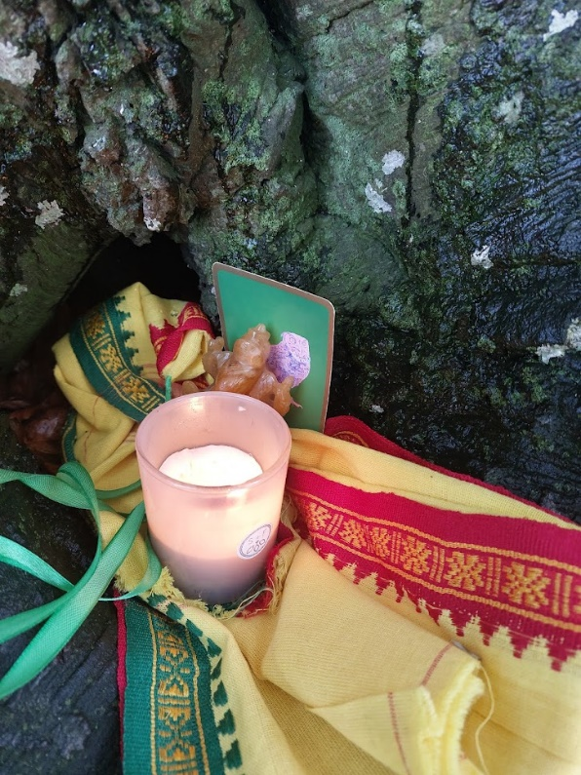
Figure 1 by Amanda Page, 4/11/23, Avebury
As well as recording the tree’s responses, I recorded events, thoughts, poems and dreams in a journal– these along with personal photographs taken on my phone and sound recordings constitute my primary sources for this investigation. The ‘narrative threads’ highlight patterns that reverberate throughout the data. There are some reflexive considerations. Qualitative research is both subjective and selective (as opposed to quantitative or objective research) and the evidence submitted is not easily cross-referenced and is ‘dependent on the researchers account’ however it does allow for many ways for the question to be explored including collecting evidence, studying relationships, observations and interviews. A further consideration is that I am culturally biased. As a white, middle-aged, middle-class woman currently living in a beautiful rural spot at the edge of Bannau Brycheiniog I have both the capital to travel and time to study topics that are of personal interest to me. However, I did not always have this privilege. I was raised in a turbulent, single parent household and left home when I was seventeen to discover more violence as a homeless young woman. I have spent the last ten years following a spiritual path to explore ways to ease the pain of childhood trauma and the subsequent chronic medical conditions that have materialised as I have aged. From a personal perspective, I am of the opinion that the disintegration of my material body, on a micro level, is linked to the destruction of biodiversity on this planet at macro. I feel the ability to link my own human suffering to that of the non-human is a strength in this investigation.
Sigurd Bergman – Goethe reflect outwards, recognise yourself in the landscape
Hindu declaration in 2015 – ‘All elements of reality are organs of God’s body… the entire universe is to be looked upon as the energy of the Lord.’
Field work and Discussion
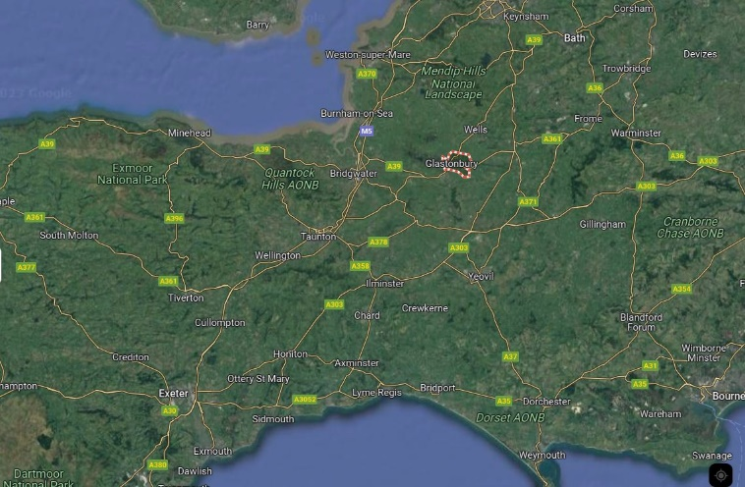
Figure 2, Google Maps accessed 29/12/23
Glastonbury is a Somerset market town situated to the south of the Mendip Hills (see figure 2). It is famous for the hill, known as the Glastonbury Tor on which stands the remains of St Michael’s church where the last abbot of Glastonbury Abbey was hanged in 1539. Glastonbury is considered a sacred place by many cultural groups and as such is a contested place. I arrived in Glastonbury in the aftermath of Storm Ciaran on the 4th November and it was still wet and wild weather. I made a stop at Avebury on route from Cambridge where I sat briefly with the huge beech trees outlining my intentions for next few days (see figure 3). It just felt right to make this stop – it was like I was asking permission because they were connected to the ancient trees I would be visiting in Glastonbury. I pulled the owl card from the oracle pack – which connected to events later in the trip. I noted that, I took my shoes off to connect to the ground/roots/mycelium. I felt an eruption of sacred life where people come to connect to the source of interconnection. We are drawn to its bright spark.
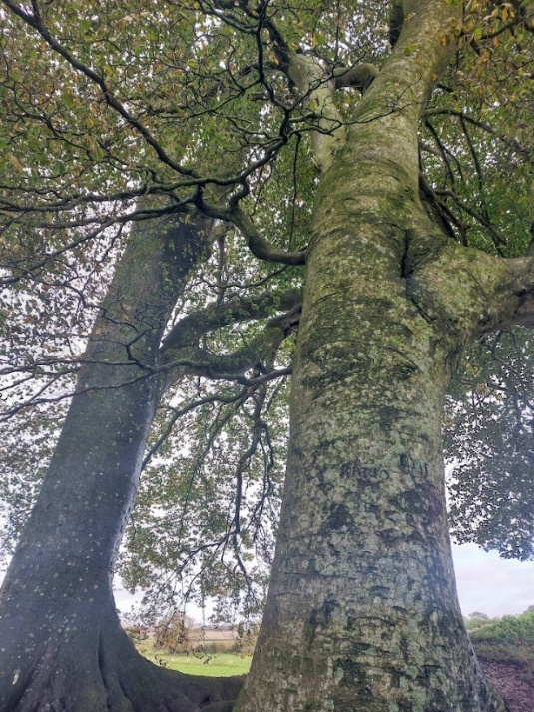
Figure 3 by Amanda Page, 4/11/23, Avebury
Being ‘drawn to’, is reminiscent of Aristole’s notion of the proper place and I was unaware of this work before writing my comment.
Once settled into the caravan, I walked the pilgrim’s paths following in the footsteps of many others to visit the significant trees in the town and I illustrated in orange the route taken in figure 4. Following the ritual outlined above, I first visited the holy thorn on Wearyall Hill; then the Chalice Well yews on day two and lastly I visited Gog and Magog on day three. I returned home on day four.
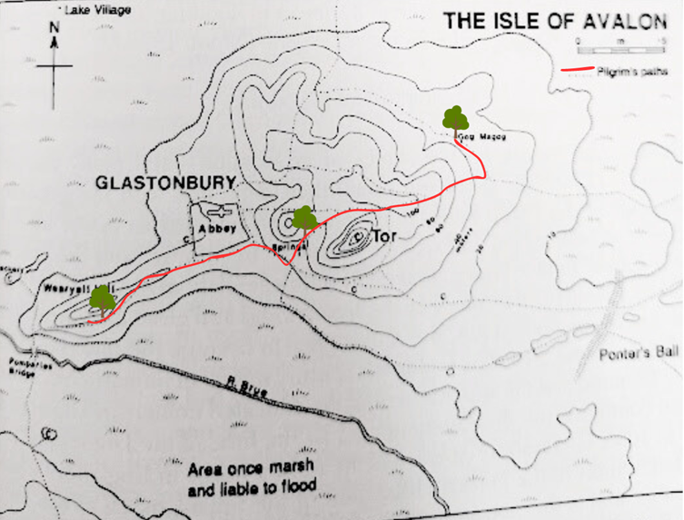
Figure 4
Unusual and unplanned events that occurred during the field trip were the visit to a sacred walnut tree and St Margaret’s church on Magdalene Street and a meditation at the Goddess Temple the first night. I was kept awake each night by banging on the roof of the caravan made by an old ash tree branches and the rain.

The Hierophany
Before discussing the sacred in relation to trees in Glastonbury, it is important to describe what I experienced in India as it is both forerunner and helps to shed light on some of the experiences in Glastonbury. Earlier this year I was part of a University tour visiting the Hindu Navagraha Temples of Tamil Nadu and on 18th January we were visiting the Mercury Temple located at Thiruvenkadu. Every Navagraha temple is based in the Cauvery Delta once a vast rainforest cut down for agricultural purposes. The group had participated in a puja ceremony giving thanks to Lord Budhan and we had each been invited by the temple priest to make a promise to him. I had vowed to speak to the trees and share what they said with others. Directly after this vow we made our way to the Ganesh shrine and my diary entry picks it up here:
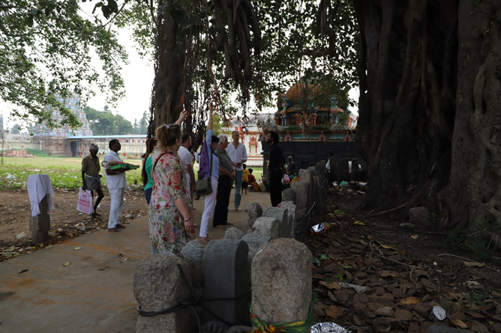
Figure 5 by Nesilhan Ayanoglu, 18/1/23, Thiruvenkadu
Before I spied the small Ganesh shrine I knew I wouldn’t be able to handle it. That emotional love energy I’d stored in my legs during the ritual began to stir and make its way up through my body until it reached my heart. It felt almost unbearable. The shrine was directly under a holy banyan tree. I saw the roots growing down from the branches forming ropes for monkeys and other climbing or flying beings to find sanctuary. As we approached I perceived the pain of many trees being cut down and re-lived the feeling, many years prior, when I stood up in my GCSE biology class on the Amazon rainforest demanding we do something about it. I’d cried in despair that no one else felt as I did about its destruction. I started murmuring.
‘I’m sorry, I’m sorry. I’m so sorry.’
As I came closer to the tree my sobs became louder, my face wetter. It was almost too intense to stand in line at the Ganesh icon. I prayed hard for forgiveness and reiterated my promise to try to do my human best to bring awareness for the amazing lessons that plants can teach us about ourselves and how to treat all beings. I noted that others were similarly moved by their experience and although I’d gone beyond caring about what other people thought of my meltdowns at least some could sense the awesomeness of this being enough for it to show on their faces.

See figure 5. Eliade would call this experience a hierophany. The tree ‘showed itself’ and the atmosphere of the space under its branches was unlike anything I had experienced before. The moment arrived like an eruption in the mundane (although being in a foreign temple is not mundane in this sense, I felt a distinct difference being beneath the tree) and had a ‘reality that does not belong to our world.’ It was if the tree were the fixed, central point and I was drawn towards it. I felt the quality of the numinous – people fell silent and felt both the ‘awefulness’ of the giant tree and the horror the surrounding rainforest’s destruction. Lane’s 4th axiom comes into play here, also for the tree was both local, being a singular temple tree, yet also universal, where it is a lone survivor of vast tropical forest and a symbol for current mass biodiversity loss.

Participation
The next part of the discussion focuses on whether trees have agency to extend an invitation for human and nonhuman participation in the landscape. In the Roman world the ‘tree stood as a potential point of contact between the human world and the world of the divine.’ I questioned that if Glastonbury landscape was a sacred place, and I agree it is, I wondered if the trees, already with their own names and myths connected with them, could be the access point to contact with the divine. I started my research online and found that local man Matt Witt gave tree tours around Glastonbury. I discovered as well as the famous trees I visited there is also a 200 year old lime tree known as Grandmother Lime, (named by locals) who is offered manmade ribbons or toys as well as natural items like fruit, flowers, feathers and leaves. Witt and other residents such as artists and poets roam the pilgrim paths where songs emerge from the landscape. I followed these same paths.
I walked and wrote about what I experience as Tilley does in his phenomenological approach. I followed in the footsteps of the many people who had made the same journey. Each of the trees had ribbons and small offerings attached to them like the Grandmother Lime and there were others along the path that were decorated too. Here, we can see the contested space idea where the tree holds meaning for each individual or group. The people who visit the trees have their own reasons for doing so – maybe to leave a simple token of thanks, or to ask a wish for a boon or as remembrance ceremony for a lost loved one. Each gift is another voice, layer, potential history and each builds import. People have chosen this tree as special – where it is located in the landscape has made it sacred and it also invites participation.

Holy Thorn, Crataegus monogyna 'Biflora'
Figure ?? shows the situation in the landscape of the newly planted holy thorn across from the Tor. The old thorn was sawn down by vandals in 2010 which in itself proves the importance of the tree but not to be discussed here. I sat with the young tree and perceived the answer to why people are called to the place:
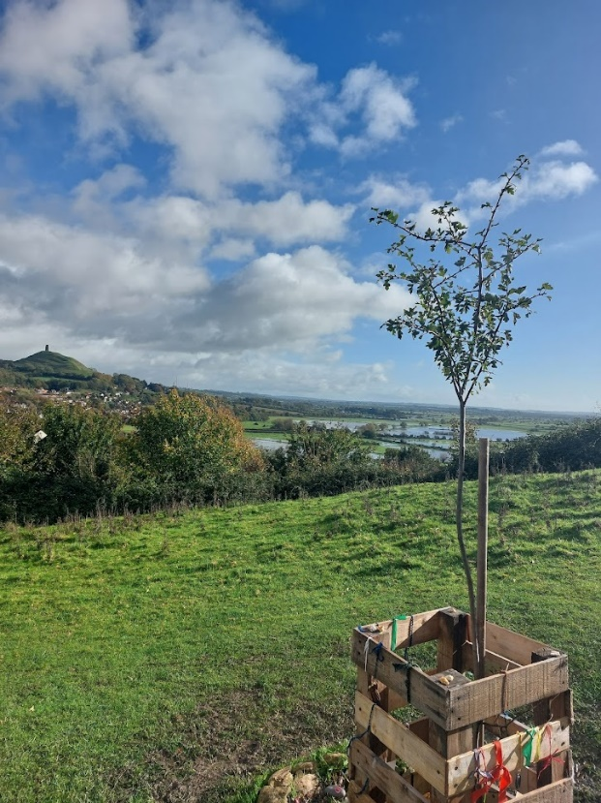
Figure 6 by Amanda Page, 5/11/23, Wearyall Hill, Glastonbury
You can see for miles, it gives you an idea that it’s not just all about you – you are part of the landscape flowing through it like a leaf on a river.
Looking back at the phrasing of the question I noticed that I made the assumption that people are called or invited to visit the tree by asking the tree, why it was so. For me, this is not disputed. There is no science that can prove that the trees invite participation however human beings have attached their meanings throughout time going back to the Middle Ages. As well as the Joseph of Arimathea story surviving until today, new ways of interacting with the tree, like Witt’s tree tours ensure that the tree continues to bring people to it. Indeed, a Google search of ‘holy thorn Glastonbury’ returns about 447,000 results. I would argue that this tree is in the collective consciousness and is in a place for anyone to access.
I asked the tree about why it needed to communicate. This is the answer I perceived:
It’s about setting you in the landscape to open your eyes to beauty and truth. You’re feeling how I feel in the sun, seeing what I see every day, hearing the birds, the traffic, the crows – the heat of the sun – the sun is life-giving. Let the wind move you.
A visit to sacred places creates memories and forms connections, it situates a person in history and establishes a lineage. For Tilley, ‘place is about situatedness in relation to identity and action.’ This is reflected in what I perceived the tree to answer about why folk leave ribbons:
Maybe their ancestors had been here and it’s a direct link through time and space to the ancients.

Chalice Well Yew, Taxus baccata
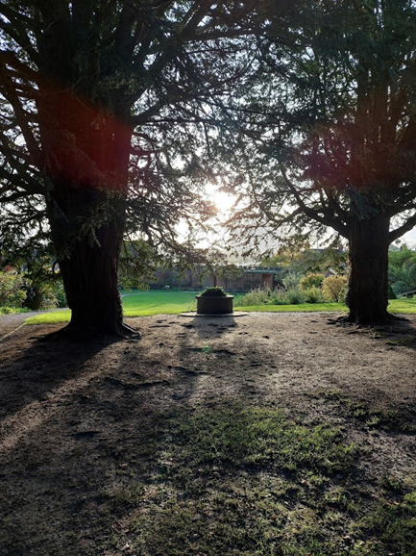
Figure 7 by Amanda Page, 5/11/23, Chalice Well Gardens, Glastonbury
The entrance to inner Chalice Well garden paths is framed by two ancient yew trees (see figure 7). An arbor provides a space for sitting with the trees for quiet contemplation. For the yews, they invite participation because (in their perceived words), ‘we like feeling your rhythm, it is like music for us. We sing with your life force and you sing with ours.’ Again people had left offerings of natural and manmade objects (see figure ??) building a sense of identity and meaning with the place.
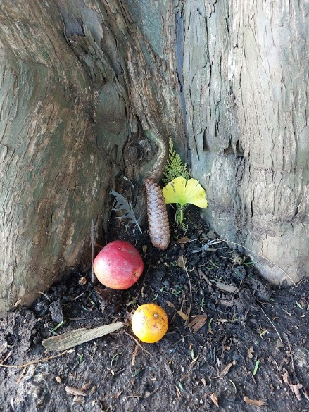
Beyond the yews is an area called Arthur’s Court where the natural ‘red spring’ water flows into a stone tank. The water has long been said to provide ‘miraculous cures’ and is a magical place for me. Arthur’s Court is a place where hierophany is possible as it has all the elements Lane claims to be necessary for an archetypal sacred place: stone, water and trees. Entering under the doorway, I felt a sense of awe and wonder (I recognised this feeling from being with the Banyan tree) when I entered the Court and silence was automatic.
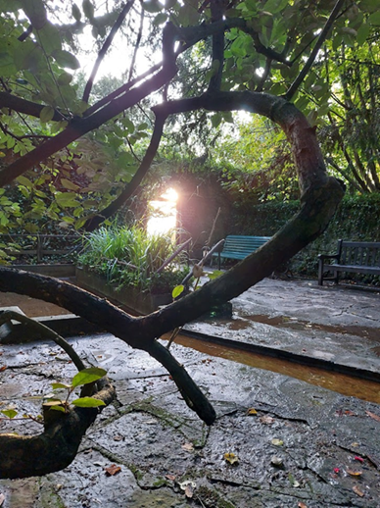
I have included a photograph (figure ??) as it goes some way to expressing the sacred and magical quality especially as I took this shot at sunset and I would argue that the light has a particularly holy quality to it. It is not only the seating that invites a person to stay and reflect. I have observed ritual paddling, praying, chanting and other rituals being performed here on many separate occasions on past visits therefore I was surprised that I was alone on the day of my field trip. Although Durkhiem would argue that the place has been made sacred by maintained human ritual, it supports Lane’s axiom that sacred space is the ordinary (here a walled garden and pond) made ritually extraordinary. One could also say that the sacred space chose me to reveal itself to me that day. As a last point, I return to my journal and the word I perceived the ancient oaks Gog and Magog to speak:
We are an invitation. An invitation to pass through our boughs to access another world where a portal opens and we have a chance to exchange energies. A whirlwind, a vortex, a power centre of vibration, colour and shadow where all are welcome and none turned away. There is no good or evil, only beings and their essence. Thank you.

Power of Place
The second part of the discussion is about the power of Glastonbury trees to create cultural meaning especially religious meaning. Cusak connects the hawthorn tree to ‘traditions [which] revolved around connection with the Holy Land’. The main myth being that it has flowered every Christmas Day for 2,000 years, since Joseph of Arimathea thrust the staff he brought from the Holy Land into the soil and it miraculously broke into blossom.
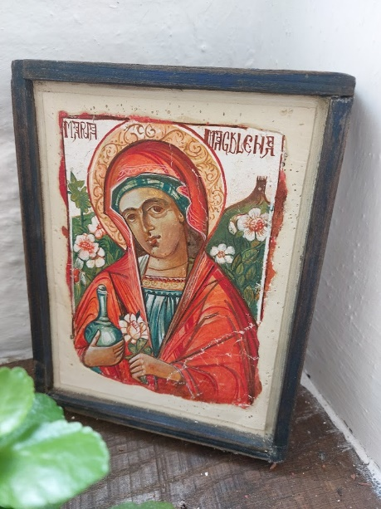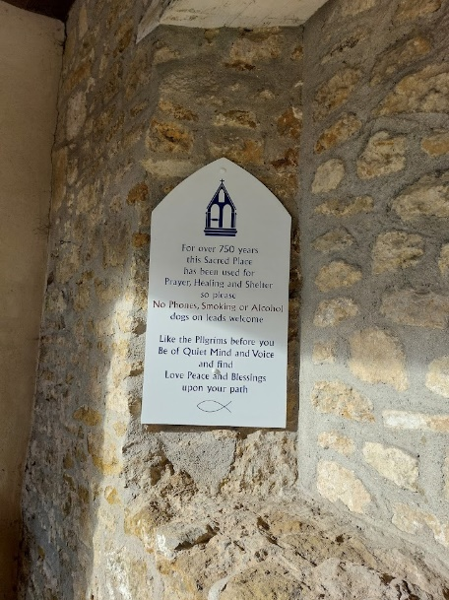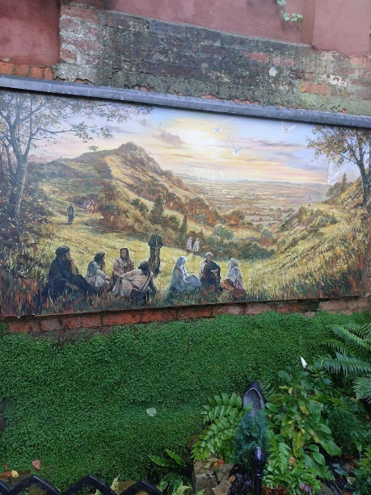

This connection extends in various ways however, I will concentrate on the association with St Margaret’s chapel in Magdalene Street. After I left the thorn I walked down the hill using The Roman Way before crossing the A361 into Magdalene Street. The chapel is known by locals as ‘the Magdalene chapel’ and is described as being a ‘sacred place’ for 750 years (see figure ??). I have visited this chapel many times before and it is one of my favourite spots. It generates an emotional response in me where my heart is both full of love and calmed at the same time. Much has been made of the connection of Mary Magdalene and Glastonbury. In the photograph of the icon above (found inside the chapel) Mary is shown holding her alabaster jar said to contain the oil she used to anoint the feet of Jesus; to her right is the Tor and to her left is pictured the holy thorn. This image is reproduced on posters, mugs and magnets and sold in the shop located the end of the run of alms houses in the small garden. What was different about this visit on the field trip was that the gate at the bottom of the garden was open having previously always been locked and beyond was another section of garden. Again, I saw this as being connected with Lane’s axiom of a place trod upon and not entered. I did not know this place existed before and it seemed that this space had opened up – not unlike a level-up on a computer game – because, perhaps I had become ready to experience it. Behind the gate was a small herb garden and a mural painted above a small pool, see figure ??. A chapel volunteer appeared by my side to describe the painting, by a local artist, again featuring the thorn. This time it depicted people from other cultures and ages (wearing biblical-time robes, kaftans or modern jeans and a baseball cap) who have walked the pilgrim’s paths and could be a visual representation of Tilley’s phenomenological approach where landscape has become ‘intertwined with topography and human intentionality’.

Gog and Magog, a pair of ancient oaks, are thought to be the ‘residue of a Druidic grove’. They are also part of the storied landscape of Glastonbury. They are situated one mile to the East of the Tor and reached by Stone Down Lane. Some think they mark a traditional entryway to Glastonbury and part of a ceremonial druidic avenue of oaks. Indeed, Cusak put forward an argument that Joseph of Arimathea was ‘drawn’ to Glastonbury as the first place to spread the word of Christianity because it was the centre of Druidic wisdom. This links the oaks to the thorn, and it could be said that the oaks invited spiritual participation prior to the establishment of Christianity. There is further evidence to suggest that the interest in druids in the Middle Ages bought more pilgrims and visitors to the area. The Chalice Well has many stories attached to Arthurian myth, not least that the red waters are the blood of Christ that flow from the Holy Grail buried under the Tor. This section has argued that stories and myths play a role in making a place sacred. Therefore sacred space could be seen under a Durkhiemien lens where it is a ‘mental construct’ where ‘human beings collectively view themselves, each other, and the natural world.’ However, I would describe the powerful feelings and emotions I experienced at certain places on the field trip were different to everyday experience as per Eliade and further, contains elements of what Otto describes as Numinous.

Extraordinary Experience
This section explores the ideas that extraordinary experiences happen in sacred places. It also looks at how the nonhuman can have a sacred space.

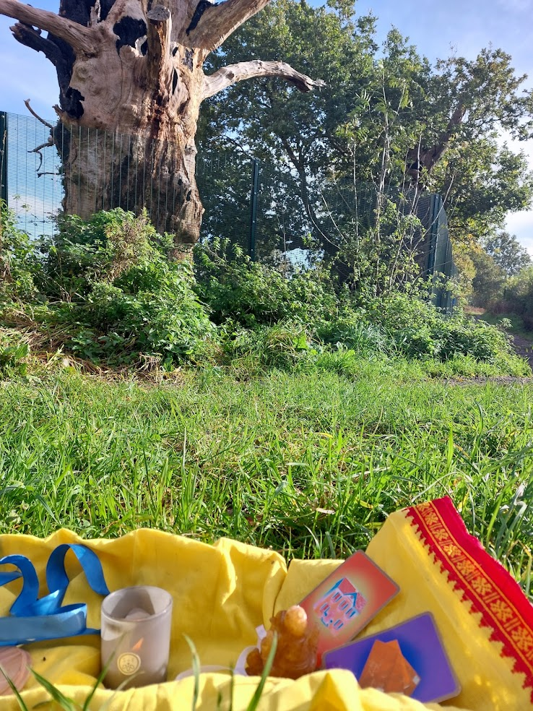
The act of ritual, automatic writing, reflection needed to understand the events to write this research project has created a special meaning for me and has created what Schroll would describe as a ‘transpersonal awakening’. There are two instances during the field trip where I felt the ‘overlapping realities’ of human and nonhuman sliding into each other. These are 1/the ash tree physically knocking on the caravan roof at night and 2/the miraculous flying insects living in the tree known as Gog.

The Ash Tree
The volunteer guide at St Margaret’s Chapel told me that the sacred tree was a walnut (not thorn) that grew in the Abbey grounds. It had since died but its ancestors were said to be planted around the town. My research uncovered an Anonymous poem circa 1502 mentioning a ‘miraculous walnut tree’. On the second day of the trip I walked past a walnut in the grounds of the Somerset Rural Life Museum housed in a 14th-century barn once belonging to Glastonbury Abbey and instantly associated it as being one of the ancestors. I was tired from the day and requested that if the tree had something to say to me it could speak via your friends during the night. That night the ash tree next to our caravan dropped rain on the roof of the caravan (and continued to do so for 3 days straight) and was so loud that my sister, also staying, got out of the caravan to look around for someone who was banging on the roof with a stick. It is to be noted that during the day, even when it was raining, the knocking was not of the same quality. The recording I made of the knocking is below.
URecorder_20231106_224647.m4a
An owl visited and hooted loudly in a space between the drumming and I was reminded of the owl card I pulled in Avebury which I saw as a message to ensure I get the significance and remember what was being told to me. Between the drumming I had a horrible dream about communication. It is long detailed to recount here but in summary, I was unable to make anyone understand me however much I tried. The only thing that came out of my mouth was, ‘ga ga ga’. I interpreted the meaning to be about what I was asking of the trees. I wanted to understand and vice versa but all we can decipher from each other is ‘ga ga’ nonsense therefor there needs to be other methods of listening that is not embedded in language. Alternatively, the dream suggests humans have medicated ourselves dumb and are unable to hear the trees speak anymore. Schroll claims sacred spaces have the capacity to influence our dreams and I because my internal dream connected with the external banging I would agree. The ash tree has many myths attached to it and is known as a sacred tree. Returning to Lane, ‘sacred place is a construction of the imagination that affirms the independence of the holy. God chooses to reveal himself only where he wills.’ For me, in this instance, the tree knocking on the roof demanding my attention ‘affirms’ its existence, agency and divine nature.

Gog & Magog
We are a gateway. We call human and non-human. All the flying things. You fly with your mind; your thoughts, your feeling and consciousness.
As I walked behind the Gog & Magog campsite toward the famous trees I dodged a huge hummingbird moth. I was surprised and had to duck out of its path: it made sure it made itself known. A tall metal fence had been erected around the trees to protect them – see figure??
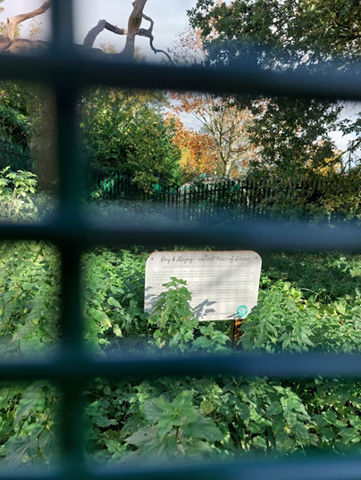
Gog had died due to a fire being lit inside his trunk and Magog is dying. I set the altar up on the grass to the left of Gog. I noticed that there were many insects flying into the burnt-out trunk. While I was there I recorded queen wasps, hornets, bumble bees and Monarch butterflies. What was unusual was the variety of insects, the time of year I was observing them (November) and how large they were. I felt that I would not be stung but like the hummingbird moth, I was made fully aware of their presence as they buzzed over my head. The insects were not attacking each other and seemed to be sharing the space, congregating while buzzing excitedly around the trunk like they had been drawn to that exact spot or what Eliade would term a ‘central axis’ to claim to their ‘proper place’. Some of the most profound messages I perceived came from the ancient oaks. When I asked why communicating with trees was important Magog’s response was:
Love. Love and communication with all beings human, non-human living or not – all together in a certain pattern. Listen, and if you want to live to the fullest be like Gog and me. LISTEN, transmute and let love fly on wings into hearts.
Lane suggests that in this time of environmental crises, ‘new ways of listening and being heard arise’ for human and non-human and the message I received seems to confirm his point. Being open to new ways of communication is critical if humans are to re-establish a healthy relationship with the other beings on this planet.

Final Thoughts
It is fact that trees communicate with each other and other species such as fungi and it is not too far a leap to suggest they may one day, be able to communicate with humans too.
But to what end? The insights gained on this field trip have confirmed the notion that extraordinary experience in nature can to initiate moral transformation. This moral transformation is needed because human and nonhumans are collectively at risk of ecological collapse. I have presented evidence that ‘unconscious connections’ with trees such as in dreams or when they trigger a strong emotional response or visions during meditations were as real to me as standing by the holy thorn across from the Tor using the physicality of my five senses.
A really interesting insight was how the nonhuman interacted with me in a variety of ways. It was not just a case of me enforcing my will upon the trees – I devised the questionnaire and deciphered the trees’ answers after all – but the ash tree kept me awake all night banging on the roof of the caravan; the huge stinging insects demanded my respect and I had nightmares about not being able to make myself understood. These experiences happened independently of me however one were to interpret them. Yes, it could be my imagination enforced certain meanings on the events however they do exist and there too many synchronicities for me to write off, as Durkheim would, as being all in my head. I have followed Tilley’s lead to taking ‘an interpretive leap’.

Conclusion
The aim of this research project was to explore the nature of sacredness through a case study of significant and holy trees situated in Glastonbury. Thus, the data and evidence presented are narratives involving the nonhuman beings situated in the sacred space and records of my own conscious and unconscious responses. I visited the holy thorn, the Chalice Well yews and Gog and Magog ancient oaks and have described the interactions I had with them. I have presented evidence that sacred spaces exist in and of themselves and are not purely a human construct. I have described my experience of a hirophany in India and how the numinious feelings experienced there were replicated at the Chalice Well garden. I have also presented my findings about storied landscape and how religious meaning can be created over time and maintained by ritual and therefore could be described as a human construct. My unique finding is that sacred space exists to allow a body, mind and spirit connection to the world beyond my limited understanding and for me, the entry point is when I am open to speaking to trees.

References

Lane, Belden C ( 2002) Landscapes of the Sacred: Geograhy and Narrative in American Spirituality, Baltimore & London: The John Hopkins University Press

Thorley, Anthony, Sacred Sites: An Overview <http://www.gaiafoundation.org> [accessed 23
October 2023] (2008)

Tilley, Christopher, A Phenomenology of Landscape: Places, Paths and Monuments, (Oxford: Berg,
1994)

Tilley, Christopher, and others, ‘Art and the Re-Presentation of the Past’, The Journal of the Royal
Anthropological Institute, 6.1 (2000), 35–62, <http://www.jstor.org/stable/2660764> [accessed 13 November 2023]

Alisa Hunt. (2016). Imagining the gods: how trees flesh out the identity of the divine. In Reviving Roman Religion (pp. 224–291). https://doi.org/10.1017/CBO9781316597859.006

Lane, Belden C., The Great Conversation: Nature and the Care of the Soul (New York, 2019; online edn, Oxford Academic, 17 Apr. 2019), https://doi.org/10.1093/oso/9780190842673.001.0001, accessed 2 Nov. 2023.

Hunter, J. (2019). Greening the Paranormal: Exploring the Ecology of Extraordinary Experience. Milton Keynes: August Night Press.

Gagliano, Monica, Thus Spoke the Plant: A Remarkable Journey Of Groundbreaking Scientific Discoveries And Personal Encounters With Plants, (Berkeley: North Atlantic Books, 2018)

James, W. (2004). The Varieties of Religious Experience. New York: Barnes & Noble

Durkheim, E. (2008). The Elementary Forms of Religious Life. Oxford: Oxford University Press

Tilley, Christopher Y, (1994) A phenomenology of landscape: places, paths and monuments, Oxford: Oxford

Otto, R. (1958) The Idea of the Holy: An Inquiry into the Non-Rational Factor in the Idea of the Divine and its Relation to the Rational. Oxford: Oxford University Press

Casey, Edward S. The Fate of Place, a Philosophical History. Berkeley, CA: University of California Press,1998: p.xii.

Lane, Belden C. (2002). Landscapes of the sacred : geography and narrative in American spirituality (Expanded ed.). Johns Hopkins University Press.

Cusack, C. M. (2018). The Glastonbury Thorn in Vernacular Christianity and Popular Tradition. Journal for the Study of Religion, Nature and Culture, 12(3), 307–326. https://doi.org/10.1558/jsrnc.33523

Eliade, Mircea, (1959) The Sacred and the Profane, London: Harcourt, Inc

Source: Studies in Comparative Religion, Vol. 14, Nos. 3 & 4. (Summer-Autumn, 1980). © World Wisdom, Inc. The Land of the Sun[1]
by
René Guénon http://www.studiesincomparativereligion.com/Public/articles/The_Land_of_the_Sun-by_Ren%C3%A9_Gu%C3%A9non.aspx

Adrian j. Ivakhiv, Claiming Sacred Ground: Pilgrims and Politics at Glastonbury and Sedona (Bloomington: Indiana University Press, 2001) p.75
Brady, B. (2020). Mountains talk of kings and dragons, the Brecon Beacons. Bloomsbury Publishing.
Thorley’s definition reference Thorley, Sacred Sites: An Overview, p. 12
http://www.studiesincomparativereligion.com/Public/articles/The_Land_of_the_Sun-by_Ren%C3%A9_Gu%C3%A9non.aspx
Adrian j. Ivakhiv, Claiming Sacred Ground: Pilgrims and Politics at Glastonbury and Sedona (Bloomington: Indiana University Press, 2001) p.45
Lecture notes
Field, forms pXI.V
Eliade p.20
Eliade p.21
Eliade p.11
Alister Hardy, The Divine Flame: An Essay Towards A Natural History of Religion, (London: Collins, 1966), p. 107.
Hardy, The Divine Flame, p. 111.
Brady, B. (2020). Mountains talk of kings and dragons, the Brecon Beacons. Bloomsbury Publishing.
Lane, Landscapes of the Sacred p. 19
Ibid (P??)
??
Christopher Tilly and others, ‘Art and the Re-Presentation of the Past’, The Journal of the Royal Anthropological Institute, 6.1 (2000), 35–62, (p. 35) <http://www.jstor.org/stable/2660764> [accessed 13 November 2023]
Tilley, A Phenomenology of Landscape, p. 18
Ibid p.51
Greening the Paranormal p.132
P.136
P.132
Lane, Falling in Love with a Tree,
Ibid P.39
Judith Bell, p.9
Eliade ??
Judith Bell p.12 and p. 22
1st lecture
Jack’s lecture
Ibak’s book
My journal
https://www.downtoearth.org.in/news/urbanisation/deforestation-urbanisation-illegal-mining-waste-dumping-leave-cauvery-battered-and-bruised-66032
Dairy entry
Eliade p.11
Ibid p.11
Numinous ref??
Hunt A. Imagining the gods: how trees flesh out the identity of the divine. In: Reviving Roman Religion: Sacred Trees in the Roman World. Cambridge Classical Studies. Cambridge: Cambridge University Press; 2016:224-291. doi:10.1017/CBO9781316597859.006 p.291
Glastonbury - Trees, Folk Music and Poetry with Matt Witt https://www.youtube.com/watch?v=tRgfy-Pd68g accessed 25th October 2023
https://www.theguardian.com/environment/2010/dec/09/glastonbury-mourns-felling-thorn-tree
Holy Thorn, journal
Cusak writes that the thorn was ‘part of the pilgrimage site at Glastonbury during the middle ages and after the reformation. The Glastonbury Thorn in Vernacular Christianity and popular tradition. Carole M cusak
Reference??
Holy Thorn, AP Journal
Ibid
CW Yews, AP Journal
P.316
Ibid (P??)
AP Journal
P.309
Reference?
Brady, B. (2020). Mountains talk of kings and dragons, the Brecon Beacons. Bloomsbury Publishing.
P.316
https://www.theguardian.com/uk-news/2017/apr/27/ancient-glastonbury-oak-tree-known-as-gog-damaged-in-fire
P.321
P.316
P313 & 321
Forms, Fields intro xviii
Greening the Paranormal p.132
Ibid P.39
P.310
P.132
Belden Lane p.19
Gog & Magog AP Journal
Eliade
Ibid Brady
GM AP Journal
Lane, Falling in Love with a Tree
Hidden Life of Trees – World Wide Web –
William James, Relgious
Lane, Falling in Love with a Tree,
Ibid P.39
Tilley??

