

University of Wales Trinity Saint David
School of Engineering

AWD Torque Vectoring

Oscar Pollitt 1900412

BEng Motorsport Engineering

ACHA6003
Table of Contents
1.0 ABSTRACT 3
2.0 INTRODUCTION 3
2.1 Base Vehicle Data 3
3.0 RESEARCH 4
3.1 Torque Vectoring 4
3.2 Torque Vectoring by Differential 4
3.3 Torque Vectoring by Brakes 4
4.0 CALCULATIONS 5
4.1 Lumped Mass Model 5
4.2 Centre of Gravity Position 5
4.3 Moment of Inertia 5
4.4 Inertial Conjugate 6
4.5 Dynamic Index 6
5.0 ANAYLSIS 7
5.1 Vehicle Specification 7
5.2 Front Mechanical Torque Path 7
5.3 Clutch Torque Capacity 8
5.4 Longitudinal Acceleration 9
5.5 Yaw Rate 10
6.0 DISCUSSION 13
6.1 On and Off Power and Straight Line and Cornering 13
6.3 On-Limit Lane Change Manoeuvres 13
7.0 CONCLUSION 14
8.0 BIBLIOGRAPHY 15

Figure 1 Ferrari FF Blueprint ( (Saranga, n.d.) 5
Figure 2 2nd Gear Torque Path 7
Figure 3 1st Gear Torque Path 7

Table 1 AWD Acceleration 20% Front 9
Table 2 RWD Acceleration 9
Table 3 AWD Acceleration 37% Front 10
Table 4 Torque Vectoring on Multiple Surfaces 12

1.0 ABSTRACT
The Ferrari FF is Ferrari’s first AWD Ferrari with innovative systems. This report requires the author to analyse the vehicle using available public information about the car to understand and calculate its vehicle dynamic characteristics, control systems and potential benefits of a torque vectoring system. The author finds that the potential benefits of a torque vectoring system are useful across multiple aspects and that the specifications of the vehicle work hand in hand with its electronic control system to improve agility, stability and traction on all surfaces. (for all calculations excel was used, see appendix)

2.0 INTRODUCTION

2.1 Base Vehicle Data
Ferrari FF
Maximum Power: 486kW @ 8000 RPM
Maximum Torque: 683 Nm @ 6000 RPM
Kerb Weight: 1880 Kg
Weight Distribution: 47% Front
Length: 4.907m
Width: 1.953m
Height: 1.379m
Wheelbase 2.990
Front Track: 1.679m
Rear Track: 1.660m
Driveline Layout: AWD Mid-Engine Manual or DCT

3.0 RESEARCH

3.1 Torque Vectoring
Torque Vectoring itself is a simple concept. In essence torque vectoring applies more torque to one wheel then the other to create a yaw moment. Comparable to how a tracked vehicle would turn, driving one side faster then the other to rotate the vehicle. Another benefit of torque vectoring is that it also uses sensors to monitor wheel slip so that it can send more power to the wheel that isn’t slipping and therefore less to the wheel controlling wheel slip. And therefore improve stability and grip on multiple surfaces. The sensors that can aid the car in calculating whether wheels are slipping and where to send torque could be ABS, steering position, and pitch, roll and yaw to evaluate the cars condition and apply power accordingly using algorithms.
However, the main reason why most cars don’t use this technology is that it’s complicated, expensive to implement and isn’t necessary enough for regular road use. Most drivers don’t require a car that can corner faster and have improved stability offroad. However for cars that do utilise this system, there are two main ways to achieve this. (Hirons, 2022)

3.2 Torque Vectoring by Differential
Torque can be vectored to each wheel by differential using electronic control. Where it sends more power to the wheel with grip, in a typical cornering situation this would be the outside wheel to aid turning. This system uses clutches on each axle that can deliberately be slipped by actuators so that power is lost and therefore sent to the wheel with most grip. This will be controlled by the driver input and the grip available that is monitored by other electronic control systems in the car. (Shah, 2021)

3.3 Torque Vectoring by Brakes
Torque vectoring doesn’t always have to use complicated differentials. A more cost effective method would be to use existing systems such as brake by wire, ABS or stability control systems that relate to steering position to deliberately brake the wheel in a turn to send more power to the outside wheel with more grip. (Klein, 2021)

4.0 CALCULATIONS

4.1 Lumped Mass Model
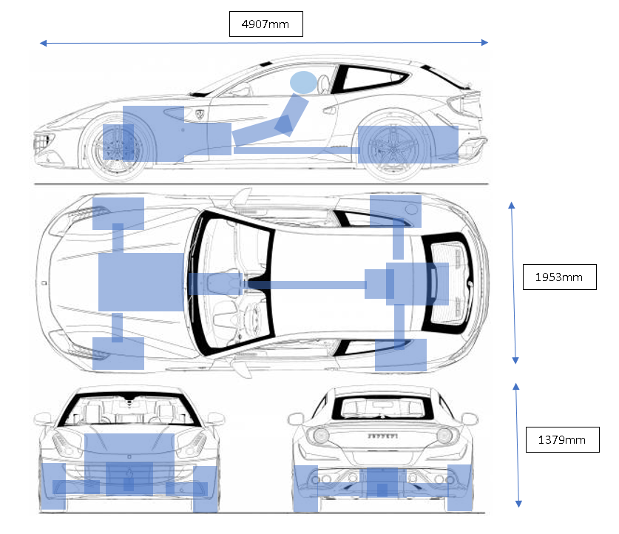
Figure 1 Ferrari FF Lumped Mass Model, Blueprint from (Saranga, n.d.)

4.2 Centre of Gravity Position
Length = 4.907m
Balance = 47% Front
$CoG Position=Mass Distribution\%×Vehicle Length=$2.306m from the front
The position of the center of gravity is unusual for a front engine AWD car. Most cars with this layout would have the gearbox at the front. The Ferrari FF however has the gearbox at the rear as well as the engine mounted far back from the front of the car. As you can see from figure 1 showing the lumped mass model the majority of the mass of the car is mounted as far back as possible therefore keeping the balance 3% more to the rear.

4.3 Moment of Inertia
Moment of inertia is calculated by taking the mass over the front of the car and the mass over the rear of the car and the distances from the axles to the CoG. The driver and passenger position is also equated where the mass of the driver and passenger are added to the moment of inertia. The drivers and passenger were estimated to be around 1/3 and 2/3 of the cars width and therefore their distance from the CoG in the centre of the car (1/2 of the width) was 0.976m – 651m. This was 0.325m. It was estimated that the driver and passenger where sat on the same position lengthways as the CoG.
The distance of the CoG to the front and therefore the rear axles is calculated by $a= Wheelbase*\frac{Rear Axle Mass}{Total Mass }$ where axle mass is the mass distribution multiplied by the total mass. a = 1.587 b = 1.4053m
(Czernia, 2020)
To calculate the moment of inertia, the masses and their radiuses from the CoG are multiplied together to give equation $Izz=\left(m_{1}*{r_{1}}^{2}\right)+\left(m_{2}*{r_{2}}^{2}\right)+\left(m_{3}*{r_{3}}^{2}\right)+(m_{4}*{r_{4}}^{2})$
Moment of Inertia 4201.50 kg.m^2

4.4 Inertial Conjugate
The inertia conjugate is the point which the yaw of the vehicle rotates around. This is calculated rearranging the formula $Izz= m.k^{2}$ to $k^{2}=\frac{Izz}{m}$. Using $k^{2}$ to calculate c inertial conjugate using $\frac{k^{2}}{a}$ = c.
Inertial Conjugate | 1.41m
The inertial conjugate is a similar distance to the distance b, the distance from CoG to rear axle. This means that the car rotates around its rear axle. This can be related to the dynamic index

4.5 Dynamic Index
Dynamic index is a way of simplifying the inertial conjugate of cars so that different cars can be compared. The equation for dynamic index is $D.I= \frac{Izz}{m.a.b}$ where m is mass.
Dynamic Index | 1.003

5.0 ANAYLSIS

5.1 Vehicle Specification
The vehicle specifications give the Ferrari FF a dynamic index value of 1.003 (with a driver and passenger) means that the car rotates around its rear axle as affirmed by the inertial conjugate. In terms of vehicle handling it said that above a value of 1 the tear tyres are shifted into the turn building force in the same direction of the corner, so forces go to inside wheel. A value lower than 1 says that the rear tyres are pushed away from turn building force in the opposite direction of the corner, so that force goes to the outside wheel. It would be assumed that a value of 1 would remove both these characteristics and therefore make the car more stable.
(Bastin, 2014)

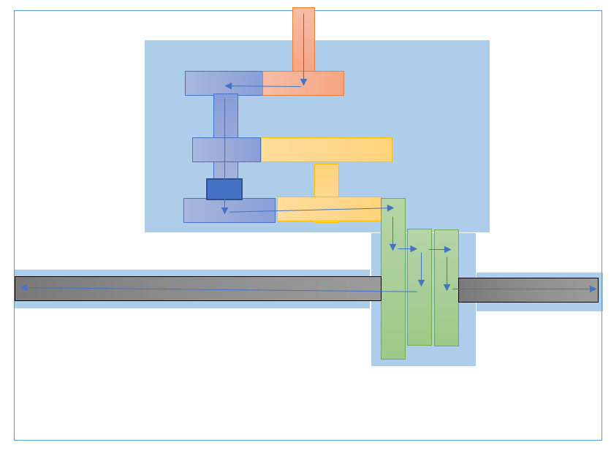
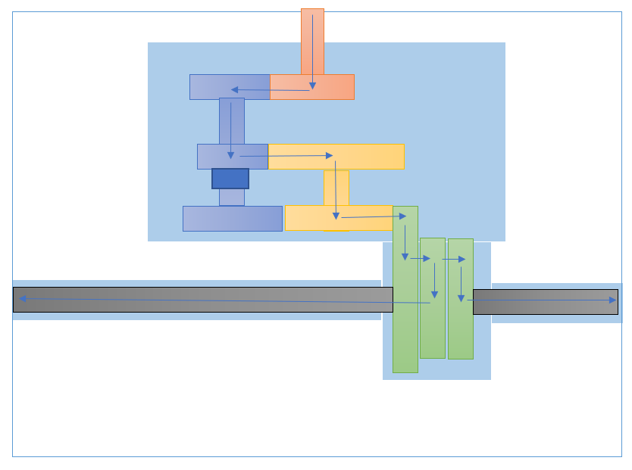
5.2 Front Mechanical Torque Path
Figure 2 2nd Gear Torque Path
Figure 3 1st Gear Torque Path

As seen in Figure 2 and 3 The mechanical torque path from the crank to the axles goes from through the PTU. This is essentially a 2 speed gearbox that takes power from the crank to the clutches that are connected to the axles that deliberately slip to deliberately let the majority of power through to rear axles. The red is the input from the crank. The blue is the layshaft that transmits power to either the first or second gear. The yellow is the output shaft that goes to the rack and pinion gear that transmits power to the clutch pack in green that transmits power to the axles in black

5.3 Clutch Torque Capacity
According to (Wan, 2016) the max torque the front wheels transmit is 20% of the peak engine torque, however from calculations further in the report regarding longitudinal acceleration a value of 37% was deemed more appropriate. Therefore 252.71Nm from the engine. Which when through the first gear ratio making the most torque which is the same gearing as the second gear at the rear (2.19) + 6% which is 2.32. (Car and Driver, 2022) (The Big Car Database, n.d.) This means each clutch at its peak has to allow 355Nm through to the axle. According to . (Chaumoo, 2019) the system has two independent carbon-fibre oil-bath wet multi-plate clutch packs. The clutch was estimated to have an outer radius of 0.13m and inner of 0.05m with a coefficient of friction of 0.14 for lubricated carbon contact (Engineersedge.com, 2022). The multiplate system has two multiplate clutch packs of 4 clutches meaning 8 faces per clutch pack
The equation to find the force needed to compress the clutches to allow this power through assuming no losses in power through efficiency and the uniform pressure theory.
$Axial Force= \frac{3 × Torque ({Outer Radius}^{2}-{Inner Radius}^{2})}{2×Coefficient of Friction ({Outer Radius}^{3}-{Inner Radius}^{3})}×No. of Clutch Faces$
This gave an axial force of 3304.79N per actuator
Using the equation $q= μ.p.V_{s}$ where p is the heat flux in W/m^2, $μ$ is coefficient of friction, P is pressure in Pascals and $V_{s}$ is sliding speed in rad/s. Sliding speed being the difference in speed between the clutch and the axle.
The largest axle speed at peak torque in first gear which is dictated by the rear gear ratio 3.81 and 4.38 final peak torque which is at 6000 RPM gives an actual wheel speed of 37.65 rad/s using RPM / transmission ratio. The speed of the input to the front clutch would be 6000 RPM over 2.32 gear ratio for the front in its first gear which gives a speed of 37.65 rad/s. A difference of 24.18 rad/s. The pressure is the axial force over the surface area which is a value of 73052 Pascals. When these values are applied to the equation the heat energy generated by the clutch slipping is 247.3 kW/m^2. Breaking down this value means that for every second 247.3 kJ of heat energy is transferred across a meter squared.
(Oday I. Abdullah, 2018)

5.4 Longitudinal Acceleration
The longitudinal acceleration was calculated by working out the driving force on the front and rear for 1st gear in both the PTU and rear gearbox which used the equation. With the engine torque at the front at 20% and 0% to calculate AWD and RWD across various surfaces and assuming the same final drive front and rear of 4.38. This was assumed because there no data for final drive on the front as there is technically no differential. However without the final drive the acceleration is very low, so it is assumed there is a final drive value on the rack and pinion
$$Driving Force N= \frac{Engine Torque×Gear Ratio×Final Drive×Driveline Efficienvy }{Wheel Radius}$$
The traction limit was calculated using the equation
$$Traction Limit N=mass ×gravity×mass distribution\% ×coefficeint of Friction$$
The actual torque was then limited by the traction limit at the rear (16937N generated at peak torque) for all surfaces as the driving force was always higher than the traction limit. On the front the traction limit was met on snow and ice for the front. Acceleration was calculated for the front and rear forces added together to get a total driving force divided by the total mass table (x-engineer, n.d.) (Car and Driver, 2022) (The Big Car Database, n.d.) (Wong, 1993)
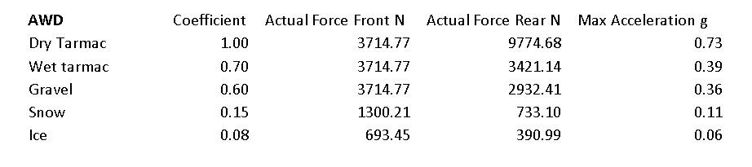
Table 1 AWD Acceleration 20% Front
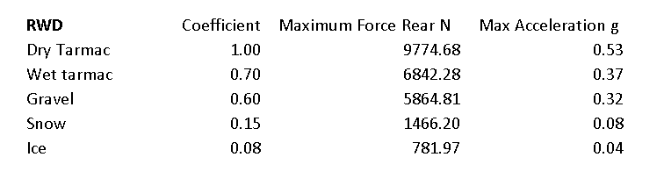
Table 2 RWD Acceleration
It can be seen that the acceleration is higher on AWD then RWD on all surfaces. However when comparing to values from (AccelerationTimes.com, 2022) the 0 to 2.7m/s time is 0.3s which is an acceleration of 9m/s^2 of 0.91g on dry tarmac. This suggests that the front wheels get more torque then 20% under initial acceleration according to this source. When taking the maxiumu traction value for the front wheels which is 8668.16N .This is attained from 9.81 x 883.6 x 1. (gravity x mass x coefficient of friction for dry tarmac) and adding it to the rear mass equated with the same equation which was 9774.68N giving a total of 18442.8N and dividing it by the mass 1880kg gives an acceleration of 9.81m/s^2 or 1.0g. This means that the final drive or power distribution could be wrong. Assuming the power distribution is wrong and not the final drive. The value 7000N was applied at the front the value which created an acceleration 0.91g. The peak torque could then be calculated at which was 252.71 Nm from the front or 37% power distribution to the front. This gave a new table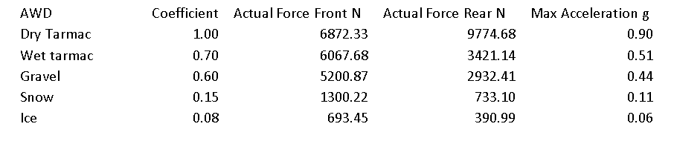
Table 3 AWD Acceleration 37% Front
It can be seen that the values for wet tarmac and below haven’t changed because the surface is traction limited and therefore no more power can be put down.

5.5 Yaw Rate
To measure the potential affect of torque vectoring on yaw rate. A base yaw rate was calculated at a velocity of 5m/s on a turn radius (r) of 15m on dry tarmac. Finding the circumference using the equation $2πr$at 94.24m then dividing the distance by speed to give a time of 18.8 seconds over 360 degrees which gives a yaw rate steady state yaw rate of 19.1 deg/sec.
Resistances to motion. The resistances included rolling resistance and aerodynamic. Rolling resistance used the equation $RR=mass ×gravity ×road rolling resistance coefficient$ = 368.86N
Aerodynamic Resistance uses the equation
$Aerodynamic Drag=\frac{1}{2}×Pressure×Frontal Area×Drag Coefficient×{Velocity}^{2}$ = 12.52N
Frontal area was calculated using (Wong, 1993) (Fenton, 1996) taking in account for general shape, width and height. 2.21m^2
Pressure was taken as 1.225 kg/m^2 at 15 degrees Celsius.
Drag coefficient was taken off a similar shaped vehicle of a Z3 M Coupe of 0.37
The total resistance to motion was therefore 381.4N
Static loading over each wheel was taken by taking the mass over each axle which was calculated by multiplying the mass by the CoG Position% and multiplying it by gravity (9.81m/s^2) and halving it to get a static load on each wheel on the front and rear
Static Load Front Wheel =4334.06N
Static Load Rear Wheel =4887.34N
Static Load Front =8668.12N
Static Load Rear =9774.68N
Lateral weight transfer was calculated using the equation
$$\frac{Mass Axle×Lateral Acceleration×CoG Height}{Track}$$
Centripetal acceleration is calculated using $\frac{{Velocity}^{2}}{Radius}$. This is 1.67m/s^2
CoG Height was estimated to be 1/3 of the vehicle height based on the estimation using the lumped mass model. 0.46m
Weight Transfer Front =403.47N
Weight Transfer Rear =462.97N
Taking away and adding these values to the static load gives the dynamic load over each wheel from weight transfer.
Dynamic Load Fi =3930N
Dynamic Load Fo =4737N
Dynamic Load Ri =4424N
Dynamic Load Ro 5=350N
Lateral Force was calculated using $Lateral Acceleration×Mass Axle$
Lateral Force Front =1472.67N
Lateral Force Rear =1660.67N
By taking the static load on the axle and dividing it by the dynamic load over each wheel to give a proportion of lateral force on each wheel. And then multiplying the axle lateral force by these values to get the lateral force on each wheel.
Lateral Force Fi =667.79N
Lateral Force Fo =804.88N
Lateral Force Ri =751.68N
Lateral Force Ro =908.99N
To calculate the maximum traction a wheel could achieve longitudinally. Multiply the dynamic load by the coefficient of friction. Then to take this value and use the equation (PW = Per Wheel) $\sqrt{{Max Traction Force PW}^{2}-{Lateral Force PW}^{2}}$
Available Long Grip FI | 3873.45 N
Available Long Grip FO | 4668.66 N
Available Long Grip RI | 4360.05 N
Available Long Grip RO | 5272.53 N

Calculate the tractive effort by dividing the total resistance by two.
Tractive Effort PW=190.69N
Then calculate the force an open differential could produce per wheel by taking away the tractive effort from the maximum traction force from the inside wheel on the front and rear.
Open Diff Front PW | 3682.76 N
Open Diff Rear PW | 4169.36 N

To then calculate what an E Diff could do to send more force to the outer wheel is to take the max possible force on the outside wheels front and rear from the forces from the tractive effort
Max Force E Diff FO | 4477.97 N
Max Force E Diff RO | 5081.85 N
Add these to the to the open diff values to get a total force per axle the vehicle could produce with an E Diff
Max Force E Diff Front | 8160.72 N
Max Force E Diff Rear | 9251.20 N

Take the forces on the inside wheel away from the outer to get a difference and multiply it by the relevant track divided to get the distance from the wheel to the CoG and therefore generate a torque
Turning Torque Front | 667.58 N
Turning Torque Rear | 809.19 N
Turning Torque | 1476.76 N

Divide the torque by the moment of inertia to get the yaw rate in rad/s. Convert the yaw rate from radians to degrees to get the potential yaw moment generated by the torque vectoring differential.
Yaw Rate rads | 0.35 | Rads
Torque Vectoring Yaw Rate Deg | 20.14 | Deg/sec
Total Torque Vectoring Yaw Rate | 39.24 | Deg/sec

Applied to different surfaces
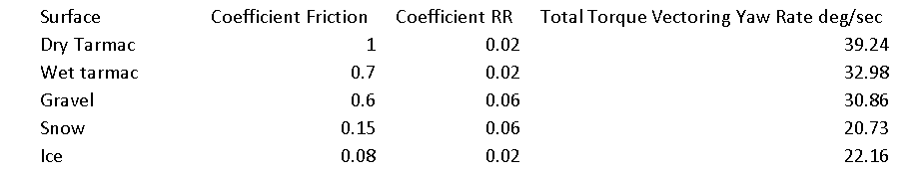
Table 4 Torque Vectoring on Multiple Surfaces
It can be seen that on tarmac the potential yaw rate is double that of the steady state yaw rate. This would yaw rate would probably be to extreme, however the system is capable of applying a significant amount of torque to the required wheels using both front and rear torque vectoring. Interestingly when looking at the surfaces that one would assume the cars ability to generate yaw decreases as the coefficient of friction decreases. This could be an error in the calculation; however it could also be that the rolling resistance coefficient of snow is higher than ice. This is because snow has more resistance to motion that the tractive effort to move a wheel in the snow is far greater then ice and therefore reduces its ability to generate a yaw moment.

6.0 DISCUSSION

6.1 On and Off Power and Straight Line and Cornering
Taking the Ferrari FF through a theoretical tight corner on a regular surface. Approaching a corner entry off power in a straight line the e diff and systems around it would want both wheels travelling at the same speed so that there isn’t a yaw moment generated. This means in this situation the wheel speed sensors and steering position sensor would be used to calculate that a straight line vector is desired. It would do this by control algorithms to keep the wheels the same speed using both the differential, controlling which side the clutch slips from engine braking, and applying the brakes asymmetrically to keep it in a straight line.
Off power braking and turning the differential could start to allow the outside wheel clutches to slip more in accordance with steering position to allow more engine breaking to slow the inner wheel more. The brakes could also be applied in accordance to steering position asymmetrically to induce a better turn in response. Whether this would be unnatural for the driver under normal conditions is debateable. However if a characteristic such as under or oversteer occurs in enthusiastic or on limit driving the system could recognise this and resist the slipping wheel more and create a better yaw moment through the turn on limit of grip compared to a system without these systems
On power out the corner the 4RM system could be in use under heavy demand to send power to the front wheels to aid traction and acceleration out the corner. Whilst torque vectoring front and rear to increase the yaw moment whilst monitoring wheel slip to stop under or oversteer out the corner and increase stability.
On power in a straight line the front PTU would be producing little to no torque depending on the gear and the differential would be near locked to get both wheels taking the same amount of power.

6.3 On-Limit Lane Change Manoeuvres
One example of a on limit lane change manoeuvre is the moose test. This is a test that to pass requires a car to accelerate to 100 kmph, decelerate to around 70kmph in mostly a straight line, rapidly change lane and return to the original one without drifting or sliding. To optimise for this test the Ferrari would use the ABS to ensure the brakes don’t lock up on heavy breaking. The system would need yaw pitch and roll sensors to calculate that the car is in a on limit situation. The differential and brakes could allow the inside wheel to slow faster than the outside relating to the steering position to aid turn in and reduce the likelihood of understeer from a rapid steering angle change to increase stability. (International Driving Authority, 2021)

7.0 CONCLUSION
In conclusion torque vectoring is great and innovative system that aids a car in its ability to turn and stay in control. The Ferrari FF with its individual gearbox for the front and rear is innovative evolution in AWD systems. In that it decreases the mass of the AWD system taking away the need for a shaft to go to the rear and back again from the transfer box. And that it keeps the traditional characteristic of a mid-engine RWD car with a CoG towards the rear.
The cars dynamics align well with the dynamic index of 1 meaning that the car is stable and confidence inspiring to drive relying on the electronic torque vectoring system to improve agility. This means that it can attain comfortable motorway driving whilst also being agile in corners with ability to generate yaw from vectoring. This also means the car has independent control over all corners which also gives it the unique ability to drive on slippery surfaces where it can limit the torque to each axle and control wheel slip. As well as the cornering traction benefits it also has traction benefits on all surfaces in a straight line being able to launch faster than a theoretical RWD counterpart. The system uses deliberate slipping wet multiplate clutches to control the power delivered to the front of the car to maintain RWD characteristic with clutches slipping all the time from 1st to 4th gear on the main gearbox transferring at most 37% of torque undertake off conditions. (1st and 2nd on 1-2 and 3-4 and neutral 5-7)

8.0 BIBLIOGRAPHY
AccelerationTimes.com. (2022). 2011 Ferrari FF 0-60, quarter mile, specs. Retrieved from AccelerationTimes.com : https://accelerationtimes.com/models/ferrari-ff
Bastin, M. (2014). An Investigation into the Effects of Hybrid Electric Vehcile Power-trains on Ride and handling. Warwick: University of Warwick, School of Engineering.
Car and Driver. (2022). Ferrari FF Features And Specs. Retrieved from Car and Driver: https://www.caranddriver.com/ferrari/ff/specs
Chaumoo, F. (2019, December 13). Top 3 Ferrari FF features that stand out from the competition. Retrieved from AutoTrader: https://www.autotrader.co.za/cars/news-and-advice/buying-a-car/top-3-ferrari-ff-features-that-stand-out-from-the-competition/6248
Czernia, D. (2020, May 29). Car Center of Mass Calculator. Retrieved from Omni Calculator: https://www.omnicalculator.com/physics/car-mass-center
Engineersedge.com. (2022). Coefficients of Friction Equation and Table Chart. Retrieved from Engineers Edge: https://www.engineersedge.com/coeffients_of_friction.htm
Fenton, J. (1996). Handbook of Vehicle Design Analysis. Society of Automotive Engineers.
Hirons, R. (2022, February 24). Torque Vectoring Explained. Retrieved from carwow: https://www.carwow.co.uk/guides/glossary/what-is-torque-vectoring#gref
International Driving Authority. (2021, March 04). All about the moose test. Retrieved from International Driving Authority: https://idaoffice.org/posts/all-about-the-moose-test-en/
Klein, J. (2021, January 29). What Is Electronic Stability Control and How Does it Work? Retrieved from TheDrive: https://www.thedrive.com/cars-101/38902/electronic-stability-control
Oday I. Abdullah, J. S. (2018). The temperatures distributions of a single-disc clutches using heat partitioning and total heat generated approaches,. Case Studies in Thermal Engineering, 43-54.
Sandford, M. (2021-2022). Vehicle Dynamics Lectures . Swansea: UWTSD.
Saranga, D. (n.d.). Ferrari FF (2011). Retrieved from theblueprints.com: https://www.the-blueprints.com/blueprints/cars/ferrari/50974/view/ferrari_ff_2011/
Shah, V. (2021). Torque Vectoring Explained. Retrieved from CarExpert: https://www.carexpert.com.au/car-news/torque-vectoring-explained
The Big Car Database. (n.d.). FERRARI FF 2011–2016. Retrieved from Motorpedia: https://gaukmotors.co.uk/motorpedia/car-make/ferrari/ff-20112016
Wan, M. (2016). 4WD with Electronic (Active) torque split:. Retrieved from Autozine Technical School: https://www.autozine.org/technical_school/traction/4WD_3.html
Wong, J. (1993). Performance Characteristics of Road Vehicles. In J. Wong, Theory of Ground Vehicles (p. 340). Ottowa, Canada: Carleton University. Retrieved from HPWizard.
x-engineer. (n.d.). Vehicle acceleration and maximum speed modeling and simulation. Retrieved from x-engineer: https://x-engineer.org/vehicle-acceleration-maximum-speed-modeling-simulation/

9.0 APPENDIX
Moment of Inertia Calculations
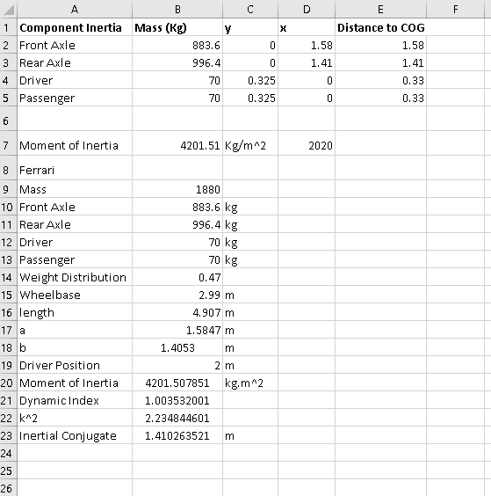

Clutch Calculations
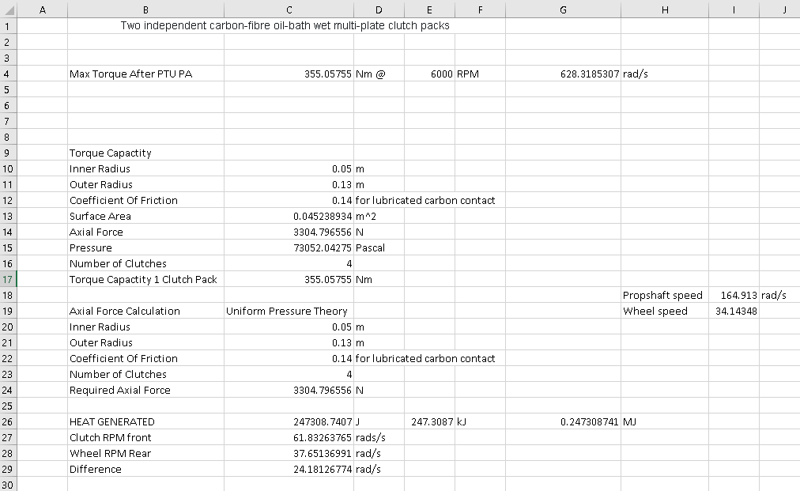

Longitudinal Acceleration
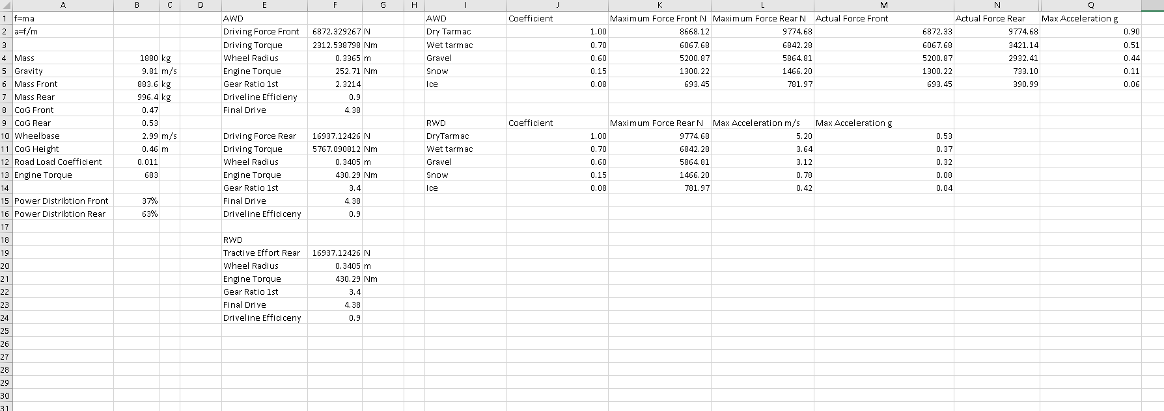

Yaw Calculations


