Choose 3 images of one group at risk of exclusion and critically reflect upon these representations and how they might be interpreted by society.

Introduction
Poverty is a widely used and meaningful concept in all countries in the world. In September 2000, the governments of 189 countries adopted the United Nations Millennium Declaration and resolved to spare no effort to free our fellow men, women and children from the abject and dehumanizing conditions of extreme poverty.
(Gordon, 2000, p1 cited in Pantazis, Gordon and Levitas, 2006)

According to Hall, Leary and Greevy’s (2014) study for the Joseph Rowntree Foundation, the way society view poverty fluctuates, some say that employment is the key to getting out of poverty. On the other hand, others understand that poverty and low income is linked, particularly with the cost of living rising (Butler, 2012; Hall, Leary and Greevy, 2016). Defining poverty is often difficult as poverty its self is very complex (Joseph Rowntree Foundation, 2016). However, the Joseph Rowntree Foundation (2016) defines poverty as people or individuals who receive income below the living cost, therefore unable to provide their families or themselves with food, heat, clothes or any other essentials that may be needed. On another note Walker (2015), suggests that living in poverty is about more than money, due to people living in poverty becoming socially isolated, excluded from activities within the community, feeling physically and psychologically unwell, and feeling powerless.

This portfolio will critically reflect upon three different images (seen in appendix 1, 2 and 3), and will discuss how they may be interpreted within today’s society.

Firstly, the portfolio is going to evaluate an image of families living in a car, this will be followed with a critique of how poverty affects children with an image of an older child looking after the younger child, and finally it will examine how society perceives a family.

The essay concludes that society looks at a picture and makes a judgment, without a second thought of how people may feel.

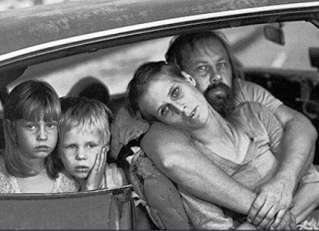

(See appendix 1)
Parental unemployment

This image characterises parents living in a car with their two children, who look as though they are going through a difficult time. However, society may have a different perspective on this image, and think all kinds of things. Firstly, they may think that the parents are too sluggish to go to work. Society assumes that if people were employed then they would not become homeless (Holmqvist, 2009 cited in Steen, Mackenzie and McCormack, 2012). However, being employed does not mean that families would not live in poverty and may end up without a home (Steen, 2012; Gill, 2016). According to Steen, Mackenzie and McCormack’s (2012) study, being able to maintain employment at a living wage is difficult, due to the many resources a family may need. Using Maslow’s hierarchy of needs as an example, if children are living in a car due to their parents being unable to find secure employment then this will affect their physiological needs such as: food, water and sleep, the same goes for feeling safe and healthy, which in the long-term will affect their mental health (Maslow, 1943; Lovell and Isaacs, 2010; Steen, Mackenzie and McCormack, 2012; Butler, 2012). On another note Onn (2017) suggests, that the council has a responsibility to prevent people from becoming homeless, but the government is failing to ensure that this happens. Furthermore, the Government has produced a guidance along with an eight-week consultation plan that will help local councils to implement the Homeless Reduction Act, which is coming into force in April 2018 (Department of: Ministry of Housing, Communities and Local Government, 2017).

Travellers

On another note they could be travellers, who may have travelled for a while, consequently feeling tired after a long journey. However, travellers generally live in caravans (Foster and Norton, 2012; The Traveller Movement, 2014; Cromarty, 2017), nevertheless, there may be a caravan attached to the car, but is not shown in the picture. According to Cromarty (2017), several travellers are beginning to settle in new homes, therefore this could be the situation here. Where this family may have only just found accommodation, but not yet settled there. However, looking at this image it is very unlikely that this is the case, since they are one of the groups that get discriminated against the most (Foster and Norton, 2012; Equality and Human Rights Commission (EHRC), 2016; Cromarty, 2017). Studies suggest that there are many disadvantages of being a traveller, such as: poor education, poor health, unrecognised, not employed, homelessness (living on the street) (Foster and Norton, 2012; The traveller movement, 2014; EHRC, 2016; Cromarty, 2017). These factors are driven by discrimination and the lack of knowledge from society, also suggested is that travellers are discriminated against by the police and other local authorities (Cromarty, 2017). According to the EHRC (2016), Britain has failed to protect this group under the Equality Act 2010, even though travellers are protected under the ‘race’ characteristic.

Substance misuse

Another reason may be seen by society is that the parents are addicted to drugs or alcohol, therefore end up being homeless. However, being a victim of substance misuse is very complex and can be caused by several factors such as: arguments within the family, financial issues, domestic abuse and a breakdown of communication within the family (Guiney, 2015). Furthermore, parents who have addictions cause their immediate families hierarchy of needs to break down, particularly when the family end up living in their car or in poverty (Maslow, 1943; Guiney, 2015; Taylor, 2013). Taylor’s (2013) study, suggests that children are then forced to grow up immediately, due to their parent’s substance misuse. Consequently, older children will become confused by their role in the family, due to them caring for their younger siblings (Taylor, 2013). Studies suggest that parents or children in this situation can seek help and advice from their microsystem, and or macrosystem (extended family, friends or professionals) (Guiney, 2015; Ettekal and Mahoney, 2017). Moreover, children and parents will need help and support, as substance misuse can affect the whole family, particularly their mental health and well-being (Taylor, 2013; Guiney, 2015).

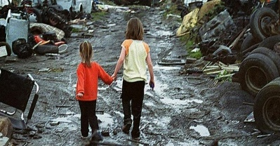

(See appendix 2)

Children’s role in the family

This image may represent an older child looking after the younger sibling, as mentioned above, and could be due to parents being addicted to drugs or alcohol (Taylor, 2013). On another note, it could be possible that both parents are working, and unable to pay for childcare (Hall, Leary and Greevy, 2014; Healthychildren.org, 2015). The children’s role model is a very important factor to their development, in that case, these children may have a good role model which has enabled the older child to look after the youngest (Figueiredo and Dias, 2012). Alternatively, these children may be from a poor family therefore, demonstrating social isolation (Wodtke, Elwert and Harding, 2012). According to Wilson (1987 cited in Wodtke, Elwert and Harding, 2012), the social isolation theory expresses the importance of an adult role model, otherwise the children’s education, health and well-being will be at risk. According to Roysten (2017), living in poverty can affect a child for their entire life, due to living in poor conditions, poor neighbourhood, lack of concentration at school and tiredness.

Looking for food

Due to living in poverty these children could have insufficient food, and be walking around the neighbourhood hoping to find something to eat. Insufficient food is one of the main factors to living in poverty, therefore, families find it increasingly difficult to feed themselves and their children (Chung et al., 2016). According to Cooper (2015), Britain is currently living below the ‘bread line’, thus meaning there is a substantial amount of the population living in poverty, particularly ‘food poverty’. According to the End Child Poverty Coalition (2018), some areas consist of more than fifty percent living in some kind of poverty, hence children are going out to look for food, this may mean looking through bins or begging from others (Cooper, Purcell and Jackson, 2014; End Child Poverty, 2018). This becomes more apparent during the school holidays whilst parents cannot rely on schools to feed their children (Cooper, 2015;). This has become worse since the government has frozen the rise in child benefits for four years yet the cost of living continues to rise (Caplan, 2016; Jaeggi and Gurven, 2017; End Child Poverty Coalition, 2018). On another note it has become apparent that there are food banks all over the UK which continue to grow, although these are not always easy to access due to needing vouchers from care professionals such as: doctors, social workers or school liaison officer (Cooper, Purcell and Jackson, 2014; Caplan, 2016). According to Cooper (2015), food banks are the answer to end child food poverty, however Cooper, Purcell and Jackson (2014), argues that unless child benefits rises in line with the living costs then child poverty of any kind will continue.

Poor neighbourhood

By looking at this image society may see the poor neighbourhood first, therefore, they may suggest that the children are homeless or that their parents are unavailable to them. Society may assume that they do not have ‘successful role models’ and are ‘socially isolated’ (Wodtke, Elwert and Harding, 2012). Compound disadvantage theory suggests that children who come from families in poverty are at a higher risk especially whilst living in a poor community (Jencks and mayer, 1990, Wilson, 1987 and Wilson 1996 cited in Wodtke, Elwert and Harding, 2012). On that note Crisp, McCarthy, Parr and Pearson (2016) suggest, that the UK has a good reputation of ‘community development’ and ‘community-led activities’ specifically in poor and run-down areas. Although many of the population in the UK remain in poverty (Royston, 2017). Study suggests that not everyone living in a poor neighbourhood are in poverty, there are some wealthy people who are able to send their children to a high standard nursery setting, and or private schools, away from the neighbourhood (Wodtke, Elwert and Harding, 2012). However, this needs to be researched more due to insufficient evidence.

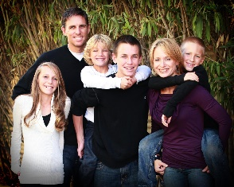

(See appendix 3)
Nuclear family

Now after looking at families living in poverty, we look at a different angle and consider this picture, which obviously looks like a happy family. Nonetheless it may be a picture of a family posing for a photo, as nobody knows what happens beyond the family door (Hutchinson Family Office, 2014; Roberts and Lawrence, 2017). Lott (2014) argues, that money is not significant for people to be happy, all that is needed is a close community and a loving family. Nowadays, family does not necessarily mean marriage and related by blood, the word family now means so much more (Moloney, Weston, QU and Hayes, 2012). Although, some parts of the country still define a family as being happy and people who bring children into the world and raise them well Walsh (2012). Although, this is not possible for everyone, however, parents try to raise their children to the best of their ability (Sear, 2016). Now there is not a specific definition of a family, as there are so many kinds of families, such as: single parent with dependent children, couples with or without dependent children, same-sex couples with or without children, people living alone, close friendships or even homeless people are defined as a family (Moloney, Weston, QU and Hayes, 2012; Office for National Statistics, 2015). Although, society looks at a family as they did in the twentieth-century, this being a ‘nuclear family’, where families consisted of heterosexual married couples with their children, and being happy was essential (Sear, 2016). However, Moloney, Weston, Qu and Hayes (2012) suggest, that any family rich or poor can face challenges, whether positive or negative. Furthermore, depending on the family’s status at the time they face a challenge, would depend on how quickly they would recover, for example a richer family would know about the support available (Moloney, Weston, Qu and Hayes 2012).

Wealthy families

Being in a wealthy family does not necessarily mean that it benefits an individual or the family (Worley, 2017; Roberts and Lawrence, 2017; Richardson, 2018). Lott (2014) suggested, that money is not as significant as a loving family and living within a close community – ‘the best things in life are free’. Although wealthy families would disagree, as they have confidence in their wealth and advocate this to the younger members of their family (Hutchinson Family Office, 2014). In this case their wealth is understood as financial capital, as they assume that money will make a better life (Hutchinson Family Office, 2014). Although, Worley (2017) and Richardson (2018) disagrees, particularly where education is concerned, and suggests that pupils from a wealthy background, may not attain a better education than poor pupils in a grammar school. Having said this children from wealthy families generally have a high earning post, even though they do not achieve high grades (Worley, 2017; Richardson, 2018). Meanwhile children who come from a wealthy background tend to have families with high contacts within their macrosystem, therefore rely on them for help to give their children a better life without reaching high grades (Hutchinson Family Office, 2014; Roberts and Lawrence, 2017). Consequently, children coming from poverty are normally socially excluded from Grammar schools particularly if they have had ‘free school meals’ (Worley, 2017; Richardson, 2018). In addition to this wealthy children or families can also become poor due to many reasons, to name a few: poor financial management, being unmotivated, not being prepared for the world or family disagreements (Hutchinson Family Office, 2014)

Strong families

Although, some may see a family as the image above it is not always that simple, families are at the heart of the community (Demuth,2010; Callan, 2014). However, it takes strong families to build a community, and a strong community to build and support families (Callan, 2014). Families in the community is an important factor to the well-being and development of children, thus children will be enabled to view society in different perspectives and with an open mind (Callan, 2014). However, to build a strong family it is vital that the whole family has an involvement, for example, if parents separate then both mum and dad should have a positive connection with each other, so that they can both be involved with the child’s upbringing (DeFrain, Brand, Friesen and Swanson, 2008; Home-Start UK, 2017). This implies that both parents can face challenges together regarding their children’s health and well-being, positive psychology theory suggests that strong families can integrate hope and confidence into their family particularly, for their children’s future (Borden et al., 2014). Although, this does not prevent families from facing challenges however big or small, these could include, their child’s behaviour, parental depression or isolation (Home-Start UK, 2017). Studies suggest that all these factors can cause poverty whether the family is on low or high income, the way to overcome them would be involvement within the community (Home-Start UK, 2017; DeFrain, Brand, Friesen and Swanson, 2008). Although in most cases, this can be difficult depending on the severity of the case, nevertheless, being a strong family may have already had an impact on the family and their involvement with the community (DeFrain, Brand, Friesen and Swanson, 2008; Home-Start UK, 2017). Consequently, the community will come together to support the family with their needs, and help them regain their hierarchy of needs (Maslow, 1943; DeFrain, Brand, Friesen and Swanson, 2008; Home-Start UK, 2017). On another note, there are other support groups available for people who go through difficult situations, Home-Start UK for one helps families with various needs whether in their own home, or through support groups (Home-Start UK, 2017). Particularly, whilst facing exclusion because of their situation, however, everyone is allowed respect, help and support under the Equality Act 2010, regardless of their status before poverty (Department of Law and the Justice System, 2013; Home-Start UK, 2017)

Conclusion

This portfolio aimed to look at families living in poverty, whilst looking at two different images as seen in appendix 1 and 2. Then the third image (appendix 3) brought in an example of a nuclear family (or how society views a family). A few issues were raised whilst looking at the images, such as: appendix one – parental unemployment, travellers and drug or alcohol addiction. Appendix two – children’s role within the family, looking for food and poor neighbourhood and finally appendix three – nuclear family, wealthy families and strong families.

These points discussed how society may interpret images of different families and what could be the issues within a family living in poverty, and what a family should look like according to society. A few subjects came out of each image such as: parental unemployment, substance misuse, travellers, children’s role within the family, children looking for food, living in a poor community, nuclear family, wealthy family and a strong family.

Having looked at the research and evidence it has become apparent that society is very judgmental about others, and make rapid decisions about what others life’s may look like. Thus, without considering the bigger picture and what that family may have gone through, and what they now need to enable them to recover from their situation. Ending poverty is much more than just about employment and money, it is about communities coming together to help end poverty and support them in need. Wealthy families particularly exclude people living on lower income, especially when considering schools and employment. However, society needs to become more knowledgeable about the effects of poverty and the causes, simply because even the wealthiest people can become poor. Accordingly, more attention needs to be placed on educating society about poverty, which should include the causes and effects, therefore, society may become more understanding and help put an end to poverty. If more people really understood then more support would be given. On another note the UK Government needs to do more to protect people in poverty or to prevent poverty in the first instance, in other words to give people more benefits especially those on low income.
Reference List
Borden, L., Brown, S., Cheatom, O., Hawkey, K., Hawkins, S., Hoang, T., Jordan, A., Kuhl, M., Otto, M., Paradis, E., Pinna, K., Sherman, M., Shortreed, T., Steinman, D. and Casper, D. (2014) Strong Family Functioning. Minnesota: The University of Minnesota.
Butler, P. (2012) Save the Children launches campaign to help UK families in poverty. The Guardian. [online] available at: https://www.theguardian.com/society/2012/sep/05/save-the-children-uk-campaign (accessed on 7th February 2018)
Callan, S. (2014) Building a strong society requires effective family policy. Edinburgh: University of Edinburgh.
Caplan, P. (2016) Big society or broken society? Food banks in the UK. UK: Goldsmith.
Chung, E., Siegel, B., Garg, A., Conroy, K., Gross, R., Long, D., Lewis, G., Osman, C., Messito, M., Wade, R., Yin, S., Cox, J. and Fireman, A. (2016) Screening for Social Determinants of Health Among Children and Families Living in Poverty: A Guide for Clinicians. America: Mosby, Inc.
Cooper, K. (2015) Food insecurity in Birmingham – a city – level response? Birmingham: Barrow Cadbury Trust.
Cooper, N., Purcell, S. and Jackson, R. (2014) Below the breadline: The Relentless Rise of Food Poverty in Britain. UK: The Trussell Trust.
Crisp, M., McCarthy, L., Parr, S. and Pearson, S. (2016) Community-led approaches to reducing poverty in neighbourhoods: A review of evidence and practice. York: Joseph Rowntree Foundation.
Cromarty, H. (2017) Gypsies and Travellers. London: House of Commons Library.
DeFrain, J., Brand, G., Friesen, J. and Swanson, D. (2008) Creating a Strong Family: Why Are Families So Important? Lincoln: University of Nebraska.
Demuth, K. (2010) Strong Families, Strong Children. Austria: SOS Children’s Villages International.
Department of Law and the Justice System. (2013) Equality Act 2010: guidance. London: GOV.UK [online] available at: https://www.gov.uk/guidance/equality-act-2010-guidance (accessed on 29th March 2018)
Department of: Ministry of Housing, Communities and Local Government. (2017) Government actions a further step in homeless prevention. London: GOV.UK [online] available at: https://www.gov.uk/government/news/government-actions-a-further-step-in-homeless-prevention (accessed on 25th March 2018)
End Child Poverty Coalition. (2018) More than half of children now living in poverty in some parts of the UK. UK: End Child Poverty Coalition. [online] available at: http://www.endchildpoverty.org.uk/more-than-half-of-children-now-living-in-poverty-in-some-parts-of-the-uk/ (accessed on 26th March 2018)
Equality and Human Rights Commission (EHRC). (2016) England’s most disadvantaged groups: Gypsies, Travellers and Roma. England: Equality and Human Rights Commision.
Ettekal, A. and Mahoney, J. (2017) Ecological Systems Theory. Thousand Oaks: SAGE Publications.
Figueirdo, C. and Dias, F. (2012) Families: Influences in Children’s Development and Behaviour, From Parents and Teachers’ Point of View. Portugal: David Publishing.
Foster, B. and Norton, P. (2012) Education Equality for Gypsy, Roma and Traveller Children and Young People in the UK. Equal Rights Trust.
Gill, A. (2016) Families under pressure: Preventing Family Breakdown and Youth Homelessness. London: Centre Point.
Guiney, E. (2015) Parenting Positively: Helping teenagers to cope with a parent’s problem drug or alcohol use. Dublin: Barnados
Hall, s., Leary, K. and Greevy, H. (2014) Public Attitudes to Poverty. York: Joseph Rowntree Foundation.
Healthychildren.org. (2015) Roles Within the Family. America: American Academy of Pediatrics. [online] available at: https://www.healthychildren.org/English/family-life/family-dynamics/Pages/Roles-Within-the-Family.aspx (accessed on 25th March 2018)
Home-Start UK. (2017) Strong Families Make Strong Communities. Social Impact Report 2017. Leicester: Home-Start UK.
Hutchinson Family Office. (2014) Keeping Wealth in the Family: Creating a Family Legacy. North Carolina: Hutchinson Family Office.
Jaeggi, A. and Gurven, M. (2017) Food Sharing Models United States: University of California.
Joseph Rowntree Foundation. (2016) What is poverty? England and Wales: Joseph Rowntree Foundation. [online] available at: https://www.jrf.org.uk/our-work/what-is-poverty?gclid=Cj0KCQjw-uzVBRDkARIsALkZAdnVwvzZjem7U-7NsjJQRdHtcfMsySdqeY0goYaE3SL6GkbHuYeU2HEaAjbVEALw_wcB (accessed on 28th March 2018)
Lott, T. (2014) Families don’t need (much) money to be happy. The Guardian. [online] available at: https://www.theguardian.com/lifeandstyle/2014/apr/11/families-dont-need-much-money-to-be-happy (accessed on 28th March 2018)
Lovell, P. and Isaacs, J. (2010) Families of the Recession: Unemployed Parents and their Children. America: First Focus Campaign For Children.
Maslow, A. (1943) A Theory of Human Motivation. New York: Brooklyn College.
Moloney, L., Weston, R., Qu, L. and Hayes, A. (2012) Families, life events and family service delivery. Australia: Australian Government.

Office for National Statistics. (2015) Families and Households: 2015. Office for National Statistics. [online] available at: https://www.ons.gov.uk/peoplepopulationandcommunity/birthsdeathsandmarriages/families/bulletins/familiesandhouseholds/2015-11-05 (accessed on 27th March 2018)
Onn, M. (2017) Homelessness is not inevitable. It’s a political choice made by the UK government. The Guardian. [online] available at: https://www.theguardian.com/housing-network/2017/sep/13/homelessness-not-inevitable-political-choice-uk-government (accessed on 25th March 2018)
Pantazis, C., Gordon, D. and Levitas, R. (2006) Poverty and Social Exclusion in Britain. Bristol: The Policy Press.
Richardson, H. (2018) Grammar school success ‘down to privilege’ – study. BBC News. [online] available at: http://www.bbc.co.uk/news/education-43542565 (accessed on 28th March 2018)
Roberts, C. and Lawrence, M. (2017) Wealth in the twenty-first century. Inequalities and drivers. UK. The IPPR Commission on Economic Justice.
Royston, S. (2017) Feeling the pinch. Buttle UK: The Children’s Society.
Sear, R. (2015) Beyond the Nuclear Family: An Evolutionary Perspective on Parenting. London: London School of Hygiene and Tropical Medicine.
Steen, A., Mackenzie, D. and McCormack, D. (2012) Homelessness and Unemployment: Understanding the Connection and Breaking the Cycle. Swinburne: Swinburne Institute for Social Research.
Taylor, A. (2013) The impact of parental substance misuse on child development. Devon: Research in Practice, The Granary Dartington Hall.
The Traveller Movement. (2014) Child poverty in the Gypsy and Traveller communities. London: The Traveller Movement.
Walsh, F. (2012) The New Normal: Diversity and complexity in 21st Century Families. The Guilford Press.
Wodtke, G., Elwert, F. and Harding, D. (2012) Poor Families, Poor Neighborhoods: How Family Poverty Intensifies the Impact of Concentrated Disadvantage. Michigan: University of Michigan Institute for Social Research.
Worley, W. (2017) It’s better to be rich and mediocre than poor and bright in the UK, admits Education Secretary. Independent. [online] available at: https://www.independent.co.uk/news/uk/politics/pupils-rich-families-talented-poorer-children-education-secretary-justine-greening-equality-a7659346.html (accessed on 28th March 2018)

Images
Image 1 - https://www.google.co.uk/search?q=families+living+in+poverty&safe=active&source=lnms&tbm=isch&sa=X&ved=0ahUKEwjJ0-7UuYTZAhWOXMAKHWfXAh0Q_AUICigB&biw=1056&bih=529#imgrc=GfxmDWtfofu0VM: (accessed on 1st February 2018)
Image 2 - https://www.politicshome.com/news/uk/home-affairs/opinion/64997/lord-jack-mcconnell-uk-can-lead-way-end-extreme-poverty (accessed on 31st January 2018)
Image 3 - https://www.politicshome.com/news/uk/home-affairs/opinion/64997/lord-jack-mcconnell-uk-can-lead-way-end-extreme-poverty (accessed on 31st January 2018)

Appendices

Appendix 1
Image 1

Appendix 2
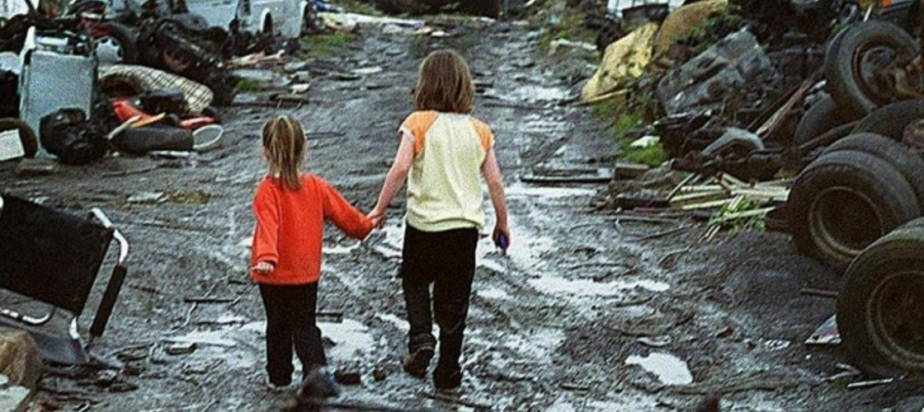
Image 2

Appendix 3
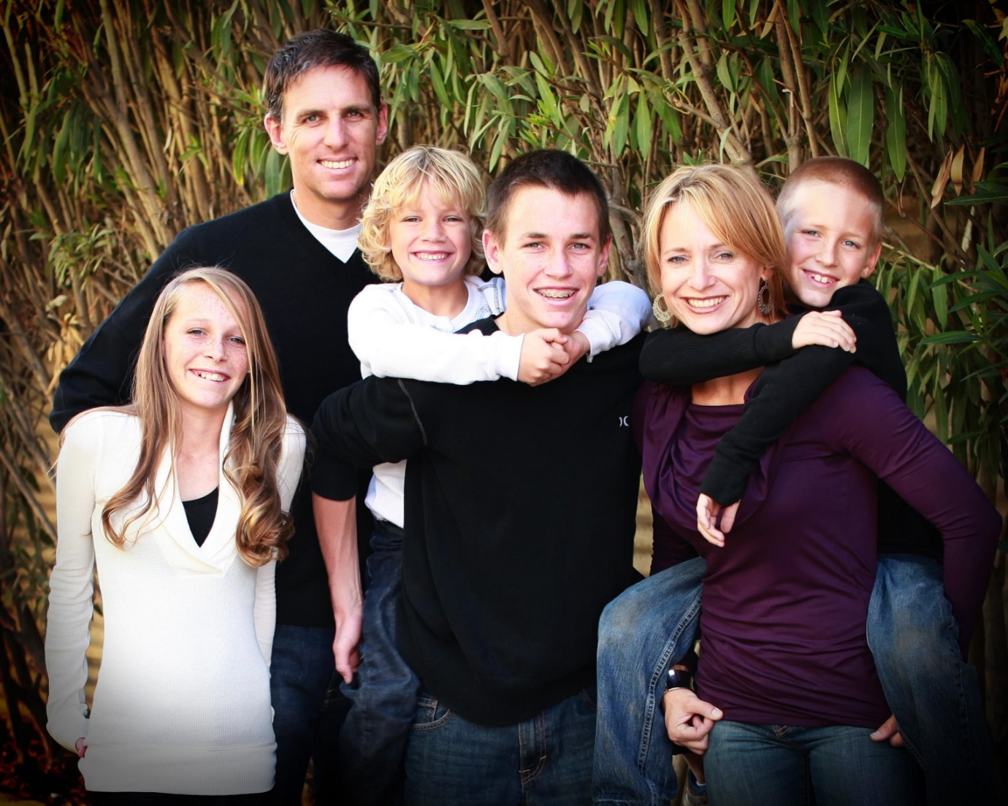
Image 3

