Exploring the relationship between attitudes towards feminism and gender.
Social Psychology: Global Perspectives

Abstract
This study aimed to investigate the potential difference in attitudes towards feminism between male and female participants. A sample of 15 undergraduate psychology students completed a 20-item Attitudes Towards Feminism (Smith et al. 1975) questionnaire designed to assess their attitudes on the topic of feminism. They were asked to record how much they agreed or disagreed to each statement. Data from the questionnaire was analysed using an independent samples t-test. Drawing on a review of past literature and research on feminism and gender differences, it was hypothesised that males would exhibit a significantly less favourable attitude toward feminism compared to females. However, the results indicated that while males did score lower overall than females, the difference was not statistically significant, leading to the rejection of the hypothesis. Therefore, further research in this area is warranted to delve deeper into potential gender differences regarding attitudes toward and involvement in the feminist movement.

Introduction

The term feminism was originally used in regard to the women’s rights movement and equality (Raina, 2017). The term feminism traces back to the Latin word ‘femina’ meaning ‘woman’, and historically, it has been associated with the concept of femininity and womanhood. However, it has also been defined as the principle of advocating for women to have political rights equal to those of men (Raina, 2017). Feminism can be traced back as far as 1848 to the women’s suffrage movement, that advocated for women’s right to vote. A resurgence of the women’s rights movement occurred in the 1960’s with the second wave, addressing women’s reproductive rights, domestic violence, marital rape, divorce laws and social equality (Srivastava et al. 2017). In the 1990’s, the focus shifted to issues such as sex-positive feminism, emphasising women’s sexual freedom. The most recent ‘wave’, starting around 2012, targets sexual harassment, rape culture, workplace discrimination, body shaming, assault in public spaces and harassment on social media (Srivastava et al. 2017). And while the feminist movement was predominantly led by women, it also received support from men, including many fathers and husbands who encouraged their daughters and wives to pursue education, careers and goals, regardless of the gender barriers. (Caine, 2015). However, the feminist movement faced challenges in reaching its current status. Many men opposed the women’s right movement, viewing the patriarchy as a system that not only granted them greater power than women, but it also provided them with a sense of identity as husbands and fathers based on their perceived dominance and ownership of women in their lives (Caine, 2015). Sexism persists as a means to justify and uphold patriarchal social structures marked by the dominance of men over women.
Furthermore, it is observed that older generations, who either experienced the development of the feminist movement, or were exposed to the attitudes and beliefs inherited from the pre-feminist era, tend to uphold more conservative values compared to the younger and more progressive generations (Off et al. 2022). Although, recently there appears to have been a regression in the feminism and gender equality movement, as labour markets persist in discriminating against women, gender pay gaps remain, and incidents of harassment and sexual violence continue (Molyneux et al. 2021). It is noticeable that the younger generation, particularly generation Z males, are stepping back from the feminist movement, aligning themselves with ideologies of male supremacy, anti-feminism and misogyny (Price, 2023). According to a study by Off et al (2022) young men are notably prone to viewing progress in women’s rights as a threat to men’s opportunities, particularly when there is perceived competition between males and females, or of fear of favouritism toward women. Toller et al (2004) conducted a similar study, exploring the connections between gender role identity, support for feminism, acceptance of non-traditional gender roles and the willingness to identify oneself as a feminist among a group of three hundred college students. Their findings revealed that among the male participants, those with elevated levels of femininity held more favourable attitudes towards the women’s movement, and were more open to identifying as feminists. Conversely, males scoring high in masculinity were less inclined to label themselves as feminists (Toller et al. 2004). They also identified a positive correlation between women who scored high for masculinity and positive attitudes toward non-traditional gender roles. Their explanation delved into how women frequently associate feminists with traits typically considered to be masculine, such as aggression and dominance. Consequently, the more feminine women in the study may have perceived feminism and non-traditional gender roles as masculine, given the common perception that feminism is closely linked with being unfeminine (Toller et al. 2004).
Furthermore, Precopio’s (2015) study, aiming to explore the correlation between five moral concerns and endorsement of feminism among men, discovered that those with strong support for binding traits (such as authority and purity) tend to hold anti-feminism beliefs and are less inclined to identify themselves as feminists. Males who exhibited strong endorsement for individualising traits, such as considerations of harm and fairness, were discovered to embrace feminist beliefs, and were more inclined to identify themselves as feminists (Precopio, 2015).
Thus, for the purpose of this research study, the role of gender will be examined, aiming to determine whether attitudes toward feminism vary between males and females. Building on the previous literature and research, it is hypothesised that males will exhibit significantly more negative attitudes toward feminism than females.

Method

Participants
Fifteen undergraduate psychology students, consisting of 13 females and 2 males, were recruited through the university’s online experiment management system (EMS). Participants age ranged from 19 to 43 (M=26.3, SD= 7.7). All participants were recruited through volunteer sampling.

Design
This study utilised a within-subjects design to assess potential disparities in attitudes towards feminism between males and females. The data was analysed using an independent samples t-test.

Materials
The Attitude Towards Feminism scale, developed by Smith et al. (1975) was used to assess the attitudes towards feminism of both male and female participants (See appendix A). The questionnaire comprised 20 statements, and participants were asked to indicate their levels of agreement and disagreement with each statement. The scale included items such as ‘A woman should be expected to change her name when she marries’ and ‘A woman who refuses to bear children has failed in her duty to her husband’. Responses were recorded on a five-point Likert scale, ranging from “Strongly agree” to “strongly disagree”. Scores on the questionnaire could range from 20 to 100, with higher scores indicating more positive attitudes towards feminism. As 16 out of the 20 items in this questionnaire were negatively worded, with ‘strongly disagree’ being assigned the value of 5, the four positively worded questions required reverse scoring before analysis. Data was collected in a lab setting utilising the Qualtrics survey system, and via a Qualtrics link through EMS for participants completing the study online. The internal reliability coefficient for measuring attitudes towards feminism was determined to be .91.

Procedure
Participants were recruited via the university’s online EMS system, and the study encompassed both an in-person, lab-based component and an online version. After selecting their preferred method of participation, participants received specific instructions on how to proceed. Those opting for the online questionnaire were directed to a link where they were presented with study information (see appendix B) and a consent form (see appendix C). Upon providing consent, participants completed a brief demographic questionnaire, which included age and gender. Following this, participants proceeded onto completing the FEM questionnaire. Once all the necessary details were submitted, a debrief form was presented (see appendix D), which outlined the study’s objectives, main hypothesis, and reiterated participants’ right to withdraw, and researcher’s contact details. After confirming their willingness to submit their responses, participants were thanked for their participation, and one credit was awarded.
For those who opted for the in-person study within the psychology labs, they were first presented with an information and consent form on the laboratory computers. Upon providing consent, they were instructed to complete the demographic and FEM questionnaire. After completing the questionnaire, participants received a debrief form and had a final opportunity to address any concerns or final inquires with the researcher. They were then thanked for their time and awarded a credit.

Results

The mean and SD for the variables included in this study, which is gender, are presented within the table below. As indicated, the mean score for attitudes towards feminism are relatively high within both groups.

Table 1.
Descriptive statistics for variables included in study.
Variable | M | SD | Range
FEM attitude of females | 85.6 | 12.3 | 65-100
FEM attitude of males | 82.0 | 15.5 | 65-100

An independent samples t-test was conducted in order to assess the potential difference in attitudes towards feminism between male and female participants (See appendix E). Results show that there was a difference in results between genders, and attitudes towards feminism were lower amongst males (M=82.0, SD=15.1) than females (M=85.6, SD=12.3) however the results are not significant, t (13) = .380, p > .05 (or p = .355). Therefore, the initial hypothesis of this study that proposed that males will hold a more negative perception of feminism compared to females is rejected.

Discussion

The objective of this study was to examine potential differences in attitudes toward feminism between males and females. Drawing upon prior literature and research, it was anticipated that males would display notable more negative attitudes toward feminism compared to females. Nevertheless, the hypothesis was rejected, as although there were differences in the results between males and females, the variance in attitudes towards feminism did not reach a level of significance. Despite the hypothesis being rejected, males did exhibit a mean score lower than that of the female participants, aligning with the findings of Precopio (2015) and Toller et al (2004). Both studies found that males or those with higher levels of masculinity were less inclined to support or identify themselves as feminists. However, the objective of this study was not to evaluate whether males identify as feminist or whether they support the movement; rather, it aimed to assess their overall attitudes towards feminist statements. While the aims of this study and those included above may have varied slightly, it was anticipated that the outcomes would exhibit similarities that mutually supported each other.
Nonetheless, this study is not without its limitations. Firstly, the sample size fell short of expectations, comprising of only 15 participants, with just two of them being male. Given the primary focus was on the influence of gender, particularly assessing whether males harbour significantly worse attitudes towards feminism, it is improbably that the findings from this study can adequately represent a broader male population. The extremely limited number of male participants greatly compromises the reliability and generalisability of this research. The probable reason for this discrepancy is in the study’s recruitment method, which relied on advertising through the university EMS system, that is accessible to all Psychology and counselling students, who are predominantly composed of females. Furthermore, the study's objectives were explicitly outlined in the outset of the questionnaire, potentially influencing participants’ responses, or even deterred some males from signing up. The scale used in this research can also be considered as a potential limitation, as it is very outdated. A more contemporary and relevant scale, with updated language and focus, would likely have been more appropriate for capturing people’s attitudes towards feminism, as many of the statements included in the scale may not apply to or carry as much significance for the participants in this study.
In summary, despite rejecting the hypothesis, the results of this study still show some correlation with previous research. However, to generalise these findings to a broader population, a larger and more gender-balanced participant pool is needed. Moreover, an updated and more relevant scale is necessary to accurately assess attitudes toward feminism among this generation, as outdated statements may not resonate with them. Therefore, further research is essential before solidifying the notion of gender differences in attitudes toward feminism.

Appendix

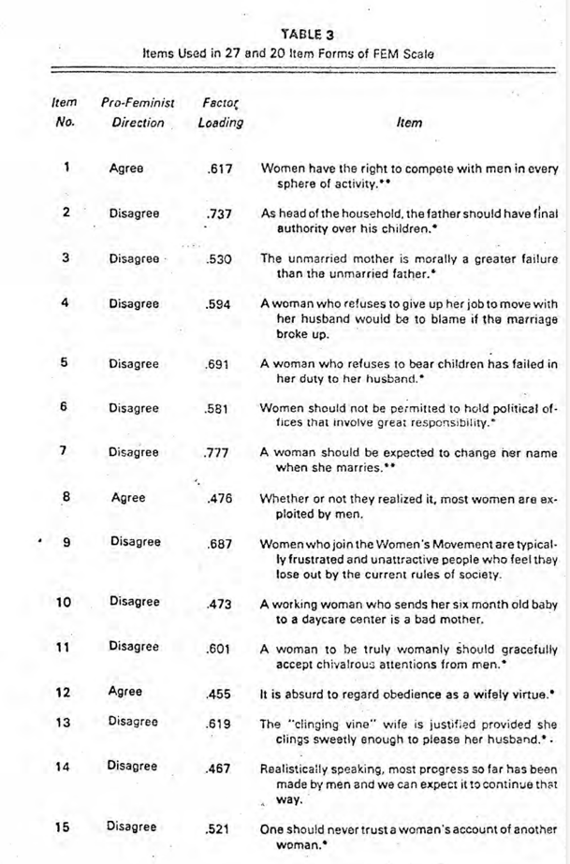
A – FEM scale

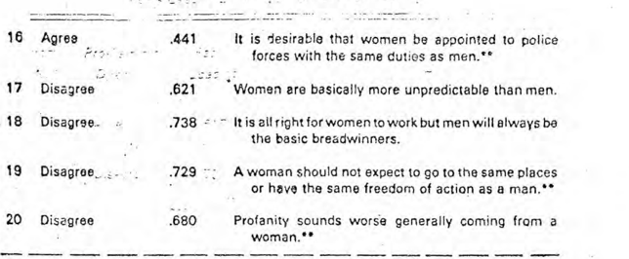

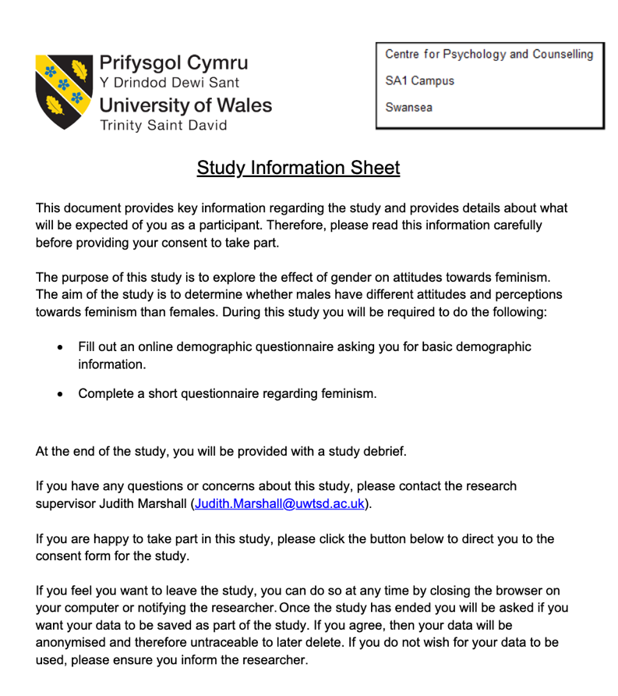
B – information sheet

C- Consent form
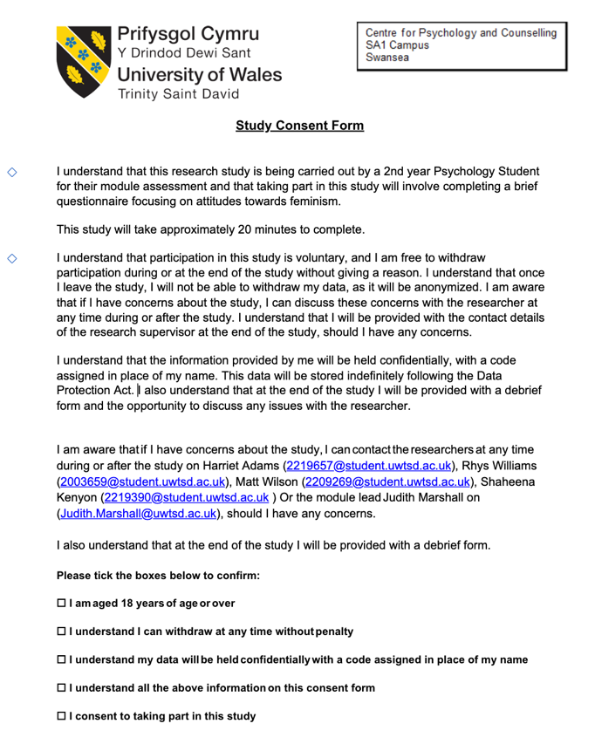

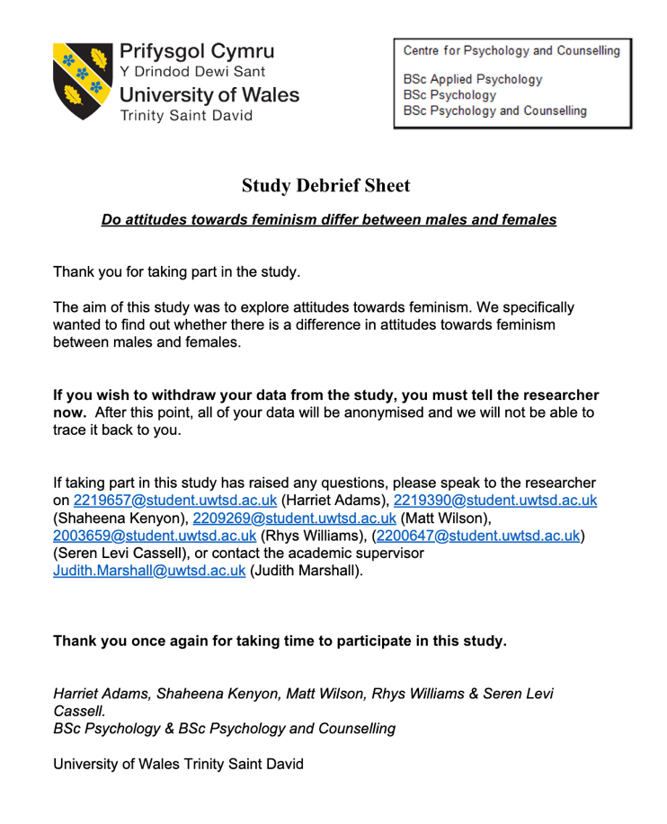
D – Debrief form

E – SPSS Output
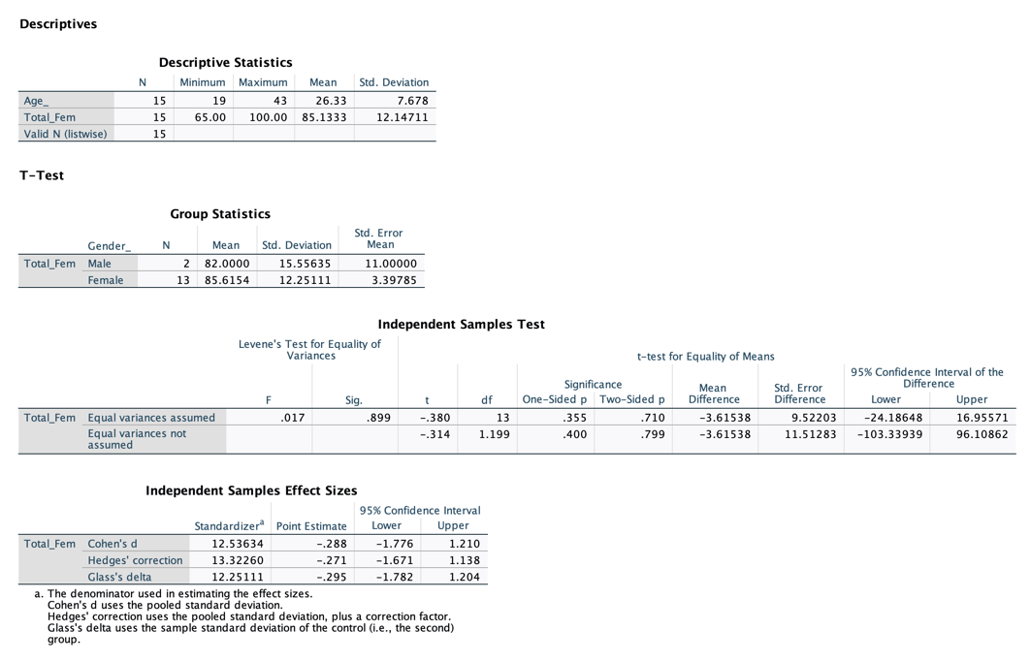

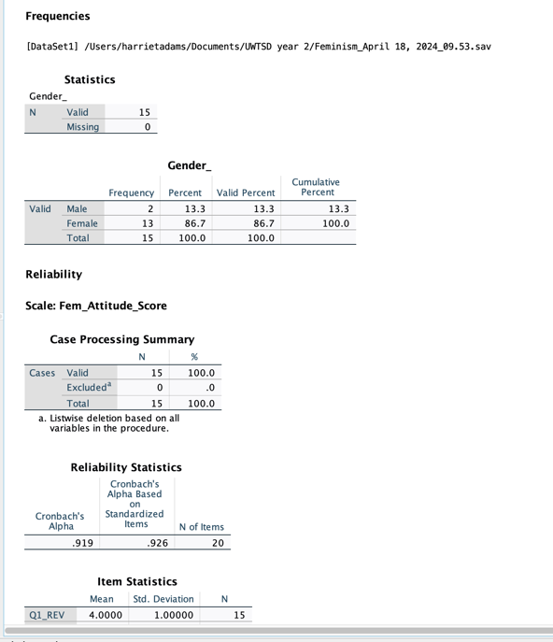

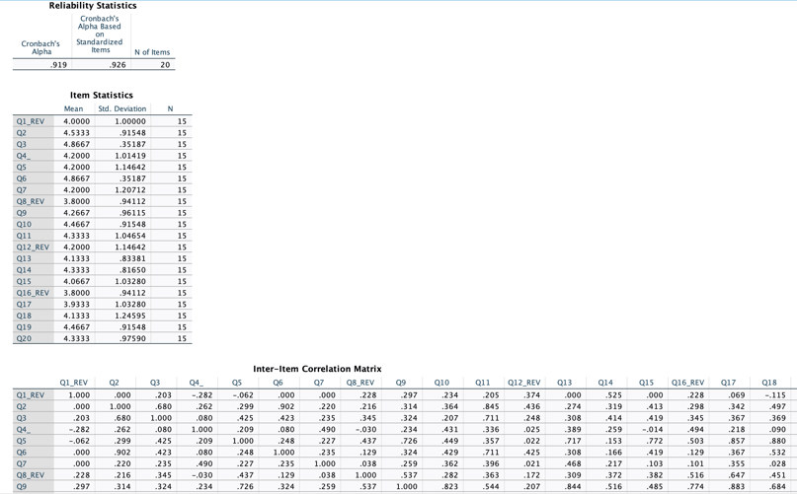

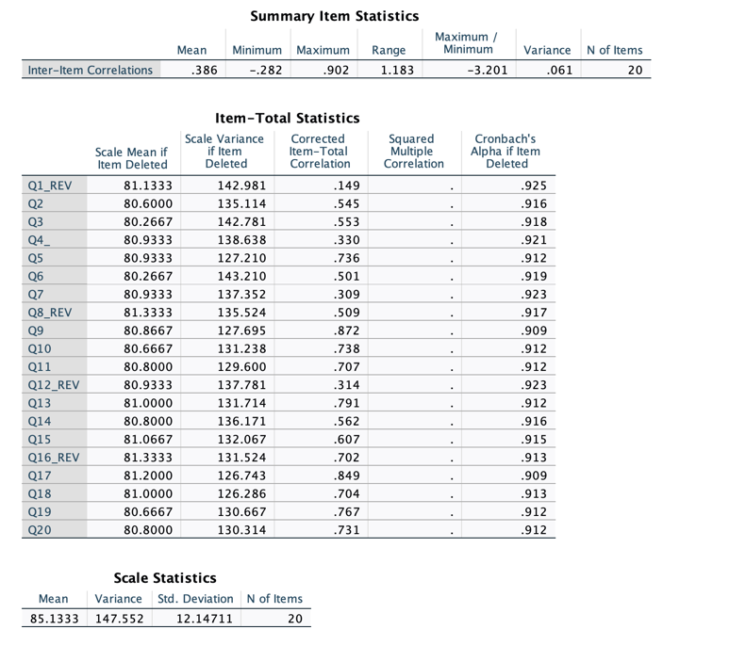

Reference list
Caine, B. (2015). “Real men” and Anti-Feminism. History Workshop Journal, 76, 262-266. https://www.jstor.org/stable/43917321
Digby, T. (2013). Men doing feminism. Routledge. https://api.taylorfrancis.com/content/books/mono/download?identifierName=doi&identifierValue=10.4324/9780203724231&type=googlepdf
Molyneux, M., Dey, A., Gatto, M., & Rowden, H. (2021). Few Feminist Activism, Waves and Generations. UN Women. https://www.unwomen.org/sites/default/files/Headquarters/Attachments/Sections/Library/Publications/2021/Discussion-paper-New-feminist-activism-waves-and-generations-en.pdf
Off, G., Charron, N., & Alexander, A. (2022). Who perceives women’s rights as threatening to men and boys? Exploring modern sexism among young men in Europe. Frontiers in Political Science. https://core.ac.uk/download/pdf/48835723.pdf
Precopio, R.F. (2015). Dude looks like a feminist! Moral concerns and feminism among men. BSU Honours Program Thesis and Projects. https://core.ac.uk/download/pdf/48835723.pdf
Raina, J.A. (2017). Feminism: An Overview. International Journal of Research, 4 (13). https://www.researchgate.net/publication/339939198_Feminism_An_Overview#:~:text='Feminism'%20is%20a%20wide%20range,and%20social%20equality%20of%20sexes.
Smith, E.R., Ferree, M.M., & Miller, F.D. (1975). A short scale of attitudes towards feminism. Representative Research in Social Psychology, 6(1), 51-56. https://psycnet.apa.org/record/1975-24474-001
Srivastava, K., Chaudhury, S., Bhat, P.S., & Sahu, S. (2017). Misogyny, feminism, and sexual harassment. Industrial Psychiatry Journal, 26(2), 111-113. https://doi.org/10.4103%2Fipj.ipj_32_18
Toller, P.W., Suter, E.A., & Trautman, T.C. (2004). Gender role identity and attitudes towards feminism. Sex Roles, 51(1), 85-90. http://dx.doi.org/10.1023/B:SERS.0000032316.71165.45

