LEVEL4ASSESSMENTSPECIFICATION
Studentname: |  | Student ID number:
Programme: | Hotel andHospitalityManagement
Module: | MarketingEssentials
Module code: | BMIH4005 | Contribution toOverall ModuleAssessment(%): | 100%
Lecturer: | ScottJames | InternalVerifier: | ChrisWilkin
AssignmentTitle: | MarketingPlan | Word count (orequivalent): | 1,500
Submissiondeadline: | Marketing Plansubmission: Friday 8thDecember2023(23:59)  Draft deadline – Thursday30thNovember(23:59) | Returndateofprovisional marks& written  feedback: | Friday 5th January2024(23:59)

Executive summary
A marketing plan is an outline for reaching your target audience and achieving specific company goals. The term "Six Senses" refers to redefining premium wellbeing. Focusing on hyper-personalised wellness experiences can help the organisation improve its value proposition. A Multifaceted Approach Can Aid in Tracking Six Senses' Success. Six Senses can track its development using a range of metrics, such as reach, engagement, and revenue generation. Optimising Existing Channels will be enabling the company to reach more customers. Social media may be utilising to creating visually attractive material that highlights Six Senses' locations, spa treatments, and visitor experiences. Run interactive polls and contests to increase involvement

Table of Contents
1. Introduction 4
2. Situation Analysis 5
3. Objectives 8
4. Strategy 9
5. Tactics 10
6. Action 12
7. Control 14
8. Conclusion 15
9. References 16

Introduction
A marketing plan is a road map for reaching your target audience and meeting certain business objectives (Perreault Jr et al., 2021). In this scenario, it would be personalised to Six Senses, a luxury hotel brand and is its primary purpose. To create this strategy, usage of frameworks such as SOSTAC (Situation, Objectives, Strategy, Tactics, Action, Control) to identify the existing market landscape, set goals, and detail ways for achieving them. It will also leverage the 7Ps (Product, Price, Place, Promotion, People, Process, and Physical Evidence) to ensure that each touchpoints is consistent with Six Senses' brand experience. Ansoff's Matrix will be a useful tool for exploring expansion ideas, whether they involve targeting new consumers with existing services or creating wholly new experiences.

Situation Analysis
Company: SWOT analysis (Microanalysis)
Strengths
Six Senses Hotel is located in a prime tourist location in London and comprises of unique amenities like an excellent spa. It also comprises of hospitable and well-trained staff (Six Senses, 2023).
Weakness
The Covid-19 pandemic affected the hotel massively and impacted their profits and revenue which took time to recover. Hence, it affected their ability in renovating and marketing in an effective manner.
Opportunities
There is an opportunity for the hotel to collaborate more with the platforms of online booking and travel agencies which help them in expanding their reach even further. There are also opportunities for infrastructural developments and upcoming local events which can be boosting inflow of tourists.
Threats
There has been a rise in competition in the hospitality sector in the UK along with economic downturns which has been affecting travel budgets. Substitutes like Airbnb also pose a threat to the business.
Customers
Segmentation: Demographic segmentation is followed by the business where the customers are mostly segmented based on their income, values and beliefs.
Targeting: Mass marketing and niche marketing are followed by Six Senses Hotel where the majority of the market is targeted by them and niche marketing for providing personalized experiences for the guests.

Competitors:
The major competitors of the company include Hilton and Travelodge UK and comprise of a strong market share and loyal customer base (Reidhead, 2020).
High Quality
High Price
Low Price
Low Quality
Hilton UK
Six Senses Hotel
Travelodge UK
Figure 1: Positioning Map
(Source: Created by the learner)
Collaborators:
The company recently collaborated with Lighting Science for enhancing the sleep experience of the guests. They have collaborated in providing the hotel with mattresses and specialty bedding along with LED bulbs for accommodations in the resort (Lighting Science, 2023).
Climate: PESTLE Analysis
Factors | Analysis
Political Factors | There will be minimum government interference for Six Senses Hotel in the UK and is a country which is stable politically with an index of 0.54 (Globaleconomy, 2023).
Economic Factors | 4.7% is the current rates of inflation, which will enhance the revenue, and profit of six senses (BBC, 2023).
Social Factors | Six Senses hotel will have no issue in expanding its workforce with a 99% literacy rate in the county (Globaleconomy, 2023).
Technological Factors | Six Senses hotels can expand their online marketing strategies as 63 million people use the internet in the UK and this is on the rise (Globaleconomy, 2023).
Environmental Factors | The hotel must limit waste emission and abide by the control of Pollution Act 1954 to avoid legal hassles.
Legal Factors | Equal pay and minimum wage should always be the focus of the company while operating in the UK.
Table 1: PESTLE Analysis
(Source: Created by the learner)

Objectives
A SMART objective summarising the Six Senses marketing plan's goals is that by the end of 2024, the brand hopes to increase direct bookings on Six Senses' website by 20% through a targeted social media campaign displaying personalised wellness retreats, resulting in a 10% lower cost-per-acquisition than the current average (Six Senses, 2024).
This is smart since it identifies:
To shows a significant rise in direct reservations (20%) and will monitor online bookings and cost-per-acquisition for bookings benefit both Six Senses and their customers and by a definite deadline of the end of 2024.

Strategy
The term Six Senses refers to redefining luxury wellness (Six Senses, 2024). Focusing on hyper-personalised wellness experiences can help the company boost its value proposition. This goes beyond conventional spa treatments and includes bespoke programmes tailored to individual needs and goals, such as DNA-based nutrition plans or AI-powered sleep optimisation. Ansoff's Matrix recommends a market penetration strategy. Six Senses keeps its core luxury audience while increasing interaction with these new, ultra-personalised health alternatives.
The marketing mix will adapt.
Product: Create tailored wellness programmes with cutting-edge technologies.
Price: The brand shall be using premium pricing, as they shall be providing the tourists with luxury hotels.
Promotion: Targeted social media campaigns to highlight success stories and the expertise behind these programmes. For instance, Hillton Hotels uses their Facebook page for the marketing.
Place: Collaborations with wellness professionals and facilities to broaden the scope of personalised experiences.
This change positions Six Senses as a revolutionary wellness leader, rather than just another luxury resort.

Tactics
Using a RACE Approaching to Revitalise Six Senses Communication can be important. Six Senses can using the RACE (Reach, Act, Convert, and Engage) framework to developing new approaching to handling situational analysis resulting (Benson and Fiarman, 2020). They can broaden their reach through content marketing; collaborate with wellness influencers on trip vlogs and social media campaigns. Targeted ads are another way they may using social media platforms to attracting consumers interesting in sustainable travelling and premium health experiences. SEO optimisation can be improving website content by optimising it for relevant keywords connecting to Six Senses' wellness retreating and unique experiences. The Act will consist of interactive content creating by the company. Creating quizzes and exams to assisting guests discover optimal Six Senses getaways depending on their wellness goals. The brand may also be providing 360-degree virtual tours that highlight the magnificent settings and unique experiences at each resort. Convert will providing Live Chat Support by integrating live chat features into the website for real-time interaction and booking assisting. The organisation can also providing personalising offers that using visitor data to tailoring unique bundles and promotions basing on previous preferences.
Engage will including Community Building, which can helping to creating a Six Senses online community where guests can connecting, exchange stories, and encouraging one another (Malhotra, Nunan and Birks, 2020). Social Listening can also be implementing by constantly monitoring brand mentioning and responding to visitor requesting and feedback via social media (Rust, 2020). Email marketing can also be using by brands to segmenting email lists and personalising information depending on guest preferences and previous interactions (Olson et al., 2021). To increase trust and bookings and be displaying success stories and testimonials will be essential. Similarweb Insights will be enabling Six Senses to examining website traffic statistics and detecting potential gaps. Concentrating content creation on topics with high user interesting can be affected due to poor conversion rating. Six Senses can be improving their communication style by using these tactics. They may be offering a more engaging and personalising visitor journey, resulting in greater brand awareness, reservations, and guest loyalty (Kotler, Kartajaya and Setiawan, 2021).
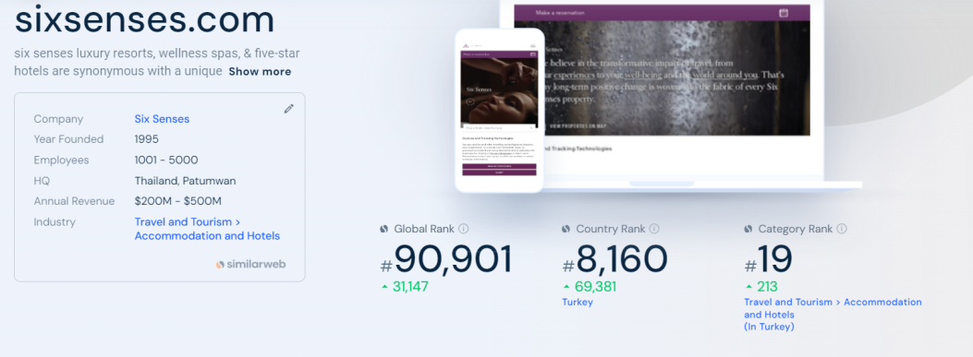
Figure 2: Six Senses (Similarweb)
(Source: Similarweb, 2024)

Action
Channel | Activity | Frequency | Content Focus | Metrics
Website | Blog Posts | Monthly | Sustainable travel tips, Wellness guides, Destination highlights | Organic traffic, Time spent on site, Conversions
Website | Interactive Content (Quizzes) | Quarterly | Personalized guest journey for ideal retreats | Lead generation, Engagement rate
Website | Virtual Tours | Bi-annually | 360° immersive experiences of resorts | Time spent on virtual tours, Conversion rate from virtual tours
Email Marketing | Newsletters | Bi-weekly | Special offers, Upcoming events, Guest testimonials | Open Rates, Click-through Rates, Booking conversions
Email Marketing | Personalised Offers | Monthly | Curated packages based on guest preferences | Redemption rates, Revenue generated
Social Media (Organic) | Posts & Stories | Daily | Stunning visuals of locations, Spa treatments, Guest experiences | Engagement Rate (likes, comments, shares), Reach
Social Media (Organic) | Live Sessions (Expert Q&A) | Monthly | Wellness experts hosting live sessions on topics like mindfulness, yoga etc. | Number of viewers, Audience interaction during live sessions
Social Media (Paid Ads) | Targeted Campaigns | Ongoing | Promote wellness retreats, Highlight unique experiences | Reach, Impressions, Click-through Rates, Cost per Acquisition (CPA)
Public Relations | Press Releases & Media Pitches | As warranted | New resort openings, Sustainability initiatives, Awards & recognition | Media mentions, Brand awareness
Influencer Marketing | Collaborations | Quarterly | Partner with wellness influencers for content creation and promotion | Engagement on influencer posts, Reach through influencer audience, Website traffic from influencer content
Table 2: Marking Channel Activities
(Source: Created by the learner)
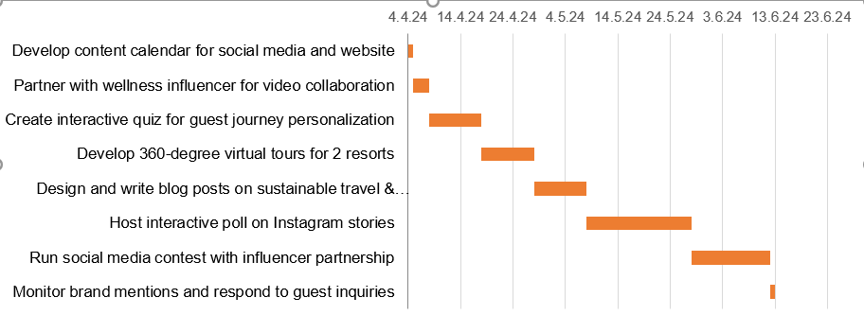
Figure 3: Gantt chart
(Source: Created by the learner)

Control
A Multifaceted Approach Can Help Track Six Senses' Success. Six Senses may tracking its progressing using a variety of indicators, including reaching, engagement, and revenue production.
Monitor website traffic, social media following, and targeting ad impressions.
Engagement: Monitor website staying time, social media engagement rating (likes, comments, shares), and email campaign click-through rating.
Conversions: Examine website bookings, quote requesting, and redemption rating for special promotions.
New customer acquisition rate: Calculating the ratio of first-time bookers versus total bookings.
Cost per Acquisition (CPA): Monitor marketing expenses per new client acquisition (Liuet al., 2024).
To assessing favourable brand perception, do social listening analysis by monitoring internet sentiment around brand mentions.
Guest Satisfaction Surveys: After a guest's staying, collecting feedback through surveys to determining their level of satisfaction with the experience.
Revenue Growth:
Total Revenue: Tracking the whole revenue earning by bookings.
Average Booking Value: Using the average amount spent per booking to evaluating the effectiveness of pricing initiatives.
By creating a KPI dashboard using these measures, Six Senses may be acquiring a data-driven knowledge of the effectiveness of their communication initiatives (Sunand Ge, 2020). This enables businesses to constantly improving their tactics and optimisingcampaigns for maximum reaching, engagement, and, ultimately, a profitable business.

Conclusion
The challenges of the marketing plan were the limited capital and traditional marketing strategies. It is important to incorporate strategies of digital marketing, which will help in reaching more customers across the UK along with implementing effective pricing strategies. Strategies like social media marketing and email marketing can be implemented which will be less costly as compared to traditional marketing techniques followed by the brand. The company will not be facing any challenges while operating in the UK according to the Pestle analysis. However, they should be aware of the competitors and implement strategies for countering them.

References
BBC (2023) What is the UK inflation rate and how does it affect me? Available at:https://www.bbc.com/news/business-12196322 .(Accessed:17 April 2024)
Benson, T.A. and Fiarman, S.E. (2020) Unconscious bias in schools: A developmental approach to exploring race and racism. Harvard Education Press.
Globaleconomy (2023) United Kingdom: Political stability. Available at:https://www.theglobaleconomy.com/United-Kingdom/wb_political_stability/#:~:text=Political%20stability%20index%20(%2D2.5%20weak%3B%202.5%20strong)&text=The%20latest%20value%20from%202021,to%20compare%20trends%20over%20time. .(Accessed:17 April 2024)
Kotler, P., Kartajaya, H. and Setiawan, I. (2021) Marketing 5.0: Technology for humanity. John Wiley & Sons.
Lighting Science (2023) Lighting Science Partners with Six Senses Hotels Resorts Spas https://www.businesswire.com/news/home/20180614005882/en/Lighting-Science-Partners-with-Six-Senses-Hotels-Resorts-Spas .(Accessed:17 April 2024)
Liu, Q., Ao, X., Guo, Y. and He, Q. (2024) ‘Online Conversion Rate Prediction via Multi-Interval Screening and Synthesizing under Delayed Feedback’. In Proceedings of the AAAI Conference on Artificial Intelligence (Vol. 38, No. 8, pp. 8796-8804).
Malhotra, N. K., Nunan, D. and Birks, D. F. (2020) Marketing research. Pearson UK.
Olson, E.M., Olson, K.M., Czaplewski, A.J. and Key, T.M. (2021)‘Business strategy and the management of digital marketing’. Business horizons, 64(2), pp.285-293.
Perreault Jr, W.D., Cannon, J.P. and McCarthy, E.J. (2021) Essentials of marketing: A marketing strategy planning approach. McGraw-Hill.
Reidhead, C. (2020) Impact of organizational culture on employee satisfaction: A case of Hilton hotel, United Kingdom. Journal of Economics and Business, 3(1).
Rust, R. T. (2020) ‘The future of marketing’. International Journal of Research in Marketing, 37(1), 15-26.
SimilarWeb (2024) sixsenses.com. Available at: https://www.similarweb.com/website/sixsenses.com/#overview(Accessed: 17 April 2024)
Six Senses (2024) About. Available at: https://www.sixsenses.com/en/about-us/ (Accessed: 17 April 2024)
Six Senses (2024) Make a reservation. Available at: https://www.sixsenses.com/en/(Accessed: 17 April 2024)
Sun, Q. and Ge, Z. (2020)‘Deep learning for industrial KPI prediction: When ensemble learning meets semi-supervised data’. IEEE Transactions on Industrial Informatics, 17(1), pp.260-269.

