
APPENDIX GA36d

LEVEL 7 ASSESSMENT SPECIFICATION

Student name: | LEUNG WING CHONG FION | Student ID number: | 2337375
Programme: | MBA
Module: | Strategic Management
Module code: | HKBM7013 | Contribution to Overall Module Assessment (%): | 100%
Lecturer: | Dr Terence Li | Internal Verifier: | Dr Alice Te
Assignment Title: | Project Report | Word count (or equivalent): | 5,000 words (+/- 10%)
Submission deadline: | 4 November 2024 | Return date of provisional marks & written feedback: | 4 December 2024
Submission method: | All written assessments, where practical and possible, must be submitted via Turnitin unless otherwise instructed by the Lecturer. (Please DO NOT put this assessment specification into Turnitin or it will match many similarities with other students’ submissions.)  Alternative submission method (if applicable):  Late submission of the assessment will result in a late penalty mark. Penalties for late submission: Up to one week late, maximum mark of 50%. Over one week late, 0%. Only the Extenuating Circumstances Panel may approve a change to submission dates.
Academic honesty / referencing: | Academic honesty is required. In the main body of your submission you must give credit to authors on whose research and ideas your work is based. Append to your submission a reference list that indicates the books, articles, etc. that you have used, cited or quoted in order to complete this assessment.

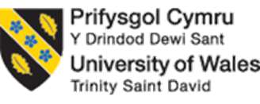

UWTSD MBA
HKBM7013 Strategic Management

H&M Case Study

Student Name | ： | LEUNG WING CHONG FION
Student ID Number | ： | 2337375
Date of Submission | ： | 4 November, 2024
Lecturer | ： | Dr Terence Li

I. Executive Summary

This report offers a comprehensive analysis of H&M's strategic management practices in the dynamic and diverse market of Hong Kong. The first chapter will provide an overview of the company, officially known as Hennes & Mauritz AB, which has established itself as a prominent player in the global fashion industry. An evaluation of the company's vision, mission, and values highlights essential aspects of its operations, delves into the competitive landscape, and outlines innovative strategies aimed at driving H&M's future growth. H&M is committed to making a positive impact on society and the environment through its operations. The objective is to gain a thorough understanding of H&M's current performance while presenting actionable recommendations to enhance its success.

The retail landscape in Hong Kong is vibrant, characterized by intense competition and rapidly changing consumer `behaviours. As a prominent shopping destination in Asia, Hong Kong is home to a myriad of fast fashion brands competing for consumer attention. Recent economic shifts and regulatory changes, along with a marked trend toward sustainability and digital shopping, have created both challenges and opportunities within the retail sector. This analysis will delve into the key macro-environmental factors affecting H&M in Hong Kong, utilizing the PESTEL framework, followed by an assessment of industry competitiveness through Porter’s Five Forces. This evaluation aims to provide H&M with a strategic proposition for navigating the Hong Kong market.
H&M is on a proactive journey toward creating a sustainable future by embracing digital innovation and adapting to the unique characteristics of local markets. By integrating sustainability into its operations and enhancing its online presence, H&M is well-positioned to meet the changing needs of consumers while fostering profitable growth.

Chapter 4 presents a constructive review of the company’s current strategies and introduces a balanced scorecard aimed at enhancing revenue growth and profit margins through four critical perspectives.

The concluding chapter will offer actionable recommendations for improvement. Furthermore, a Gantt chart will be included to provide a clear roadmap for implementing these strategic initiatives, outlining specific tasks, timelines, and interdependencies to ensure effective and timely execution.

By adopting these recommendations, H&M can strengthen its strategic management practices in Hong Kong, paving the way for sustained growth and aligning closely with consumer expectations in a dynamic retail landscape.
Table of Contents
I. Executive Summary 3
1. Introduction 5
1.1. Company Overview 5
1.2. Company Vison, Mission and Value Overview 6
1.3. Current Business Environment in Hong Kong 8
2. H&M Compeitive Analysis 9
2.1. Marco Environment 9
2.1.1. Economic 9
2.1.2. Social 10
2.1.3. Technology 12
2.1.4. Environmental 13
2.2. Porter’s five forces analysis 13
2.2.1. Key Highlight 15
2.3. H&M competitive strategies 16
2.3.1. Cost Leadership 16
2.3.2. Differentiation through sustainability 16
3. H&M Value Chain Evaluation 17
3.1. Primary Activities 17
3.2. Support Activities 18
4. Current Strategy Evaluation 19
4.1. Balanced Scorecard 20
5. Conclusion and Recommendations 21
5.1. Enhance Sustainability Initiatives in Hong Kong Market 21
5.2. Strengthen Local Market Consumer Perception 22
5.3. Invest on People 22
5.4. Contingency Plan 22
6. GANTT Chart 24
II References 25

Introduction
This study delves into the remarkable strategic development of the multinational fashion powerhouse H&M. It traces the company's extraordinary journey from a humble women's clothing store in Sweden in 1947 to its status as a prominent global conglomerate. The analysis will thoroughly review H&M's Vision, Mission, and Values, while closely examining the company's adept response to macro and micro environmental issues in Hong Kong. Furthermore, the internal analysis will vividly highlight the company's unwavering commitment to innovation, diverse product offerings, and strategic alliances.

H&M embracing the fast-fashion business model, offers a wide range of affordable clothing, accessories, and homeware. The company is the proud proprietor of twelve unique brands, including H&M, H&M Move, H&M Home, COS, Weekday, Cheap Monday, Monki, & Other Stories, ARKET, Afound, The Sigular Society, Creat::R Studio, and Sellpy. H&M Group's extensive footprint spans over 4,000 physical stores, operating across more than 75 markets, and is also involved in online sales in 60 markets (H&M Group, 2024).

Company Overview
In 1947, Swedish entrepreneur Erling Persson established a women's clothing store in Sweden, naming it Hennes, following his visit to New York City. During the 1960s to 1970s, the company expanded by acquiring a Stockholm-based hunting apparel and fishing equipment retailer and subsequently rebranded as Hennes & Mauritz. This expansion culminated in the listing of Hennes & Mauritz on the Stockholm Stock Exchange in 1974. H&M entered the online market in Sweden in 1998 and later engaged in collaborations with eminent fashion designers including Karl Lagerfeld, Stella McCartney, Roberto Cavalli, Versace, and Alexander Wang in the 2000s. In 2009, H&M introduced H&M Home and subsequently launched a collection of sustainable materials. Recent years have seen a dedicated focus on sustainability, with H&M setting ambitious targets to achieve a 56% reduction in absolute greenhouse gas emissions across its value chain by 2030 and a 90% reduction by 2040, ultimately aiming for net zero emissions by 2040. Furthermore, H&M, in partnership with Remondis, established Looper Textile Co., a joint venture focused on the collection, sorting, and resale of used and unwanted garments and textiles (H&M Group, 2024).

Company Vison, Mission and Value Overview
H&M Vision
Figure 1.2.1 from H&M's official website illustrates the company's vision: "to lead the change towards supporting a circular fashion industry with a net-zero climate while being a fair and equal company and respecting human rights". H&M is actively working towards its vision of leading sustainability in the fast fashion industry, embracing a more environmentally responsible approach that focus on three areas that maximize their impact – scaling innovation, promoting transparency and engaging partners for industrywide progress (H&M Group, 2024a). By setting a standard for other clothing brands, the company encourages enhancements in manufacturing processes while promoting continuous innovation in a fair and equitable environment. Furthermore, H&M emphasizes that its supply chain is built on long-term strategic partnerships, mutual trust, and fair purchasing practices (H&M Group, 2024). The annual report includes an impact review titled "Equal and Fair," which constructively evaluates the effectiveness of these management solutions and highlights areas for ongoing improvement (H&M Group, 2024). It concluded that H&M aspiration is actively working towards becoming a leader in the fast fashion industry by embracing innovation. The company is committed to minimizing its climate impact during production, striving for sustainability, and fostering a fair work environment around the world.
Figure 1.2.1 H&M Vision (H&M Group, 2024c)
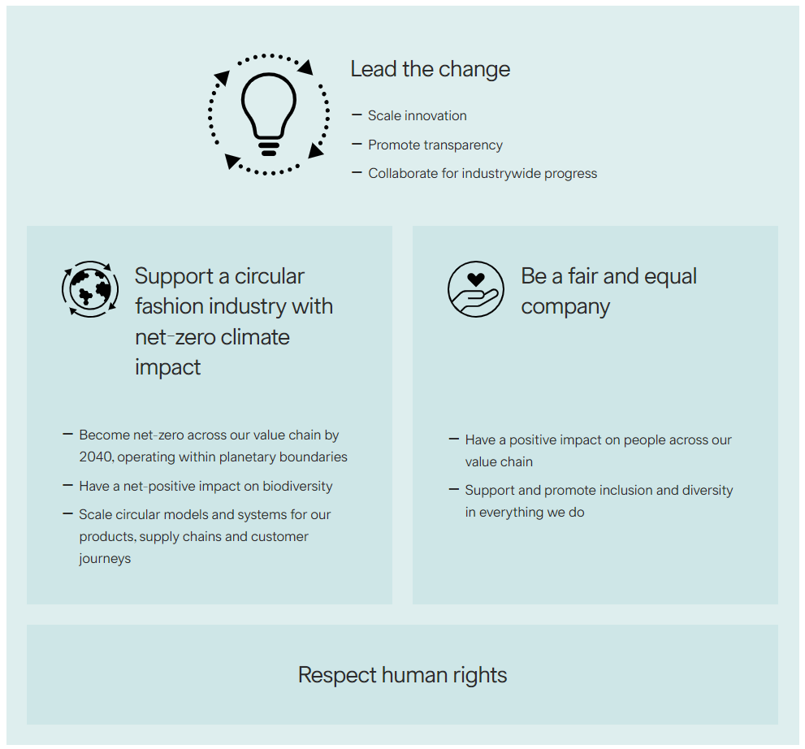
Source: (H&M Group, 2024b)

H&M Mission
H&M's mission clearly states their commitment: "Our mission is to offer fashion and quality at the best price" (Wondershare EdrawMind, 2023). This straightforward approach not only highlights their dedication to affordability but also emphasizes the importance of fashion and quality. By communicating this powerful message, H&M effectively engages both internal team members and external customers, fostering a shared understanding of their values and objectives.

H&M’s Core Values
The foundation of H&M’s culture that shared by seven core values (H&M Group, 2024a):
We are one team – emphasizing the workplace is inclusive and respectful
We are believe in people – empower and trust on employees ownership and interaction between colleagues
We are entrepreneurs – building strong business sense to capture the opportunities under changing world
We make constant improvement – encourage feedback, learn and adaptation to contribute everyday improvement
We are cost-conscious – support on sustainable lifestyle for everyone
We are straightforward and open-minded - delivery should be open, honest, humble and committed
We keep it simple – it is aligned with last value that to keep simple and direct to drive efficiency

H&M prioritizes its core values centered around people and a commitment to value, striving to deliver high-quality fashion at competitive prices. By fostering trust among teams and promoting a collaborative "one team" concept, H&M creates an inclusive work environment. Furthermore, the company empowers employees to take ownership and embrace entrepreneurial thinking, which contributes significantly to business growth and innovation.

H&M's vision and mission are not just statements; they are clear and compelling guides that define our path forward. Our vision highlights "where we aspire to go," while our mission articulates our business objectives with precision. At the heart of H&M lies a commitment to caring for people, embodied in our core values, which serve as essential principles in driving us toward our vision and mission.

Current Business Environment in Hong Kong
H&M has made a significant impact in the vibrant market of Hong Kong since its entry in 2007, demonstrating resilience and adaptability in a dynamic retail environment. Several factors influence the company's operations, including changing consumer behaviour, a competitive landscape, sustainability initiatives, and regulatory considerations.

In this lively market, H&M competes with well-established brands like Zara, UNIQLO, and Abercrombie & Fitch. Additionally, the presence of various emerging players who import fashion from Japan and Korea adds to the diversity of options available to consumers. According to Figure 1.3.1, H&M currently holds 1% of the market share, while other competitors account for 79%. This statistic underscores the high level of competition in Hong Kong’s apparel sector, highlighting opportunities for H&M to innovate and strengthen its market position moving forward.

Figure 1.3.1 Key Players in Hong Kong Apparel Market
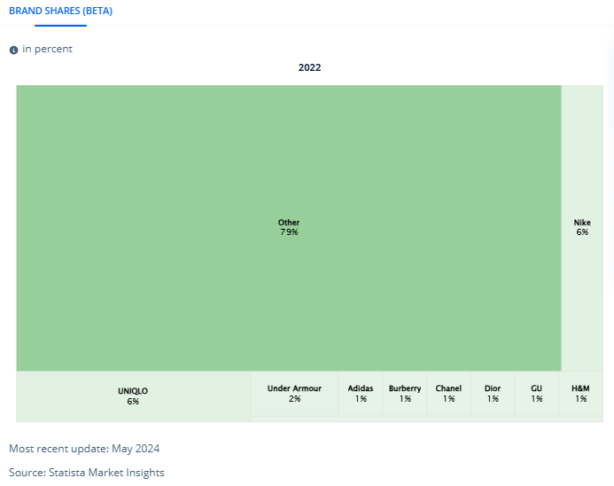

H&M Compeitive Analysis
This chapter will further evaluate the competitive advantage for H&M in Hong Kong. The company’s business model is centred around fast fashion, which involves quickly moving new styles from the catwalk to retail stores.

Marco Environment
A PESTLE analysis is a valuable tool for examining the Political, Economic, Social, Technological, Legal, and Environmental factors that impact H&M's operations in Hong Kong, Hong Kong has a relatively stable political climate, and adherence to free-market practices create a conducive environment for retail operations, the analysis will be more focus on Economic, Social and Technological. By conducting this analysis, the company can gain a deeper understanding of the external environment, enabling it to make strategic decisions that strengthen its position and foster growth in the market.

Economic
Hong Kong continues to exemplify a highly developed economy, with strengths such as a free flow of capital, a robust legal framework, and favourable low tax rates. In the second quarter of 2024, the economy showcased moderate growth, with real Gross Domestic Product (GDP) increasing by 3.3% year-on-year. However, it is important to address the reported decline in business sentiment among large enterprises in the retail sector, which saw a drop of 16% compared to last year (HKSAR, 2024).

As of October 2024, the retail landscape in Hong Kong is poised for significant evolution. This shift, which began in August 2024, signals the onset of a “new consumption” phase that encourages innovation and adaptability within the retail industry. The trend of "Northern stores going south" from mainland China, initially impacting the food and beverage sector, is now expanding to luxury goods, fashion, beauty, and skincare. This presents a unique opportunity for local businesses to reassess their strategies and align offerings with changing consumer preferences.

While the tourism industry is currently facing some challenges, this can serve as a valuable opportunity for businesses to diversify and tap into new markets. By embracing these changes and proactively responding to consumer needs, Hong Kong's retail sector can not only navigate current obstacles but also thrive in an evolving market environment. This adaptability will be key to maintaining Hong Kong's economic resilience and growth in the future (Top News, 2024).
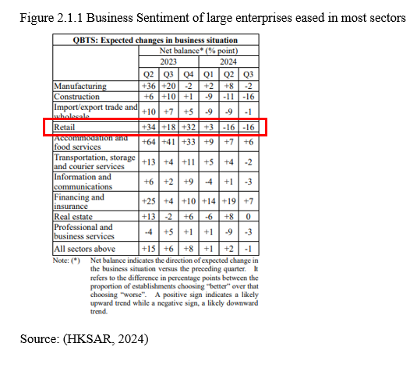

Social
E-commerce was already on an upward trajectory prior to the COVID-19 pandemic. The pandemic has significantly accelerated this trend, leading to a remarkable surge in sales for e-commerce retailers across Asia. Hong Kong stands out as a prime example of this growth, rapidly emerging as one of the most dynamic e-commerce markets, with over 4.5 million online shoppers.
Looking ahead, the future of e-commerce in Hong Kong appears bright, with projections suggesting that the number of online users will reach 6.6 million by 2027 and a user penetration rate of 84.1%. The demographic driving this trend primarily includes individuals aged 25 to 54, who make up an impressive 79.6% of online shoppers (Osome, 2023).

Furthermore, the Hong Kong e-commerce market is expected to thrive, with an anticipated compound annual growth rate (CAGR) of 8.7% from 2022 to 2027 (Mordor Intelligence, 2023). This growth presents exciting opportunities for businesses to leverage the expanding online marketplace and meet the evolving needs of consumers.

A noteworthy 45% of social media users in Hong Kong actively utilize these platforms to foster connections with loved ones through messaging apps, shared stories, and group chats (Guzman, 2023). Additionally, the Hong Kong Consumer Council highlights (Figure 2.1.2) that many individuals are eager to go online, with 43% recommending it to friends and family. This insight is crucial, especially regarding trending topics. In Hong Kong's digital landscape, communication often occurs within groups, with WhatsApp leading the way, followed by Facebook and Instagram (Guzman, 2023). As such, digital interaction marketing can greatly benefit from adapting to the dynamic changes in Hong Kong's media environment, ensuring that strategies are effective and relevant.
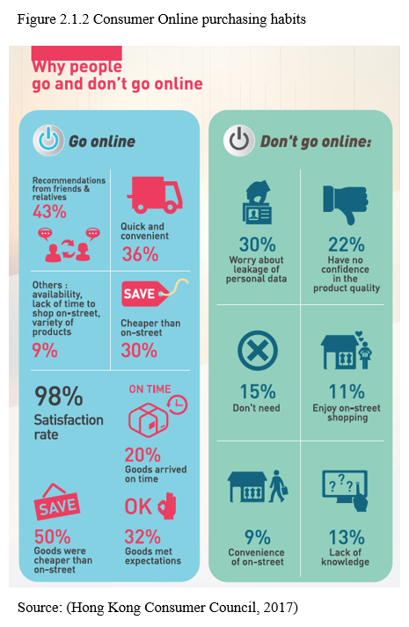

Technology
Technology plays a pivotal role in shaping H&M’s global business strategy, particularly through its online sales operations across 60 markets (H&M Group, 2024). By focusing on enhancing e-business efficiency, H&M effectively engages customers in the competitive fashion retail landscape.

As depicted in Figure 2.1.3, online sales channels in Hong Kong accounted for only 4.8% in 2024. However, this figure presents an opportunity for growth, as there is a projected upward trend in the coming years. The decline in online sales after the pandemic highlights the need to further understand and cater to Hong Kong consumers' strong preference for in-store shopping.

H&M effectively taps into global consumer behaviour by employing big data analysis to develop personalized marketing strategies and tailored product assortments. Leveraging digital social media platforms, the brand enhances the online-to-offline (O2O) shopping experience, aligning with consumer expectations. Furthermore, big data analysis supports improved inventory management and boosts logistical efficiency, paving the way for sustained success in the evolving retail environment.
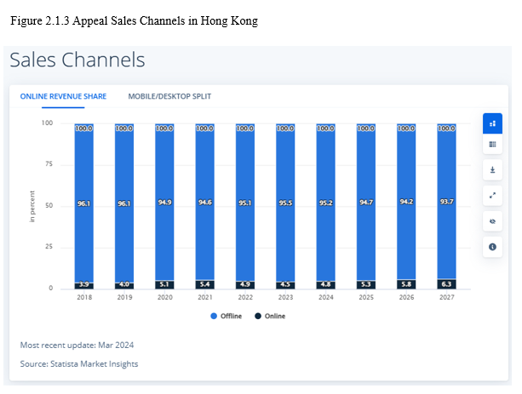

Environmental
Environmental factors identified in a PESTEL analysis closely align with those considered in an ESG (Environmental, Social, and Governance) analysis. H&M emphasizes sustainability in its vision statement, which aligns with the growing global awareness of environmental issues. However, a survey indicates that many people in Hong Kong do not perceive the climate crisis as urgent. Notably, 80% of respondents feel that the government should take on a greater role in addressing these challenges. This presents an opportunity for dialogue and collaboration between businesses, citizens, and policymakers to foster a more sustainable and proactive approach to climate action (Green Queen, 2020).

Porter’s five forces analysis
In this paragraph, it will be using Porter’s five forces analysis to determine the intensity of competition and profitability that can be expected in the fashion retail sector.

Threat of new entrants
The Hong Kong fashion retail market offers an exciting opportunity for new entrants, its relatively low barriers to entry. From Figure 1.3.1 showed that 75% key players in Hong Kong market is itemized, with minimal investment and little technical expertise required, aspiring retailers can easily access this vibrant marketplace. The rise of online platforms like Tao Bao and SHEIN, along with consumer interest in fashion imported from Japan and Korea, enhances the appeal. Established Instagram shops further contribute to a dynamic competitive environment.
While high consumer spending and a fashion-conscious population create a favourable landscape, established brands such as ZARA and Uniqlo, alongside numerous small merchants, reflect the diversity within the market. A critical area for growth is brand loyalty; for brands like H&M, nurturing strong customer relationships can help navigate this competitive terrain. Although there are existing barriers, such as brand recognition, the low capital requirements for new retailers empower shop owners on Instagram and Carousell to effectively engage with consumers. This environment fosters innovation and collaboration, making the market ripe for those ready to make their mark.

Bargaining Power of Suppliers
In the Hong Kong market, H&M enjoys relatively low bargaining power among suppliers, which offers several advantages for the company. H&M strategically sources products from a diverse range of global suppliers, reducing reliance on any single source and enhancing flexibility to meet changing customer demands.
The dedicated global sourcing team manages supplier relationships, ensuring readiness to switch suppliers if costs rise or quality declines. H&M's extensive supply chain allows it to benefit from economies of scale, leading to significant volume purchases that strengthen its negotiating position (H&M Group, 2024b).
With substantial purchasing power, H&M can secure favorable terms from suppliers, helping maintain competitive prices and high-quality standards. This strategic approach fosters long-term partnerships that support the company’s business objectives and sustain its competitive edge.

Bargaining Power of Buyers
Consumers in Hong Kong exhibit a strong sensitivity to pricing and routinely engage in comparing prices across different retailers. This behavior not only highlights their keen interest in getting the best deal but also creates substantial pressure on brands like H&M to ensure their pricing remains competitive and appealing (Calvar, 2023). As a result, the bargaining power of buyers within the Hong Kong market is significantly elevated.
Additionally, the proliferation of social media has transformed the way consumers gather information about trends and prices. With just a few clicks, shoppers can access a wealth of information, including real-time price comparisons and product reviews. This broad availability of knowledge, along with the ability to receive recommendations from friends and family, allows consumers to make well-informed purchasing decisions. This, in turn, amplifies their bargaining power and influences overall market dynamics.

Threat of Substitute Products & Industry Rivalry
The threat of substitutes for H&M is notable, the level of threat of substitute products is moderate to high while the industry rivalry is fierce. Facing similar challenges for Threat of subsitite product and industry rivalry, consumers have access to a diverse range of alternatives to fast fashion, including well-established brands such as Zara and Uniqlo, which are known for their trendy offerings and competitive pricing. Moreover, several local brands have emerged, catering to the specific tastes and preferences of consumers in Hong Kong.
The shift towards local and sustainable fashion is particularly significant, as many consumers increasingly prioritize ethical choices in their purchasing decisions. This trend not only promotes community-oriented businesses but also encourages environmental responsibility, creating a compelling alternative to traditional fast fashion. As a result, H&M has an opportunity to engage with this growing market by enhancing its sustainable practices and local collaborations.

Key Highlight
Porter's Five Forces Model is an essential framework for analyzing the competitive dynamics within an industry and determining a company's market position. As outlined in Figure 2.2.1, H&M faces various influences from these five forces. To thrive in this competitive and dynamic landscape, H&M can adopt a cost leadership strategy while also leveraging its heritage brand to develop a unique differentiation strategy. This constructive approach aligns with current H&M mission and will help strengthen its market presence and promote sustainable growth in the future.
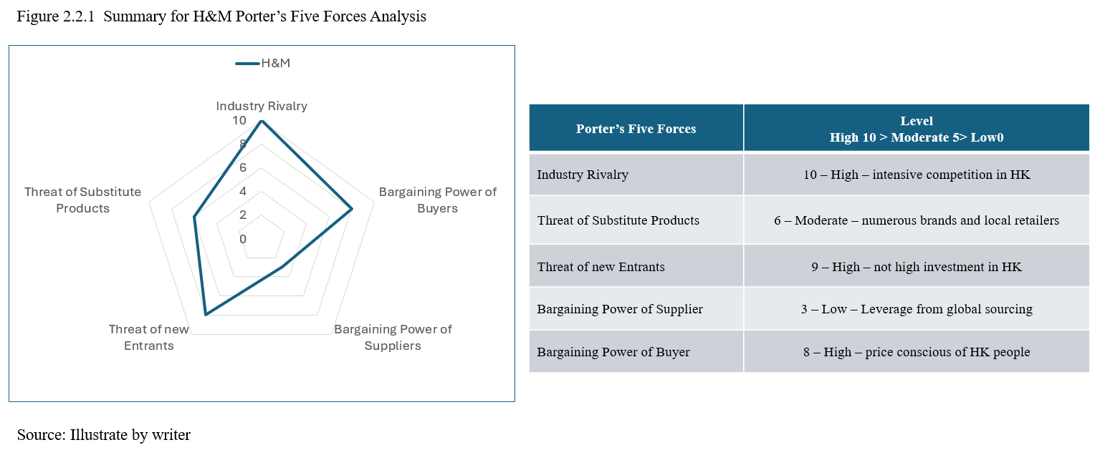

H&M competitive strategies
H&M’s business mission is to offer fashion and quality at the best price. The critical success factors in Hong Kong that an H&M store is on the most prominent shopping streets with several floors divided into difference departments, location selection in the most convenience town center such as Tsmi Sha Tsui, Mong Kok, Shatin Tin, Causeway Bay etc., apart from fast fashion, H&M also doing product development strategy that offering H&M Home and H&M Beauty

Cost Leadership
H&M effectively navigates Hong Kong's competitive fashion landscape by employing a diverse array of strategic approaches. By prioritizing cost leadership, differentiation, and market responsiveness, H&M successfully meets the varied preferences of consumers while driving profitability (Datta, 2010). This comprehensive strategy not only strengthens its market position but also enhances overall customer satisfaction.
H&M capitalizes on a global sourcing team that skilfully outsources production to countries with lower labour costs. This approach allows the company to maintain low production expenses while offering a broad range of products. With an extensive network of stores and significant sales volume, H&M benefits from economies of scale, further minimizing costs. This enables the brand to provide competitive pricing, making it easier to attract price-sensitive shoppers in the market.

Differentiation through sustainability
In recent years, H&M has made commendable progress in prioritizing sustainability, which has effectively distinguished it in the fashion industry. By committing to using organic and recycled materials, the company successfully appeals to an increasingly environmentally conscious consumer base. Furthermore, H&M has proactively introduced guides to help customers care for their clothes, promoting longevity and reducing overall waste (H&M, 2018).

The brand’s dedication to ethical sourcing and fair labour practices is also noteworthy, as it aligns with the values of consumers who prioritize corporate social responsibility. H&M emphasizes the importance of a safe and equitable working environment for all involved in the production process. Suppliers are required to sign a sustainability commitment, ensuring adherence to essential ethical standards.

This holistic strategy not only aligns with H&M's vision but also reinforces its core values, positioning the company as a positive influence in the realm of sustainable fashion.

H&M Value Chain Evaluation
H&M's value chain evaluation highlights how the company creates value through its various activities, from design to retail. This analysis can be broken down into primary and support activities, reflecting how H&M maintains its competitive advantage in the fast fashion industry.

Primary Activities
Inbound Logistics:
H&M diligently sources materials from a diverse array of suppliers worldwide, blending cost efficiency with a commitment to quality. As sustainability becomes a key concern for consumers, H&M is at the forefront of this movement (Ullah, 2021). The company features an extensive selection of materials, including cotton, polyester, and innovative sustainable fabrics, all while forging partnerships with suppliers who uphold H&M's rigorous ethical sourcing standards, and maintain quality control, by fostering collaboration and transparency. (H&M Group, 2023).

Operations
H&M’s production process is thoughtfully designed for speed and adaptability, enabling seamless transitions from design to store. By embracing a “design-to-store” model, H&M efficiently delivers trendy products to its customers within weeks, ensuring they can easily access the latest styles (Tokatli, N., 2023). In addition, H&M is fostering a strong commitment to sustainability by incorporating organic cotton and recycled materials into its offerings, they aiming to use 100% recycled or sustainably sourced materials by 2030, to achieve the vision statement as a leader in environmental responsibility and appealing to the values for consumers (H&M Group, 2023).

Outbound Logistics
According to H&M’s annual sustainability reports (H&M Group, 2023), over half of the company’s carbon emissions come from the transportation of goods between factories and stores. H&M is proactively addressing this issue by implementing efficient and clean transportation methods to minimize its environmental impact. Currently, more than 80% of shipments from suppliers to distribution centres utilize sustainable ferry and train services, resulting in a significant reduction of over 700 tons of carbon dioxide emissions annually.

H&M is also enhancing customer engagement by offering preferred delivery options in select markets, such as bicycle and foot deliveries for receiving and returning items. These initiatives not only boost convenience for customers but also play an important role in reducing greenhouse gas emissions. While these options are not yet available in the Hong Kong market, H&M is committed to making them accessible whenever feasible (H&M Group, 2023).

Marketing and Sales
H&M effectively positions itself as a trendy and affordable fashion brand, successfully attracting a diverse range of consumers. Its marketing strategy highlights a commitment to sustainability and ethical fashion, which aligns well with the values of the growing demographic of socially conscious shoppers in Hong Kong (Shen, 2014). By utilizing targeted campaigns and collaborating with prominent designers and influencers, H&M enhances brand visibility and reaches various consumer segments. However, there is an opportunity for H&M to develop a more tailored marketing campaign specifically for the Hong Kong market. Currently, their global approach, which relies on platforms like Facebook (Facebook, 2022) and Instagram, could benefit from localized strategies to increase engagement and connection with the community.
Service
H&M is committed to providing an exceptional in-store customer service experience in Hong Kong. Customers can enjoy a seamless shopping journey with hassle-free returns and exchanges, allowing them to shop with confidence. In addition, our responsive customer support team is always ready to assist with any inquiries or concerns, ensuring that every visitor feels valued and heard. Our friendly and patient staff go above and beyond to create a welcoming atmosphere, making each interaction a positive and memorable part of the shopping experience.

Support Activities
H&M is a proactive multinational company that effectively utilizes global support in support activities areas such as firm infrastructure, human resource management, technology development, and procurement. Its centralized management structure enhances operational efficiency across different markets. H&M places a strong emphasis on diversity and inclusion within its workforce, recognizing that a team with varied backgrounds can unlock creativity and better serve its diverse customer base. Positive feedback from former employees in Hong Kong, as highlighted on Glassdoor (n.d.), showcases the company's commitment to fostering a supportive work environment. Additionally, H&M demonstrates a dedication to sustainability through its technology development and procurement strategies, focusing on building strong, long-term relationships with suppliers to create a positive impact on both the business and the planet.

H&M's value chain analysis demonstrates a strong capability to leverage global resources for its operations in Hong Kong. This strategy effectively optimizes resource allocation and minimizes waste, supporting the company's mission. However, increasing local support in Marketing and Sales could enhance the connection with local consumers. While global campaigns provide a valuable framework, adapting them to better fit local preferences can help mitigate the risk of potential sales losses and unlock greater revenue opportunities.

Current Strategy Evaluation
H&M's business strategy in Hong Kong basically aligns with its global mission while it is not completely addressing the unique dynamics of the Hong Kong market. By evaluating H&M's approach in this region, there are identify several key components that highlight its adaptability and potential for growth.
Fashion & quality at the best price in a sustainable way, this is the statement bold in the H&M career website that they are dedicated to transforming vision and mission together on sustainability with best price offer (H&M, 2024). H&M product offerings to meet the global tastes and preferences for consumers and maintain relevance in a competitive landscape dominated by international image in Hong Kong.

H&M's pricing strategy plays a significant role in enhancing the business model in Hong Kong. By focusing on competitive pricing while maintaining quality, H&M successfully attracts a diverse customer base in Hong Kong. The company's approach to providing trendy apparel at reasonable prices not only meets the needs of price-sensitive consumers but also caters to their fashion-conscious desires. This strategy promotes a positive shopping experience and fosters brand loyalty among customers.

H&M's corporate strategic approach can be viewed as a diversification strategy, as the company is broadening its portfolio beyond clothing to address stagnant sales. By venturing into beauty products and housewares, H&M is creatively responding to market challenges. The company has successfully increased its number of home goods stores from 11 pre-pandemic to 32 worldwide, although Hong Kong currently operates just one location, which highlights the potential for further growth through online platforms for homeware products (News, 2023).
Additionally, H&M's entry into the beauty market with two dedicated H&M Beauty stores in Norway, along with an online presence in various countries, reflects its commitment to evolving with consumer demands. This diversification of offerings not only aims to adapt to changing market conditions but also seeks to re-engage H&M's core audience and enhance overall sales performance.

Balanced Scorecard
Figure 5.1.2 illustrated H&M balanced scorecard, it is an invaluable tool that effectively measures the performance of company management. This structured report goes beyond simple financial metrics by including perspectives such as customer satisfaction, internal processes, and employee engagement. By assessing the management team against Key Performance Indicators (KPIs), organizations can gain a clearer understanding of their strengths and areas for improvement in executing strategic initiatives. This constructive evaluation not only recognizes the contributions of the management team towards achieving organizational goals but also encourages continuous growth and development, paving the way for future success.

Figure 4.1.2 H&M Balanced Scorecard (Kaplan, 2009)
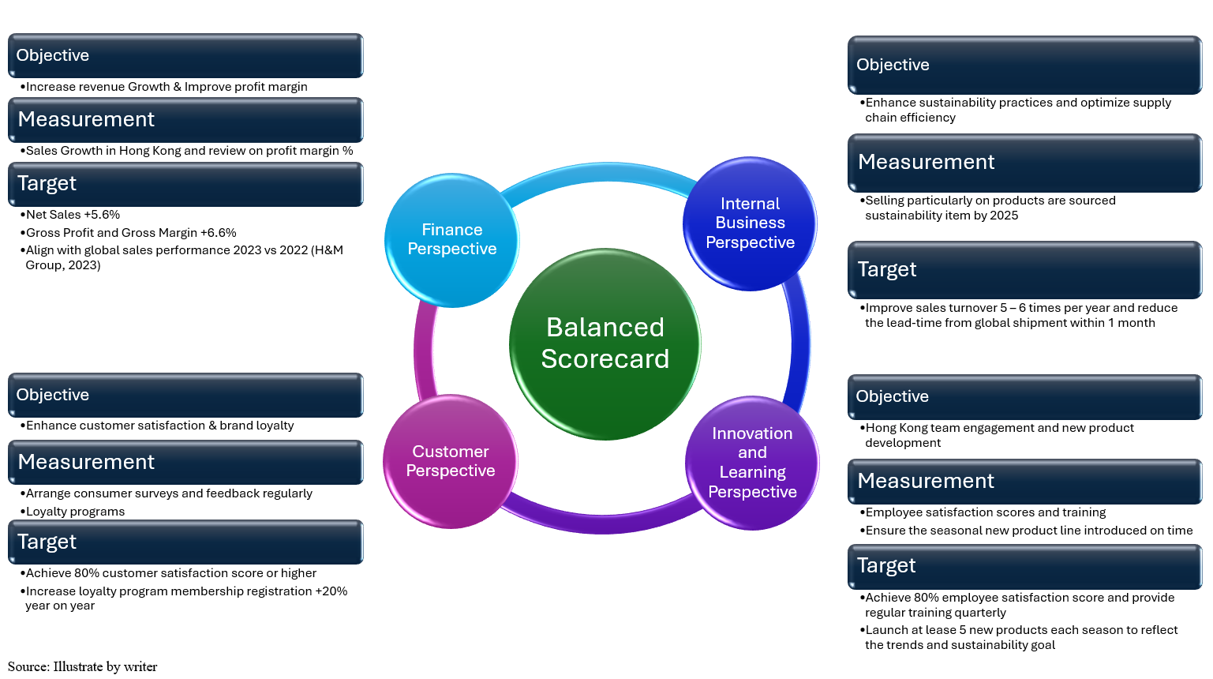
Source: illustrated by writer

Conclusion and Recommendations
H&M has firmly established its presence in the Hong Kong market by expertly leveraging its fast fashion model, dedication to sustainability, and competitive pricing strategies with cost leadership in worldwide. This success stems from H&M’s unique ability to cater to local consumer preferences while preserving a strong global brand identity. Nevertheless, H&M now confronts substantial challenges, including fierce competition from both international and local brands, as well as an increasing consumer demand for sustainable practices as the sustainability awareness is very low in Hong Kong market, the sustainability development facing serious challenge (浸大新報人, 2024). To maintain its competitive edge and achieve continued growth in this ever-evolving market, H&M must enhance its strategic management approach.

Enhance Sustainability Initiatives in Hong Kong Market
H&M has a valuable opportunity to strengthen its sustainability initiatives by significantly increasing the percentage of sustainable materials used in its product offerings. By implementing more ambitious targets, such as striving for 100% sustainable sourcing by 2025, H&M can not only enhance its brand reputation but also attract a growing segment of environmentally conscious consumers who prioritize sustainable fashion choices. Furthermore, establishing collaborations with local non-governmental organizations (NGOs) and sustainability experts in Hong Kong can provide H&M with critical insights and best practices, thereby increasing the credibility of its sustainability efforts. This partnership can also foster community engagement by creating opportunities for local initiatives and supporting environmentally friendly projects. Such actions not only align with global sustainability goals but also position H&M as a leader in the fashion industry committed to making a positive environmental impact (H&M Group, 2023).

Strengthen Local Market Consumer Perception
H&M has a valuable opportunity to strengthen the connection with the Hong Kong market by enhancing the understanding of local consumer preferences. By conducting regular market research and actively engaging with customers through social media and feedback platforms, H&M can gather insights that will inform product development and marketing strategies. This proactive approach will enable the brand to introduce exclusive collections that resonate with Hong Kong consumers. Additionally, collaborating with local designers and influencers can greatly enhance the brand’s relevance and appeal in this unique market (KPMG, 2022).

Invest on People
Investing in employee training and development is vital for enhancing customer service and boosting operational efficiency. H&M must establish comprehensive training programs that prioritize sustainability practices, customer engagement, and in-depth product knowledge. By cultivating a culture of innovation and inclusivity, we can empower our employees to actively support and drive the company's strategic goals (Bain & Company, 2022).

Contingency Plan
In Hong Kong's vibrant and competitive retail landscape, H&M has a valuable opportunity to enhance its resilience and adaptability in the face of potential disruptions. There are some constructive recommendations to strengthen its operations and market position.
Invest in digital and e-commerce capabilities in Hong Kong, H&M can seize the opportunity to invest in robust digital platforms and e-commerce capabilities to ensure seamless online operations during disruptions, develop O2O and omnichannel complete consumer shopping journey. This recommendation includes optimizing website scalability, enhancing cybersecurity measures, and collaborating closely with logistics partners to effectively manage increased online order volumes during peak times or crises (Gallery and Conlon, 2024).

GANTT Chart
Prepared a Gantt chart is an visual tool for effective project management, offering a clear timeline of recommended tasks and activities. By outlining start and end dates, as well as task dependencies, ready for responsible teams to plan, schedule, and monitor progress efficiently. Utilizing a Gantt chart is a smart strategy for achieving project success. Below is a guide on how to create and use a Gantt chart to maximize your project outcomes.

II References


