Student number: 2518183
Word count: 2,902
Module code: ECEY4001

Professional practice portfolio
I confirm that I have not used any AI tools in the research and creation of this assignment. I confirm that I have not presented any AI generated materials as my own work. I confirm I have copies in my drafts, notes, and other resources I used, which I may be asked to provide in evidence.

Part 1

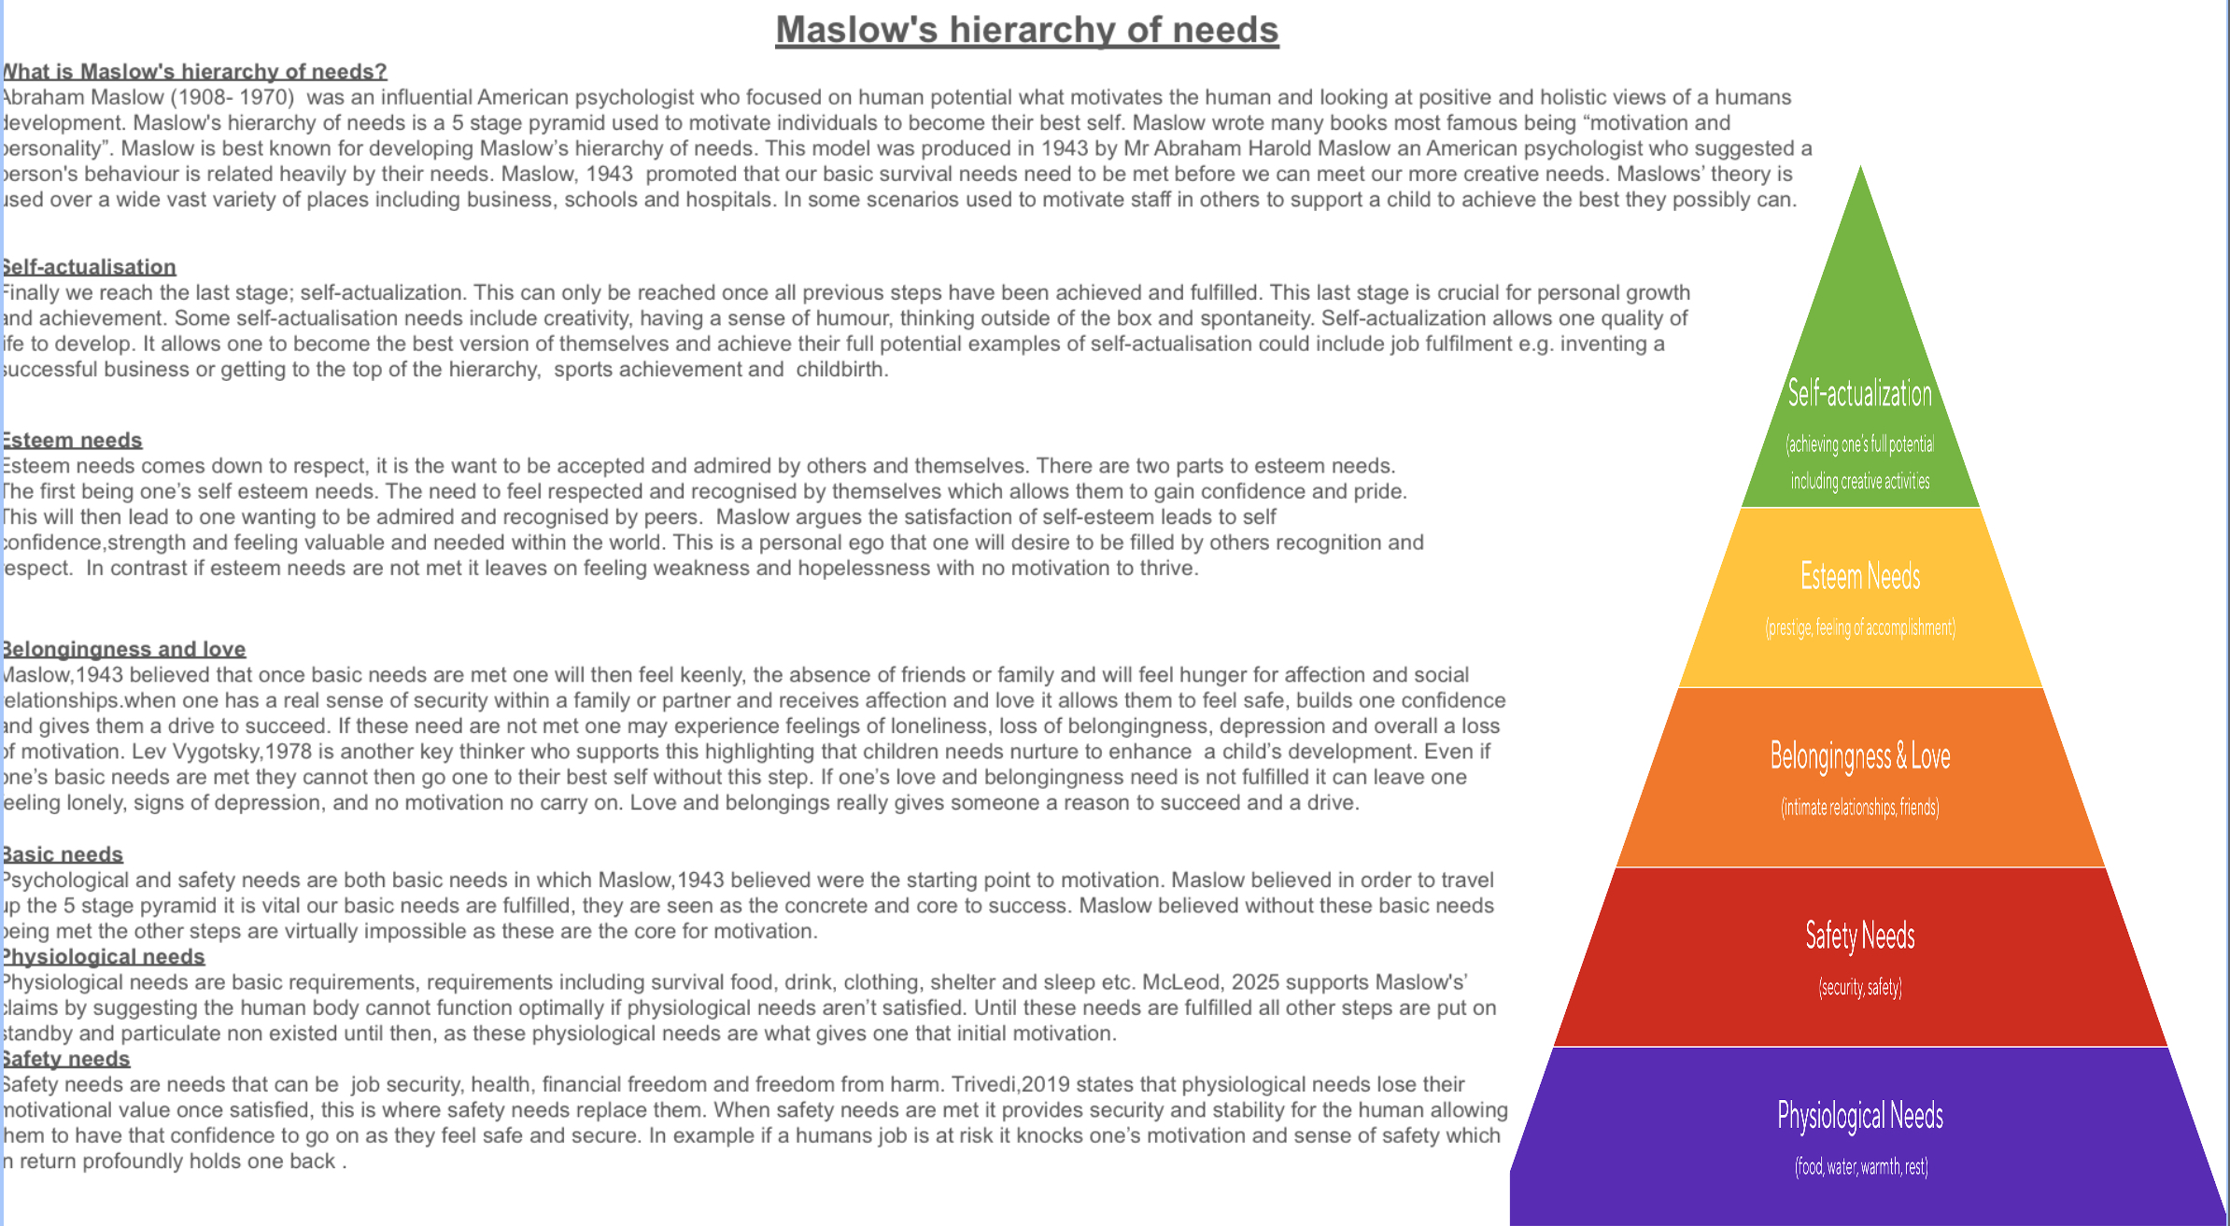
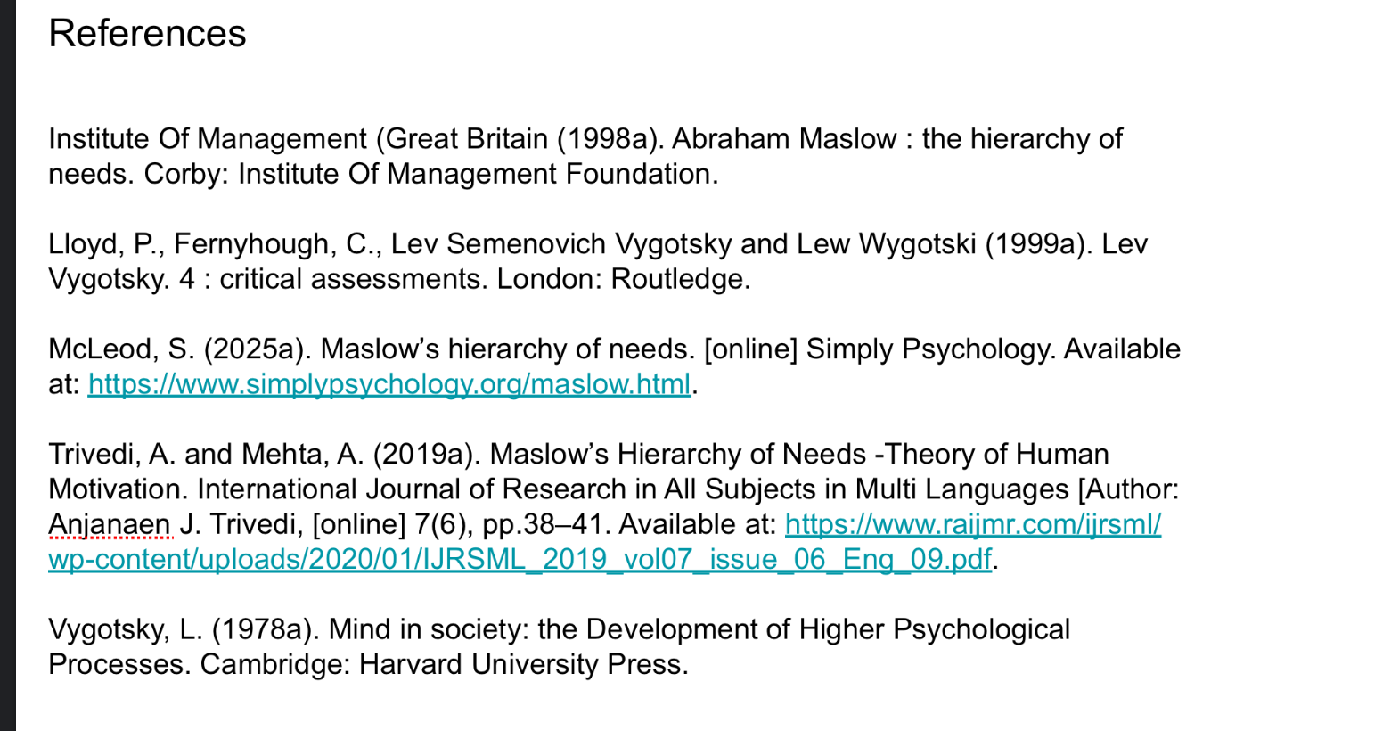

Part 2

Holistic child development
Holistic child development is an approach where a child Is looked at as a whole putting aside their academic development, in turn looking at all different traits that contribute to their development. Not every child early life experience is the same, the holistic approach supports this and ensures that not every child is treated the same. Unicef, 2021 suggests that the quality of a child’s early experiences makes a critical difference as their brains develop, providing either strong or weak foundations for learning, health and behaviour throughout life. It is studying all areas of the child’s growth and understanding, noticing how they are all intertwined and affected by one another. These areas include; physical, emotional, social and cognitive development. In the essay I am going to be looking at this in depth and how Maslow’s theory supports and allows us to understand this. HIGH5, 2024 believe that understanding a child’s top 5 strengths is the key to unlocking their needs. When looking at a child’s development it’s extremely important we firstly understand just how extraordinary a child’s brain is in the early years. The child’s brain rapidly develops between birth and the age of 5. Hoffman,2008 highlights that in the first few years of life, more than 1 million new neural connections are formed every second, far more than an adult. Therefore, with that knowledge and understanding of just how busy, sensitive and complex the child’s brain is and not a typical step by step development, it is crucial we look at a child’s progress with a holistic approach to ensure the best outcome and development for the child. One part of a child’s development is their physical development. This being their health, height, weight and muscle control. This is seen as a basic need in Maslow’s theory as it comes down to the child’s nutrition and basic health. Maslow claimed that the man who is dangerously hungry, no other interests exist but food. This is a fundamental factor to be considered in a child’s development. Wagner, 2024 emphasises that food insecurity is associated with adverse social, emotional and mental health outcomes among children, including symptoms of depression, externalizing and internalizing behaviours, and hyperactivity, as well as psychological distress. This is a factor that can often be overlooked in early years settings. Often being misunderstood for bad behaviours. Vandette,2025 supports this by emphasising how although some children may not be able to verbally communicate every behaviour is a way of communicate and beneath those behaviour are many emotions and feelings. A child whom isn’t having a good nutritious diet experiences many physical symptoms for example anger and weakness. Therefore, asking the child to then produce something that may seem simple for example a piece of work is a mammoth task for the child as their body is in survival mode and far from ready to learn.This brings me on to a child’s emotional development. This is a child’s feelings and understandings. During the early stages of a child’s life a child will experience new and big emotions and feeling, most of which they will not know how to comprehend or manage. This affects a child’s overall wellbeing in result affecting their development. Maslow allows us to understand this by explaining that a human needs emotional security to feel confident enough to be motivated to develop onwards. Bowbly,1969 proposed that humans have a natural need to form strong emotional bonds with caregivers. This is known as secure attachment; which Maslow highlighted. When this need is not met children may find it difficult to regulate their emotions; in which can affect many different aspects of their development. Another development trait is a child’s social development where they build relationships, learn how to play, gain independence and learn social rules. Maslow model gives us insight to the importance of this as he highlights the importance of feeling loved and having a sense of belonging. If a child’s social development is tainted it can lower their self-esteem, confidence and may doubt their abilities. A child’s social development could be a struggle for many reasons including additional needs to a child’s home environment. sundram,2020 asserts that social development can impact everything from learning new words as a toddler as being able to resist peer pressure as a high school student, to successfully navigating the challenges of adulthood. Finally, another development trait to look at is their cognitive development; the ability to problem solve, ones thinking and reasoning, attention, concluding and perception. This trait is developed by a mixture of social, biological and psychological factors. Maslow explains the importance of cognitive development through his self-esteem stage. When one has the ability to learn and accomplish new things it promotes confidence and motivation. Piaget,1980 claimed that children should be encouraged to explore and experience the world around them to achieve good cognitive development. This could be a limiting factor for some children who do not get that opportunity, again highlighting that not all children’s development is the same. After looking at the different areas of a child’s development, it is prominent how important it is to look at the whole child and really looking at the bigger picture. A child’s development is so complex and they may not be able to communicate or understand what they are experiencing. This is why it is the care practioner duty of care to use the holistic approach to try and unpick and find what may be going on; whether that’s observing the child’s, working with the families or looking at the wider picture as doing so is what supports the child’s development the most. Maslow’s theory lets us understand the holistic approach deeply. He emphasises that reaching a human full potential impossible without meeting a human’s basic needs first. Just like a child’s development.

Part 3

Scenario 1
A Child was coming into school every day not ready to learn, developing behavioural problems and was becoming a cause for concern. This particular morning he was particularly upset. I took the child for a walk and a chat to try and regulate the child. I asked whether the child had eaten some breakfast. The child shook his head. Upon further investigation it was found the child’s home life was very unstable and love and nurture wasn’t something that was familiar to the child, aswell as good nutrition. I gave the child some toast and water and sat with him as he regulated and ate. Slowly the child became more relaxed and engaging in conversation. Within an hour he was a different child. The child was more present alert and motivated to learn. His temperament took a complete switch, he spoke calmly and began to express his feelings and thoughts. I found the child was beginning to trust me more and more and began to form a bond; it was clear the child was beginning to feel safe around me. This is a clear example just how important Maslow’s theory is. Almost all of the child’s basic needs were not being met at home. Physiological, safety, love and belonging needs were foreign to him. The child was in a constant state of panic. Maslow,1994 expressed that children seem to thrive better with a routine of such, something that can be counted upon and that the central role of parents and guardian’s setup are indisputable; something that unfortunately the child had never experienced. With a central role of parents not be stable to the child it meant the child wasn’t familiar to social interaction. In which is highlighted by Maslow in his love and belongingness stage, encouraging good relationships and interaction ensuring someone feels safe and in return giving them motivation. Vgotsky,1978 further supports this by asserting that children need social interaction to thrive in education.

Scenario 2
unfamiliar faces, big scary classrooms and a whole day without mum or dad; the first week of reception “big school” through the eyes of a 4 year old. As a new term rolled around I was ready for the all predicted tears. This year was the year following our lockdown. Many of our pupils had spent the first 4 years with their parents not a day apart for some, and most had skipped nursery through lockdown measurements and this was their first time attending school completely. As the weeks rolled by it quickly came to my attention that the all expected tears were not settling or getting any better; in which they usually did in previous years. Work was virtually impossible and any attempt of entertaining the children or distracting the children through play was useless. Using Maslow’s theory, it was clear to see that the children’s safety and belongingness needs were not being met. Although their basic needs had been met at home their safety needs now felt compromised therefore they could not go on and thrive in their education. Maslow’s theory emphasises that everything looks less important to a human when their safety is compromised which helps us understand why the children would not participate in any activities. I knew we now had the task of ensuring their safety needs were met. Although it was clear to us adults they were safe and in loving hands we now had to look through the lens of a 4 year old. We had to understand how much their routines and little worlds had been changed and turned upside down. EYSEND,2024 states that young children struggle to understand how long 5 minutes or an hour actually is therefore a visual timeline supports the child with understanding what is coming next. I then had the idea of a virtual timeline as trying to talk and explain the day to the children verbally wasn’t visible as they were not regulated. Using the virtual timeline, we used fun pictures of how our day was going to look. Over time the timeline worked. The children became visually less stressed as they could see what they were doing next and could then begin to trust and build bonds with us staff. Slowly their safety needs were being met more and more each day. With this being fulfilled we then could move on to working with the children and learning new things. This was only now possible as their safety needs had been met and had the motivation to learn.

Scenario 3
A little girl in my class was a bright and hardworking child. Over time I started to notice that she isn’t participating in activities as much, she’s stopped putting her hand up and is losing motivation. Through observation I realise that even though her basic needs are being met. Her self-esteem needs aren’t being supported. She doesn’t feel confident or worthy therefore is giving up as she is not motivated. I realised us as teachers weren’t encouraging, challenging and supporting her enough. Being in a busy school with behaviour being a significant issue and day to day school life being hectic, Unfortunately, it is easy for the child whom has all her safety, love and belongingness needs met and is bright and achieving above average to not be monitored as much and slip through the net. To ensure her self-esteem needs were being met I started putting more challenges in place for her as Maslow,2024 allows us to understand that sense of achievement through challenges brings satisfaction of self-esteem, satisfaction of self-esteem then leads to confidence, strength and self-worth, motivating one to achieve their best.

References
Bowlby, J. (1969). Attachment and Loss: Attachment.
HIGH5 Content & Review Team (2024a). What is Maslow’s Hierarchy of Needs? Explained In-Depth. [online] HIGH5 Strengths Test. Available at: https://high5test.com/what-is-maslows-hierarchy-of-needs/.
HIGH5 Content & Review Team (2024b). What is Maslow’s Hierarchy of Needs? Explained In-Depth. [online] HIGH5 Strengths Test. Available at: https://high5test.com/what-is-maslows-hierarchy-of-needs/.
Hoffman, M.T. (2008). The Science of Early Childhood Development: Closing the Gap between What We Know and What We Do. Journal of Developmental & Behavioral Pediatrics, [online] 29(4), p.261. doi:https://doi.org/10.1097/dbp.0b013e3181833804.
Maslow, A.H. (2021). Maslow on management. New York: John Wiley.
Piaget, J. (1926). Language and thought of the child. Routledge.
Sundram, Dr.S. (2020). Social development in children: An analysis. International Journal of Advanced Academic Studies, [online] 2(4), pp.82–84. doi:https://doi.org/10.33545/27068919.2020.v2.i4b.334.
UNICEF Vision for Every Child. (2023). Available at: https://www.unicef.org/media/145336/file/Early_Childhood_Development_-_UNICEF_Vision_for_Every_Child.pdf.
vandette.c, dr marie-pier (n.d.). Understanding children’s emotions. [online] Available at: https://theirworldisus.ca/wp-content/uploads/Full_PDF_EN.pdf [Accessed 30 Nov. 2025].
Wagner, H. (2024). Impact of Nutrition and Food Insecurity on Child Health Health and Policy Context. [online] Available at: https://www.nemours.org/content/dam/nemours/shared/collateral/policy-briefs/impact-of-nutrition-and-food-insecurity-on-child-health-brief.pdf.

