

BSc (Hons) Professional Police Practice

(SOUTH WALES POLICE, GWENT POLICE AND UWTSD)

Learner name: ______Luke Evans______

Learner’s University Registration Number:
________1920625_____________________

FACULTY OF BUSINESS AND MANAGEMENT
PUBLIC SERVICE PROGRAMME

Module title: Professional Police Practice 3 (PCDA) BMP

Serving officers perspective on the current Pursuit Policy in England and Wales.

Acknowledgements
Firstly, I would like to thank my dissertation supervisor Michelle Hill who kept in touch throughout to remind of deadlines, give advice and motive me to conduct research. It also helped inspire me to believe I am capable of completing the project. Secondly, I would like to thank friends and work colleagues who have inspired me to do research, supported me and given me knowledge required to complete certain tasks and advice on the dissertations. Lastly, I would like to thank my family who have provided me with support and motivation throughout my research project and specifically within the last few months of my time studying which have proved to be the most difficult to adapt to whilst working a shift pattern.

- Declaration - This work has not previously been accepted in substance for any degree and is not being concurrently submitted in candidature for any degree.
Signed: L. Evans Date: 02/01/2023

- Statement 1 - This dissertation is being submitted in partial fulfilment of the requirements for the degree of BSc.
Signed: L. Evans Date: 02/01/2023

- Statement 2 - This dissertation is the result of my own independent work/investigation, except where otherwise stated. Other sources are acknowledged by footnotes giving explicit references. A bibliography is appended.
Signed: L. Evans Date: 02/01/2023

- Statement 3 - I hereby give consent for my dissertation, if accepted, to be available for photocopying and for interlibrary loan, and for the title and summary to be made available to outside organisations.

Signed: L. Evans Date: 02/01/2023

- Statement 4 - I hereby give consent for my dissertation, if accepted, to be available on the university’s IT system to those who have consent to use the system.
Signed: L. Evans Date: 02/01/2023

Abstract:

The overall findings of this study have shown that it is time to review the pursuit policy within South Wales Police and other forces throughout the UK. Many officers’ opinions supportively reflect this. This outcome was established through statistics, case studies, research and other literature that was reviewed when conducting the study to assist in accomplishing the aims and objectives of the project.
The results and findings section of the project allowed for the research to involve current officers’ opinions and wishes on the topics, aims and objectives, which contained a range of different responses to be studied. The majority of these indicated that most officers feel the current policy is letting them down. Overall, the researcher feels that the aims and objectives were met throughout the project and analysed efficiently.

Table of contents
- Acknowledgements
- Chapter 1 – Introduction
1.1Introduction
  - Background
  - Research focus
  - Aim and objectives

- Chapter 2 – Literature Review
2.1 What is a police pursuit?
2.2 Why are pursuits effective
2.3 The Effects of pursuits on officer’s ability to conduct their work
2.4 When pursuits go wrong
  - Summary

- Chapter 3 – Methodology
  - Introduction
  - Research Tools
  - Ethical Practice
  - Research Methods

- Chapter 4 – Findings and analysis
4.1 Introduction
4.2 Participant information
  - Participant Views

- Chapter 5 – Conclusion and recommendations
  - Introduction
  - Main Findings
  - Recommendations
  - Limitations
  - Future Research
  - Conclusion

- References

- Appendices

Chapter 1 – Introduction
1.1
The aim of this dissertation is to explore the current policing pursuit policy and if it is becoming outdated. This chapter will therefore provide an insight into the following;
- How roads policing unit is being run.
- An overview of the dissertations research focus and why the topic was chosen.
- An overview of the research aims and objectives.

1.2 Background
Policing the roads of the UK is heavily reliant on the road policing unit. As other departments are stretched and have other responsibilities, it is key that the road’s policing unit is proactive and available to attend when needed. So why are they being cut and why is roads policing being left out of many policing manifestos? (HMICFRS 2019)

According to research, the number of officers attached to the road policing unit within England and Wales has dropped by 15% since 2016. In effect, this has seen a fall of approximately 757 officers patrolling the roads and dealing specifically with road related incidents and crimes. It suggests that it has affected road related deaths, as they were falling between 2010 and 2016. However, it has now remained stable and in some instances increased. Furthermore, in a 10-year time span between 2007-2008 and between 2017-2018, there was a 64% increase in death or serious injury through unlawful driving (BBC). To the researcher this shows a clear coloration between the increase in road related deaths and crimes, and the decrease in roads policing officers.

It also asks the question of what can be done in order to change that. If there is no funding for roads policing units then other methods need to be considered and experimented to be able to tackle serious road related crimes efficiently. More training and skills need to be offered and provided to response policing officers to be able to catch and convict the more serious criminals using the roads. Skills such as pursuing can play a key role in this, as criminals have become smart in knowing which officers and vehicles can pursue them and which vehicles cannot.

It has also been in the public domain recently. BBC Panorama have broadcasted a document on the roads policing unit. It highlights the issue of cutting roads policing officers. It is believed by the researcher that this is a big issue for the public perception of policing and without further research and solutions the statistics could get worse.

This topic was chosen due to roads policing being largely neglected throughout the UK police forces. The researcher has vast interest in roads policing and believes it to play a key role in disrupting large, organised crime groups, whilst also saving lives of avoidable road traffic collisions. The researcher is also able to access a lot of history within the Roads policing unit. A family member was a roads policing officer for over 15 years and has many connections within the unit that could assist in the research and give opinions where appropriate.

1.2 Research focus
The objective of the research is to see why roads policing is being widely neglected and how we can use other methods to stop road related crime.
Part of this topic, being the cuts of Roads policing officers was covered in a documentary by BBC panorama recently. This suggests that the topic is in the public eye and the issues do exist. The research around pursing is very disputed and widely discussed. This will allow the researcher to get several points of view and widen the research to discuss the positives and negatives around police pursuing.

There is believed to be many statistics in relation to road related crimes and deaths, which can be of used in this study. This can be accessed in many ways, such as the college of policing for national statistics and then more specifically through local forces for more targeted areas.

It is intended that both methods of quantitative and qualitative research are used in the study to avoid any bias and gain access to a wider range and balanced views. The researcher hopes to include a survey or questionnaire which will be sent to officers of South Wales Police to gain a general consensus. This is with a view of obtaining their views on the topic and what we can do going forward to make it more efficient. However, care will be taken when reviewing questionnaires as it is purely based on the information that the person has and how they are feeling at the time. The researcher will also have access to a wide range of research through colleagues and officers. These officers will have a wide range of experiences with policing and in which the study hopes to find the opinions of some to have access to such information.

1.4 Aims and objectives
The overall aim of this study is to explore if the current pursuit policies in England and Wales are working, or if officers’ abilities are being restricted and if they believe it is affecting road related crimes. To achieve this, the research study will have the following objectives:

- Explore the current pursuit policies in England and Wales
- Evaluate if current pursuit policies are having an impact on an officer ability to carry out their role and if they believe it increases road related crimes.
- Evaluate serving officers personal opinions on current pursuit policies and if they believe it has an impact on public perception.
- Chapter 2 – Literature Review

2.1 What is a police pursuit?
A police pursuit is when a driver or motorcyclist indicates by their actions or continuance of their manor of driving that they have no intention of stopping for police and the driver of the police vehicle believes that the driver of the subject vehicle is aware that they have required them to stop.
There are two stages to a pursuit. The first is the initial phase. This period is spontaneous and is before the tactical resolution phase can be considered or actioned. Only pursuit trained police officers are able to participate in this stage and they must be in suitable authorised vehicles. Information is then relayed to staff within the control room who authorise whether the pursuit can continue or must stand down. They then assess the risk and consider tactical options (College of Policing 2013).

The next stage is the tactical phase. This stage of the pursuit is where appropriate resolution tactics are available and considered. Again, the tactical phase must be conducted by a tactically trained advanced driver in an authorised vehicle. A pursuit commander is identified within the control room to assess the risk and authorise the tactical options. In this phase the main aim is to bring the pursuit to a conclusion with the commander directing which tactical options to use.

Officers should seek authorisation for the pursuit as soon as practically possible from control room staff. In some instances, officers can self-authorise a pursuit due to the time between recognising the need to take action may be too short to acquire authorisation from the control. For example, in instances where a cars manor of driving immodestly changes on sighting a police vehicle. This decision would need to be justified at a later time in line with the NDM. When non-pursuit trained officers request a vehicle to stop, and it becomes evident that a vehicle is refusing to stop the officers must discontinue immediately (Met Police 2020).

Every country has different pursuit polices and skilled drivers. Within the UK, each force also has different policies for their officers. In South Wales Police, you are not allowed to pursue unless you are an authorised trained driver and driving an authorised vehicle. There is very little of these within each UK force and most of these trained officers will be attached to the road policing department within that force. In South Wales Police the roads policing department will have only 100 vacancies for officers. With shifts, that will leave only 20% of them on at a time with around a maximum of 20 officers deployable. With how large the area of South Wales is, and the volume of calls they receive, it’s very difficult for these officers to get into the right place at the right time. Furthermore, there are many occasions where a divisional officer, who is not in an authorised vehicle or trained to purse will get behind a suspect vehicle. They would then be told to stand down by the control room and allow that vehicle to escape, without knowing who was driving or what offences they may have committed.

2.2 Why are pursuits effective
Every scenario and pursuit are going to be different. Therefore, it is difficult to answer this question as the only way you can see how effective it is, is by seeing the result. With a pursuit comes many risks to officers, suspects and the general public. Many pursuits will be conducted at high and dangerous speeds with the suspects manor of driving usually putting themselves and other road users at risk of colliding causing serious injury. There is also the potential of them colliding with walkers, cyclists and animals. On conducting a pursuit there are many factors in which you must take into consideration. For example, choosing whether to continue with it or if the risk outweighs the potential results. Some of these include the seriousness of any known offence committed, whether there are vulnerable people in the vehicle, type of vehicle being used, availability of tactical options and the road and whether conditions (Home Office 2018).

Due to these risks, officers have certain policies and procedures. An example of this is if an offender who is making off goes around a roundabout the wrong way. An officer driving a police vehicle must not follow the suspects’ vehicle in going the wrong way and must go the right way, hoping to catch the direction that the offender went in. This is to minimise the risk to both officer and public. This is also why a pursuit commander is set to take charge within the control room. Normally, this is usually a senior or higher-ranking officer within the control room who risk assesses it along with the highly trained officers conducting it on the ground. If the risk outweighs the potential result, the senior member of staff will stand the pursuit down no longer allowing it to continue, and in retrospect letting that offender go, who officers may or may not know carrying unknown potential evidence.

2.3 The Effects of pursuits on officer’s ability to conduct their work
Not all police officers can pursue. The level of training you receive is based on your ability to pursue. Standard, response, advanced and pursuit trained are the 4 levels required in order to be able to be trained to pursue a vehicle. Regular officers will start on Standard, after 2 years’ service can become response trained, which allows you to respond to emergencies on blue lights with sirens. Advanced then upskills you again, allowing you to drive more high-powered vehicles at higher speeds. Finally, you can become pursuit trained. This will allow for the officer to become involved in a pursuit and become engaged in tactical options in order to bring the subject vehicle to a controlled and hopefully safe stop (NPCC 2018).

The difficulty comes when an officer is not pursuit trained, may have a vehicle in sight that due to its manor of driving is clearly not going to stop. If that officer does not have the required training or the required vehicle, illuminates their lights and as expected the vehicle does not stop, said officer under the current policy is required to come to a stop, and pass observations for the subject vehicle over the airwave to notify other officers. That officer is unable to follow the subject vehicle for any duration of time, without any consideration for the time of day, weather or congestion (College of Policing 2020).

If that subject vehicle has no plates on it, or the registered owner has told the DVLA it is no longer the keeper, and it is without insurance, the officer involved is extremely unlikely to ever know who the subject driver is and furthermore will be unable to prosecute, leaving them to do the same on a different day. It is now believed that organised crime gangs have become aware of these polices and that the majority of officers are unable to pursue unless they have the required training. They are aware of the vehicles and officers that are unable to conduct pursuits and are implementing them in their strategy to commit crime (GOV. 2018).

2.4 When pursuits go wrong
Subsequently, police pursuits do have the tendency to go wrong. Most of the time they are conducted at high speed and include dangerous and unpredictable driving from the subject vehicle. Sometimes, suspects have not got a licence or have the minimal training in driving. This can lead to all types of dangers to public, themselves and officers. Police often come under scrutiny when these pursuits do go wrong which is why they have to be risk assessed at every moment. This scrutiny is hugely down to the fact that when they do go wrong a person is either seriously injured or has died. In the early 2000s it was found that only 5% of fatal collisions involved “someone the public would regard as a serious criminal”. The media is the biggest culprit of this, when a person has an accident, the police are always in the firing line. According to figures taken by the IOPC (Independent office of police complaints) in 2013 there were at least 93 people who died from chases in England and Wales (Tom Lamont 2019). More recently IOPCs latest statistics show that 20 fatal police-related traffic incidents in England and Wales in 2020/21, 25 people died, which represents an increase from previous years.

The IOPC (Independent office of police complaints) does play a key part in the investigations of police pursuits, and it is one of the reasons it exists. The IPOC is independent of the police and is there to investigate any wrongdoing by the police and any complaints made by the public. If pursuits were to go wrong, then the force should refer itself to the officer and offer help in the investigation. This would include statements being taken from the officers, dash cam footage watched, and CCTV footage viewed. The IOPC will then decide if there is any criminality involved from a policing perspective and if it needs to be put to the CPS.

These pursuit related deaths create a lot of questions for the public, which the majority will ask was it worth it? People will interpret this differently, as it depends on the outcome of the pursuit and the suspects. Not every case is there a murder, rapist or terrorist making off from the police. Much of the time it’s a known nominal evading the police, due to crime such as traffic offences or drug related. It is asked why officers don’t stop the pursuit, get the registration and investigate the offences slow time and another day. This is believed to reduce the likely hood of risk to all parties involved. “Terrorism, violent crime, I understand – you pursue. I don’t say never, never pursue. I just say it has to be proportionate” (Andrew Clovis 2019).

An example of when things go wrong was in 2013. A wanted male was making off from police traffic officers. A young family had been involved in an accident up ahead when the wanted male had collided with the family, killing the 13-year-old daughter. It was later said that the male police were pursing that day, was a wanted male but not wanted for rape, murder or a terrorist. Which would lead some to ask if the police did not get him nor would they ever.

2.5 Summary
This literature review has so far highlighted some of the important points involved with police pursuits, and how the dangerous around it is scrutinised. It is clear that police pursuits are dangerous and can result in serious injury. However, the difficulties come when you must establish what is proportionate. It would be beneficial to conduct comparative research into how useful police pursuits can be and how it effects an officer’s ability to do their job.

Chapter 3 – Methodology
3.1 Introduction
To make this a successful research study, it is important for the researcher to adapt the most appropriate methodology. It is also imperative that the researcher abides by and meet ethical standards throughout. This will ensure that any research that is carried out is done so with the utmost integrity and honesty. Furthermore, by choosing a suitable research method, it can aid in making an unbiased study, which will in turn reduce the likeliness of researcher bias.

3.2 Research Tools
Due to the nature of the topic chosen, the research will use a range of methods to approach both qualitative and quantitative research. This will be in the form of an online questionnaire. This will allow for further depth of knowledge to be gained, and in hope enhance the participants confidence in the studies (SCHOONEN and JOHNSON 2017). An online questionnaire will consist of multiple-choice questions, along with gathering data from responding individuals. This method of not being face to face with the researcher can give the participating individual a choice to remain anonymous. Furthermore, this can help to allow participants to feel like they can answer honestly, freely and to not give in to social bias. However, it is important to note that it is almost impossible to eradicate all possibilities of research bias, as the research is unique to that person. This method of research will also include additional comment space. This will also allow the participant a free space to express their thoughts and comments as they please. This can benefit participants by giving them the freedom and opportunity to provide their own thoughts and opinions, where they may have been unable to in the questionnaire. This can also give the researcher the opportunity to address issues and topics they may have missed.

3.3 Ethical Practice
In order to ensure that ethical standards are met within this study, an ethics consent form will be included. The consent form will highlight what will be required of the participants, how the study will be conducted, how confidentiality will be held and how their information is stored. In regard to the study, an ethics form was also completed by the researcher and was granted. To ensure answers from participant’s remains confidential, the data that is collected from them is stored on password protected devices, ensuring it meets high ethical standards.

To give the participant’s confidence in the study, they will be told that their data will remain confidential, will be protectively stored during the study and destroyed after completion. The participants will also be given the right to withdraw from the study at any time. During the study, it is key that the researcher makes every effort to ensure the views of participants are respected and recorded accurately. It is important to note that at the start of the study, participants will be told that they are free to give scrutiny of the topic in their answers and not just positive ones. Before the study is conducted, these points will be included in the disclaimer, and will be required to be read by participants before taking part.

3.4 Research Methods
I have chosen to include a quantitative research approach as it will allow me to transfer the participant’s responses into numerical data. This will make analysing the findings a lot easier, as if it is a large sample, it will be stored better leaving less room for error. Convenience sampling will be the sample choice of this study. It has low cost, is efficient and simple to implement. However, the main disadvantage of this choice of sample method is that it cannot be generalised to the wider population or the population as a whole. It is a widely used sampling method as it involves selecting a sample of participants from the population readily available to the researcher. Even though it is not being used, random sampling would have also been beneficial as it gives each individual an equal probability of being chosen. The use of random sampling can help ensure the research is as representative as possible, in turn allowing to create a more reliable conclusion (Stevens 2022). However, it is argued that a quantitative approach may be regarded as a restricted approach in obtaining participants views and lack any context. Leading onto why the research is also going to involve qualitative data. This will allow participants to express their thoughts and feelings which is key to an emotive study. Additional space will be provided in some questions to allow for the contributors to add qualitative data (Alisson 2019).

If only quantitative data was used, the participant’s actual views and opinions may not be shared as it would be forcing them to only select from predetermined responses made by the research. Imposing them to do this may not accurately describe the views on the responder (MOZYRKO 2012). However, this does make it harder for the researcher to analyse the data and will also be more time consuming. It could also be hard to accept or process the data as it may not be relevant to the study or could have a negative impact on it (Gaille 2017). Because participants may want to remain anonymous, this can bring issues to the researcher by restricting them from being able to ask any follow up questions to the participant.

An online questionnaire was chosen by the researcher for the study as it will consist of many benefits. It will also allow the researcher to ask certain questions in order to assist with the study and reach the target aims and objectives, which allows the researcher to abstract specific information from the participant. They also provide masses of data from different sources in relatively short amount of time with no cost. This can also assist in time keeping and it will eradicate any irrelevant information or information that is not necessary to the study. To answer the questions posed in the questionnaire and gain an understanding from an officer’s perspective, only officers will be required to participate and give an opinion.
The researcher also hopes to be able to briefly interview officers who have been involved in pursuits. The researcher can also interview officers who have not been involved in pursuits, to allow for an even wider range of views, in hope to develop and assist in asking more questions. This would also have allowed for more in depth and informative questions whilst gaining more information. Time will be the main issue here, as the resources and availability of officers to participate in the interview is very limited.

Chapter 4 – Findings and analysis

4.1 Introduction
The purpose of this chapter will be to analyse and review the results that were received from the survey/questionnaire. The survey was completed by members of the South Wales Police in order to assist the policing project. This study was created in order to gather an insight into police officers’ perception of pursuits and how it affects their job. It will also see if expert’s opinions are supported by the statistics. Including in the questionnaire, where a range of different questions were designed to assist the researcher with the aims and objectives of the study. Closed and open questions were used by the researcher in order to gain the best results. Open questions were used for participants to be able to give their personal views and opinions. The participants were also requested to clarify the answer they had given to the closed questions in more detail to help the researcher with the study.

4.2 Participant information
The study consisted of 40 participants, who voluntarily replied to the 12 relevant questions in the survey. Participants also wanted to take part in the study to provide and share their own personal opinions and knowledge. There was a variety of ages who participated; however, all were currently serving or retired police officers. In relation to age ranges, there were 18 participants between the ages of 18-25, 13 participants between the ages of 26-35, 7 between the ages of 36-55 and 2 participant 56+. This is a good response to the survey as it allows the researcher to gather the opinions of different age ranges that are serving police officers. This section will allow the researcher to analyse the questions in the questionnaire and discuss the results of the answers from the participants.

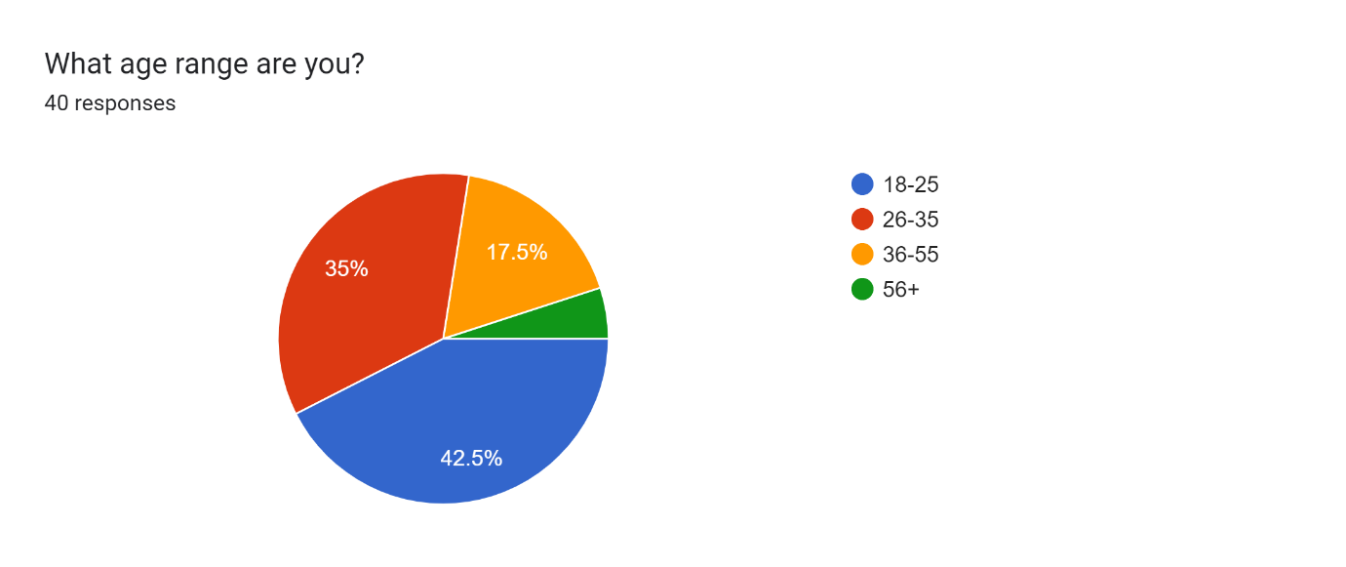
Results of Q1:

4.3 Participant Views
Questions 2, 3 and 4
Question 2 started with asking participants if their role in South Wales Police was. There was a different number of responses, with many respondents answering that they were attached to response currently. There were 15 participants who were from the roads policing department. This was beneficial for the study as these officers were more educated when it comes to pursuits. This was key for the researcher as they wanted police officers’ opinions and knowledge on the topic. Question 3 then asked do you know what a pursuit is? All 40 participants replied yes to this question. This again, is key for the researcher as the study is based around the topic of pursuit. As all participants knew what a pursuit is, they could discuss the matter further and allow a better insight into the topic to give their opinion. Question 4 was then an open question which asked their interpretation of a pursuit. Most answers were very similar which included definitions such as “A vehicle who is aware of the presence of a police vehicle, and has been requested to stop, but by his manor of driving indicates that he will not stop and continues to drive dangerously”. This is much like the definition from the college of policing in that a driver is deemed to be in a pursuit when a driver indicates by their actions or continuance of their manner of driving that they have no intention of stopping for police and the police driver believes that the driver of the subject vehicle is aware of the request to stop and decides to continue the subject vehicle with a view to either report its progression or stopping it. This shows a good understanding from participants of what a pursuit is and that it will contribute better to the overall study (College of policing 2019).

Results of Q2:
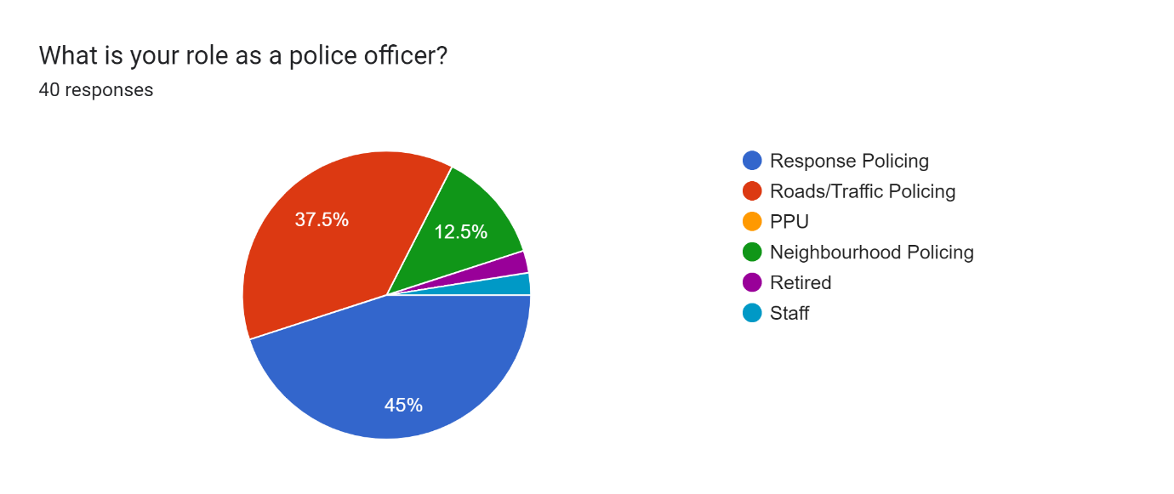

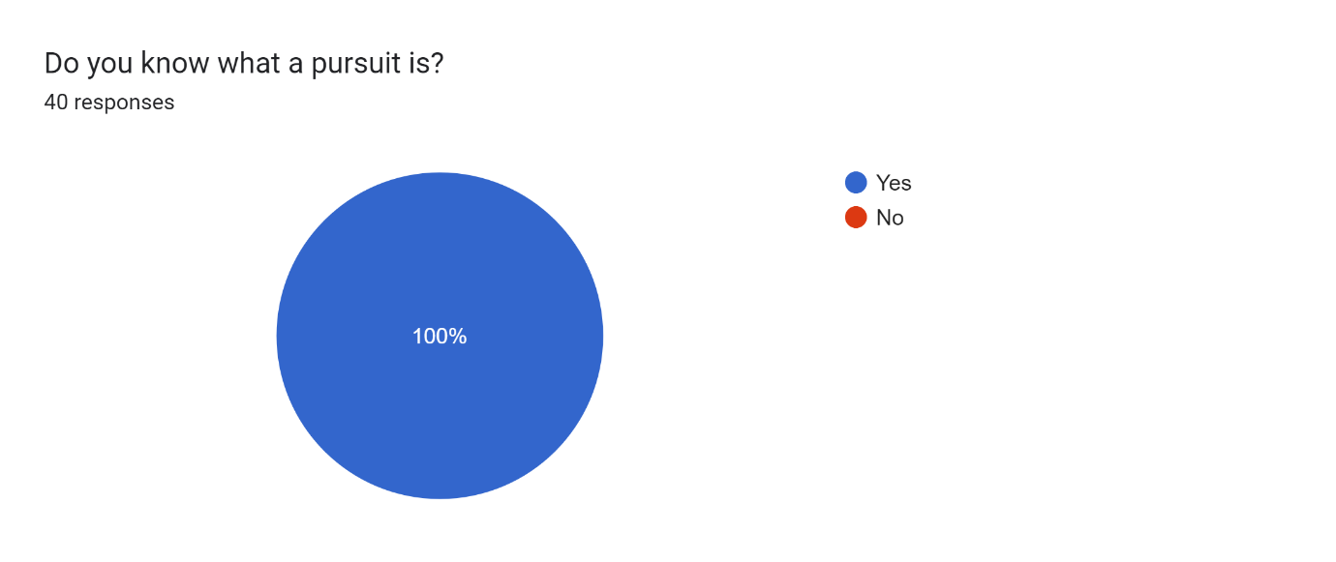
Results of Q3:
Question 5 and 6
Questions 5 and 6 were an important part of the study as it asked participants if they were pursuit trained and if yes, for how long? This allowed the researcher to have a better understanding of the participant and their role as a police constable. This could also assist in understanding some of the opinions to the questionnaire. As you are now able to differentiate between what department each participant are on, and able to see the understanding and opinions of pursuits of that department. The response to question 2 was that 15 participants were attached to the road policing department, which meant that 25 others were not specially trained traffic officers. The researcher would have expected these results as the research was based on pursuits and the survey was answered by both traffic and response officers. They would assume that traffic officers would have a keen interest in pursuits and more likely to participate. It does help the researcher meet one of the objectives, as a number of officers are pursuit trained, so would have a good understanding of pursuits. Question 5 had a response that 14 officers were pursuit trained and had been able to learn the skill through their job role. This allowed the researcher to understand that the probable outcome was that 1 roads policing officer had not yet been trained but 15 others had the experience. It also clearly showed the researcher that only roads policing officers could be pursuit trained as no other officers replied.

Results of Q5:
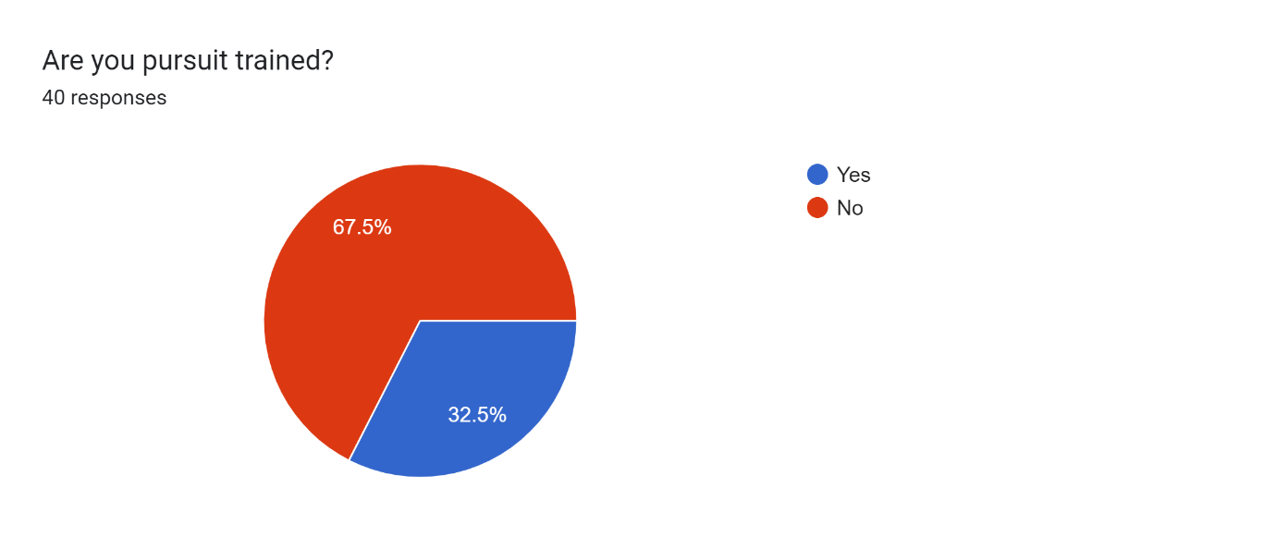

Question 6 had the same number of replies as question 5 as expected. It asked participants how long they have been pursuit trained. Only 15 participants replied to the question as only 15 were pursuit trained. This question received a variety of results and ranges of experience. Some officers had been pursuit trained for over 12 years where other had only been trained for 2 months. This is key in the study as it shows a variety of experience responding to the questionnaire allowing for a range of knowledge to be included. There was a range from 2 months to 12 years of experience, with the average for this being around 4 years. This allowed the researcher to gather the opinions from officers who had been involved in only a little number of pursuits and those who had been involved in over 12 years.

Results of Q6:
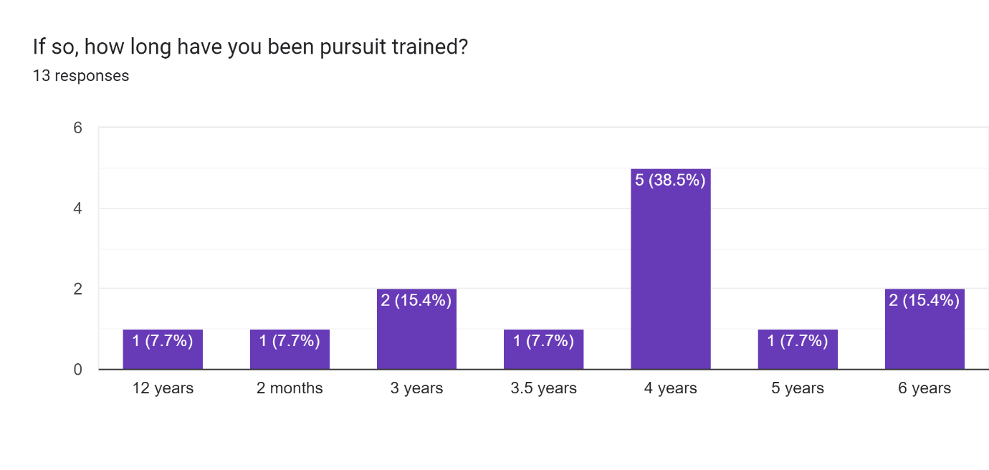

Question 7, 8 and 9
Question 7 then went onto ask had the person been involved in a pursuit as passenger or a driver. All participants were able to answer this question as constables could have been involved in a traffic attachment or gain an experience of a pursuit another way. This gained a good response of 21 officers answering with that they were the driver at the time of the pursuit, whilst 5 replied that they were the passenger and 14 replied that they had not been involved in a full pursuit. This suggests that many of the officers responding would not have had the training required.

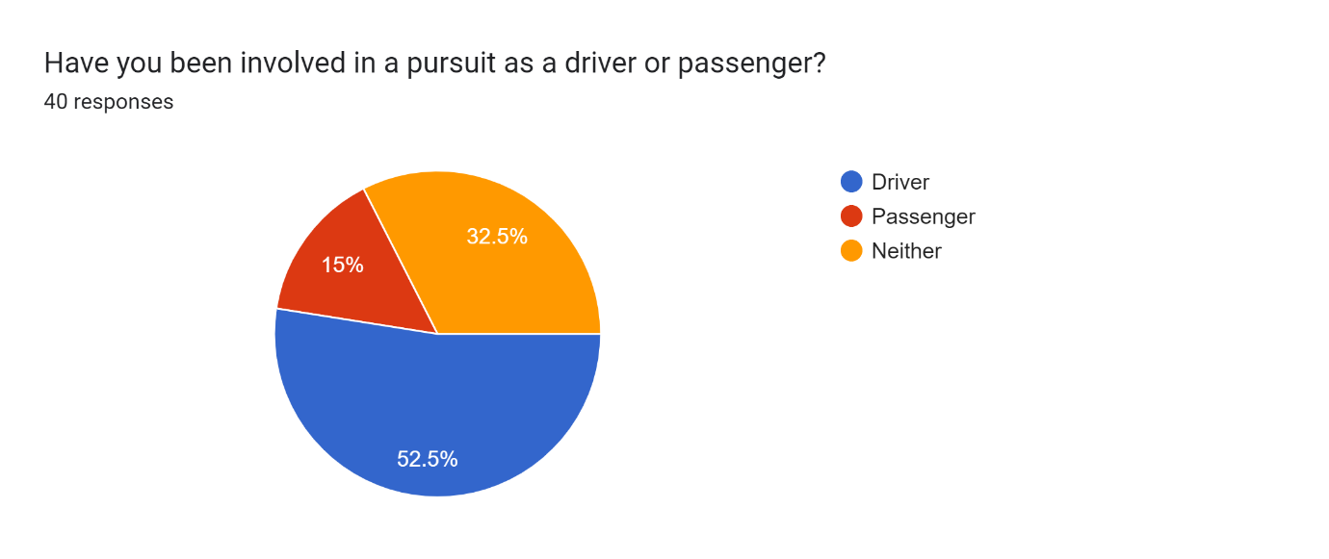
Results of Q7:

Question 8 was very important to the researcher as it answers one of the objectives of the study. It asks the participant if they know the South Wales Police policy on police pursuits and if so, what is it? The objective of this study is to identify officers’ opinion on the current pursuit policy within the police force and if they believe it is sufficient in them conducting their duties. To start it would be key to knowing if the participants know the current policy in place. There was a positive response to this with the majority of participants knowing the correct policy as 33 contributors gave a vague account that unless pursuit trained officers are to stand down, come to a stop and give direction and travel over the radio wave. This is positive for the study as if people are aware of what a pursuit is they can give structural answers to the questions. However, the negative being due to the anonymity you are unable to distinguish between the people who know what it is and the people who do not.
Question 9 asked the persons do they believe the current policy has a negative effect on public perception. There were mixed replies on this question with 14 participants answering no. This left 26 others answering yes, giving the overall opinion being that it is having a negative impact. Different views were expected with such question due to there being no definite answer and people being more confident with driving.

Results of Q8:
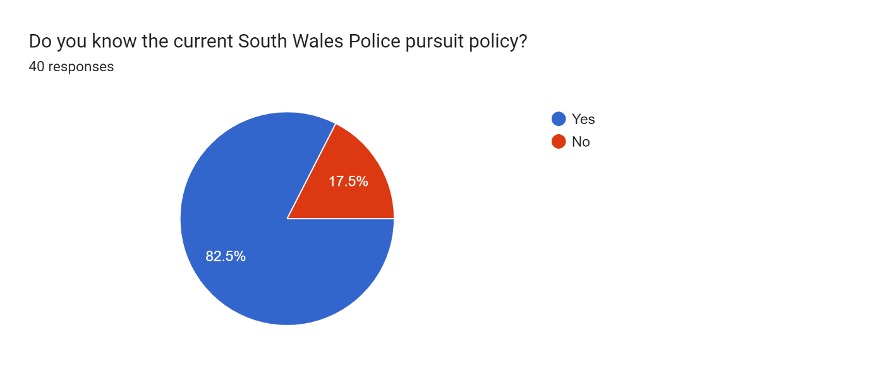

Results of Q9:
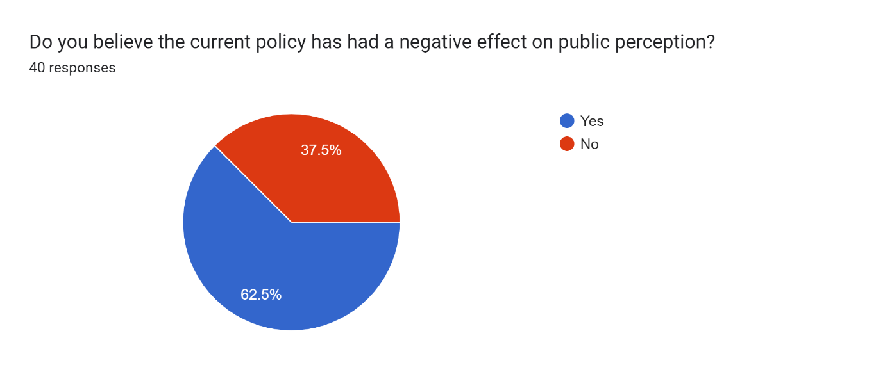

Question 10, 11 and 12
Question 10 led the researcher to ask if every officer should be initially pursuit trained and if not, why? The majority of contributors, being 29 answering yes to this, limiting the responses to if not, why not? However, many of the replies to 11 were similar. This being that if officers were to stand down it may have an impact of the driving of the subject causing him to drive to a suitable manor on exiting police sight and in hindsight being safer for the public.
Question 11 was again put it to meet and objective and see if the participant has ever attempted to pull a vehicle over, it has not complied, and the person has been forced to leave the vehicle go due to policy. Again, it was a mixed response to this question, with 24 officers stating that they have been involved in a situation similar to this and 16 saying they have not.
Question 12 was a follow up question, which asked the officers feelings in relation to not being able to do anything with a vehicle failing to stop. Once again, it was limited, due to 16 participants not experiencing this. However, there were mixed responses due to people having different opinions. These varied to people suggesting that they would stick to policy due to it being in place for a reason and others responding that they were angry and frustrated as in some circumstances the subjects would not be located and could potentially be wanted persons.
Furthermore, question 13 asked if the officer was a driver or a passenger. 19 officers answered with that they were the driver at the time of the pursuit, whilst 5 replied that they were the passenger. This suggests that many of the officers responding would not have had the training required.

Results of Q10:
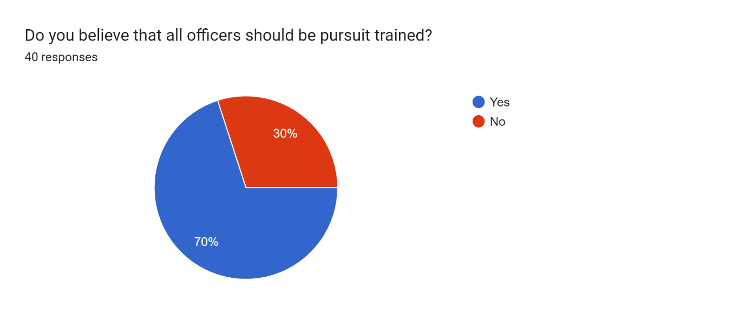
Results of Q11:

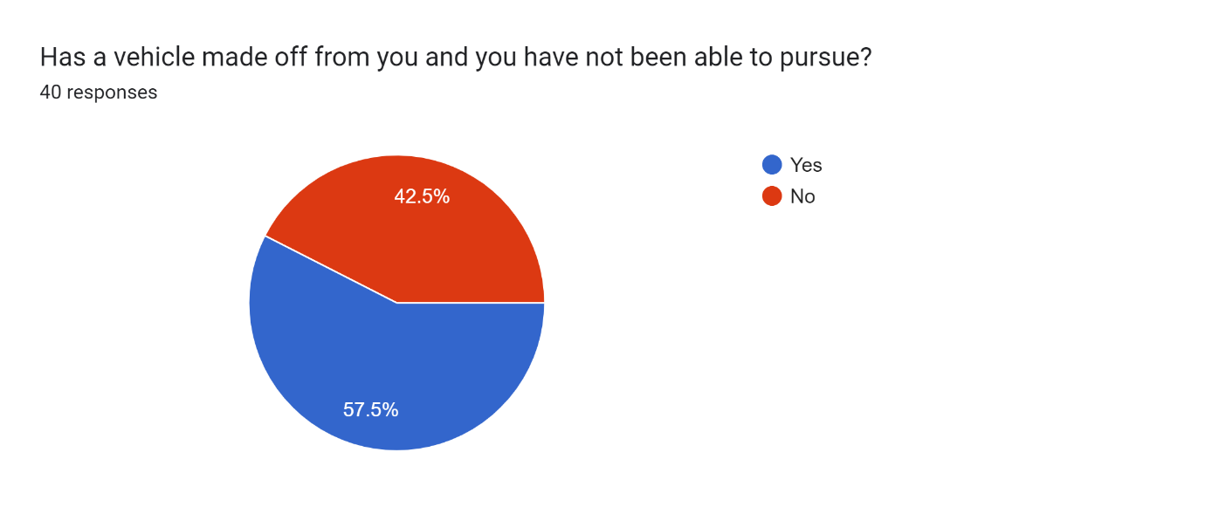
Question 13 and 14
Question 13 was again included to meet one of the objectives. The researcher asked if partipant believed that the policy has a negative effect on road related crimes. With it being a closed question there were mixed replies, however received a similar response as question 9 with 13 answering no and 27 answering yes.
Question 14 asked to explain their answer to 13. Again, as it was opinion based open question it received a range of replies. The majority who stated yes, had a generic reply of they believe criminals are aware of the policy that officers are unable to and will make off when a crime is committed. The general opinion of the 13 who replied no seemed to be due to little involvements with pursuits and state they are yet to experience it.
Results of Q13:
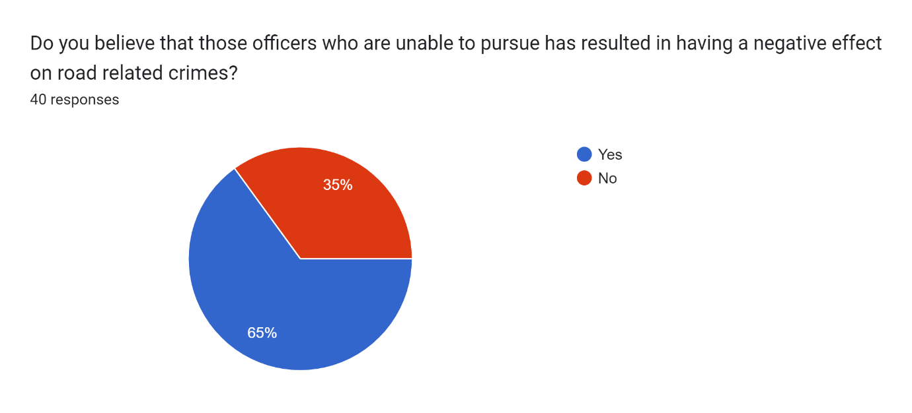

Chapter 5 – Conclusion and recommendations

5.1 introduction
The chapters of this dissertation have so far included an introduction, literature review, a planning phase and an analysis of the results of the primary data collected. This conclusion chapter will provide a summary of the primary research project findings. In phase 3 planning phase, objectives were set out as an aim for the research project. The first objective was to assess the impact of the limited amount of roads policing officers and the link to the increase in road related deaths. The second objective was to assess the issues around only allowing roads traffic officers to pursue and the link to how organised crime operates. The final objective was to see the personal opinions on pursuing and how it affects public perception. I feel these objectives were answered to an extent with the resources available.
5.2 Main Findings
The main aim of this study was to find officers perception of pursuits. Throughout this project, within the different chapters, several findings have developed and presented themselves. Early on within the findings it became clear that there were split opinions on the pursuit policy within South Wales Police. Likewise, that some people have a better understanding on pursuits and had engaged in more as officers. This could be due to the fact that people have more interest in traffic related crimes or that it is more suited to their job role.
After gaining some information from participants and their understanding on pursuits, it was apparent that it was a call for some change. In recent times Gov did a similar project where participants stated police officers should be required to drive in such a way that is both necessary and proportionate to the circumstances (Gov 2019). In effect this links in with the research conducted in this study that the pursuit policy needs review as police and criminals are both aware of the circumstances of when police can pursue. If it met the public suggestion of when the circumstances are proportionate it would allow for officer discretion.
Throughout the study, to meet certain objectives it would require the opinions of participants who are officers and have experience or an outlook on the current pursuit policy. Evidently, participants who had experience and knowledge of pursuits had a varied and different opinion to those who knew little about it. It also appeared that officers were frustrated with the current policy due to having to allow criminals to get away from officers with no consequences.

5.3 Recommendations
A number of recommendations have been identified throughout this study. Within the study it became clear that the people who had the little knowledge on pursuits were those who had not been involved in them. Therefore, it would be useful to have more education around pursuits for officers during training. For example, it is important to make officers aware of the percentage of people prosecuted after they make off from officers and such crimes that they committed. This would allow officers to become more aware when on general patrol and identify vehicles for officers who are possibly trained.
A second recommendation would be to review the current pursuit policy and involve officer discretion. It is apparent that some organised crime gangs are aware of what officers can purse and what officers cannot by the vehicles they drive. For example, if all officers looked the same in the same vehicles or were able to use their discretion in some circumstances then it may prevent some people trying their luck.
5.4 Limitations
During the study there were some limitations which could be addressed in order to gain a more educated study. A huge limitation in the study was the sample size of the questionnaire. Although the study did have a good number of participants it did not account for a large proportion of officers within South Wales Police.
A further issue with sample size was not everyone was pursuit trained or aware of what it was. This limited the information they could offer, as they had not been involved or aware of what it is. It would have been more beneficial if all participants were aware of the policy and had viewed or had experiences in pursuits in order to put forward more educated opinions.
Another issue was the availability of the individual for an interview. It was arranged for an interview to be conducted in order to assist with the study however, circumstances changed, and the person was no longer part of the roads policing unit and retired. This then prevented the interview taking place which could have assisted with information from experience on the study.
Lastly, there was a limit on the research projects word count which limit the context you could include in the study. More data could have been analysed, including the different opinions of participants if the word count allowed.
5.5 Future Research
Due to there being a time restriction on the research, a significant amount of officers’ opinion within South Wales Police was not collected or included in the study. This meant that only a convenience sample was collected in order to complete the research in such a short time frame. In future research, if more time is given then a wider variety of sample size could be used gaining more opinions to assist in the study.
Another thing to consider in future research would be the publics opinion on the pursuit policy. If a sample of this was collected and collated it could be compared with officers’ views, which in turn would have provided a better argument to review.
5.6 Conclusion
To conclude, the research study identified a number of issues with the current policy expressed by current officers on pursuit policies. On evaluating opinions, it has allowed for a number of factors to be addressed in order reduce the pursuit rate and improve morale within the police force. Reviewing the current policy, involving better training and officers’ discretion, were a number of areas identified in order to build morale and allow for officers to become more confident. However, contrary to most of the feedback given within the research identified, a small number of officers do agree with the pursuit policy. This is due to fear of public fallback should something go wrong. With a larger sample size from officers and public, this area could be investigated in order to expand current knowledge. The researcher hopes that the issues identified can be used to revisit the current policy and involve officers’ opinion to improve morale.

Bibliography
The bibliography should only include sources referenced within the workbook using the Harvard referencing system. Information about referencing in written assignments and how to avoid plagiarism can be found on Moodle. It is important that you are aware of the importance of ensuring that the work submitted is your original work.
Chapter 1
(BBC 2021)
available at : https://www.bbc.co.uk/programmes/m0013mvC
Accessed May 2022

(HMICFRS 2019)
available at : https://www.justiceinspectorates.gov.uk/hmicfrs/publications/not-optional-an-inspection-of-roads-policing-in-england-and-wales
Accessed May 2022

(DPP LAW 2016)
Available at : https://www.dpp-law.com/driving-offences-statistics
Accessed May 2022

Chapter 2
(Andrew Clovis 2019)
Available at : https://www.sciencedirect.com/science/article/abs/pii/S0047235297000809
Accessed June 2022

(College of policing 2021)
Available at : Police pursuits | College of Policing
Accessed JUNE 2022

(David P SCHULTZ 2010)
Available at : https://leb.fbi.gov/articles/featured-articles/evidence-based-decisions-on-police-pursuits-the-officers-perspective
Accessed June 2022

(Home office 2018)
Available at : police pursuits (publishing.service.gov.uk)
Accessed June 2022

(Gov. 2018)
Available at : Serious and Organised Crime Strategy 2018 - GOV.UK (www.gov.uk)
Accessed December 2018
(Met Police 2020)
Police Driver & Vehicle - Pursuits Standard Operating Procedure | Metropolitan Police
Accessed June 2022

(NPCC 2018)
Available at : https://www.npcc.police.uk/documents/uniformed/2009/200906UNMPP01.pdf
Accessed December 2022

(P WADDINGTON 2010)
Available at : https://academic.oup.com/policing/article/4/2/119/1515806
Viewed 20/06/22

(Tim DEES 2017)
Available at : https://www.police1.com/police-products/pursuit-management-technology/articles/what-cops-need-to-know-about-pursuit-training-Uj6BQS3Fa90KpRie/#:~:text=Although%20the%20trend%20on%20pursuit%20policies%20seems%20to,performs%20some%20high-risk%20tactic%2C%20it%20often%20goes%20wrong.
Accessed June 2022

(Tom LAMONT 2019)
Available at : https://www.theguardian.com/news/2019/jul/02/deaths-uk-police-pursuits-chases
Viewed 17 JULY 2022

(UKROEd 2020)
Available at : Report on police pursuits offers safety recommendations | UKROEd
Accessed June 2022

Chapter 3
(Alisson 2019)
Available at :https://study.com/academy/lesson/what-is-qualitative-data-definition-examples.html
Accessed June 2022

(Gaille 2017)
Available at :https://vittana.org/23-advantages-and-disadvantages-of-qualitative-research
Accessed June 2022

(MOZYRKO 2012)
Available at :https://research-methodology.net/sampling-in-primary-data-collection/random-sampling
Accessed June 2022

(SCHOONEN AND JOHNSON 2017)
Available at : A.J.M. Schoonen's research works | University of Groningen, Groningen (RUG) and other places (researchgate.net)
Accessed June 2022

(Stevens 2022)
Available at : Random Sampling - Overview, Types, Importance, Example (corporatefinanceinstitute.com)
Accessed June 2022

Bibliography

CONFIDENTIALITY and PLAGIARISM

This is automatically checked via Turnitin submission of your workbook.

Appendix A – Questionnaire





