Programs in C and documentation

David John Jeffery (1810950)
ACCA4017 - Software Development
School of Applied Computing
22.02.19

Contents
PART A (UNDERSTANDING) 2
A1. What is a variable and why are they important in writing programs? 2
A2. Explain why the for-loop can also be referred to as a counting-loop and give an example of when you would use it. 2
A3. Explain what an array is, what their features are, and give an example of when you would use one. 3
PART B (IMPLEMENTATION) 4
Exercise 1 4
1.1 Problem identification and Solution 4
Pseudocode 4
1.2 Annotated Code 4
1.3 Testing 4
Exercise 2 5
2.1 Problem identification and Solution 5
Pseudocode: 5
2.2 Annotated Code 6
2.3 Testing 7
Exercise 3 9
3.1 Problem identification and Solution 9
Pseudocode: 9
3.2 Annotated Code 9
3.3 Testing 10
Exercise 4 12
4.1 Problem identification and Solution 12
Pseudocode: 12
4.2 Annotated Code 12
4.3 Testing 14
Bibliography 17

PART A (UNDERSTANDING)

A1. What is a variable and why are they important in writing programs?
A variable is a name specified in a computer program that refers to a location in computer memory that is used to store data[1], the values of which may change over time depending on conditions or information supplied to the program [2]. They are important when writing programs because they are able to store different types of data that can be essential for the running or overall purpose of the program. Variables can also be used to store data input by an end user and can be important for interactivity.
When writing programs in C, variables must first be defined with a data type that limits them to store a value of that type only. In the example below, a variable named ‘age’ has been defined of type int to store the age of a user, meaning it can only store integer values. In this case the variable is initialised with a value of 37.
Int age = 37;
Other data types used in C are:
- char – Used to define a variable that holds character type values such as ‘d’ or ‘x’
- float – Used to define a variable that holds floating-point values such as 37.7 or -81.1
- double – Used to define a variable that holds very large or vary small floating-point values
Variables names must adhere to the following rules when they are created:
- Variable names must be unique and cannot be used more than once within a program.
- A variable name can consist of letters, numbers and underscore, but cannot begin with a number. Blank spaces are not allowed.

A2. Explain why the for-loop can also be referred to as a counting-loop and give an example of when you would use it.
Occasionally a block of code within a program may need to be executed several times. Instead of writing the same code repeatedly, a loop can be employed to repeat the required code instead. A for loop requires a conditional expression that is true to repeat the loop until the condition becomes false. The required number of iterations of the loop is known prior to execution and this is why it can also be referred to as a counting loop. The syntax of a for loop is shown below[3]:

for (variable initialisation; condition; variable update)
{
Code executed when condition is true;
}

The variable initialisation is evaluated and checked against the condition. If it is true, the code in the body of the for loop is executed and the value of the variable is updated according to the increment/decrement condition specified. When the condition evaluates to false, the loop exits.
An example of when a for loop could be used might be as part of a program that calculates mileage expenses for 12 eligible employees within a company. The rate paid per mile would be constant and the miles travelled would be input by the operator. The calculation would repeat 12 times using a for loop – once for each eligible employee.

A3. Explain what an array is, what their features are, and give an example of when you would use one.
An array is a collection of variables of the same data type stored under a single variable name [4]. Arrays can be created out of any data type and each variable within an array is known as an array element. These elements are distinguished using a numerical index known as an array subscript. Array subscripts always begin at 0 and increase depending on the size of the array required. They are useful at storing multiple values of the same data type under a single variable name that would otherwise require variables to be declared for each. For example, if the highest temperature of the day was to be recorded every day for a year, rather than store the values in multiple separate variables it would make sense to declare an array to hold the values, as demonstrated below:
float temparray[365];
Elements of the above array can be initialised during declaration or individually by using their index, as follows:
temparray[195] = 24.8;
Two-dimensional arrays can also be represented. An example of a 2D array could be int a[2][3]; declared using the following format [4]:

data-type array-name[row][column];
Where row represents the number of rows and columns represents the number of columns.

PART B (IMPLEMENTATION)

Exercise 1
Task:
Show how variables can contain different types of values by declaring three variables that contain a name, a measure of height (e.g. 1.81cm) and a person's age (e.g. 32). Input these values and display them on the screen.

1.1 Problem identification and Solution
For this problem we must determine the data type of each variable to be declared from the information provided. Once these variables have been initialised with the appropriate values they will be output on the screen.
Pseudocode:
- Declare 3 variables for each value: character array type for name, float type for height and integer for age.
- Assign values to variables.
- Print values on screen.

1.2 Annotated Code

#include <stdio.h>

void main()

{
char name[5] = { 'D', 'a', 'v', 'e' };
float height = 1.75;
int age = 37;

printf("My name is %s, I am %.2f cm tall and I am %d years of age\n", name,
height, age);
}

1.3 Testing

1.3.1 Normal Values:
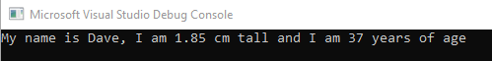
Result: Program ran as expected.

1.3.2 Array subscript too small ([4]):
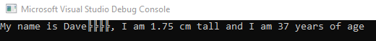
Result: Program ran with corrupt output for name.

Exercise 2
Task:
Allow the user to enter the dimensions of shapes shown below (Figure 1), then calculate the area of the blue shaded part. Note: The triangular area in the centre is empty.

Figure 1

2.1 Problem identification and Solution
To calculate the blue shaded area within the circle we must subtract the area occupied within the circle by the triangle. The user will be prompted to enter values for radius, base and height. To ensure the user enters dimensions of a triangle that will fit within the circle we will limit base and height values to be less than the value for radius. The areas of each shape will then be calculated according to their respective formula and subtracted to determine the remaining area within the circle.

Pseudocode:
- Declare variables of type float for radius, base and height
- Request values for radius from user
- Store in radius
- Request values for height and base
- Store values in base, height
- If base and/or height values are greater than radius, request lower values to ensure triangle can be inscribed within circle dimensions
- Calculate area of circle and store in areacircle
- Calculate area of triangle and store in areatriangle
- Calculate shadedarea by submitting areatriangle from areacircle
- Print shadedarea on screen

2.2 Annotated Code

#include <stdio.h>
#define PI 3.142

void main()

{
float base, height, radius;//variables to hold user input
float areacircle, areatriangle, shadedarea;//variables to calculate shape areas

printf("Please enter the radius of the circle in cm:\n");
scanf("%f", &radius);//store value in radius

printf("Please enter the size of the triangle base in cm:\n");
scanf("%f", &base);//store value in base

while (base >= radius)//check if triangle base is smaller than the circle radius as depicted in figure 1 to ensure triangle can be inscribed in circle
{
printf("The base length must be less than %.2f, please enter a lower value\n", radius);
scanf("%f", &base);//get new value for base if required
}

printf("Please enter the height of the triangle in cm:\n");
scanf("%f", &height);//store value in height

while (height >= radius)//check if triangle height is smaller than the circle radius as depicted in figure 1 to ensure triangle can be inscribed in circle
{
printf("The height must be less than %.2f, please enter a lower value\n", radius);
scanf("%f", &height);//get new value for height if required
}

areacircle = PI * (radius * radius);//calculate area of circle using declared PI constant
printf("The area of the circle is %.2f cm squared\n\n", areacircle);
areatriangle = (base * height) / 2;//calculate area of triangle
printf("The area of the triangle is %.2f cm squared\n", areatriangle);

shadedarea = areacircle - areatriangle;//calculate shaded area by submitting area of triangle from area of circle

printf("The blue shaded area is %.2f cm squared\n", shadedarea);

}

2.3 Testing

2.3.1 Normal Values:
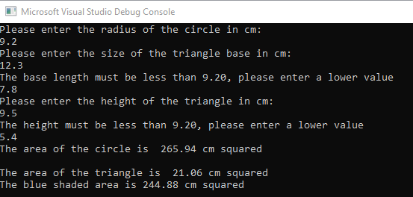
Result: Program ran and calculated blue shaded area as expected.

2.3.2 Values for triangle base greater than permitted:
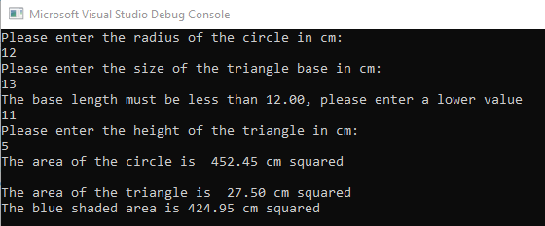
Result: Program ran as expected, user prompted for lower value.

2.3.3 Values for triangle height greater than permitted: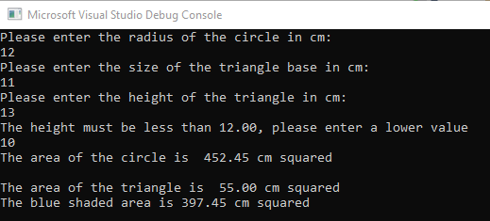
Result: Program ran as expected, user prompted for lower value.

2.3.4 Impossible values – letters entered:
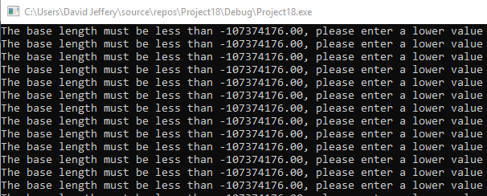
Result: Program failed with infinite loop.

Exercise 3
Task:
Write a program that allows the user to enter the price of 5 products into an array. Once all the prices are entered calculate the total price, and then calculate the total price plus 20% VAT.

3.1 Problem identification and Solution
The VAT amount of 20% will be stored in decimal form of .2 and declared as a constant value. As a decimal value will be used to calculate the VAT on the combined prices of each product, a float array will be used to store their individual values. The sum of each element will be calculated, followed by the amount of VAT. A final combined price will be calculated and printed on screen.

Pseudocode:
- Create float array to hold product price values and variables to hold price calculations
- Request first product price from user, store in products array
- Loop until 5 product prices have been entered
- Store sum of product prices in price
- Print price value on screen
- Multiply price value by vat amount and store in addedvat
- Add price and addedvat values to calculate the total price
- Store in totalprice
- Print totalprice value on screen

3.2 Annotated Code

#include <stdio.h>
#define VAT .2 //vat value is constant
void main()

{
float products[6], price = 0, totalprice, addedvat; //create float array for product price values, float variables for price calculations
int i;

for (i = 1; i <= 5; i++)//iterate for 5 products
{
printf("Please enter the price of product %d in pounds\n", i);
scanf("%f", &products[i]);//store price in array element for given iteration

price = price + products[i];//calculate sum of prices and store in price
}
printf("The total price of the 5 products is %.2f pounds\n\n", price);

addedvat = VAT*price;//calculate amount of VAT to be paid on the total amount and store in addedvat
printf("The amount of VAT to pay on the 5 products is %.2f pounds.\n\n", addedvat);

totalprice = price + addedvat;//calculate the total price paid and store in total price

printf("The total price of the 5 products with VAT is %.2f pounds", totalprice);//print totalprice on screen
}

3.3 Testing

3.3.1 Normal Values:
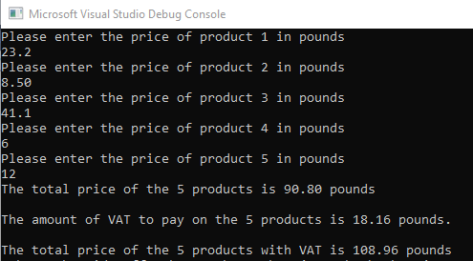
Result: Program runs as expected, all calculations performed correctly.

3.3.2 Negative Values:
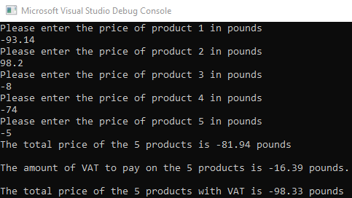
Result: Program runs as expected, all calculations performed correctly.

3.3.3 Impossible values, letter entered for dimension value:
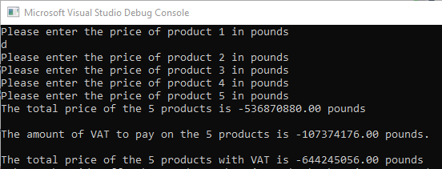
Result: Program fails.

Exercise 4
Task:
Build a fruit machine game which represents the 3 reels of symbols using numbers ranging from 1 to 5. Allow the user to have as many goes as they like (the numbers are chosen randomly each time).

4.1 Problem identification and Solution
3 random integers will be calculated and stored in an array to represent the outcome of 1 spin of the 3 fruit machine reels. Each spin will be checked for the frequency of numbers 1 to 5 in sequence. If the frequency of a number matches a scoring combination, the user will be informed, and points will be added to a cumulative score. The user will be given the option to generate another spin if desired, else their final score will be displayed on screen and the game will exit.

Pseudocode:
- Specify libraries for random number generation
- Declare integer type array to hold 3 generated random numbers
- Declare looping variables, random number range variables, score and tally variables
- Generate 3 random numbers, store in spin[3], print on screen
- Check each spin for frequency of numbers 1 through 5, store frequency total of each number in tally.
- If tally value of any number matches winning score combination, print details and score on screen, store score in variable score to keep running total, prompt user to play again.
- If tally value is a non-winning combination, display running total and prompt user to play again.
- If input from user is not ‘y’ or ‘n’, prompt until valid input received.
- If input is ‘y’, repeat steps 4 – 8.
- If input is ‘n’, display total score, end game.

4.2 Annotated Code

#include <stdio.h>
#include <stdlib.h>
#include <time.h>

void main()
{
int spin[3], x, y, low = 1, high = 5, tally, score = 0;//create array to represent each reel, variable y to represent reel numbers, tally to track frequency of numbers in each spin
char repeat = 'y';//used to spin again if required
srand(time(NULL));//seed randomness

printf("\n\nWelcome to the Fruit Machine Game! Lets get spinning!\n\n");

while (repeat == 'y')//repeats game until user opts to finish
{
for (x = 0; x < 3; x++)//iterate for each of the 3 reels
{
spin[x] = rand() % (high - low + 1) + low;//Assign random integer between 1 and 5 to each element of array (reel)
}

printf("\nThe numbers are: ");

for (x = 0; x < 3; x++)
{
printf("%d ", spin[x]);//Display reel values
}

/*code to determine tally value*/
for (y = 1; y < 6; y++)//values to check frequency of in spin
{
tally = 0;//set initial tally to 0 at beginning of each check
for (x = 0; x < 3; x++)
{
if (spin[x] == y)//check each element for occurrence of y value
{
tally++;//add 1 to tally if present for running total of number frequency
}
}

/*code to determine if tally value is winning or losing score*/
if ((tally == 3) && (y != 5))//used to detect winning score for 3 numbers that aren't 5
{
printf("\nThree of the same number bags you +20 bonus points! ");
score = score + 20;//adds points to running score
printf("Score score so far is %d", score);
y = 7; //prevents fifth iteration of loop
}
else if ((tally == 2) && (y == 5))//use to detect winning score if 2 five numbers are detected
{
printf("\nTwo fives = +100 bonus points! ");
score = score + 100;//adds points to running score
printf("Score score so far is %d", score);
}

else if ((tally == 3) && (y == 5))//used to detect if 3 numbers that are 5 are detected (jackpot)
{
printf("\nThree fives = JACKPOT! +2000 bonus points! ");
score = score + 2000;//adds points to running score
printf("Score score so far is %d", score);
}

else if (y == 5)//runs if none of the previous logic is true after all numbers have been checked
{
printf("\nNo winning numbers. Score score so far is %d.", score);
}
}

printf("\n\nWould you like another go? y/n ");
scanf(" %c", &repeat);//determine if game should loop

while ((repeat != 'y') && (repeat != 'n'))//check that correct repeat values have been entered
{
printf("\nInvalid character entered. Please enter y to continue or n to quit.\n");

scanf(" %c", &repeat);//prompts if supplied value not in range
}
}

printf("\nThanks for playing! Your final score is ** %d **\n\n", score);//prints when user chooses 'n' to finish game, displays total score
}

4.3 Testing

4.3.1 Normal values – No score
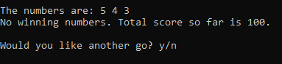
Result: Runs as expected, no score added to total, user prompted to play again

4.3.2 Normal Values – 2 fives winning score (tally == 2, y == 5, elements 2 & 3)
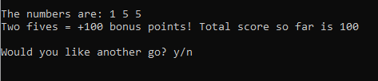
Result: Runs as expected, points awarded and added to running total, user prompted to play again.

4.3.3 Normal Values – 2 fives winning score (tally == 2, y == 5, elements 1 & 2)
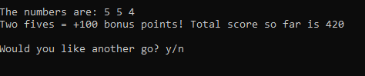
Result: Runs as expected, points awarded and added to running total, user prompted to play again.

4.3.4 Normal Values – 2 fives winning score (tally == 2, y == 5, elements 1 & 5)
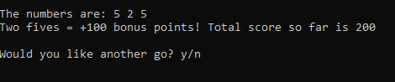
Result: Runs as expected, points awarded and added to running total, user prompted to play again.

4.3.5 Normal Values – 3 of the same number winning score (tally == 3, y ==1)
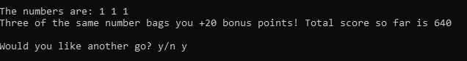
Result: Runs as expected, points awarded and added to running total, user prompted to play again.

4.3.6 Normal Values – 3 of the same number winning score (tally == 3, y ==2)
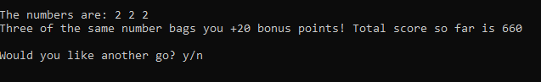
Result: Runs as expected, points awarded and added to running total, user prompted to play again.

4.3.7 Normal Values – 3 of the same number winning score (tally == 3, y ==3)
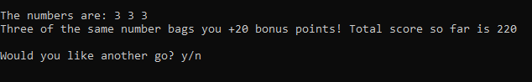
Result: Runs as expected, points awarded and added to running total, user prompted to play again.

4.3.8 Normal Values – 3 of the same number winning score (tally == 3, y ==4)
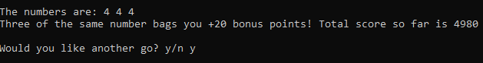
Result: Runs as expected, points awarded and added to running total, user prompted to play again.

4.3.9 Normal Values - 3 of the same number jackpot score (tally == 3, y ==5)
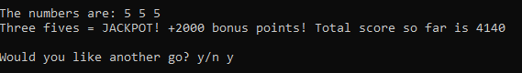
Result: Runs as expected, points awarded and added to running total, user prompted to play again.

4.3.10 Normal Values – user enters ‘n’ to end game
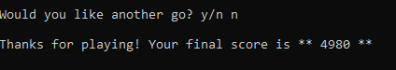
Result: Runs as expected, running total displayed on screen, program ends.

4.3.11 Incorrect value entered for repeat option
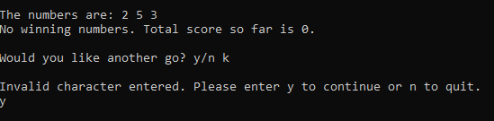
Result: Runs as expected, user prompted for choice until value is correct.

Bibliography
[1] Perry, Greg, C Programming Absolute Beginner’s Guide, 3rd ed. Que Publishing, 2013.
[2] ‘What is variable? - Definition from WhatIs.com’, WhatIs.com. [Online]. Available: https://whatis.techtarget.com/definition/variable. [Accessed: 17-Feb-2019].
[3] ‘For Loop: Definition, Example & Results’, Study.com. [Online]. Available: http://study.com/academy/lesson/for-loop-definition-example-results.html. [Accessed: 22-Feb-2019].
[4] Intellipaat, ‘C Array - C Tutorial’, Intellipaat. [Online]. Available: https://intellipaat.com/tutorial/c-tutorial/c-array/. [Accessed: 22-Feb-2019].

