Cyber Lab 2 Reflection

List the applications in the CyberOps menu
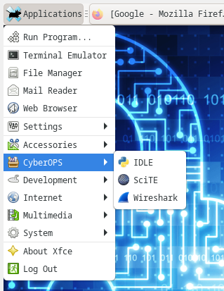
- Wireshark
- IDLE
- SciTE

What are the IP addresses assigned to your virtual machine?
127.0.0.1/8 which is the local host loopback address.
Also 10.0.2.15/24

Can you navigate to your favourite search engine?
Yes I was able to open the web browser and go to google.com.

What is the purpose of a virtual machine?
A virtual machine can be used to test changes to an environment, without impacting on a live environment. As such it is a good place to handle files that could cause harm as if they contain a virus it will not spread to the rest of the network

HOST | IP Address | Mac Address
H1 | 10.0.0.11/24 | 2a:a8:cf:10:8e:a5
H2 | 10.0.0.12/24 | 6e:1e:fc:6c:2d:a6

The source mac address captured matches the H1 interface, and the destination matches the H2 interface when examining the packet in Wireshark.
HOST | IP ADDRESS | MAC ADDRESS
H4-eth0 | 172.16.0.40/12 | 26:8B:F6:77:BF:4a
R1-eth1 | 10.0.0.1/24 | 36:2b:28:d9:34:a7
R1-eth2 | 172.16.0.1/12 | 22:c3:6b:99:38:b6

IP Address: 172.16.0.40
MAC Address: 36:2b:28:d9:34:a7 (R1-eth1)

Regarding the geographical locations, multiple routers are picked up with a different hop. Each of which have different starts to the IP address (for example 166.), which indicates the router is in a different country to the last.

I got an error when trying to use the website, which I could not rectify.
“can’t connect..please check the host you queried. Not all IPv6 can be tracerouted.”
Host | IP Address | MAC ADDRESS
H3 | 10.0.0.13/14 | 5A:AB:86:07:53:08

Gateway is 0.0.0.0

