Bethan Mackay
2307135
The Teaching Toolkit 2
ECPT6007 – Assessment 1

Contents
Introduction 3
Rationale 3
Course content 5
Aims and objectives 6
Learning outcomes 6
Knowledge and understanding skills 6
Cognitive and intellectual skills 7
Practical and professional skills 7
Transferable key skills 7
Scope 8
Delivery and resources 8
Teaching strategy 10
Professional standards and benchmarking 11
Scheme of work 12
Lesson 1 – Budgeting 13
Lesson 2 – Debt 14
Lesson 3 – Savings 14
Lesson 4 – Pension 15
Lesson 5 – Family planning 16
Lesson 6 – Mortgages and borrowing 16
Lesson 7 – Investments 17
Further development 17
Assessment strategy 18
Summative assessment 18
Formative assessments 18
Reading list 19
Essential 19
Further reading 19
Appendices 20
Appendix 1 - 2 x lesson plans and resources 20
Appendix 2 – Assessment specification and benchmarking 67
Appendix 3 - Confirmation of Attendance documentation 71
References 72

Introduction
The course entitled Financial Education will be a seven-week entry level programme based in communities across South Wales for adult learners (age 18+) covering personal finances. The seven-week course will have a thematical approach and will follow a progression model starting with basic budgeting through to more complex investments.

Rationale
Every year, the 14^{th of} August celebrates Financial Awareness Day, and it is dedicated to promoting financial literacy for people to take control of their finances. A recent survey by Money Wellness (2024) found that 95% of their customers in the UK did not receive any financial education but had they done so, believe that they would have made better decisions on savings, spending and have a positive attitude towards money (Money Wellness, 2024). In 2024, one in three working families across Britain have less than £1,000 in savings (Resolution Foundation, 2024) and for those with savings in the UK, over a quarter hold most of their money in a current account earning no interest (Building Societies Association, 2024).

Following the global financial crisis in 2008 (Bank of England, 2024), financial education was introduced by the Welsh Government to mainstream schools across Wales. The curriculum was revised in 2022, and the topic of financial education was placed alongside maths, numeracy, health and wellbeing. As research from University of Cambridge shows that attitude towards money is formed around the age of seven (Go Henry, 2022), the Welsh Government has acknowledged the importance of financial education by incorporating the topic of financial education in the curriculum at schools. However, reports also show that wider family members can influence long term financial behaviour (Ghafoor & Akhtar, 2024), therefore this course aims to fill the gap for post-16 adults who were not offered financial education. Similar to other topics, the financial education course will also utilise up-to-date content and could act as a refresher for adults. The benefits also extends beyond personal finances, with advantages for employers or business owners to encourage their employees to attend as results could lead to more focus in work, less stress, increase retention rates and preparation to invest further in education and to upskill (Open Wage, 2022).
As education providers around the world are reconsidering their programmes to ensure demands of the twenty first century are met, it is important to remember that a curriculum is more than just a course outline (Ashwin, et al., 2022).

“Financial education enhances financial wellbeing and prepares learners to understand and manage their incomes now and in the future. It can help them choose the best financial products and services and protect themselves from fraud and exploitation.”
(Young Money, Your Money Matters: A Teacher’s Guide Wales, 2022)

The mental health charity Mind also supported financial wellbeing, as the lack of financial education and poor money management can affect people’s mental health, triggering feelings of anxiety, panic, sleep problems and isolation (Mind, 2024). In The Well-being of Future Generations Act 2015, Wales aims to create a ‘equal Wales’ and a ‘Healthier Wales’, therefore it is important to understand the inequality of financial education in Wales and the link between personal finances and mental health. Evidence shows there is an imbalance of financial education in society with females falling into more debt (Young Women's Trust, 2024). Alongside gender, households with low income are likely to fall into debt resulting in social stigma and social exclusion (Wales Centre for Public Policy, 2022).

Whilst provision has been established to provide financial education to children in schools across Wales (Money and Pensions Service, 2024) it could be argued that limited resources are available for adult learners regarding financial education as it has been reported that the majority of UK adults received no financial education which now negatively impacts household struggling with finances (FinTech Finance, 2024).

It is important to acknowledge that there are a limited number of short online courses available in personal finance offering self-paced study at a time that suits the student, with providers offering a formal qualification at University level (The Open University, 2024) which may not be suitable for students who do not wish to dedicate years to study. Whilst there is a vast amount of information on the internet, online programmes can miss important dimensions of learning from discussions to debates with fellow students and tutors (Race, 2020). Therefore, this face-to-face course aims to target adult learners in communities across South Wales and the course will be tailored to local resources.

County Councils currently deliver community courses on topics such as seasonal crafts (Carmarthenshire County Council, 2024), Welsh lessons (Pembrokeshire County Council, 2022) and digital literacy skills (Swansea Council, 2024). Following the COVID-19 pandemic, households have faced a significant rise in the cost of living (UK Parliament, 2024) and as a result, several County Councils in England have recently launched courses in personal financial management to help residence manage their household budgets (Kent County Council, 2024). Based on the Wales Index of Multiple Deprivation 2019 report, the course will be delivered in communities that have been identified as lower-layer output areas in deep-rooted deprivation such as Swansea, Neath Port Talbot, Bridgend and Rhondda Cynon Taf (Welsh Government, 2022).

Having identified the rationale for the course, the approach used to produce this curriculum will be for ‘social change’, which is to be used “to promote social justice, undo the inequalities of society and empower students from subordinated groups” (Ashwin, et al., 2022, p. 178).

Course content
The curriculum takes a praxis approach as the course will focus on the ethical and caring aspect of teaching as financial education requires a wider consideration beyond budgeting and saving with gender, culture, values and socio-economic class impacting financial decision making (Blue & Grootenboer, 2019). The curriculum will also focus on learning to change behaviour, which is possible through experience, training or practice (Reece & Walker, 2009).

The seven-week course is built on a progression model similar to Dave Ramsey’s USA concept of ‘The 7 Baby Steps’ to take control of personal finances (Ramsey, 2024). Whilst the course does not aim to provide financial advice, or a “quick fix” solution to personal financial difficulties, there is currently no UK equivalent to Dave Ramsey’s baby steps model, therefore the course will aim to start with the basics of budgeting through to complex investments as it could be argued that investments can only be made once other financial steps have taken place such as budgeting and savings (Money Helper, 2024).

The seven-week course will cover one new topic per week, and the topics will complement the previous topic, giving students a sense of progression. Each topic will have equal weighting and importance, with students being tasked with relevant assessment strategies before moving on to the next subject. This community-based course will allow students to attend in person, ask questions and feel committed to attend each week. The course will be tailored for the area in order to provide the students with signposting opportunities such as charities, banks, advisors and support facilities in the local areas.

Aims and objectives
This course aims to introduce financial education and provide a framework to make informed and confident decisions about personal finances.

The course objectives are to:
- Review financial education theory model
- Compare and contrast financial products
- Discuss poor money management and the support available, especially mental health

Learning outcomes
On completion of this course, students will be able to:
- Demonstrate effective money management techniques
- Explain key financial decisions by drawing up a simple plan for future planning
- Confidently analyse own financial decisions and develop financial targets

Knowledge and understanding skills
Students will have clear knowledge and understanding of basic financial education by using methods and theories relating to the discipline. Students will have knowledge of current and external economic factors that influence personal finances. Students will have a clear understanding of products and services available to confidently make personal financial choices based on the knowledge obtained on the course.

Cognitive and intellectual skills
Savard & Cavalcante (2021) explained that knowledge and understanding of financial education is not sufficient due to the complexity of the topic, therefore in order for students to confidently apply their knowledge, students need to develop cognitive, affective, behavioural and motivational skills in order to have an impact on everyday life (Savard & Cavalcante, 2021).

Students will have skills to compare and select financial products currently available on the market that best suits their household needs. Students will have the cognitive and intellectual skills to analyse and critic financial problems such as debt or mental health issues.

Practical and professional skills
Students will gain practical and professional skills as they use skills to improve their personal financial budgets. Practical skills will help students to analyse their household bills and design a system based on priority to set and meet financial deadlines. Professional skills obtained will include the ability to analyse basic financial data, interpret data, research external organisations in the finance sector and use various ICT applications.

Transferable key skills
Throughout the programme, students will learn and develop transferable skills which could be useful in other areas of their personal life including the workplace:
- Financial literacy
- problem solving and decision making
- confidence
- time management
- planning and organisational
- critical thinking
- teamwork
- communication and listening skills

Upon completion of attending the seven-week course, students will be awarded a ‘Confirmation of Attendance’ document (see appendix 3). As the programme does not award credits or modules, it is important the awarding document does not contain the word certificate which could imply a level 4 qualification.

Scope
As the course will be delivered over seven weeks, there will be limitations due to the timescale and the need to keep topics relevant. Recruitment onto the course will target adults (18+) based or have easy access to South Wales. No prior knowledge or experience of financial education is required to gain entry onto the course.

It is important that both students and teachers are aware that no financial advice will be given throughout the course. The purpose of the course is to empower the students to make decisions and to gain skills to source independent advice outside of the course in order to make appropriate financial decisions.

It is important to be aware and not discard the topic of economical abuse as it is linked to 95% of domestic abuse cases in the UK (Surviving Domestic Abuse, 2025). The teachers will adhere to the professional standards by ensuring that the welfare and wellbeing of students are taken into account by signposting to appropriate organisations to assist with financial abuse.

Delivery and resources
As the curriculum focuses on social change, student engagement is extremely important and therefore students should not be passive recipients but instead take an active role in the classroom (Ashwin, et al., 2022). Savard & Cavalcante (2021) also emphasised that the subject of financial education should involve studying of an object or phenomenon in a sociocultural context, meaning students should engage in financial concepts such as buying items and profits. To ensure that student participate, resources are essential (Reece & Walker, 2007).

The programme will be delivered face-to-face in the local community as the content will be tailored to the area. The number of students will be capped at 30 to have a manageable number and for activities to be personalised. It is important not to underestimate the importance of small group learning as Race (2020) states that most meaningful learning happens in small groups as “larger the institution and the cohort, the more likely it is that modules and other curriculum delivery components are designed and delivered in isolation, without clear thinking going into what the overall programme experience is like for the students undertaking them” (Race, 2020, p. 299). This concept was also supported by Reece & Walker (2007) who encouraged small class sizes to easily promote questions and answer sessions in group discussions.

As 30 hours of financial education is the minimum amount required to be financially literate (Brader, 2024), the programme delivery will be 5-hour sessions once a week with a 30-minute break for each lesson. The course will run from 5th January 2026 until 16th February 2026 totalling 31.5 hours of teaching and learning delivery. In the UK, over 30 million people set new year’s resolutions with 27% of those around money (Oxfordshire Mind, 2023) and as the holiday season has passed, January can bring financial stress and anxiety (Change Mental Health, 2024). Therefore, the course will run at the beginning of the new year as people are keen to set personal goals for the upcoming year and the timings of the course does not clash particular ethnic or religious events such as Ramadan, which will help to foster cross-cultural capability (Race, 2020).

A teacher for the course will teach financial education, ideally with a background in management, economics or finance. As the programme is designed for day-to-day use, accountancy or mathematic qualifications would be an advantage but not essential. Experience of delivering programmes to widening access students in communities with local knowledge to signpost content will be required.

The curriculum will acknowledge the importance of all presentations and resources to remain professional, accessible and set within the providers guidelines, however themes in the financial sector such as professional accountancy or mathematical genres will be avoided in order to provide students with a sense of day-to-day personal finances rather than a profession in finance.

The resources required for each lesson will be computing facilities to deliver a PowerPoint presentation along with an interactive board. For activities to be interactive, access to the internet will be required. The tangible facilities in community centres will be tables, chairs and comfortable learning environments such as heating, lighting, bathrooms and adequate space.

Teaching strategy
Having previously identified the curriculum for social change, it is suggested that teachers for the programme should take a dialogical, negotiated or collaborative approach (Ashwin, et al., 2022).

Before the beginning of each lecture, all teaching resources will be emailed to students which will enable students to review the content in class and keep the materials to reflect back. As part of the introduction of each lesson, it is strongly recommended that a short period of reflection will be embedded in the lesson plans to summarise what was learned in the previous lesson and what will be taught in the coming lesson (Reece & Walker, 2007).

At the beginning of each lesson, a list of approximately five questions will be asked for the students to answer at the end of the lesson. This will encourage students to find and note the answers throughout the lesson.

Independent learning will be encouraged from the start of the course. Students will be advised to start a reflective journal for their own personal finances and set personal goals in accordance with each topic covered every week.

Scenarios and case studies will be used throughout the course to demonstrate real-life situations. This will also help students develop their teamwork and communication skills as providing examples can bring the subject to life (Reece & Walker, 2007).

To encourage student participation, the class will be split into smaller teams for group work to encourage debates for students to present their findings with fellow students to share ideals and knowledge. This teaching method is a classic approach to promote engagement and participation in the classroom (Ashwin, et al., 2022).

To ensure student feedback is not left to the end of the course which could easily be discarded as an afterthought, after each lesson, the teacher will gather informal feedback as part of their reflective practice. Feedback needs to be timely (Forsyth, 2023) as feedback received early in the course is strongly linked to student retention, motivation and commitment (Race & Pickford, 2007). Like feedback to our students, feedback from our students is equally important (Ashwin, et al., 2022) therefore time will be embedded in the planning of each lesson.

Professional standards and benchmarking
The course aims to meet at least three professional standards for further education teachers, work-based learning practitioners and adult learning practitioners in Wales to deliver the following:
- “Enable learners to share responsibility for their own learning and assessment by working with all learners to empower them to set challenging goals and targets and to evaluate their own progress against these by communicating effectively with all learners, employers and others as appropriate
- Demonstrate dignity, courtesy and respect towards others by listening to and respecting other peoples’ views, opinions and ideas by acting as a role model for fair, courteous and respectful behaviours supporting the wellbeing of learners and colleagues, seeking support where necessary
- Maintain and update knowledge of my subject(s) and how best to teach and assess them by keeping abreast of my subject or vocational area and of effective teaching and assessment methods by using assessment of and for learning to support learner progress”
(Welsh Government, 2023)

As the course does not hold accreditation, the content does not require external verification. A benchmarking criterion will be used to score the summative assessment (see appendix 2) against the skills listed under the learning outcomes of the course. The benchmarking assessment form will also provide valuable feedback to students at the end of their course.

Scheme of work
The scheme of work will be in a thematical order to provide a stepping stone for each lesson to enable the students to have a progression throughout the course. The steps are similar to a USA financial model Dave Ramsey’s ‘The 7 Baby Steps’ but have been customised to the financial system in the UK i.e. student loan system is different and therefore does not warrant a whole lesson.

Dave Ramsey’s The 7 Baby Steps:

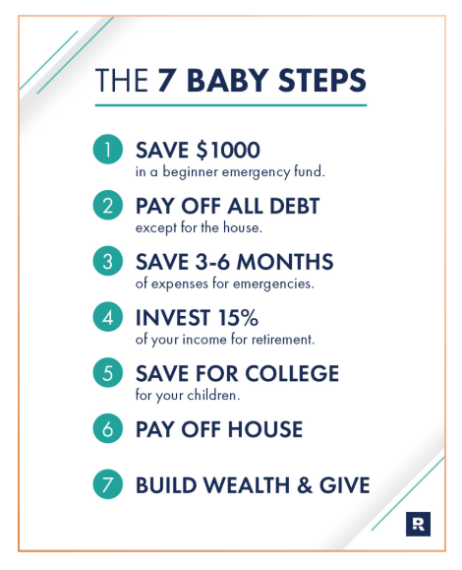
(Dave Ramsey, Using the 7 Baby Steps, 2023)

Proposed Scheme of Work:
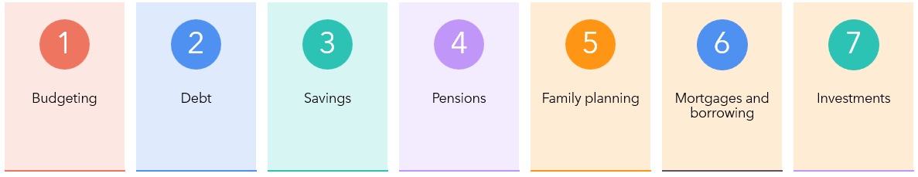

Lesson 1 – Budgeting
Save £1,000
Topic | Aim | Objectives | Learning Activities | Resources
Income and expenses | Ease into course and review assessment criteria (reflective journal) | Apply 50-30-20 budgeting guideline by identifying needs and wants to develop critical thinking skills | Brainstorm – ways to save money | Budget calculator
Benefits – council tax discount, universal credit etc | Raise awareness of financial support and guidance | Discuss different benefits available by utilising teamwork skills | Group work - research into benefits available and eligibility – present findings to class | Internet access to Turn2us  Entitled To  Money Helper
Household utilities | Explore real-life financial scenarios | Identify the importance of budgeting and gain problem solving skills | Comparison tasks to find cheapest provider - energy, heating, broadband, telephone, insurance | Flip chart  Pens  Scenario examples

Lesson 2 – Debt
Pay off debt
Topic | Aim | Objectives | Learning Activities | Resources
Loans | Explore impact of poor money management | Compare different financial strategies using personal development skills | Scenario activity – list debt into snowball v avalanche method | Interactive whiteboard
Credit cards | Effectively manage money | Apply knowledge of customer choices by using communication and listening skills | Debate – are reward credit cards worth it? | Pen and paper
Overdrafts | Raise awareness of mental health linked to debt | Describe the effect of debt on people’s lives by utilising critical thinking skills | Research task – pros and cons of overdrafts | Internet

Lesson 3 – Savings
Save 3-6 months of expenses
Topic | Aim | Objectives | Learning Activities | Resources
Personal saving allowance | Explore importance of savings | Discuss the concept of ‘rainy day’ and becoming a ‘Super Saver’ | Group task – reasons to save | Pen and paper  Flip chart
Interest rates, inflation rate, annual equivalent rate (AER) and annual percentage rate (APR) | Become familiar with financial literacy | Review financial terminology by developing financial literacy skills | Work in pairs to define and present the terms | Internet
Types of saving accounts – fixed, instant easy access, Cash ISA (individual savings accounts), premium bonds | Know the difference between various savings accounts | List current offerings available on the market using decision making skills | Comparison chart – list different types of savings account along with advantages and restraints | Internet

Lesson 4 – Pension
Invest for retirement
Topic | Aim | Objectives | Learning Activities | Resources
State pension | Know the different ways to save for retirement | Evaluate the importance of long-term financial planning | Video explaining pensions | Internet and sound
Private pension | Analyse the options for retirement | Differentiate retirement options | Interactive quiz about retirement | Internet on phones or laptops
Lifetime ISA | Raise awareness of options outside of pension pots | Debate the consequences for not planning for retirement | Present your findings to the group – how much do I need to save for retirement? | Internet PowerPoint

Lesson 5 – Family planning
Save for family planning
Topic | Aim | Objectives | Learning Activities | Resources
Childcare | Importance of financial planning | Name financial offerings and key childcare deadlines | Pair work – research topic and eligibility | Internet access to  Childcare Offer for Wales
Life, critical illness, health and income protection insurance | Manage money for planned and unplanned events | Explore types of insurance for financial security by developing reflective skills | Present your findings on planning for the unexpected | Life insurance calculators and flip charts
Further or Higher Education | Prepare for education | Define the financial requirements for college or university by using teamwork skills | Group task - pros and cons of university education | Flip charts and pens

Lesson 6 – Mortgages and borrowing
Save for mortgage
Topic | Aim | Objectives | Learning Activities | Resources
Borrowing | Make important decisions on borrowing | List examples of borrowing | Brainstorm - Risk of unplanned spending | Balance charts
Mortgage | Explore suitable mortgage offers | Evaluate different mortgage loans and critically analyse contracts | Activity sheet – overpayments on mortgage | Mortgage calculators
Credit scores | Able to apply for credit scores | Demonstrate the ability to analyse information on a credit report | Interactive quiz – what affects your credit score? | Internet access to  - Experian  - Equifax

Lesson 7 – Investments
Topic | Aim | Objectives | Learning Activities | Resources
Financial advisors | Explore the use of financial advisors for personal finance | Compare and contrast services by financial advisors | Work in pair – list pros and cons | Internet access to  Unbiased  Vouchedfor
Stocks and shares | Grasp the meaning of stocks and shares investments | Describe the basics of stocks and shares | Research task – providers and platforms | Internet and worksheets

Further development
As with most topics, it is important for students to maintain current skills, knowledge and understanding (Gravells, 2017). This can be achieved with commitment to further development by signing up to financial education newsletters, reading credible sources and signposting to financial charities. For students who wish to take further studies in finance, courses are available in accounting, economics, bookkeeping or mathematics at further or higher education institutions.

For personal development and future planning, it is advisable to frequently review financial planning especially after significant life events such as marriage, children or change of work. For financial planning such as Wills, it is recommended that these are reviewed at least every 5 years (William Sturges Solicitors, 2022).

Assessment strategy
It is important to recognise that the assessments in the course usually drives student learning (Duckworth, 2014) and has an impact on the motivation level of students to study (Gardner, 2012).

Summative assessment
Having reviewed the traditional summative assessment of exams, one of the main disadvantages that exams do not increase a students want to learn (Race, 2020), a formal written assignment was also discarded as students from non-academic backgrounds are disadvantaged simply by not having been coached in essay writing (Race, 2020). For the Financial Education course, one summative assessment in the form of a ‘reflective journal’ (see appendix 2) is to be submitted at the end of the course. A reflective journal has been chosen as reflection can be a powerful learning process as students write what they have learned by drawing on experiences and practice (University of Edinburgh, 2024). Journals also play a key role for students to question their actions and feelings about the topic (Bolton & Delderfield, 2017).

Formative assessments
Formative assessments are a central part of the learning process (Duckworth, 2014), as studies show its practice enhances the learner’s achievement (Gardner, 2012). It is widely reported that if a curriculum is committed to the principles of assessment for learning, then the assessment strategy should focus on formative assessments (Ashwin, et al., 2022). To assess the learning process, assessments should take place frequently throughout the course (Duckworth, 2014). The following formative assessments will be used in each lesson to monitor student learning, gather feedback and adapt teaching approaches.

Lesson | Assessment 1 | Assessment 2
Lesson 1 | Entry questionnaire | Anonymous quiz
Lesson 2 | Short comparative assessments | One-minute papers on a specific subject matter
Lesson 3 | Doodle mind mapping | Polls (Vevox)
Lesson 4 | Quiz (Kahoot!) | Opinion work cloud
Lesson 5 | Q&A | Discussion board
Lesson 6 | Survey | Structured class presentations
Lesson 7 | Exit questionnaire | Reflections

After each assessment, informal feedback will be provided to students to actively improve student learning. As a motivational factor, feedback to students plays a key role (Gardner, 2012) as Race (2020) stated that assessments are most effective when feedback is informative, supportive and facilitates positive attitude to learning.

Reading list

Essential
- Ramsey, D., (2024), The Total Money Makeover Updated and Expanded: A Proven Plan for Financial Peace, Publisher: Thomas Nelson Publishers
- Callaghan, G., Fribbance, I., Higginson, M., (2011), Personal Finance, Second Edition, Publisher: Red Globe Press
- Kornick, A., (2023), Time Management Essentials, McGraw-Hill Education

Further reading
- Whetten, D., and Cameron, K., (2023), Developing Management Skills, Global Edition, Pearson Education Limited
- Krogerus, M., and Tschappeler, R., (2023), The Decision Book: Fifty models for strategic thinking (New Edition), Profile Books

Word count (excluding direct quotations): 3964

Appendices

Appendix 1 - 2 x lesson plans and resources
Lesson 1



Lesson Plan

Topic: Budgeting |  | Class: 7-week short course
Date: 5th January 2026 | Length of lesson: 5 hours |  | Number of students: 30
Resources required:
PPT facilities
PC and screen
Lecture room
Internet for online quiz – Kahoot!
Online access to calculator:

https://www.natwest.com/life-moments/managing-your-money/budget-calculator.html?utm_source=NatWest+MoneySense&utm_medium=Website&utm_campaign=budget_calculator&utm_id=16-18s+Budget+Calculator+Tool
Aim of Lesson
- Ease into course and review assessment criteria (reflective journal)
- Raise awareness of financial support and guidance
- Explore real-life financial scenarios
Learning Outcomes – The Learners Should Be Able To:
- Apply 50-30-20 budgeting guideline by identifying needs and wants to develop critical thinking skills
- Discuss different benefits available by utilising teamwork skills
- Identify the importance of budgeting and gain problem solving skills

Lesson Detail:

Stage | Focus | Strategy | Time
Introduction  Development  Plenary/conclusion | Welcome and greet students. Introduce the lecturer.  Outline the course and give an overview of todays lesson.  Icebreaker.  First lesson, get feedback of their experience with financial education  Dave Ramsey theory and plan. Save £1,000  Income and expenses  Break  Benefits – council tax discount, universal credit  Household utilities  Recap todays lesson and explain next week lesson. Encourage students to ask questions. | Take register. PPT slides.  Outline of todays lesson.  Activity in PPT.  Q&A session for student experience and complete entry quiz.  Explore and discuss 50-30-20 budgeting guidelines.  PPT – brainstorm – ways to save. Using budget calculator. Anonymous online quiz using Kahoot!  Break  PPT – group task – research into benefits available and eligibility  Energy, heating, broadband, telephone and insurance. Group tasks – comparison tasks to find cheapest provider. Scenario task.  Q&A Session for feedback  PPT explaining next week topic. | 10 mins  15 mins  30 mins  30 mins  60 mins  30 mins  60 mins  60 mins  5 mins

Assessment Strategies: when and how are they included within the lesson?
At the beginning of the lesson – gather students feedback and stories of previous financial education, Q&A session and entry quiz.

Middle of the lesson – anonymous online quiz using Kahoot! to explore the topic of income and budgeting.

At the end of the lesson - Q&A session to recap the lesson and encourage students to ask questions to gather feedback. Ensure topic has been thoroughly completed before moving onto next week’s session.

Informal reflection (to be completed after the session)

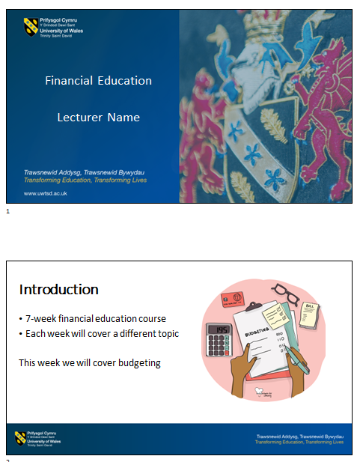
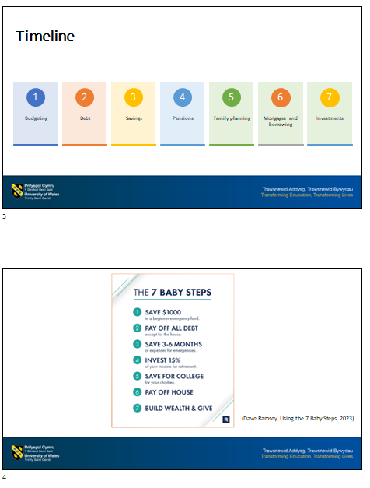
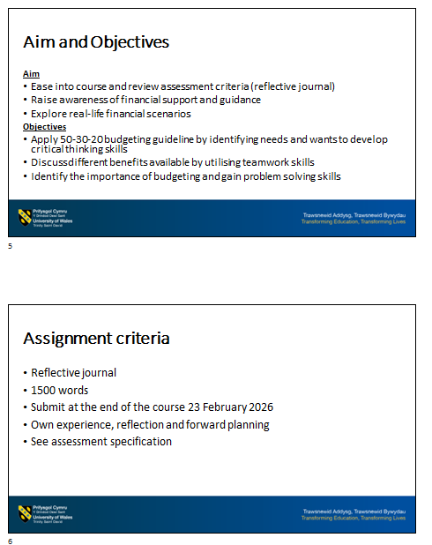
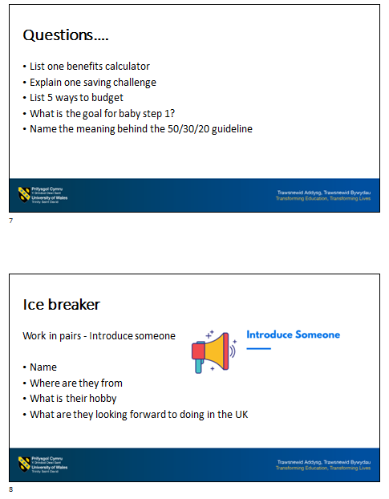
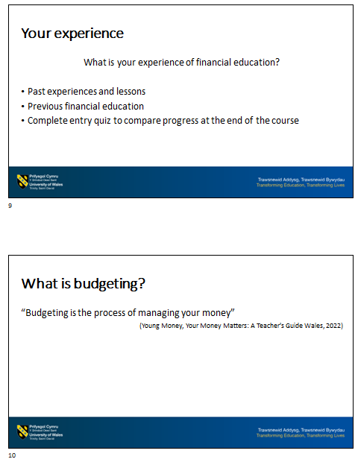
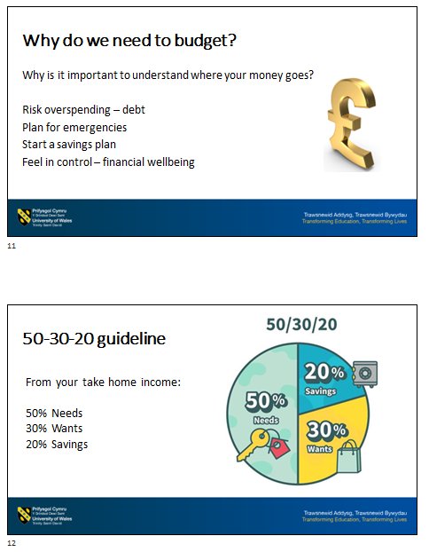
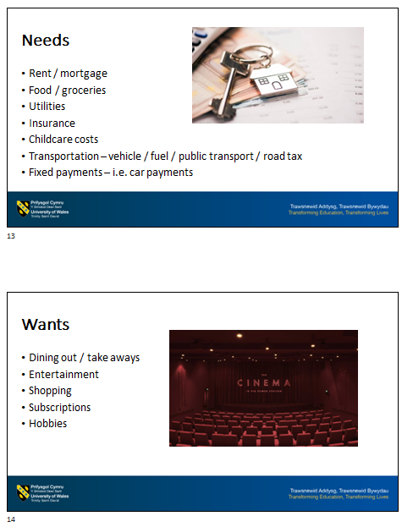
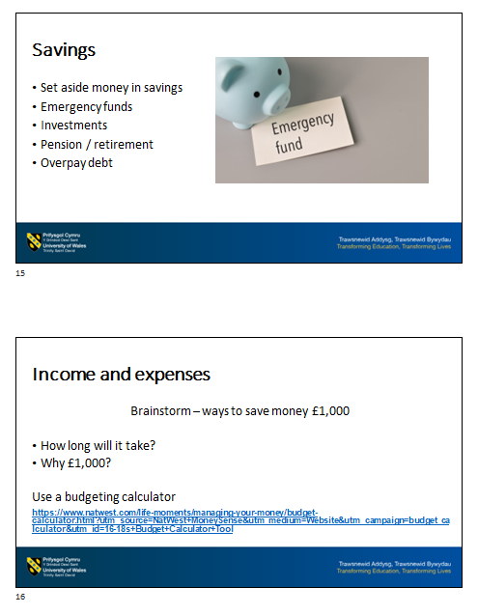
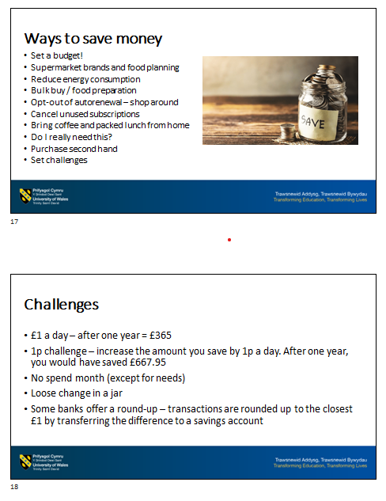
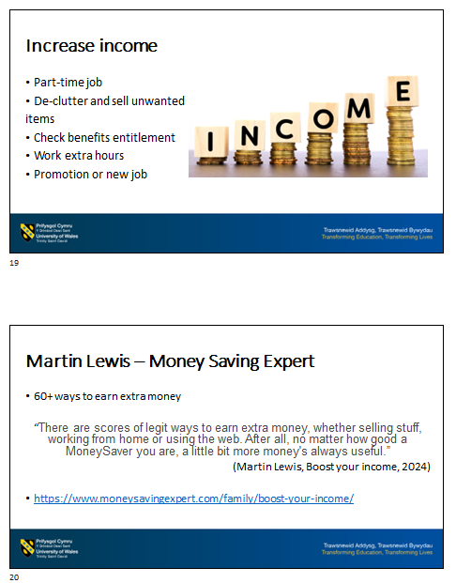
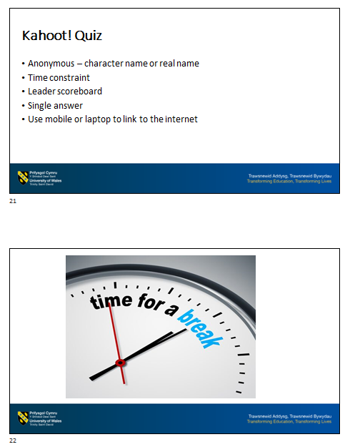
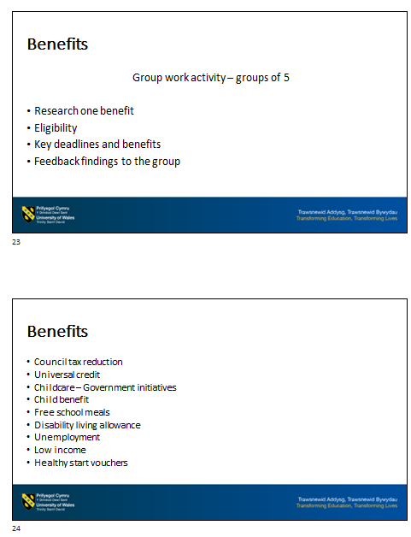
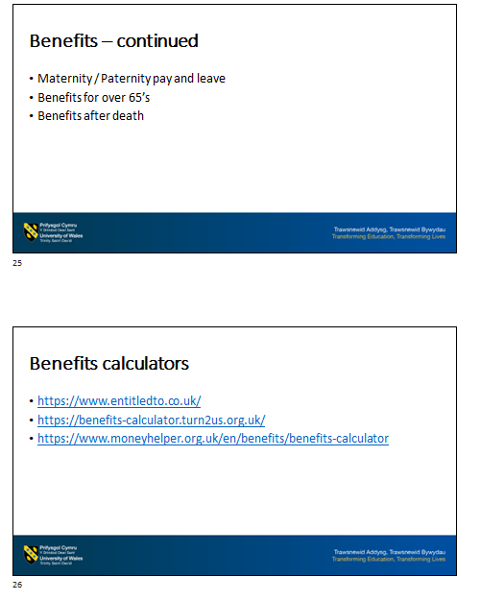
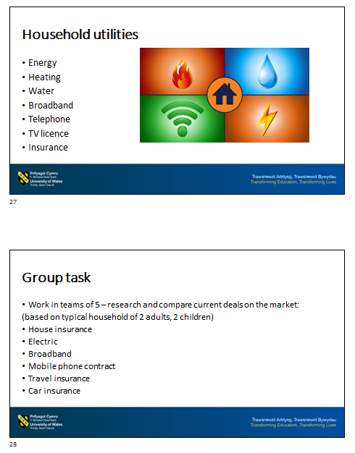
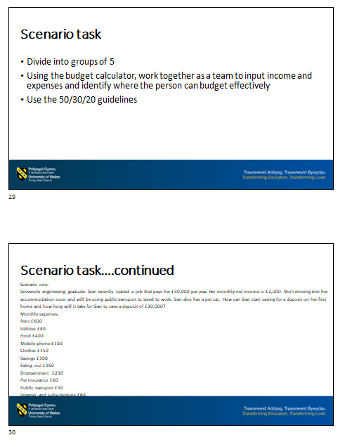

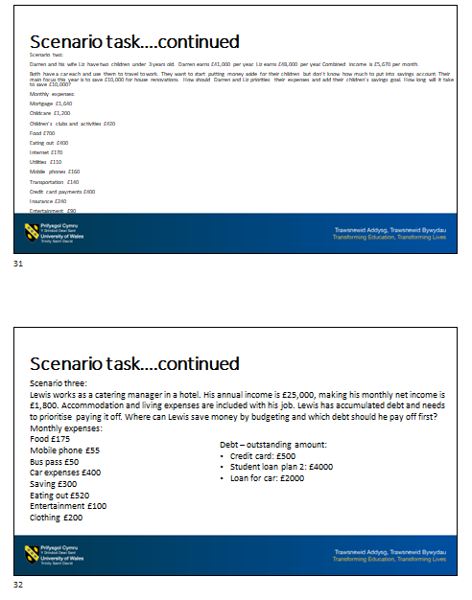
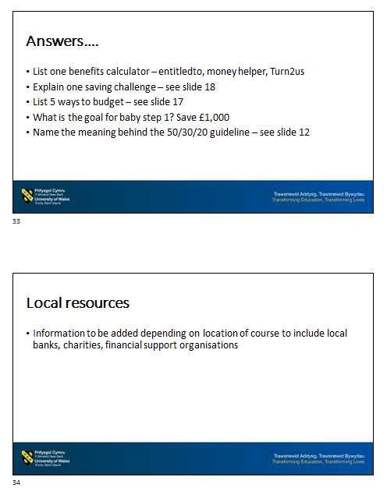
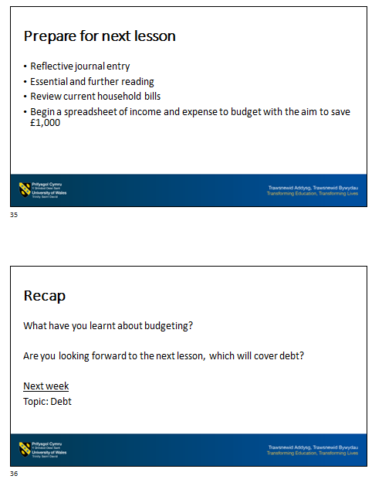
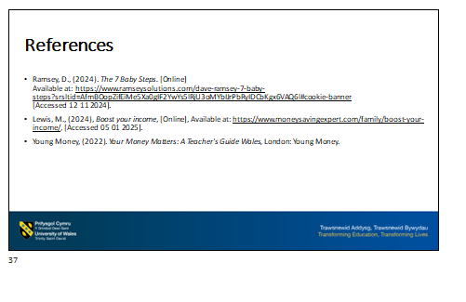

Entry Student Questionnaire – Financial Education
In 2026, the University launched its first Financial Education course. In order to manage expectations and monitor progression along with feedback, students are asked to complete an entry and exit questionnaire as part of the course. This will also help us improve facilities and teaching content for future students.
Student Number:

Did you experience Financial Education before enrolling on this course? | Y / N
If yes, in what capacity?
Have you used external organisations to help with personal finances? | Y / N
If yes, in what capacity?
 | Agree | No preference | Disagree
I prefer the course being taught face-to-face as appose to online / distance learning
I believe the course gives an overview of topics relevant to money management
I hope to relate the topics of money management to my own personal finances
Financial Education courses should be widely available to the public
Lack of knowledge and experience of financial management was one factor of enrolling onto the course
I look forward to using different sources as part of the learning process, from budget calculators to quizzes
I want to use the knowledge and information obtained in the course for long term financial goals
I would like further information on future courses relating to financial management

Any other comments or suggestions
_________________________________________________________________________________________________________________________________________________________________________________________________________

Please return the Entry Student Questionnaire to your lecturer

Kahoot! Budgeting Quiz
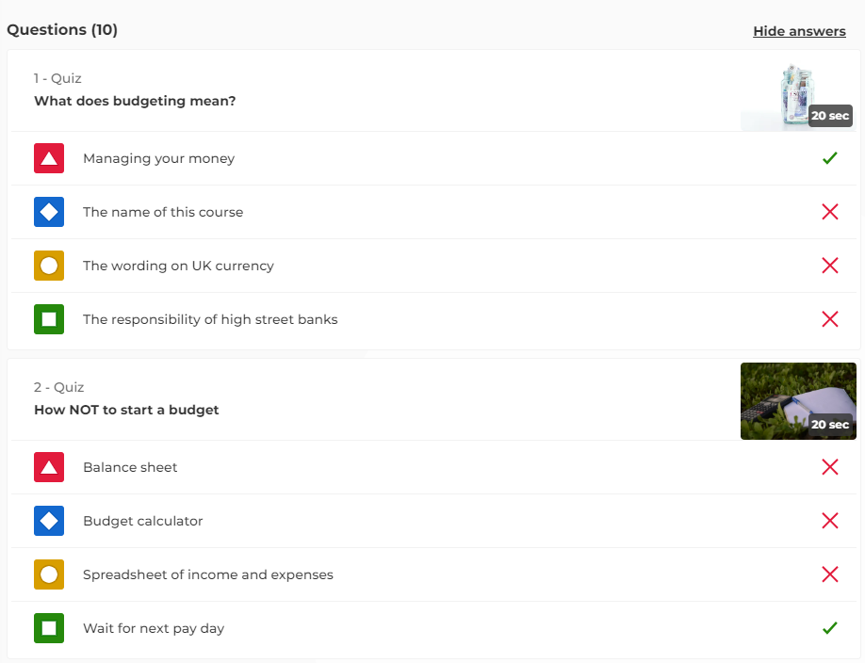
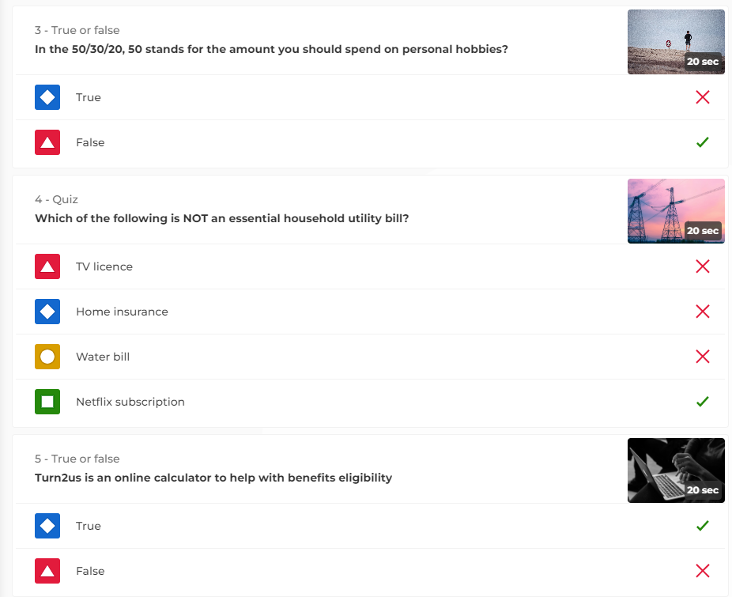
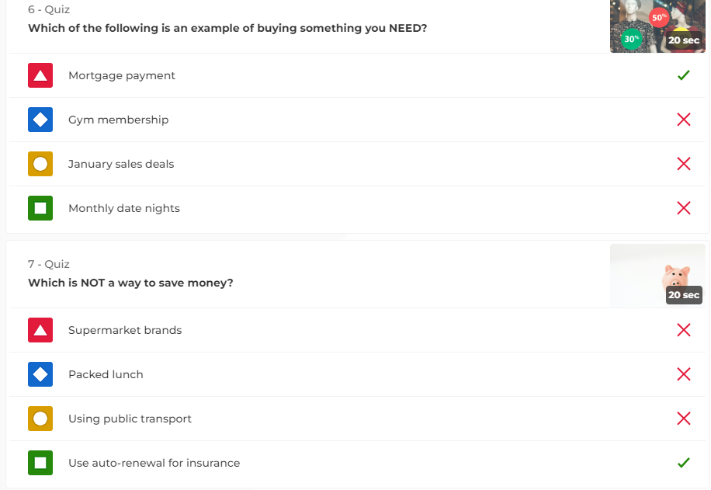
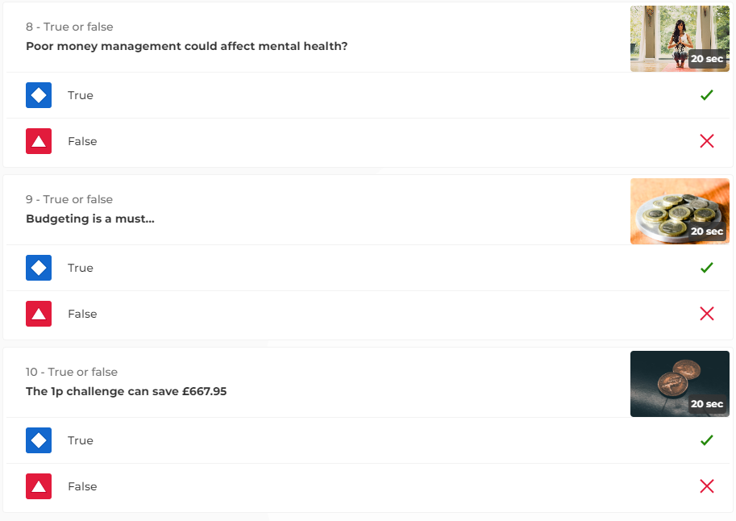

Lesson 3

Lesson Plan

Topic: Savings |  | Class: 7-week short course
Date: 19th January 2026 | Length of lesson: 5 hours |  | Number of students: 30
Resources required:
PPT facilities
PC and screen
Lecture room
Pen and paper
Flip chart
Internet access for Vevox
Aim of Lesson
- Explore importance of savings
- Become familiar with financial literacy
- Know the difference between various savings accounts
Learning Outcomes – The Learners Should Be Able To:
- Discuss the concept of ‘rainy day’ and becoming a ‘Super Saver’
- Review financial terminology by developing literacy skills
- List current offerings available on the market using decision making skills
Previous student knowledge required for the session:
Students have limited or no prior experience of the topic
Anticipated difficulties (if applicable):
Financial knowledge – avoid using acronyms
Teaching style – community course – students may not be familiar with formal teaching settings. Students may be reluctant to participate or ask questions as financial matters can be personal
Professional Standards (where are these being met within the session)
In my practice and with others, I will:
- Enable learners to share responsibility for their own learning and assessment by working with all learners to empower them to set challenging goals and targets and to evaluate their own progress against these by communicating effectively with all learners, employers and others as appropriate
- Demonstrate dignity, courtesy and respect towards others by listening to and respecting other peoples’ views, opinions and ideas by acting as a role model for fair, courteous and respectful behaviours supporting the wellbeing of learners and colleagues, seeking support where necessary
- Maintain and update knowledge of my subject(s) and how best to teach and assess them by keeping abreast of my subject or vocational area and of effective teaching and assessment methods by using assessment of and for learning to support learner progress

Lesson Detail:

Stage | Focus | Strategy | Time
Introduction  Development  Plenary/conclusion | Greet students and outline todays lesson  Previous week students - get feedback of their experience.  Dave Ramsey theory and plan. Save 3 – 6 months of expenses.  Personal saving allowance  Break  Interest rates, inflation rate, annual equivalent rate (AER) and annual percentage rate (APR)  Types of saving accounts – fixed, instant, cash ISA (individual savings accounts), premium bonds  Recap today’s lesson and explain next week lesson. Encourage students to ask questions | Take register. PPT slides review of previous week and outline of todays lesson.  Q&A session.  Explore and discuss concept of ‘rainy day’ and becoming a ‘Super Saver’.  Group task – reasons to save – doodle mind mapping  Break  Work in pairs. Define and present the terms.  Comparison charts – list different types of savings account along with advantages and restraints. Poll assessment using Vevox.  Q&A Session  PPT explaining next week topic. | 10 mins  15 mins  30 mins  60 mins  30 mins  60 mins  60 mins  35 mins

Assessment Strategies: when and how are they included within the lesson?
At the beginning of the lesson – gather students feedback on previous lesson.

Middle of the lesson – doodle mind mapping and polls assessment.

At the end of the lesson - Q&A session to recap the lesson and encourage students to ask questions to gather feedback. Ensure topic has been thoroughly completed before moving onto next week’s session.

Informal reflection (to be completed after the session)

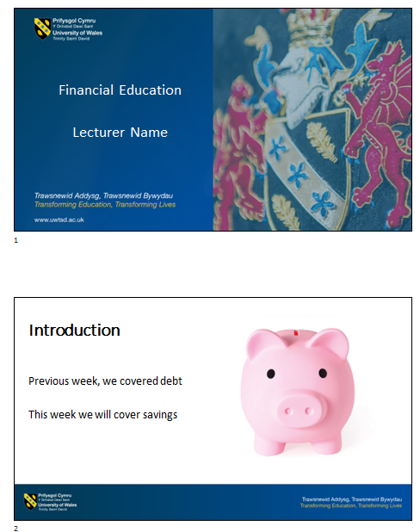
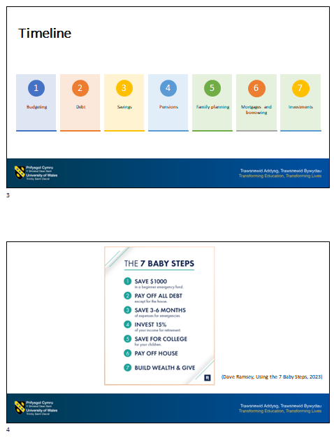
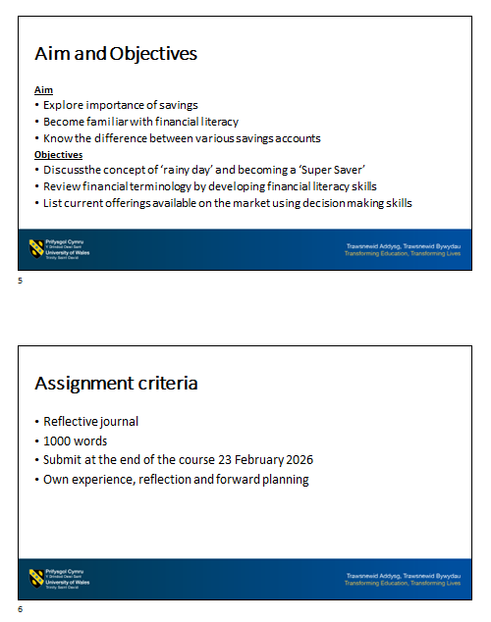
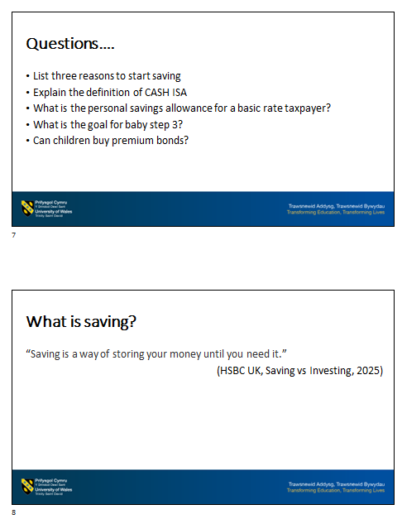
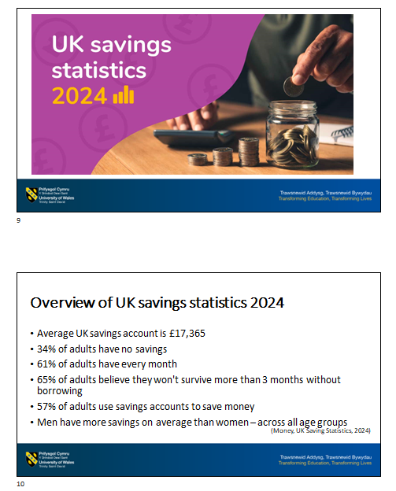
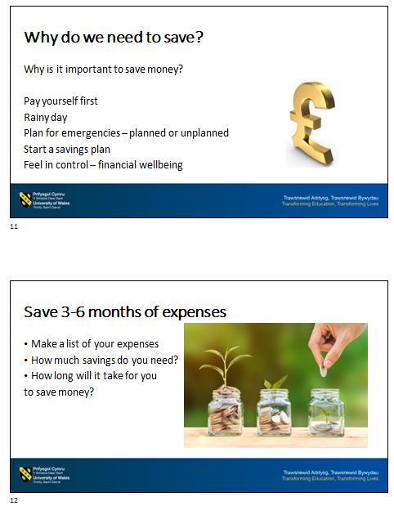
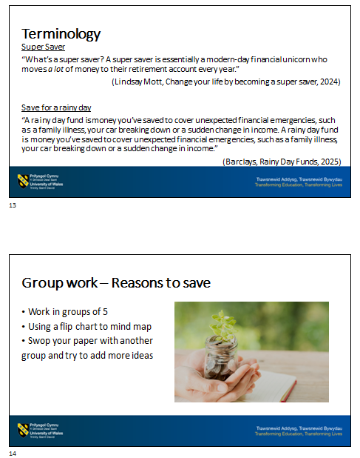
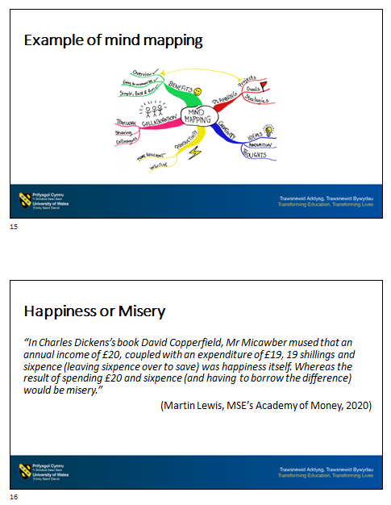
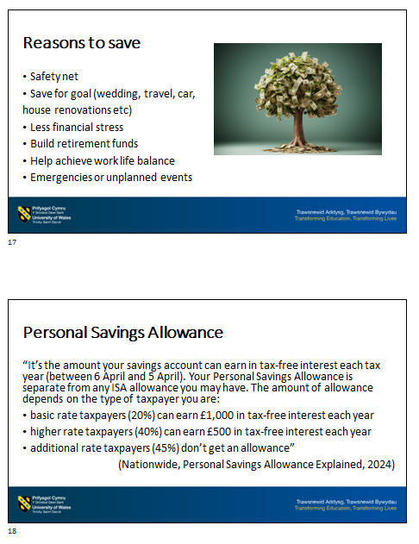
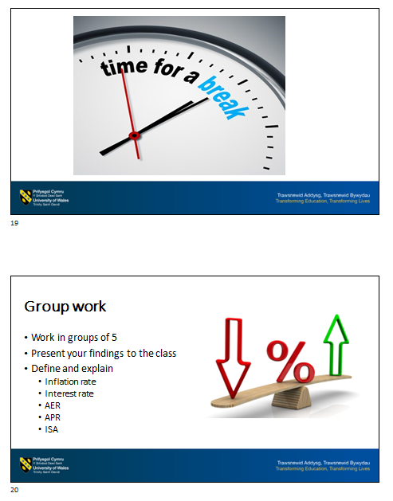

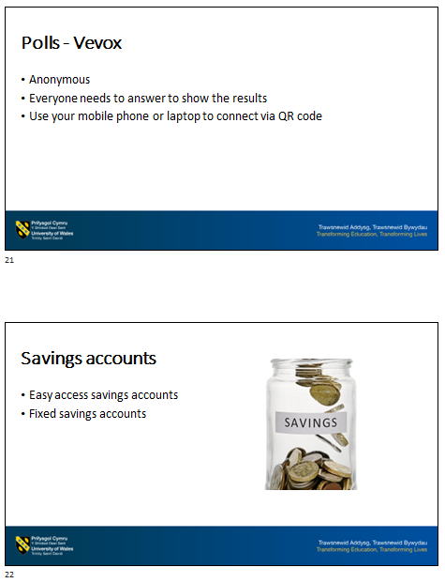

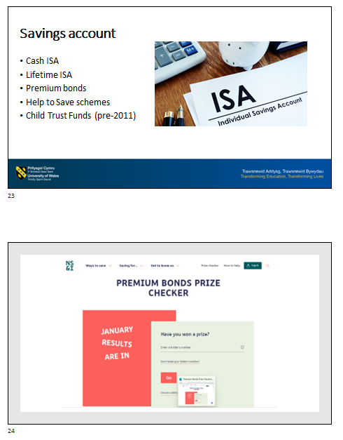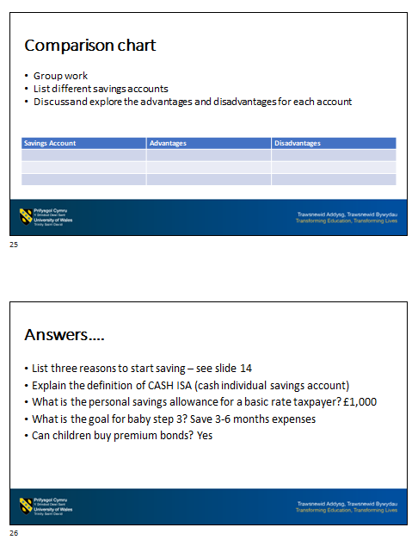
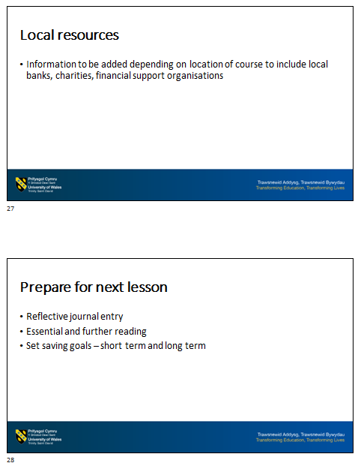
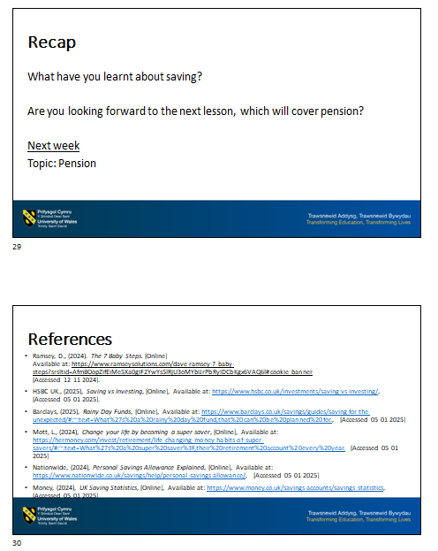
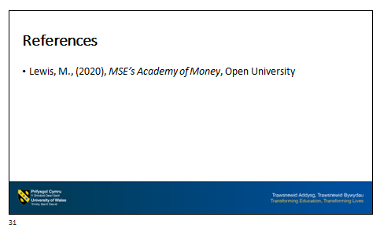

Poll Assessment (Vevox)
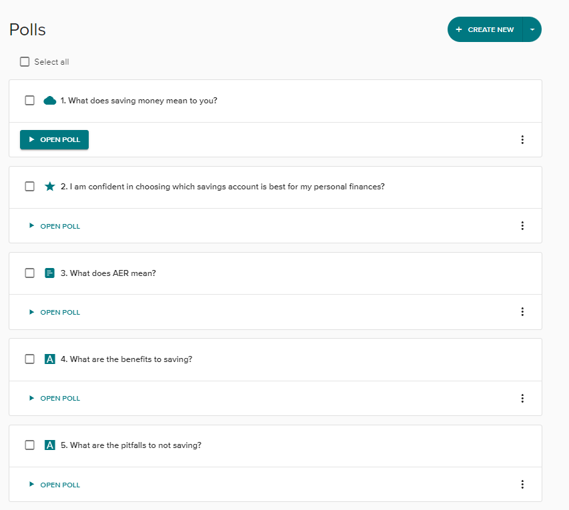

Appendix 2 – Assessment specification and benchmarking

ASSESSMENT SPECIFICATION
Student name: |  | Student ID number:
Programme: | Financial Education
Assignment Title: | Reflective journal | Word count (or equivalent): | 1500 words
Submission deadline: | 23 February 2026 | Return date of provisional marks & written feedback: | 9 March 2026
Submission method: | All written assessments, where practical and possible, must be submitted via Turnitin unless otherwise instructed by the Lecturer. (Please DO NOT put this assessment specification into Turnitin or it will match many similarities with other students’ submissions.)  Alternative submission method (if applicable):  Late submission of the assessment will result in a late penalty mark. Penalties for late submission: Up to one week late, maximum mark of 40%. Over one week late, 0%. Only the Extenuating Circumstances Panel may approve a change to submission dates.
Academic honesty / referencing: | Academic honesty is required. In the main body of your submission, you must give credit to authors on whose research and ideas your work is based. Append to your submission a reference list that indicates the books, articles, etc. that you have used, cited or quoted in order to complete this assessment.
Learning Outcomes
On completion of this course, students will be able to:
- Demonstrate effective money management techniques
- Explain key financial decisions by drawing up a simple plan for future planning
- Confidently analyse own financial decisions and develop financial targets

Reflective Journal
Students will be required to collate and monitor their own learning progression throughout the course as they navigate through the seven topics covered on the course.

There is no specific word count for each topic, only an overall word count of 1500 words or equivalent. The reflective journal may consist of additional information such as diagrams, worksheets or images that reflect the students learning. Students are required to write a reflective journal that captures the following elements:
- Reflect and document the professional learning gained
- Reflections on the feedback obtained from the lecturer and peers throughout the course.

- Student FEEDBACK FORM  - Generic Assessment Criteria | Marks available | Marks  awarded
Knowledge and Understanding Skills

 | 25
Cognitive and Intellectual Skills

 | 25
Practical and Professional Skills

 | 25
Transferable Key Skills

 | 25

Assessment Mark  Contribution to overall assessment: 100% | Late Submission Penalties (tick if appropriate) | %
Assessment Mark  Contribution to overall assessment: 100% | Up to 1 week late (40% Max) | %
Assessment Mark  Contribution to overall assessment: 100% | Over 1 week late (0%) | %

Entry level | FAIL | PASS | GOOD | EXCELLENT
Category | 0-30% | 31-50% | 51-70% | 71-100%
Knowledge and understanding | No awareness of knowledge or understanding. | A few examples of knowledge and understanding but with a need to expand. | Good range of knowledge and understanding of relevant financial guidelines. | Excellent demonstration of knowledge and understanding with detailed reflection and future planning.
Cognitive and intellectual skills | No development of cognitive or intellectual skills. | Limited attempt of reflection on cognitive or intellectual skills. | Good range of skills with evidence included. Clear need to expand reflection to achieve a wider range of skill set. | Excellent demonstration obtained with in-depth reflection on the cognitive and intellectual skills achieved.
Practical and professional skills | No use of practical or professional skills. | Weak use of practical and professional skills with a clear need to develop further. | Straightforward evidence demonstrating the skills achieved but with the need to go further in-depth with reflection. | Well established skill set showing reflection on how each skill was achieved and will be utilised in the future.
Transferable key skills | No evidence of transferable key skills. | Poorly presented reflection of the set of skills. | Most transferable key skills obtained but shows minor gaps. | Clear and concise evidence demonstrating a full range of transferable key skills obtained.

Appendix 3 - Confirmation of Attendance documentation


CONFIRMATION OF ATTENDANCE

Financial Education Programme
Short Course

It is hereby certified that

_____________XXXX XXXX_______________

has taken part in Financial Education training between the following dates

05/January/2026 and 16/February/2026

delivered by the Institute of Management and Health

______________________________________

Date:
Signature:
Title/position of signatory:
Stamp of institution:

References
Ashwin, P., Boud, D., Calkins, S. & Coate, K., (2022). Reflective Teaching in Higher Education. 2nd ed. London: Bloomsbury Publishing Plc.
Bank of England, (2024). The financial crisis - 10 years on. [Online]
Available at: https://www.bankofengland.co.uk/news/2018/september/the-financial-crisis-ten-years-on#:~:text=What%20happened%2C%20and%20what%20has,global%20financial%20system%20and%20beyond.
[Accessed 25 11 2024].
Blue, L. & Grootenboer, P., (2019). A praxis approach to financial literacy education. Journal of Curriculum Studies, 51(5), pp. 755-770.
Bolton, G. & Delderfield, R., (2017). Reflective Practice: Writing and Professional Development. 5th ed. London: SAGE Publications Ltd.
Brader, C., (2024). Financial education in schools. [Online]
Available at: https://lordslibrary.parliament.uk/financial-education-in-schools/#ref-9
[Accessed 25 11 2024].
Building Societies Association, (2024). UK Savings Week reveals that more than one in four Brits are missing out on over £800 in savings interest. [Online]
Available at: https://www.bsa.org.uk/media-centre/press-releases/uk-savings-week-reveals-that-more-than-one-in-four-brits-are-missing-out-on-over-%C2%A3800-in-savings-int
[Accessed 12 11 2024].
Carmarthenshire County Council, (2024). Adult Learning Courses. [Online]
Available at: https://www.carmarthenshire.gov.wales/council-services/education-schools/adult-learning-courses/
[Accessed 12 11 2024].
Change Mental Health, (2024). new year resolutions and mental health. [Online]
Available at: https://changemh.org/resources/new-years-resolutions/
[Accessed 09 12 2024].
Dave Ramsey, (2023). Using the 7 Baby Steps. [Online]
Available at: https://www.ramseysolutions.com/debt/how-to-stay-motivated-while-paying-off-debt
[Accessed 09 12 2024].
Duckworth, V., (2014). How to be a Brilliant FE Teacher: A practical guide to being effective and innovative. London: Routledge.
FinTech Finance, (2024). Majority of UK Adults Received No Financial Education in School, as Many Struggle to Manage Household Finances. [Online]
Available at: https://ffnews.com/newsarticle/fintech/majority-of-uk-adults-received-no-financial-education-in-school-as-many-struggle-to-manage-household-finances/
[Accessed 03 01 2025].
Forsyth, R., (2023). Confident Assessment in Higher Education. London: SAGE Publications Ltd.
Gardner, J., (2012). Assessment and learning. 2nd ed. London: SAGE Publications Ltd.
Ghafoor, K. & Akhtar, M., (2024). Parents’ financial socialization or socioeconomic characteristics: which has more influence on Gen-Z’s financial wellbeing?. Humanities and Social Sciences Communications, Volume 522.
Go Henry, (2022). Financial milestones for kids: An age-by-age guide. [Online]
Available at: https://www.gohenry.com/uk/blog/financial-education/financial-milestones-for-kids-an-age-by-age-guide
[Accessed 02 01 2025].
Gravells, A., (2017). Principles and Practices of Teaching and Training: A Guide for Teachers and Trainers in the FE and Skills Sector. London: SAGE Publications Ltd.
Kent County Council, (2024). Kent Libraries offer free course to help residents with personal finances. [Online]
Available at: https://news.kent.gov.uk/articles/kent-libraries-offer-free-course-to-help-residents-with-personal-finances
[Accessed 12 11 2024].
Mind, (2024). Money problems can affect your mental health. [Online]
Available at: https://www.mind.org.uk/information-support/tips-for-everyday-living/money-and-mental-health/the-link-between-money-and-mental-health/#money-can-affect-mental-health
[Accessed 12 11 2024].
Money and Pensions Service, (2024). Financial education supporting material for schools in Wales. [Online]
Available at: https://maps.org.uk/en/publications/research/2024/financial-education-supporting-material-for-schools-in-Wales#:~:text=The%20UK%20Strategy%20for%20Financial,meaningful%20financial%20education%20by%202030.
[Accessed 16 11 2024].
Money Helper, (2024). How to reduce borrowing on credit. [Online]
Available at: https://www.moneyhelper.org.uk/en/everyday-money/credit/should-i-save-or-pay-off-debt
[Accessed 02 01 2025].
Money Wellness, (2024). Financial Awareness Day – four out of five say financial education could have helped them avoid problem debt. [Online]
Available at: https://www.moneywellness.com/blog/financial-awareness-day-four-out-of-five-say-financial-education-could-have-helped-them-avoid-proble
[Accessed 12 11 2024].
Open Wage, (2022). Financial literacy and financial education: What’s the difference?. [Online]
Available at: https://openwage.com/financial-literacy-and-financial-education-whats-the-difference/#:~:text=Financial%20education%20is%20the%20process,education%20goes%20beyond%20practical%20actions.
[Accessed 02 01 2025].
Oxfordshire Mind, (2023). New Years Resolutions: What are the numbers and how do we achieve our goals?. [Online]
Available at: https://www.oxfordshiremind.org.uk/new-years-resolutions-what-are-the-numbers-and-how-do-we-achieve-our-goals/
[Accessed 09 12 2024].
Pembrokeshire County Council, (2022). Adult Learning Courses. [Online]
Available at: https://www.pembrokeshire.gov.uk/adult-learning-courses
[Accessed 12 11 2024].
Race, P., (2020). The lecturer's toolkit: a practical guide to assessment, learning and teaching. 5 ed. Oxon: Routledge.
Race, P. & Pickford, R., (2007). Making Teaching Work 'Teaching Smarter' in Post-Compulsory Education. London: SAGE Publications Ltd.
Ramsey, D., (2024). The 7 Baby Steps. [Online]
Available at: https://www.ramseysolutions.com/dave-ramsey-7-baby-steps?srsltid=AfmBOopZifEiMe5Xa0gIF2YwYs5lRjU3oMYbIJrPbRyIDCbKgx6VAQ6l#cookie-banner
[Accessed 12 11 2024].
Reece, I. & Walker, S., (2007). Teaching, Training and Learning A Practical Guide. 6th ed. Sunderland: Business Education Publishers Limited.
Reece, I. & Walker, S., (2009). Teaching, training & learning. 6th ed. Tyne and Wear: Business Education Publishers Limited.
Resolution Foundation, (2024). Families need help in rising to the ‘triple savings challenge’ of saving more for rainy days, bigger life events and retirement. [Online]
Available at: https://www.resolutionfoundation.org/press-releases/families-need-help-in-rising-to-the-triple-savings-challenge-of-saving-more-for-rainy-days-bigger-life-events-and-retirement/
[Accessed 12 11 2024].
Savard, A. & Cavalcante, A., (2021). Financial Numeracy in Mathematics Education. Switzerland: Springer International Publishing.
Surviving Domestic Abuse, (2025). What is economic abuse?. [Online]
Available at: https://survivingeconomicabuse.org/what-is-economic-abuse/
[Accessed 02 01 2925].
Swansea Council, (2024). Adult Education - Lifelong Learning. [Online]
Available at: https://www.swansea.gov.uk/lifelonglearning?lang=en
[Accessed 09 12 2024].
The Open University, (2023). Managing my money for young adults. [Online]
Available at: https://www.open.edu/openlearn/money-business/personal-finance/managing-my-money-young-adults/content-section-overview?active-tab=description-tab
[Accessed 16 11 2024].
The Open University, (2024). Certificate of Higher Education in Economics and Personal Finance. [Online]
Available at: https://www.open.ac.uk/courses/economics/certificates/certificate-of-higher-education-in-economics-and-personal-finance-t36
[Accessed 16 11 2024].
UK Parliament, (2024). Rising cost of living in the UK. [Online]
Available at: https://commonslibrary.parliament.uk/research-briefings/cbp-9428/
[Accessed 03 01 2025].
University of Edinburgh, (2024). Reflective Journals. [Online]
Available at: https://institute-academic-development.ed.ac.uk/learning-teaching/staff/assessment/online-remote/types/reflective-journals
[Accessed 05 01 2025].
Wales Centre for Public Policy, (2022). Poverty and Social Exclusion: Review of household debt. [Online]
Available at: https://www.wcpp.org.uk/wp-content/uploads/2022/09/Household-debt-policy-briefing.pdf
[Accessed 02 01 2025].
Welsh Government, (2022). Welsh Index of Multiple Deprivation 2019: analysis relating to areas of deep rooted deprivation. [Online]
Available at: https://www.gov.wales/sites/default/files/pdf-versions/2022/8/2/1660655653/welsh-index-multiple-deprivation-2019-analysis-relating-areas-deep-rooted-deprivation.pdf
[Accessed 09 12 2024].
Welsh Government, (2023). Professional standards for further education teachers, work-based learning practitioners and adult learning practitioners in Wales. [Online]
Available at: https://hwb.gov.wales/api/storage/c08350b0-22e5-4d12-ba0d-544abb35ba95/Professional%20standards%20for%20FE%20%20WBL%20and%20ACL%20Practitioners%20-%20June%202023%20%28E%29.pdf
[Accessed 12 11 2024].
William Sturges Solicitors, (2022). Seven reasons why you need to review your Will every five years. [Online]
Available at: https://www.williamsturges.co.uk/seven-reasons-why-you-need-to-review-your-will-every-five-years/
[Accessed 29 11 2024].
Young Money, (2022). Your Money Matters: A Teacher's Guide Wales, London: Young Money.
Young Women's Trust, (2024). New survey shows a gender imbalance around financial worries. [Online]
Available at: https://www.youngwomenstrust.org/media-centre/new-survey-shows-a-gender-imbalance-around-financial-worries/#:~:text=As%20the%20cost%20of%20living,debt%20%27all%20the%20time%27.
[Accessed 02 01 2025].

