Sophie Pitcock
P150414
BA Hons Illustration

Contextual practice
Louise Burston and Sarah Tombs
Word Count: 2035

“How do we remember? Using at least three examples, discuss the social, political and historical aspects of commemoration.”

Within this assignment the art of commemoration will be discussed, having a comprehensive look at the social, political and historical aspects behind it in hope to answer the question ‘How do we remember?’
The dictionary definition of commemoration describes it as “the act of honouring the memory of or serving as a memorial to someone or something.” This tells us that generally the act of commemoration is a way of paying tribute to those who have had a part to play in the significant historical events in our cultures history.
Bill Murphy once stated “Remembering our collective past, and especially those who gave up on their futures so we can enjoy our futures, is very important.” This suggests that commemoration is an integral part of the human experience. It is a way of honouring those who have made our lives easier to live through sacrificing their own.
Each county has its own unique events that it celebrates and different ways of going about this. This differs depending on the history of that country, religious and political convictions and the cultural background of the people living there. This difference can be highlighted when looking at religious commemorative events celebrated around the world. For example, Diwali in India, Dia de los Muertos in Mexico and Semana Santa in Guatemala. Even though these celebrations stand to signify something different for each culture and religion, the underlying themes surrounding the celebrations remains the same. Each of these occasions revolve around inclusive human emotion such as love, loss, joy, despair, achievement and sacrifice.
Seline Shenoy (2016) expressed that:
“It seems that as a species we are instinctually driven to honour the significant moments in our lives. There are deep underlying needs that drive us to engage in celebrations. As a result, we have found so many wonderful ways to meet these needs and create more meaning in our lives.”
By saying this she is suggesting that our need to commemorate things that happen to us collectively is innate as it drives us to live a more fulfilled and connected life with the people around us.
The reasons behind why we do this are vast and varied. By commemorating times of significance as a collective, whether it be to celebrate or to mourn, brings us closer together and provides us with a sense of unity. We celebrate the paramount milestones in our lives and the lives of others to give a sense of meaning and significance to our time spent in this world.
J. Winter The Brill Dictionary of Religion (2006) stated that:
“Public commemoration is a matrix of activity, through which social groups express a collective shared knowledge of the past, on which a groups sense of unity is based.”
This tells us that commemoration in a social sense is a community of people gathering to remember the same thing on the same day, and with this we develop a bond through our shared past experiences. An example of this would be Christmas, an event originally started by the Christian faith to celebrate the birth of Jesus. As time has moved on, the original meaning behind celebrating this event has somewhat lost what it stood for and transformed into something slightly different. Less people are celebrating Christmas in a religious sense and are instead using it as a time to create long-lasting fond memories with their loved ones. This can be seen when looking at a few statistics from recent Christmases. It is approximated that last year the U.K. consumed approximately 10 million turkeys but in 2014 only 2.4 million people attended a festive Church of England service. These statistics suggest that there are more people partaking in the social aspect of celebrating the festive period than the religious aspect, which were the primary origins for this commemorative event.
J. Winter (2001) wrote:
“All forms of public commemoration have a half-life; the initial charge that they bear diminishes when those who create it move away, grow old, or turn to other interests. Then newcomers take over and transform an event within one context into another.”
This supports the idea that the original meaning behind commemorative events has the ability to change and adapt through different generations as time goes on. Another example of this occurring is the Pagan holiday of May Day, where dancing around a maypole and Morris dancing were a way of celebrating love and romance on the first day of May. Because of the celebrations strong roots in the Pagan religion, when Paganism became less popular, fewer and fewer people began to celebrate May day in the same way that it was originally celebrated.
The change in our overall religious views brought change in the social commemorative events that we celebrate throughout the year. As time moves on, so do our views, memories and commemorations.
When you look at the act of commemoration in a political sense rather than a social sense the general themes shift from those of celebration to memorial. For example, on Remembrance day we wear poppies to symbolise the memory of sacrifices made by soldiers in past wars. By wearing the poppy it serves as a reminder of the awful things that happened politically within our country and to not let them happen again.
A. Whitmarsh (2001) declared that:
“The twentieth century saw the development of commemorative traditions: customs and narratives by which individuals, groups and nations remember, commemorate and attempt to resolve memories of the traumatic experience that is war.”
This could suggest that by commemorating the distressing things that have happened to our country, it can provide the people involved with a bit of closure. By everyone standing together to remember the people who sacrificed their lives for ours, it shows a collective appreciation for those people. By remembering that these horrible situations happened, it makes the original events a little bit more bearable to emotionally deal with.
There is also a certain social pressure that goes hand in hand with political commemoration. For example, if you were not to wear a poppy on Remembrance day this may be viewed as a political statement against the troops and everything they did. To avoid confrontation people may join in with this commemoration and that’s what carries it on.
Dr Dominic Bryan (2016) specified that:
“Commemoration of historical events has important current political relevance… where contested events from the past have the potential to both upset and enhance community relations”
This tells us that political commemoration could also cause protest. For example, in Christchurch on Anzac day in 1967 a protest wreath was placed as a way of protesting the people’s views opposing the Vietnam war. Ten years later more protest arose when another wreath was laid by a women’s group in memory of the women that were raped and killed during the war. It was felt that the protestors were dishonouring the memorial by turning the day into a platform to voice their political opinions. As a result, Anzac day is a day of both commemoration and a celebration of nationhood. They now claim that they debate defence against war related issues to avoid the need to build war memorials in the future.
Sir Seretse Kgama President of Botswana proclaimed that:
“A nation without a past is a lost nation and a people without a past is a people without a soul.”
This suggests that because we have a past it completes us in some way, and to remember this past pays respect to our ancestors who made history for our culture. Celebrating and commemorating our past is a way of building a collective memory and develops a social unity, it brings us together as a nation.
Public holidays and national events are a way of commemorating historical significance. An example of this would be Guy Falkes night. Every year we join together and set off fireworks to remember one specific night in our nation’s history where one man’s plans to overthrow the government and monarchy failed.
An English folk verse was created proceeding the event (c.1870):
“Remember remember the fifth of November
Gunpowder, treason and plot
I see no reason why gunpowder treason
Should ever be forgot.”
Teaching these nursery rhymes to our children is an act of commemoration in itself, that along with actually celebrating the event every year helps us to teach the generations below us the defining moments in our nation’s history whilst still coming together and having a good time.
Art is a medium that can be used to express people’s commemorative views. For example, to mark a century since the start of World War one, in July 2014 street theatre company Royal de Luxe created giant marionettes and walked them through the city of Liverpool. The art piece was titled ‘Memories of 1914.’
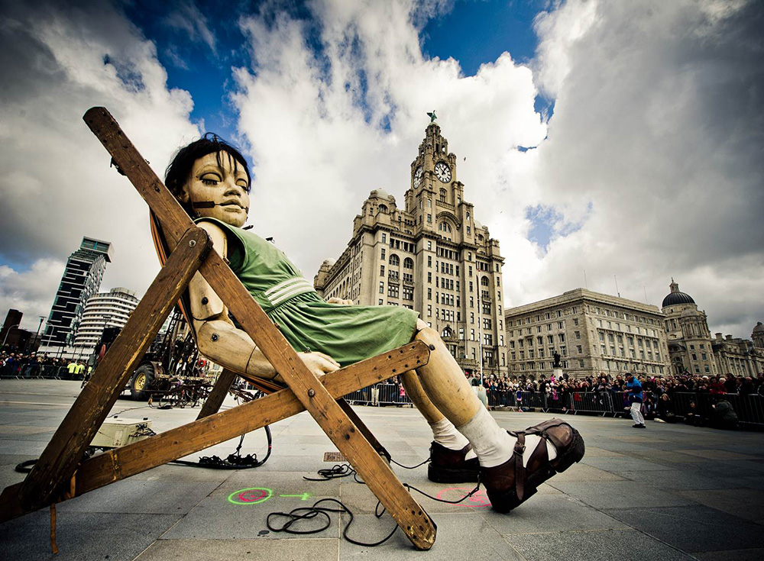
Clausen, A. (2014). Memories of 1914. [image]
Commemorating crucial moments in time through the medium of art engages with us in a far more significant way than any other form of commemoration would be able to. This is due to the fact that it is so visual, we can see it and its tangible and this makes the reasoning behind the experience far easier to emotionally process.
Another act of commemoration that has been shown through the use of art is that of the Holocaust survivors. By creating a self-portrait in relation to a specific moment in time the artist is encapsulating their emotions indefinitely, we then as the viewer can look back on and remember what caused them to look this way.
Self-portraits are an extremely intimate form of art as they can express a plethora of information, including how the artist was feeling, the state that their mind was in and what was going on in their life at the time.
Sheryl Silver Ochayon commented on these self-portraits saying:
“At times, rather than expressing identity in a recognizable form, they express a jarring loss of identity, the result of the trauma experienced by the artist.”
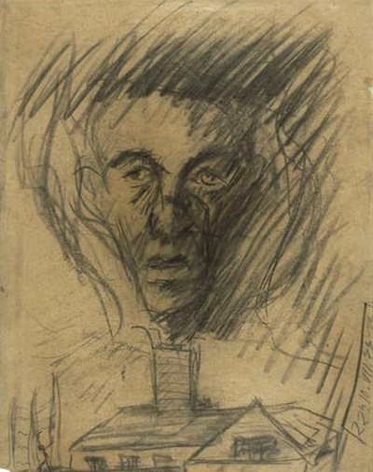
“Yehuda Bacon (b.1929), In Memory of the Czech Transport to the Gas Chambers. 1945. Charcoal on paper”
The portrait shows a face that comes across as gaunt and exhausted rising from a chimney, presumably a gas chamber. By creating this art, it makes the memory of the event live on, commemorating the thousands of deaths that happened in this way. It ensures that the lives of many mistreated people won’t be forgotten.
We see a human face in front of us, making the image instantly recognisable and relatable. Powerful imagery is used causing the piece to be hard to dismiss and easily memorable. The paramountcy of importance of this art work is highlighted when taking into account that the artist was only sixteen when he created this dark and comfortless piece. It reminds us of the awful things that happened to the innocent, and how we cannot let them happen again.
We also create art to commemorate and celebrate important figures in our history. For example, the Oscar Wilde memorial in Merrion square, Dublin 1997 by Danny Osbourne.
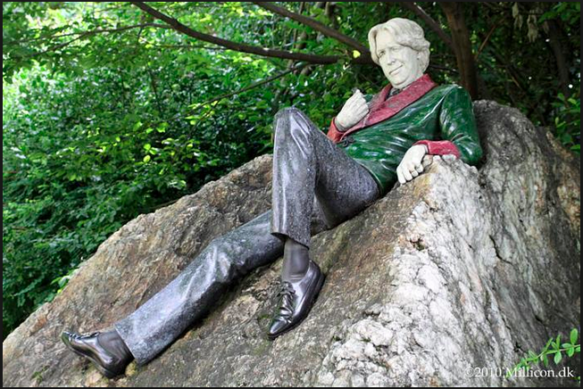
The Oscar Wilde Memorial In Merrion Square (Dublin) 1997 by Danny Osborne The materials are granite, green nephrite jade, white jadeite and thulite.
The statues green jacket is carved from nephrite Jade, the pink collar from the semi-precious stone Thulite and the head and hands from Guatemalan Jade. This use of precious stone could represent the affluence and enrichment that Wilde brought to our culture. The pose captures his playful and colourful personality and really encapsulates his memory in a sentimental and appreciative way. It is an artwork that outlives the person that it illustrates and therefore commemorates his memory for generations after to see.
To conclude, we remember in a number of ways for a variety of different reasons. The human race is a complex and diverse species. We honour the events and people that we deem important to us through creating traditions, ceremonies and art that ultimately out lives the circumstance we intend to remember; and that is something that naturally comes from deep within all of us.

Bibliography
Anon, (2017). [online] Available at: https://www.thefreedictionary.com/commemoration [Accessed 13 Dec. 2017].
Audley Travel. (2011). Top Festivals Around The World | Audley Travel. [online] Available at: https://www.audleytravel.com/blog/2011/september/top-festivals-around-the-world [Accessed 13 Dec. 2017].
BBC. (2014). BBC Arts - The Art of Commemoration - BBC Arts. [online] Available at: http://www.bbc.co.uk/programmes/articles/1XPVWqHCZ8wlGFxbXHpvw13/the-art-of-commemoration [Accessed 13 Dec. 2017].
Bowes, M. (2017). Christmas Stats and Traditions. [online] British Turkey. Available at: http://www.britishturkey.co.uk/facts-and-figures/christmas-stats-and-traditions.html [Accessed 13 Dec. 2017].
Bryan, D. (2002). [online] Niassembly.gov.uk. Available at: http://www.niassembly.gov.uk/globalassets/documents/raise/knowledge_exchange/briefing_papers/series5/bryan-coleman-.pdf [Accessed 13 Dec. 2017].
Chambers, D. (2016). Explosive Images of Guy Fawkes Day Celebrations. [online] News.nationalgeographic.com. Available at: https://news.nationalgeographic.com/2016/11/guy-fawkes-bonfire-gunpowder-plot/ [Accessed 13 Dec. 2017].
Clausen, A. (2014). Memories of 1914. [image] Available at: https://www.1418now.org.uk/commissions/memories-of-august-1914/ [Accessed 13 Dec. 2017].
Conway, B. (2010). Commemoration and Bloody Sunday. Basingstoke, Hampshire England: Palgrave Macmillan.
Dublincity.ie. (2017). OSCAR WILDE MEMORIAL SCULPTURE | Dublin City Council. [online] Available at: http://www.dublincity.ie/DublinArtInParks/English [Accessed 13 Dec. 2017].
Gillis, J. (2010). Commemorations. Princeton, NJ: Princeton University Press.
Habing, B. (2006, November 3). The Fifth of November - English Folk Verse. Retrieved from http://www.potw.org/archive/potw405.html
Inc.com. (2017). 31 Inspiring Quotes About Why We Remember. [online] Available at: https://www.inc.com/bill-murphy-jr/31-inspiring-quotes-about-why-we-remember.html [Accessed 13 Dec. 2017].
Johnson, B. (2013). May Day Celebrations. [online] Historic UK. Available at: http://www.historic-uk.com/CultureUK/May-Day-Celebrations/ [Accessed 13 Dec. 2017].
Nzhistory.govt.nz. (2017). Commemoration and protest - War and remembrance | NZHistory, New Zealand history online. [online] Available at: https://nzhistory.govt.nz/classroom/war-and-remembrance/commemoration-and-protest [Accessed 13 Dec. 2017].
Ochayan, S. (2017). Commemoration in the Art of Holocaust Survivors | www.yadvashem.org. [online] Yadvashem.org. Available at: http://www.yadvashem.org/articles/general/commemoration-in-the-art-of-holocaust-survivors.html [Accessed 13 Dec. 2017].
Shenoy, S. (2016). 5 Reasons Why it's Important to Commemorate Special Occasions - Project Happiness. [online] Project Happiness. Available at: https://projecthappiness.com/why-its-important-to-commemorate-special-occasions/ [Accessed 13 Dec. 2017].
Sherwood, H. (2016). Church of England weekly attendance falls below 1m for first time. [online] the Guardian. Available at: https://www.theguardian.com/world/2016/jan/12/church-of-england-attendance-falls-below-million-first-time [Accessed 13 Dec. 2017].
South African History Online. (2012). Commemoration of Significant Historical Anniversaries. [online] Available at: http://www.sahistory.org.za/topic/commemoration-significant-historical-anniversaries [Accessed 13 Dec. 2017].
Whitmarsh, A. (2017). "We Will Remember Them" Memory and Commemoration in War Museums. Journal of Conservation and Museum Studies.
Winter, J. (2001). Public Commemoration - International Encyclopedia of the Social & Behavioral Sciences. [online] Sciencedirect.com. Available at: http://www.sciencedirect.com/science/article/pii/B008043076704540X [Accessed 13 Dec. 2017].
Winter, J. (2006). Monument/Memorial Places. [online] Referenceworks.brillonline.com. Available at: http://referenceworks.brillonline.com/entries/brill-dictionary-of-religion/monumentmemorial-places-COM_00292?s.num=5 [Accessed 13 Dec. 2017].
Yisart.wikispaces.com. (2017). yisart - Art and Commemoration. [online] Available at: https://yisart.wikispaces.com/Art+and+Commemoration [Accessed 13 Dec. 2017].

