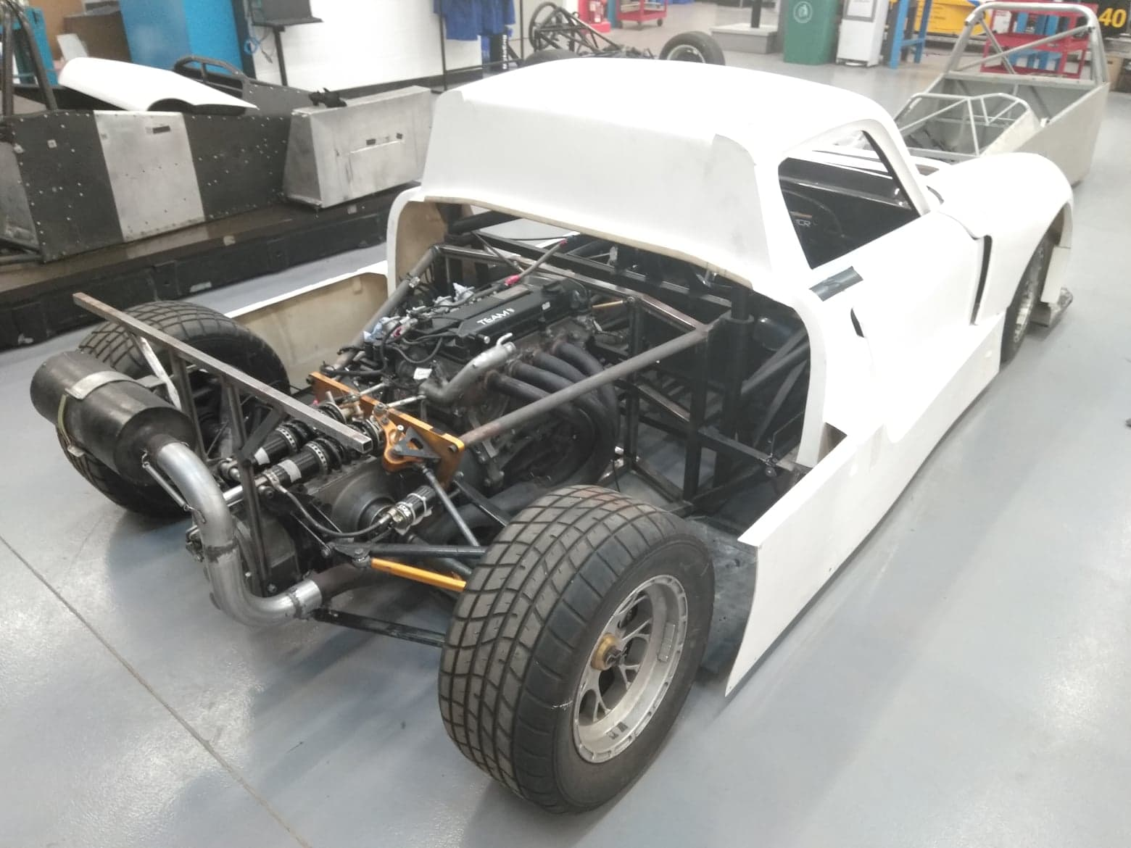  Figure 1.0  Conrod Dynamic Forces  Richard Sutton Lecturer Analytical Methods with Study Skills | Abstract  A conrod is a connecting rod which is attached to the crankshaft and the piston. The main function is to drive the piston up and down the cylinder wall. This report will be evaluating the length, speed of the conrod and the mass weight of the piston. The effects on the engine and materials used will be discussed within this report using factual data from the manufacturers. The conrod forces that are to be focused on is a Ford 2.0 Duratec. A breakdown of the four main processes will look at where and when the demands on the conrod are at its maximum. The forces that are endured on the conrod itself with different RPM values, the mass of the piston and its effects will be evaluated. As the conrod undergoes the different processes, the stresses that are relevant from different factors such as rpm, mass of the piston etc change and impact giving different outcomes.  Steve Patch (1802858)

Acknowledgements:
For information and in-depth knowledge on Ford engines and conrod sizes I wish to thank Russ Wakeling (BEng). from E&M Aberystwyth Branch.

Contents
Acknowledgements: 0
List if figures: 1
Introduction: 1
The conrod travels180degrees up to 720degrees on a full cycle using induction, compression fire and exhaust. Throughout these processes there is varied pressures and side forces on the piston and conrod. 1
Induction 1
Compression 2
Research/literature review: 2
Methodology: 2
Analysis: 2
Conclusion: 2
Recommendations for further study: 2
References: 2
Appendices: 2

List if figures:
Figure 1.0 Image taken by Steve Patch 2018 at UWSTD, Car owned by UWTSD.
Figure 1.1 Image taken from Book Automotive engineering 8 edition (Prof. Dr.-Ing. Konrad Reif, 2011)

Introduction:

The conrod travels 180º up to 720º on a full cycle using induction, compression fire and exhaust. Throughout these processes there is varied pressures and side forces on the piston and conrod which will be seen through generated graphs The firing order is 1,3,4,2 on the Duratec 2.0L engine. The forces that are being evaluated are on number 1 cylinder.

Induction:
The rotation of the crankshaft at 180 degrees half a rotation of the crankshaft. The process of the rotation causes the piston to pull down allowing fuel and air to enter the cylinder. At this stage there is minimal pressure to the conrod no forces are on the piston at this stage apart from minimal rotational force.

Compression:
On the compression stroke, it collects the air and fuel compressing the mixture. It elevates towards the top of the cylinder, between the head and the piston. The pressure on the centre of the piston, gives a downward force on the small end and big end of the conrod.

Firing:
The firing stroke occurs before the top dead centre, as the sparkplug ignites the fuel and air. The explosion causes the most amount of pressure on the conrod, this all happens within the area of the piston and the head. The force that this process onto the big and small end of the conrod is the highest impact.

Exhausts:
The gasses are forced out of the exhaust valve, on the conrod up stroke. The piston and conrod would have moved 720 degrees throughout this process releasing pressure from the bore. The conrod at this stage has minimal force on the big end.

Conrod Forces:

The diagram below shows where the different forces impact on rotation of a basic crankshaft.
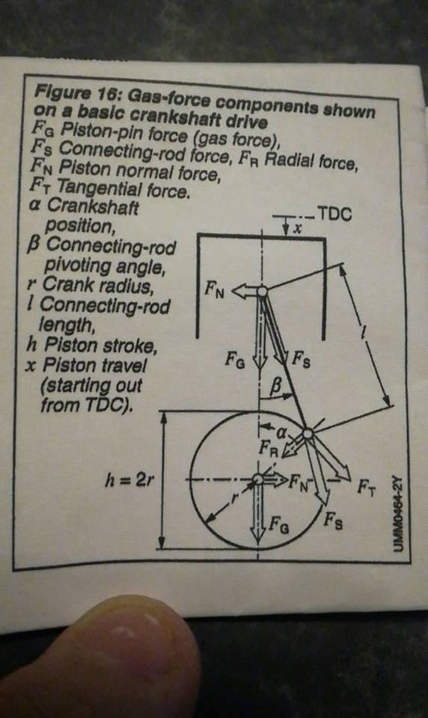
Figure 1.1

Research/literature review:
Different manufacturers of conrod use varying densities of metals and composites like alloy, carbon, aluminium and steel. K1 produce conrods with a higher density for racing. The Arrow company have introduced the M2000 these are only for Subaru models, The M2000 has an exceptional core strength (2100) pa. These products have been vigorously tested for fatigue.
In the Automotive Handbook (Prof.Dr.-Ing.Konrad Reif 2011), there are many references of Tensile force, the connecting rod force on page 419 the authors state (Prof.Dr.-Ing.Konrad Reif 2011). ”The kinematics of the single cylinder crankshaft assembly can be determined from the geometrical assignments of piston and piston/ pin axis, connecting rod and crankshaft. (Crankshaft radius equal to one half stroke). This gives the reader insight into how the gudgeon pin and the crankshaft alignment can put different forces onto the conrod.

Methodology:
Initially the evaluation will be made from actual conrod sizes and speed that equates to tick over. An increase of Rpm to 5000 rpm will be made without any other changes to compare. A third exploration will be made at 9000rpm. This speed is the maximum set by the manufacturer of Duratec engines that is feasible to uphold. The time that it is at this level of firing is detrimental to the strains of engine.

Analysis:
The Crank shaft, conrod length and rpm, piston mass figures have been calculated on excel these are actual conrod sizes from GT motorsports. Below is the generated graphs of velocity, height and acceleration. As the speed increases the velocity line increases the difference significantly from the velocity of idle. At the time set of 0.0004 on the 5000 and 9000rpm graph, The force at 5000rpm is minus 22911.8, at 9000rpm the force is minus 61086.7. calculating the difference in force at 9000rpm is greater by -38174.9. The velocity in M/S (meters per second) at 5000RPM Is calculated at -20.3169, at 9000 RPM the calculation is -63.1084. The maximum tensile force on the Conrod at 9000rpm is 80111.82. On the 1000rpm scenario the maximum tensile force on the Conrod is

Crank Radius (mm) | 120 | mm
Conrod Length (mm) | 464.25 | mm
RPM | 1000 | rpm | ω | 104.7198
Compute Time Interval | 0.0002
Mass of Piston/gudgeonpin etc (kg) | 0.6 |  |  | Max tensile force on rod |  |  |  | 992.2274
Time (s) |  | 0 | 0.0002 | 0.0004 | 0.0006 | 0.0008 | 0.001 | 0.0012 | 0.0014 | 0.0016 | 0.0018 | 0.002 | 0.0022 | 0.0024 | 0.0026 | 0.0028
Crank Angle (radians) |  | 0 | 0.020944 | 0.041888 | 0.062832 | 0.083776 | 0.104719755 | 0.125664 | 0.146608 | 0.167552 | 0.188496 | 0.20944 | 0.230383 | 0.251327 | 0.272271 | 0.293215
Crank Angle (degrees) |  | 0 | 1.2 | 2.4 | 3.6 | 4.8 | 6 | 7.2 | 8.4 | 9.6 | 10.8 | 12 | 13.2 | 14.4 | 15.6 | 16.8
Distance X |  | 0 | 2.51309 | 5.025078 | 7.534862 | 10.04134 | 12.54341559 | 15.03999 | 17.52996 | 20.01225 | 22.48576 | 24.9494 | 27.4021 | 29.84279 | 32.27038 | 34.68382
inv sine phi |  | 0 | 0.005413 | 0.010824 | 0.01623 | 0.021629 | 0.027018666 | 0.032396 | 0.03776 | 0.043107 | 0.048435 | 0.053741 | 0.059024 | 0.064282 | 0.069511 | 0.074709
phi (radians) |  | 0 | 0.005413 | 0.010824 | 0.016231 | 0.021631 | 0.027021954 | 0.032402 | 0.037769 | 0.04312 | 0.048454 | 0.053767 | 0.059059 | 0.064326 | 0.069567 | 0.074779
Height (dist between top of conrod and crankshaft) |  | 584.25 | 584.2169 | 584.1175 | 583.9521 | 583.7205 | 583.4231433 | 583.0601 | 582.6316 | 582.138 | 581.5796 | 580.9568 | 580.2701 | 579.5198 | 578.7066 | 577.8309
Velocity mm/s |  | -165.6 | -496.686 | -827.428 | -1157.6 | -1486.97 | -1815.316013 | -2142.41 | -2468.02 | -2791.94 | -3113.93 | -3433.77 | -3751.26 | -4066.17 | -4378.28 | -4687.39
Velocity m/s |  | -0.1656 | -0.49669 | -0.82743 | -1.1576 | -1.48697 | -1.815316013 | -2.14241 | -2.46802 | -2.79194 | -3.11393 | -3.43377 | -3.75126 | -4.06617 | -4.37828 | -4.68739
Acceleration |  | -1655.43 | -1653.71 | -1650.86 | -1646.86 | -1641.73 | -1635.463356 | -1628.08 | -1619.57 | -1609.95 | -1599.23 | -1587.42 | -1574.53 | -1560.57 | -1545.56 | -1529.5
Force |  |  | -992.227 | -990.513 | -988.115 | -985.036 | -981.2780136 | -976.845 | -971.741 | -965.971 | -959.54 | -952.455 | -944.72 | -936.345 | -927.336 | -917.702

Crank Radius (mm) | 120 | mm
Conrod Length (mm) | 464.25 | mm
RPM | 5000 | rpm | ω | 523.5988
Compute Time Interval | 0.0002
Mass of Piston/gudgeonpin etc (kg) | 0.6 |  |  | Max tensile force on rod |  |  |  | 24805.7
Time (s) |  | 0 | 0.0002 | 0.0004 | 0.0006 | 0.0008 | 0.001 | 0.0012
Crank Angle (radians) |  | 0 | 0.10472 | 0.20944 | 0.314159 | 0.418879 | 0.523598776 | 0.628319
Crank Angle (degrees) |  | 0 | 6 | 12 | 18 | 24 | 30 | 36
Distance X |  | 0 | 12.54342 | 24.9494 | 37.08204 | 48.8084 | 60 | 70.53423
inv sine phi |  | 0 | 0.027019 | 0.053741 | 0.079875 | 0.105134 | 0.129240711 | 0.151932
phi (radians) |  | 0 | 0.027022 | 0.053767 | 0.07996 | 0.105329 | 0.12960323 | 0.152522
Height (dist between top of conrod and crankshaft) |  | 584.25 | 583.4231 | 580.9568 | 576.8934 | 571.3026 | 564.2795 | 555.9426
Velocity mm/s |  | -4134.28 | -12331.6 | -20316.9 | -27954.1 | -35115.6 | -41684.65965 | -47559
Velocity m/s |  | -4.13428 | -12.3316 | -20.3169 | -27.9541 | -35.1156 | -41.68465965 | -47.559
Acceleration |  | -40986.7 | -39926.3 | -38186.3 | -35807.3 | -32845.4 | -29371.5472 | -25470.3
Force |  | -24592 | -23955.8 | -22911.8 | -21484.4 | -19707.2 | -17622.92832 | -15282.2

 |  | 0 | 0.10472 | 0.20944 | 0.314159 | 0.418879 | 0.523598776
 |  | 0 | 6 | 12 | 18 | 24 | 30
  xzssssssssssssssssssssssssssssn [=]m=
  0.33 | 120 | mm
  Conrod Length (mm) | 464.25 | mm
  RPM | 9000 | rpm | ω | 942.4778
  Compute Time Interval | 0.0002
  Mass of Piston/gudgeonpin etc (kg) | 0.6 |  |  | Max tensile force on rod |  |  |  | 80111.82
  Time (s) |  | 0 | 0.0002 | 0.0004 | 0.0006 | 0.0008 | 0.001 | 0.0012
  Crank Angle (radians) |  | 0 | 0.188496 | 0.376991 | 0.565487 | 0.753982 | 0.942477796 | 1.130973
  Crank Angle (degrees) |  | 0 | 10.8 | 21.6 | 32.4 | 43.2 | 54 | 64.8
  Distance X |  | 0 | 22.48576 | 44.17495 | 64.29922 | 82.14565 | 97.08203932 | 108.5792
  inv sine phi |  | 0 | 0.048435 | 0.095153 | 0.138501 | 0.176943 | 0.209115863 | 0.233881
  phi (radians) |  | 0 | 0.048454 | 0.095298 | 0.138948 | 0.177879 | 0.210670746 | 0.236067
  Height (dist between top of conrod and crankshaft) |  | 584.25 | 581.5796 | 573.7167 | 561.095 | 544.4009 | 524.5200672 | 502.4677
  Velocity mm/s |  | -13352 | -39314.5 | -63108.4 | -83470.6 | -99404.2 | -110262.086 | -115800
  Velocity m/s |  | -13.352 | -39.3145 | -63.1084 | -83.4706 | -99.4042 | -110.262086 | -115.8
  Acceleration |  | -129813 | -118969 | -101811 | -79667.9 | -54289.5 | -27689.82511 | -1911.01
  Force |  | -77887.7 | -71381.5 | -61086.7 | -47800.7 | -32573.7 | -16613.89507 | -1146.6
 |  | 0 | 12.54342 | 24.9494 | 37.08204 | 48.8084 | 60
 |  | 0 | 0.027019 | 0.053741 | 0.079875 | 0.105134 | 0.129240711
 |  | 0 | 0.027022 | 0.053767 | 0.07996 | 0.105329 | 0.12960323
 |  | 584.25 | 583.4231 | 580.9568 | 576.8934 | 571.3026 | 564.2795
 |  | -4134.28 | -12331.6 | -20316.9 | -27954.1 | -35115.6 | -41684.65965
 |  | -4.13428 | -12.3316 | -20.3169 | -27.9541 | -35.1156 | -41.68465965
Conclusion:  As the petrol engine progresses, the need for lighter components may be required to enhance the  part performance. The height of the piston on the conrod, at its maximum length would alter the  compression ratio which in turn would put more load onto the gudgeon pin, big end bearing and crankshaft.  On the firing stroke, the graph shows the greatest force on the conrod at the point of TDC (top dead centre).  Tensile force changes the metal through elasticity, if a repeated continuation of high rpm the components  will fail. |  | -40986.7 | -39926.3 | -38186.3 | -35807.3 | -32845.4 | -29371.5472
 |  | -24592 | -23955.8 | -22911.8 | -21484.4 | -19707.2 | -17622.92832

Recommendations for further study:
To change different weight, conrod and piston mass whilst changing the design of piston and conrod to enhance the tensile strength. The height of the piston on the conrod, at its maximum length would alter the compression ratio which in turn would put more load onto the gudgeon pin, big end bearing and crankshaft.

References:
Prof DR.-Ing.Konrad Reif. Dipl.-Ing Karl-Heinz Dietsche. Automotive Handbook 8th edition :Robert Bosch GmbH.
Arrow precision. (M2000) Available at: https://goo.gl/ijWFui (Accessed: 29th November 2018).
Roger Clark Motorsport Available at: https://goo.gl/8rWJYD (Accesses: 29th November 2018).
Graphs generated by: Steve Patch UWTSD (2018).

Appendices:
Arrow precision. (M2000) Available at:https://goo.gl/iiWFui

Content from conrod companies:
Arrow precision. date accessed: 08 December 2018.
STEEL CONNECTING RODS
Arrow Precision steel con rods are found in almost every arena of motorsport as well as in a wide variety of the world’s most prestigious motor vehicles.
Our steel con rods are fully machined in-house from our own specification double air re-melted 817M40 forgings. All rods are shot peened using our automated process to increase fatigue strength and durability. The rods are balanced end over end into matched engine sets and are 100% magnaflux crack detected prior to final inspection by CMM in our temperature controlled inspection department.
Our design team works closely with each customer using the latest CAD CAM technology to optimise each design whether it be a fully 3D machined prototype for an OE application or custom made rods for full race applications.
For customers with particularly extreme requirements, we have developed our M2000 grade of steel with a tensile strength in excess of 2000 MPa and a high fatigue strength. Careful development and control of the material chemistry and heat treatment has lead to an excellent balance of mechanical properties suitable for use in the most heavily loaded race engines.
As part of the design process, we work closely with ARP to select the best available fastener for each project.
In addition to custom batch manufacture, we also hold a wide variety of rods in stock for many popular race engines, both modern and vintage.

