18/05/2026
Kelly casey

Image classification using Artificial Neural Networks
ACCA7025

Contents
1. Introduction 2
2. Literature Review 3
3. Methodology 4
3.1 Development Environment and Dataset Preparation 4
3.2 Baseline CNN Model Architecture 6
3.3 Baseline CNN Model Compilation 7
3.4 Baseline CNN Model Training 7
3.5 Baseline CNN Performance Visualisation 8
3.6 Baseline CNN Model Evaluation 9
3.7 Baseline CNN Confusion Matrix Analysis 10
3.8 Baseline CNN Prediction Example 11
3.9 Baseline CNN Classification Report 11
4 Comparative CNN Model Development and Evaluation 12
4.1 Experimental CNN Architectures 12
4.2 Training of Experimental CNN Models 14
4.3 Dropout CNN Evaluation 16
4.4 Deeper CNN Evaluation 20
4.5 Comparative Analysis of CNN Models 24
5 Discussion and Recommendations 25
5.1 Discussion 25
5.2 Recommendations and Future Improvements 25
6 Conclusion 26
Bibliography 27
Appendix 28
YouTube link 28

Introduction
Artificial Intelligence (AI) and Machine Learning (ML) are increasingly used within modern computing systems to support tasks involving prediction, automation, and pattern recognition [1]. One important area of machine learning is image classification, where computer systems are trained to recognise and classify images into predefined categories. Image classification is widely used in areas such as healthcare, autonomous vehicles, facial recognition, and security systems [2].
Artificial Neural Networks (ANNs) are machine learning models designed to learn patterns from data and improve prediction accuracy through training [3]. More advanced architectures, including Convolutional Neural Networks (CNNs) and Recurrent Neural Networks (RNNs), have been developed for more specialised machine learning tasks.
This project investigates the use of Convolutional Neural Networks for image classification using the CIFAR-10 dataset. The practical implementation was developed using Python, TensorFlow, and Jupyter Notebook. Multiple CNN architectures were developed, trained, and evaluated to investigate how architectural changes and regularisation techniques affect classification performance.
The project compares a baseline CNN model with two experimental CNN architectures: a dropout CNN model and a deeper CNN model. Performance was evaluated using testing accuracy, loss values, confusion matrices, classification reports, and training visualisations to assess model behaviour and overfitting.
The report also reviews related literature surrounding Artificial Neural Networks, Convolutional Neural Networks, and hyperparameter optimisation before evaluating the performance of the developed image classification models.

Literature Review
Artificial Neural Networks (ANNs) are machine learning models inspired by the structure of the human brain. ANNs consist of interconnected processing nodes called neurons that learn patterns and relationships within data during training [3]. Neural networks are widely used for tasks such as classification, prediction, and pattern recognition because they can learn directly from training data instead of relying completely on manually programmed rules [1].
Several specialised neural network architectures have been developed for different machine learning tasks. Convolutional Neural Networks (CNNs) are mainly designed for image processing and computer vision tasks, while Recurrent Neural Networks (RNNs) are typically used for sequential and time-dependent data such as speech recognition and language processing [5][9]. Although RNNs work well for sequential tasks, CNNs are generally more suitable for image classification because they are specifically designed to identify spatial image features [5]. For this reason, CNN architectures were selected for the practical implementation stage of this project instead of RNN-based approaches.
CNNs are particularly effective for image classification because they can automatically learn important visual features directly from image data, reducing the need for manual feature extraction [7]. CNN architectures usually contain convolutional layers, pooling layers, activation functions, and fully connected dense layers. Convolutional layers apply filters to detect features such as edges, textures, colours, and shapes [6], while pooling layers reduce the size of the data and improve computational efficiency.
Activation functions such as Rectified Linear Unit (ReLU) are commonly used within CNN architectures because they help improve training efficiency and reduce vanishing gradient problems [12].
The performance of CNN models can also be strongly affected by the hyperparameters used during training [8]. Common hyperparameters include learning rate, batch size, optimiser selection, number of epochs, dropout rate, and the number of convolutional filters. Poor hyperparameter selection can lead to problems such as underfitting or overfitting [4]. Overfitting happens when a neural network learns the training data too closely and performs less effectively on unseen data.
Optimisers such as Adam and Stochastic Gradient Descent (SGD) are commonly used to improve training performance by updating network weights during learning [12]. Regularisation techniques such as dropout are also widely used to improve generalisation performance by preventing the network from relying too heavily on specific training features [4].
Although deeper CNN architectures can improve feature extraction and classification accuracy, they can also increase computational complexity and overfitting if regularisation techniques are not applied effectively. This highlights the importance of balancing model complexity with generalisation performance during CNN development.
Evaluation metrics including accuracy, loss values, confusion matrices, and classification reports are commonly used to assess CNN performance and identify model strengths and weaknesses [13]. Visualisations such as training and validation accuracy graphs can also help identify unstable learning behaviour and signs of overfitting during training.

Methodology

3.1 Development Environment and Dataset Preparation
The practical implementation for this project was developed using Python within Jupyter Notebook. TensorFlow and Keras were used to develop and train the Convolutional Neural Network models, while additional libraries including NumPy, Matplotlib, Pandas, and Scikit-learn were used for numerical processing, visualisation, and evaluation tasks [14].
The CIFAR-10 dataset was loaded directly from the TensorFlow Keras dataset library using the cifar10.load_data() function [15]. The dataset contains 60,000 colour images divided across 10 categories, including airplanes, automobiles, birds, cats, deer, dogs, frogs, horses, ships, and trucks. The dataset was automatically split into 50,000 training images and 10,000 testing images.
Sample images from the dataset were displayed to confirm that the images and class labels loaded correctly within the development environment. Before training began, the image data was pre-processed by normalising the pixel values from a range of 0–255 to values between 0 and 1. Data normalisation helps improve training stability and overall neural network performance during learning [16].
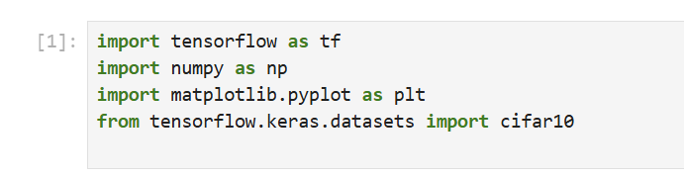
Figure 1. Shows the Python libraries imported during the practical implementation stage.
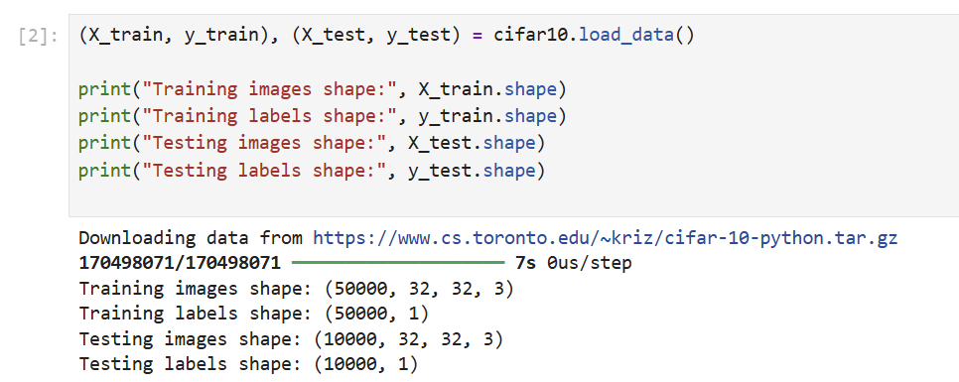
Figure 2. Loading the CIFAR-10 dataset and displaying dataset shapes.
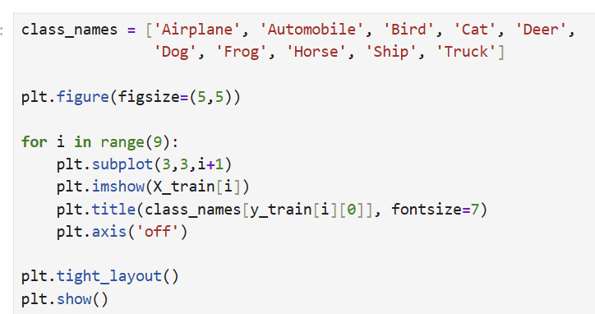
Figure 3. Python code used to display sample CIFAR-10 images.
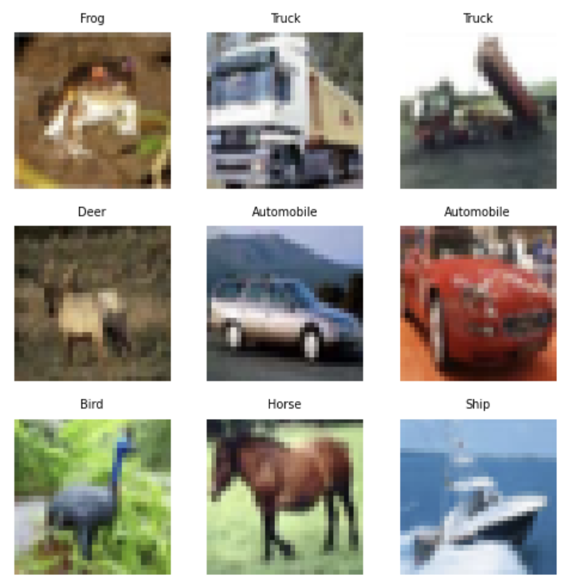
Figure 4. Sample images from the CIFAR-10 training dataset.
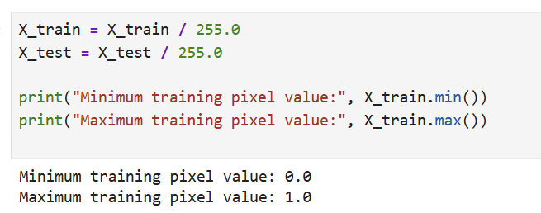
Figure 5. Normalising CIFAR-10 pixel values before neural network training.

Baseline CNN Model Architecture
A Convolutional Neural Network (CNN) was developed using TensorFlow Keras for the CIFAR-10 image classification task [14]. A sequential architecture was used containing convolutional layers, max pooling layers, and fully connected dense layers.
The CNN architecture used convolutional layers with 32 and 64 filters alongside Rectified Linear Unit (ReLU) activation functions to improve feature extraction and support non-linear learning [12]. Max pooling layers were included to reduce the size of the data and improve computational efficiency. A relatively simple architecture was intentionally selected for the baseline model to provide a clear comparison point for the later experimental CNN architectures.
The output was then flattened before being passed into dense layers, while a final SoftMax output layer containing 10 neurons was used to classify the CIFAR-10 image categories.

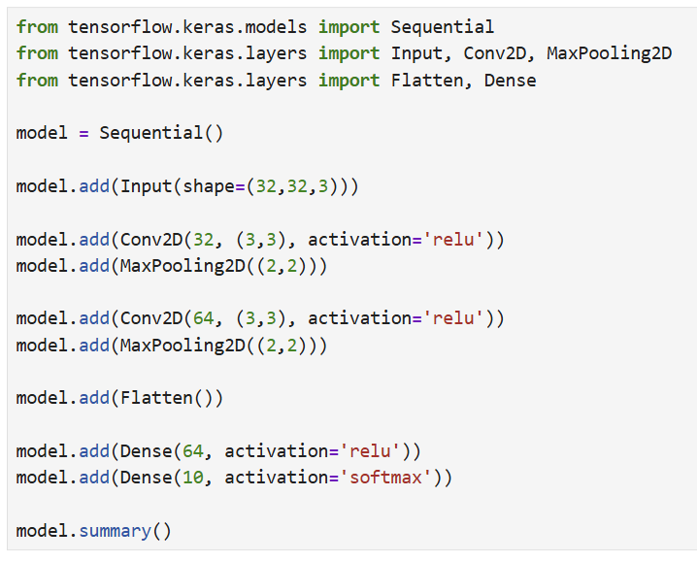
Figure 6. Python code used to construct the CNN architecture.
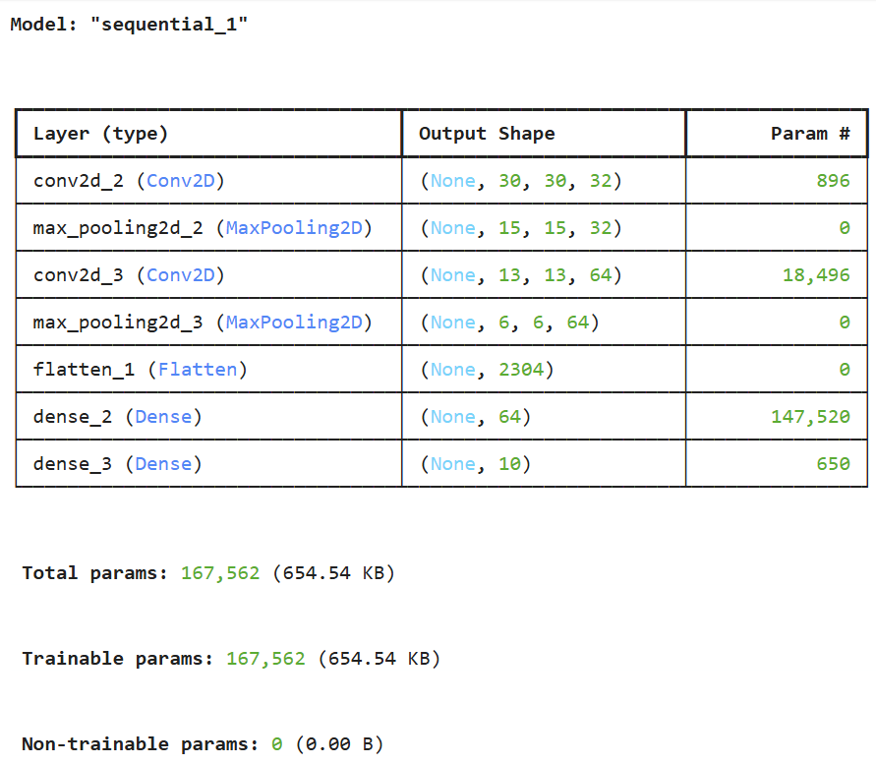
Figure 7. CNN model summary showing layers and trainable parameters.

Baseline CNN Model Compilation
The CNN model was compiled using the Adam optimiser, sparse categorical crossentropy loss function, and accuracy evaluation metric. Adam was selected because it is widely used in deep learning and helps improve training performance through efficient weight optimisation [12].
Sparse categorical crossentropy was used because the CIFAR-10 dataset contains multiple image categories represented using integer labels. Model accuracy was monitored throughout training to measure classification performance as the model learned.
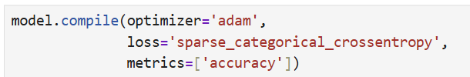
Figure 8. Python code used to compile the CNN model.

Baseline CNN Model Training
The baseline CNN model was trained using the CIFAR-10 training dataset over 10 epochs, while the testing dataset was used as validation data during training.
Training accuracy improved from 46.67% during the first epoch to 79.31% by the final epoch. Validation accuracy also improved throughout training and reached 70.18% after 10 epochs. These results showed that the baseline CNN could learn useful image features from the CIFAR-10 dataset despite using a relatively simple architecture.
A growing gap between training accuracy and validation accuracy became more noticeable during the later epochs, suggesting early signs of overfitting as the model started learning the training data more closely than the unseen validation data.
This suggested that additional optimisation and regularisation techniques could potentially improve model generalisation performance.
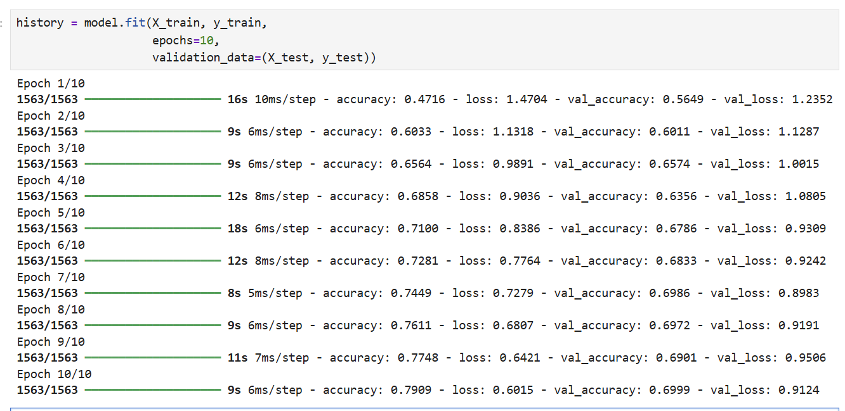
Figure 9. CNN training output showing training and validation accuracy across 10 epochs.

Baseline CNN Performance Visualisation
Training and validation accuracy and loss graphs were generated to visualise the CNN learning performance [16].
The accuracy graph showed that both training and validation accuracy improved steadily during training, while the loss graph showed decreasing training and validation loss values. Final training accuracy reached 79.31%, while validation accuracy reached 70.18%. Validation loss began to stabilise during the later epochs, while the increasing gap between training and validation accuracy suggested early signs of overfitting within the CNN model.
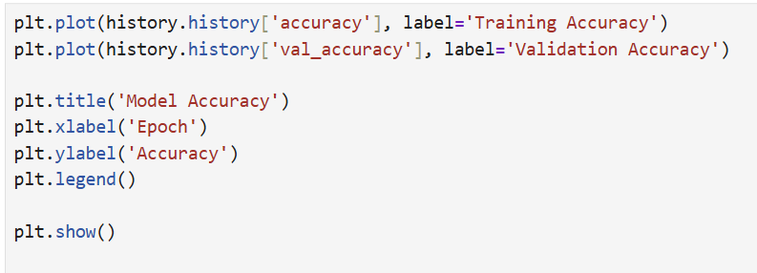
Figure 10. Python code used to generate the model accuracy graph.
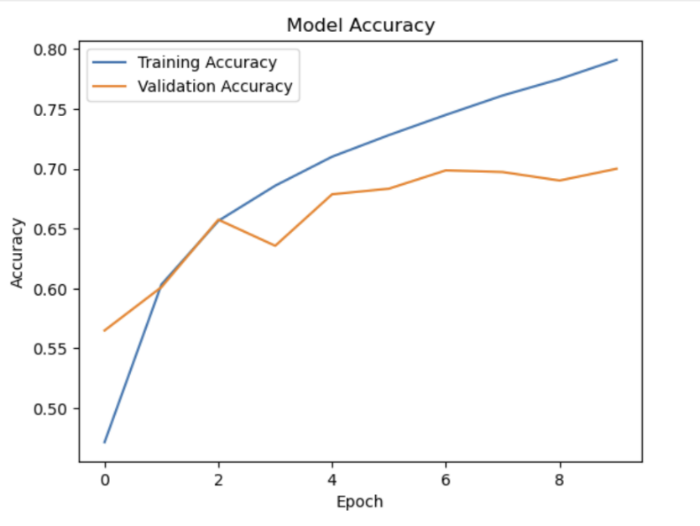
Figure 11. CNN training and validation accuracy graph.
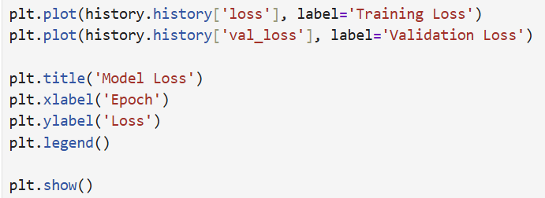
Figure 12. Python code used to generate the model loss graph.
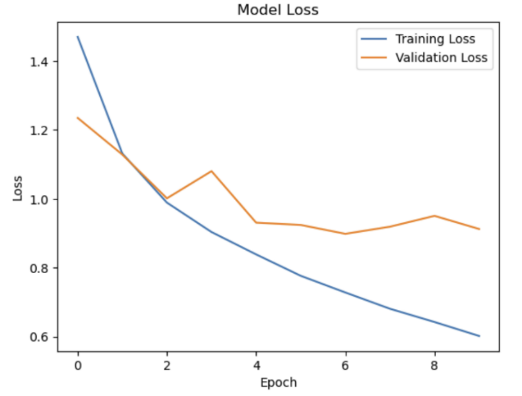
Figure 13. CNN training and validation loss graph.

Baseline CNN Model Evaluation
After training was completed, the baseline CNN model was evaluated using the CIFAR-10 testing dataset to measure performance on previously unseen data.
The evaluation results showed that the CNN model achieved 70.18% testing accuracy with a testing loss value of 0.9056. Prediction probability outputs were also generated to observe how the model assigned confidence values across the 10 CIFAR-10 categories during classification.
These results showed that the CNN model was able to classify unseen CIFAR-10 images effectively.
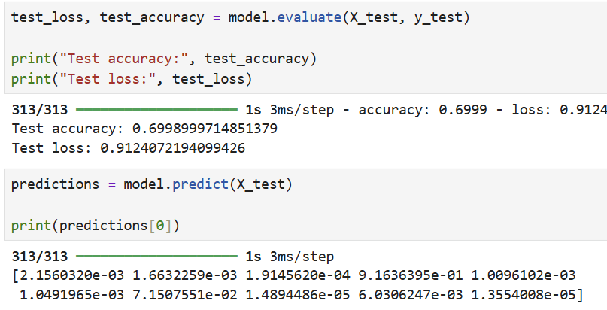
Figure 14. CNN evaluation results and prediction probability output.

3.7 Baseline CNN Confusion Matrix Analysis
A confusion matrix was generated to provide a more detailed evaluation of the baseline CNN classification performance across the CIFAR-10 image categories [13].
The confusion matrix showed stronger classification performance for categories such as ships, automobiles, frogs, and trucks, while higher levels of misclassification occurred between visually similar animal categories including cats, dogs, and deer. This suggested that some image classes were harder for the CNN model to distinguish because of similarities in visual appearance and the relatively low 32 × 32 image resolution of the CIFAR-10 dataset.
Using the confusion matrix provided additional insight into the strengths and weaknesses of the trained CNN model beyond the overall accuracy score alone.

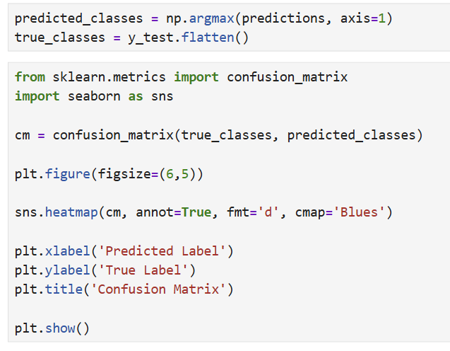
Figure 15. Python code used to generate the CNN confusion matrix.
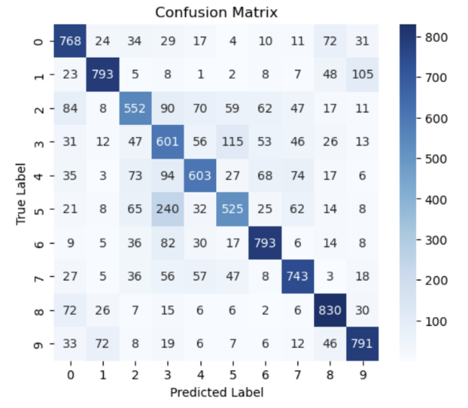
Figure 16. Confusion matrix showing CNN classification performance across CIFAR-10 categories.

Baseline CNN Prediction Example
An example prediction was generated using an image from the CIFAR-10 testing dataset to observe the classification behaviour of the trained CNN model.
The prediction example showed that the CNN model was able to correctly classify previously unseen testing images after training and evaluation had been completed. This provided a practical demonstration of how the trained neural network performed image classification using CIFAR-10 data.
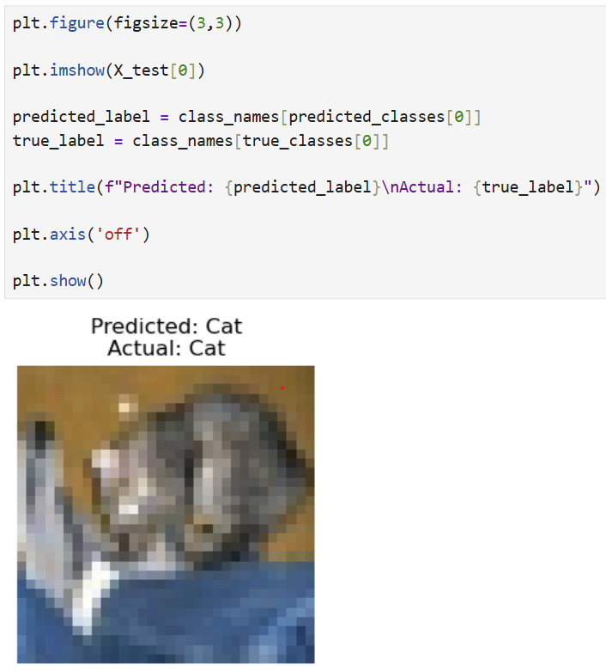
Figure 17. Python code and resulting CIFAR-10 image classification generated by the trained CNN model.

Baseline CNN Classification Report
The classification report provided a more detailed evaluation of precision, recall, and F1-score performance across the CIFAR-10 categories. Stronger results were achieved for automobiles, ships, frogs, and trucks, while lower scores were seen for cats and birds because of similarities between image features within the dataset.
The overall weighted average F1-score reached 0.70, showing that the baseline CNN model achieved balanced classification performance across most CIFAR-10 categories.
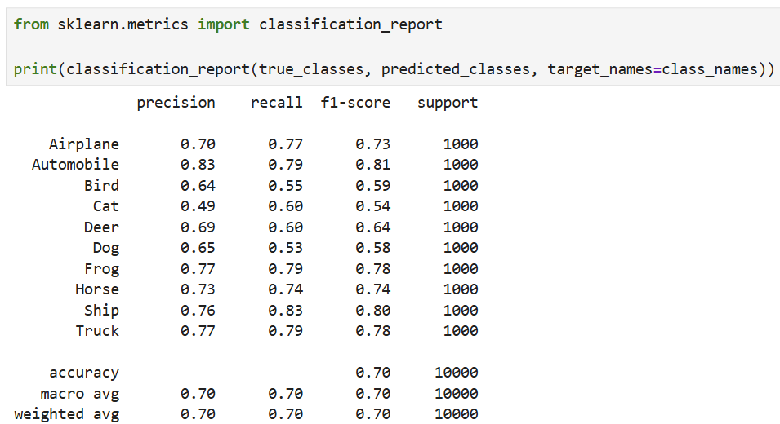
Figure 18. Classification report showing CNN precision, recall, and F1-score results for each CIFAR-10 category.

Comparative CNN Model Development and Evaluation
Following the development and evaluation of the baseline Convolutional Neural Network model, additional CNN architectures were developed to further investigate how different design changes and regularisation techniques could affect image classification performance on the CIFAR-10 dataset.
Although the baseline CNN model achieved reasonable classification accuracy, signs of overfitting could be seen during the later training epochs through the growing gap between training accuracy and validation accuracy. To explore ways of improving model performance and generalisation, additional experimental CNN models were developed and evaluated.
This stage focused on testing how changes such as dropout regularisation and deeper convolutional layers affected training stability, classification accuracy, loss values, and overall model performance. Each experimental model was trained and evaluated using the same CIFAR-10 dataset so that the results could be compared fairly against the baseline CNN model.

Experimental CNN Architectures
To further investigate CNN performance, two additional experimental architectures were developed and evaluated using the CIFAR-10 dataset.
The first experimental model introduced dropout regularisation layers to help reduce overfitting and improve validation stability. Dropout rates were selected to reduce excessive dependency on specific neurons during training while still allowing the CNN model to learn meaningful image features. The dropout CNN kept a similar structure to the baseline model but added dropout layers after the max pooling and dense layers.
The second experimental model used a deeper architecture containing additional convolutional layers and a larger dense layer. This increased the number of trainable parameters and allowed the network to learn more detailed image features during training.
Increasing the depth of the architecture allowed the network to learn more complex image patterns, although this also increased the risk of overfitting and higher computational requirements.
Both experimental CNN models were trained and evaluated using the same CIFAR-10 dataset and preprocessing techniques as the baseline CNN model to allow a fair comparison of the results.
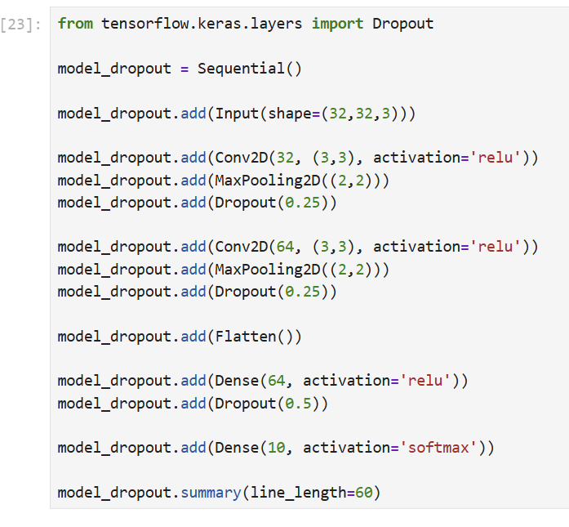
Figure 19. Python code used to construct the CNN model with dropout regularisation layers.
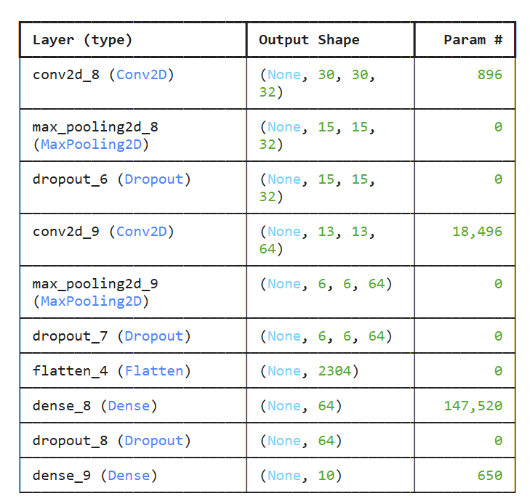
Figure 20. Architecture summary of the CNN model containing dropout regularisation layers.
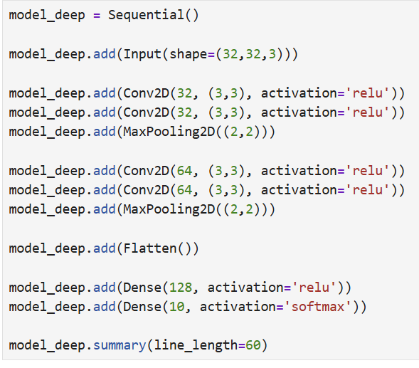
Figure 21. Python code used to construct the deeper CNN architecture.
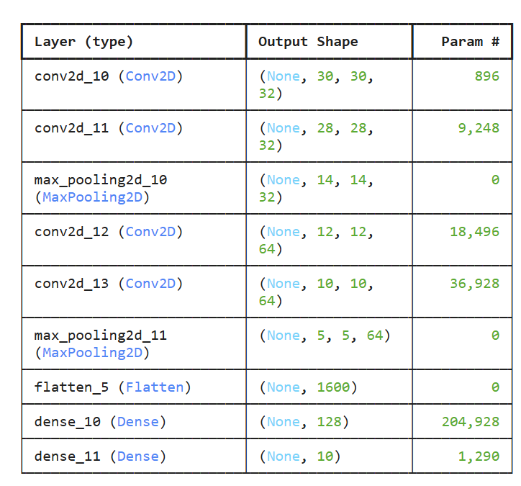
Figure 22. Architecture summary of the deeper CNN model with additional convolutional layers.

Training of Experimental CNN Models
Both experimental CNN architectures were compiled using the Adam optimiser, sparse categorical crossentropy loss function, and accuracy evaluation metric. Each model was trained for 15 epochs using the CIFAR-10 training dataset, while validation performance was monitored using the testing dataset.
The dropout CNN model achieved a final training accuracy of 63.4%, while the validation accuracy reached 69.8% after 15 epochs. Compared to the baseline CNN model, the dropout CNN achieved lower training accuracy but showed more stable validation performance throughout training. This suggested that dropout regularisation helped reduce overfitting and improve validation stability.
The deeper CNN model achieved much higher training accuracy, reaching 93.9% after 15 epochs, while validation accuracy stabilised between 72% and 74%. Although the deeper CNN achieved the highest overall classification accuracy out of all the models tested, the larger gap between training and validation performance suggested increased overfitting during the later training epochs.
These results demonstrated the trade-off between model complexity and generalisation, where increasing network depth improved learning capability but also increased overfitting behaviour.
The training results showed noticeable differences between the two experimental CNN architectures. The dropout CNN produced more stable validation performance and reduced overfitting, while the deeper CNN architecture achieved higher training accuracy but showed a much larger gap between training and validation results.
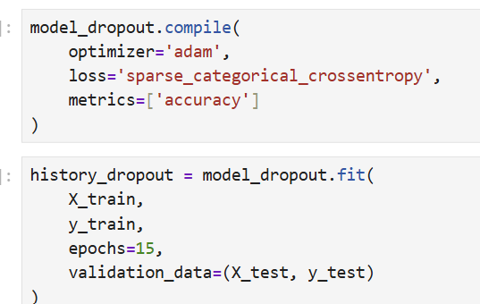
Figure 23. Python code used to compile and train the dropout CNN model.
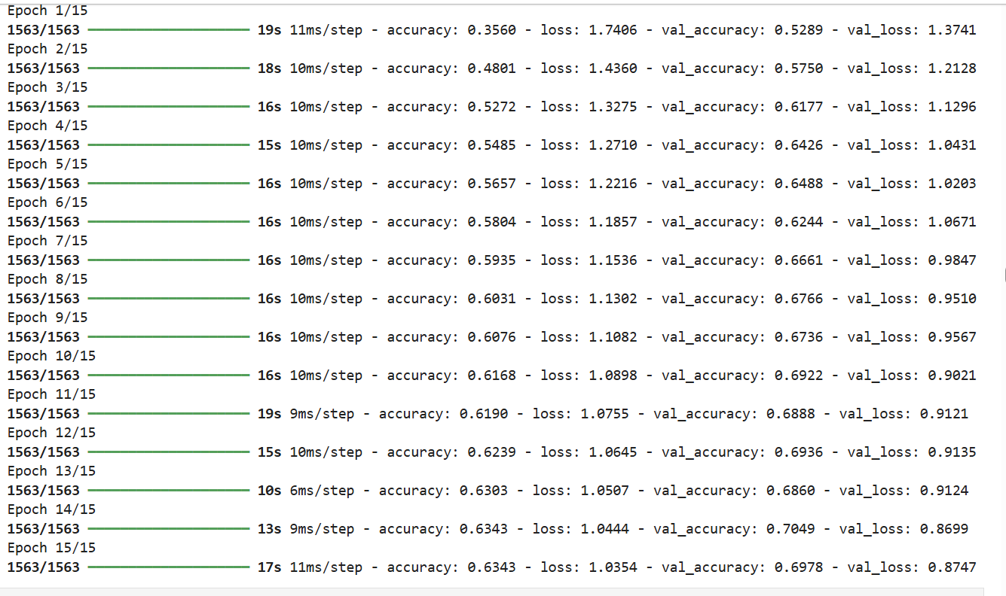
Figure 24. Training output for the dropout CNN model across 15 epochs.

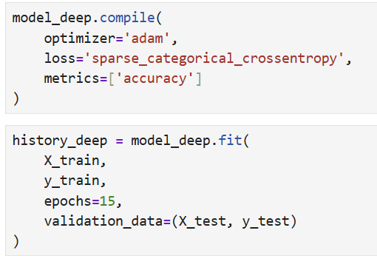
Figure 25. Python code used to compile and train the deeper CNN model.
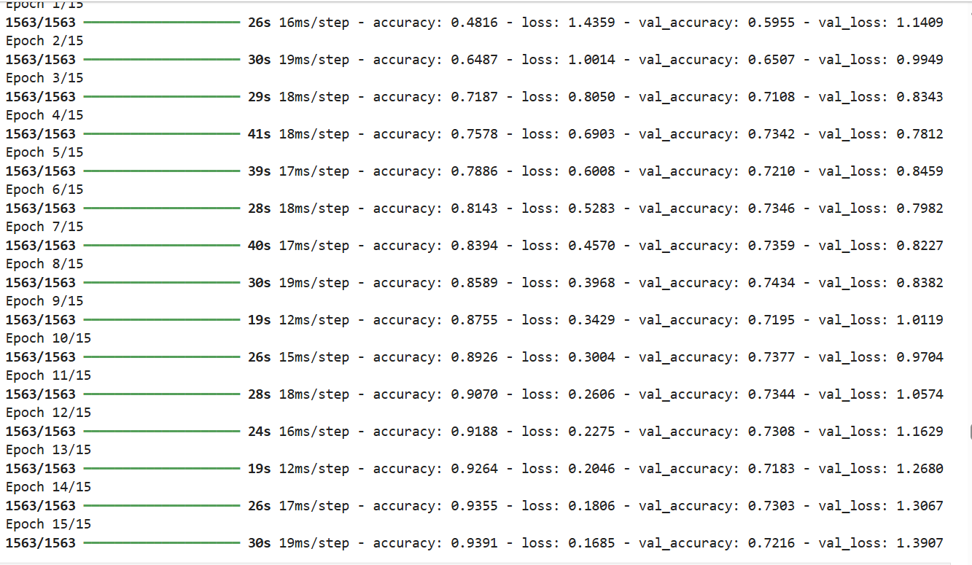
Figure 26. Training output for the deeper CNN model across 15 epochs.

Dropout CNN Evaluation
The dropout CNN model was evaluated using the CIFAR-10 testing dataset and achieved a testing accuracy of 69.78% with a testing loss value of 0.8747. Training accuracy improved from 35.60% during the first epoch to 63.43% after 15 epochs, while validation accuracy increased to 69.78%. Compared to the deeper CNN architecture, the dropout CNN showed more stable validation performance and less separation between training and validation loss values, suggesting reduced overfitting and improved generalisation performance.
The confusion matrix and classification report showed stronger classification performance for automobiles, ships, frogs, horses, and trucks, while lower performance was still seen for visually similar categories such as cats and birds.
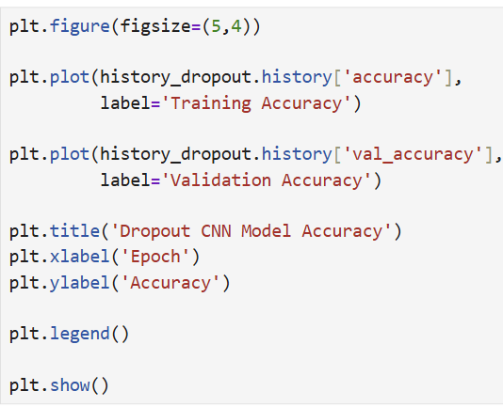
Figure 27. Python code used to generate the dropout CNN accuracy graph.
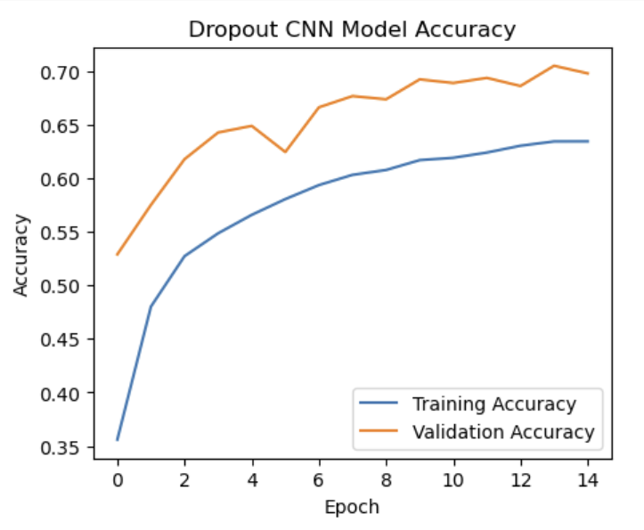
Figure 28. Dropout CNN training and validation accuracy graph.
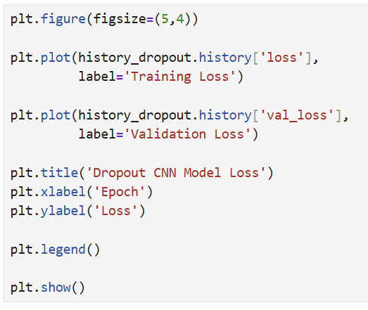
Figure 29. Python code used to generate the dropout CNN loss graph.
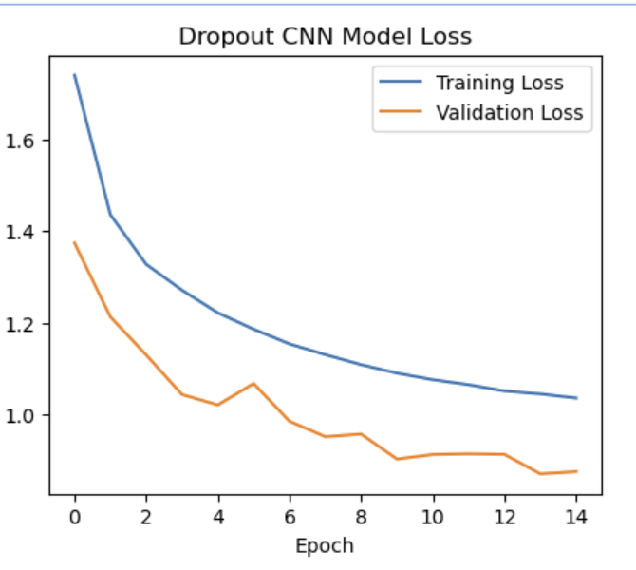
Figure 30. Dropout CNN training and validation loss graph.
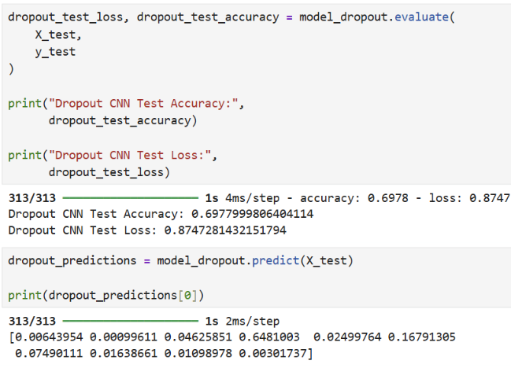
Figure 31. Dropout CNN evaluation results and prediction probability output.
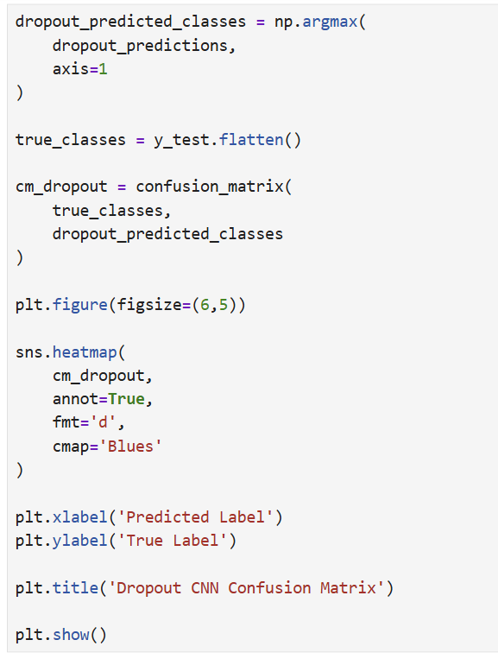
Figure 32. Python code used to generate the dropout CNN confusion matrix.
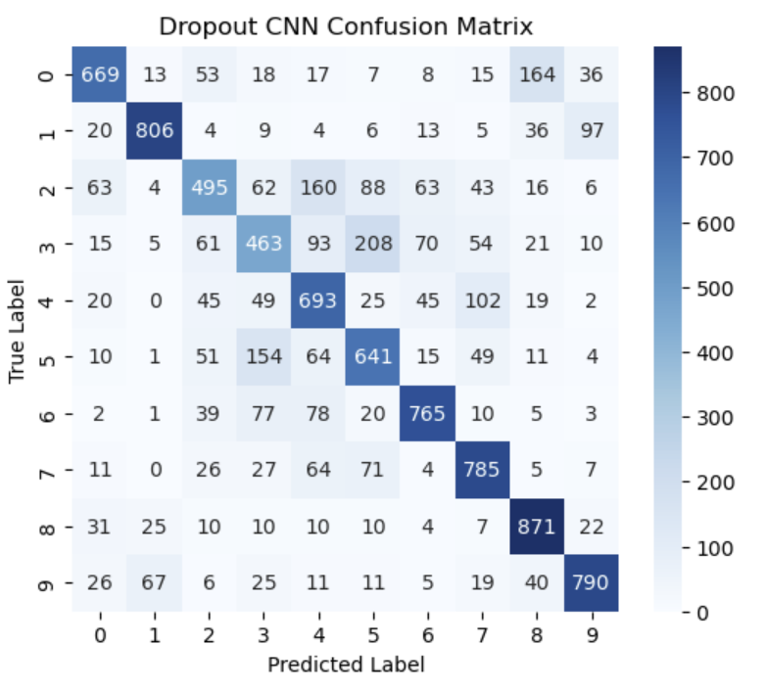
Figure 33. Dropout CNN confusion matrix showing classification performance across CIFAR-10 categories.
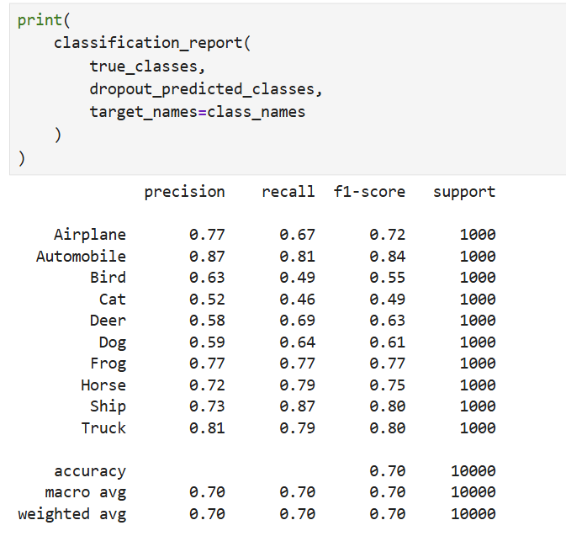
Figure 34. Dropout CNN classification report showing precision, recall, and F1-score results.
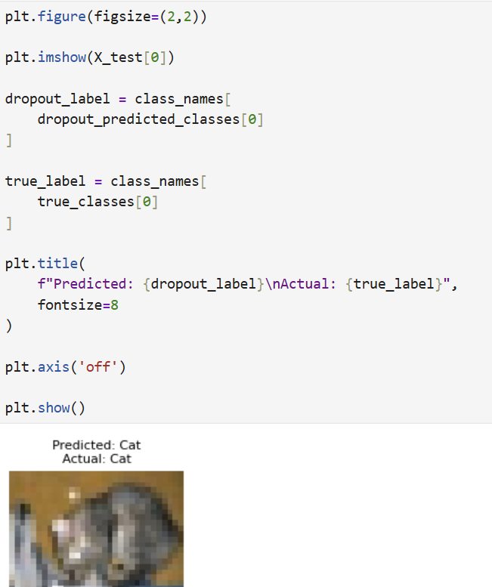
Figure 35. Dropout CNN prediction example showing predicted and actual CIFAR-10 class.

Deeper CNN Evaluation
The deeper CNN architecture achieved the highest overall classification performance out of the three developed models, reaching a testing accuracy of 72.16% with a testing loss value of 1.3907. Training accuracy increased rapidly from 48.16% during the first epoch to 93.91% after 15 epochs, while validation accuracy stabilised between 72% and 74% during the later training epochs. The growing gap between training and validation performance suggested much stronger overfitting within the deeper CNN architecture.
The confusion matrix and classification report showed improved classification performance across several CIFAR-10 categories compared to the baseline and dropout CNN models, particularly automobiles, ships, frogs, and trucks. However, lower performance was still seen for visually similar categories such as cats and birds. The prediction example further showed that the deeper CNN model was able to successfully classify unseen CIFAR-10 testing images despite the challenging nature of the dataset.

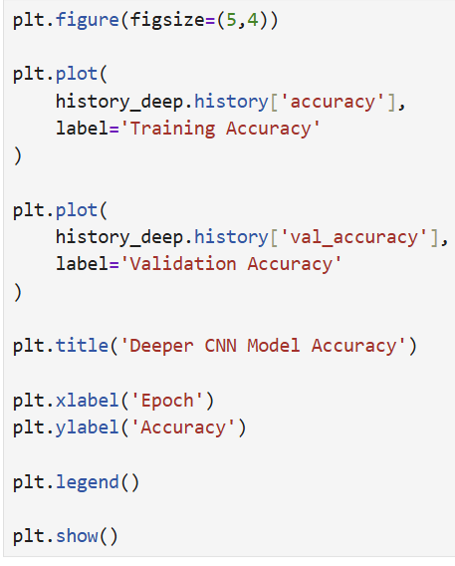
Figure 36. Python code used to generate the deeper CNN accuracy graph.
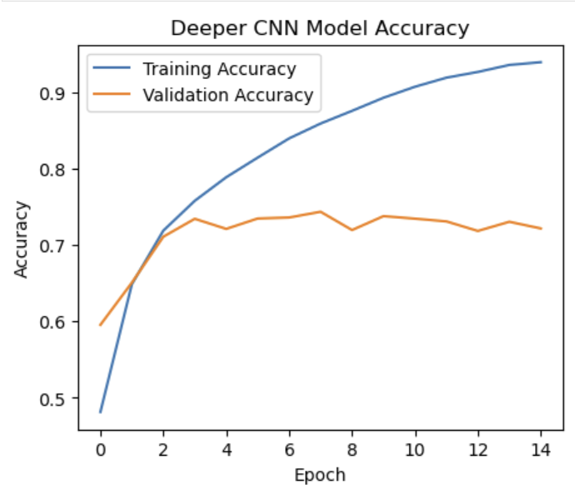
Figure 37. Deeper CNN training and validation accuracy graph.
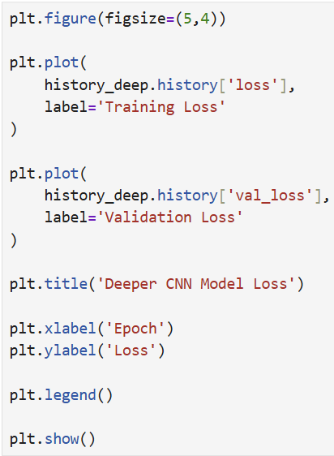
Figure 38. Python code used to generate the deeper CNN loss graph.
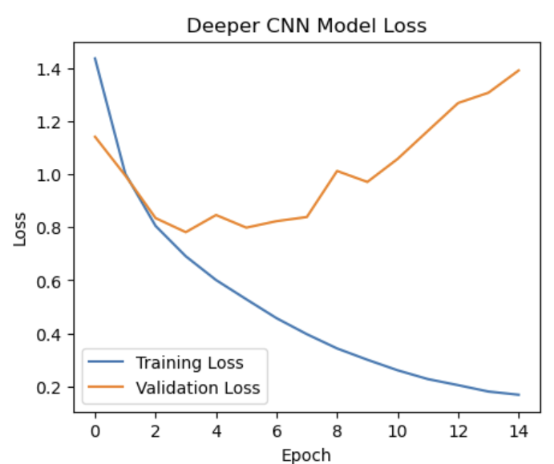
Figure 39. Deeper CNN training and validation loss graph.
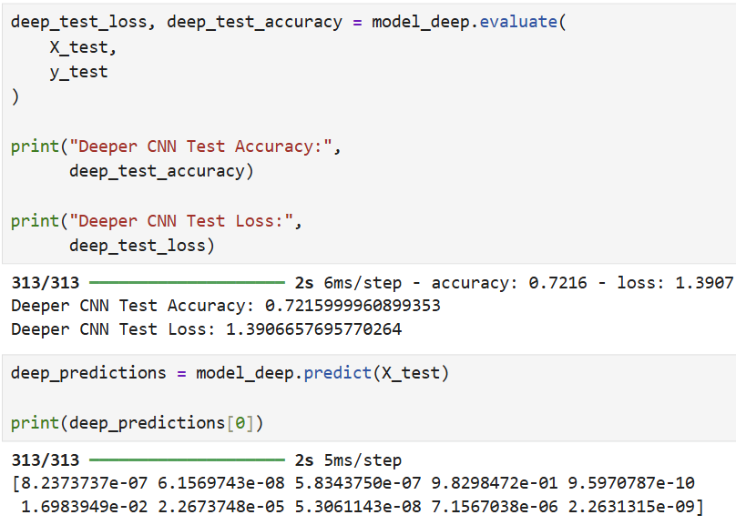
Figure 40. Deeper CNN evaluation results and prediction probability output.
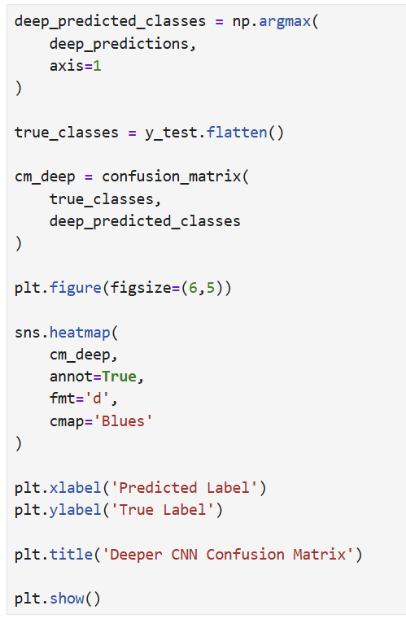
Figure 41. Python code used to generate the deeper CNN confusion matrix.
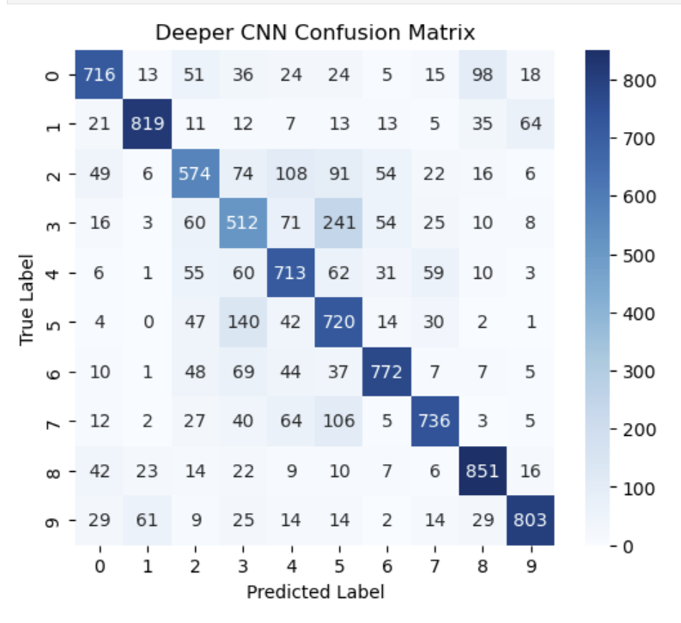
Figure 42. Deeper CNN confusion matrix showing classification performance across CIFAR-10 categories.
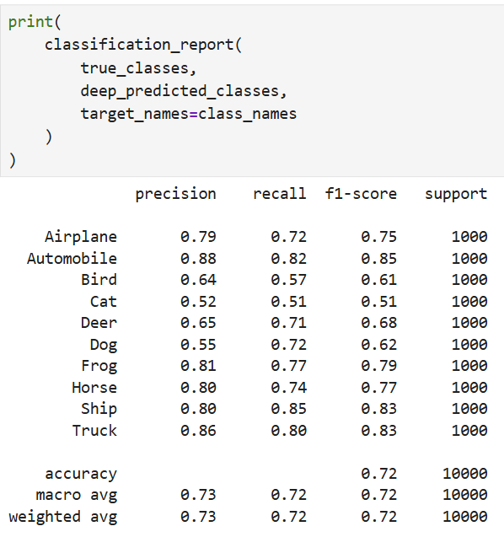
Figure 43. Deeper CNN classification report showing precision, recall, and F1-score results.
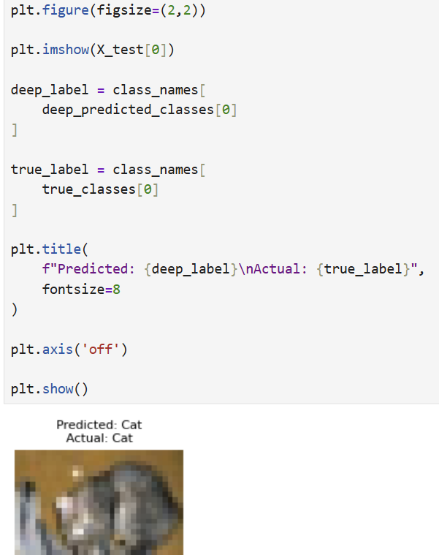
Figure 44. Deeper CNN prediction example showing predicted and actual CIFAR-10 class.

Comparative Analysis of CNN Models
The three CNN architectures developed during this project showed clear differences in classification performance and overfitting behaviour when trained using the CIFAR-10 dataset.
The baseline CNN achieved stable performance with approximately 70.0% testing accuracy while maintaining relatively balanced training and validation results. The dropout CNN achieved similar testing accuracy at 69.78% but showed more stable validation behaviour and reduced overfitting because of the dropout regularisation layers.
The deeper CNN architecture achieved the highest overall testing accuracy at 72.16% and improved classification performance across several CIFAR-10 categories, particularly automobiles, ships, frogs, and trucks. However, the model also showed the clearest signs of overfitting, with training accuracy increasing to 93.91% while validation accuracy stabilised between 72% and 74%.
All three models struggled more with visually similar categories such as cats, dogs, and birds, while more visually distinct categories achieved stronger classification performance. Overall, the comparative evaluation showed that increasing CNN complexity can improve classification accuracy, but it can also increase overfitting and reduce generalisation stability.

Discussion and Recommendations

Discussion
The comparative evaluation demonstrated that architectural design choices and regularisation techniques had a significant impact on CNN classification performance and model stability.
The experimental results demonstrated that CNN architectures can effectively perform image classification using the CIFAR-10 dataset. All developed CNN models achieved classification accuracies close to or above 70%, showing that Convolutional Neural Networks are capable of learning meaningful visual features from low-resolution image data.
The baseline CNN provided balanced performance while maintaining a relatively simple architecture. The dropout CNN achieved similar classification accuracy while showing more stable validation behaviour and reduced overfitting through regularisation. In comparison, the deeper CNN achieved the highest overall testing accuracy of 72.16%, showing that the deeper architecture improved classification performance.
However, the deeper CNN also showed stronger overfitting behaviour. Training accuracy increased to 93.91% while validation accuracy remained between 72% and 74% during the later epochs. The increasing validation loss suggested that the model was learning the training data too closely rather than generalising effectively to unseen images.
While the deeper CNN achieved the highest overall accuracy, the increased separation between training and validation performance suggested that the model was learning the training data too closely. In comparison, the dropout CNN achieved slightly lower accuracy but showed improved generalisation and more stable validation behaviour.
The confusion matrices and classification reports showed that all models achieved stronger performance for visually distinct categories such as automobiles, ships, frogs, and trucks. Lower classification performance was consistently seen for visually similar categories such as cats, dogs, and birds. This demonstrated the difficulty of classifying low-resolution CIFAR-10 images containing similar visual features.

Recommendations and Future Improvements
Several changes could further improve the performance of the CNN architectures developed during this project. Data augmentation techniques such as image rotation, flipping, and zooming could increase dataset diversity and improve model generalisation.
Additional regularisation techniques including batch normalisation and early stopping could also help reduce overfitting during training. Early stopping would prevent the model from continuing training once validation performance begins to decrease.
Transfer learning using pre-trained architectures such as VGG16, ResNet, and MobileNet may also improve classification accuracy compared to smaller custom CNN architectures [5]. However, these approaches would require greater computational resources and increased implementation complexity.
Future work could also explore more advanced hyperparameter tuning, including adjustments to learning rate, batch size, optimiser selection, and convolutional filter sizes. Using larger and higher-resolution datasets may also improve classification performance for visually similar categories such as cats, dogs, and birds.

Conclusion
This project investigated the use of Convolutional Neural Networks for image classification using the CIFAR-10 dataset. Multiple CNN architectures were developed, trained, evaluated, and compared using Python, TensorFlow, and Jupyter Notebook.
The baseline CNN model demonstrated effective image classification performance while maintaining a relatively simple architecture. The dropout CNN improved training stability and reduced overfitting through regularisation, while the deeper CNN architecture achieved the highest overall classification accuracy of 72.16%.
The comparative evaluation showed that increasing CNN complexity can improve feature extraction and overall classification performance, but it can also increase overfitting and reduce generalisation stability. Overall, the project showed that CNN architectures can perform image classification effectively, while also demonstrating how changes to network design and regularisation techniques can influence accuracy and overfitting behaviour.

Bibliography
[1] IBM, “What is machine learning?,” IBM Think Topics. Accessed: May 17, 2026. [Online]. Available: https://www.ibm.com/think/topics/machine-learning/
[2] IBM, “What is image classification?,” IBM Think Topics. Accessed: May 17, 2026. [Online]. Available: https://www.ibm.com/think/topics/image-classification/
[3] IBM, “What are neural networks?,” IBM Think Topics. Accessed: May 17, 2026. [Online]. Available: https://www.ibm.com/think/topics/neural-networks/
[4] TensorFlow, “Overfit and underfit,” TensorFlow Tutorials. Accessed: May 17, 2026. [Online]. Available: https://www.tensorflow.org/tutorials/keras/overfit_and_underfit/
[5] IBM, “What are convolutional neural networks?,” IBM Think Topics. Accessed: May 17, 2026. [Online]. Available: https://www.ibm.com/think/topics/convolutional-neural-networks/
[6] CS231n Stanford University, “Convolutional Neural Networks (CNNs / ConvNets),” CS231n: Convolutional Neural Networks for Visual Recognition. Accessed: May 17, 2026. [Online]. Available: https://cs231n.github.io/convolutional-networks/
[7] TensorFlow, “Convolutional Neural Network (CNN),” TensorFlow Tutorials. Accessed: May 17, 2026. [Online]. Available: https://www.tensorflow.org/tutorials/images/cnn/
[8] GeeksforGeeks, “Hyperparameter tuning & fixing overfitting in neural networks,” GeeksforGeeks. Accessed: May 17, 2026. [Online]. Available: https://www.geeksforgeeks.org/machine-learning/hyperparameter-tuning-fixing-overfitting-in-neural-networks/
[9] IBM, “What are recurrent neural networks?,” IBM Think Topics. Accessed: May 17, 2026. [Online]. Available: https://www.ibm.com/think/topics/recurrent-neural-networks/
[10] Stanford University CS230, “Recurrent Neural Networks Cheatsheet,” CS230 Deep Learning Cheatsheet. Accessed: May 17, 2026. [Online]. Available: https://stanford.edu/~shervine/teaching/cs-230/cheatsheet-recurrent-neural-networks/
[11] Christopher Olah Blog, “Understanding LSTM Networks,” colah’s blog. Accessed: May 17, 2026. [Online]. Available: https://colah.github.io/posts/2015-08-Understanding-LSTMs/
[12] Medium, “Types of optimizers in deep learning: From gradient descent to Adam,” Medium. Accessed: May 17, 2026. [Online]. Available: https://medium.com/%40ThiyaneshwaranG/types-of-optimizers-in-deep-learning-from-gradient-descent-to-adam-1572e657c8c5
[13] scikit-learn, “3. Model selection and evaluation,” scikit-learn Documentation. Accessed: May 17, 2026. [Online]. Available: https://scikit-learn.org/stable/modules/model_evaluation.html
[14] TensorFlow, “TensorFlow learning resources,” TensorFlow Learn. Accessed: May 17, 2026. [Online]. Available: https://www.tensorflow.org/learn/
[15] TensorFlow, “tf.keras.datasets.cifar10.load_data,” TensorFlow API Documentation. Accessed: May 17, 2026. [Online]. Available: https://www.tensorflow.org/api_docs/python/tf/keras/datasets/cifar10/load_data/
[16] GeeksforGeeks, “Feature engineering: Scaling, normalization, and standardization,” GeeksforGeeks. Accessed: May 17, 2026. [Online]. Available: https://www.geeksforgeeks.org/machine-learning/feature-engineering-scaling-normalization-and-standardization/

Appendix
https://www.youtube.com/watch?v=WyGUpEqUdfo

