The Handbook for Early Years Practitioners:
A Guide for Transitions
“Education is not the filling of a pail, but the lighting of a fire.”
~ William Butler Yeats
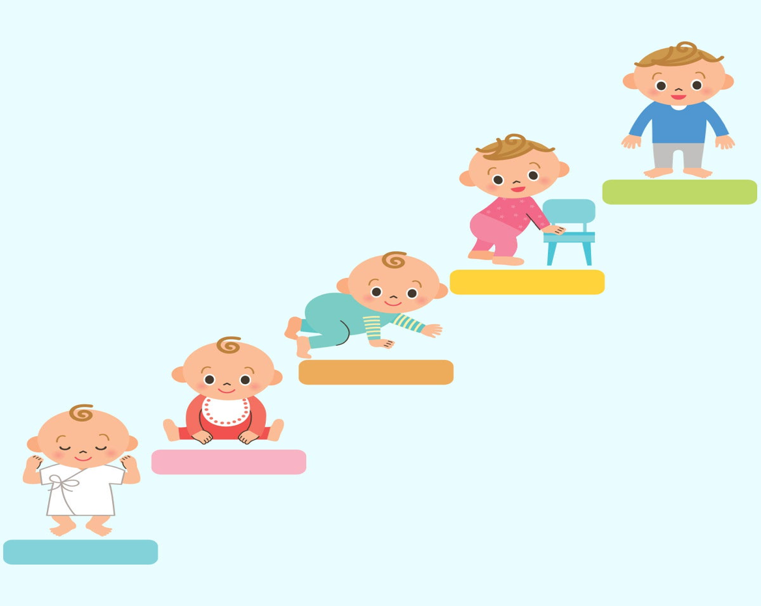

(Source: Medium, 2020)
Contents

Introduction to the Handbook pg. 2

What are Transitions? pg. 3

The Needs of the Child pg. 4
The Role of the Adult pg. 6

Partnerships pg. 9
Interventions

Proposed Outcomes

Reference List

Introduction
As Early Years Practitioners play a fundamental part in supporting children through imperative transitions, it is crucial that practitioners are equipped with in-depth knowledge and understanding of child development, and adept with skills that enable childcare professionals to provide a smooth, and positive transition experience for children entering the education setting (The Welsh Government, 2018 and Ferguson, 2020). As emphasised by Alexander (2010) and Dewey (1933), the quality embedded into teaching and the environment of the setting is significant for the successful holistic development of the child. His Majesty’s Government (2004) support the emphasis on quality education through the declaration of The Children Act 2004, whose purpose states that a child-centred approach is at the pinnacle of practice. It is therefore salient that there are correct and defining policies in place to ensure a positive transition experience for the child into the new environment.

How to use this handbook
This handbook has been produced for Early Years Practitioners to successfully support children from ages 3 through the transition from home life to starting full-time education, providing practitioners with fundamental knowledge of child development supported by key theorists, some of which underpin current curriculum and practice. Additionally, the approaches and interventions stated may be utilised in other stages of transitions. The golden thread emphasised throughout the handbook will focus on the imperativeness of consistent and effective communication between the parties encompassing the child during the transition period.
This handbook is comprised of 6 key components on aspects that will enable practitioners to successfully support children through the transition process:

- What is meant by the term ‘transitions’
- The needs of the child that are necessary to consider for a positive transition
- How the role of the adult can facilitate a smooth and comfortable transition
- The value of effective partnerships
- Practical interventions that practitioners can incorporate to encourage a positive transition
- Proposed outcomes of a successful transition



(Source: Coy, 2015)

What are transitions?

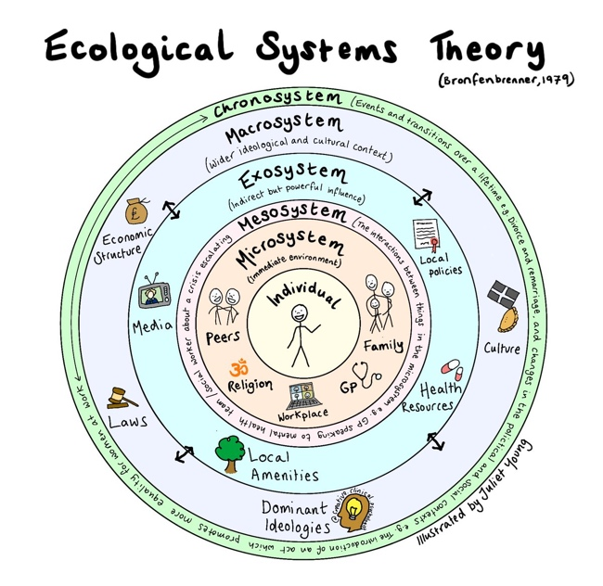
Birth to 5 Matters (2021) and the Oxford English Dictionary (2023) define transition as a period of change from one significant stage to another, and children will experience many transitions throughout their childhood which will continue into adulthood. Transitions from one setting to another must be seen as a journey involving not only the individual child, but also the parents, carers, and practitioners to ensure continuity throughout the transition (PACEY, 2016). According to Härkönen (2008) who interlinks Bronfenbrenner’s Ecological Systems Theory specifically to transition, it is vital that the microsystem of the individual (which includes parents, siblings, practitioners, and friends), communicate effectively and consistently ensuring a positive transition process for the child, as the microsystem has the most influence on the child by virtue of daily interaction. (Source: Young, 2021)
Types of transitions
Children will experience a multitude of transitions as they develop. Not only will children be destined to sustain vertical transitions, which are key and significant changes from one stage to another, moreover, children will also encounter horizontal transitions which consist of less significant, routine transitions that occur on a daily basis (Vogler, et al. 2008).
Consider the individual
Throughout the course of the transition, it is vital that the needs of the individual child and the family are appraised in a versatile manner (The Welsh Government, 2017).
The Welsh Government continue by maintaining that in order to facilitate a positive transition, practitioners must:
Be supportive and inclusive of circumstances – practitioners must understand that support and involvement will differ for every individual child and that families ought to be supported during every circumstance without judgement
Stage not age – practitioners must have detailed knowledge of child development and understand that every child adjusts in their own way

- Horizontal transitions: (Johansson, 2007)
- Different parent dropping them off/
picking them up from school
- Going to after-school clubs, i.e.
swimming, gymnastics
- Sleeping at a grandparents' house

- Vertical transitions: (PACEY, 2016)
- Arrival of a new sibling
- Separation of parents/ carers
- Moving to a different house/ school
- Loss/ bereavement
The Needs of the Child
“Play is indeed the child’s work, and the means whereby he grows and develops”
~ Isaacs (1929, quoted in Murray, 2021, p.1235)
Isaacs maintains her theory that children must be central to every decision concerning their learning and development in order for the child to successfully develop holistically (Murray, 2021). The child’s interests currently form the foundation of the curriculum and planning strategies for funded non-maintained nursery settings in Wales, the Welsh Government (2014), therefore highlights the importance of a child-centred education on children's cognitive and academic development. The Department of Education (2010) support this by stating that a child as either a…
- ‘being’ (humans in their own right, actively establishing their childhood)
- ‘becoming’ (budding adults, lacking skills and experiences)
… suggests that these attributes imbricate and that children should be considered as both being and becoming, therefore further developing their agency.

What will the child need?
For children, change can be frightening especially when they must part from their primary carer in order to embark on a new environment. It is therefore of utmost importance that practitioners ensure that the child is comfortable, happy and that their specific needs are met in a sensitive manner during the process of transition. Practitioners must develop the environment that will build on familiarity, consistency, and stimulation.
- Transitional object – i.e. a blanket or toy that would comfort the child during the transitional period, where, according to Winnicot, the child would obtain a sense of self and identity whilst being soothed by the concept of their home, a familiar environment (Litt, C. J., 1986).
- Avoid fluctuation – Not only is it crucial to provide an enriching environment, it is also salient that the environment is not continually modified. As a result of an ever-changing environment, the transition process would be detrimental as the children will be unable to settle and explore due to the consistent modification of the classroom and its commodities. Children require consistency in both environment and practitioner behaviour in order to thrive (Brock, Curby, and Cannel-Cordier, 2018).
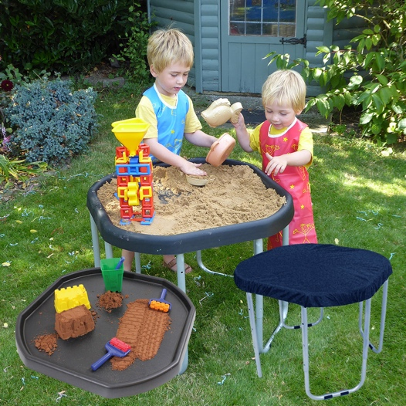
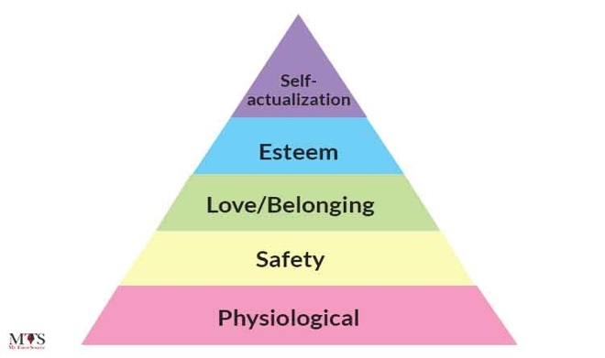
- Stimulating environment – Brain development begins shortly after conception and progresses throughout life. Development is highly affected by the senses, i.e. sound, touch, vision, smell, and thoughts, therefore it is essential that the practitioner creates an environment that will enhance the child’s development through sensorial and stimulating experiences as brain growth and development depends on the degree of richness of the environment. On the contrary in the absence of new experiences, the child’s brain may possibly begin to prune, which leads to pathways beginning to fade and cut off. (Howard Hughes Medical Institute, 2018). Froebel, who established the first preschool, suggests the importance of a natural environment to a child’s natural development, with amassed access to nature advancing holistic development -a Froebelian holistic perspective- (Watts, 2021).
(Source: Kub, no date)
(Source: Kub, no date)

Why is play important?
Play is a fundamental right and an essential element of child development - Article 31 of the UNCRC (Children’s Commissioner for Wales, no date and Murray, 2018). Smidt (2011) maintains that play is divergent for every child, regardless of whether playing is to meet a specific need, to solve a problem, or to convey an emotion. The Welsh Government (2015) and The Welsh Assembly Government (2002) agree that every aspect learnt from free play is beneficial to the child, as play has contributed significantly to the evolutionary survival of humans. Furthermore, providing a natural environment for children to interact with promotes knowledge of the world around them, as supported by theorists Montessori (Ozgen, 2023) and Piaget (Bormanaki and Khoshhal, 2017). Ozgen (2023) and Bormanaki and Khoshhal (2017) argue that practitioners must provide a significant amount of time for children to engage and play freely in order to appropriately and accurately observe to detect areas of weakness or areas of required support. Playing ensures that children develop appropriate and necessary skills, such as problem-solving through verbal and non-verbal communication, dexterity and muscle growth, and a myriad of social skills such as sharing, taking turns, and increasing feelings of empathy and compassion (Sutton-Smith, 1997). According to Kumar, et al. (2022), there are a multitude of emotional-behavioural benefits such as the reduction of fear and irritability, but moreover a significant increase in feelings of joy, self-esteem, and mastery that are not based on the loss of esteem of others. These experiences adhere to the criteria of the psychological needs in Maslow’s Hierarchy of Needs (see pyramid model below), and for children to therefore achieve self-actualisation, it is crucial that practitioners ensure that their basic and psychological needs are met (TES, 2019).

(Source: My Tutor Source, 2022)

The Role of the Adult
“No significant learning occurs without a significant relationship”

~ Dr. James P. Comer, 2021
In order for practitioners to successfully facilitate a smooth transition it is indispensable that…
- Practitioners form relationships built on compassion and respect
- Practitioners and carers interact responsibly and effectively to share necessary information about the child
- Practitioners create a nurturing and stimulating environment for the children

(Source: VectorStock, no date)

You may be a child’s secure attachment…

Pioneer theorist in attachment theory, Bowlby argues that children can form secure attachments not only to their primary caregivers or parents but to you, their teacher, this is supported by MacKay, et al. (2010) who suggest the effects of the quality of practitioner interaction with children on children's academic progress.
What is secure attachment?
- When the primary carer/ practitioner is…
    - Responsive to child’s needs
    - Sensitive
    - Consistent (reaction and environment)
- Therefore the child is…
    - Happy and secure
    - Exploring new experiences (Source: Learning Theories, 2023)
    - Communicating (verbal and non-verbal)
Potential behaviours of securely attached children include an increase in confidence whilst socialising, interacting, forming relationships built on inclusion, and exploring new opportunities. Therefore, not only is a secure attachment crucial in terms of academic development, in addition it is vital for children’s holistic development (Schore, 2003).

Forming a secure attachment to a practitioner can be monumental for children who have built long-term insecure attachments to their primary caregiver. A study by the National Centre for Biotechnology Information that was published in 2013 maintains that fortunately, a secure attachment with a secondary caregiver can indeed reverse the neglectful effects on the child’s brain as a result of a prior insecure attachment (Stronach, Toth, Rogosch and Cicchetti, 2013).
~ See the scan below that indicates the effect of insecure attachment on a child’s brain ~
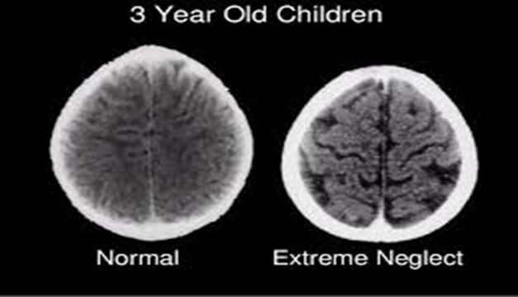

(Source: Perry and Pollard, 1997)

How can I put this into practice?
Practitioners can facilitate a smooth transition by…
- Successfully forming a secure attachment bond with the child by spending time getting to know the child and discovering their likes, dislikes, strengths, and weaknesses that may need possible early intervention.
- Being consistent with responses and approaches
    - crucial as it may be detrimental to forming a secure bond with the child, as they may become additionally unsettled and withdrawn from others, as suggested by Bowlby (Van Rosmalen, Van der Horst, and Van der Veer, 2016).
- Providing a stable and consistent environment when forming secure attachments, as the environment must cater to the child’s needs whilst also ensuring new opportunities and experiences to explore.
    - An ever-changing environment may be unsettling to a child who is encountering a transition (Bornstein, Putnick and Esposito, 2017).
- Communicating effectively with the child’s parents in order to become aware of the child’s background, ability, any health conditions or concerns, and the specific circumstances of the child’s family.
    - As maintained by Bronfenbrenner, effective communication between the microsystem on the child is crucial for a successful transition (Härkönen, 2008).
- Sharing information concerning transitions using varied approaches (The Welsh Government, 2017)
    - this may consist of; face-to-face meetings with parents, newsletters including information on the setting and staff in order to be inclusive of parents with additional needs, stay-and-play sessions and half-day visits in order for the child to become familiar with the setting beforehand.
- Welcoming families with respect and inclusivity
    - Practitioners must strive to be unbiased and refrain from initial judgments (Children’s Workforce Development Council, 2010).



(Source: Burning Bright, 2016)

Partnerships

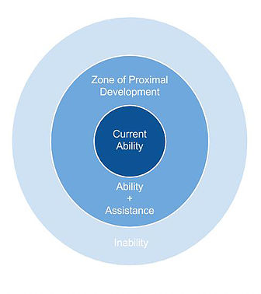

(Source: Blue Ring Media, no date)

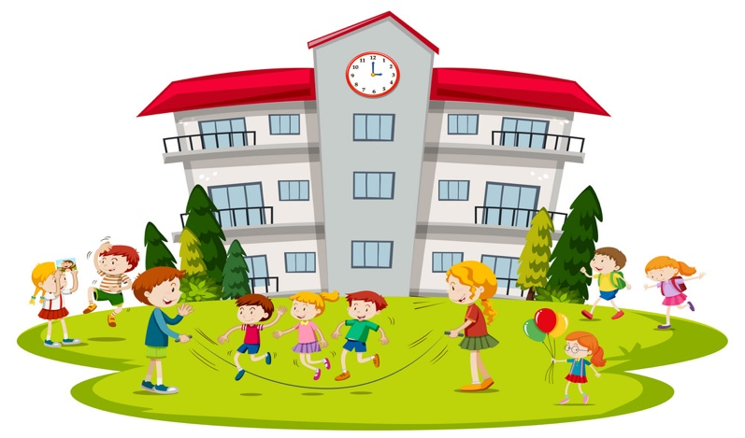
Effectice comm. (partnerships)

Vygotsky model (interventions)

partnerships – maslow’s hierarchy

Proposed outcomes – how do you know that the child is happy/ how a positive transition can benefit children

Interventions

Proposed Outcomes

Reference List
Alexander, E. (2010) ‘A successful child: early years practitioners’ understandings of quality’, Early Years, 30(2), pp. 107-118.

Birth to 5 Matters (2021) Transitions. Available at: https://birthto5matters.org.uk/transitions/ (Accessed: 15th November 2023).

Blue Ring Media (no date) Children playing at school. [Cartoon]. Available at: https://www.vectorstock.com/royalty-free-vector/children-playing-at-school-vector-22784443 (Accessed: 29th November 2023).

Bormanaki, H. B., Khoshhal, Y. (2017) ‘The Role of Equilibration in Piaget’s Theory of Cognitive Development and its Implication for Receptive Skills: A Theoretical Study’, Journal of Language, Teaching and Research, 8(5), pp. 996-1005.
Brock, L. L., Curby, T. W., Cannel-Cordier, A. L. (2018) ‘Consistency in Children’s Classroom Experiences and Implications for Early Childhood Development’, Kindergarten Transition and Readiness, pp. 59.83.
Burning Bright (2016) Those Parent-Teacher Meetings. [Cartoon]. Available at: http://burnighbright.blogspot.com/2016/08/those-parent-teacher-meetings-fear.html (Accessed: 29th November 2023).
Children’a Commissioner for Wales (no date) Article 31. Available at: https://www.childcomwales.org.uk/wp-content/uploads/2018/04/Play-FINAL.pdf (Accessed: 29th November 2023).
Children’s Workforce Development Council (2010) Common Core Skills and Knowledge for the Children’s Workforce. Available at: https://moodle.uwtsd.ac.uk/pluginfile.php/86466/mod_resource/content/1/Common%20core%20of%20skills%20and%20knowledge%20for%20the%20childrens%20workforce.pdf (Accessed: 29th November 2023).

Coy, W. (2015) Starting kindergarten. [Image]. Available at: https://www.sheknows.com/parenting/articles/1087842/concerns-when-starting-kindergarten/ (Accessed: 8th November 2023).

Department of Education (2010) Listening to children’s perspectives: improving the quality of provision in early years settings. Available at: https://assets.publishing.service.gov.uk/government/uploads/system/uploads/attachment_data/file/183412/DfE-RR239b_report.pdf (Accessed: 23rd November 2023).

Dewey, J. (1933) How We Think: A Restatement of the Relation of Reflective Thinking to the Educative Process. Boston: Heath & Co Publishers.

Ferguson, J. (2020) ‘Supporting Smooth Transitions in the Early Years’, Herts for Learning. Available at: https://www.hertsforlearning.co.uk/blog/supporting-smooth-transitions-early-years (Accessed: 8th November 2023).

Härkönen, U. (2008) ‘The Bronfenbrenner ecological systems theory of human development’, Scientific Articles of V International Conference, pp. 7-10.

His Majesty’s Government (2004) Children Act 2004. Available at: https://www.legislation.gov.uk/ukpga/2004/31/contents (Accessed: 8th November 2023).

Howard Hughes Medical Institute (2018) Prenatal Development of the Human Brain. Available at: https://www.youtube.com/watch?v=4CZJTNurVHE (Accessed: 23rd November 2023).

Johansson, I. (2007) Informing transitions in the early years. Berkshire: Open University Press.

Kub (no date) The Original Tuff Tray. [Image]. Available at: https://kubdirect.co.uk/products/original-tuff-tray-stand-and-cover (Accessed: 23rd November 2023).

Kumar, P. A., et al. (2022) ‘Play and Play Spaces for Global Health, Happiness, and Well-being’, Handbook of Health and Well-being, pp. 129-154.

Learning Theories (2023) Attachment Theory (Bowlby). [Image]. Available at: https://learning-theories.com/attachment-theory-bowlby.html (Accessed: 29th November 2023).

Litt, C. J., (1986) ‘Theories of Transitional Object Attachment’, International Journal of Behavioural Development, 9(3), pp. 383-399.

MacKay, T., Reynolds, S. & Kearney, M. (2010) ‘From attachment to attainment: The impact of nurture groups on academic achievement’, Educational & Child Psychology, 27(3), pp. 100-110.

Medium (2020) Developmental Milestones. [Cartoon]. Available at: https://medium.com/@TheraspOT/developmental-milestones-7a6d91dde2cc (Accessed: 8th November 2023).

Murray, J. (2018)’The play’s the thing’, International Journal of Early Years Education, 26(4), pp. 335-339.

Murray, J. (2021) ‘How do children build knowledge in early childhood education, Susan Isaacs, young children are researchers and what happens next’, Early Child Development and Care, 191 (7-8), pp. 1230-1246. (Accessed: 23rd November 2023). doi.org/10.1080/03004430.2020.1854242

My Tutor Source (2022) Maslow’s Hierarchy of Needs. [Image]. Available at: https://ksa.mytutorsource.com/blog/maslows-hierarchy-of-needs/ (Accessed: 29th November 2023).

Ogzen, Z. (2023) ‘Nature-Based Education in the Light of Montessori Philosophy: Meaning, Principles, and Practices’, European Journal of Alternative Education Studies, 8(1), pp. 134-153.

Oxford English Dictionary (2023) ‘Transition’. Available at: https://www.oed.com/dictionary/transition_v?tab=meaning_and_use#12645704 (Accesssed: 8th November).

PACEY (2016) Transitions and settling in. Available at: https://www.pacey.org.uk/Pacey/media/Website-files/PACEY%20member%20practice%20guides%20(PDFs)/PG10-transitions-and-settling-in.pdf (Accessed: 15th November 2023).

Perry, B. D. and Pollard, D. (1997) “Altered brain development following global neglect in early childhood”. Society For Neuroscience: Proceedings from Annual Meeting, New Orleans.

Schore, A. N. (2003) ‘Effects of a secure attachment relationship on right brain development, affect regulation, and infant mental health’, Infant Mental Health Journal, 22(1-2), pp. 7-66.

Smidt, S. (2011) Playing to Learn; The role of play in the early years. Abingdon: Routledge.

Sutton-Smith, Brian. (1997). The Ambiguity of Play. Cambridge: Harvard University Press.

TES (2019) Pedagogy Focus: Maslow’s Hierarchy of Needs. Available at: https://www.tes.com/news/pedagogy-maslows-hierarchy-needs (Accessed: 29th November 2023).

The Welsh Assembly Government (2002) Welsh Assembly Government Play Policy. Wales: Welsh Assemble Government.

The Welsh Government (2014) An independent Stocktake of the Foundation Phase in Wales. Cardiff: Welsh Government.

The Welsh Government (2015) Curriculum for Wales; Foundation Phase Framework. Wales: Welsh Government.

The Welsh Government (2017) ‘Transition Guidance’, Flying Start-Annex. pp. 1-106. Available at: https://gov.wales/sites/default/files/publications/2019-07/flying-start-transition-guidance-for-professionals.pdf (Accessed: 15th November 2023).

The Welsh Government (2018) Foundation Phase Framework revised 2015. Available at: https://gov.wales/sites/default/files/publications/2018-02/foundation-phase-framework-revised-2015.pdf (Accessed: 8th November 2023).

Van Rosmalen, L., Van der Horst, F. and Van der Veer, R. (2016) ‘From Secure Dependency to Attachment’, History of Psychology, 19(1), pp. 22-39.

VectorStock (no date) Primary school children with smiling teacher. [Cartoon]. Available at: https://www.vectorstock.com/royalty-free-vector/primary-school-kids-with-smiling-teacher-children-vector-32216625 (Accessed: 29th November 2023).

Vogler, P., et al. (2008) Early childhood transitions research: A review of concepts, theory, and practice. Available at: https://ora.ox.ac.uk/objects/uuid:dfa1d685-97e1-4365-a8b7-ca7d44ffc618 (Accessed: 15th November 2023).

Watts, T. (2021) ‘I’m Learning Nature now With Them’: What can a Holistic Perspective Contribute to our Understanding of the Influential Relations Between Young Children, Adults and a Natural Environment?. Canterbury Christ Church University.

Young, J. (2021) Ecological Systems Theory. [Image]. Available at: https://twitter.com/Juliet_Young1/status/1423018236350799872 (Accessed: 15th November 2023).

