APPLICATION OF INFORMATION SECURITY GOVERNANCE, DATA PROTECTION AND COMPLIANCE PRINCIPLES WITHIN NATUREGREEN'S CLOUD-BASED ENVIRONMENT

Abstract
This report examines the implementation of information security governance, data protection, and compliance principles within a cloud-centric organisational environment. It evaluates major frameworks—including ISO 27001, NIST Cybersecurity Framework, COBIT, and ITIL—to determine how they can strengthen confidentiality, integrity, and availability across a distributed workforce relying heavily on wireless networks and Bring-Your-Own-Device (BYOD) practices. The analysis highlights key vulnerabilities arising from cloud misconfigurations, identity compromise, weak access controls, and the absence of formal governance structures. A comprehensive security model is proposed, integrating Zero Trust Architecture (ZTA), Security Information and Event Management (SIEM), data-classification standards, regulatory alignment, and RACI-based governance. The recommended approach ensures continuous monitoring, risk reduction, and compliance with global data-protection requirements. By adopting layered controls, clear policies, and structured accountability, organisations can enhance resilience, minimise cyber-attack exposure, and maintain trustworthy, sustainable digital operations in rapidly evolving threat landscapes.

Assumptions Made
This report assumes that the organisation operates primarily in a cloud-first environment with a globally distributed workforce that relies heavily on wireless networks and BYOD access. It is assumed that no formal information security governance framework currently exists and that policies, risk-management practices, and regulatory compliance mechanisms are either minimal or undocumented. The analysis also assumes that cloud services follow a standard shared-responsibility model, that existing security controls such as MDM, Zero Trust, and SIEM are not yet implemented, and that the organisation processes sensitive customer and operational data requiring classification and protection. These assumptions provide a baseline for designing governance structures, technical controls, and compliance requirements.

Table of Contents
Abstract 2
Assumptions Made 3
1. Introduction 5
2. Literature Review 5
3. Analysis of NatureGreen Case Environment 8
4. Proposed Information Security, Governance & Compliance Framework 9
5. Mechanisms of Control, Protection and Policies 13
6. Critical Discussion: Formulation of Regulations and Standards. 15
7. Conclusion 16
References 17
Annexure 19

1. Introduction
The high growth rate of digital ecosystems has altered the operations of organisations, making it possible to be connected to the world, access remotely, and computer in the cloud. NatureGreen is a global wellness brand, the operations of which are strongly associated with a competitive environment in the digital sphere, with its unique role in service provision, data availability and consumer relationships. Nevertheless, the organisation has greater cybersecurity issues because of the prevalence of wireless networking, cloud reliance and the augmented need to access with the Bring-Your-Own-Device (BYOD) access. These elements further increase the attack surface of the organisation, as well as putting sensitive data such as customer records and intellectual property at risk of cyber attacks. The organisation functions in a susceptible online setting in the absence of a laid-down information security governance policy and compliance frameworks. With constantly changing cybersecurity risks, ensuring the continued security of the data assets demands a well-thought-out methodology and strategy based on accepted standards, frameworks and best practices. The current report reviews available information security and governance frameworks and puts them into the scenario of NatureGreen. A rigorous analysis will be used to propose a flexible and robust model that will boost the readiness of confidentiality, integrity, availability, and compliance.

2. Literature Review
General Introduction to Information Security Governance Frameworks
Information security governance frameworks give systematic approaches to risk management and hold accountability, as well as provide security of information assets in digital ecosystems [1]. These frameworks bolster security practices to organisational goals, regulatory provisions and business settings. They are useful in enhancing consistency, resiliency and maturity in the face of emerging threats, particularly in the globally distributed and cloud-dependent businesses.
ISO 27000 Family
One of the most recognised security standards globally is still the ISO 27000 series, especially the ISO 27001 and the ISO 27002. The ISO 27001 sets up the fundamental provisions towards the implementation and maintenance of the Information Security Management System (ISMS). It embraces a risk-based and process-driven approach via the Plan-Do-Check-Act (PDCA) process of improvement. ISO 27002 expounds this by outlining security controls that deal with such areas as identity management, cryptographic controls, physical protection, network security and operational procedures. The main strength of the ISO 27001 is the certification pathway, global acceptance and formal compliance system [2]. But, implementation can be an intensive resource cost, organisational maturity- based and reliant upon cultural acceptability and commitment to continuous monitoring.
NIST Cybersecurity Framework (CSF)
The NIST CSF is a flexible and modular framework that can be applied to different industries and technical settings. The framework is made up of five fundamental functions, namely Identify, Protect, Detect, Respond and Recover, which make up the entire security lifecycle. Its model of categorisation allows organisations to map the capabilities, set benchmarks on maturity and prioritise improvement in terms of risk exposure [3]. A comparison between NIST and ISO is dissimilar; NIST lacks a certifiable model of compliance, but its flexibility is desired in case of progressive execution, cloud infrastructure protection and current threat detection strategies.
COBIT Governance Framework
COBIT puts much emphasis on information and technology enterprise governance. It focuses on harmonising the IT processes with organisational goals, regulatory and performance measurement. The model presents processes, maturity models and governance principles that allow strategic oversight and audit readiness [4]. COBIT is outstanding in the setting where there is great executive responsibility, quantifiable controls and organisational cohesion. Nonetheless, it does not provide granular technical security advice, and, therefore, it is necessary to complement the approach with other frameworks like ISO or NIST.
ITIL Framework Service Management
ITIL indirectly helps in the protection of information by systems in terms of planned design of services, deliveries, and improvement. Secure operations and accountability are helped by the modules like incident management, service-level management and change control. ITIL is also quite helpful in cloud-based operation setups in which configuration management, role-based access and continuity of services are the building blocks of secure service provision. ITIL is not devoted particularly to cybersecurity controls; however, its design, based on governance, contributes to better operational efficiency and resilience.
Compliance and Other Regulations
The current governance will also need some coordination with the legislative frameworks like the General Data Protection Regulation (GDPR), California Consumer Privacy Act (CCPA) and industry-specific cybersecurity laws [5]. GDPR provides the obligatory conditions of the lawful processing of the data, reporting of the breaches, privacy-by-design, and personal rights. Acquiescence guarantees moral data administration and lowers the liability. These regulations are becoming more dominant towards shaping and transforming industry structures, in assuring that they are in line with societal and legal expectations.
Technical Security Models
Governance frameworks are complemented by such technical control models as Zero Trust Architecture (ZTA) and Defence-in-Depth strategies. Zero Trust does not assume any default trust but instead applies authentication and contextual authentication on an ongoing basis. Defence-in-Depth also creates further implementation of the layered control on the physical, administrative and technical levels [6]. A combination of these models operationalises the requirements of governance and strengthens distributed infrastructures.
Relative Analysis of Frameworks
All the frameworks have different strategic values. No ISO offers a certifiable relief system, NIST offers flexibility in operations, COBIT offers alignment to the governance level, and ITIL offers notorious control to manage services. Hybrid adoption is also more frequently found, especially where cloud-centric companies are involved, where regulatory compliance is needed, operational maturity and adaptive control systems are required [7]. The integration relies on the organisational priorities, industry regulation, resource capability and the infrastructure architecture.
This literature review has shown that current digital landscapes necessitate systematic, scaled and integrated frameworks of governance to uphold data integrity, reduce risk and serve compliance. Their implementation helps to achieve safe working patterns that can suit working in an environment prone to threats and dynamic cyber ecosystems.
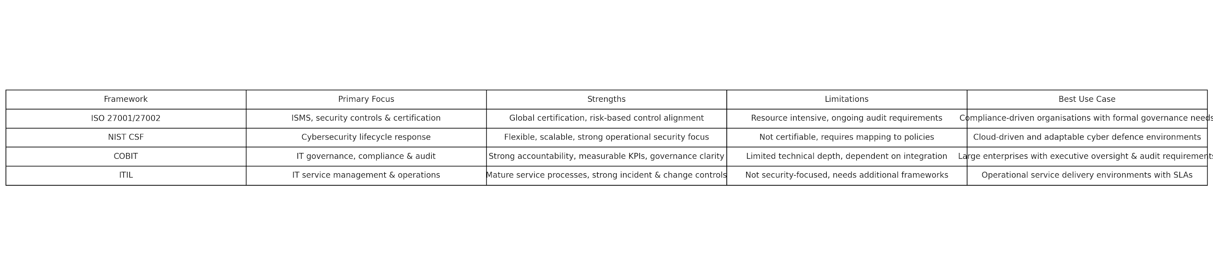
Figure 1: Comparative analysis of ISO 27001/27002, NIST CSF, COBIT, and ITIL frameworks, illustrating their primary focus, strengths, limitations, and most suitable implementation environments

3. Analysis of NatureGreen Case Environment
NatureGreen functions in an intricate computerised world-wide digital setting that is typified by cloud computing, massive dependency on wireless networks and a vast, widely-dispersed workforce [8]. The organisation has roughly 95% of its infrastructure being wireless, which has led to a great exposure to attacks like rogue access points, unauthorised interception, denial-of-service attacks and credentialed compromise. Misconfigurations, identity compromise and data sovereignty considerations, and shared responsibility models are more prominent because of the reliance of the company on cloud services.
The BYOD access requirement adds another risk dimension, especially when it comes to unmanaged devices, insecure local storage, lax authentication practices and endpoint standardisation. The lack of either Mobile Device Management (MDM) or Zero Trust controls enhances the chances of unauthorised access and sensitive data leakage [9].
The digital aspect of NatureGreen, such as e-commerce and social media, exposes the customer to phishing, ransomware, identity theft, and reputational manipulation attacks. The current system of governance does not provide sufficient protection of customer data and intellectual property, which is estimated to possess high commercial value.
There are no formal security policies, governance models and alignment to compliance in the organisation, which leads to disjointed and reactive cybersecurity [10]. Lack of regulatory convergence is related to the exposure to legal sanctions associated with privacy, consumer and intellectual property laws.
In general, NatureGreen reflects a high-risk status that needs to be technologically regulated by creating formal compliance procedures and improving the operation of operational stability to protect vital information assets and sustain shareholder trust.
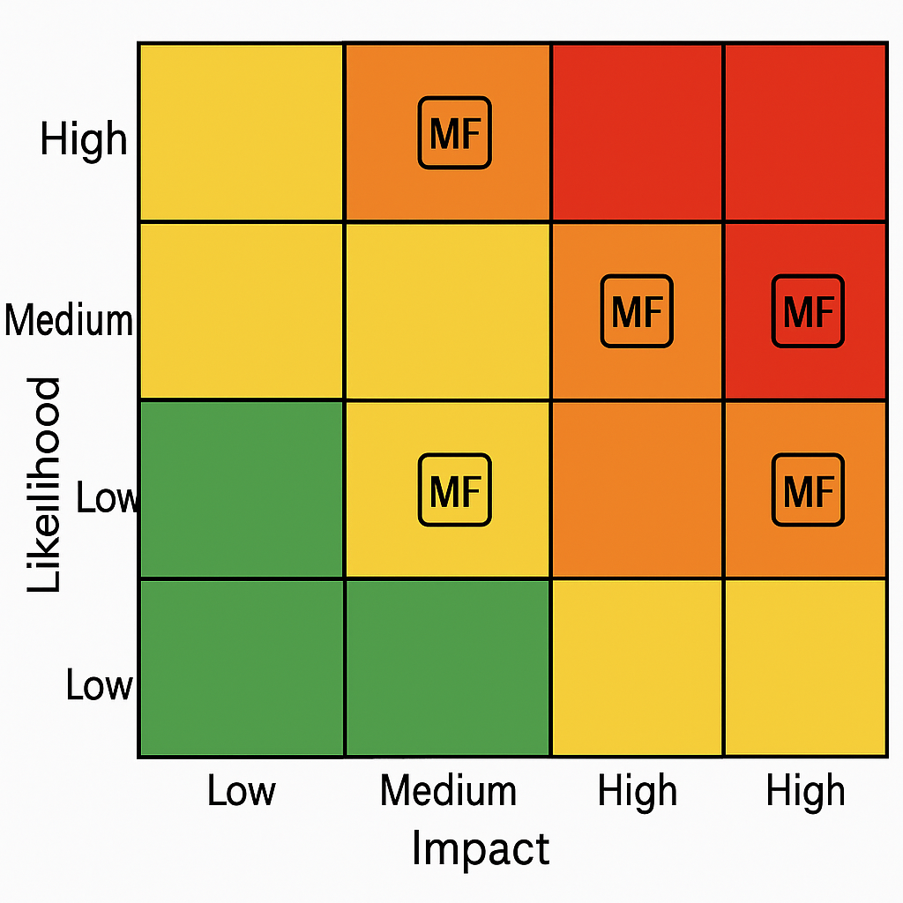
Figure 2: Risk Heat Map for NatureGreen Cybersecurity Exposure

4. Proposed Information Security, Governance & Compliance Framework
An effective Information Security, Governance and Compliance framework of NatureGreen needs to be based on a concise strategy that incorporates the governance responsibility, regulatory congruency, risk of operational control and relentless surveillance. The framework should take into consideration the dependence of the organisation on wireless networks, cloud computing, interacting with global customers and Bring-Your-Own-Device (BYOD) options, with the need to ensure security of sensitive information and intellectual property.
Framework Overview
An integrated model of risk management, regulatory compliance, operational controls and continuous monitoring is necessary to support a comprehensive security and governance model that will be specific to NatureGreen [11]. An all-inclusive strategy using ISO 27001, NIST CSF, alongside ITIL service concepts, offers a systematic governance approach and operational endurance strategy.
Governance and Organisational Structure
Effective governance begins with a defined leadership hierarchy and documented responsibilities. A dedicated governance model should be established, including:
Role | Responsibility
Chief Information Security Officer (CISO) | Executive oversight and policy enforcement
Data Protection Officer (DPO) | Privacy compliance and regulatory alignment
Security Operations Centre (SOC) | Real-time monitoring, incident response, threat detection
Risk, Audit and Compliance Committee | Internal audits, maturity assessments, and reporting
IT Security Engineering Unit | Technical control deployment, vulnerability remediation
It acts as a framework of accountability, transparency and stakeholder ownership of all functions on cybersecurity and compliance.
Policy Framework and Standardisation
Secure operations are based on policy development. The categories of core policy are:
Access and Identity Management Policy: requirement of least privilege, Multi-Factor Authentication (MFA) and the role of Access Control.
- BYOD Policy: enrolment of devices, management of mobile devices (MDM) and device encryption and control over applications is required.
- Policy on Data Governance and Classification: establishing the level of sensitivity, the requirement for retention and secure disposal.
- Incident Response and Cyber Resilience Policy: the description of the processes of detection, escalation, reporting and recovery.
- Acceptable Use and Remoting Working Policy: providing safe access practice and digital behaviour practice.
The policies are to be guided by ISO 27001 Annex A and consistent with relevant laws, like GDPR.
Risk Management and Conformity to Compliance
The cyclical and systematic nature of risk management is a way of guaranteeing continuous safety against emerging cyber threats. It is possible to implement a methodology based on ISO 27005 and the NIST CSF:
- Identify: inventory assets, risk owner definition, legal obligations assessment and evaluation of cloud shared responsibility models.
- Assess: use either a qualitative or quantitative scoring model to achieve the likelihood and impact.
- Treat: choose administrative, technical and physical control.
- Monitor: oversee the development of risks with the help of dashboards, audits and evaluation of maturity.
Regulatory adherence should constantly be brought into correlation with GDPR, CCPA and other cybersecurity guidelines. Service-Level Agreements (SLAs) and the assessment of compliance requirements of the third party should be performed on a contractual basis (Folorunso et al., 2024).
Operation and Technical Controls
The Defence-in-Depth architecture should be a mechanism that ensures operational security. Key controls include:
- Zero Trust Network Access (ZTNA): authenticating both identity and device posture and context before being allowed the call.
- Encryption Protocols: hiding data both in transit and at rest using standards approved in the industry.
- Network Segmentation and Internet Firewalls: separating the most important computer assets and eliminating a jump to the right.
- Endpoint Protection Systems: Endpoint Protection Systems, such as EDR, anti-malware and automatic patching, empower BYOD and corporate device protection.
- Security Information and Event Management (SIEM): the ability to centralise real-time analytics, anomaly discovery and compliance.
Such controls minimise the chances of being exposed to ransomware, credential theft, data exfiltration and wireless intrusion threats.
Cloud and Vendor Governance
Being an organisation that relies on a cloud, NatureGreen is forced to deal with third-party risks by evaluating them contractually and ensuring them constantly [12]. Measures of cloud governance are:
- Sharing responsibility mapping.
- Compliance attestation verification (ISO 27017/18, SOC 2, PCI-DSS)
- Automated configuration auditing and vulnerability scanning
- Encryption key lifecycle oversight
The sustainability of external control of vendors is met as the SLAs specify the availability of their services, timelines of breach notification, security testing requirements and audit rights.
Incident Response, Continuity and Recovery
An organised cyber resilience program will guarantee operational continuity in cases of security events [13]. Response to the incident has to be based on accepted models like NIST 800-61 and should incorporate containment, evidence preservation, analysis of root cause and post-incident reporting.
BCP and Disaster Recovery (DR) strategies should specify:
- It is the recovery time objectives (RTO).
- Recovery point objectives (RPO)
- Failover architecture
- The frequency and off-site copy retention.
- Tabletop exercises and maturity reviews undertaken on a regular basis guarantee that response capabilities are maintained.
Ongoing Analysis and Refurbishment
The maturity of a security occurs as a result of a continuous assessment, compliance scanning, in-house auditing and penetration testing. The posture improvements should be measured using key performance indicators (KPIs) and balanced scorecards in the areas of closure rates of vulnerabilities, response time and policy compliance levels of the balanced scorecard. The application of the ISO and the NIST principles of continuous improvement also guarantees that the framework is kept in line with the current trend of technological, regulatory, and threat advancement [14]. This consolidated model offers a flexible, robust and enforceable security framework befitting the operational needs, regulatory and strategic priorities of NatureGreen in the short and long-term perspectives.
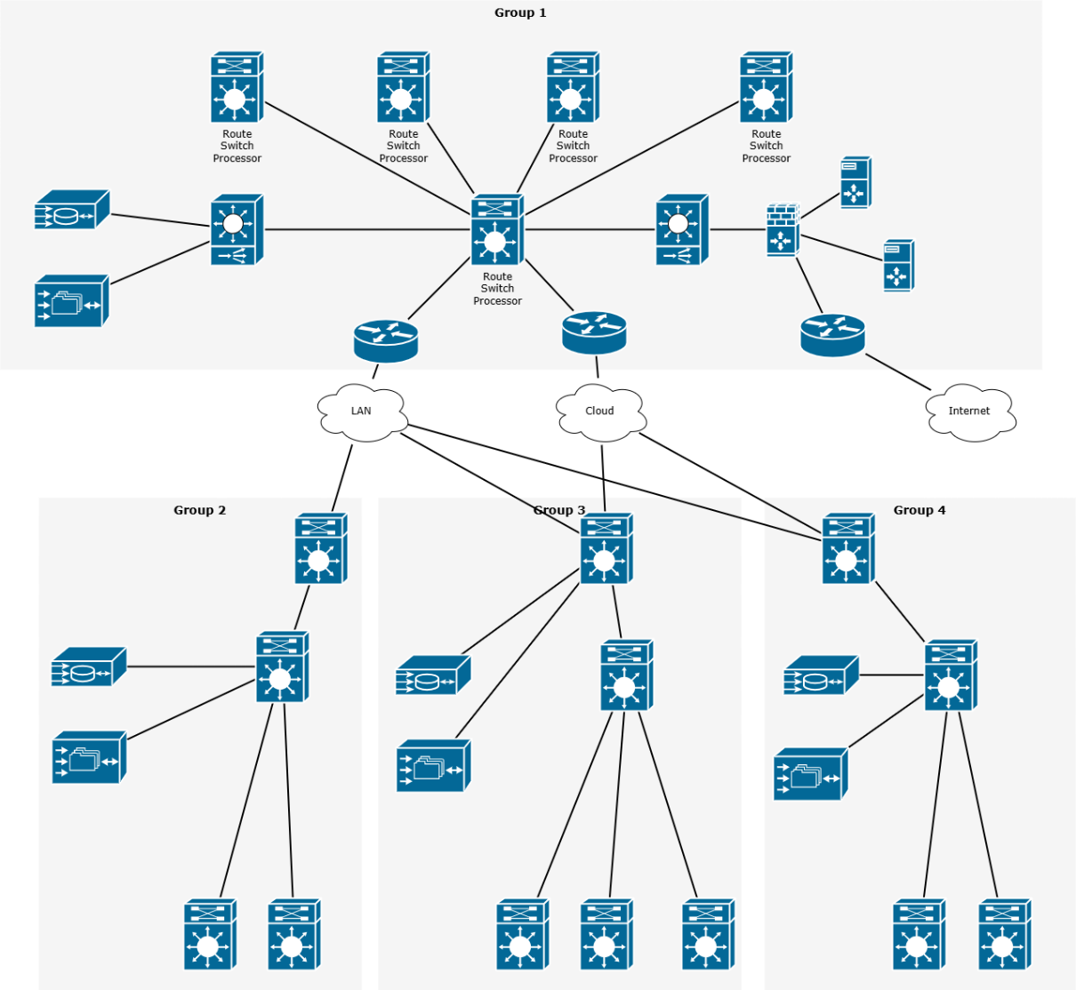

Figure 3: Information Security Governance Structure

5. Mechanisms of Control, Protection and Policies
A secure information environment is anchored on the integration of clear policies, good controls and layered protection mechanisms. These parts work together in order to protect the critical systems, personal data, and intellectual property and operational continuity. In the case of an organisation that is highly dependent on wireless networks, the use of cloud services and BYOD access, these measures are needed to minimise the exposure to cyber threats and legal compliance with legal and regulatory conditions [15].
Administrative Policies
Administrative policies set expectations of governance, specify accountability and give the operational regulations that ensure the same security practices. Some of the major security policies include:
- Access Control Policy: Determines the authentication, user provisioning, vertical access granting and periodic review of access. These principles of role-based access limits and least privilege can decrease risks of internal malpractice and escalation of privileges.
- BYOD and Mobile Device Policy: Imposes security needs on individual devices that have access to organisational systems [16]. Onboarding, automatic updates and the ability to remotely wipe Mobile Device Management (MDM), mandatory encryption are necessary security measures.
- Data Classification and Data Handling Policy: This policy classifies the data at levels of public, internal, confidential and restricted, with particular procedures governing its access, retention, storage and disposal.
- Acceptable Use Policy: This is used to define how an organisation's systems should be used and in the process of what should not be done, i.e. installing unauthorised software or sharing data.
- Incident Response and Reporting Policy: Makes the procedures of identifying, escalating, containing, documenting and reporting security incidents formal based on compliance requirements, including GDPR breach deadlines.
Policies give the basis on which the technical and operational controls are established.
Technical Controls
Technical controls implement the policies in an automated manner and guard digital assets against exploitation. The fundamental technical processes are:
- Multi-Factor Authentication (MFA): Authenticate account compromise as identification verification takes place on levels other than passwords.
- Encryption: Provides secrecy to sensitive data stored in cloud environments, databases and in wireless networks.
- Network Segmentation and Firewalls: Isolate high-value networks distinctly from the general IT networks and restrict the movement of cyber intruders.
- Endpoint Detection and Response (EDR): Surveillance and acts on malware, behavioural deviations and suspicious access to company and own devices.
- Security Information and Event Management (SIEM): Consolidates information on logs, assists in detecting anomalies in real-time and aids in forensic analysis to aid in compliance reporting.
- Zero Trust Architecture (ZTA): It assumes that none of the equipment, individuals, or services on the network or on the internet should be trusted, and one has to keep on verifying to avoid internal and external attacks.
Such controls enhance the integrity of the system, reduce its attack surfaces and facilitate quick identification of threats.
Mechanisms of Physical and Operational Protection
Physical controls, such as security measures, do not enable unauthorised individuals to enter facilities and equipment [17]. The measures may include some of the following: access to the five-building access through secure building entry, CCTVs, biometric authentication and controlled server-room access.
This is assisted with operational safeguarding mechanisms that enhance the resilience by confirming the frequent repairs and checking (including):
Vulnerability scan and penetration testing.
Patch management, configuration management.
Frequent backup and backup back up location.
Evaluating business continuity and disaster recovery.
These measures are applied to maintain the system availability, reduce the interruption time and recoverable time of security events.
Together, administrative policies, technical control and operational safeguards create a multilayer defence policy that facilitates safe digital operations and regulatory adherence.

6. Critical Discussion: Formulation of Regulations and Standards.
Development of the new technology, the reliance on being digital and the sophisticated nature of the modes of attack are causing the cybersecurity threat to develop very fast [18]. Recruitment of regulatory frameworks and compliance measures, therefore, must be revised continuously, in order to be relevant and feasible. Rather, outdated requirements will not be able to resolve such risks as attacks with the assistance of artificial intelligence, threats of quantum computing, supply chain vulnerabilities, and massive ransomware attacks.
The modifications of policies are evidence of rising requests of society in the sphere of the right to privacy and ethical data processing and disclosures. Recent models and policies, such as GDPR and the ISO 27001 update, lay greater emphasis on responsibility, risk-based control and governance in advance. The continuous transformation ensures that organisations operate in healthy, ethical and legal manners in the fields and win the trust of the concerned parties. Refined standards provide methodological as well as systematic measures of risk elimination, implement best practices and establish a measurable amount of maturity of security in computer ecosystems.

7. Conclusion
NatureGreen has been experiencing a digitally inefficient landscape that requires application of a formal cybersecurity threefold consisting of risk management, adherence to regulations and governance. The analysis shows that it is vulnerable due to serious vulnerabilities of cloud dependency, wireless network and uncontrolled access to devices. The introduction of the defined frameworks, such as ISO 27001, NIST CSF, as well as ITIL, provides the fostering of policy formulation, operation management and strategy alignment. A multi-layered security model that has governance structures, technical security and in-built monitoring brings about resilience and reduces the susceptibility to an attack. There is an adaptation to the shifting norms of rules, which will mediate the task of the law, and which will promote trust and fidelity in action. In general, a preventive and proactive security posture is vital in the sustainability of organisations in the long term.

References
- Antiya, D.S., 2025. Harnessing AI for Data-Driven Compliance and Security in Cloud Environments: A Blue-Green Infrastructure Approach. In Integrating Blue-Green Infrastructure Into Urban Development (pp. 245-270). IGI Global Scientific Publishing.
- Albazaz, F.A.K., Almolaa, O.S. and Yaseen, D.S., 2024, December. A Study on Examining Strategies for Ensuring Data Security and Regulatory Compliance in Cloud-Based Information Systems. In International Conference on Biologically Inspired Techniques in Many-Criteria Decision-Making Technologies (pp. 202-212). Cham: Springer Nature Switzerland.
- Lasopoulou, V., 2025. Cloud security and privacy (Master's thesis, Πανεπιστήμιο Πειραιώς).
- Omar, H.Y., Abdulqader, D.M., Abdullah, R.M., Ismael, H.R., Rashid, Z.N. and Sami, T.M.G., A Review on Upshots of Cloud Computing and Web Technology on the Future Green Transformation: AI, IoT, and Secure Enterprise Systems in Fostering Sustainable Work Practices. Journal of Information Technology and Informatics, 3.
- Sekti, B.A., Laksono, M.N.G., Laksono, M.I.A., Widodo, A.M., Anwar, N. and Tiaraputri, Z.A., 2025. Principles of Green Computing in Information Security. In Sustainable Information Security in the Age of AI and Green Computing (pp. 1-16). IGI Global Scientific Publishing.
- Layode, O., Naiho, H.N.N., Adeleke, G.S., Udeh, E.O. and Labake, T.T., 2024. Data privacy and security challenges in environmental research: Approaches to safeguarding sensitive information. International Journal of Applied Research in Social Sciences, 6(6), pp.1193-1214.
- Julakanti, S.R., KiranmayeeSattiraju, N.S. and Julakanti, R., 2025. Data protection through governance frameworks. arXiv preprint arXiv:2502.10404.
- Osakwe, J. and Haitula-Waiganjo, I., 2025. Data security and compliance through effective data governance. International Journal of Information Security (IJIS), 4(1).
- Kolade, T.M., Aideyan, N.T., Oyekunle, S.M., Ogungbemi, O.S., Dapo-Oyewole, D.L. and Olaniyi, O.O., 2024. Artificial intelligence and information governance: Strengthening global security, through compliance frameworks, and data security. Available at SSRN 5044032.
- Nayak, R., Ghugar, U., Gupta, P., Dash, S. and Gupta, N., 2025. Data Privacy and Compliance in Information Security. Securing the Digital Frontier: Threats and Advanced Techniques in Security and Forensics, pp.17-33.
- Sargiotis, D., 2024. Key Principles of Data Governance: Building a Strong Foundation. In Data Governance: A Guide (pp. 137-163). Cham: Springer Nature Switzerland.
- Folorunso, A., Wada, I., Samuel, B. and Mohammed, V., 2024. Security compliance and its implication for cybersecurity. World Journal of Advanced Research and Reviews, 24(01), pp.2105-2121.
- Morales-Sáenz, F.I., Medina-Quintero, J.M. and Reyna-Castillo, M., 2024. Beyond data protection: Exploring the convergence between cybersecurity and sustainable development in business. Sustainability, 16(14), p.5884.
- Qudus, L., 2025. Cybersecurity governance: Strengthening policy frameworks to address global cybercrime and data privacy challenges. International Journal of Science and Research Archive, 14(1), pp.1146-1163.
- Salako, A.O., Fabuyi, J.A., Aideyan, N.T., Selesi-Aina, O., Dapo-Oyewole, D.L. and Olaniyi, O.O., 2024. Advancing information governance in AI-driven cloud ecosystem: Strategies for enhancing data security and meeting regulatory compliance. Asian Journal of Research in Computer Science, 17(12), pp.66-88.
- Mahmood, H.S., Abdulqader, D.M., Abdullah, R.M., Rasheed, H., Ismael, Z.N.R. and Sami, T.M.G., 2024. Conducting in-depth analysis of AI, IoT, web technology, cloud computing, and enterprise systems integration for enhancing data security and governance to promote sustainable business practices. Journal of Information Technology and Informatics, 3(2), pp.297-332.
- Oyetunji, S.A., 2024. Investigating Data Protection Compliance Challenges. Int. J. Innov. Sci. Res. Technol.(IJISRT), 9, p.17.
- Sargiotis, D., 2024. Data security and privacy: Protecting sensitive information. In Data governance: a guide (pp. 217-245). Cham: Springer Nature Switzerland.
- AllahRakha, N., 2024. Cybersecurity Regulations for Protection and Safeguarding Digital Assets (Data) in Today’s Worlds. Lex Scientia Law Review, 8(1), pp.405-432.
- Ogborigbo, J.C., Sobowale, O.S., Amienwalen, E.I., Owoade, Y., Samson, A.T., Egerson, J., Ogborigbo, J.C., Sobowale, O.S., Amienwalen, E.I. and Owoade, Y., 2024. Strategic integration of cyber security in business intelligence systems for data protection and competitive advantage. World Journal of Advanced Research and Reviews, 23(1), pp.081-096.

Annexure
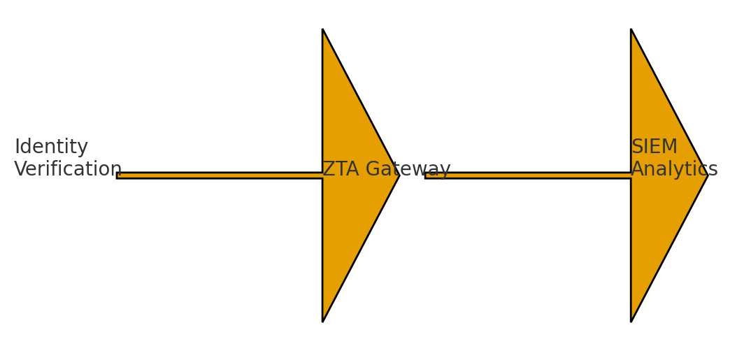
Figure: Workflow showing integration of SIEM monitoring with Zero Trust validation
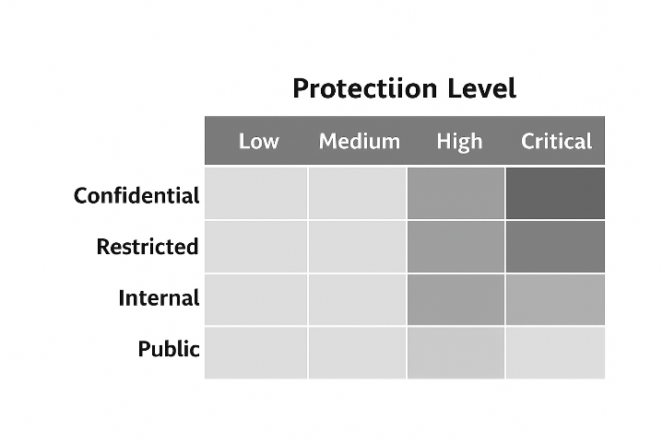
Figure: Data Classification Matrix showing sensitivity categories mapped to required protection levels
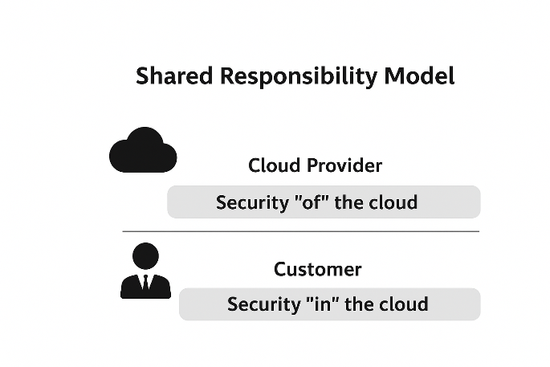
Figure: Cloud Shared Responsibility Model between provider and customer
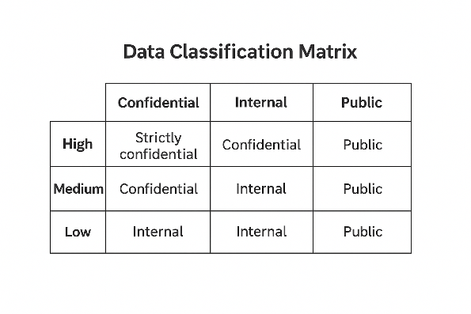
Figure: Data Classification Matrix showing data sensitivity levels aligned with access and handling requirements

