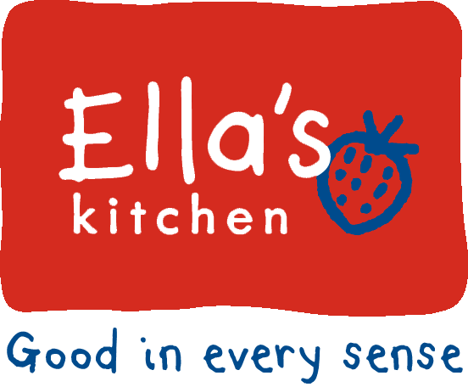

Creativity and innovation
  - Contempory issues in marketing
Cameron Borkett | 1702706 | 17/01/2020
Contents
Table of figures 1
Executive summary 2
Introduction 3
Background of organisation 3
Creativity and innovation 4
Creativity 4
Innovation 4
Creativity and innovation in Ella’s kitchen 6
Benefits and pitfalls of creativity and innovation 7
Benefits 7
Pitfalls 8
Conclusion 9
Recommendations 9
References 11

Table of figures

Figure 1:diagrammatic definition of innovation (Baregheh, Rowley,Sambrook,2009) 4

Executive summary
Ella’s kitchen is a small business who sells baby and children food products and they conduct their business sustainably and green and they are constantly looking to improve and change the way they recycle and conduct business
Their goals to be the business that do it right can be achieved through innovation and creativity by evolving their business they can grow and become a more desirable brand through their green innovation to making their product more recyclable, helping in building trust with buyers and their catering to the nutrition for children.
The ups and downs of the creative approach are the pressures that time constraints can have and the issue of having to be careful of copyright over trademarked and intellectual property and making sure they do not violate it. However, this free environment opens doors to be able to express the new ideas and be able to adapt the environment around them making them less susceptible to failure as they have the innovation to be able to scope out the issues and deal with things from another angle
The recommendations were methods of creativity and innovation exercises even in the forms of a simple brainstorm or a mind map just to get creativity constantly flowing so that the content of then business does not become irrelevant or dated by keeping up with current trends.

Introduction
In todays business where there are many businesses doing the same thing with only minor changes where every business strategies are only change price or to do special deals but now there is a call for creativity and innovation where in order to get the strategic advantage you need to stand out and this becomes even more important when you are a small business among big companies so having a new and fresh idea is more important than ever to gain competitive advantage and it was shown in a study that “Business creativity has a positive influence on business superiority” (Oktarina & Witiastuti,2019)

Background of organisation
This report will study in to Ella’s kitchen a baby and children’s food company that wishes to reduce the use of additives in their products so that the babies/children have a healthier diet and increase their wellbeing. Ella’s kitchen is only a small business that only had 72 employees in the fiscal year of 2018,a business being that small can be difficult in keeping up with larger businesses so keeping relevant is very important so that they do not fade in to the shadows of larger competitors. There aims and objectives are based on sustainability and making sure that their packaging is recyclable and that their ingredients are ethically. Their major focuses are on packaging, people, planet, ingredients and to be the ones who make the change. This goal that they wish to achieve can be achieved especially with the help of creativity and innovation so that they can find or create alternative ways to make their products greener and more sustainable.

Creativity and innovation

Creativity
At face value the definition according to the dictionary is to create or be inventive, however, it is more complicated than that as another definition of creativity is the ability to be able to produce work that is original and appropriate. This means it needs to come from an original and new standpoint and must be useful and able to adapt to the limitations of the task (Sternberg,1999), however, the word creativity or creative have so many different definitions depending on the context examples include individual talent in this context creativity is described as something a creative person does. Another is as a process as a way in which ideas are produced, finally as a product so something that is produced such as a painters work of art, all of these can be applied (Green, 2007) with so many definitions the word almost seems overused but that at least means that there is room for interpretation and leeway when considering the topic as a whole. But in this context, it will be more aimed towards an idea or a product as dealing with businesses and marketing ideas of how to do things and the question of what’s next? As William o’barr put it as “one of those you-know-it-when-you-see-it things that eludes a specific definition.” (O'Barr, 2011) Which is very accurate as people struggle to define it one way so it is easier to take it at face value

Innovation
Innovation is similar to creativity in the idea that it is not easily defined as it can be interpreted and people have their own ideas about what defines innovation, but again from the dictionary it states that it is to make change and to bring in new methods and ideas but again there is debate over what is the actual definition so another definition of it is a process or something that has many attributes as shown below:
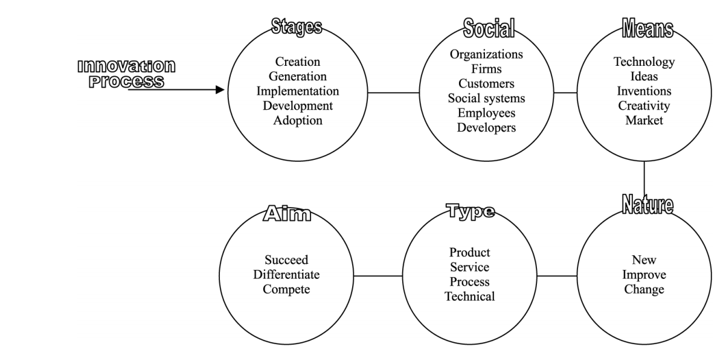
Figure 1:diagrammatic definition of innovation (Baregheh, Rowley,Sambrook,2009)

So, in the diagrammatic definition creation is tied in with the process as whole so creative is part of the beginning and the continuing attribute that is needed to keep things original and fresh. isn’t the creation of something but more of the how of making something a reality an example would be apple having the creativity to draw up the idea for a phone, but then having the innovation to create and improve on the product. “An invention becomes an innovation when it is successfully commercialized.” Brem & Maier & Wimschneider,2016) Additionally, with the new emerging technologies and the way that people and the planet are changing it is good for businesses no matter the size has that ability to stay current through innovation and creativity. This could be key to a business’s success or downfall “Corporations that embrace innovation and, as importantly, manage innovation well, are able to remain buoyant even in the choppy waters of today's uncertain global economics.” (Anon 2012)
This is good news for smaller businesses that have a creative and innovative side as smaller businesses are usually most effected by economies due to the size.

Creativity and innovation in Ella’s kitchen

Creativity and innovation are an important role marketing as a business will always need to find new and exciting ways to get their products or companies seen among all the competition around them. A business that could benefit from creativity and innovation in their business is Ella’s kitchen who provide food for babies and children with no sugar, salt, additives, or concentrates but as they are working with kids this could demand a larger scope to be able to tailor marketing to not only the parents but maybe to children as well.

Ella’s kitchen working within the production of processed children’s food they will need to make them selves stand out so that the customers will purchase their goods. additionally they need to make sure that their competitors aren’t getting the competitive advantage over them.in order to help with getting notices is through creativity and innovation can be the way to make sure you stand out. Ella’s kitchen stands out with them innovating and making food. As there are a variety of food companies they have innovated and created a variation of the standard food by making it more suitable for the health of children. They did this with making it with less additives making it more desirable to parents to give to their children. They additionally are catering to those who wish to help the environment by creating their recyclable packaging and consistently trying to make it more recyclable (Ellaskitchen.co.uk, 2018) this is showing that they are constantly coming up with new ideas and improving on their product. This green innovation is relevant to todays society and can help their business to “To gain the trust of external institutions, companies have a good reason to green their products and to undertake green innovations.” (Chang, 2011) which not only aligns with their goals but again gets them noticed as being a company that is doing something right

Benefits and pitfalls of creativity and innovation

Benefits
Creativity and innovation have the capability of giving you the competitive advantage as said by porter “achieve competitive advantage through acts of innovation” (Porter, 1990, p. 75). And if innovation and creativity is used right to be able to bring something new to the table, additionally it could give employees more freedom to be creative within the workplace and can bring rise to intrapreneurs that can work to improve a business that is already established. Creativity and innovation by nature is quite flexible as you can adjust and change things as per the definition to come up with ideas and change things companies that have chosen to have a creative work culture are more likely to take value in taking more opportunities and being more experimentally open. (Kumar,2018) this is important as businesses need to be able to take creative risks and be able to experiment with new ideas. Additionally, businesses that are around the innovative culture can also be more adaptable to uncertain and unfavorable circumstances (Covin and Slevin,1989) as the creative environment can adapt and change by finding new ways to improve and to make the best of the situation.

Pitfalls
Creativity and innovation is good for businesses in a lot of ways, however, there are limitations such as the uncertainty of whether the idea will be successful. The issue is that the idea of a product being creatively brilliant is subjective and one great idea may be disliked by some or many. If a product is not liked then that means a lot more work needs to go in if the product or service was unsuccessful while having to put in more research to see if people would like the product in the first place. Additionally with time constraints on some businesses that want to consistently bring out new products or upgrades is that there is a time constraint on the innovation process as if managed correctly time restraints aren’t an issue however the issues that arrive is the decisions are made too quickly so that there is not much looking in to other potential directions also there would be a lack of guidance and support and it is hard to have face to face meetings (Erno Salmela et al, 2016). Another issue that could be faced is a legal one with copyright. Copyright is a double edged sword as someone could have an amazing idea and further down the line what you wanted to do is now restricted as someone else has had a similar idea, however same goes for the other way around as it also adds protection to that persons intellectual property so that it can not be used by someone else. This happens mostly in creative industries most known in the music industry but also applies to many others such as technology but in food industry it is more about the brand as you cannot copyright as “The taste of food cannot be copyrighted, rules EU court” (Pinsentmasons.com, 2018), copyright is just another obstacle that businesses must be able to learn to deal with.

Conclusion
The idea of creativity and innovation in a marketing context is that there is a great uncertainty on how well a new product will do but in order for a business to do well it must run this risk by creating and improving the product and its business by finding new ways to operate depending the environment around them and being able to adjust is crucial to a small business especially as competitive advantage at that stage is seriously important as they are competing with much bigger competitors. It was noted that ellas kitchen is doing well for itself considering the size to be able to adjust to the social changes and begin their green innovation to be able to achieve their goals and catch the attention of the people who care about the environment and the ethical issues around ingredients and been able to operate well.

Recommendations
One recommendation is brainstorming sessions as it was “was ranked first among small businesses in seven countries” (Robinson & Stubberud, 2015) and can be an effective method of helping creativity flow among the staff allowing ideas to improved on by coming up with an idea and then other staff members can comment and give their suggestions on the idea and how different it could be.
Additionally, mind mapping is another creative activity that can also benefit the business as it starts with a problem that you want to solve and around it ideas on what you need this could be a good idea for Ella’s kitchen to keep on top of the issues and coming up for ellas kitchen it would be issues revolving their packaging and how they can make it more green and easier to recycle or maybe making their distribution cleaner, or if they wished to make a new product they can find issues around the new problem and assure that there are as little surprises as possible when releasing.

References
Anon, 2012. Innovation. Strategic Direction, 28(2), pp.9–11.
Baregheh, A., Rowley, J. and Sambrook, S., 2009. Towards a multidisciplinary definition of innovation. Management decision, 47(8), pp.1323-1339.
Brem, A., Maier, M. & Wimschneider, C., 2016. Competitive advantage through innovation: the case of Nespresso. European Journal of Innovation Management, 19(1), pp.133–148.
Chang, C.-H., 2011. The Influence of Corporate Environmental Ethics on Competitive Advantage: The Mediation Role of Green Innovation. Journal of Business Ethics, 104(3), pp.361–370.
Covin, J.G. and Slevin, D.P. (1989), “Strategic management of small firms in hostile and benign
Ellaskitchen.co.uk. (2018). the good stuff we do. [online] Available at: https://www.ellaskitchen.co.uk/static/images/sustainability/Ella-s-Kitchen-GSWD-FY18.pdf [Accessed 14 Jan. 2020].
environments”, Strategic Management Journal, Vol. 10 No. 1, pp. 75-87.
Erno Salmela et al., 2016. Is Time Pressure an Advantage or a Disadvantage for Front End Innovation – Case Digital Jewelry. Journal of Innovation Management, 3(4), pp.42–69.
Green, A., 2007. Creativity in public relations 3rd ed., London: Kogan Page.
Kumar, N., 2018. The role of organisational culture in the internationalisation of new ventures. International Marketing Review, 35(5), pp.806–832.
O'Barr, W.M., 2011. Creativity in Advertising. Advertising & Society Review, 11(4), pp.Advertising & Society Review, 2011, Vol.11(4).
Oktarina, N. and Witiastuti, R., 2019. THE DEVELOPMENT OF BUSINESS CREATIVITY, BUSINESS SUPERIORITY, AND ENTREPRENEURSHIP NETWORK TO IMPROVE BUSINESS PERFORMANCE. International Journal of Business & Society, 20(2).
Pinsentmasons.com. (2018). The taste of food cannot be copyrighted, rules EU court. [online] Available at: https://www.pinsentmasons.com/out-law/news/taste-of-food-copyright-ruling [Accessed 16 Jan. 2020].
Robinson, S. & Stubberud, H., 2015. A COMAPRISON OF METHODS OF CREATIVITY IN SMALL AND LARGE EUROPEAN BUSINESSES. International Journal of Entrepreneurship, 19, pp.140–151.
Sternberg, R.J. ed., 1999. Handbook of creativity. Cambridge University Press.

