Organisational Structure and Culture in Airline Industry
Roxana Mihaela Baciu
University of Wales Trinity Saint David

Introduction
British Airways (BA) is the largest airline in the United Kingdom (UK), which was founded in the year 1974. The airline operates to more than 200 destinations in 80 countries of the world, putting the customers, as well as sustainability at its heart for providing service excellence to the travellers (British Airways Plc., 2020). The principal place of business BA is in London; however, it has a significant presence at Gatwick, London City, and Heathrow airports. As a part of the International Consolidated Airlines Group (IAG), and along with other joint businesses, franchise partners, and codeshare, the BA operates one of the most widespread international scheduled networks of airlines (British Airways Plc., 2020). BA is also a founding member of the Oneworld airline, such that the member airlines of Oneworld serves almost 1000 destinations in about 170 territories. BA operated on the largest and most modern fleets of any airline across the globe and operates with Boeing 777-300, Airbus A350-1000, Airbus 380-800, Boeing 777-200 etc. (British Airways, 2022a). The performance of BA has been strongly influenced by a number of factors, including organisational structure, culture, and behaviours of employees (Colquitt, Lepine, and Wesson, 2014; Trew, 2018). This report aims to discuss the manner in which the organisational structure and culture influence the performance of BA. Moreover, it also explains the factors influencing the behaviours of employees of BA.

Impacts of Organisational Structure of British Airways on its Performance
The organisational structure of any business determines the manner in which the primary objective of maximisation of profit is achieved by the organisation (Eketu et al., 2020). Specifically, the organisational structure reflects the roles, as well as tasks of employees, as well as the scope of their contribution to achieving the organisational objectives (Colquitt, Lepine, and Wesson, 2014). The structure of any organisation has a significant influence on the performance, effectiveness, creativity, innovation, knowledge management, as well as psychological empowerment of any organisation (Griffin and Moorhead, 2014; Holagh, Noubar, and Bahador, 2014). As previously discussed, BA is a part of IAG, which also owns other airlines. The structure of IAG is as follows.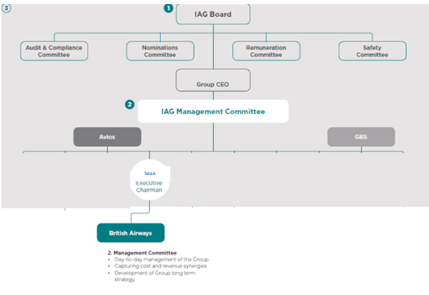
Figure 1: IAG Structure (Source: International Consolidated Airlines Group, 2022)

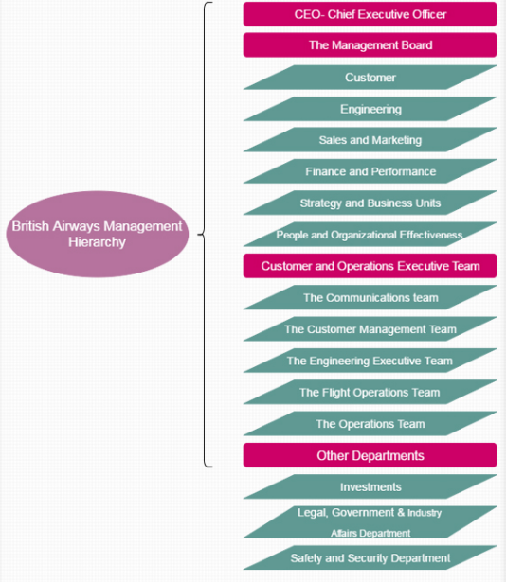
Figure 2: Current Structure of BA (Source: Author)
The current structure of BA is presented in figure 2, which includes teams and departments responsible for performing business operations of the airline. The organisation introduced certain changes within its organisational structure in the year 2015, which contributed to the de-layering of the organisational structure. Moreover, from October 2020, the Board comprised of Chief Executive Officer, and Chief Financial Officer (CFO), along with N=5 non-executive directors. Out of these executive directors, two of them also had roles within IAG, whereas, N=3 of them were external to IAG. 2020, the CEO and Chairman roles, when Alex Cruz stepped down as CEO; however, still possesses the position of Chairman (British Airways Plc., 2020). The Boards possess collective responsibility for managing, as well as oversight the business of the organisation. The Chairperson, who is also responsible for assuring that all of the board members have access towards essential information for informing the business-related decisions (British Airways Plc., 2020), led the board. The director-level employees of BA have accessibility to professional advice, as well as the services of the Company Secretary. However, the Directors are required to upgrade their knowledge, skills, as well as familiarity with business by efficiently communicating with the employees.
BA’s organisational structure includes a well-established framework for assuring that the employees are represented and respected (British Airways, 2022). As the organisational structure of BA distinguished the lines of communication, as well as authority; therefore, the employees of all levels are required to report to the senior management. The current organisational structure of BA facilitates harmony within the organisation, contributing to structured communication between employees of all levels. With reference to the annual report of BA Plc. (2020), the long-term success of BA was predicted on the basis of the commitment of the workforce towards the purpose as well as a demonstration of the values of BA. For acquiring the ability to compete within the challenging environment of commercial aviation, there was a requirement for an adaptive workforce. Therefore, the availability of several layers of management, and a long line of command assures an efficient engagement with the workforce, and increase their levels of motivation. According to the report published by Financial Times (2022a), with efficient organisational structure, and management policies, the IAG has achieved approximately 81 per cent of its capacity, similar to the year 2019. According to an estimate, due to the organisational structure, and management policies of BA, it is expected to operate at approximately 95 per cent of its pre-pandemic capacity in the first quarter of 2023.

Impacts of Organisational Culture of British Airways on its Performance
The organisational culture is referred to as an essential ingredient for the performance of an organisation and is considered a sustainable source for acquiring a competitive advantage. The culture of any organisation is one of the significant elements contributing to unifying the culture of an organisation in comparison to the structure of a corporate group (Trew, 2018). Abubakar and Dogoji (2015) mentioned that cultural change is an integral part of the system of BA, and it has been achieved over the decades, due to efficient struggles, and efforts of leadership-level employees. Analysing the persistent problems including high competition, rising prices of fuel, low projections of profit, and low financial performances of BA, the leadership of the organisations focused towards changing the culture, for stabilisation of its position within the competitive industry. The leadership and management at BA identified that the individuals associated with BA are their potential; therefore, created a culture of putting people first. The BA has been operating by adopting the role, as well as task culture. With reference to the role culture, the power of decision-making within the business position is due to the personal position of the employees of leadership levels (Dekker, 2018). Whereas, within the task culture, the power of decision-making is derived collectively from the team (Dekker, 2018). Considering the context of BA, the business-related decisions have been made by the top-level management; however, these decisions have been made after efficient communication with the team members, highlighting the presence of role, as well as task culture at BA.
The annual report of BA Plc. (2020) mentioned that the organisation have a strong belief that employees are vital for organisational success; therefore, retaining culture having communication gaps between the employees of all levels is likely to hinder attraction, motivation, development, and retention of employees. For overcoming this problem, the BA adapted the approach to communication by utilising digital platforms, and engagement of employees. The creation of a culture facilitating communication between different levels of management also altered the perceptions of the internal as well as external levels of the organisation. The focus of BA’s management on the development of leadership, talent strategy, and the creation of a talent pipeline for future leaders has been attracting the pool of young talent from diverse backgrounds towards BA (British Airways Plc., 2020). The creation of a culture of diversity, energy, creativity, a sense of responsibility, respect, and fair play has been attracting more service users towards BA, having a positive influence on their financial performance (British Airways, 2018). In the year 2021, the revenue of BA was €3.7 billion, such the revenue is less than the previous years; however, has been following a trajectory of pre-COVID-19 conditions (Statista, 2022). The report published by the Guardian (2022) mentioned that due to the organisational culture, as well as the culture of service delivery, BA has been experiencing a strong customer demand, and the profit for the current year is likely to exceed €1.1bn. Thus, the establishment of efficient organisational culture within the corporate group has been facilitating BA in improving its performance, as well as productivity.

Factors Influencing Employee Behaviours in BA
Social Practices of Working with Everyone
BA has been doing social practice for working with everyone having different track records, age, culture, faith, gender, and ethnicity, and treating the employees without discrimination. BA is a signatory of the Race at Work Charter, and a member of Business in the Community (BITC), and assures that employees from ethnic minorities are represented well at all levels of management (British Airways, 2022b). The provision of equal employment and growth opportunities for everyone positively influences the performance of employees, and encourages them to work with more dedication for availing growth opportunities at work (Thirusanku, 2021). Due to fair social practices at BA, the employees of BA tend to provide maximum satisfaction to their service users and fulfil their responsibility of providing a conducive environment for them. Thus, the social practices adopted by BA have a significant influence on its employees’ behaviours.

Pay and Rewards at BA
Another factor influencing employee behaviour at BA is the pay and reward system. In the year 2020, BA lost approximately €3.9bn; however, the company still managed to pay small bonuses. The management of BA believes that the staff of BA must receive rewards and incentives for being at the back of the company’s heart. According to the report published by Financial Times (2022b), in an attempt for strengthening the relationships with the employees, the BA has offered a one-off bonus to around 20,000 pilots, as well as crews. Moreover, the BA management has informed the union for offering approximately 10 per cent of the bonus to the employees working at the operational level, including the round staff, and crew of aircraft. Within a separate negotiation with the union Balpa, a 5 per cent bonus has been offered to the pilots (Financial Times, 2022b). These bonuses have been considered as part of a pledge by Sean Doyle, the chief executive of BA, in an attempt of restoring the staff’s morale, and improve services for the passengers. The rewards and incentives offered by the BA management strongly influence the behaviours as well as the performance of employees.

Inclusive Workplace
Along with delivering equitable pay, and equal working opportunities for everyone, the BA management believes in providing support to employees belonging to different backgrounds, for progressing in their careers. Having the idea regarding the challenging situations experienced by the employees having different levels of expertise, the BA management believes in the creation of a global community, having individuals from different professional backgrounds in their field, for the creation of an inclusive workplace (British Airways, 2022b). The work experience and apprenticeship programmes of BA have been introduced for encouraging a diverse mix of newly recruited employees from different professional backgrounds. Thus, inclusive behaviour at BA has a significant influence on the behaviours of BA employees.

Caring for Well-being of Employees
Caring for the well-being of individuals refers to providing support for the physical, mental, as well as emotional health of employees working at all levels. The BA management facilitates that the employees assist one another for feeling their best while fulfilling personal and professional responsibilities (British Airways, 2022b). The well-being team of BA work in collaboration with the healthcare service providers for delivering care and support to the stakeholders. The availability of a mindfulness app, as well as a 24- hour helpline, provides the opportunity for BA employees to speak to trained advisors, and counsellors (British Airways, 2022b). Moreover, the establishment of a network of 150 inclusion and well-being champions as well as sponsors assures the provision of support to the BA employees. Thus, the focus of BA management towards employee well-being is another factor, influencing the behaviour of employees.
Conclusion
In conclusion, it can be stated that BA, the largest airline in the UK has been operating to more than 200 destinations in 80 countries of the world. BA’s organisational structure includes a well-established framework for assuring that the employees are represented and respected. The organisational structure of BA distinguished the lines of communication, as well as authority and the employees of all levels, who are required to report to the senior management. The leadership and management at BA identified that the individuals associated with BA are their potential; therefore, created a culture of putting people first, and provided equal employment and growth opportunities to all employees without discrimination. The rewards and incentives offered by the BA management, and inclusive behaviour at BA strongly influence the behaviours as well as the performance of employees. In addition, the focus of BA management towards employee well-being is another factor, that also influences the employees’ behaviour.

References
Abubakar, S.G. and Dogoji, B.A., 2015. An investigation into the management of organisational culture and its impact on employee performance in the context of the aviation industry: a case study of some legacy and lowcost airlines in the United Kingdom. International Journal of Advanced Academic Research, 1(2), pp.1-19.
British Airways Plc. 2020. Annual Report and Accounts Year ended 31 December 2020. British Airways. Retrieved from https://www.iairgroup.com/~/media/Files/I/IAG/annual-reports/ba/en/british-airways-plc-annual-report-and-accounts-2020.pdf
British Airways. 2018. Working with us. British Airways. Retrieved from https://careers.ba.com/working-with-us
British Airways. 2022. Fleet Facts. British Airways. Retrieved from https://www.britishairways.com/en-gb/information/about-ba/fleet-facts
British Airways. 2022b. People: Championing diversity, inclusion and wellbeing. British Airways. Retrieved from https://www.britishairways.com/en-gb/information/about-ba/ba-better-world/people
Colquitt, J., Lepine, J.A. and Wesson, M.J., 2014. Organizational Behavior: Improving Performance and Commitment in the Workplace (4e). New York, NY, USA: McGraw-Hill.
Dekker, S., 2018. Just culture: restoring trust and accountability in your organization. CRC press.
Eketu, C.A., Ogbu Edeh PhD, F., Ule, P.A., Fern, Y.S., Kumari, P. and Eder, J., 2020. Effects of Organizational Structure on Employee Resilience. Prince Alamina and Fern, Yeo Sook and Kumari, Pallavi and Eder, Johnson, Effects of Organizational Structure on Employee Resilience (November 20, 2020).
Financial Times.2022a. British Airways owner IAG’s revenue returns to pre-pandemic levels. Financial Times. Retrieved from https://www.ft.com/content/ebac1fdb-56bb-4425-a7a7-e1f8eace42d3
Financial Times. 2022b. BA offers one-off bonus to pilots and crew to rebuild relations with staff. Financial Times. Retrieved from https://www.ft.com/content/7df6d516-bfb4-4f7c-b4d3-8acfcce29aeb
Griffin, R.W. and Moorhead, G., 2014. Managing people in organization. South-Western: USA.
Holagh, S.R., Noubar, H.B.K. and Bahador, B.V., 2014. The effect of organizational structure on organizational creativity and commitment within the Iranian municipalities. Procedia-Social and Behavioral Sciences, 156, pp.213-215.
https://www.researchgate.net/publication/346032377_Effects_of_Organizational_Structure_on_Employee_Resilience
International Consolidated Airlines Group. 2022. Unique group structure. IAG. Retrieved from https://www.iairgroup.com/en/the-group/unique-group-structure
Statista. 2022. British Airways Plc's worldwide revenue from FY 2010 to FY 2021. Statista. Retrieved from https://www.statista.com/statistics/264296/british-airways-worldwide-revenues-since-2006
The Guardian. 2022. BA owner raises profit forecasts as airline revenues return to pre-Covid levels. The Guardian. Retrieved from https://www.theguardian.com/uk-news/2022/oct/28/iag-increases-profit-forecasts-as-airline-revenues-return-to-pre-pandemic-levels
Thirusanku, J. 2021. Equal Opportunity Within the Workplace. Journal of Economics and Business, 4. 208-220.
Trew, A.N., 2018. Impact of organisational culture and decision-making on program assurance for continuing airworthiness (Doctoral dissertation, Queensland University of Technology).

