TASER, TASER!

A synthesis of use of TASER within Policing

Benjamin Willmett
1552440
BSc Professional Policing Practice
Declaration
This work has not previously been accepted in substance for any degree and is not being concurrently submitted in candidature for any degree.
Signed: Ben Willmett (1152440) Date: 04/07/2022

- Statement 1 - This dissertation is being submitted in partial fulfilment of the requirements for the degree of BSc.
Signed: Ben Willmett (1152440) Date: 04/07/2022

- Statement 2 - This dissertation is the result of my own independent work/investigation, except where otherwise stated. Other sources are acknowledged by footnotes giving explicit references. A bibliography is appended.
Signed: Ben Willmett (1152440) Date: 04/07/2022

- Statement 3 - I hereby give consent for my dissertation, if accepted, to be available for photocopying and for interlibrary loan, and for the title and summary to be made available to outside organisations.
Signed: Ben Willmett (1152440) Date: 04/07/2022

- Statement 4 - I hereby give consent for my dissertation, if accepted, to be available on the university’s IT system to those who have consent to use the system.
Signed: Ben Willmett (1152440) Date: 04/07/2022

Introduction

The use of Taser, or a CED as it is accurately known is a relatively new introduction into the world of Policing within the United Kingdom. A CED as explained by the College of Policing is ‘a less lethal weapon system designed to temporarily incapacitate a subject through use of an electrical current which temporarily interferes with the body’s neuromuscular system and produces a sensation of intense pain’ (College of Policing, 2021). The term Taser, comes from a brand of CED which is widely adopted by UK police forces. The introduction and implementation of Taser in modern day policing has garnered much notoriety over the years and it has almost been villainised at times.
Frontline Police Officers whilst fulfilling their duties are not only at the risk of injury and the risk of violence whilst undertaking their duties within their role, but they are also acutely aware of the risk and the violence that others can subject to themselves and to others around them. Police Officers within the United Kingdom are issued with Personal Protective Equipment (PPE). PPE is issued and designed to protect Police Officers and used within the remit of their role. They are to be utilised when necessary and proportionately to the circumstances presented before them. It is suggested the introduction of Taser was sought after to bridge a gap in the issued PPE for all police officers, this would include a baton and then up to that of a firearm issued to authorised firearm officers. It was also considered as part of an exploration into less lethal weapons. ‘Police agencies have searched for ‘‘less lethal’’ weapons to fill the operational gap between the baton and the gun. The ideal ‘‘less lethal’’ weapon will incapacitate a potentially dangerous person to facilitate their safe arrest, with only minimal risk of injury or death to the subject, the police officer, or bystanders.’ (Bleetman, 2004).
The aim of this research is to assess the associated risks that arise from the use of Taser as a use of force within Policing in the United Kingdom, any fatalities associated with Taser use as a use of force within operational policing and more prevalently during this current period of intense scrutiny bestowed upon use of force by the Police research the public perception of the Police use of Taser since its introduction and adoption by all UK police forces.
That being said, the use of Taser is still a relatively new concept to UK Policing and the literature as such is limited. This in turn may contribute to why the use of Taser has been heavily critiqued since its introduction.
This is where this research may benefit the subject area to provide more contrast to what literature is already available by constructing a more balanced view point whilst looking to answer the aim of the research at hand.

Literature Review
This section of the research project reviews the existing literature available on the subject matter.
Since its rather controversial adoption into the world of UK Policing in 2003 Taser officers is still considered a relatively new concept. Despite this less lethal option to bridge the gap between a standard issue baton and a firearm is arguably one of the largest changes to police issued PPE in recent years, research amongst its use is still limited. The material available largely depicts Taser in that of a negative stance, using only the sensitive, more complex Taser deployments as data to provide an outcome which is not wholly representative of its use as a whole. This review will be broken down into the following:

Risks
As with any PPE issued to Police Officers, its use and implementation within the world of policing and its interactions with members of the public carries risks and limitations. These risks and limitations can extend to the police officer, their colleagues, members of the public and even as far as organisational reputation.
The use of Taser carries its own specific risks, despite the risk of serious injury developing being relatively low compared to the wide spread usage of Taser. This is stated in a publication by the Scientific Advisory Committee on the Medical Implications of Less-Lethal Weapons (SACMILL), which are an non-departmental public body specialising in providing advice to government with regards to less lethal weapons, the publication was titled “Statement on the Medical Implications of Use of the TASER X2 Conducted Energy Device System”, it stated “Despite the broad range of potential injuries that have been linked to the use of CEDs, the internationally reported incidence of serious injury – as judged by the relatively low number of published clinical case reports – appears to be low relative to the widespread use of CEDs. Notwithstanding the likelihood of under-reporting in the medical literature, the infrequency of reports of serious injury implies that most uses of CEDs result in unremarkable medical outcomes’ (SACMILL, 2016). Some of the risks as outlined by SACMILL within the same reported included ‘Muscular contraction or strain-related injury (including bone fractures, hernia rupture and dislocation), Injuries, particularly to the head, from falls or other uncontrolled movements. This risk may be exacerbated in people who are running or are located at height at the time the discharge is administered, Injury from probe penetration of the eye, blood vessels, genitalia, breast, neck, throat, thorax and other sensitive structures’ (SACMILL, 2016). These findings are interesting to note that, despite the widespread use they conclude there is a low relative pattern to serious injury compared to the widespread use. Of course, they concluded within the report the use of Taser does come with risk as aforementioned, but these risks would need to be justified and proportionate when taken within the set of circumstances to which the Taser was used. These circumstances and the decision making process concerned with how to deal with these said circumstances are that of the Police Officer.
It is difficult to perceive the risks and decision making taken by each police officer operationally when responding or dealing with a specific incident, especially when faced with a volatile and more often or not dangerous set of circumstances. This is echoed in the findings in a release titled “Statistics on the number of police officers assaulted in 2019/20, England and Wales” from the Office of National Statistics. They stated ‘In 2019/20 there were over 30,000 assaults on police officers in England and Wales (including British Transport Police but excluding Greater Manchester Police) (ONS, 2020). These findings could be argued to be representative of the necessity and use of Taser as a form of issued PPE within the UK. The risk factors to Police Officers conducting their roles is increasing, evidently by the increase in assaults on Police reported. This is turn may add traction to the underlying necessity for Taser and that the risks associated with its use, arguably justified when faced with such incidents.

Fatalities
Since its inception into the world of UK policing in 2003 there have been a total number of 18 fatalities that have been linked with Taser usage within that time period. Amnesty.org, published on their website stating ‘a total of 18 people have died after a Taser was discharged against them by police’ (Amnesty.org, 2018) and news outlets often report with similar outlooks such as an article published in the Guardian Newspaper titled ‘Families urge ban on English Police Taser use against people in distress’ (The Guardian, 2021). It can be suggested these sorts of releases and information in the public domain sensationalise Taser fatalities but it is apparent further investigation into these facts are required to assist with further fact finding and a more accurate depiction of Taser involvement in these unfortunate fatalities. These sorts of publications may have a negative impact upon public perception of the police as a whole and specifically use of Taser.
It is difficult to wade through the readily available material in order to find clarity in certain claims or statements like the above published. This in turn could arguably make it difficult to ascertain full facts in certain scenarios around Taser use and when Taser has been utilised. In some places however more clarity on events is available, in a statement on the National Police Chiefs Council website (NPCC). The NPCC states ‘to date there have been no deaths in the UK that have been attributed to the direct electrical effects of CED on the body (for example, the electrical discharge directly affecting heart rhythm). There has been an instance where CED use resulted in death from a secondary effect of the discharge (ignition of flammable fuel) and one occasion where a Coroner’s court concluded that the use of a TASER CED contributed to a person’s death along with a series of other factors. The inquests on six further UK deaths where the use of a CED featured have yet to reach a conclusion. Deaths from head injury as a result of discharge-induced falls, have been documented in other countries and there has been at least one incidence of serious head injury in UK use of CED. (National Police Chiefs Council, 2021). As per this release, it has stated Taser has not attributed directly to a fatality in any instance. However there are instances where it has had a secondary effect and or the Coroner has ruled it contributed amongst other factors to a fatality. However the risk of secondary injury or contributing factors could arguably be said for the same for any type of PPE issued to Police Officers or that of a firearm if the bridged gap by a Taser as a less lethal option was not available. It would also require to be considered whether the risk of not utilising Taser in that instance would have resulted in a different outcome, potentially of more risk which remains to be seen.
The use of Taser is now large scale, Police have a requirement to gather information on use of force statistics including their use of Taser. This has been in place since 2017, whereby before this date the use of Taser was collated by the Home Office itself. The latest report collating Police force data dating between April 2019 and March 2020 stated ‘CEDs were used in 32,000 incidents, although the CED was not discharged in 86% (27,000) of these incidents.’ (Home Office, 2021). These figures are just a snapshot of the use of Taser within operational policing and only cover a period of 12 months. This scale of use would be significantly larger since its adoption in 2003. Therefore considering the scale of the use of Taser and the reported fatalities associated with such widespread use over an extended period of time, it could be argued that this less lethal weapon essentially works in bridging the gap between a baton and a gun by yielding a minimal fatality to use ratio.

Public Perception
To first understand the public perception of Taser and its subsequent use by Police across the United Kingdom I think it is important to understand the public’s perception of the Police as a whole. It is reasonable to suggest the two will go hand in hand with perceptions of the police being based upon their actions.
A publication conducted by Her Majesty’s Inspectorate of Constabulary and Fire & Rescue Services (HMICFRS) commissioned a large scale survey to assess current perceptions of police within England and Wales. The survey was conducted by BMG Services and titled “Public Perceptions of Policing in England and Wales 2018” it stated that ‘Satisfaction with local police is relatively high. Over three-fifths of respondents (61%) say that they are satisfied, and only 12% are dissatisfied. (Her Majesty’s Inspectorate of Constabulary and Fire & Rescue Services, 2018). Whilst these largely depict a positive perception of the Police, suggesting overall more people hold the police to higher regard than those who do not. It however is to be noted that the same report also outlines ‘Fewer respondents agree that their local police use physical force and stop and search appropriately, but this is not because a greater proportion disagrees with the statements, rather that they don’t know.’ (Her Majesty’s Inspectorate of Constabulary and Fire & Rescue Services, 2018). So contrary to the positive overall satisfaction the public hold toward the Police, the findings do still demonstrate there is this ambiguity to which the public perceive the use of force, by either not agreeing at all or stating they did not know. Furthermore, it is reasonable to suggest those who do not know, perhaps do not have the confidence or the trust to say that their local Police utilise force, including use of Taser reasonably and proportionately. However it is be noted, there are not Taser specific questions within this survey. This again, further highlighting the aforementioned of the need for further Taser use specific research to be conducted.
In contrast however in a Taser specific piece of research, an online survey conducted in 2016 by Ipsos MORI on behalf of the Police Federation of England and Wales titled “Attitudes toward Taser” sampled 2004 adults aged 16 – 75. Their findings concluded ‘that 71% of survey participants consider it fairly or completely acceptable for police officers to carry a Taser when on patrol. In comparison, 12% said it was fairly or completely unacceptable for officers to do so’ (Police Federation of England and Wales, 2016). However the limitations within this research may be that the sample pool within this survey was small in comparison to the United Kingdom adult population and it does not specify as to how or why the participants were chosen so may not truly captures an accurate depiction. Interestingly though, of the people sampled 31% answered ‘Yes – aware of Taser, but not in detail’ (Police Federation of England and Wales, 2016). This statistic, although with the sampling restrictions could suggest that a lack of knowledge generally surrounding the use of or the overall knowledge of Taser within Policing could impact the perception to which public hold, regarding its use and that of the Police as a whole. This could potentially provide to be especially pertinent when the coverage in any press or findings of research into the use of Taser utilise isolated, sensitive incidents of data relating to specific incidents rather than the entirety of its use on widespread scale.
This then leads on to contrasting views to the positive perception that the public hold of the Police compared to the findings initially critiqued. The IOPC conducted a review titled “Review of IOPC cases involving the use of Taser 2015-2020”, reviewing 101 cases of Taser uses by Police, whilst they recognise their own limitations, they advised around 17 changes as a result of this review and released statistical data, they stated findings such as ‘108 people were subjected to Taser use. 94 people had a Taser discharged against them... 26 investigations led to a case to answer finding or a Crown Prosecution Service (CPS) referral’ (IOPC, 2021). It is accepted that the incidents to which they would investigate would be the isolated, more sensitive cases that involved potential injury to some mitigation as a result of Taser use or excessive use, however their sample pool is limited to those sorts of incidents. This release was slammed by the Police Federation of England and Wales who released a statement via their website stating ‘Taser is deployed based on highly complex and difficult assessments of threat, harm and risk. Deployment is not based on race, age, or sex. This report makes recommendations on 101 IOPC investigations into Taser use in a five-year timescale. However, there were almost 100,000 recorded Taser usages in this period, so it is statistically insignificant. For many years, PFEW has fully supported the IOPC’s desire to seek improvements to national Taser guidance and training. Police officers are the practitioners of Taser and would ultimately be affected by these recommendations if implemented. We are naturally disappointed our 130,000 members were not consulted and this study is based on 0.1 per cent of Taser uses over a five-year period.’ (Police Federation of England and Wales, 2021).
However, it still remains to be seen that the perception of Taser by the public is held within high regard or not. This is especially pertinent in the current climate following impactful events occurring within the world since. These have brought the Police as a whole into what some may say disrepute, such as that of the George Floyd murder, which specifically demonstrated excessive use of force by a police officer or the murder of Sarah Everard by a serving Police Constable. Incidents such as these will further increase the public’s ambiguity and perception surrounding use of force that has been aforementioned and the confidence in police has the potential to be marred by the actions of individuals in sensitive, isolated incidents. YouGov is an international research and analytics group, they have polled the British Public since these events. They state ‘Following several high-profile murders of young women, including that of Sarah Everard by Metropolitan police officer Wayne Couzens, coupled with botched responses from police commanders, new YouGov data reveals the extent of the damage this has caused to public confidence. YouGov routinely asks the British public their confidence in the police to deal with crime in their local area, and for the first time since we started asking in July 2019 more people are now unconfident in the police (48%) than confident (43%).’ (YouGov, 2021). With that being said, if the confidence of the Police is falling, it could be argued that actions of the police, including the use of Taser as a use of force may never be well received when isolated incidents are scrutinised under the current climate where there could arguably be a decline in trust and confidence in the police as whole.

Methodology
Introduction
This section of the research project includes the research projects strategy. This will outline the procedures of the research and justifying the techniques that were used. As aforementioned in the literature review, there is a lot of not only negative perception but ambiguity around Taser. The risk to use ratio has not fully been explored and the secondary data draws on isolated incidents through publications. Through a time of scrutiny bestowed upon Police, where the public’s trust in the police has been tested, the research outlined in this chapter will aim to provide a more versatile outlook on Taser use as a whole. The key aims of this research is to research the associated risks that arise from the use of Taser, the fatalities associated with Taser use and the public’s perception of the Police use of Taser therefore the research methodology will reflect obtaining this.
Research Strategy
Within this research it will bring together an evidence base which will be formed by both secondary data and primary data. The secondary data within this research will include analysis of the existing readily available data and literature utilising publications, articles and websites. The primary data within this research will consist of online surveys. It is the hope that through this research that this mixture of empirical data compared with the more factual readily available secondary data will allow for a more fairly representative overview on Taser use as a whole, rather than focusing on isolated views and not considering its widespread efficient use as a use of force within the world of Policing within the United Kingdom.
This research will gather primary data through the form of an online survey of which the research will create two separate surveys. Each with its own representative subject audience both consisting of a series of questions garnering information on the subject matter of Taser. The primary data within this research will include a survey with civilians as the targeted sample population with the aim to survey their perception of Taser as a whole and their feelings in regards to the use of Taser as a use of force by Police. The research will also survey serving Police officers, capturing their perception of Taser, their understanding of the public’s perception of Taser and collecting outcomes of their use of Taser.
This research will undergo a quantitative research method as it allows the collection of the required data from the representative audiences with predetermined sets of closed questions, this benefits the research as it allows for accurate collection of specific predetermined responses, ensuring the question at hand is answered rather than allow for a forum of expression which may veer off the subject matter taking into consideration the current reputation damage the Police have sustained in recent times. Quantitative research as defined in the journal titled “The SAGE Encyclopaedia of Action Research” which states ‘Quantitative methodology is the dominant research framework in the social sciences. It refers to a set of strategies, techniques and assumptions used to study psychological, social and economic processes through the exploration of numeric patterns. (Coghlan and Brydon-Miller, 2014).
Quantitative research gathers a range of numeric data. Some of the numeric data is intrinsically quantitative (e.g. personal income), while in other cases the numeric structure is imposed (e.g. ‘On a scale from 1 to 10, how depressed did you feel last week?’). (Coghlan and Brydon-Miller, 2014)
The collection of quantitative information allows researchers to conduct simple to extremely sophisticated statistical analyses that aggregate the data (e.g. averages, percentages), show relationships among the data (e.g. ‘Students with lower grade point averages tend to score lower on a depression scale’) or compare across aggregated data (e.g. the USA has a higher gross domestic product than Spain). Quantitative research includes methodologies such as questionnaires, structured observations or experiments and stands in contrast to qualitative research’ (Coghlan and Brydon-Miller, 2014).
Taking into consideration the above outlined by Coghlan and Brydon Miller, the research will ensure that the data collected is relevant and on topic and can be easily collated to establish trends and identify concise findings around Taser and its perceived use as a use of force. This will benefit the research.
The research methodology for this project has chosen not utilise Qualitative Data in the research methodology. Qualitative data as defined by the website “Scribbr” is ‘involves collecting and analysing non-numerical data (e.g., text, video, or audio) to understand concepts, opinions, or experiences. It can be used to gather in-depth insights into a problem or generate new ideas for research. Qualitative research is the opposite of quantitative research, which involves collecting and analysing numerical data for statistical analysis. Qualitative research is commonly used in the humanities and social sciences, in subjects such as anthropology, sociology, education, health sciences, history, etc.’ (Scribbr, 2020).
Taking into consideration this, it is accepted the quality of the data collected within a quantitative methodology may not offer as much participant participation beyond the constraints of multiple choice options. However, this is because qualitative inquiry is generally open-ended, the participants have more control over the content of the data collected (Choy, 2014). Therefore, the quality of the data may not be as concise as the research requires for a complex understanding of Taser but to ensure accuracy on the research subject, it would benefit the research if the data collection was not to become a forum for which the subject audience can veer off topic and provide answers that may not necessarily aid the research topic.
A quantitative surveying method allows the research to gather the data in a simple format, which given the target data population of police officers and civilians is more practical and more likely to achieve a higher response rate as it easy to complete and requires little time or expense to the target audience. Given the nature of the research it is important that the representative sampling pool be from both serving Police Officers and from a civilian demographic. The literature review aforementioned leads heavily on circumstantial outcomes of isolated Taser incidents. These are often linked with the perception of individuals who are opposed to Taser and basing the findings solely on its use within that particular incident, rather than considering its use as a whole. The research would benefit from sampling both police officers and civilians as it would ensure the findings would be better-rounded and provide an appropriate stance from both aspects and the opinions of both the practitioners of Taser and that of the public.

Data Collection
Following the completion of the online surveys by the representative audiences, the data will be collected and then processed into readily available and easy to view formats such as graphs.
The two representative audience’s surveys will then be analysed and concise findings made in respect to their answers of the perceived use of Taser and the subject matter.
They can then be compared against each other and the secondary data to consider findings on a whole and identify any themes.

Limitations & Problems
Within this research, it is to be accepted that the chosen method of data collection for the primary data sources will not allow for a more diverse range of findings from the target audience, largely through decreased participation from the subject audience other than the closed set of responses within the multiple choice options. An alternative method of data collection may have yielded a more diverse response inclusive of the individual’s perceptions and views on the topic of Taser and the use of Taser as a use of force. This would be rather than the accumulation of quantitative data through sets of closed questions which this research has opted for. However, as aforementioned this method would allow the responses not to lose sense of its purpose and for the survey to become a forum for which the representative audiences could provide data not necessarily relating to that of which is being asked for in the question.
However in this research there will also be fair consideration given to the ongoing COVID 19 pandemic which, although seems to be progressing to a rate of some normality slowly, still hinders people’s everyday lives. It still hinders particularly those within the demographic of the target research population.
The ease of the collecting the data in the format of a survey may allow for greater uptake of response rates, especially considering that one demographic work shifts and the other are the public to which have different availabilities. Therefore in comparison to interviewing which both demographics may not consider appropriate given the circumstances of the pandemic and any arising issues with set availability.

Analysis of Results:
This section discusses the findings obtained from the primary research undertaken. This research took the approach of obtaining quantitative data as a primary source of data. This was obtained through the use of two online surveys. Each survey had a representative target audience, with one survey being civilians as the target population and the second survey being Police Officers as the target population. It was the aim that the empirical data obtained would allow for comparison with the secondary data of already available literature to garner a representative overview on the use of Taser and to answer the aims of this research, to assess the associated risks that arise from the use of Taser as a use of force within Policing, any fatalities associated with Taser use as a use of force within operational policing and more prevalently during this current period of intense scrutiny bestowed upon use of force by the Police research the public perception of the Police use of Taser since its introduction and adoption by all UK police forces. This method of data collection was used to ensure a respectable uptake in response rates, giving consideration to the on-going COVID 19 pandemic and ensuring that the opportunity to discuss the subject matter did not open the possibilities for answers not relating to the subject.
Survey 1: Compiling of 10 questions was taken up by 15 respondents from a civilian background. All of which were not serving Police Officers or have any affiliation to the Police within a work capacity.
Survey 2: Compiling of 11 questions was taken up by 15 respondents, all from a serving Police Officer background.

Risks
The following question was asked to the respondents of Survey 2: Showing that 80% of the 15 respondents are Taser carriers whilst 20% are not.
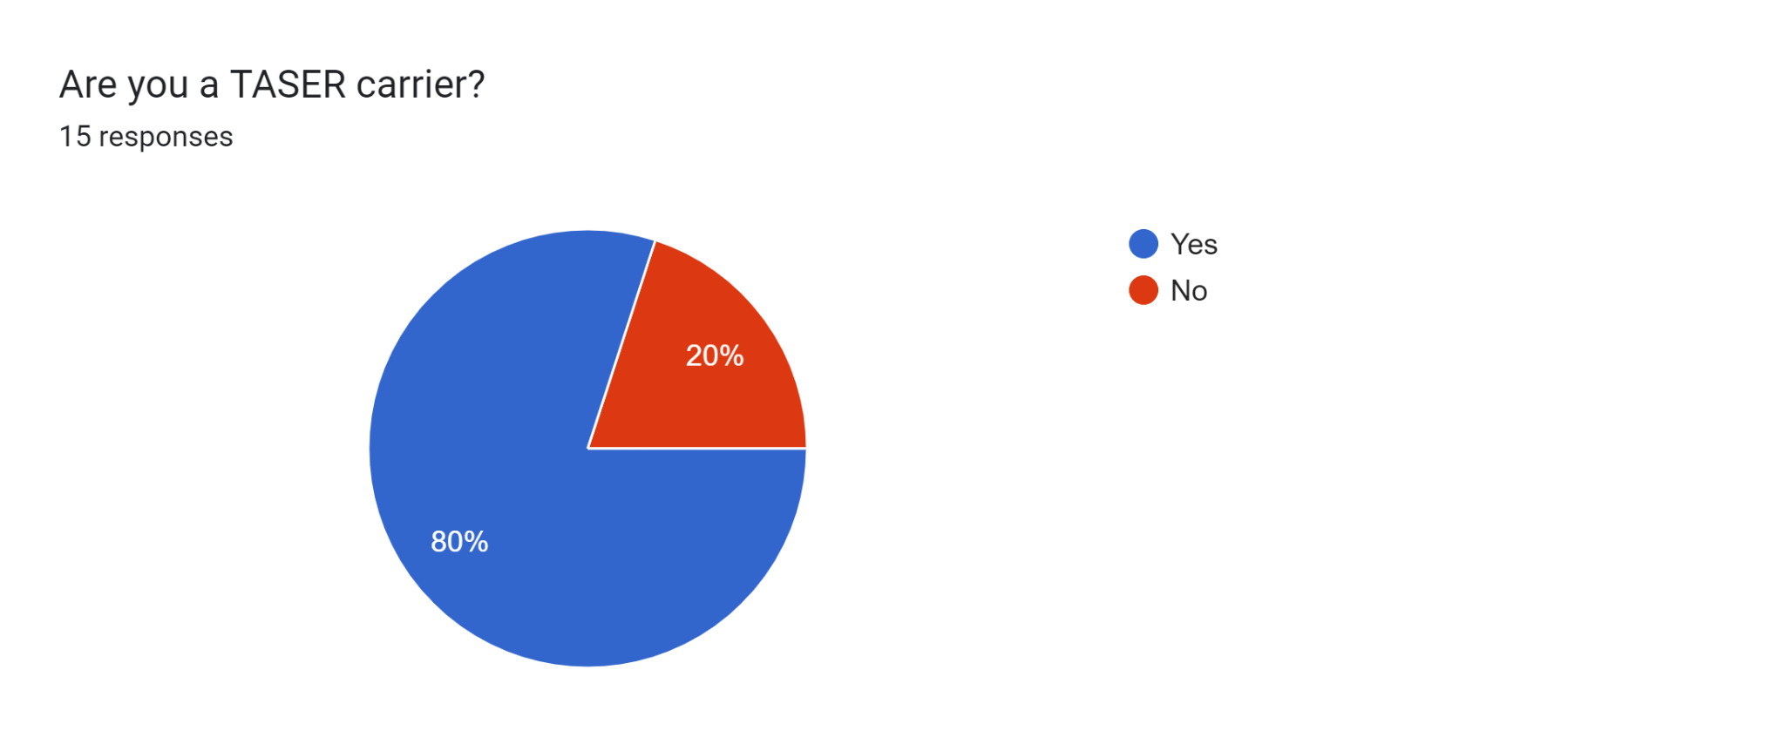
The following question was asked to the respondents of Survey 1:
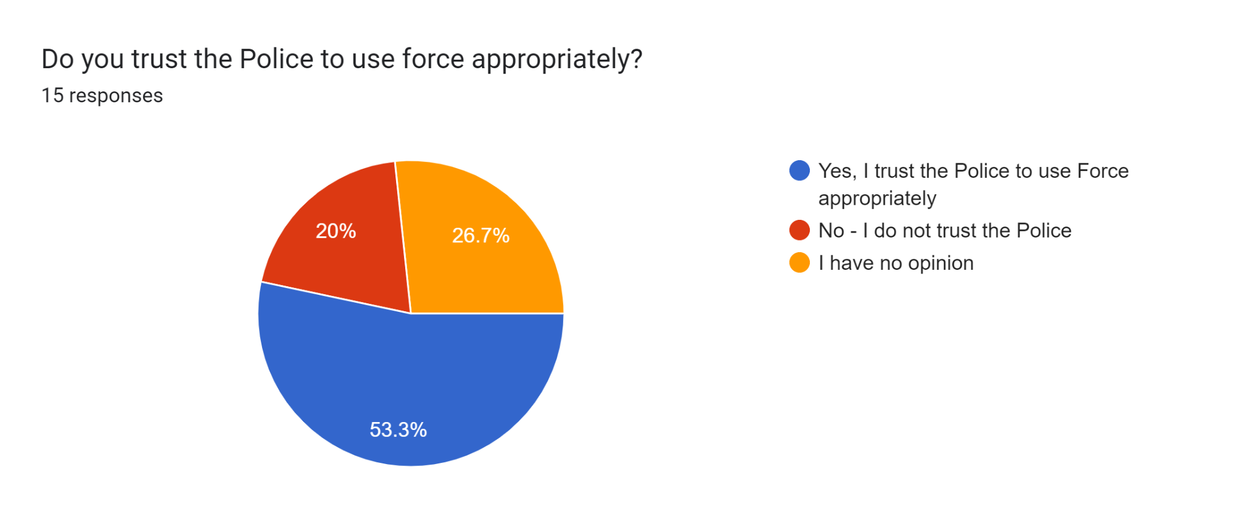

The following question was asked to the respondents of Survey 2: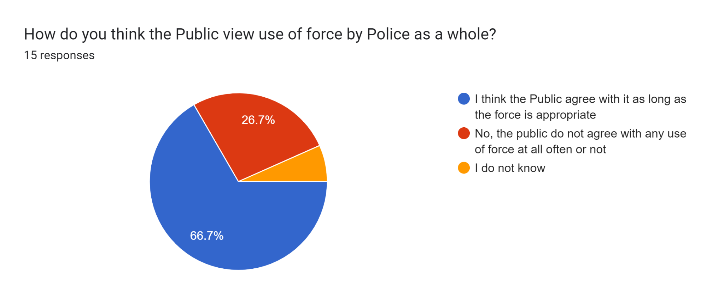

The following question was asked to the respondents of Survey 1:
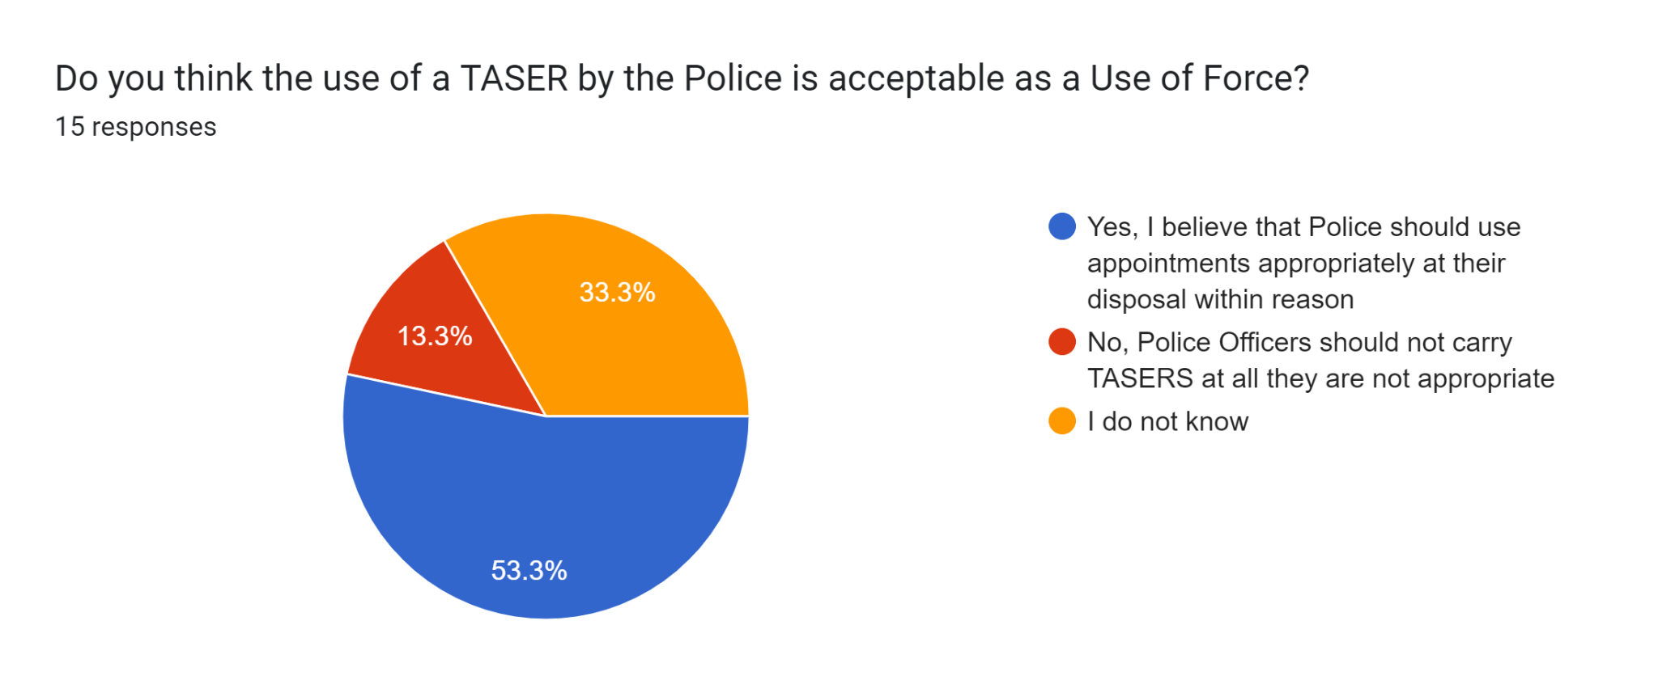

To consider the first research aim at hand, the associated risks from the use of Taser cross over with not only the physical implications which are referred to below but also the implications of reputation and perception. Taking into consideration, of the 15 respondents surveyed from survey 2 there was an 80% majority for Police Officers stating they are Taser carriers, this is a significant number for the majority now carrying Taser. Therefore the risk of such carriage may be heightened when they are now becoming more widespread amongst UK forces. The subject audience of Survey 1 were asked if they think that the use of a Taser by the Police is acceptable as Use of Force, to which 53.3% stated yes, 33.3% saying they did not know and 13.3% stated Police Officers should not carry them. There is a surprisingly majority in favour of the Police using Taser, however there is still 33.3% who did not know. The associated risk from the public not knowing or understanding Taser or why Police have them would need to be addressed in the next chapter in comparison with the secondary data. However there is a theme between both the Public and the Police surveyed that the majority believe that Use of Force by Police is agreed upon when used appropriately. If this theme exists, along with the knowledge of Taser then there may be less risk of organizational harm when people understand when it is used correctly and necessary.

Fatalities
As per the below Graph, it can be seen out of the 15 respondents from Survey 2 that 33.3% of them stated they had used their Taser to ‘Red Dot’ someone, that with 46.7% saying no they had not done so and the further 20% stating they are not Taser carriers.
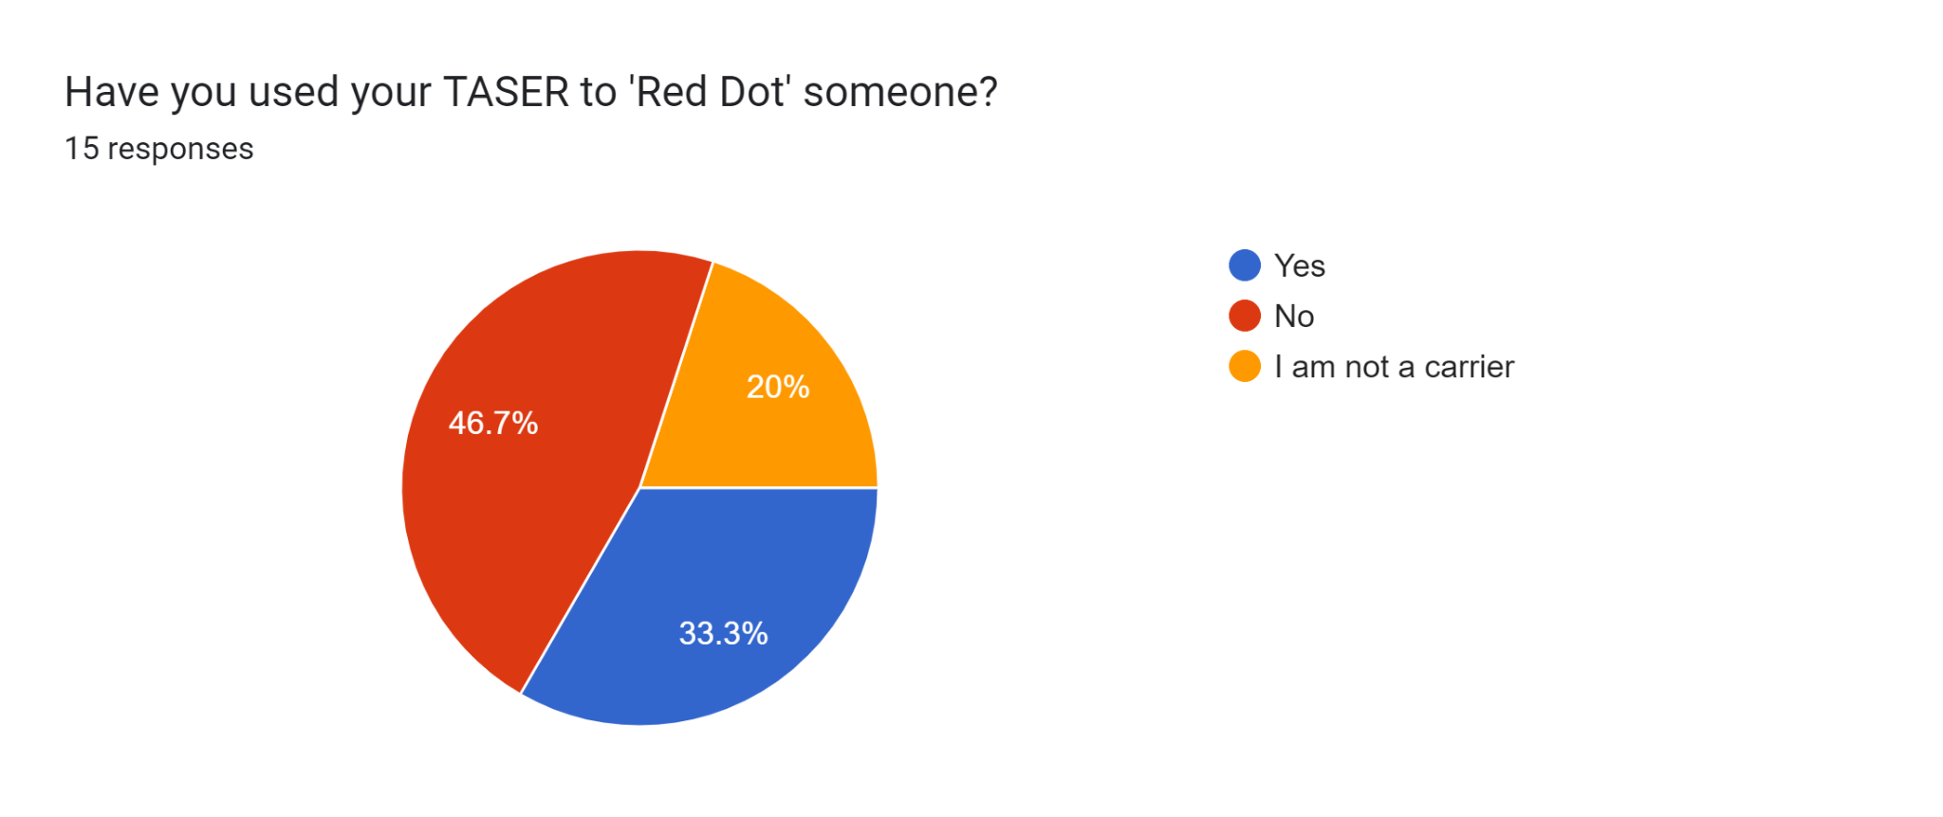

As per the below graph, the Police Officer subject audience have stated for the majority that 53.3% of them had not discharged their Taser. 26.7% of respondents stated they had, with again 20% of the respondents stating they are not carriers.
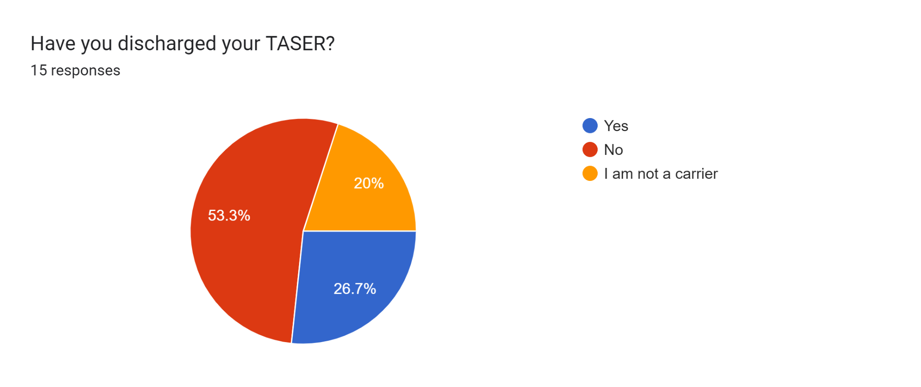
Additionally, as per the below as far as the officers knowledge, 60% of the respondents stated that they were not aware of anyone sustaining injuries as a result of their Taser usage. With 13.3% saying they would rather not say, 20% saying they were not a carrier. Then, 6.7% which equates to 1 respondent stated yes.
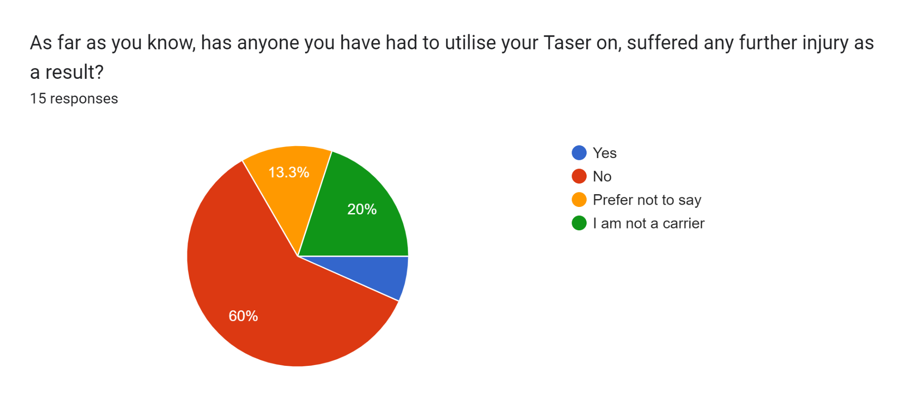

Looking at the above data, despite in the aforementioned chapters of widespread notoriety for isolated Taser incidents, of the respondents surveyed, the majority had not discharged their Taser and that was inclusive of 20% of the respondents not being carriers with a further 26.7% stating they had. Furthermore, only 33% of the 15 respondents had even had to use their Taser to red dot someone with 46.7% still saying they had not. Across the 15 respondents, only the equivalent of one respondent stated as a result of their Taser use did the subject sustain an injury, although the level of injury is unknown. The results of this will need to be explored in comparison with the secondary data as the theme is that use of Taser is not as perhaps as widespread or does not always lead to a discharge. From surveying the subject audience, there is a suggestion that the majority have not used their Taser in any instance, whilst some only to Red Dot the subject. This may give pace to the potential that the sensationalising of isolated Taser incidents rather than the appropriate and safe Taser use as a whole may be affecting the opinion of the use of Taser.

PUBLIC PERCEPTION
The last question posed was tested by means of a series of questions completed by both subject demographics.
The below questions were contained in Survey 1 and asked from the ‘civilian’ population. They surmise that out of 15 respondents, 73.3% stated they knew what a Taser was. However, 73.3% of the same respondents stated they did not understand how a Taser works. This indicates although the majority public population of the research know what a Taser is, they however do not understand how it works.

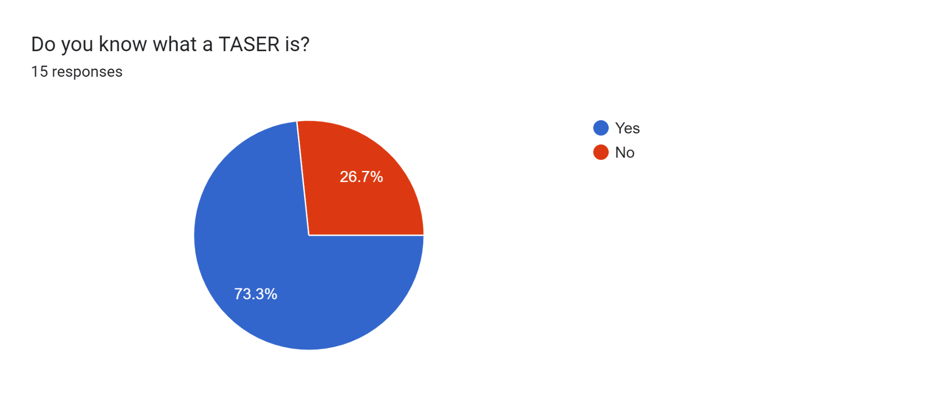

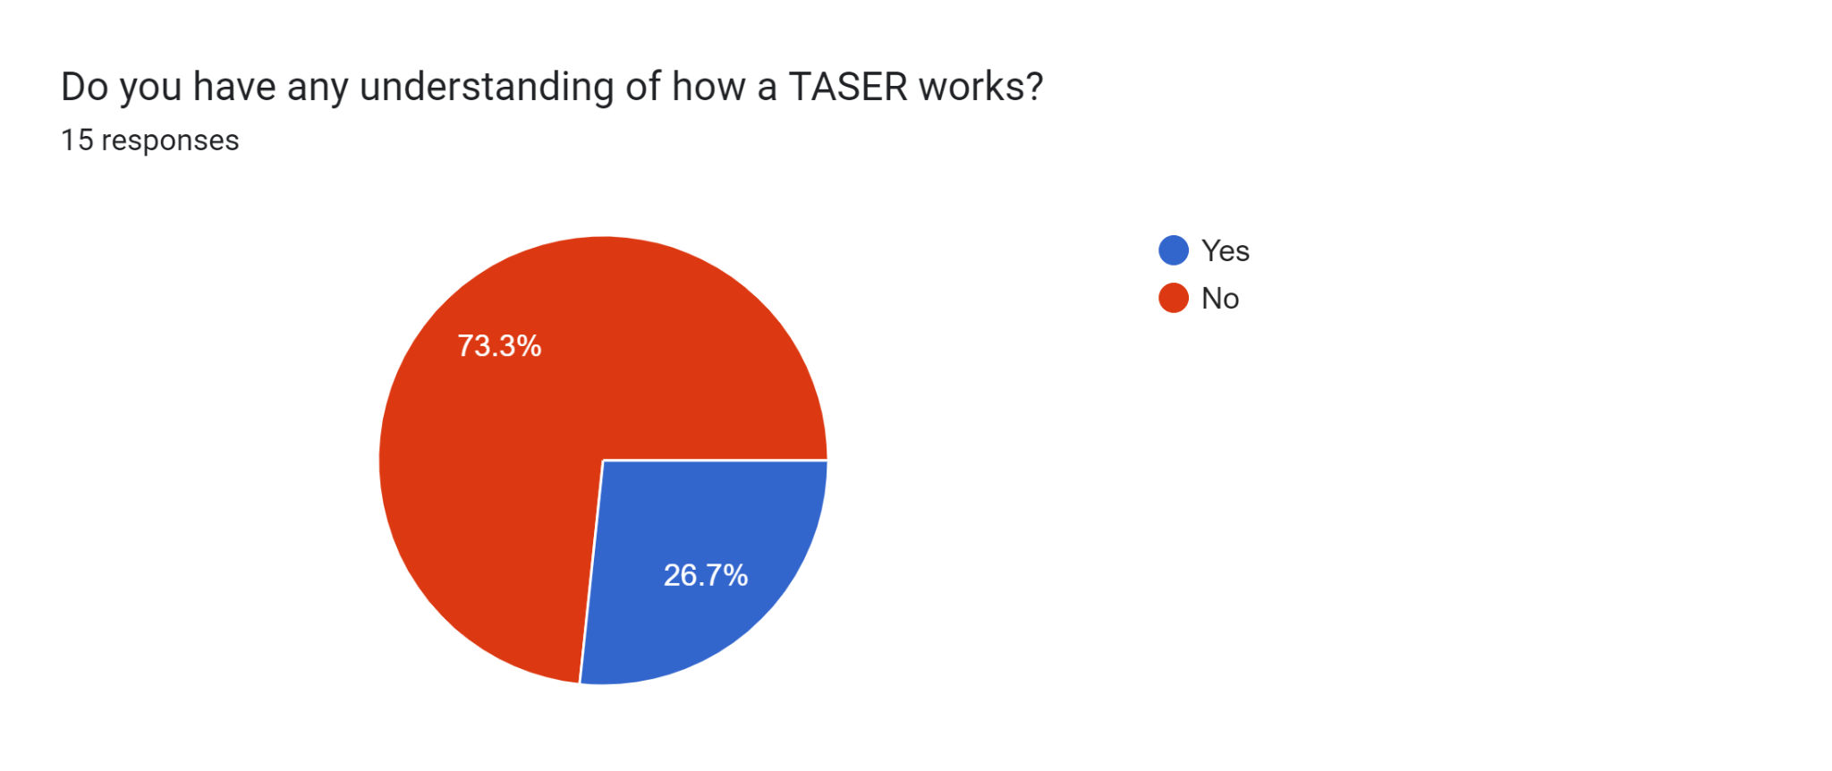

Similarly, as per the below graph, the Police survey population of Survey 2 when asked the same question outlined that the vast majority of them, being 86.7%, say that they do not think the public fully understand what a Taser is.
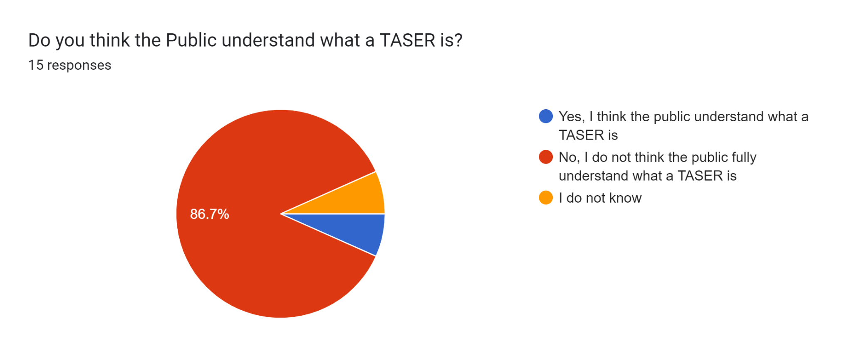

As per the below graph, 46.7% of respondents of Survey 1 stated they would approach a Police Officer carrying Taser whereas, 20% said no and a further 33.3% said they do not know.

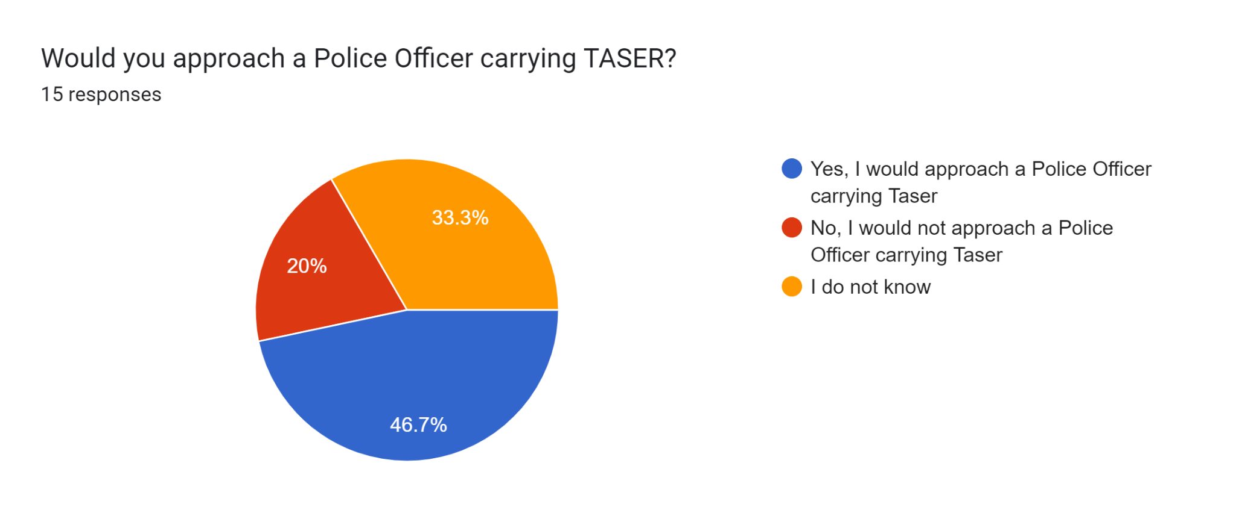

The same question was then asked to the Police Officer subject audience, as per the below graph with 66.7% stating No, 13.3% stating yes and 20% of respondents having no opinion on the matter.
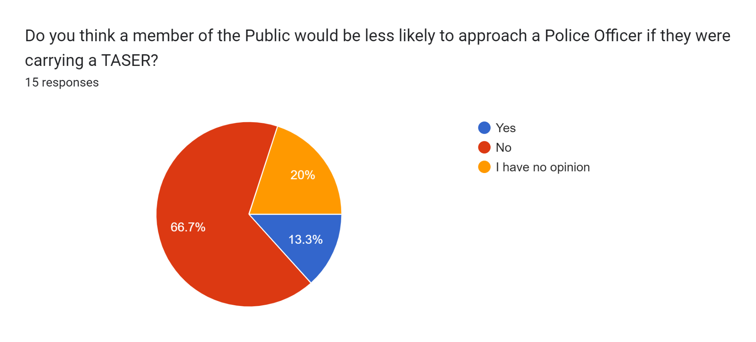

The following graph below was asked of respondents of survey 1:
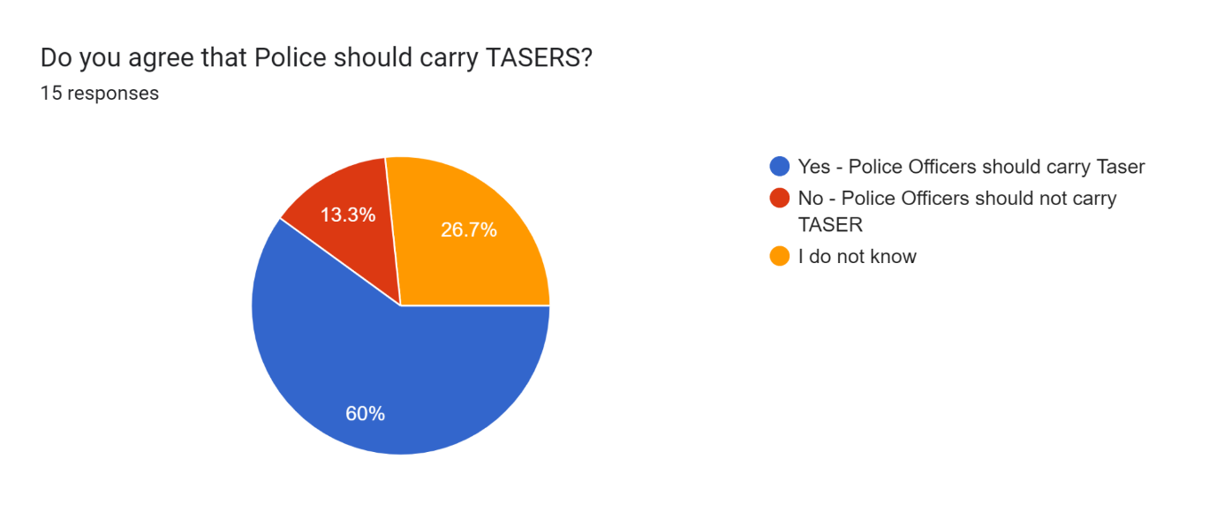

The following was asked to respondents of Survey 2: The shows that there was a 100% response rate from the subject audience of the Police in favour of Taser being an effective use of force.
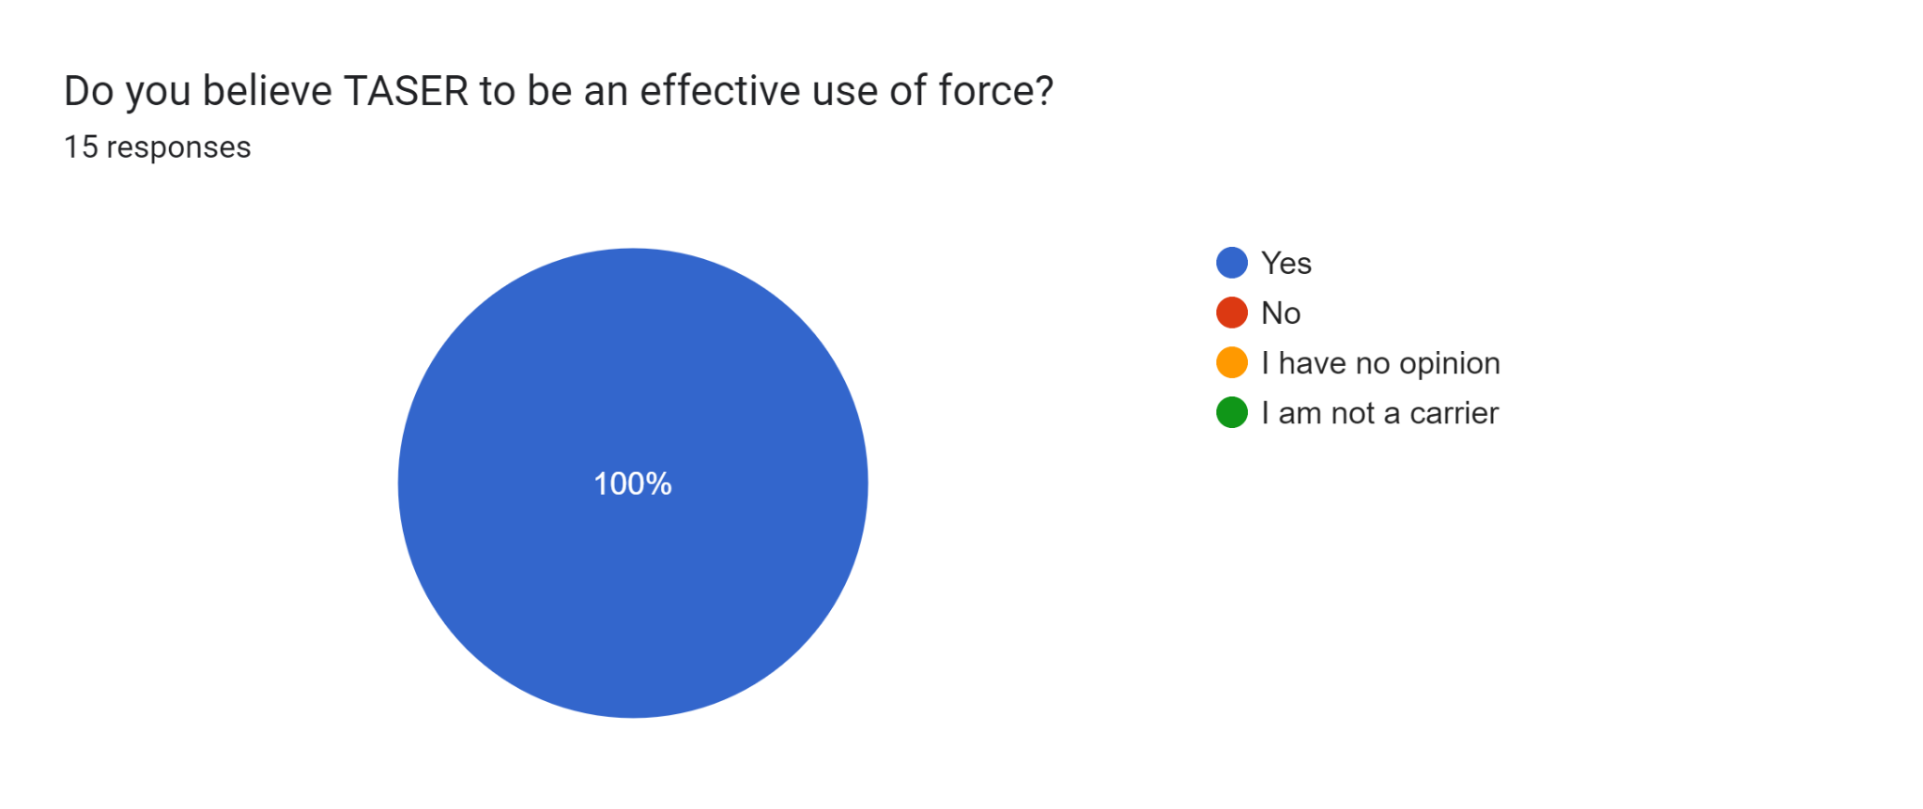

The below graph was representative of the respondents of survey 1 showing that 53.3% of respondents voted in favour of liking the Police the police, with the breakdown of 20% saying they did not and further 26.7% saying they had no opinion.

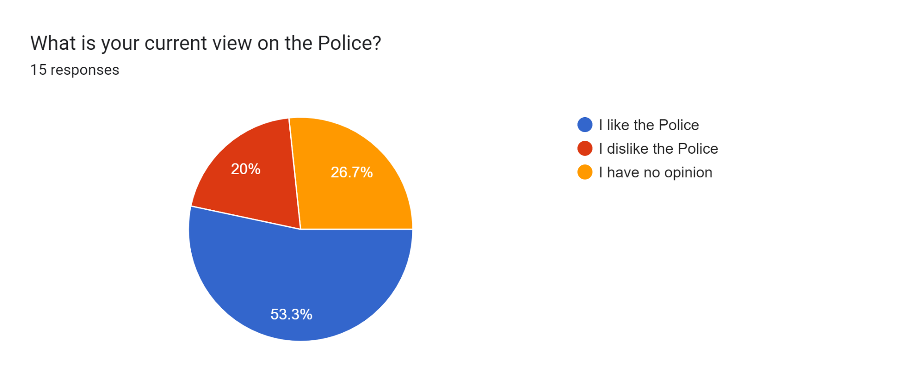

Therefore, in light of the research question at hand, the significance of common theme to which the Police believe the public do not fully understand what a Taser is and that of the majority of the public stating they do not understand what a Taser is. It may be difficult for the public to have an accurate perception on something they do not fully understand. Whilst trying to answer the research question at hand, the public subject audience have answered with 46.7% of respondents saying they would approach a Police Officer carrying Taser with 20% then saying no they would not. 33.3% of the respondents then stated they do not know. With the Police Officer audience of Survey 2 with 66.7% of them citing that No, a member of the public would be less likely to approach them if they were carrying a Taser. Again this may be a theme to which, the public are less likely to approach an officer with a Taser if they do not fully understand what it is or may relate to the overall trust or perception of the police. The Police audience would not be able to account for the people who chose not to approach them, rather than only realise the ones who do. In the next chapter, the findings need to be explored in comparison with the secondary research. However, as there is a 100% response rate in favour of Taser being an effective use of force, there may be some work around education and transparency with the public for them to make more informed decisions around its use.

Findings
This section of the research discusses the findings obtained from both the primary research and secondary research conducted.
Risks
The outcomes of the research showed that the majority of respondents surveyed in Survey 2 are that of Taser carrying officers, namely 80%. This research demonstrates its now widespread use amongst Officers, which is indicative to the existing literature from (SACMILL, 2016) and further reinforced by the research conducted in which out of the 15 respondents from Survey 2, only one reported that a subject sustained further injury as a result of their Taser use.
The findings of the research were surprising in the fact that, 53% of the public voted in favour of Taser usage by the Police. This means despite the reported risks which are often portrayed in existing media, (The Guardian, 2021), the other existing literature, that of (SACMILL, 20216), (ONS, 2020) and subsequently the (Home Office, 2021) all point toward that the scale of usage of Taser, vastly outweigh the reported risks that come with its use. It would also be reasonable to suggest that of the literature reviewed, the risk as a result of its use would outweigh the risk to what would have happened if it was not used. These are risks that the Officer utilising Taser would need to justify.
Fatalities
The research conducted found that in despite of the widespread notoriety for isolated Taser incidents, of the respondents surveyed from Survey 2, the majority had not discharged their Taser and that was inclusive of 20% not being carriers, with a further 26.7% stating they had. Furthermore, only 33% of the 15 respondents had to use their Taser to ‘red dot’ someone with then 46.7% still saying they had not. This research is congruent with existing literature conducted by (Home Office, 2021) whereby despite Taser being used or carried, it is not discharged in the majority of incidents. Limitations are accepted within this research as there is no broad spectrum of time with the subject data pool and it would not be known how long that particular officer has carried Taser for. However, the sensationalising of the isolated, sensitive Taser incidents are not considering the broad spectrum of effective use safely or the benefit of just carriage and not using the Taser could bring.
This is further evidenced in this research as across the 15 respondents of survey 2, only the equivalent of one respondent stated as a result of their Taser use did the subject sustain an injury, although the level of injury is unknown. Given the widespread usage of Taser across UK Police Forces which is echoed in the existing literature conducted by (Home Office, 2021) and the further publications from the (National Police Chiefs Council, 2021) and (Police Federation of England and Wales), the isolated incidents that warrant further investigation due to any fatality or injury are procedural and this secondary data would need to be further relied upon as specific lines of investigative matters surrounding Taser fatalities are investigated by the relevant organisations, of which have found no direct fatality to Taser usage solely.

Public Perception
This research found that, surprisingly, despite the initial concerns surrounding events that put the Police under scrutiny in recent times especially in regards to use of force, such as the death of George Floyd and the murder of Sarah Everard that respondents of Survey 1 held a majority in favour of the Police in their views with 53.3% saying answering that they liked the Police. This is unexpected and contrary to existing literature as the current climate indicated from the survey conducted by (YouGov, 2021) indicated more people lacked confidence in the Police than those who did not. This is also reflective of the earlier literature involving the risk of Taser carriage and use by the Police whereby the respondents of Survey 1 voted the majority to the majority of 53.3% in favour of trusting the police to use force appropriately. These findings although with a small data pool within this research, the repercussions to Police reputation and use of force perception may have not be as negative as first suggested. This would aid in the reputational perception of the use of Taser if use of force by the Police is accepted.
The research also found that the respondents of survey 1, 46.7% of them answered that they would approach a Police officer carrying Taser, this with 20% saying no and then the remainder stating they did not know. This is congruent of existing literature and of the results of this conducted research, demonstrating there is a clear disparity in the knowledge the Public hold around Taser, it would need to be considered if the reluctant to approach Police officers would be subjective to the carriage of Taser or not and whether a lack of understanding or acceptable of Taser would be a factor or the public perception of Police as a whole, this however remains to be seen. The existing literature from
Interestingly, the research conducted in this project concluded that 60% of the respondents of survey 1 answered in favour of Police Officers carrying Taser, with 13.3% saying they should not with 26.7% stated they did not know. This almost mirrors the statistics from the previous literature from the survey conducted by (Police Federation of England and Wales, 2016), this congruent theme suggests again, that the majority of the public do agree with Police Officers carrying Taser but there is still a percentage who do not and some who do not know. It is reasonable to suggest that some members of the public would always be opposed to force used by Police but there is still that ambiguity of people who do not know. Which leads on to a question of whether there is a gap in the knowledge of the public in regards to the functionality of Taser and its uses. More so, this research concluded that the respondents of Survey 1, 73.3% of them knew what a Taser was. However, 73.3% of them answered they did not understand how a Taser works. This means that despite the knowledge of Taser in the first instance, it seems that it is only superficial knowledge at best and there is no depth to the understanding of its use. This echoes the existing literature of the survey conducted by (Police Federation of England and Wales, 2016), although the limited sample pool conducted by them shares the same problem as this research in that there is a small data pool, there is a clear correlation with the lack of knowledge the public holds about Taser in its entirety. These findings were to be expected when the respondents of Survey 2, the serving Police officers answered that 86.7% of them overwhelmingly stated they did not believe the pubic understood what a Taser fully was. This ambiguity in public knowledge could perhaps lead to skewed data on perception of the Taser as they do not fully understand Taser in order to have a realistic perception.
The research also found that of the respondents of survey 2, there was a 100% response rate in which serving Police Officers believed that Taser is an effective use of force. This research, comparative to the existing literature such as the quantity of record assaults studied by (ONS, 2020), is not surprising. There will always be a balance of risk when any PPE is used, especially Taser but the requirement to justify its use would be that of the Police Officer who can only justify the use given the unique set of circumstances presented, such application will always lead to risk and subjected to the opinions of the public.

Conclusions
The main aims of this research were to explore the associated risks that arise from the use of Taser as a use of force within Policing, to research any fatalities associated with Taser use as a use of force within operational policing and to research the public perception of the Police use of Taser since its adoption by all UK police forces.
The research showed that there is, as with any PPE a risk of the use of Taser however there are a myriad of factors to consider when Taser is used. To which the Police Officer must justify given the set of circumstances. PPE when used by will always carry risk by the primary and secondary research demonstrated that further injury after Taser use is small scale compared to the effective use of Taser as whole. The risk from Taser use, as demonstrated by the research may amount to more reputational for the Police after isolated incidents take precedence over the successful use of Taser as whole. However, the research has demonstrated despite these publications, the public hold Taser use to a higher regard than those who do not and the trust in Police is holding higher than first anticipated.
This research has also demonstrated that despite the widespread usage of Taser, its capacity of execution is limited in that, it is not always discharged and is used in other capacities if at all. The primary and secondary data demonstrated that fatalities and associated injuries on a comparative scale to its use are only a small percentage. Furthermore, the secondary data has demonstrated the use of Taser has not directly attributed to the death of any subject.
Additionally, the research has shown that despite the original reservations from the existing literature, the Police are held in higher regard from the public than first anticipated. This is despite the circumstances occurring in the world at the time, increasing scrutiny on the Police as whole. The research demonstrated that the public consider Taser use and carriage acceptable by the Police paired with a demonstration of trust in the Police to use force appropriately. However, considerations need to be taken to some respondents still unknown in their answers which imply a lack of trust or knowledge. Therefore this research has found that the perception of Taser by the public seems higher than first thought, however has demonstrated that despite Taser being known of, there is a clear gap in the knowledge that the public hold in regards to its use. This lack of knowledge or understanding in Taser and use of force may always skew the public’s perception of Taser especially when paired with the sensationalising of isolated incidents rather than the knowledge of its widespread use.
The research demonstrated that serving Police Officers, Taser carriers or not considered Taser as an effective use of force and ultimately, these are the individuals who would find themselves in the circumstances to which they would need to utilise Taser in the first instance. PPE used by Police Officers will always carry risk, however consideration needs to be taken that the aim of introduction of Taser was to bridge a gap between the baton and lethal firearms and the research demonstrates that its widespread use accommodates this.

Recommendations
To better understand the implications of this research project, further research could be undertaken to address the risk to use ratio of Taser as a whole. This would explore its wide varied use whether that means it is discharged, used to simply red dot someone or just simply carried. This would be in substitute to singularly using set data from isolated incidents and referrals to the IOPC, which does not provide an all representative view of its use. This would consider and educate the risk to ratio in a public setting and perhaps steer public perception of Taser and promote an understanding of the risk to both the subjects and to organisational reputation.
Aside from the publications portraying select Taser incidents and the limitations with interpreting a small sample size that is within this research. I believe further research is needed to determine the effects that an increase in the public’s overall understanding and knowledge of Taser in the first instance has upon their perception of its use as a use of force by Police within the United Kingdom.

References
Amnesty International UK, 2018. UK: Public should resist drum-beat of calls for all police to carry a Taser. [online] Amnesty.org.uk. Available at: <https://www.amnesty.org.uk/press-releases/uk-public-should-resist-drum-beat-calls-all-police-carry-taser> [Accessed 4 July 2022].
Bleetman, A., 2004. Introduction of the Taser into British policing. Implications for UK emergency departments: an overview of electronic weaponry. Emergency Medicine Journal, 21(2), pp.136-140.
Coghlan, D. and Brydon-Miller, M., 2014. The SAGE Encyclopedia of Action Research.
Choy, L., 2014. The Strengths and Weaknesses of Research Methodology: Comparison and Complimentary between Qualitative and Quantitative Approaches. IOSR Journal of Humanities and Social Science, 19(4), pp.99-104.
College of Policing, 2013. Conducted Energy Devices (Taser). [online] The College of Policing. Available at: <https://www.app.college.police.uk/app-content/armed-policing/conducted-energy-devices-taser> [Accessed 4 July 2022].
Her Majesty’s Inspectorate of Constabulary and Fire & Rescue Services, 2018. The Public Perception of Policing England & Wales 2019. BGM, p.6.
Her Majesty’s Inspectorate of Constabulary and Fire & Rescue Services, 2018. The Public Perception of Policing England & Wales 2019. BGM, p.6.
Home Office, 2021. Police use of force statistics, England and Wales: April 2019 to March 2020. [online] GOV.UK. Available at: <https://www.gov.uk/government/statistics/police-use-of-force-statistics-england-and-wales-april-2019-to-march-2020> [Accessed 4 July 2022].
IOPC, 2021. Review of IOPC cases involving the use of Taser 2015-2020. [online] Available at: <https://policeconduct.gov.uk/sites/default/files/Documents/research-learning/IOPC_Taser_review_2021.pdf> [Accessed 4 July 2022].
Jones, S., Murphy, F., Edwards, M. and James, J., 2008. Doing things differently: advantages and disadvantages of web questionnaires. Nurse Researcher, 15(4), pp.15-26.
National Police Chiefs Council, 2021. NPCC Questions and Answers on Conducted Energy Devices. [online] Npcc.police.uk. Available at: <https://www.npcc.police.uk/ThePoliceChiefsBlog/NPCCQuestionsandAnswersonTaser.aspx> [Accessed 4 July 2022].
Police Federation of England and Wales, 2016. Attitudes Toward Taser. [online] Ipsos. Available at: <https://www.ipsos.com/ipsos-mori/en-uk/seven-ten-people-believe-its-acceptable-officers-carry-taser> [Accessed 4 July 2022].
Police Federation of England and Wales, 2021. IOPC review of Taser use is statistically insignificant. [online] Polfed.org. Available at: <https://www.polfed.org/news/latest-news/2021/iopc-review-of-taser-use-is-statistically-insignificant> [Accessed 4 July 2022].
Scribbr. 2021. An introduction to qualitative research. [online] Available at: <https://www.scribbr.com/methodology/qualitative-research/> [Accessed 7 March 2022].
Yougov.co.uk. 2021. More Britons now unconfident than confident in the police to deal with crime locally | YouGov. [online] Available at: <https://yougov.co.uk/topics/politics/articles-reports/2021/10/06/more-britons-now-unconfident-confident-police-deal> [Accessed 23 January 2022].

Appendices
Survey 1 Questions and Responses – Graph format
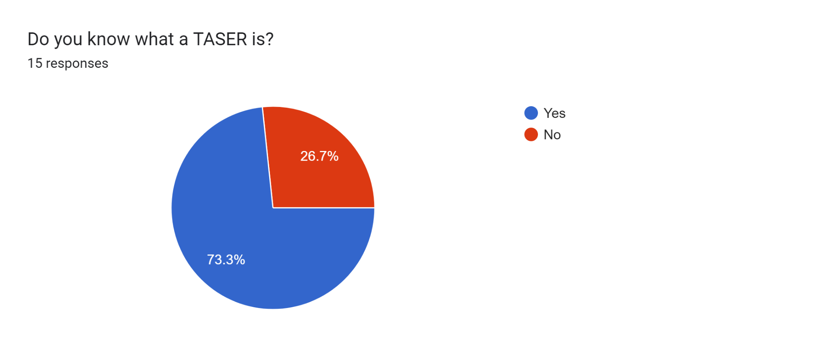

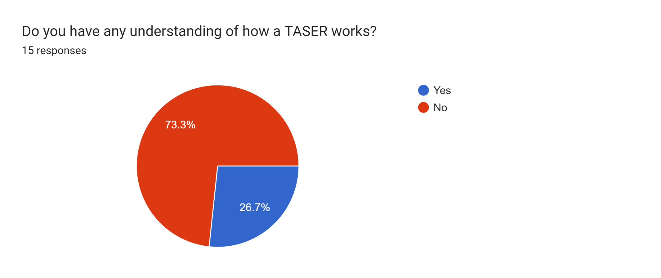

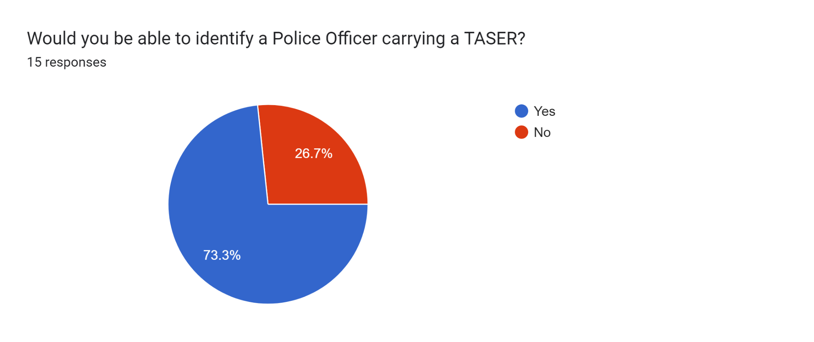
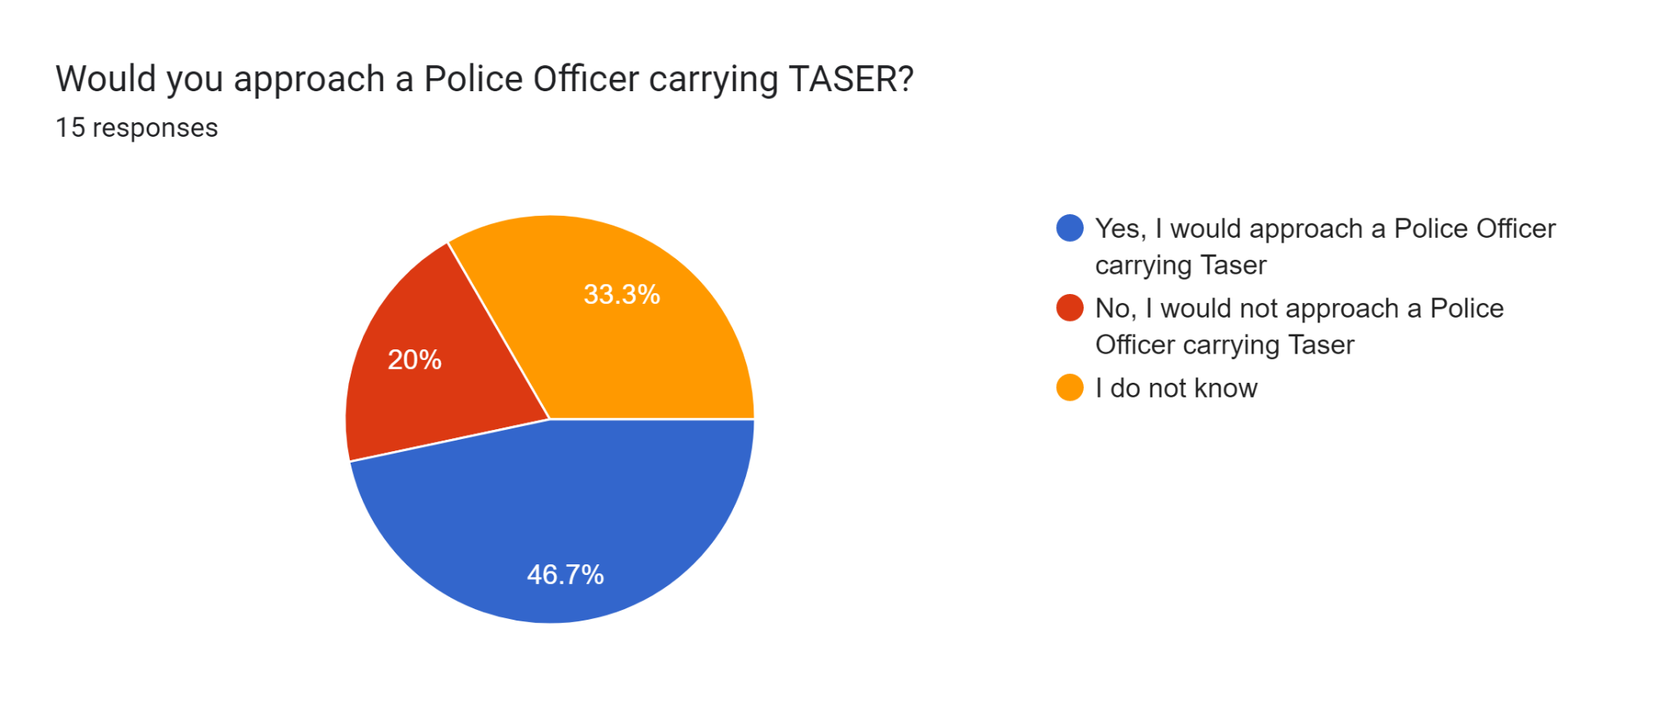

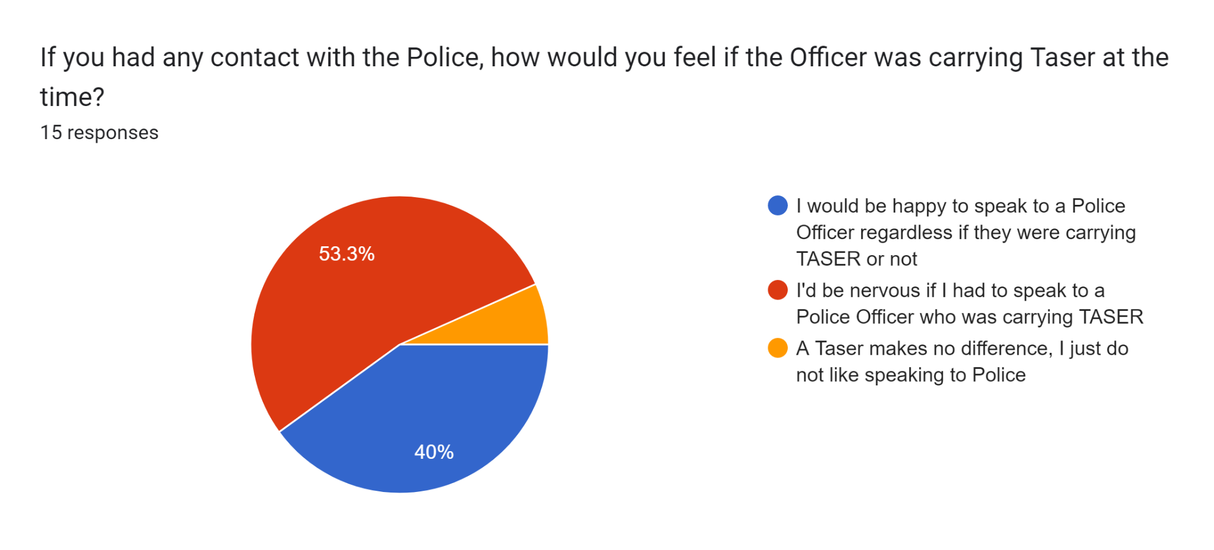

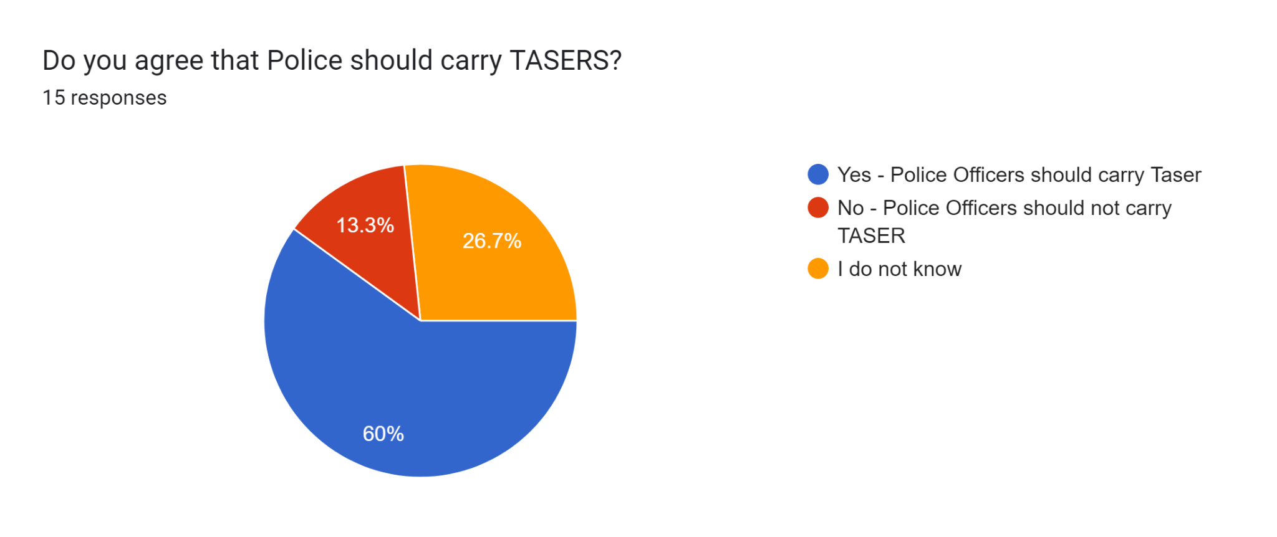

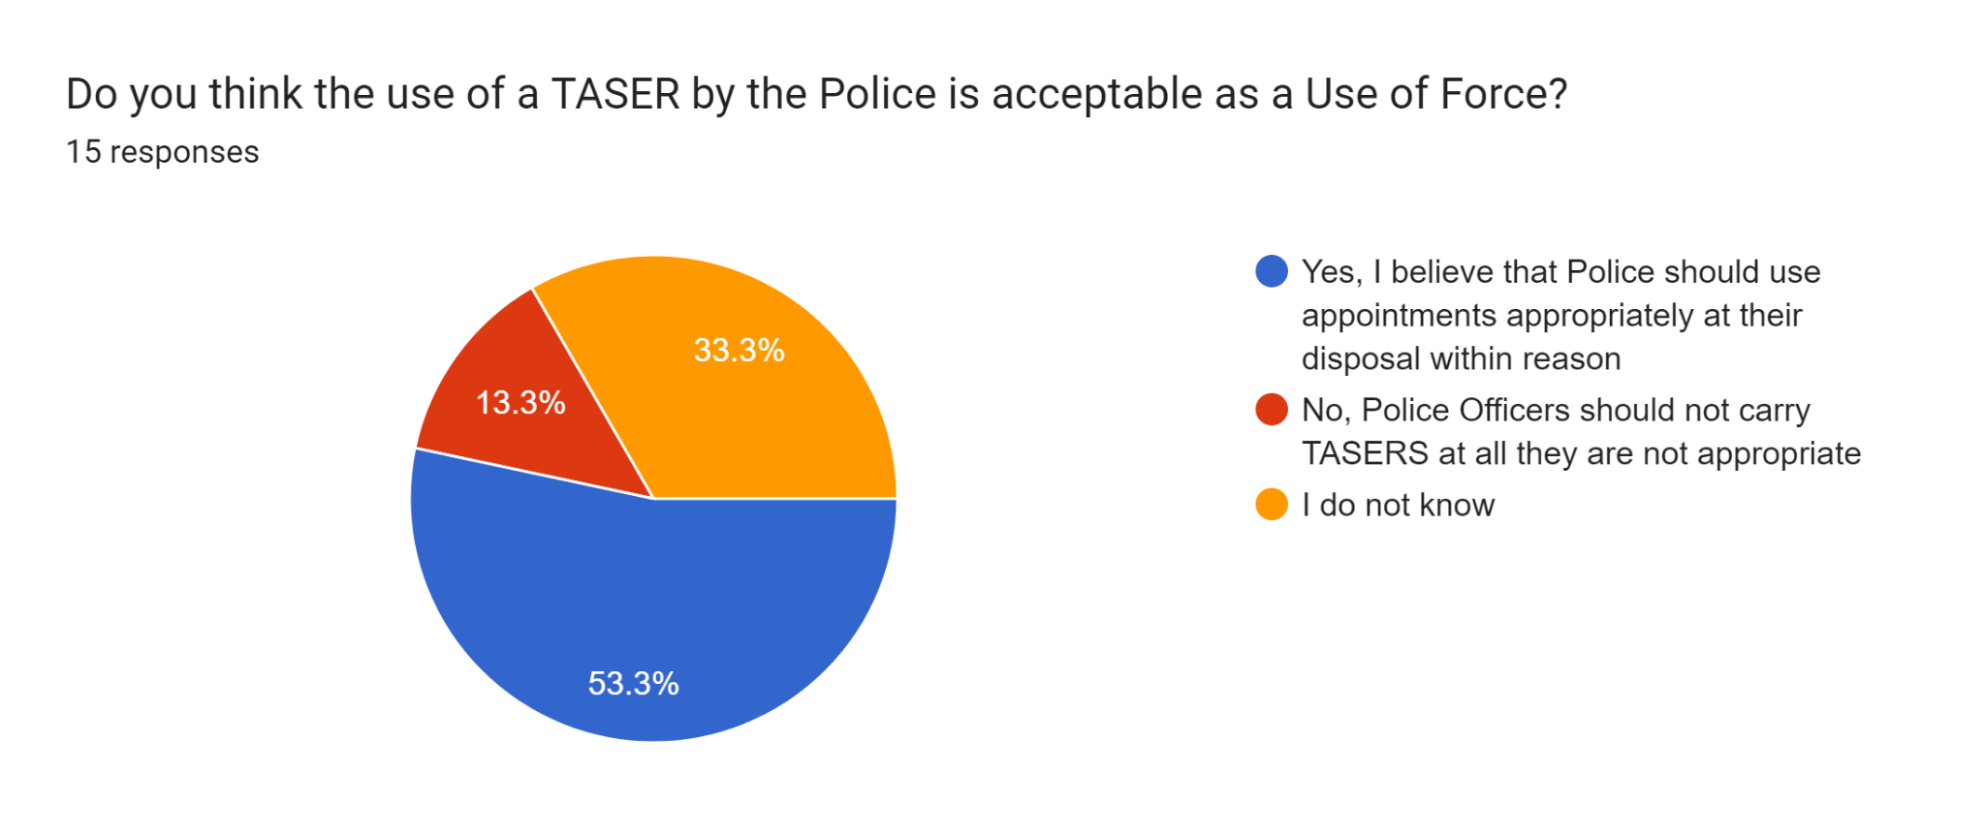
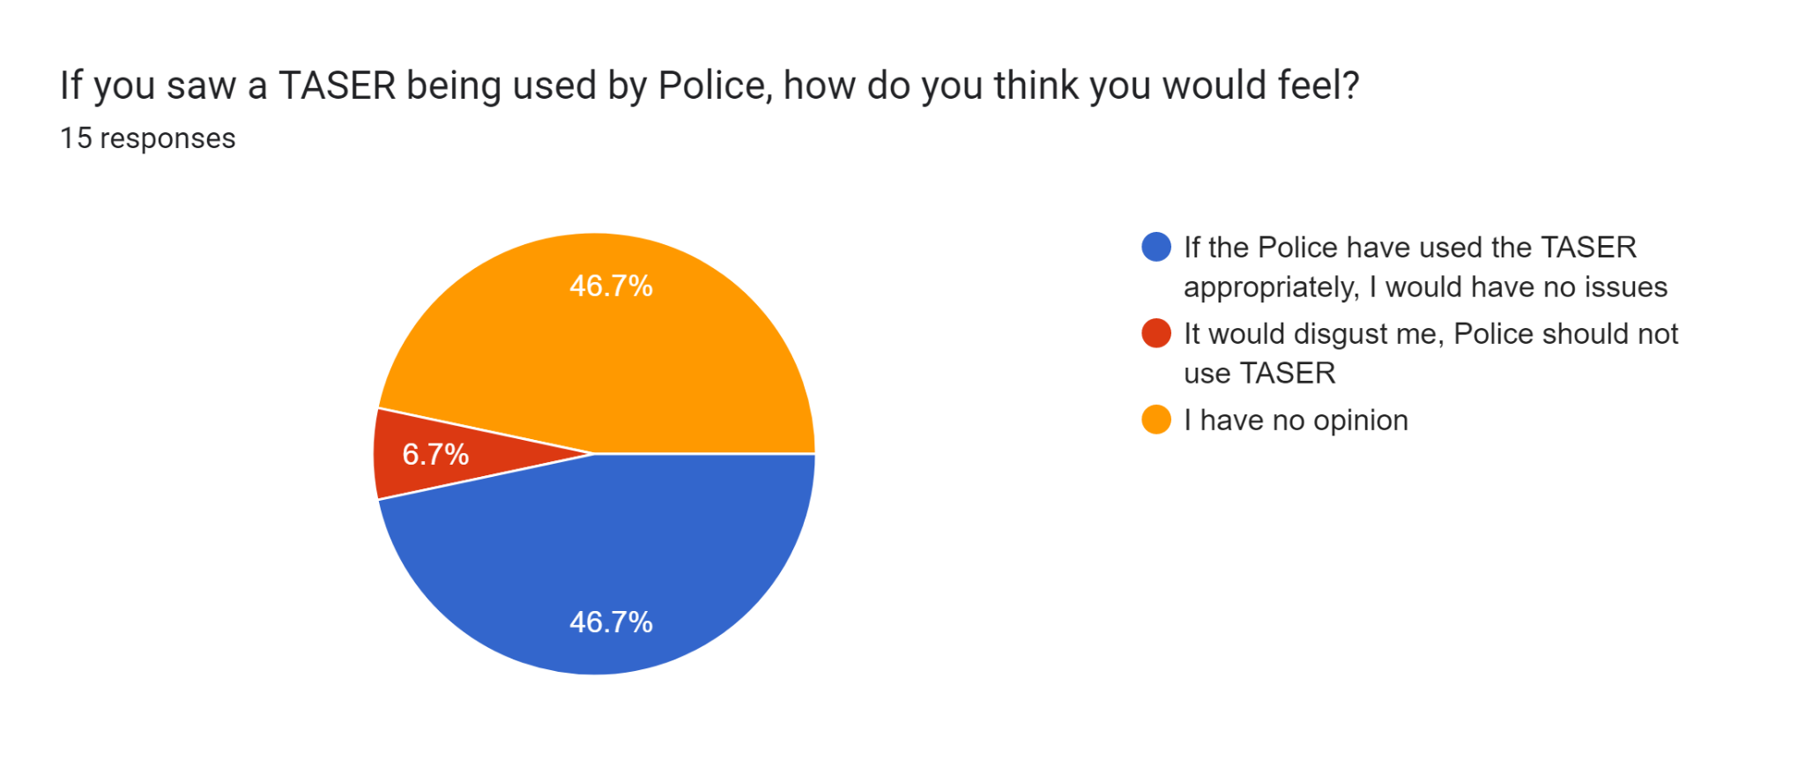

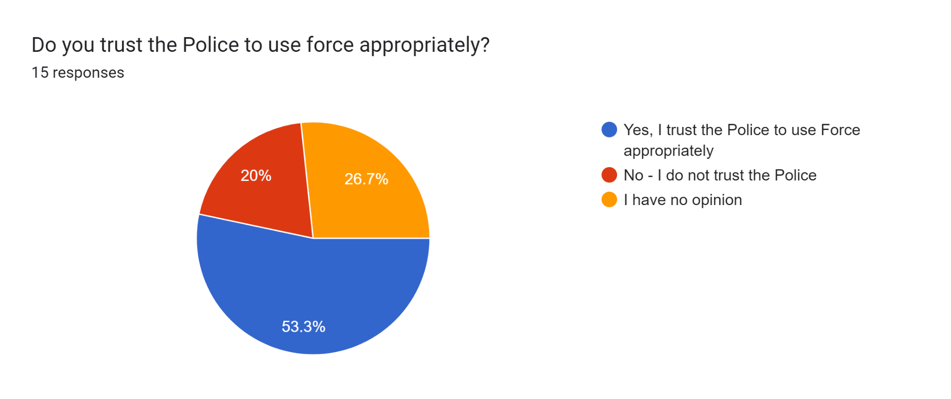

Survey 2 Questions and Responses – Graph format


