

Student name: | Diya Ganguly | Student ID Number: | 2013048
Programme: | DBA-Doctor of Business Administration
Module: | Strategic Change and Organisations
Module code: | LCDB7005 | Contribution to Overall Module Assessment (%): | 50%
Lecturer: | Dr Amare Desta | Internal Verifier: | John Paul Okeke
Assignment Title: | Assessment 2 | Word count (or equivalent): | 4000 Words  (-/+ 10%)

Table of Content
Topics | Page numbers
Introduction | 1
SoftBank’s Corp Profile- A Saga of Unusual Bets That Have Paid Off in A String of Successes | 1-3
ARM Holdings Corporate Profile | 3-4
Strategic fundamentals Behind Acquisition, from the view of Softbank – Early in technology business, gain, SoftBank’s Recognition of the 1st mover advantage in the space of AI Technology and Gain in Competitive Advantage- Understanding ARM’s acquisition from Michael E. Porter’s Competitive Advantage Philosophy | 5-9
ARM’s reasons to accept the takeover proposition by SoftBank? – ARM’s perspective | 9-10
Understanding why SoftBank had to exit the ARM Holdings business - Evaluating SoftBank’s biggest acquisition deal. | 10-11
Future RoadMap of ARM Holdings with Nvidia as its new investor | 11
SoftBank’s Future RoadMap in the post pandemic era | 11-12
Conclusion | 12
Reference List | 13-14

Softbank is a multinational Japanese conglomerate, owing stakes in multiple ventures including the areas of energy, marketing, e-commerce, energy, and technology. It’s headquartered in the city of Minato, Tokyo, running the Vision fund which is world’s chief technology-focused venture capital fund valued with over $ 100 billion in capital. Softbank have also been involved in quite a few risky moves and aggressive investment campaigns, bringing itself often in the forefront of news feeds and headlines. Nevertheless, SoftBank now has more than 88 companies under its portfolio, making it one of the of the influential organization in the world. Hence there is no denying in saying, there has been some extensive level of strategic planning in attaining the peak of stardom, Softbank has achieved today. (The Economic Times, 2019)
In this report we will explore who SoftBank Corporation is and closely examine its strategic imperative behind the acquisition of Britain’s high-tech venture, ARM holdings. Besides, a thorough assessment will be done on both the companies to identify their organizational structures, cultures, strategies, and their future roadmaps.
Softbank Corp Profile- A Saga of Unusual Bets That Have Paid Off in A String of Successes
Softbank started in 1981, in Tokyo as a Telecom Company. However, long before that, SoftBank’s CEO Masayoshi Son, as a student of California Berkeley had a passion for entrepreneurship and inventions. Around 1977 Son started his journey by selling a patent for a pocket translator to Sharp Corporations. This fuelled his lifelong appreciation for invention and private enterprise. (SoftBank Group, n.d.)
Brimming with joy and ambition, Son returned back to his home country Japan and started his own start-up. Son made an early move by spotting the market gap in the PC market industry and started leveraging on it. Personal computers during 1980’s was considered nothing short of toys, unless Son realised there was a way to make it lucrative for the future market. The software’s required in smooth operations of a computer, as seen today, were non-existing around that time. It was Masa Son, who first figured this out and started developing customised computer software’s. This was a real game changer as it propelled Japan’s PC industry by making available every type of software for user convenience. This built the hype around technology revolution and persuaded many others to fall for this. While Sons company was already picking up movement in Japan, he played a masterstroke of expanding globally for seeking the next big opportunity for this tech-based venture. (YouTube, 2016)
Softbank started their initial public offerings around July 1994 as they were registered with the Japan securities and Dealers Association however the internet industry was booming in the US by that time. However, to take internet to the next level, US needed a user-friendly portal, and this inspired Masa Son to formally launch his company in the United States and even rebrand the company as Softbank Holdings form SoftBank Groups with the hopes of becoming mega investors in the space of internet technology. Around 1960’s, impressed by Jerry Yang’s vision for user-friendly portal of Yahoo, Softbank made it’s early investment. Both the companies successfully launched Yahoo, which revolutionized the internet technology. (The Market is Open,2020)
While pioneering an Information Revolution, Masa Son also acquired Ziff-Davis US Publishing company, which not only expanded organizations investment portfolio but also gave SoftBank an insider’s view on emerging possibilities in the technology industry. Soon SoftBank got listed in the Tokyo Stock Exchange and started investing in many other start-ups. (The Market is Open,2020)
SoftBank’s capital backing for Alibaba for Information Revolution
Softbank’s business dipped for a while after the dot.com bust, incurring the company significant finical losses. However, it came all guns blazing when it partnered with the future tech-giant Alibaba. Softbank invested $20 million inspired by Jack Ma’s (Founder of Alibaba) vision for his internet-based in China. China’s booming economy and Alibaba’s vision to thrive in a rapidly progressing technology market in China, pushed SoftBank Corporations to see the potential and partner with Jack Ma for future capital gains. (SoftBank Group, n.d.)
At this stage, SoftBank Telecom company perceived shifts within the tech market as it invested heavily in the Broadband internet access. Masa Son believed bringing high-speed internet access to Japan will change the future of technology and so did it happen.
By 2002, SoftBank bagged a deal with Japanese government to deliver broadband infrastructure and related services throughout Japan. This enabled them to provide affordable, high-speed internet access to the entire Japanese community including offices, schools, libraries, and other public facilities. As a result of this, SoftBank connected communities, increase user accessibility and ultimately brough internet within the reach of everyone.
In the interim, Alibaba successfully launched Vodaphone 3G services, iPhone in Japan followed by iPad and sate of the art electronic personal robot with the power to sense emotions, named as Pepper. (SoftBank Group, n.d.)
However, SoftBank’s big win only came when it together with Alibaba became the internet giant in China, propelling its initial twenty-million-dollar investment into sixty million dollars valuation.
Be it robotics or mobile technology, Softbank wanted to dominate the space of artificial intelligence or commonly known as AI. This spurred their vision to expand further and invested in next generation of AI technology by acquiring ARM Holdings-a UK based, avant-garde microprocessor designer and software developer company. (SoftBank Group, n.d.)
On account of this acquisition, SoftBank’s visionary CEO Masa Son quoted that “I will look back on our acquisition of ARM as the single most important deal in my life. In the next 20 years, we will see one trillion Internet of Things devices.” (SoftBank Group, n.d.)

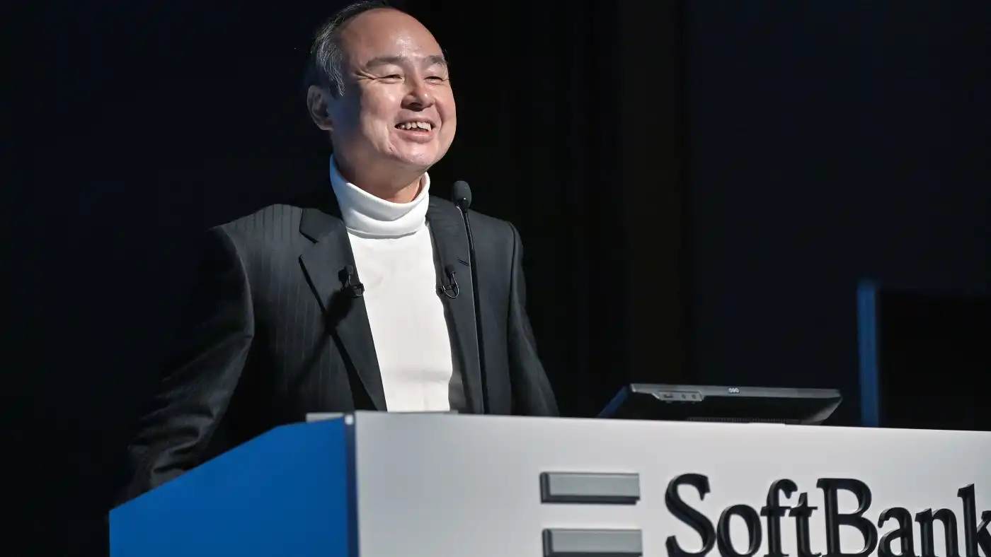Source- Nikkei Asia, (2021)
ARM Holding’s Corporate Profile- The Pathbreakers of AI technology
SoftBank’s acquisition of ARM holding’s was a massive investment of $31.4 billion dollars but was this bet paid off? In order to find that out, first let’s understand who ARM is and why it hauled up SoftBank’s interest. ARM is a high-tech company that operates by supplying semiconductor intellectual property, physical IP, system designs and other assistive AI technology. ARM includes a product catalogue offering 16/32/64-bit RISC microprocessors, graphics, digital libraries, embedded memories, and additional peripheral software that can accelerate the performance of analogy functions and high-speed connectivity gadgets. (CHCompaniesHistrory.com, 2020)
So, in a nutshell ARM is a British (Cambridge, UK) based company that designs and manufactures semiconductor equipment’s, to be precise mobile chips, that’s entrenched in ninety percent of the mobile devices used globally today, be it the most simplest Android device or the luxurious iPhones.
The acronym ARM initially came from “Acorn RISC Machine” as it’s RISC processor used the Acorn Archimedes. However later the acronym was changed to “Advanced RISC Machines Ltd” but at the time of company IPO in 1998, the name was shortened to “ARM Holdings”, which now is often only referred as ARM. (CHCompaniesHistrory.com, 2020)
ARM is headquartered in Cambridge and has other head offices in Silicon Valley and Tokyo. After being selected by Apple for the Newton project, ARM invested in Palm chip Corporations to enter the disk drive market. This helped ARM to get itself listed on the London Stock exchange and NASDAQ around 1988.
By 2010, ARM joined hands with other tech companies like Samsung, IBM, ST-Ericsson, Texas Instruments for expanding their vision of wireless connectivity among daily use items.
However, after UK voted to leave the European Union, it made ARM Holdings an easy and indeed a juicy target for foreign investors. Masa Son who is known for making early moves and an enigmatic visionary leadership, did not fail to seize this opportunity. Hence by June 2016, SoftBank formally announced to acquire ARM holdings for 31.4 billion dollars, making the biggest purchase ever in the history of European technology company. (The Financial Times, 2019)
Source- (SoftBank Group, n.d.)
Strategic fundamentals behind SoftBank’s Biggest Investment to acquire ARM Holdings-
ARM holdings who’s was already well known for designing and licensing microprocessor chips to state-of-the-art mobile companies like Samsung and Apple, were predicted to dominate the mobile technology space in the near future. Before SoftBank’s acquisition, ARM chips were used by world’s half of the mobile devices, pushing it to ship fifteen billion dollars ARM-chips annually, which was only predicted to grow in the recent times.
As the British pound value plummeted, after British government’s decision to leave EU, SoftBank acted on this opportunity by making an early move in the technology investment business by completing the acquisition of ARM Holdings. Although it’s fair to state here that this acquisition of ARM was bigger than any other investment SoftBank has made earlier, including the mega investment of $20 billion on Sprint and $15 billion in Vodafone’s Japanese telecom division. So, the question here is to understand what convinced SoftBank to make this hefty price tagged acquisition. Below are some of the explanations for SoftBank’s biggest ever purchase of ARM Holdings; - (The Financial Times, 2019)
SoftBank’s Recognition of the 1st mover advantage in the space of AI Technology
SoftBank acquisition of ARM holdings was seen by industry experts as an investment in the so-called Internet of Things- meaning a world with wireless connectivity among everyday items including cars, refrigerators, trains, 3rd printers and any other devices that would lead to better user experience. (Rosoff. M.,2020)
SoftBank’s acquisition of ARM was expected to augment its Internet of Things plan. After it’s successful partnership with Alibaba, which helped them to gain a capital advantage of 40 million dollars, Masa Son, SoftBank’s CEO have been known for making wild bets of investment. Be it WeWork, Uber, Slack, Sprint, Brightstar etc, SoftBank have been splashing it’s money in internet related products and companies owning such products. (The Financial Times, 2019)
While ARM wasn’t a huge money churner globally when SoftBank acquired it, that said it was definitely not a small player in the semiconductor processor selling market. Moreover, ARM was certainly punching above its weight already, by designing and licensing chips for huge firms like Apple and Samsung and collecting royalties out of these companies on each chip developed. Having the status as the provider of the intellectual property to practically all mobile devices, was enough of a reason to convince SoftBank conglomerate to acquire ARM as a solid investment. (Byford. S., 2016)
Also, another reason could be, ARM’s technology is almost unparalleled. ARM’s architecture is in-built in ninety percent of the mobile devices our world uses today. Honestly its even hard to imagine who or what can match ARM’s architecture to overthrow ARM from the market position it holds today. This means there’s no way ARM’s value is going to be dropping any time soon, as it has been successful in creating the hype around low-power, resourceful and wireless connected AI products. More importantly this fad around AI gadgets is only anticipated to grow exponentially.
SoftBank’s Early Move in exploiting the benefits of ARM’s Internet of Things Technology (IoT)-
To understand this, we first need to explore what is this Internet of things and how this works? The term was first coined by Procter and Gambles Kevin Ashton (1999) to explain the role the RFID tags for efficient supply chain operations. To put it simply, the Internet of things (IoT) is the combination of network enabled devices barring the traditional PC’s, laptops, or servers. The network packages that IoT includes are wireless Wi-Fi-connections, Bluetooth connections and the Near-field-communications used for single touch payments, paying bills, downloading coupons etc.
Our life today, is surmounted by such wireless IoT technology- be it smart phones, smart homes, computer peripherals like webcam and printers, home appliances such as thermostats and freezers, wearables like smart watches, Fitbits, smart tech entertainment devices including Google Home speakers and Amazon’s Echo etc, the IoT technology is engrained everywhere. So, the question is how is this embedded in the devices we use? To be price, all the smart devices use IP or internet protocol for identifying the host interfaces and for routing packets of data or datagram from the host interface to a destination host interface. Hence the key to Internet of Things (IoT) is data traversing which efficiently allows different network devices to communicate with each other. Be it analogue or digital communications, IoT technology is used everywhere. (Byford. S., 2016)
However, with IoT technology, it’s now anticipated that the smart devices will self-report in real time without depending on systems that require human intervention, hence it’s going to be much faster and more efficient in bringing the real time empirics or information to the host device.
Therefore, levering on this unique Internet of Things technology, ARM holdings is intending to transform a wide range of fields (from medicines to traffic control to planning new cities or public infrastructures) for establishing a digitally connected world. Hence the reason, Softbank has invested around £32 billion to complete the acquisition of ARM holdings. (Rosoff. M.,2020)
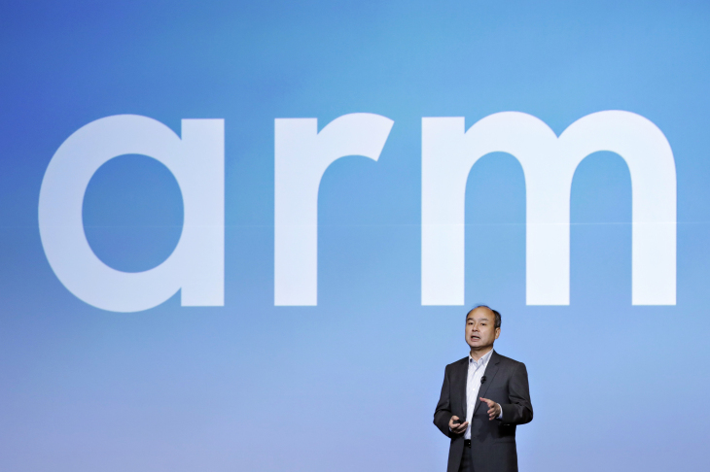
Source- (Bloomberg 2018)
Gain in Competitive Advantage- Understanding ARM’s acquisition from Michael E. Porter’s Competitive Advantage Philosophy
Around 1979, Michael E. Porter, an American academic and Harvard Research Scholar, established a framework for assessing and evaluating business organizations competitive strength and position. Porter popularly known for his ground-breaking work in field of business strategy and economy, basically originated a framework for Competitive Position Analysis for creating and sustaining superior organizational performance. (iEduNote, 2021)
The framework provides an understanding of the strength of organizations current competitive position as well as it’s weakness in comparison to the competitors in the market for sustaining it’s potential profitability. Porters four competitive strategies are as under:
-Differentiation Strategy- differentiation in product or the service organization is selling

-Cost Leadership Strategy- Low-cost strategy for selling standardized products at low-per unit cost for price-sensitive customers.
-Market-niche or focus strategy- Identification of niche product and launching the niche segment of a total market

-Best Cost Strategy- Delivering products or services of high quality but with low price in comparison to its competitors in the market. (iEduNote, 2021)

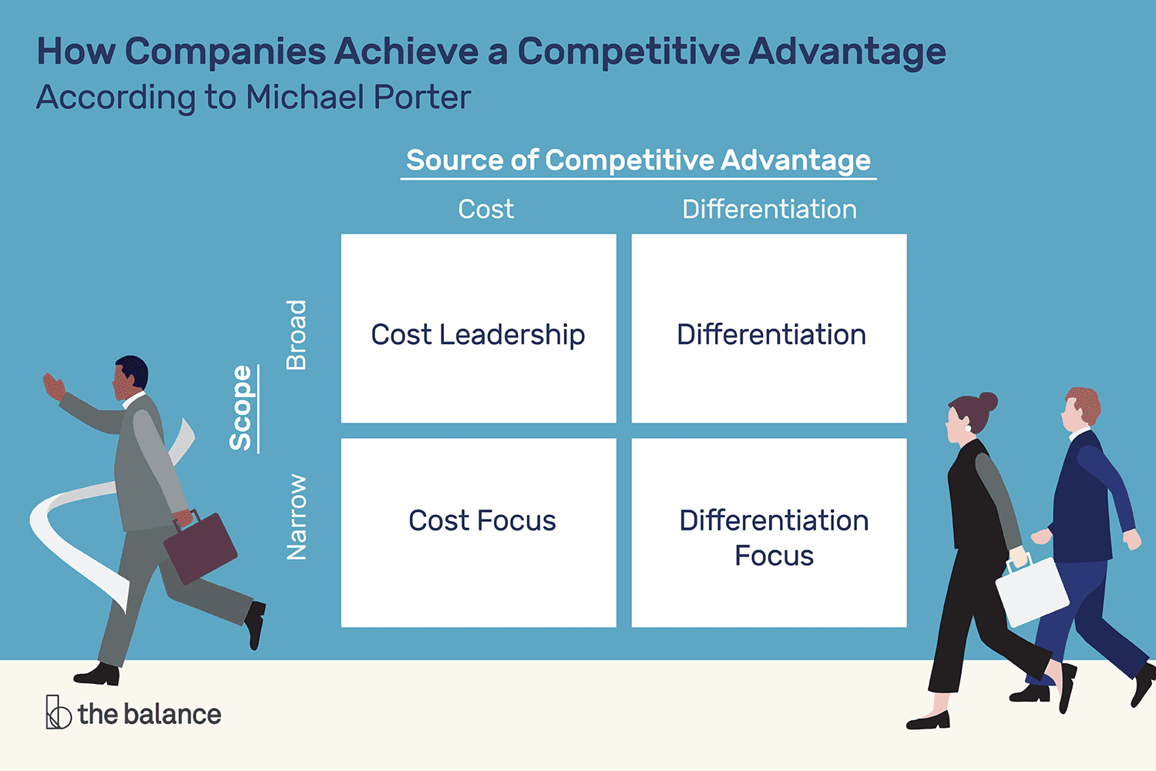

Applying Porter’s Competitive Advantage Analysis framework to understand why Softbank’s acquired ARM holdings –
Sources:
Cost Differentiation
SOURCES-

BROAD

NARROW

ARM created a business ecosystem by creating a large network of partnerships with 400 other companies to develop semi-conductor equipment’s. | Every year ARM ships trillions of tiny microprocessors that’s utilised by both Apple and Android devices. These chips are designed for low-power functionalities, giving the pocket-mobile-devices the long battery life, it requires.
ARM produces high quality chips, cell libraries, embedded memory cards and related tools at a much affordable price compared to its top competitors like MACOM, RAMBUS etc. Going by the Best Cost Strategy ARM at least for now generate 1.3 billion dollars more revenue annually than MACOM and 1.7 billion dollars more revenue than RAMBUS who also specialises in semiconductor equipment’s. However, it is yet to catch up with Intel’s profitability. | ARM memory chips are integrated in Samsung, Qualcomm Snapdragon, Nvidia Tegra and Apple platforms as it’s the most convenient microprocessor chips/architecture for any mobile device. Also is constantly investing is finding solutions for the next generation needs of AI, security, and other Specialized computing applications. Source-  (Smith, G. D., 2020)

Decoding the Porter’s Competitive Advantage Analysis framework outlined above-
The above table indicates that why ARM stands out in terms of both cost and product differentiation strategy. Not only it’s in the business of IP sellers or microchip designer which is a niche market in its way but at the same time it’s microprocessors are more efficient and mobile friendly for any mobile device even compared to the Intel processors which is the finest microprocessor designer in today’s generation and undoubtedly ARM’s biggest competitor. (TechRepublic,2020)
However, ARM processors not only use less battery but also have a reduced operating device temperature than any other microprocessors-including Intel. This makes it suitable for mobile devices unlike laptops as mobile devices can’t be constantly connected to a power source, to perform the user’s required tasks. Arm processors are designed in such a way that they reduce the amount of power necessary to keep the system operational as longer possible for the mobile devices. So be it Apple or Android, all mobile manufactures are dependent on ARM’s technology. (Edge Ecosystem, 2021)
Thus, to summarize, whether one is running apps on their phones or the world’s fastest supercomputers, most likely they’re running ARM’s technology. Hence the reason SoftBank could let go their temptation to acquire ARM, even though this possession burnt a hole in their pocket.
ARM’s reasons to accept the takeover proposition by SoftBank? – ARM’s perspective
SoftBank partnered with the Saudi kingdoms most sovereign wealth fund known as the Public Investment Fund of Saudi Arabia (PIF) to create world’s largest private equity fund. This equity fund is known as Vision Fund and comprises a capital of $93 billion. The Prince of Saudi Arabia is the main investor in the fund as it has agreed to invest 45-billion-dollars over 5 five consecutive years from its inception, becoming by volume it’s largest investor. The other investments will come from conglomerates like Qualcomm, Foxconn, Apple, Sharp etc bringing around 15-billion-dollar investment in the fund. The goal of this Vision Fund is to develop technologies in concurrence with global Artificial Intelligence, including multiple sectors such as energy, telecommunications, finance, robotics, transportations etc. This global private equity fund gave SoftBank more mileage to back more tech-based companies such as ARM, who’s considered one of the best in what it does. So, reviewing from ARM’s point of view, SoftBank is a neutral buyer that wouldn’t affect the equation ARM holds with its important and long-standing customers like Qualcomm, Samsung and Apple. ARM whose massive chunk of revenue comes for issuing IP’s and microprocessors for Apple and Android products, would change much even it’s acquired by SoftBank. Infact, with SoftBank’s Vision Fund’s goal in mind, it can only be anticipated that SoftBank will go out more aggressively in investing on ARM’s R&D unit to attain a new peak of success together. (TechRepublic,2020)
Besides, ARM has been able to convince SoftBank to run itself the way it always has, additionally giving it more leverage in the UK as well outside. Also, SoftBank’s ownership will open the floodgates to explore other areas, giving ARM more mileage as a semiconductor selling company. With Softbank’s financial backing, the company can now focus on everything from 5G and networking to Inter of Things technology. Thus, Softbank’s acquisition is as good a return for ARM’s shareholders as it could hope for. (TechRepublic,2020)
Understanding why SoftBank had to exit the ARM Holdings business - Evaluating SoftBank’s biggest acquisition deal-
SoftBank’s acquisition of ARM, was predicted to be the next biggest successes for SoftBank, given the influence ARM has on the technology industry. However, as the pandemic hit, this narrative was no longer found to be true. The economic catastrophe caused by the Covid-19 pandemic in 2020, significantly dropped Softbank’s finances that year. This deterioration happened as the company incurred huge losses on investments in companies like Uber and WeWork. Also, Softbank’s shares lost value as it had taken some large stakes in tech giants, which suffered a significant loss in stock market value in the same year of 2020 around early September. Also, companies under SoftBank’s vision fund, like Slack, OYO, Grab, ByteDance, Roivant etc were neither performing well, plummeting SoftBank’s overall fiscal revenue. However, WeWork, the office-coworking company was the biggest disappointment for SoftBank’s vision fund. Out of £ 100 billion of SoftBank’s vision fund, over 9-billion-dollar was pumped into this office-coworking company WeWork, which was not only a risky investment, infact proved to be failed experiment for Softbank. In the first half of the year, SoftBank had a loss of £690 million on $1.5 billion in revenue, cutting the companies valuation by fifty percent and ultimately cancelling it’s IPO. (Morris, M, 2019)
WeWork’s collapse had been impactful on its primary investor SoftBank, and with Covid-19 it’s future seems bleaker than ever as fewer people are willing to work in offices these days. More importantly the work from home concept, is there to stick for a long haul, putting WeWork’s foundation business at risk.
Also, as travel came to sudden halt due to the pandemic, OYO, a budget hospitality chain and SoftBank another massive investment, incurred a massive loss, as its operation froze around the globe. With travel restriction orders in place, the travel industry collapsed and so did OYO. This dropped OYO’s company valuation, meaning that SoftBank which made a guaranteed £2 billion dollar investment for OYO, was now seen stumbling. (ndtvprofit, 2020)
The saga of such failures continued throughout 2020, incurring SoftBank a total loss of 17 billion dollars. Hence SoftBank decided to sell out ARM Holdings, to raise the additional capital it needed in sustaining it’s Vision Fund and other investment portfolios. Softbank which once believed ARM had more potential than Google and bought it outright back in 2016, ultimately had to close a deal with Nvidia to sell ARM for £40 billion dollars to recover from its fiscal loss.
Although Softbank to be blamed majorly for not being able to retain ARM under its wing for longer tenure, ARM’s Holding on the other hand is not completely blame free. The reason why business experts say so are as under; - (Crichton, D., 2020)
First, ARM despite selling billions of successful chips designs every year for half of the worlds smart phones, still struggled to turn itself into a fast-growing company. Before Softbank acquired it, Arm was already dominating the mobile technology space, and it was anticipated that with SoftBank’s help the company will double its chips sales and expand into other areas like car, or automobiles or refrigerators etc where its micro processor chips could be ingrained. However, that failed to happen, as the company despite having some notable successes haven’t been able to translate these wins into significant profits. (Crichton, D., 2020)
Secondly ARM’s blurring future of the semiconductor industry was another concern for SoftBank. ARM in order to expand beyond smart phone devices, need to produce more efficient semiconductor equipment’s. For instance, for laptops or other powered devices, Intel still dominates the market and ARM seems to be nowhere close to it in that segment. Although, ARM’s powered processor design is said to be included to the Apple’s iconic Macintosh Line-up, this still failed to pick up the necessary traction for significant profits. (Heater, B, 2020)
Thus, SoftBank’s deal to sell off ARM to Nvidia is seen to be justifiable. Economically if 40-billion-dollar is the selling price asked for ARM, then SoftBank is earning a 25% gain in roughly four years with this sale.
Future RoadMap of ARM Holdings with Nvidia as it’s new investor
For SoftBank, it’s fair to mention ARM was another sign of the company’s cost-cutting in the face of extreme loss but for ARM it was a different story altogether. Although Softbank had a likely win on its hand with ARM holdings deal, let’s review how this deal turned out to be for ARM. Given Softbank’s track record of making risky investments, ARM seems to be in more safe hands with Nvidia. It’s more likely that Nvidia would give ARM a leading position in the microprocessor market, augmenting the company’s strength in graphic designs and Artificial Intelligence. This intensifies both ARM and Nvidia’s place as one of the major centres of gravity in microprocessors chips. (Rosoff, M., 2020)
Besides, Nvidia has pledged that ARM’s operation will remain in the United Kingdom rather than being moved to Unite States, and also would continue with ARM’s licensing model and customer neutrality. While the pandemic and subsequent lockdowns have economically scarred some of the start-ups Softbank invested in, Nvidia was in absolute tears as it’s data centre business outperformed, beating the companies own expectations. Nvidia’s overall revenue rose to 50% on an annual basis as people spent more time playing video games during the pandemic, giving Nvidia’s gaming business an absolute boom. Infact, Nvidia now has decided to launch a new graphic card for PC’s that shows promising performances for computer gamers. Thus, this combination of ARM holdings and Nvidia working together, makes financial sense as both are invested in producing microprocessor chips that are widely used to support graphics and artificial intelligence applications, including automobile, video gaming or self-driven vehicles. (Novet, J., 2020)
As SoftBank’s finances deteriorated during the pandemic last year, and it was desperately looking for cash to help start-ups it invested in through its Vision Fund, it also made sense for SoftBank to sell off ARM holdings, as Nvidia was willing to pay a hefty price for ARM’s acquisition, including £ 21.5 billion in Nvidia stock and $12 billion in cash and $2 billion dollar cash transaction at signing. (Rosoff, M., 2020)
SoftBank’s Future RoadMap in the post pandemic era
Despite all the triumphs and glooms, SoftBank has witnessed in last few years, it has full confidence in their long-term vision of bringing the world together with the Artificial Intelligence or AI enabled technology. It has already invested in two more funds putting across to the world it’s support for technology-based ventures and the risks they willing to take to deploy artificial intelligence technologies around the world.
The two funds include, Latin American Fund and Vision Fund 2, the prior was set up to solely invest in Strat-ups across Latin America and the later was initiated to fund businesses from any part of the world that designs or manufactures AI based products. So, it’s evident that although SoftBank had to let go ARM holdings, to raise the required cash it lost during Covid-19 crisis, it has not shifted it focus from AI technology. It’s long-term vision still sticks around the philosophy of utilising the power of AI technology to bring humans or communities across the globe closer to one another. As SoftBank popularly call it a Shared Vision to Amply Ambitions.
Also, a new altruistic side of SoftBank was seen when it launched the Opportunity Fund in October 2020 to support and build a community of Black, Latinx and Native American Founders who were significantly impacted due to the global Covid-19 pandemic. This 100-dollar-million venture fund was set up to support the underrepresented founders of colour, who brings unique perspective to any firm they join and also who has the potential to become extraordinary leaders tomorrow, if right amount of support and capital backing is furnished to them. (SB Opportunity Fund, n.d.)
Also, SoftBank partnered with Correlation One to help around 200 students to graduate from AI talent Program in Latin America. This data literacy course will students in understanding how with AI bottom line results in operation in various business sectors can be enhanced. This will additionally help in creating immediate business impact generating economic opportunities and transformational progress for the Latin American community. (SoftBank Group Corp, 2020)
As far as economic growth is concerned, Softbank has made a significant comeback despite the substantial damage its own principal technology Vision Fund caused it in 2019. SoftBank’s Vison Fund turned losses into unexpected profits by the summer of 2020 as it is set to report a net profit of 41.7 billion dollar for the financial year that ended in March 31, 2021. This is an absolute reversal of previous year’s result, when the company incurred a largest ever net loss. However, it seems to be new dawn of rise for SoftBank this year, as it has pulled off to attain record net profits of 41.7 billion dollar this year, which is the highest net profit ever attained by any Japanese corporation in the history. (Wilhelm, A,. 2020)
To conclude, both the companies seem to be pretty well off in doing what they do best. Although both have separated now, the common link that still binds them together is it’s vigour and sheer passion for artificial intelligence. While Softbank is proving to be the most impactful tech company in the world, ARM is busy working behind the scenes on the future of the artificial intelligence enabled products, which is ultimately helping it to grow exponentially in it’s potential. (Nikkei Asia, 2021)

REFERENCE LIST-
The Economic Times (2019) "Softbank's Son the Most Powerful Tech Investor, May Be the Most Dangerous Too Available at: https://economictimes.indiatimes.com/small-biz/entrepreneurship/softbanks-son-the-most-powerful-tech-investor-may-be-the-most-dangerous-too/articleshow/58800283.cms
IEduNote, (2021) Porter’s Competitive Strategy- Four Types of Competitive Strategy Available at: https://www.iedunote.com/competitive-strategy
EcosystemEdge (2020) ARM Holdings Plc: Ecosystem Advantage Available at: https://ecosystemedge.com/arm-holding-plc-ecosystem-advantage/
TechRepublic (2020) Why the Next 10 years belong to ARM Available at: https://www.techrepublic.com/article/why-the-next-10-years-may-belong-to-arm/
Kenton, W. (2020) The Internet Of Things Available at: https://www.investopedia.com/terms/i/internet-things.asp
Smith, G. D. (2020) ARM Vs Intel Processors: What’s the Difference? Available at: https://www.androidauthority.com/arm-vs-x86-key-differences-explained-568718/#:~:text=Arm%20is%20RISC%20(Reduced%20Instruction,(Complex%20Instruction%20Set%20Computing).&text=This%20is%20a%20key%20difference,%2C%20instruction%20set%2C%20and%20hardware.
Rosoff, M. (2020) ARM Holdings Internet of Things Available at: https://asia.nikkei.com/Business/SoftBank2/Arm-scraps-transfer-of-Internet-of-Things-units-to-SoftBank

Byford, S. (2016) ARM is another wild bet that's likely to pay off for SoftBank Available at: https://www.theverge.com/2016/7/19/12222662/softbank-buying-arm-why-masayoshi-son

Wilhelm, A. (2020) Downturn of SoftBank Available at: https://techcrunch.com/2020/11/12/how-softbanks-vision-fund-turned-losses-into-gold-this-summer/

NikkeiAsia (2021) SoftBank set for record $41.7bn net profit in fiscal 2020 Available at: https://asia.nikkei.com/Business/SoftBank2/SoftBank-set-for-record-41.7bn-net-profit-in-fiscal-2020
Morris,M.(2019) SoftBank’s Vision Fund Investments Available at: https://www.bloomberg.com/news/articles/2020-06-18/softbank-will-invest-in-14-companies-run-by-diverse-founders
Novet, J. (2020) Nvidia earnings beat expectations, its data center business is bigger than its gaming business for the first time ever Available at: https://www.cnbc.com/2020/08/19/nvidia-nvda-earnings-q2-2021.html
Morris, M. (2019) Nvidia to buy Arm Holdings from SoftBank for $40 billion Available at: https://www.cnbc.com/2020/09/14/nvidia-to-buy-arm-holdings-from-softbank-for-40-billion.html
Crichton, D. (2020) SoftBank could make, gasp, a profit on its expected sale of Arm for $40B Available at: https://techcrunch.com/2020/09/12/softbank-could-make-gasp-a-profit-on-its-expected-sale-of-arm-for-40b/#:~:text=%2440B%20%7C%20TechCrunch-,SoftBank%20could%20make%2C%20gasp%2C%20a%20profit%20on%20its%20expected%20sale,of%20Arm%20for%

Smith, G. D. (2020) ARM Vs Intel Processors: What’s The Difference? Available at: https://www.alphr.com/features/390064/arm-vs-intel-processors-what-s-the-difference/

NDTV Profit (2020) Oyo Says Annual Loss Grew Over Six-Fold On China Expansion Available at: https://www.ndtv.com/business/oyo-says-annual-loss-grew-over-six-fold-on-china-expansion-2181394
Wilhelm, A. (2020) How SoftBank’s Vision Fund turned losses into gold this summer Available at: https://techcrunch.com/2020/11/12/how-softbanks-vision-fund-turned-losses-into-gold-this-summer/
SB Opportunity Fund (n.d.) An open letter to Black, Latinx, and Native American Founders Available at: https://theopportunityfund.com/

