Student Name: Cristina Silva Pita  Student ID: 2228861  Module Title: Foreign Language and Cultural Awareness  Module Code: BMIH5003  Lecturer: Lisa Basseler  Date: 08.02.2024 | 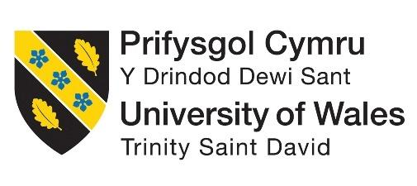
ASSIGNMENT 1: PORTFOLIO
(4 Components)

Component 1: Professional Reflection (500 words +/- 10%)

Weighting: 25%
Cultural misunderstandings can occur when two or more individuals speak the same language, however, they understand or mean two different things. There are several factors, which are responsible for forming cultural misunderstandings in hotels. Differences in cultural norms can be responsible. Every culture has its unique etiquette. Not being informed about cultural differences might result in disrespecting the norms (Christiansen et al., 2020). Language primarily promotes cultural understanding, but sometimes it might create cultural misunderstandings. Certain words or phrases can have different meanings across different cultures. Therefore, it promotes misunderstandings. Apart from that, physical body language and gestures may differ, across different cultures. Henceforth, it can actively communicate different emotions.
Cultural misunderstandings are highly evident in Premier Inn, East Cliff Bournemouth. A large number of German tourists visit the hotel chain. However, the problem of the language barrier has prompted negative guest experiences. The guests are facing severe problems in actively communicating their needs and preferences. Therefore, it leads to incorrect orders and services (Maheshkar and Sharma, 2018). Moreover, people belonging to different cultures have their norms regarding etiquette and services. However, the problem of the language barrier can restrict from effectively identifying the intentions.
Therefore, the following factors actively result in a negative guest experience for Premier Inn. To mitigate these, there are certain behavioural changes or skills I need to develop. First of all, it is essential to be well-versed in the German language. It can help to establish effective communication with the guests (Hampden-Turner and Trompenaars, 2020). Learning basic German phrases and words can help me in this context. Words such as “Guten Tag”, which means having a good day can help me to foster a positive guest experience. Moreover, I need to patiently listen to the visitors, who are not fluent in English. Patiently listening to what they want to say, can help me to understand their needs and preferences. Learning German to assist visitors in a short period might be challenging. Henceforth, I can use digital translators with me.
The translating tools can interpret what the guests want from the hotel. Double-checking facts when unsure about a certain thing, is always regarded as a good habit. It is because I can provide the actual service the guests want, therefore fostering a positive guest experience. Making up guesses or assumptions might create conflicts (Salem, 2021). Henceforth, it is always desired to cross-check facts. There are some skills, which I need to develop to assist the guests in a better way. I need to develop emotional empathy skills. Emotional empathy can be defined as the practice of sharing emotional experiences with others. It actively helps to understand how the other person feels. Such skills can help me to understand the kind of services that the German guests want from Premier Inn. Apart from that, active listening skills can also help me in this context. Active listening skills can be referred to as the practice of preparing to listen as well as observing the nonverbal and verbal messages an individual is willing to send.
References:
Christiansen, B., Branch, J.D. and Karmowska, J. 2020 Cultural Factors and Performance in 21st Century Businesses. Hershey: IGI Global.
Hampden-Turner, C. and Trompenaars, F. 2020 Riding the Waves of Culture. 4th Ed. London: John Murray Press.
Maheshkar, C. and Sharma, V. 2018 Handbook of Research on Cross-Cultural Business Education. Hershey: IGI Global.
Salem, S.F., 2021. Do relationship marketing constructs enhance consumer retention? An empirical study within the hotel industry. Sage Open, 11(2), p.21582440211009224.
Component 2: Training Plan (500 words +/- 10%)

Weighting: 25%

Identified cultural misunderstanding (in a few words) :
The problem of language has resulted in creating cultural misunderstandings between the guests and the staff of Premier Inn, Bournemouth. The primary cultural misunderstanding that has been identified is request misinterpretation. It is particularly happening with the German customers. The customers tend to ask for something, which completely makes sense in German. However, it is difficult and at the same time confusing for English language speakers to interpret (Lumentut and Lengkoan, 2021). The German dining etiquette as well as greetings are not similar to that of English practices. Henceforth, the staff of Premier Inn Bournemouth is unable to understand the differences in cultural norms. Henceforth, it creates misunderstandings, which ultimately leads to negative guest experiences.
Apart from that, the guests who visit from Germany, who are not affluent with the English language, fail to understand the policies and programmes of the hotel. The hotel policies include cancellation policies as well as check-ins and check-outs (Hofstede et al., 2020). Failing to understand these basic accommodation policies has resulted in creating frustration for the German guests. Apart from that, the defined language barriers have restricted the visitors from engaging in interactions with the staff of Premier Inn East Cliff. Therefore, guests are suitably discouraged.
Training plan (Why/What//Who/Where/When):
The training plan is devised for the staff of Premier Inn, to mitigate the problem of cultural misunderstandings that have occurred due to the language barrier in German. The plan is devised to help me to foster a positive guest experience for the guest. The training plan will introduce the staff to the basics of the German language, and the culture that the country follows (Liang et al., 2023). Basic language etiquette such as well-wishing and greetings will be taught in the training plan. The differences in the cultural norms will also be taught to the hotel staff. The norms include the German etiquette. The staff will be also taught about the different communication strategies that should be incorporated to enhance fluent communication within the hotel premises. Such strategies can help me to understand and cater for the needs and requirements of the hotel staff. Relevant role-playing scenarios for the staff can help in this context (Youn, 2020). The hospitality landscape in the United Kingdom is constantly evolving. Henceforth, the staff of Premier Inn East Cliff should use different language translation tools. Such tools can help me to understand the needs of the guests accurately, therefore, preventing any chances of miscommunication. Seeking guidance from the mentors can also help me.
Experienced mentors in the hospitality sector can allow me to develop various problem-solving strategies. These strategies can help me to actively mitigate any conflicts that might arise due to German language barriers. The training methods will consist of classroom-type sessions. In these sessions, debates, discussions and presentations on the German language will be facilitated (Bachman and Adrian, 2022). The classroom will invite guest speakers. These speakers will provide insights into the German way of living, their culture and habits. To verify the knowledge gained by the staff, assessments will be conducted before the training and after the training. It can portray, what the hotel staff of Premier Inn East Cliff has learned throughout the training session.
References:
Bachman, L. and Adrian, P., 2022. Language assessment in practice: Developing language assessments and justifying their use in the real world. Oxford University Press.
Hofstede, G., Hofstede, G.J. and Minkov, M. 2010 Cultures and organizations: software of the mind. 3rd Ed. New York: McGraw-Hill.
Liang, J., Huang, W., Xia, F., Xu, P., Hausman, K., Ichter, B., Florence, P. and Zeng, A., 2023, May. Code as policies: Language model programs for embodied control. In 2023 IEEE International Conference on Robotics and Automation (ICRA) (pp. 9493-9500). IEEE.
Lumentut, Y. and Lengkoan, F., 2021. The relationships of psycholinguistics in acquisition and language learning. Journal of English Culture, Language, Literature and Education, 9(1), pp.17-29.
Youn, S.J., 2020. Managing proposal sequences in role-play assessment: Validity evidence of interactional competence across levels. Language Testing, 37(1), pp.76-106.
Component 3: Student Self-Reflection (500 words +/- 10%)

Weighting: 25%
The self-reflection model that will be used to perform the student self-reflection is Driscoll's model of reflection. The model comprises 3 distinct phases. These are what, so what and now what.
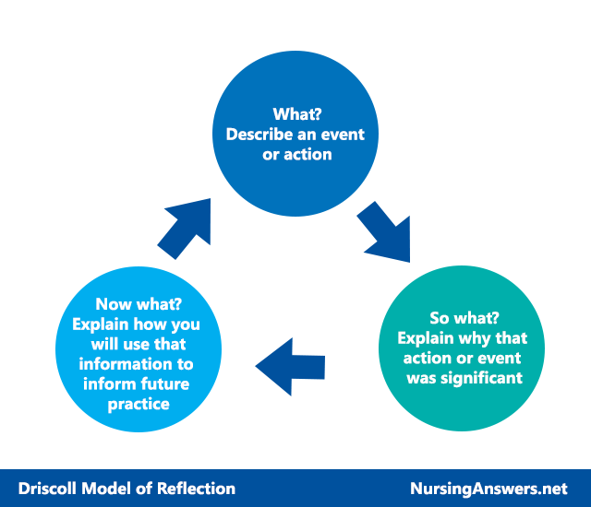
Figure 1: Driscoll model of reflection
(Source: Driscoll and Zhang, 2022)
What?
The hospitality sector in the United Kingdom has to deal with a diversified population. The Premier Inn East Cliff deals with a lot of guests, who are from Germany. Therefore, cultural awareness is critically important for the hospitality industry. It can help me to understand the needs and preferences of travellers belonging to other cultures. Understanding their backgrounds and cultures can assist me in providing personal experiences for them. The guests who are availing of the services tend to feel valued when their customs are respected and their needs are fulfilled. Apart from that, cultural awareness can help to build trust, between the hotel staff as well as the guests. When the diversified cultural background is respected, it actively promotes a perception that is positive by form. These positive perceptions ultimately help to increase customer loyalty. Moreover, sufficient awareness regarding the culture can help me to facilitate positive interactions with the guests, without generating any negative consequences. I think that the problem of the language barrier when mitigated, can help me to raise cultural awareness, which in turn can foster positive guest experiences.
So what?
The step so what helps elaborate on what an individual feels at the specific moment, and the way they react (Stonehouse, 2020). I have figured out that the problem of the German language barrier is creating problems for Premier Inn, as it disrupts cultural awareness. I have found out that a lack of knowledge of the German language has restricted me from understanding the needs and preferences of the guests, who are availing of the services of the hotel. I have limited knowledge regarding the German way of life, their customs and their language. Due to these reasons, I am unable to support them in the way they desire. For example, body language alongside gestures might vary from one culture to another. It might act offensive in one culture, however, it might be respectful in the other one. Therefore, I think that I need to develop behavioural changes and skills, which might assist me in providing appropriate services to the diversified guests.
Now what?
The stage now reflects how an individual can better prepare themselves for future circumstances. I need to make behavioural changes and develop skill competencies. The skills which I need to develop are emotional empathy and active listening skills. These skills can help me to patiently understand what the diverse travellers want from me. Apart from that, attending training workshops on the German language can help (Guhr et al., 2020). I can develop a basic understanding of the language. Henceforth, it can help me to understand the culture that guides them. Through these workshops, I can gain experience regarding cultural sensitivity. It usually assists an individual in understanding the differences in culture. Moreover, it can help me to generate insights in direct and indirect communication.
References:
Stonehouse, D., 2020. Reflection and you. British Journal of Healthcare Assistants, 14(11), pp.572-574.
Guhr, O., Schumann, A.K., Bahrmann, F. and Böhme, H.J., 2020, May. Training a broad-coverage German sentiment classification model for dialogue systems. In Proceedings of the Twelfth Language Resources and Evaluation Conference (pp. 1627-1632).
Driscoll, D.L. and Zhang, J., 2022, March. Mapping Long-Term Writing Experiences: Operationalizing the Writing Development Model for the Study of Persons, Processes, Contexts, and Time. In Composition Forum (Vol. 48). Association of Teachers of Advanced Composition.
Component 4: Training Presentation (6 Slides)

Weighting: 25%
Introduction
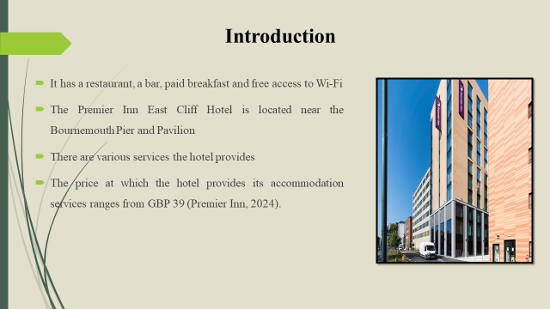

Benefits of multilingualism
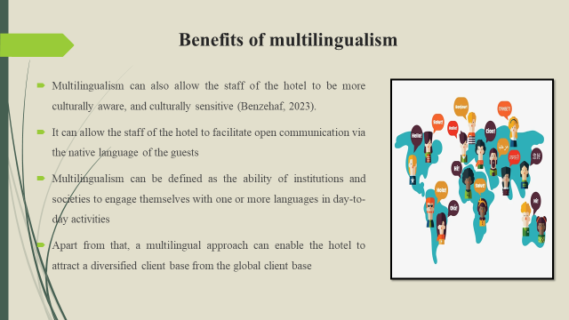

Significance of language awareness skills
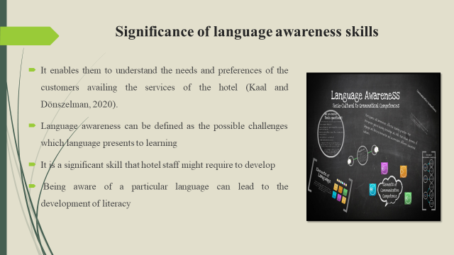

Overview of German language
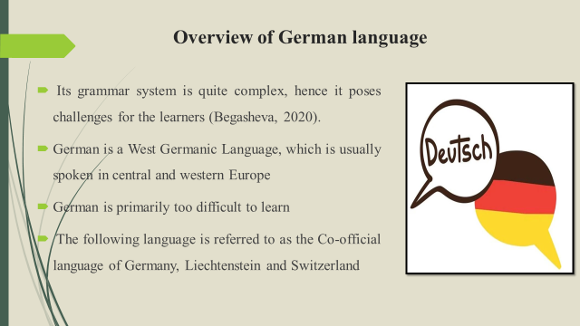

Conclusion
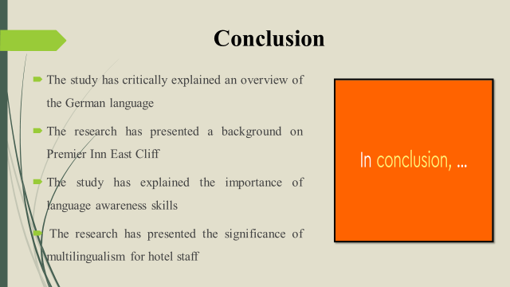

References (no screenshots):
‌Begasheva, S.N., 2020. APPLICATION OF DESIGN METHODOLOGY IN GERMAN LANGUAGE LESSONS. Theoretical & Applied Science, (1), pp.559-562.
Benzehaf, B., 2023. Multilingualism and its role in identity construction: a study of English students’ perceptions. International Journal of Multilingualism, 20(3), pp.1145-1163.
Kaal, A.A. and Dönszelman, S., 2020. Towards language aware citizenship. Language awareness, 29(3-4), pp.197-198.
Premier Inn, 2024. Bournemouth East Cliff Hotel | Premier Inn. [Online] Available at: <https://www.premierinn.com/gb/en/hotels/england/dorset/bournemouth/bournemouth-east-cliff.html> [Accessed 5 Feb. 2024]

