Employability Skills and Reflection Portfolio


Mahbub-E Elahi
Student Number: 2115103

Contents Page

A log of Programme Engagement Hours……………….Page 3

Group Poster (Obesity)…………………………………………Page 5

Academic Interview………………………………………………Page 6

Academic Blog………………………………………………………Page 7

Log of Programme Engagement Hours

Date of event | Time | Subject | Hours
29/09/2021 | 10am-1pm | Introduction to health and social care online (Joanna) | 3
04/10/2021 | 10am-4pm | Study Skills in care online (Karen) | 6
06/10/2021 | 10am-1pm | Introduction to health and social care (Joanna) | 3
11/10/2021 | 10am-4pm | Study Skills in care online (Karen) | 6
13/10/2021 | 10am-1pm | Introduction to health and social care (Joanna) | 3
18/10/2021 | 10am-4pm | Study Skills in care online (Karen) | 6
20/10/2021 | 10am-1pm | Introduction to health and social care (Joanna) | 3
25/10/2021 | 10am-4pm | Study Skills in care online (Karen) | 6
27/10/2021 | 10am-1pm | Introduction to health and social care (Joanna) | 3
01/11/2021 | 10am-4pm | Study Skills in care online (Karen) | 6
03/11/2021 | 10am-1pm | Introduction to health and social care (Joanna) | 3
08/11/2021 | 10am-4pm | Study Skills in care online (Karen) | 6
10/11/2021 | 10am-1pm | Introduction to health and social care (Joanna) | 3
15/11/2021 | 10am-4pm | Study Skills in care online (Karen) | 6
17/11/2021 | 10am-1pm | Introduction to health and social care (Joanna) | 3
22/11/2021 | 10am-4pm | Study Skills in care online (Karen) | 6
24/11/2021 | 10am-1pm | Introduction to health and social care (Joanna) | 3
29/11/2021 | 10am-2pm | Employability skills and reflection (Joanna) | 4
01/12/2021 | 10am-12pm | Effective communications in Health and social care (Amanda) | 2
06/12/2021 | 10am-2pm | Employability skills and reflection (Joanna) | 4
08/12/2021 | 10am-1pm | Effective communications in Health and social care (Amanda) | 3
13/12/2021 | 10am-2pm | Employability skills and reflection (Joanna) | 4
15/12/2021 | 10am-1pm | Effective communications in Health and social care (Amanda) | 3
10/01/2022 | 10am-2pm | Employability skills and reflection online (Joanna) | 4
12/01/2022 | 10am-12pm | Effective communications in Health and social care online (Amanda) | 2
17/01/2022 | 10am-2pm | Employability skills and reflection online (Joanna) | 4
19/01/2022 | 10am-12pm | Effective communications in Health and social care online (Amanda) | 2
19/01/2022 | 1pm-1:30pm | Online session with Amanda | 30 mins
24/01/2022 | 10am-2pm | Employability skills and reflection, academic interview (Joanna) | 1
26/01/2022 | 10am-12pm | Effective communications in Health and social care (Amanda) | 2
02/02/2022 | 10am-12pm | Effective communications in Health and social care (Amanda) | 2
Start till 31/01/2022 | - | WhatsApp communication with classmates | 30

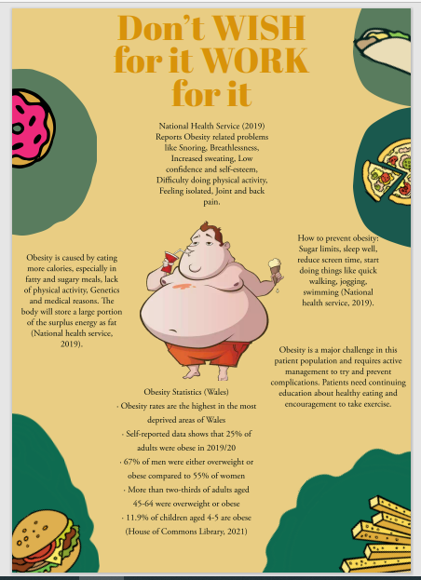
Group Poster
Academic Interview
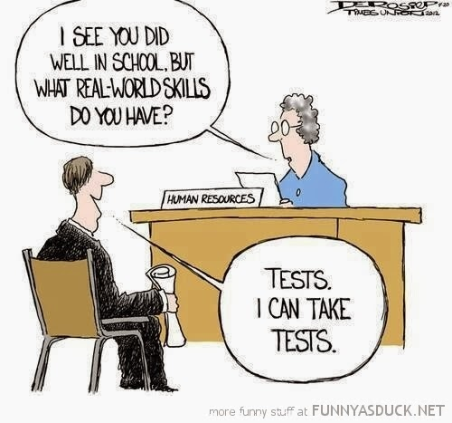

I had an academic interview with Joanna Fender on Monday 24th January 2022.

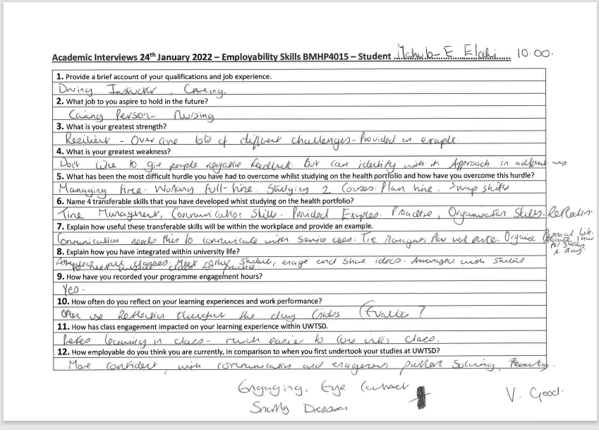

Academic Skills Blog

Being resilient and bouncing back!


Life can be demanding and very difficult at times, so it’s important to find ways to cope and manage stress. This is called being resilient. Stella Cottrell (2013, p.22) explains it as being able to withstand and recover from challenging situations in our personal or professional lives. Being resilient requires qualities like staying clam; be adaptable, think positively and confidence. She believes that it helps us bounce back afterwards (2013, p.22).

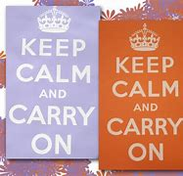
For example, when I did my first ever presentation I found myself in a difficult situation. I became stressed and went blank. I had to calm myself quickly and take time to think and adapt so that I could continue. I found that, as Cottrell suggested (2013, p.22) resilience helped me manage. By doing this I avoided being overwhelmed by stress, regained control and thrived. This helped me build self-belief and confidence.

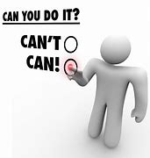
Think of a time when you had to deal with a difficult situation. How did you overcome it? When we reflect on our success or failures, we realise our strengths and weaknesses, existing skills and learn to develop new skills. Cottrell (2013, p. 22) states that resilience builds your confidence and gives you confidence to take on new challenges.

Academic Skills Blog

Proactive not reactive

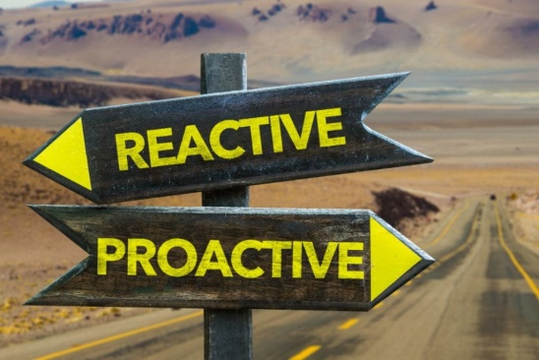
It’s amazing how some people always seem to be more organised than others. They are the ones who can help you if you need hand sanitizers, painkillers, packet of tissue etc. They are the anticipators who make changes and take actions instead of waiting for things to happen (Clockify 2022). Here, we will talk about proactivity. What is proactivity? Being proactive means to think about the future, this includes anticipating problems and looking for solutions beforehand. Proactivity is defined in Collins dictionary as actions that are ‘intended to cause changes, rather than just reacting to change’ (Collins 2022).

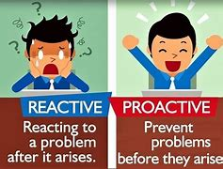
You may be asking ‘how can I be proactive?’ You have to anticipate future events, problems and situations in personal life or work. By this, I mean, take action, plan ahead, set goals and prioritise (Clockify 2022). For example, when I was a driving instructor I had to plan routes to suit individual learner’s ability, anticipate all the complex situations that may occur and deal with them in a timely manner. Being proactive meant being organised as thoroughly as possible.

Academic Skills Blog

Teamwork is in demand!

People working together create great energy, creativity, productivity and efficiency. In short it is an environment set for success. Teamwork as an employability skill has risen in popularity due to its benefits. Tom Burns and Sandra Sinfield (2012, p.431) in the Essential Study Skills explain teamwork as being able to ‘motivate yourself and others to the achievement of common goals’. Here are some benefits:

- Great Ideas are refined through teamwork, as different skills and knowledge come together to refine an idea.
- Being in a team of diverse people with different experiences, skills and opinions can unlock and create new opportunities because different perspectives can be the key to success.
- Teamwork can create a happier working environment because it reduces pressure and encourages support and respect for one another. This will increase productivity.

Last week I worked in a team to make a poster related to a health issue. Our team chose to focus on obesity. We brainstormed ideas and each team member chose a task to focus on, research and gather information. Everything was then compiled into a poster. Teamwork helped us achieve this efficiently as working together is the key principle in getting the job done (Burns and Sinfield, 2012, p.431).

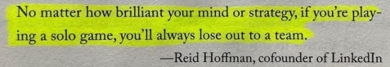


Academic Skills Blog

Do you have good listening skills?

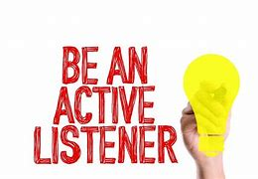
Cottrell (2013, p.259) explains that good communication skills is essential to effective group-working. She states that it is a two-way process that require both listening and participation (2013, p. 252). Do you think you are a good listener? What is good listening? Good listening or active listening is when the brain purposefully focuses to understand the meanings expressed by the speaker (SkillsYouNeed 2022). It is an act that is voluntary, intentional and focused because as a listener you are aware of both, the verbal and non-verbal messages that are being conveyed.

Benefits of good listening:

Based from my own experience, I have realised that you will be more successful and efficient through active listening because you listened, asked questions to clarify matters and improved knowledge. This minimises the risk of misunderstandings and errors, saves time and helps detect problems early on. For example, during my mind map assignment, I did not do active listening as the session was online so I struggled to engage with it. This meant that I misunderstood the task and made several mistakes which had to be fixed so in the end I spent longer in completing the task. The whole experience was stressful and uncomfortable but I have learnt from it.

Academic Skills Blog

Time is of the essence!

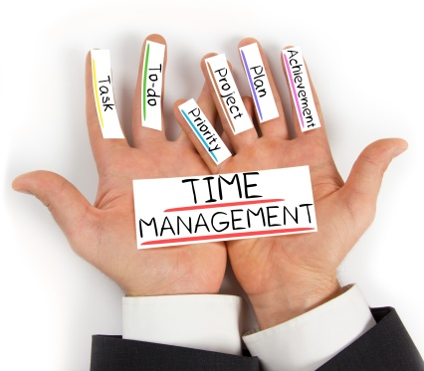

Life is tough so we always seem to be busy trying to manage work, study and personal time (Cottrell 2013, p. 121). Being able to manage time effectively is an essential skill for success; it is also a difficult skill to master. We are introduced to time management from a young age and continue to develop those strategies through higher education, work life and personal commitments. Cottrell (2013, p.123) believes that successful time management is measured by how much time you spend doing something and how well you used that time.

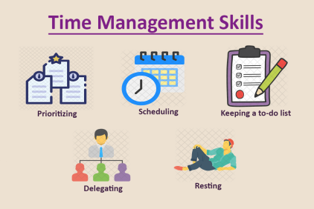
For example, if you plan, prepare and prioritise your workload you will be able to set yourself a goal and organise your time most effectively. This will save time and give you choices to spend your saved time to relax or pursue other activities. Being able to schedule your time helps you take control and monitor how you spend time and helps you stay focused to meet deadlines (Cottrell 2013, p.125).

I use the above time management steps to manage my hectic lifestyle.

Academic Skills Blog

Critical thinking

This is an important skill because it helps us think clearly, logically and accurately when dealing with information. It helps us make connections, reflect on different ideas and solve problems carefully. Burns and Sinfield (2012, p.428) explain that critical thinking helps us make up our own mind about something.

Some forms of critical thinking include analysing, being objective, evaluating, reasoning and problem solving. Cottrell refers to it as “detective-like” approach (2013, p.202). After my presentation on Healthcare workers, I had to critically evaluate my presentation performance, reflect on the things that went well and identify things that didn’t go well. I had to analyse why some parts of the presentation didn’t go well and make an action plan to improve for next time. It was a great process as I felt I had learnt more about my skills and identified areas that needed more work.
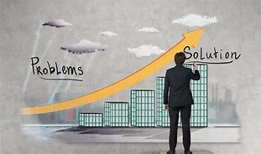
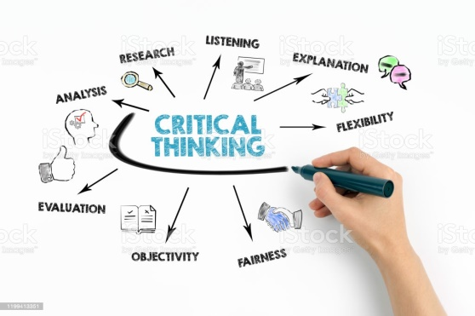
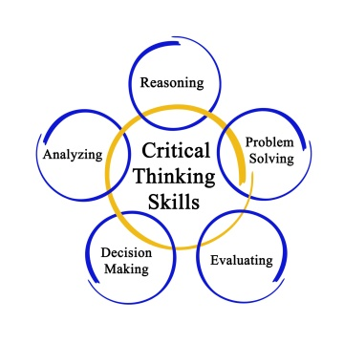

References

Burns, T. and Sinfield, S. (2012) Essential Study Skills. 3rd ed. London: Sage Publications Ltd.

Collins (2022) Proactivity. [Online] Available at: https://www.collinsdictionary.com/dictionary/english/proactive [Accessed at 1st of February 2022]

Cottrell, S. (2013) The Study Skills Handbook. 4th edn. Hampshire: Palgrave Macmillan.

Clockify (2022) Proactivity. [Online] Available at: https://clockify.me/blog/managing-time/be-proactive/ [Accessed at 1st of February 2022]

SkillsYouNeed (2022) Active Listening. [Online] Available at: https://www.skillsyouneed.com/ips/active-listening.html [Accessed at 1st of February]

